**Reviewer’s Comments**

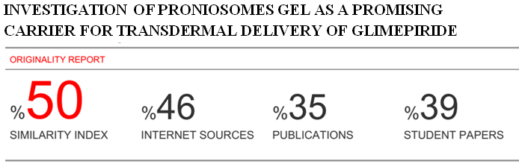

**INVESTIGATION OF PRONIOSOMES GEL AS A PROMISING CARRIER FOR TRANSDERMAL DELIVERY OF GLIMEPIRIDE.**

**ABSTRACT:**

The aim of the study was to develop a proniosomal carrier system that is capable of efficiently delivering entrapped glimepiride over an extended period of time for the treatment of type 2 diabetes. Proniosomal gels were developed based on Span 60 with and without cholesterol. The entrapment efficiency ofdrug inside niosomes developed from hydration of the proniosomes gel was also characterized. The in vitro release and skin permeation of glimepiride from various proniosome gel formulations were investigated. The stability studies were performed at 4°C and at room temperature. The maximum entrapment efficiency was obtained when the cholesterol concentration was 10% of total lipid (90.02%). In vitro release through Mixed Cellulose Estermembrane showed sustained release of drug from proniosomes gels. In vitro drug permeation across rabbit skin revealed improved drug permeation and higher transdermal flux with proniosomes gels compared to hydro-alcoholic gel of drug. Also, good physical stability was also achieved with proniosomes gels. Kinetics of in vitro skin permeation showed diffusion model of drug release from formulations. The study proved that the concentration of cholesterol had great influences on the properties of proniosomes gels. Hence, preparation containing 10% cholesterol can significantly increase trans-epidermal flux and prolong the release of glimepiride.

**KEYWORDS:** Cholesterol, Glimepiride,Proniosomes gel, Span 60, Sustained release, Transdermal drug delivery.

**INTRODUCTION:**

The transdermal mode offers several distinct advantages; the skin presents a relatively large and readily accessible surface area for absorption, Further benefits of transdermal drug delivery (TDD) include the potential for sustained release, Provides the ease of termination, if need arises (e.g. systemic toxicity) with less pain sensation1 and avoiding the first pass hepatic metabolism2.

The self-assembly of non-ionic amphiphiles in aqueous media is resulting in closed bilayer structures called niosomal vesicles or niosomes3. They are analogous to liposomes (phospholipids vesicles) and can encapsulate both hydrophilic and lipophilic solutes, hence, serve as drug carriers4. Among all routes of administration, the enhanced transdermal delivery of niosome encapsulated drugs was seriously considered. Transdermaldrug delivery with niosomes appear promising for hydrophobic andamphiphilic drug molecules and would require that the dose to be appliedin high concentration and within niosomes prepared from low phasetransition surfactant mixtures5.

Moreover, for transdermal application, niosomal vesicles should be included into polymeric matrix like methylcellulose gels. However, the use of polymeric matrix in the formulation may affect drug penetration and niosome integrity6. This problem in addition to the physical instability of the niosomal dispersion can be circumvented by the formulation of liquid crystalline compact proniosomes gels or alcoholic solutions of the nonionic surfactant. Both of them are of great stability due to very little water content.

Previously, proniosomes have been introduced as a stable form alternative to the liquid formulations of niosomes, offering advantages in terms of formulation stability and shipping expenses7. They transform into niosomal vesicles immediately upon hydration, hence, they are called proniosomes8-10. The great advantage offered by proniosomes is their ease of use and their hydration is much easier than the time consuming shaking process required to hydrate surfactants in the conventional dry film method11. Furthermore, unacceptable solvents are avoided in proniosomes formulations. The systems may be directly formulated into transdermal patches and doesn't require the dispersion of vesicles into polymeric matrix12.

Glimepiride (GMD), a 3rd generation sulfonylurea drug used for treatment of type 2 diabetes. Clinical studies have proven GMD to be safe and effective in reducing fasting and postprandial glucose levels, as well as glycosylated hemoglobin concentrations, with dosages of 1–8 mg/day. GMD has been associated with severe and sometimes fatal hypoglycemia and gastric disturbances like nausea, vomiting, heartburn, anorexia, hemolytic anemia due to the transient high blood concentration that occurs after oral administration and increased appetite after oral therapy13. GMD has a relatively short elimination half-life (5 h), thereby requiring twice or thrice daily dosing in patients, Since these drugs are usually intended to be taken for a long period, patient compliance is also very important14.To circumvent these drawbacks GMD was entrapped in vesicular carrier system to improve therapeutic efficacy of GMD via transdermal route.

The purpose of this study to develop GMD proniosomes carrier systems using the common, non-irritant, safe and available non-ionic surfactants Span 60 with and without cholesterol and to investigate the possibility of using proniosomes gels for transdermal delivery of GMD.

**MATERIALS AND METHODS:**

**MATERIALS:**

GMD was a kind gift from Medical Union Pharmaceuticals, Abu Sultan, Ismailia, Egypt; Sorbitanmonostearate (Span 60), Cholesterol (> 99%), Sodium azideand Hydroxy Propyl Methyl Cellulose (HPMC; MW 86,000 Da, viscosity of 2% solution 4000 cP)were procured from Sigma-Aldrich, St. Louis, MO, USA.All other chemicals and solvents were of analar grade and obtained from El-Nasr Company for pharmaceutical chemicals, Cairo, Egypt.

**METHODS:**

**Preparation of Proniosomes gel**s

Proniosomes gels were prepared by the Coacervation phase separationmethod previously repoerted15. In glass vials accurately weighed amountsof Span 60 were mixed with the calculated amount ofcholesterol. The cholesterol was added as 0%, 10%, 30%and 50% of totallipids. Absolute ethanol (about 400 mg) was added to thesurfactant or surfactant/cholesterol mixtures. Precisely, surfactants: alcohol (1:1) then vials were tightly sealedand warmed in water bath (55-60 °C) for 5-10 min while shaking untilcomplete dissolution of cholesterol. To each of the formed transparentsolutions, about 0.16 ml hot distilled water (55-60°C) was added while warming in the water bath for 3-5 min till a clear or translucent solution was produced. The mixtures were allowed to cool down at room temperature and observed for the formation of white creamy proniosomal gel (Table 1). The obtained formulations were kept in the same closed glass vials in dark for further characterization15.

**Drug loading into proniosomesgels**

GMD was added as (5, 10, 12, 15, 17and 20 mg) to the nonionic surfactant/ cholesterol mixture (400mg) and dissolved by the aid of absolute ethanol while warming at 50-60°C in water bath. It was noted that the addition of the drug didn't show turbidity or precipitated crystals in preparations.

Table 1. Formulation design and characterization parameters of proniosomes gels.

|  |  |  |  |  |  |  |
| --- | --- | --- | --- | --- | --- | --- |
| **Formula Code** | **Formula Composition** | | | | **Characterization Parameters** | |
| GMD Conc. (mg) | Span 60 Conc. (mg) | Cholesterol Conc.  (mg) | Ethyl alcohol (mg) | Physical Appearance | Entrapment Efficiency %* |
| **P6** | 15 | 400 | 0 | 400 | White creamy gel | 89.07±0.21 |
| **P6A** | 15 | 360 | 40 | 400 | White creamy gel | 90.02±0.23 |
| **P6B** | 15 | 280 | 120 | 400 | White creamy gel | 87.56±0.30 |
| **P6C** | 15 | 200 | 200 | 400 | White creamy gel | 86.88±0.70 |

* Each result is the mean ± SD. (n = 3)

**Hydration step and formation of niosomes**

About 7 ml of phosphate buffer (pH 7.4) were added into each vial followed by heating for 10 minat a temperature 60°C±3 in a water bath while vortexing. The final volume was adjusted to 10 ml by the same buffer15.

**Preparation of 50%alcoholic HPMC gels containing GMD**

Weighted amount of HPMC-4000 cP were dispersed in distilled water containing 50% ethyl alcohol and stirring sufficient time (about 30min) was allowed for complete hydration and gel formation, then weighted amount of GMD was added and dispersed thoroughly. The concentration of HPMC-4000 cp was 2% and the final concentration of GMD was adjusted to be 15mg/gm.

**Characterization of proniosomes gel bases**

**Total drug content**

1 ml of aqueous dispersionwas disrupted using sufficient quantity of methyl alcohol16and the absorbance was recorded at 228 nm.

**Microscopic examination**

***Light microscopy***

A thin layer of proniosomes gel were spread on a glass slide, and examined for the gel structure and the presence of insoluble drug crystals using ordinary light microscope with magnification powers (40 X). Photomicrographs were taken for either proniosomal gel or niosomes12.

***Transmission electron microscopy (TEM)***

Transmission electron microscopy (JEOL-JEM-2100, Tokyo, Japan) was performed to investigate the morphology of niosomes.A drop of the diluted dispersion was applied to a carbon-coated 300 mesh copper grid and left for 1min to allow some of the niosomes to adhere to the carbon substrate. The remaining dispersion was removed by absorbing the drop with the corner of a piece of filter paper and the sample was air dried17.

**Fourier transform-infrared spectroscopy (FT-IR) studies**

The FT-IR spectral analysis was conducted to verify the possible chemical intermolecular interactions between GMD, Span 60 and cholesterol. The samples were scanned using FT-IR spectrophotometer, Nicolet 200 FT-IR, USA in the spectral region between 4000 and 400 cm-1. The smoothing of the spectra and the baseline correlation procedures were applied. The detector was purged with dry nitrogen gas to reduce moisture and to increase the signal level.

**Differential scanning calorimetry (DSC)**

The thermotropic properties of the samples were explored to assess the degree of crystallinity and the presence of possible interactions between GMD, Span 60 and cholesterol. DSC was performed with a DSC Q2000 V24.4 Build 116. The calorimeter was calibrated for temperature and heat flow accuracy using the melting of pure indium (mp156.6°C and *Δ*H of 25.45 J gm−1). The temperature range was from 0 to 300°C with a heating rate of 10°C/min. The gas used was nitrogen with a purging rate of 50 ml/min. The weight of each sample was 5-9 mg.

**Determination of entrapment efficiency of GMD in niosomes by Freez-thawing/ Centrifugation method**

1 ml Samples of niosomes dispersion were frozen for 24 h at 20°C in Eppendorf tubes. The frozen samples were removed from the freezer and let to thaw at room temperature, then centrifuged at 20000 rpm for 60 min at 4°C. Two times washings with phosphate buffer (pH 7.4) were done for complete removal of drug adsorbed on the surface of niosomal vesicles. The supernatant was separated each time from niosomal pellets and prepared for the assay of free drug15. Each result was the mean of three determinations (±SD).The drug content was determined spectrophotometrically at 228nm against phosphate buffer (pH 7.4) as blank. The %of GMD entrapped was calculated by subtracting amount of un-entrapped drug from the total drug incorporated18.

% Encapsulation efficiency $=\frac{amount of drug encapsulated}{total amount of drug}×100$

**Assessment of GMD release rates from proniosomesacross mixed cellulose ester (MCE)membrane**

The release of GMD from different proniosomes gelswere determined using modified Franz cell fabricated locally with 6.6 cm2 of diffusion area. MCE membrane (0.45μm pore size), previously soaked in phosphate buffer (pH 7.4),was mounted between the donor and receptor compartments of the diffusion cells. The proniosomes gels were placed on MCE membrane in the donor chamber whilst phosphate buffer containing 10% methanol (pH 7.4) was used as a receiver medium in the receptor chamber. The temperature was kept at 32± 0.5 °C and the stirring rate was 100 rpm in Kottermann shaker (D3165 Hangisen, Germany). About two milliliter samples were withdrawn at specified time intervals (0.5, 1, 2, 3, 4, 6, and 8 h) and replaced with equal volumes of fresh receiver medium to keep the volume constant during the experiment. Samples were analyzed spectrophotometrically at 228 nm against samples collected from diffusion of drug free systems as blank.

**Assessment of GMD release rates from niosomes**

The niosomal pellets were resuspended in 50 ml of phosphate buffer (pH 7.4). The suspension was placed in a stoppered glass flask in a shaking water bath at 37°C. 1 ml samples were withdrawn at the following intervals; 0, 1, 2, 3, 4, 6 and 8 h after incubation. Samples were centrifuged as before and supernatants assayed at 228nm. The percentage of drug release was plotted as a function of time15.

**Ex vivo skin permeation study**

Abdominal skin of male rabbits (2-2.5 kg) was used in the study. Hair was removed from the abdominal skin with the aid of an electric animal clipper and shaver. Care was taken not to damage the skin surface. Rabbits were sacrificed and the abdominal skin of the rabbit was separated. Sodium azide (0.02%) is applied to the skin as preservative and the skin was stored at -20°C and used within three days for the permeation study. The permeation experiments were run by using the same diffusion cells previously described in the release through MCE membrane. However, skin membranes were mounted, with the stratum corneum side towards the donor (drug loaded system) and the dermal side facing and in contact the receptor compartment which contain phosphate buffer containing 10% methanol (pH 7.4) maintained at 32±0.5°C19and the stirring rate was 100 rpm in Kottermann shaker.

Proniosomes gels of Span 60 and alcoholic HPMC were applied to the stratum corneum side. 2 ml aliquots were sampled at 0.5, 1, 2, 3, 4, 6, 8, 12 and 24 hr after starting the experiment from the receptor medium and replaced with equal volume of the fresh receiver medium. Samples were analyzed spectrophotometrically at 228 nm using samples collected from permeation of drug free systems as a blank. Each experiment was carried out in triplicate.

All skin permeation parameters such as steady state transdermal flux (SSTF), permeability coefficient (PC), maximum diffusion (Dmax) and diffusion coefficient (D) of GMD across rabbit skin were estimated for different formulations. Permeability parameters of GMD were constructed by plotting the cumulative amount of the drug permeated per unit area (Q) as a function of time. The steady state flux (*JSS*) was calculated from the slope. The permeability coefficient (PC) was calculated by dividing the flux by the initial drug load (Co).The diffusion coefficient (D) was calculated by plotting the cumulative amount of drug permeated versus square root of time $(\sqrt{t})$ according to Equation13.

Q=2Co (Dt/) ½ (Higuchi model).

**Assessment of physical stability for proniosomes gels**

Proniosomes gels stability and aggregation of niosomes dispersions as a function of temperature were determined as the change in total drug content and entrapment efficiency after storage. The proniosomal gels and niosomes dispersions were stored in glass vials at room temperature or kept in refrigerator (4°C) for 3 months17.

**Statistical analysis**

The data were reported as mean ± SD (n = 3) and statistical analysis of the data were carried out using one-way ANOVA at a level of significant of *P*< 0.05.

**RESULTS AND DISCUSSION:**

**Formation of proniosomes gel**s

A sol phase of Proniosomes gelswere formed when distilled water (about 30-40% w/w of total lipids) at 60°C is added in drops to the nonionic surfactant dissolved into hot absolute ethanol while vortexing, where the temperature was kept at 60°C. Since the solvent (absolute ethanol) amount is small and the formation of micelles is not possible into this solvent, it is expected that the addition of small amount of water favors the self-assembly of the surfactant into w/o microemulsion sol phase, where the aqueous droplets bound by surfactant interfacial films which are dispersed in the continuous solvent phase20.

Cooling the sol phase results in a decrease in the solubility of Span 60 and cholesterol in the solvent and consequently, lower solvent- cholesterol affinities due to the limited solvent system present. The formed gel structure proposed to be amphiphilic system comprising double layers of oriented molecules placed head to head and tail to tail with water present as droplets or sheets of water molecules between the hydrophilic residues of the surfactant layers. Span 60 (Tc=53°C) produced white creamy gel in the presence or absence of cholesterol as it has the greatest transition temperature and is solid at room temperature, so it acts as gelator by itself. The formed proniosomes gels is thermo-reversible as an increase in temperature results in the solvation of the gelator into the solvent and returns again to the gel structure upon cooling15.

**Hydration of proniosomes gels**

Niosomes are formed only when the proniosomes gels comes into contact with an aqueous environment such as moisture found on the skin or mucosal surfaces. The contact of proniosomes gels with water leads to swelling of the lamellar liquid crystal bilayers and vesicles due to the interaction of the hydrophilic head groups of the surfactant with water molecules. The surfactant tubules serve as conduits for water penetration into the gel network and the gel fragments21.

The complete hydration of proniosomes gels was found to take long time ranging from 1h to 2h at room temperature with continuous stirring or vortexing. So, warming the gel with excess water above the transition temperature of Span 60 (>60°C) accelerates the transformation to niosomal structures within 5-10 min only.

**Drug loading in proniosomes gels**

15 mg of GMD was found to be completely dissolved into proniosomes gels. This is perhaps due to high solubility of the drug in surfactant/cholesterol/ethanol mixture. Microscopic examination showed no drug crystals precipitated.

**Drug content**

The drug content of the developed formulations was not found to be significantly different (*P*< 0.001) from the added amount.

**Microscopic examination**

***Gel structure***

The gel structures were formed fromfloccules of small tubular and vesculating particles which have creamy opaque appearance and also no drug precipitates (Figure 1). The units of the gel are often bound together by van der Waals forces so as to form crystalline regions throughout the entire system. The dominant coherent gel phase is built up by surfactant/cholesterol lamellae with water phase mainly bound interlamellarly to the hydrophilic head groups of surfactant/ cholesterol lamellae. This resulted in an interconnected network of a mixture of lamellar liquid crystals resembling palisades or tubular aggregates and vesculating lamellae12.

***Niosomes dispersions:***

Niosomes dispersionsunder ordinary microscope gave rise to randomly scattered spherical structures comprising multilamellar and Multivesicular vesicles (Figure 2). The examined niosomes appeared as small unilamellar, spherical nano-vesicles under TEM (Figure 3).

**FT-IR studies**

The FT-IR spectra of GMD, Span 60, cholesterol and physical mixture are displayed in Figure 4. The GMD showed strong absorption peak at 1159 cm-1 corresponding to the sulphonamide group (S=O) and peaks at 1696 cm-1 corresponding to carbonyl group (C=O). The broad bands at 3374 cm-1and 3377cm-1could be assigned to O—H stretching vibrations of Span 60 and cholesterol, respectively. The FT-IR spectrum of the physical mixture revealed that the characteristic bands of GMD did not disappear or exhibit major shifts. Furthermore, no new bands were formed. These findings pointed out the lack of considerable intermolecular interactions between GMD, Span 60 and cholesterol.

Differential scanning calorimetry (DSC)

DSC is a fast and reliable method to screen drug-excipient interactions as indicated by appearance of a new peak(s), change in the peak shape and its onset, peak temperature/ melting point and relative peak area or enthalpy. Figure 5 depicts various DSC thermograms obtained during the study. Pure GMD showed a sharp endothermic peak at 205.72°C. Thermogram of Span 60 exhibits an endothermic peak with onset at 44.62°C and maximum occurrence at 52.24°C. Cholesterol is reported to show an endothermic peak at 148-150°C. It is evident that the original peaks of GMD disappear from the thermogram of proniosomal gel (containing Span 60, Cholesteroland GMD or Span 60 and GMD). These observations confirm incorporation of GMD into proniosomal gel proving complete entrapping of drug into the vesicles.

**Factors affecting entrapment efficiency of glimepiride in niosomes dispersions**

***Effect of cholesterol***

Cholesterol is one of the common and essential additives in niosomesdispersions in the present study. Incorporation of cholesterol was known to influence vesicle stability and permeability22. The effect of cholesterol on GMD entrapment was varied according to its concentration. A significant increase (*P <* 0.05) in the entrapment efficiency of GMD was obtained when 10% of cholesterol was incorporated into niosomes prepared from Span 60 (P6A) followed by a decrease in entrapment efficiency of the drug upon further increase in cholesterol content (Table 2).

Reason revealed for this type of behavior is cholesterol molecules accommodate itself as ‘‘vesicular cement’’ in the molecular cavities formed when surfactant monomers are assembled into bilayers to form niosomal membranes and this space filling action results in the increased rigidity and the improved entrapment efficiency. On further increase of cholesterol beyond certain concentration it compete with the drug for the space within the bilayers, hence excluding the drug and can disrupt the regular linear structure of vesicular membranes23.

**In vitro release studies**

Figure 6 showed the percentage GMD released from proniosomes gels over 8 h. From the obtained results it is clear that P6 showed the lowest release rates among all proniosomal preparations. Addition of 10% cholesterol (P6A) gave greater release rates than those without cholesterol. Increasing cholesterol content up to 50% was accompanied by gradual decrease in the release rate, however, remained significantly higher than that of cholesterol free systems (*P*< 0.05). This could be due to the fact that the addition of cholesterol appeared to disrupt the ordered array of the hydrocarbon chains in the gel phase15, 24. Below the transition temperature, addition of cholesterol made the membrane less ordered, while above the transition temperature made the membrane more ordered25, 26. At 37°C P6 gave rise to highly ordered gel phase than those containing cholesterol, consequently, they produced lower release amounts of GMD.

**Kinetic analysis of the release data of GMD Proniosomal systems**

The kinetic analysis of GMD release data from different Proniosomes gels were tested according to zero, first order kinetic and diffusion controlled model. The results clearly revealed that all proniosomal systems fitted better with Higuchi diffusion model.

**Glimepiride release rates from niosomes**

The release profiles of GMD from niosomes of different cholesterol contents is an apparently biphasic release process. Rapid drug leakage was observed during the initial phase where about 30–35% of the entrapped drug was released from various formulations in the first hour. However, during the following 8 ha slow release occurred in which only further 3% to5% of GMD was lost from different niosomal preparations (Figure 7). This could be explained on the basis that the drug is mainly incorporated between the fatty acid chains in the lipid bilayers of niosomal vesicles. This leads to rapid ionization and release upon dispersing niosomes in increased buffer (pH 7.4) volumes until reaching equilibrium27.

Figure 7 showed that P6A displayed the lowest extent of drug release after 8h. The percent GMD released from P6A & P6Cafter 8 h was 34.54% and 39.08%, respectively. The increase in release rates of GMD from P6C formulation was statistically significant (*P*< 0.05) compared to P6 and P6A formulation. This result attributed to the cholesterol concentration.10% cholesterol produced an optimum hydrophobicity that decreased the formation of the transient hydrophilic holes, responsible for drug release through liposomal layers28. On the other hand, further increase in cholesterol amounts into niosomes formulations could increase the release of GMD23.

**Ex vivo skin permeation studies**

After 24 h about 213.19, 187.37, 203.18 and203.58 μg/cm2were permeated across rabbit skin from P6A, P6, P6B, and P6C proniosomal formulations respectively as showed in figure 8. Addition of 10% cholesterol (P6A) significantly enhanced GMD permeability from proniosomes gel (*P*<0.05).

The steady state transdermal fluxes (SSTF) of GMD from P6A (7.339 µg/cm2.hr) higher than SSTF ofGMD from P6, P6B and P6C (6.356, 6.560 and 6.306 µg/cm2.hr respectively) and five times more than alcoholic HPMC (Table 2). Statistical analysis showed a significant difference between SSTF of P6A and other formulations.

The reduced permeation of GMD from proniosomal gels of Span 60 is primarily attributed to its high transition temperatures which made them in a highly ordered gel state at the permeation temperature (32°C)19.

Table 2. Permeability parameters of GMD released across rabbit skin.

|  |  |  |  |  |
| --- | --- | --- | --- | --- |
| **Formula**  **Code** | **Permeability Parameters** | | | |
| ***D*max (µg)** | ***J*SS (µg/cm2.hr)** | ***P*C (cm/hr)** | **(*D*)** |
| **Alc.HPMC** | 454.41 | 2.031 | 3.692×10-4 | 4.121×10-6 |
| **P6** | 1236.63 | 6.356 | 1.155×10-3 | 3.836×10-5 |
| **P6A** | 1407.02 | 7.339 | 1.334×10-3 | 5.131×10-5 |
| **P6B** | 1341.01 | 6.560 | 1.238×10-3 | 4.334×10-5 |
| **P6C** | 1343.59 | 6.306 | 1.146×10-3 | 4.060×10-6 |

*D*max: maximum amount of drug permeated,*J*SS: steady state flux, *P*C: permeability coefficient and *D*: diffusion coefficient

**Kinetic analysis of the permeation data of GMD Proniosomal systems**

The kinetic analysis of the permeation data of GMD from different proniosomal systems were tested according to zero, first order kinetic and diffusion controlled model. The results clearly revealed that all proniosomes gels fitted better with the diffusion controlled model.

**Physical stability**

The results of stability studies were compiled in Figures 9-12. The effects of storage temperature on entrapment efficiency were expressed as % of GMD retained entrapped according to the following equation.

$$\% Glimepiride retained=\frac{Entrapped glimepiride after storage}{Entrapped glimepiride before storage} x100$$

Generally, drug leakiness from niosomal dispersions upon storage in refrigerator was significantly low; while at room temperature there was an appreciable drug loss and decreased in entrapment efficiency. Hence the niosomes dispersions needs to be refrigerated for use as is the case with all other vesicular systems17.

Proniosomes gels were more stable than niosomal vesicles under refrigerated and room temperature condition. This suggests that proniosomes offered a more stable system that could minimize the problems associated with conventionally prepared niosomes like degradation by hydrolysis, or oxidation, sedimentation, aggregation and fusion during storage. P6A (1.86% loss in drug content and 5.89% decrease in entrapment efficiency) were more stable than other formulations at 3 months.

**CONCLUSION:**

Concluding the above mentioned results; Proniosomes gels could enhance the solubility of certain poorly soluble drugs but to a maximum limit after which any increase in the drug concentration may lead to drug precipitation.The EE% of GMD (as a model for poor soluble drugs) into niosomes prepared by the proniosomal method was a function of cholesterol content.Cholesterol content affected the drug release and permeation properties of proniosomal system.All proniosomal gels fitted to diffusion model when using MCE membranes and when using rabbit skin for release and permeation studies, respectively.It is clear that niosomal formulations containing 10% cholesterol are the most stable among other tested formulations.

#### **CONFLICT OF INTEREST:**

No conflict of interest was associated with this work.

**REFERENCES:**

1. Keleb E, Sharma RK, Mosa EB, Aljahwi A-AZ. Transdermal drug delivery system-design and evaluation. International Journal of Advances in Pharmaceutical Sciences. 2010;1(3):201-11.

2. Kalluri H, Banga AK. Transdermal delivery of proteins. Aaps Pharmscitech. 2011;12(1):431-41.

3. Karim KM, Mandal AS, Biswas N, Guha A, Chatterjee S, Behera M, Kuotsu K. Niosome: a future of targeted drug delivery systems. Journal of advanced pharmaceutical technology & research. 2010;1(4):374.

4. Yoshida H, Lehr C-M, Kok W, Junginger H, Verhoef J, Bouwstra J. Niosomes for oral delivery of peptide drugs. Journal of controlled release. 1992;21(1-3):145-53.

5. Uchegbu IF, Vyas SP. Non-ionic surfactant based vesicles (niosomes) in drug delivery. International Journal of pharmaceutics. 1998;172(1):33-70.

6. Reddy PD, Swarnalatha D. Recent advances in novel drug delivery systems. International Journal of PharmTech Research. 2010;2(3):2025-7.

7. Hu C, Rhodes DG. Erratum to ‘Proniosomes: A Novel Drug Carrier Preparation’:[Int. J. Pharm. 185 (1999) 23–35]. International journal of pharmaceutics. 2000;206(1):109-22.

8. Gupta A, Prajapati SK, Balamurugan M, Singh M, Bhatia D. Design and development of a proniosomal transdermal drug delivery system for captopril. Tropical Journal of Pharmaceutical Research. 2007;6(2):687-93.

9. Fang J-Y, Yu S-Y, Wu P-C, Huang Y-B, Tsai Y-H. In vitro skin permeation of estradiol from various proniosome formulations. International journal of pharmaceutics. 2001;215(1):91-9.

10. Varshosaz J, Pardakhty A, Mohsen S, Baharanchi H. Sorbitan monopalmitate-based proniosomes for transdermal delivery of chlorpheniramine maleate. Drug delivery. 2005;12(2):75-82.

11. Hofland H, Bouwstra J, Spies F, Gooris G, Nagelkerke J. Interaction of liposomes and niosomes with human skin. J Pharm Sci. 1994;83:1192-6.

12. Vora B, Khopade AJ, Jain N. Proniosome based transdermal delivery of levonorgestrel for effective contraception. Journal of controlled release. 1998;54(2):149-65.

13. Ahmed OA, Afouna MI, El-Say KM, Abdel-Naim AB, Khedr A, Banjar ZM. Optimization of self-nanoemulsifying systems for the enhancement of in vivo hypoglycemic efficacy of glimepiride transdermal patches. Expert opinion on drug delivery. 2014;11(7):1005-13.

14. Ahmed TA, Khalid M, Aljaeid BM, Fahmy UA, Abd-Allah FI. Transdermal glimepiride delivery system based on optimized ethosomal nano-vesicles: Preparation, characterization, in vitro, ex vivo and clinical evaluation. International Journal of Pharmaceutics. 2016.

15. Mokhtar M, Sammour OA, Hammad MA, Megrab NA. Effect of some formulation parameters on flurbiprofen encapsulation and release rates of niosomes prepared from proniosomes. International journal of pharmaceutics. 2008;361(1):104-11.

16. Radha G, Rani TS, Sarvani B. A review on proniosomal drug delivery system for targeted drug action. Journal of basic and clinical pharmacy. 2013;4(2):42-8.

17. Ammar H, Ghorab M, El-Nahhas S, Higazy I. Proniosomes as a carrier system for transdermal delivery of tenoxicam. International journal of pharmaceutics. 2011;405(1):142-52.

18. Alsarra IA, Bosela AA, Ahmed SM, Mahrous G. Proniosomes as a drug carrier for transdermal delivery of ketorolac. European journal of pharmaceutics and biopharmaceutics. 2005;59(3):485-90.

19. Zidan AS, Mokhtar M. Multivariate optimization of formulation variables influencing flurbiprofen proniosomes characteristics. Journal of pharmaceutical sciences. 2011;100(6):2212-21.

20. Murdan S, Gregoriadis G, Florence AT. Sorbitan monostearate/polysorbate 20 organogels containing niosomes: a delivery vehicle for antigens? European Journal of Pharmaceutical Sciences. 1999;8(3):177-85.

21. Sudaxshiina M, Van Den BB, Gregory G, Alexander T. Water in sorbitan monostearate organogels (water in oil gels). J Pharm Sci. 1999;88(6):615-9.

22. El-Samaligy M, Afifi N, Mahmoud E. Increasing bioavailability of silymarin using a buccal liposomal delivery system: preparation and experimental design investigation. International journal of pharmaceutics. 2006;308(1):140-8.

23. El-Laithy HM, Shoukry O, Mahran LG. Novel sugar esters proniosomes for transdermal delivery of vinpocetine: preclinical and clinical studies. European journal of pharmaceutics and biopharmaceutics. 2011;77(1):43-55.

24. Ladbrooke B, Williams RM, Chapman D. Studies on lecithin-cholesterol-water interactions by differential scanning calorimetry and X-ray diffraction. Biochimica et Biophysica Acta (BBA)-Biomembranes. 1968;150(3):333-40.

25. Yoshioka T, Sternberg B, Florence AT. Preparation and properties of vesicles (niosomes) of sorbitan monoesters (Span 20, 40, 60 and 80) and a sorbitan triester (Span 85). International journal of pharmaceutics. 1994;105(1):1-6.

26. Arunothayanun P, Bernard M-S, Craig D, Uchegbu I, Florence A. The effect of processing variables on the physical characteristics of non-ionic surfactant vesicles (niosomes) formed from a hexadecyl diglycerol ether. International journal of pharmaceutics. 2000;201(1):7-14.

27. Wissing S, Kayser O, Müller R. Solid lipid nanoparticles for parenteral drug delivery. Advanced drug delivery reviews. 2004;56(9):1257-72.

28. Cócera M, Lopez O, Coderch L, Parra J, De la Maza A. Permeability investigations of phospholipid liposomes by adding cholesterol. Colloids and Surfaces A: Physicochemical and Engineering Aspects. 2003;221(1):9-17.

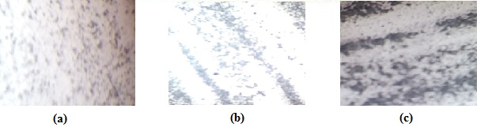

Figure 1: Photomicroscopic view of proniosomal gels: (a) P6 (b) P6A (c) P6C.

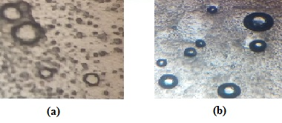

Figure 2: Niosomal vesicles photomicrographs of (a) P6 (b) P6A



Figure 3: TEM micrographs of niosomal vesicles at 60000x magnification power.

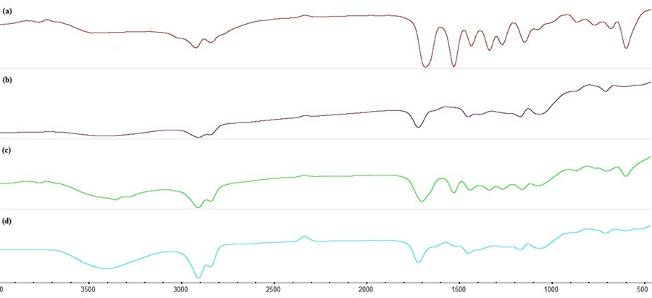

Figure 4: FT-IR spectra of (a) GMD, (b) Span 60, (c) Span 60 and GMD and (d)Span 60, GMD and Cholesterol.

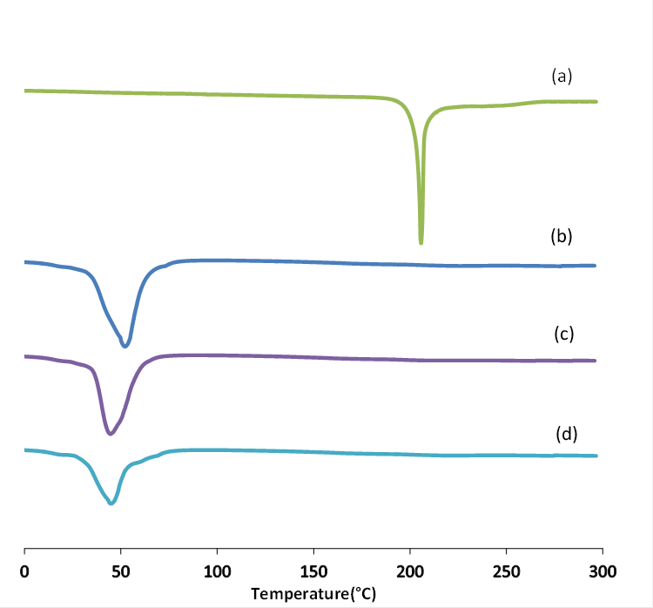

Figure 5: DSC thermogram of (a) GMD, (b) Span 60, (c) Proniosomes gel of Span 60 and GMD and (d) proniosomes gel of Span 60, GMD and Cholesterol.

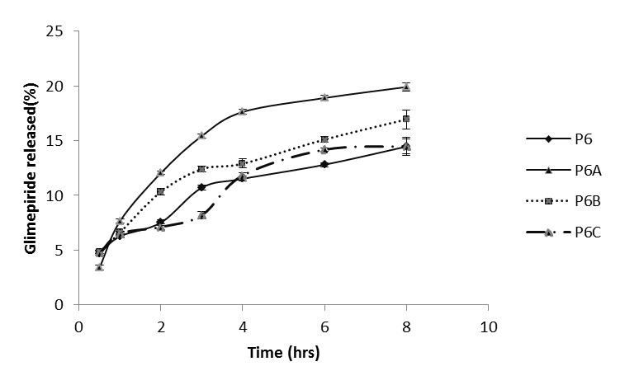

Figure 6: Effects of cholesterol on the in-vitro release of GMD from proniosomes gels.

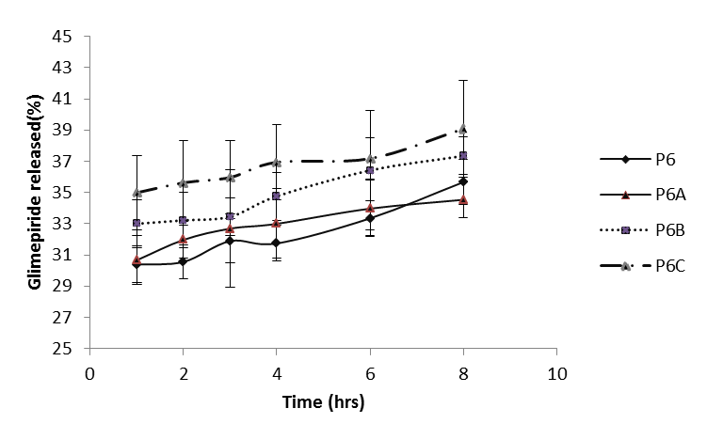

Figure 7: In vitro release of GMD from niosomes after incubation in phosphate buffer pH 7.4.

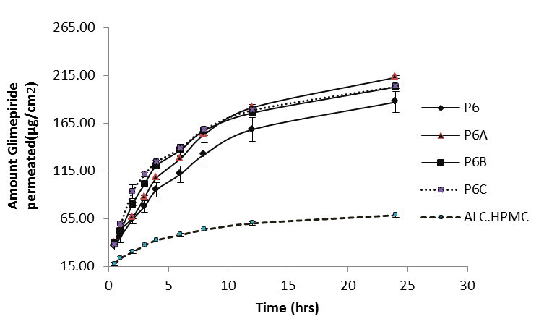

Figure 8: Effects of cholesterol content on GMD permeability across rabbit skin.

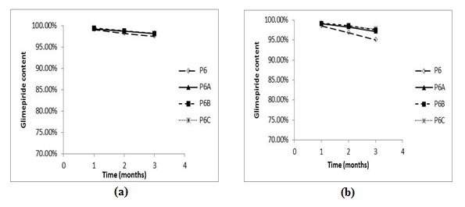

Figure 9: GMD content in proniosomes gels after storage for 3 months (a) at 4°C (b) at 25°C.

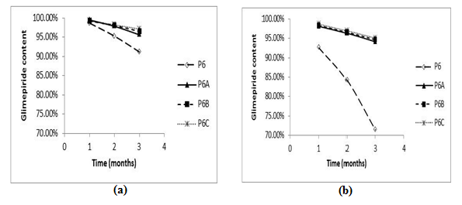Figure 10: GMD content in proniosomes dispersions after storage for 3 months (a) at 4°C (b) at 25°C.

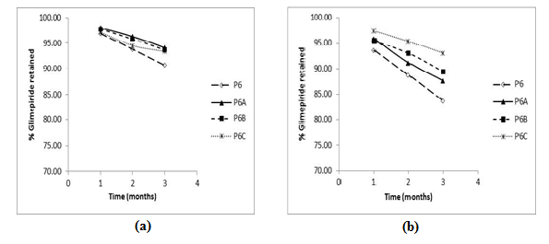Figure 11: % GMD retained in proniosomes gels after storage for 3 months (a) at 4°C (b) at 25°C.

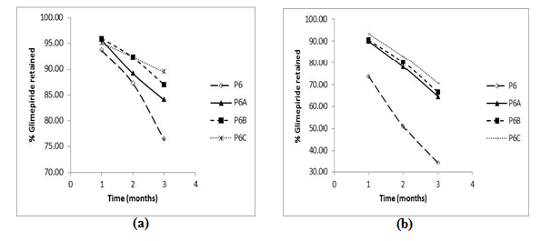Figure 12: % GMD retained in proniosomes dispersions after storage for 3 months (a) at 4°C (b) at 25°C.