**Reviewer’s Comments**

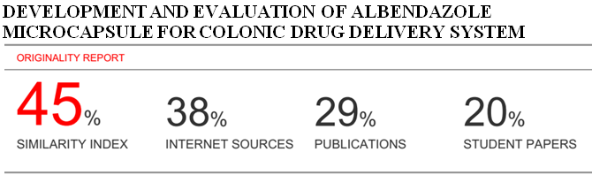

**Development and evaluation of albendazole microcapsule for colonic drug delivery system**

**ABSTRACT**

At present scenario colon specific drug delivery has gainedincreased importance. Colon drug delivery system not only used for the treatment of local diseases, associated with the colon but also it is a potential site for systemic delivery of therapeutic drug.

Albendazole is a benzimidazole carbamate broad spectrum oral anthelmetic drug. It is poorly water soluble and it undergoes extensive metabolism in the intestine and liver.

Different batches of Albendazole microcapsules were preparedusing different concentration of polymers like Eudragit RS-100, chitosan, HPMC. The microcapsules were then evaluated for micromeritic properties, percentage yield, incorporation efficiency, drug content. *In vitro* dissolution profile of each formulation was determined by employing USP XXIII rotating basket method.

**Keywords:** Albendazole,microcapsules, colon specific, eudragit,.

**INTRODUCTION**

Colon targeted drug delivery isused to deliver the drugs that are degraded by the digestive enzymes in the stomach such as proteins and peptides. The colon is attracting interest as a site where poorly absorbed drug molecule may have an improved bioavailability1. Colon is recognized as having a somewhat less hostile environment with less diversity and intensity of activity as compared to stomach and small intestine2. Furthermore, the colon has a long retention time and appears highly responsive to agents that enhance the absorption of poorly absorbed drugs. Colon is also found to be a promising site when delay in absorption is desirable from therapeutic point of view for the treatment of disease that have peak symptoms in early morning and that exhibit circadian rhythm, such as rheumatoid arthritis, nocturnal asthma and angina pectoris. Colon targeted drug delivery of drugs reduces the systemic side effects3. Microencapsulation is a process in which tiny particles or a coating to give small capsules with many useful properties surrounds droplets. Furthermore the administered dose of a drug is subdivided into small units that are spread over a large area of the gastrointestinal tract, which may enhance absorption by diminishing localizeddrug concentration4.

Albendazole is a benzimidazole carbamate broad spectrum oral anthelmetic used to treat a variety of worm infections caused by nematodes and cestodes5. It falls into the BCS class II category as has high permeability and low solubility6. It is poorly soluble having aqueous solubility to be 0.2 mg mL–1 at 25 °C. Because of its low aqueous solubility, it is poorly and erratically absorbed following oral administration7,8,9.

In present study microcapsules of Albendazole were formulated for colonic drug delivery to avoid side effects associated with albendazole therapy and to improve pharmacological effect as most of the worms reside in large intestinal part and.

**MATERIALS AND METHODS**

Albendazole was obtained from Emzor Pharmaceutical Industries Limited, Lagos Eudragit RS-100 was obtained from Evans Medical PLC, Lagos, Nigeria, HPMC and chitosan were obtained from Revive Technologies, lagos. All other chemicals and reagent used in this study were of analytical grade.

**METHOD OF PREPARATION**

Albendazole microcapsules formulations wereprepared by solvent evaporation method10. Accurately weighted Eudragit RS‐100, chitosan and HPMC were taken in different ratios as shown in table 1. All polymers were dissolved in 30ml of acetone to form a homogenous polymers solution. Core material, i.e. Albendazole was dispersed in it and mixed thoroughly.

This organic phase was slowly poured at 15°C in to liquid paraffin (100 ml) containing 1% (w/w) of Span‐80 with stirring at 1000 rpm to form a uniform emulsion. Thereafter, it was allowed to attain room temperature and stirring was continued until residual acetone evaporated and smooth‐walled, rigid and discrete microcapsules were formed. The microcapsules were collected by decantation and the product was washed with petroleum ether (40– 60°C), four times and dried at room temperature for 3 hrs. Themicrocapsules were then stored in a desiccators over fused calcium chloride.

**EVALUATION OF ALBENDAZOLE MICROCAPSULES**

**Micromeritic properties**

The microcapsules are characterized by their micromeritic properties such as bulk density, true density, porosity, Hausner’s ratio11.

**Particle size**: Determination of average particle size of the Albendazole microcapsules was carried out by the optical microscopy method. A minute quantity ofmicrocapsules was spread on clean glass slide and average sizes of 100 microcapsules were determined in each batch12.

**Percentage yield**

The measured weight was divided by total amount of all non‐volatile components which were used for the preparation of microcapsule13.

% yield =(Actual weight of product)/(Total weight of excipient and drug) X 100

**Incorporation efficiency:**

In 100 ml volumetric flask 25mg of crushed microcapsuleswere taken and dissolved with small quantity of ethanol of the volume is made up to mark with pH 6.8 and stirred for 12 hours. After stirring the solution was filtered through Whatman filter paper and from the filtrate appropriate dilutions were made and absorbance was measured at 261 nm by using UV‐spectrophotometer14.

**Drug content**

In a 100 ml volumetric flask, 25 mg of crushed microcapsules were taken, and volume was made up to mark with pH 7.4. The flask was shaken for 12 hours using an orbital shaker incubator. Then the solution was filtered and from the filtrateappropriate dilutions were made and absorbance was measured at 261 nm15.

**In vitro release studies:**

In vitrodissolution profile of each formulation was determined by employing USP XXIII rotating basket method (900 ml of pH 6.8‐phosphate buffer, 100 rpm, 37±0.5 0C). Microcapsules equivalent to 150 mg of Albendazole was loaded into the basket of the dissolution apparatus. Five milliliters of the sample was withdrawn from the dissolution media at suitable time intervals

and the same amount was replaced with freshbuffer. The absorbance of the filtrate was determined at wavelength of 261 nm by using UV spectrophotometer, against pH 6.8 as blank16.

**Table 1: Composition of Albendazole microcapsules**

|  |  |  |  |  |  |  |  |
| --- | --- | --- | --- | --- | --- | --- | --- |
| **Code** | **Drug (mg)** | **Eudragit RS-100 (mg)** | **Chitosan (mg)** | **HPMC (mg)** | **Liquid paraffin (ml)** | **Span 80 (ml)** | **Acetone**  **(ml)** |
| MC1 | 400 | 300 | - | - | 50 | 1 | 30 |
| MC2 | 400 | - | 300 | - | 50 | 1 | 30 |
| MC3 | 400 | - | - | 300 | 50 | 1 | 30 |
| MC4 | 400 | 200 | 100 | - | 50 | 1 | 30 |
| MC5 | 400 | - | 200 | 100 | 50 | 1 | 30 |
| MC6 | 400 | 200 | 100 | 200 | 50 | 1 | 30 |

**Table 2: Characterizationof Albendazole microcapsules**

|  |  |  |  |  |  |  |  |  |
| --- | --- | --- | --- | --- | --- | --- | --- | --- |
| **Batch Code** | **% Yield** | **%Incorporation efficiency (%)** | **Mean particle size**  **(µm)** | **% Drug content** | **Angle of repose** | **Bulk density** | **Tapped density** | **Hausners Ratio** |
| MC1 | 90±0.08 | 88.58±0.21 | 180±2.5 | 96 | 18.1 | 0.60 | 0.62 | 1.031 |
| MC2 | 96±0.12 | 90.72±0.45 | 210±3.2 | 90 | 22.5 | 0.61 | 0.63 | 1.030 |
| MC3 | 94±0.32 | 88.46±0.42 | 195±1.5 | 93 | 20.4 | 0.62 | 0.64 | 1.024 |
| MC4 | 90±0.41 | 93.57±0.08 | 230±3.6 | 94 | 19.3 | 0.59 | 0.61 | 1.046 |
| MC5 | 93±0.37 | 90.24±0.11 | 240±1.8 | 95 | 21.5 | 0.57 | 0.59 | 1.040 |
| MC6 | 97±0.46 | 96.48±0.38 | 245±3.5 | 98 | 20.6 | 0.64 | 0.66 | 1.029 |

(Mean± S.D., n=4)

**Figure 1: % Incorporation efficiency of Albendazole microcapsules**

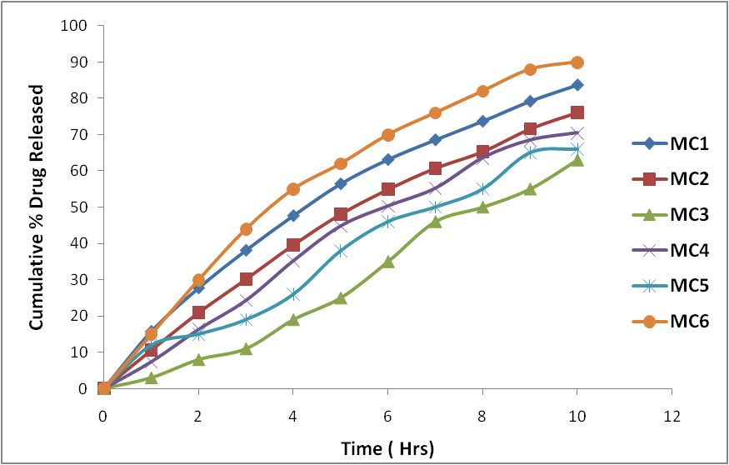

**Figure 2: Comparative *in-vitro* releasestudy of Albendazole microcapsules**

**RESULTS AND DISCUSSION**

Six different microcapsules formulations were prepared by solvent evaporation using different polymers ratio. Pure acetone did not dissolve Eudragit; however acetone with 2% water fitted the criterion well. Liquid paraffin was used as the dispersion media or external phase. Petroleum ether was used to clean the microparticles since it removesliquid paraffin without affecting the integrity of the microparticles.

Results are shown in Table 2. The drug content was found to be very high in all the cases probably due to polymer loss by adherence to the container as a result of viscous nature of slurry.

The incorporation efficiency was found to be good in all formulations. Highest incorporation efficiency 96.48 % was found in batch of MC6. Entrapment efficiency increase with increase in the polymer concentration from the results it can be inferred that there is a proper distribution of Albendazole in the microcapsules and the deviation is withinthe acceptable limits.

The arithmetic mean particle size of the formulations was determined by the optical microscope fitted with an ocular micrometer and stage micrometer. In general mean particle size of the microcapsules significantly increases with increase in polymer concentration due to high viscosity of medium at a higher polymer concentration resulting in enhanced interfacial tension and diminished shearing efficiency.

The angle of repose of microcapsule ranges from 18-22.5° (table 2). The values of angles of repose indicate excellent flow properties.

*In vitro* release studies were carried out by employing USP XXIII rotating basket method. The release profile obtained for all the six formulations in 10 hrs. The release of drug from polymer matrix takes place after complete swelling of the polymer and as the amount of polymer in the formulation increases the time required to swell alsoincrease thereby decrease in the drug release. However, the release showed a biphasic release with an initial burst effect. Maximum drug release was shown by microcapsules formulation of batch MC6 (90.18 %) and minimum release is shown by formulation of batch MC3 (63.7%).

**CONCLUSION**

Different microcapsules formulations wereprepared by solvent evaporation method using different polymers like Eudragit RS-100, chitosan and HPMC. From the results it seems that formulation MC6 was found to be satisfactory in terms of excellent micromeritic properties, yield of microcapsule, (97±0.46 %), incorporation efficiency (96.48±0.38%) and highest *in vitro* drug release of 90.18 %) % in a sustained manner with constant fashion over extended period of time for 10 hrs. Hence the prepared Albendazole microcapsules may prove to be potential candidate for safe and effective sustained drug delivery.

Further in-vivo investigation is required to establishefficacy of these formulations.

**REFERENCES**

1. Jantzen GM, Robinson JR, Sustained and controlled- release drug delivery systems, in modern pharmaceutics, Banker GS and Rhodes CT, eds. *Informa healthcare*: USA; 2009, 502.
2. Robinson JR and Lee VHL, Controlled drug delivery: Fundamentals and Applications. USA: informa healthcare. 2009, 20, 5-6.
3. Kothawade KB, Gattani SG, Surana SJ, Amrutkar JR. Colonic Delivery of Aceclofenac Using combination of pH and time dependent polymers. *Indian Drugs*. 2009;46 (11): 67‐70.
4. Chien YW, Novel Drug Delivery Systems: Oral drug delivery and delivery systems. New York: Marcel Dekker; 1992. 141.
5. Guchelaar. Relative bioavailability of three newly developed albendazole formulations: a randomized crossover study with healthy volunteers, Antimicrob. *Agents Chemother*. 2004, 48, 1051–1054;
6. García JJ, Bolas F, Torrado JJ. Bioavailability and efficacy characteristics of two different oral liquid formulations of albendazole, *Int J Pharm*. 2003, 250, 351–358;
7. Torrado S, Cadorniga R, Torrado JJ. Formulation parameters of albendazole solution, *Int J Pharm*, 1996, 140, 45–50.
8. Lopez S, Torrado S, Torrado AR, Bolás F. Improvement of albendazole efficacy against enteral, but not against parenteral stages of Trichinella spiralis by preparing solid dispersions in polyvinylpyrrolidone, Chemotherapy, 1997, 43.
9. Kalaiselvan R, Mohanta GP, Kannan K, Manna PK, Manavalan R. Optimization of drug-polymer mixing ratio in albendazole-polyvinylpyrrolidone solid dispersion by moisture absorption studies, Acta Pharm Sci. 2006, 48, 141–151.
10. Allen LV, Popovich NG, Ansel HC, Ansel’s pharmaceutical dosage forms and drug delivery systems. 9th ed. Lippincott Williams and Wilkins: USA. 2011, 258-259.
11. Waqas BS, Asad M, Nazir I, Qamar S. Alamgeer. Development and *in-vitro* evaluation of orlistat microcapsules by ionic gelation method. *Europ J of Bas and App Sci*. 2016, 3 (3), 32-43.
12. Bogdansky S. Natural polymers as drug delivery systems, In: Biodegradable polymers as drug delivery systems, Mark Chasin and Robert Langer (eds.) New York: Marcel Dekker Inc, 231- 232.
13. Bhanja S, Panigrahi BB, Shukla N, Hardel DK, Sudhakar M. Formulation and *in vitro* evaluation of nicardipine hydrochloride microcapsules, *AJPCR*. 2012; 5(3): 60-63.
14. Jose S, Dhanya K, Cinu TA, Litty J, Chacko AJ. Colon targeted drug delivery: different approaches, *J of young pharm*. 2009; 1: 13-19.
15. Narkhede PS, Umarkar AR, Patil PP, Patil PV, Jain S. Formulation and evaluation of tetracycline hydrochloride microcapsules by solvent evaporation method. *Int J of Pharm and Biol Sci*. 2011, 1(3), 372-376.
16. Prakash K, Raju PN, Shanta KK, Lakshmi MN. Preparation and characterization of Lamivudine microcapsules using varius cellulose polymers. *Trop J of Pharm Res*. 2007; 6(4): 841-847.