**Reviewer’s Comments**

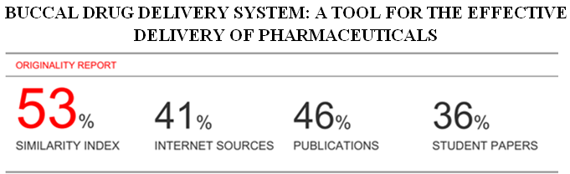

**Buccal drug delivery system: a tool for the effective delivery of pharmaceuticals**

**Abstract-**

The Buccal drug delivery system includes drugadministration through the buccal mucosa, mainly composed of the lining of the cheeks. Buccal drug delivery system provides a convenient route of administration for both systemic and local drug actions.

**Keywords**- Buccal drug delivery system, hepatic first pass effect, buccal films.

**Introduction**

Amongst the various routes of drug delivery, oral route is consideredbetter for patient. Based on our understandings on different aspects of absorption and metabolism, many drugs cannot be delivered successfully through the oral route, because after administration the drugs are subjected to extensive pre- systemic clearance, which often leads to a lack of significant correlation between membrane permeability, absorption1.

Buccal drug delivery refers to the delivery of drugs within/through the buccal mucosa to affect local/systemic pharmacological actions. The buccal route is responsible for maintaining a delivery system at a particular position for an extended period of time therefore it has a great appeal for both local as well as systemic drug bioavailability2. The buccal mucosa is relatively permeable with a rich blood supply and absorption occurring from this place is efficient, and the route also provides rapid drug transport to the systemic circulationand avoids degradation by gastro-intestinal enzymes and first pass hepatic metabolism3.

The delivery of drug requires some type of dosage form present in the oral cavity, which release drug and then diffuses from the mucosa into the blood flow and is then added to the blood circulation.

**Advantages of buccal drug delivery systems**

1. Bypass of the gastrointestinal tract and hepatic portal systemtherefore increasing the bioavailability of orally administered drugs that otherwise undergo hepatic first-pass metabolism. The drug is also protected from degradation due to pH and digestive enzymes of the middle gastrointestinal tract.

2. Improved patient compliance because of the elimination of associated pain with injections;

3. A relatively rapid onset of action can be achieved relative to the oral route, and the formulation can be removed if therapy is required to be discontinued asthe buccal patches are there.

4. Increased ease of drug administration

5. High blood supply and good blood flow rate cause rapid absorption.

6. Mucosal surfaces do not have stratum corneum. Thus, the major barrier layer to transdermal drug delivery is not a factor in transmucosal routes of administration.

**Disadvantages of buccal drug delivery systems**

As compared to the sublingual membrane the buccal membrane has low permeability.

1. Limited surface area is available for absorption.

2. This route cannot administer drugs which irritate the mucosa or havea bitter or unpleasant taste or an obnoxious odour.

3. This route is unacceptable for those drugs which are unstable at pH of buccal environment.

4. The continuous secretion of the saliva (0.5-2 l/day) takes place whichleads to subsequent dilution of the drug. Drugs with large dose are difficult to be administered.4,

5. Drugs which are unstable at buccal pH cannot be administered

**Buccal mucosa overview**

Oral mucosa is divided into two parts:

**A. Epithelium:** The epithelium, act as a protective layer for the tissues and is divided into:

(a) non-keratinized surface in the mucosal lining of the soft palate, the ventral surface of the tongue, the floor of the mouth, alveolar mucosa, vestibule, lips, and cheeks.

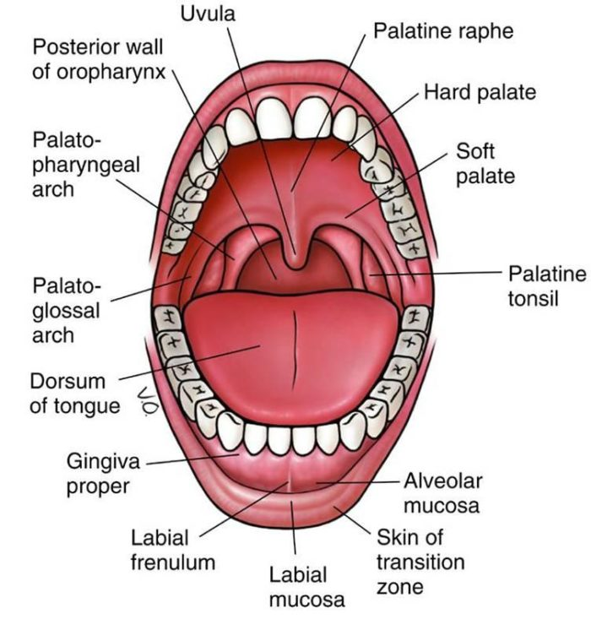

**Figure 1: Structure of buccal mucosa**

(b) Keratinized epithelium, found in the hard palate and non-flexible regions of the oral cavity. Basement membrane and connective tissue: Basement membrane is a boundary which is found in between the basal layer of epithelium and connective tissue. Itconsists of extracellular materials. The organisation which determines the mechanical stability, resistance to deformation, extendibility of tissue is made up of bulk of connective tissue.

The cells of oral epithelia are surrounded by an intercellular grond substance called as mucus.

The oral cavity is marked by the presence of saliva produced by the salivary glands.

Mucus is secreted by the major and minor glands as a part of saliva5.

**(B). Mucus**

The mucus is composed of proteins and carbohydrates. Mucus plays an important role in the absorption of buccal dosage form. cell-cell adhesion takes place. It isassumed that the permeability of buccalmucosa is 4 to 4000 times greater than that of skin.

**Saliva.**

It is considered as an protective fluid for all tissues of the oral cavity. Saliva is composed of 99.5% water in addition to proteins, glycoproteins and electrolytes. Continuous mineralization of the tooth enamel takes place. To hydrate oral mucosal dosage forms.

**MECHANISM OF BUCCAL ABSORPTION**

Buccal drug absorption takes place by passive diffusion of the non-ionized species. Passive diffusion is a process which is mainly governed by a concentration gradient, through the intercellular spaces of the epithelium. The buccal mucosa is considered as a lipoidal barrier to the passage of drug

**Factors affecting buccal absorption:**

The oral cavity is a complex environment for drug delivery as there are manyinterdependent and independent factors which reduces the absorbable concentration at the site of absorption. The factors are as follows:

**1. Factors related with membrane**: This mainly involves degree of keratinization, surface area available for absorption, mucus layer of salivary pellicle, intercellular lipids ofepithelium, basement membrane and lamina propria.

**2**. **Factors related with environment**:

i). **Saliva**: The thin film of saliva coats throughout

the lining of buccal mucosa and is called salivary film. The thickness of salivary film is 0.07 to 0.10 mm. The thickness, composition and movement of this film affected by the rate of buccal absorption.

ii). **Salivary glands**: The minor salivary glands are located in epithelial or deep epithelial region of buccal mucosa. They constantly secrete mucus on surface of buccal mucosa.

iii). **Buccal tissues movement:** Buccal region of oral cavity shows less activemovements. The mucoadhesive polymers are to be incorporated to keep dosage form at buccal region for long periods to withstand tissue movements during talking and if possible during eating food or swallowing6.

**Buccal patches**

A buccal patch is a non dissolving thin matrix modified- release dosage form. Buccal patch is mainly composed of one or more than one polymer films or layers containing the drug and/or other excipients. The patch may contain a mucoadhesive polymer layer which bonds to the oral mucosa, gingiva, or teeth for controlled release of the drug into the oral mucosa (unidirectional release), oral cavity (unidirectional release), or both (bidirectional release). Thepatch is then removed from the mouth and disposed of after a specified time7.

**Types of buccal patches**

**Matrix type (Bi-directional):**

The buccal patches designed in a matrix configuration including drug, adhesive, and additives mixed together. Bi- directional patches release drug in both the mucosa as well as mouth.

**Reservoir type (Unidirectional):**

The buccal patch designed in a reservoir system contains a cavity for the drug and additives

separate from the adhesive. These types of buccal patches are used fordrug delivery in the buccal cavity for local as well as systemic effect8.

**Ideal characteristics**

An ideal buccal adhesive system should possess the following characteristics:

1) The drug should be released in a controlled fashion.

2) The patch should facilitate the rate and extent of drug absorption.

3) It should possess good patient compliance.

4) It should not create problem in normal functions such as talking, eating and drinking.

5) It should have good resistance to the flushing action of saliva.

**Composition:**

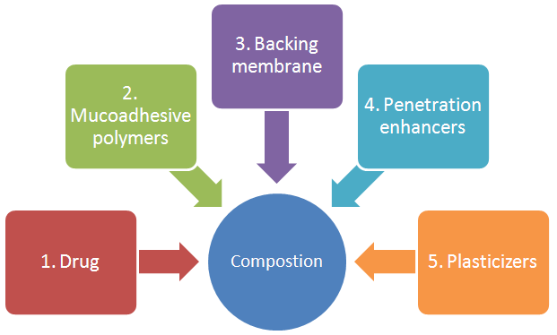

**Figure 2: Composition**

**1. Drug- active pharmaceutical ingredient (API):**

For buccal drug delivery, it is important to increase the contact between API and mucosa to obtain the desired therapeutic effect. The important drug properties that affect its diffusion through the patch as well as the buccal mucosa are molecular weight,chemical function and melting point. The selection of a suitable drug for design of buccal

drug delivery system should be based on following characteristics:

1. The conventional single dose of the drug should be low.

2. The drugs having biological half-life between 2-8 hours are good candidates for controlled drug delivery.

3. The drug absorption should be passive when given orally.

4. It should not produce any irritancy, allergy and discoloration or erosion of teeth.

**2. Mucoadhesive polymers**: Mucoadhesives are synthetic or natural polymers which interact with the mucus layer covering the mucosal epithelial surface and main molecules constituting a major part of mucus. Polymers are also used in matrix where the drug isembedded in the polymer matrix, which controls the duration of release of drugs.

**2.1. Properties of ideal mucoadhesive polymer.**

An ideal polymer for mucoadhesive drug delivery system should have the following characteristics:-

1..The polymer and its products should be non-toxic and non-absorbable from the GIT.

2. It should not be irritant to the mucus membrane.

3. It should allow easy incorporation of the drug and offer no hindrance to its release.

4.The polymer must not decompose on storage or during the shelf life of the dosage form.

5. The polymer should be easily available in the market and economical.

**3. Backing membrane**: Backing membrane plays a major role in the attachmentof bioadhesive devices to the mucus membrane.

1.The materials used as backing membrane should be inert.

2.It should be impermeable to the drug and penetration enhancer.

3.The commonly used materials in backing membrane include carbopol, magnesium separate, HPMC, HPC, CMC, polycarbophil etc.

**4. Penetration enhancers**: Substances that facilitate the penetration through buccal mucosa are referred as penetration enhancers. Various compounds have been investigated for their use as buccal penetration and absorption enhancers which can increas the flux of drugs through the mucosa and act by reducing the viscosity of the mucus and saliva overcomesthis barrier9.

**5**. **Plasticizers**: These are the materials which are used to achieve softness and flexibility of thin films of polymer or blend of polymers. Examples of common plasticizers includes glycerol, propylene glycol, PEG 200, PEG 400, castor oil etc. The plasticizers helps in releasing of the drug substances from the polymer base as well as acting as penetration enhancers. The choice of the plasticizer depends upon the ability of plasticizer material to solvate the polymer and alters the polymer- polymer interactions. When used in correct proportion tothe polymer, these materials impart flexibility by relieving the molecular rigidity.

**Preparation of mucoadhesive patches**

Mucoadhesivebuccal patches can be prepared by the following methods:

**A. Solvent casting:** In this method, all ingredients are firstly weighed accurately and mixed in pestle and mortal. Then the mixture is added to solvent system, which contains the plasticizer. The solution is then transferred to petri- dish. The petri-dish is covered with inverted funnels to allow evaporation of the solvents. These are kept at 20-25ºC temperature for 24 to 48 hours depending upon the solvent system used. After evaporation of the solvent a thin layer of the protective backing material is laminated onto the sheet of coated release liner to form a laminate that is die-cut to form patches of the desired size and geometry

**B. Direct milling:** In this type of patches manufacturing there is not theuse of solvents. Drug and excipients are mechanically mixed by direct milling without the presence of any liquids11

**Evaluation of buccal patches.**

The following tests are used to evaluate the Buccal Patches:

**1. Weight uniformity**: Five different selected patches from each batches are weighed and the weight variation is calculated.

**2. Thickness uniformity**: The thickness of each patch is measured by using digital vernier calipers at five different positions of the patch and the average is calculated.

**3. Folding Endurance:** The folding endurance of each patch is determined by repeatedly folding the patch at the same place till it is broken or folded up to 300 times, which is considered satisfied to reveal good film properties.

**4. Surface pH:** The prepared buccal patches are swelled for 2 hrs onthe surface of an agar plate, prepared by dissolving 2% (w/v) agar in warm phosphate buffer at pH 6.8 under stirring and then poured the solution into a petri dish till gelling at

room temperature. The surface pH is determined by placing pH paper on the surface of the swollen patch. The mean of three readings is recorded.

**5. Drug content uniformity:** For drug content uniformity, 3 cm patch (without backing membrane) is separately dissolved in 100 ml of ethanol and simulated saliva solution (pH 6.2) mixture (20:80) for 12 h under occasional shaking12.

**6. Swelling Index:** Buccal patches are weighed individually (W1) and placed separately in petri dishes containing phosphate buffer pH 6.8. The patches are removed from the petri dishes and excess surface water is removed using filter paper13. The patches are reweighed (W2) and swelling index (SI) is calculated as follows:

(W2-W1)/ W1

**7. Moisture content**: The buccal patches are weighed accurately andkept in dessicator containing anhydrous calcium chloride. After 3 days, the patches are taken out and weighed. The moisture content (%) is determined by calculating moisture loss (%) using the formula:



**8. In-vitro drug release:** rotating paddle method is involved in studying thedrug release from the bilayered and multilayered patches. The dissolution medium consisted of phosphate buffer pH 6.8. The release is performed at 37 ± 0.5°C, with a rotation speed of 50 rpm. The backing layer of buccal patch is attached to the glass disk with instant material. The disk is allocated to the bottom of the dissolution vessel. Samples (5 ml) are withdrawn at predetermined time intervals and replaced with fresh medium. The samples are then filtered through whattman filter paper and analyzed for drug content after appropriate dilution.

**Future challenges of buccal drug delivery system14, 15, 16**

1. The buccal drug delivery system is a promising mean for systemicdelivery of orally inefficient drugs as well as a feasible and attractive alternative for non-invasive delivery of potent peptide and protein drug molecules. Mucoadhesive drug delivery systems may be useful for many pharmaceuticals and can be modified to adhere to any mucosal tissue, including those found in oral cavity, gastrointestinal tract, vagina, eye etc.

2. The liquid formulation of insulin plays a very important role in the treatment of Diabetes. Various forms of doses form. Recently due to the various research done the novel drug delivery system is introduced via liquid aerosol formulation has been developed. In this system the metered dose inhaler are introduced inside the mouth in the form of fine aerosolized drops.

**3.** Development of suitable delivery devices can take place, permeation enhancement improvement, and buccal delivery of drugs that undergo a first-passeffect, such as cardiovascular drugs, analgesics, and peptides.

**4.** The further research on vaccines may leads to the formulation of many new buccal products.

**5**. In mucoadhesive placebo buccal patches we can use any potent drugs which fulfill the criteria for buccal patch as drug delivery system.

**7.** *In-vivo* studies for the prepared mucoadhesive buccal patches may be beneficial for future products.

**8**. Stability studies can justify the feasibility of the

mucoadhesive buccal patches.

9. Buccal nitroglycerin can be used for acute therapy for an anginal attack aswell as for chronic prophylaxis. Nitroglycerine is an important treatment for heart attack symptoms.

**Conclusion**

**References**

1. Gandhi RB, Robinson JR. Oral cavity as a site for bioadhesive drug delivery, *Adv drug del Rev*. 1994, 13:43-74.

2. Rathod S, Surve GD, Phansekar M, Bhagwan A. review on mouth dissolving film technology. *Int J Pharm Res Schol*. 2014; 3(1): 635-47.

3. Giradkar KP. Design development and in vitro evaluation of bioadhesive dosage form for buccal route, *International journal of pharma research and development*. 2010, 2, 28-34.

4. Khanna R, Agarwal SP, Ahuja A. Mucoadhesive buccal drug delivery: a potential alternative to conventional therapy, *Int J Pharm Sci*. 1998, 60(1), 1-11. 15.

5. Rao S, Song Y, Peddie F, Evans AM. A novel tri-layered buccal mucoadhesive patch for drug delivery: assessment of nicotine delivery. *J Pharm Pharmacol*. 2011; 63:794–99.

6. Venkatalakshmi R, Sudhakar Y, Buccal drug delivery using adhesive polymeric patches. 2012, 3(1), 35-41.

7. Sattar M, Sayed OM, Lane ME. Oral transmucosal drug delivery--current status and future prospects. Int J Pharm. 2014, 471 (1-2): 498–506.

8. Mujoriya R, Dhamande K, Wankhede UR, Angure S, A Review on study of Buccal Drug Delivery System, *Inn Sys Design Eng*. 2011, 2(3), 24-35. 27.

9. Desai KGH, Kumar TMP. Development and evaluation of noval buccal adhesive core-in-cup tablets of propranolol hydrochloride. *Indian J Pharm Sci*. 2004; 66 (4):438.

10. Aungst BJ, Rogers NJ, Site Dependence of Absorption- Promoting Actions of Laureth 9, Na Salicylate, Na2 EDTA, and Aprotinin on rectal, nasal, and buccal insulin delivery, Pharm. Res. 1988, 5 (5), 305–308.

11. Salamat-Miller N, Chittchang M, Johnston TP, The use of muco adhesive polymers in buccal drug delivery. *Adv drug deliv review*. 2005, 57(11), 1666-1691.

12. Lalla JK. Gurnancy RA, Polymers for mucosal Delivery-Swelling and Mucoadhesive Evaluation, *Indian drugs*. 2002, 39(5), 48-55.

13. Cilurzo F, Cupone IE, Minghetti P, Selmin F, Montanari L. Fast dissolving films made of maltodextrins. *Eur J Pharm Biopharm*. 2008, 70: 895-900.

14. Shin SC, Bum JP, Choi JS. Enhanced bioavailability by buccal administration of triamcinolone acetonide from the bioadhesive gels in rabbits. Int J Pharm. 2000, 209:37–43.

15. Shrutika M. Gawas, Asish Dev, Ganesh Deshmukh, S. Rathod. Current approaches in buccal drug delivery system pharmaceutical and biological evaluations. 2016; 3 (2): 165-177.

16. Kraan, H. Buccal and sublingual vaccine delivery. *J Control Release*. 2014, 190: 580–92.