**Reviewer’s Comments**

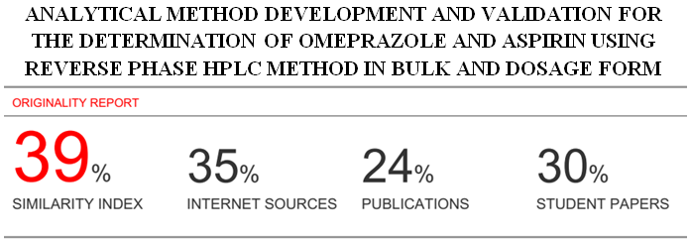

**ANALYTICAL METHOD DEVELOPMENT AND VALIDATION FOR THE DETERMINATION OF OMEPRAZOLE AND ASPIRIN USING REVERSE PHASE HPLC METHOD IN BULK AND DOSAGE FORM**

**Abstract:**

A new simple, accurate, precise and reproducible RP-HPLC method has been developed for the simultaneous estimation of Aspirin and Omeprazole in bulk and pharmaceutical dosage form using C18 column (Agilent, 250 x 4.6 mm, 5 μm) in isocratic mode. The mobile phase consisted of Methanol & 0.1 M Dipotassium Phosphate buffer (pH 3) in the ratio of 60:40 v/v. The detection was carried out at 256 nm . The method was linear over the concentration range for Omeprazole 50-250 μg/ml and for Aspirin 10-50 μg/ml. The recoveries of Omeprazole and Aspirin were found to be 100.07 and 100.06% respectively. The validation of method was carried out utilizing ICH-guidelines. The described HPLC method was successfully employed for the analysis of pharmaceutical formulations containing combined dosage form.

**Keywords:** Omeprazole, Aspirin, reverse phase HPLC, validation.

**Introduction:**

Aspirin (ASP) is chemically 2-(acetyloxy)-benzoic acid (Figure 1). It is nonselective cyclooxygenase inhibitor used as an antipyretic, analgesic, anti-inflammatory, and antithrombotic agent. Esomeprazole magnesium (ESO) is S-isomer of omeprazole and proton pump inhibitor. It is magnesium, bis [5-methoxy-2-[[(4-methoxy-3,5-dimethyl-2-pyridinyl)methyl]sulfinyl]-1H-benzimidazolato] (Figure 2). It is used in treatment of peptic ulcer disease, NSAIDS-associated ulceration and Zollinger-Ellison syndrome, used as antiulcerative. ASP and ESO in combined dosage form are used in cardiovascular disorder and cerebrovascular disorders [1–3]

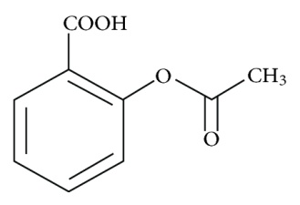 Figure 1: Structure of aspirin.

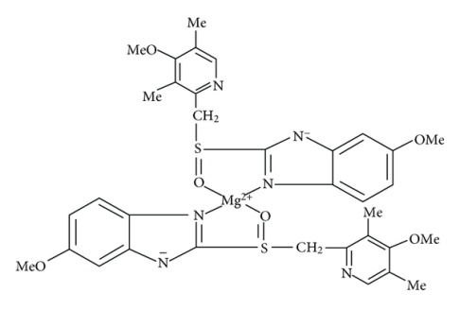 Figure 2: Structure of esomeprazole .

The review of literature revealed that various analytical methods involving spectrophotometry [5-7], HPLC [8-11] and HPTLC [12] have been reported for ASP in single form and in combination with other drugs. Several analytical methods have been reported for ESO in single form and in combination with other drugs including spectrophotometry [13, 14], HPLC [15, 16], and HPTLC [17].

The present work describes the development of a simple, precise, accurate, and reproducible HPLC method for the simultaneous estimation of ASP and ESO in combined dosage form. The developed method was validated in accordance with ICH Guidelines [1&18] and successfully employed for the assay of ASP and ESO combine dosage form.

**Materials**

ASP and OMP were received gratis from Hetero drugs, Hyderabad and were used as received. HPLC grade Methanol was purchased from SD Fine Chem Pvt. Ltd. (Mumbai, Maharashtra). Ultra-pure water was obtained from ELGA (Bucks, UK) water purification unit. Waters total recovery vials (Waters, Milford, MA, USA) were of glass type 1, class A with 950 μL maximal injectable volumes. All other chemicals were of analytical reagent grade.

**EXPERIMENTAL WORK:**

**Chromatographic conditions**

The HPLC system (LC Waters, Milford, MA, USA) consisted of quaternary gradient system (600 Controller), in-line degasser (Waters, model AF), photodiode array detector (Water, 2998 model) and auto sampler (Waters, model 717 plus). Data was processed using Empower Pro software (Waters, Milford, MA, USA).

Isocratic elution of the mobile phase 0.1 M Dipotassium Phosphate buffer (pH 3) and Methanol in the ratio of 40:60 v/v with the flowrate of 1 ml/min. Separation was performed on a Waters C18 (250 x 4.6 mm i.d, 5 μ particle size) analytical column and a pre-column to protect the analytical column from strongly bonded material. Integration of the detector output was performed using the Waters Empower software to determine the peak area. The contents of the mobile phase were filtered through a 0.45 µm membrane filter and degassed by sonication before use. Mobile phase was used as diluents.

The flow rate of the mobile phase was optimized to 1 ml/min which yields a column back pressure of 110–112 kg/cm. The run time was set at 6 min and a column temperature was maintained at 35°C. The volume of injection was 10 µl, prior to injection of the analyte, the column was equilibrated for 30–40 min with the mobile phase. The eluents were detected at 256 nm. The developed method was validated in terms of specificiy, linearity, accuracy, limit of detection (LOD), limit of quantification(LOQ), intra-day and inter-day precision and robustness for the assay of ASP and OMP as per ICH guidelines.

**Preparation of standard solutions**

ASP and OMP were weighed (10 mg each) and transferred to two separate 10 ml volumetric flasks and dissolved in 5 ml of water and make up the volume up to the mark with mobile phase. Working standards of the drugs were prepared from this solution.

**Preparation of sample solution:**

Twenty tablets (Yosprala, Make:Aralez Pharmaceuticals) were weighed. Anaccurately weighed amount of the finelypowdered tablets equivalent to 10mg was made up to 10mL with mobile phase. The solution was filtered followed by serial dilution to the required concentrations for each experiment.

**Results and Discussion:**

**Method Development:**

Number of mobile phase and their different proportions were tried and finally was selected as 0.1 M Dipotassium Phosphate buffer (pH 3) and Methanol in the ratio of 40:60 v/v appropriate mobile phase which gave good resolution and acceptable system suitability parameters. The results of system suitability parameters were shown in table 2. The chromatogram of working standard solution is shown in Fig 3. The summary of Chromatographic conditions was given in table 1.

**Table 1: Summary of Chromatographic conditions**

|  |  |  |
| --- | --- | --- |
| **S. No** | **Parameter** | **Description/Value** |
| 1. | Stationary Phase | Water’s C18 (250X4.6X5) |
| 2 | Mobile Phase | 0.1 M Dipotassium Phosphate buffer (pH 3) and Methanol in the ratio of 40:60 v/v |
| 3 | Flow rate | 1 ml/min |
| 4 | Detection Wavelength | 256 nm |
| 5 | Detector | Photo diode array |
| 6 | Injection | auto sampler -Waters, model 717 plus |
| 7 | Rt’s | Omeprazole – 2.323Min  Aspirin – 4..342 Min |
| 8 | Injection volume | 10 μl |
| 9 | Column Temperature | 35 °C |
| 10 | Run time | 6 mins |
| 11 | Diluent | Mobile Phase |

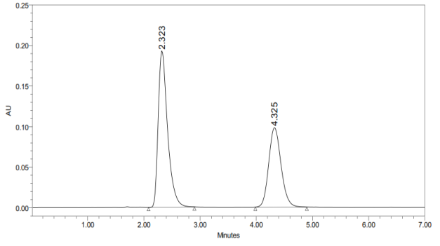

**Fig.3 Typical Chromatogram of Omeprazole & Aspirin**

**Table 2: System suitability parameters**

|  |  |  |  |
| --- | --- | --- | --- |
| **S. No** | **Parameter** | **Result** | |
| **Omeprazole** | **Aspirin** |
| 1 | Retention Time | 2.323 min | 4.325 min |
| 2 | Tailing | 1.079 | 1.189 |
| 3 | Theoretical Plates (n) | 5076 | 7837 |
| 4 | Resolution factor (R) | 3.08 | |
| 5 | Similarity Factor | 1.0124 (Limit: 0.98 – 1.2) | |

**Method Validation:**

**Accuracy**

Recovery assessment was obtained by using standard addition technique which was by adding known quantitiesof pure standards at three different levels in 50%, 100%and 150% to the pre analysed sample formulation. From the amount of drug found, amount of drug recoveredand percentage recovery were calculated which sense to conformation that the proposed method was accurate. The results were tabulated in Table 3.

**Table 3: Results of Accuracy**

|  |  |  |  |  |  |  |  |
| --- | --- | --- | --- | --- | --- | --- | --- |
| S. No | % Concentration (at specific level) | **Omeprazole** | | | **Aspirin** | | |
| Amount added (µg) | Amount found (µg) | Mean % Recovery | Amount added (µg) | Amount found (µg) | Mean % Recovery |
| 1 | 50 | 75 | 75 | 100* | 15 | 15 | 100* |
| 2 | 100 | 150 | 149.25 | 99.13** | 30 | 30 | 100** |
| 3 | 150 | 225 | 224.89 | 99.69* | 45 | 44.55 | 99* |

*Mean % Recovery of 6 replicates; **Mean % Recovery of 3 replicates

**Precision**

The intraday and interday precision of the proposed methodwas determined by analyzing mixed standard solution of OMP and ASP at concentration 150 µg/mL and 30 µg/mL, 3 times on the same day and on 3 different days. The results shown in table 4 were reported in terms of relative standard deviation.

**Table 4: Results of Precision (%Assay)**

|  |  |  |  |  |
| --- | --- | --- | --- | --- |
| **Sample No.** | **Omeprazole** | | **Aspirin** | |
| **Sample Area - 1** | **% Assay - 1** | **Sample Area - 2** | **% Assay - 2** |
| 1 | 2194758 | 100.06 | 1456296 | 100 |
| 2 | 2195700 | 99.49 | 1457422 | 100 |
| 3 | 2196191 | 99.14 | 1456513 | 98 |
| 4 | 2195326 | 100.27 | 1454579 | 99 |
| 5 | 2200951 | 100.27 | 1451483 | 99 |
| 6 | 2196585 | 100.39 | 1455259 | 99 |
| Average Assay: | | 100 | Average Assay: | 99 |
| STD | | 0.51 | STD | 0.82 |
| % RSD | | 0.51 | % RSD | 0.83 |

**Linearity**

Calibration graphs were constructed by plotting peak area vs concentration of ASP and OMP and the regression equations were calculated. The calibration graphs were plotted over 5different linear concentrations in the range of 10-50µg/ml for ASP and 50-250 µg/ml for OMP. Aliquots (10 µl) of each solution were injected under the operating chromatographic condition described above [Number of replicates (n =6)]. The linearity graphs were shown in fig 4 & 5.

Fig 4: Linearity of Omeprazole

Fig 4: Linearity of Aspirin

**Limit of detection (LOD) and limit of quantitation(LOQ):**

The limit of detection (LOD) and limit of quantitation (LOQ) of ASP and OMP were determined by calculating the signal-to-noise(S/N) ratio of 3:1 and 10:1, respectively according to International Conference on Harmonization guidelines.LOD values for ASP and OMP were found to be 3.08and 3.041 µg/mL respectively. LOQ values for C were found to be 10.37 and 9.79µg/mL respectively.

**Assay of the tablet dosage form**

The proposed validated method was successfully applied to determine ASP and OMP in tablet dosage form. The result obtained for ASP and OMP were comparable with corresponding labeled amounts. The results were tabulated in table 4.

**Conclusions**

The proposed method has advantage of simplicity and convenience for the separation and quantitation of ASP and OMP in the combination which can be used for the assay of their dosage form. Also, the low solvent consumption and short analytical run time lead to environmentally friendly chromatographicprocedure. The method is accurate, precise,rapid and selective for simultaneous estimation of Aspirin and Omeprazole in tablet dosage form. Hence itcan be conveniently adopted for routine analysis.

**Acknowledgments**

The authors are grateful to Principal, Management of Shadan Women’s College of Pharmacy, Hyderabad, India for providing necessary facilities to carry out this research project. Authors are thankful for Hetero drugs, Hyderabad, AP for kindly providing the gift sample of OMP and ASP.

**References:**

1. International Conference on Harmonization (ICH) of Technical Requirements for Registration of Pharmaceutical for Human Use: Harmonized Triplicate guideline on Validation of Analytical procedures: Methodology, Recommended for Adoption at Step 4 of the ICH Process on November 1996 by The ICH Steering Committee, IFPMA, Switzerland.
2. Martindale-the Complete Drug Reference, Pharmaceutical Press, London, UK, 34th edition, 2005
3. M. J. O'Neil, Ed., The Merk Index- An Encyclopedia of Chemicals, Drugs and Biological, Merck Research Laboratories, 14th edition, 2006.
4. Antithrombotic Trialists' (ATT) Collaboration, “Aspirin in the primary and secondary prevention of vascular disease: collaborative meta-analysis of individual participant data from randomised trials,” The Lancet, vol. 373, no. 9678, pp. 1849–1860, 2009. View at Publisher · View at Google Scholar · View at Scopus
5. M. D. Game, K. B. Gabhane, and D. M. Sakarkar, “Quantitative analysis of clopidogrel bisulphate and aspirin by first derivative spectrophotometric method in tablets,” Indian Journal of Pharmaceutical Sciences, vol. 72, no. 6, pp. 825–828, 2010. View at Publisher · View at Google Scholar
6. Z. Kokot and K. Burda, “Simultaneous determination of salicylic acid and acetylsalicylic acid in aspirin delayed-release tablet formulations by second-derivative UV spectrophotometry,” Journal of Pharmaceutical and Biomedical Analysis, vol. 18, no. 4-5, pp. 871–875, 1998. View at Publisher · View at Google Scholar · View at Scopus
7. P. Mishra and A. Dolly, “Simultaneous determination of clopidogrel and aspirin in pharmaceutical dosage forms,” Indian Journal of Pharmaceutical Sciences, vol. 68, no. 3, pp. 365–368, 2006. View at Google Scholar · View at Scopus
8. D. Shah, K. Bhatt, R. Mehta, M. Shankar, S. Baldania, and T. Gandhi, “Development and validation of a RP-HPLC method for determination of atorvastatin calcium and aspirin in a capsule dosage form,” Indian Journal of Pharmaceutical Sciences, vol. 69, no. 4, pp. 546–549, 2007. View at Google Scholar · View at Scopus
9. E. R. Montgomery, S. Taylor, J. Segretario, E. Engler, and D. Sebastian, “Development and validation of a reversed-phase liquid chromatographic method for analysis of aspirin and warfarin in a combination tablet formulation,” Journal of Pharmaceutical and Biomedical Analysis, vol. 15, no. 1, pp. 73–82, 1996. View at Publisher · View at Google Scholar · View at Scopus
10. E. Deconinck, P. Y. Sacré, S. Baudewyns, P. Courselle, and J. De Beer, “A fast ultra high pressure liquid chromatographic method for qualification and quantification of pharmaceutical combination preparations containing paracetamol, acetyl salicylic acid and/or antihistaminics,” Journal of Pharmaceutical and Biomedical Analysis, vol. 56, no. 2, pp. 200–209, 2011. View at Publisher · View at Google Scholar · View at Scopus
11. S. L. Yang, L. O. Wilken, and C. R. Clark, “A high performance liquid chromatographic method for the simultaneous assay of aspirin, caffeine, dihydrocodeine bitartrate and promethazine hydrochloride in a capsule formulation,” Drug Development and Industrial Pharmacy, vol. 11, no. 4, pp. 799–814, 1985. View at Google Scholar · View at Scopus
12. P. K. Sinha, M. C. Damle, and K. G. Bothara, “A validated stability indicating HPTLC method for determination of aspirin and clopidogrel bisulphate in combined dosage form,” Eurasian Journal of Analytical Chemistry, vol. 4, no. 2, pp. 152–160, 2009. View at Google Scholar
13. S. S. Patil, P. N. Dhabale, and B. Kuchekar, “Development and statistical validation of spectrophotometric method for estimation of esomeprazole in tablet dosage form,” Asian Journal of Research in Chemistry, vol. 2, no. 2, pp. 154–156, 2009. View at Google Scholar
14. V. V. Gawande and A. V. Chandewar, “Spectroscopic estimation of esomeprazole magnesium in solid dosage form,” International Journal of Pharmacy & Technology, vol. 2, no. 3, pp. 617–622, 2010. View at Google Scholar
15. A. Önal and A. Öztunç, “Development and validation of high performance liquid chromatographic method for the determination of esomeprazole in tablets,” Journal of Food and Drug Analysis, vol. 14, no. 1, pp. 12–18, 2006. View at Google Scholar · View at Scopus
16. P. Sripal Reddy, S. Sait, G. Vasudevmurthy, B. Vishwanath, V. Prasad, and S. Jayapal Reddy, “Stability indicating simultaneous estimation of assay method for naproxen and esomeprazole in pharmaceutical formulations by RP-HPLC,” Der Pharma Chemica, vol. 3, no. 6, pp. 553–564, 2011. View at Google Scholar
17. S. Sharma and M. C. Sharma, “Densitometric method for the Quantitative determination of Esomeprazole and Domperidon,” American—Eurasian Journal of Toxicological Science, vol. 3, no. 3, pp. 143–148, 2011. View at Google Scholar
18. ICH Harmonized Tripartite Guidelines, Validation of Analytical Procedures: Text and Methodology, Q2 (R1), Geneva, Switzerland, 2005.