**Reviewer’s Comments**

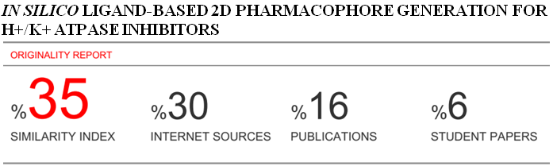

***IN SILICO* LIGAND-BASED 2D PHARMACOPHORE GENERATION FOR H+/K+ ATPASE INHIBITORS**

# ABSTRACT

**Objectives:** At the beginning of the 20th century, Peptic Ulcer became the most prevalent disease as Non-Steroidal Anti-Inflammatory Drugs (NSAIDs) proved ineffective. Researches proved proton pump inhibitors as most successful drugs for the treatment of peptic ulcer. Hence, a ligand based pharmacophore was generated on LigandScout based on fifteen selected H+/K+ ATPase inhibitors.

**Methods:** A pharmacophore model with three Hydrogen bond acceptors, one Hydrogen bond donor and one Hydrophobic Domain was developed. The distance between these features was estimated on Visual Molecular Dynamics (VMD) software.

**Results:** The range between HBA-HBD was found to be 1.89-2.96A. The range between HBD-HP was 4.00-5.46A and range between HP-HBA was 1.89-2.96A.

**Conclusion:** This research study will thus help in designing new and effective drugs for the treatment of peptic ulcer disease.

**Key words:** Peptic Ulcer, NSAIDs, ligand, pharmacophore, Visual Molecular Dynamics

# INTRODUCTION

Gastric H+/K+ ATPase pump is located in the parietal cells [1] and plays a crucial role in the formation of ulcers in the stomach. *H pylori* transmission occurs in 50% of the people worldwide [2]. A peptic ulcer is caused by *Helicobacter pylori (H. pylori)* infection in the gastric mucosal lining. This bacterium causes inflammation in the lining of the stomach. In response to this, gastrin hormone stimulates the gastric acid production. High levels of gastrin cause the enhance release of acid through H+/K+ ATPase pump and lead to the formation of the ulcer. High acidic concentration hinders the growth of *H pylori.* To prevent inhibition of growth it releases urease that buffers the environment and breaks down urea into carbon dioxide and ammonia. Hence in increased acid production, this bacterium is still able to survive [3].

H+/K+ ATPase pump consists of 2 subunits; alpha and beta subunits. The main role of alpha subunit is for the secretion of gastric acid into the stomach and for hydrolysis of ATP. The role of beta subunit is still not understood yet. When the H+/K+-ATPase pump is in an inactive state, it is enclosed in a vesicle inside the cytoplasm. But when it is in activated state it fits itself into the plasma membrane. It is magnesium dependent and causes exchange of a proton against a potassium ion through a membrane. For this process to be efficient, energy is required in the form of ATP [1].

Researchers have identified H+/K+ ATPase as a therapeutic target for the treatment of Peptic ulcer (Sachs et al., 2010). This enzyme is also recognized as a drug target for treatment of other various diseases such as dyspepsia, gastroesophageal reflux disease, and Zollinger-Ellison syndrome. A peptic ulcer can be treated by H+/K+ ATPase pump inhibitors such as Omeprazole which is considered as the most effective one for the treatment [4].

Other proton pump inhibitors include Esomeprazole, Lansoprazole, Rabeprazole, Tenatoprazole, and Pantoprazole [5]. As proton pump inhibitors are more effective in the treatment, H+/K+ ATPase enzyme is selected as the pharmacologic target. Once the activity of H+/K+ ATPase pump is blocked, acid production is reduced in the stomach. H2 blockers can also be used to reduce secretion of acid and target on histamine H2-receptor but they have severe side effects such as diarrhea, headache, dizziness, rash, and tiredness [6].

By blocking the activity of H+/K+ ATPase only the secretion of acid is inhibited but the bacterium H. pylori is not eradicated. For the complete treatment of peptic ulcer disease antibiotics such as Metronidazole, Amoxicillin and Clarithromycin with one proton pump inhibitor are taken orally [7].

Effective and new proton pump inhibitors could possibly be discovered via pharmacophore modelling. In this approach, essential binding features of a specified drug are identified and the pharmacophore model is developed on the basis of analysis of the enzyme inhibitors. [8].

In 1909 Paul Ehrlich coined the concept of pharmacophore [9]. The features that are described by the pharmacophore model are significant binding features that bind to the target of interest. Recently novel inhibitors have been identified for various diseases by pharmacophoric modeling. In 2013, Wang et al. [10] generated a pharmacophore based on H1 receptor antagonists. Recently a pharmacophore was designed by Valasani for the identification of novel cyclophilin d inhibitors [11]. These researchers proved to be successful hence till now pharmacophore methodology is still being used to identify novel drugs for the treatment of various diseases.

The essential features of the drug are identified using computational methods. Both structures based and ligand based pharmacophores can be generated by using this software. The possible features that are highlighted are Hydrogen bond acceptor, Hydrogen bond donor, Aromatic ring, Hydrophobic interactions, Negative and positive ionizable areas [12]. These are basically the ligand features that bind to the specific target and initiate a biological activity.

The main goal of this software is to generate a pharmacophore which is a very important step in the discovery of a novel drug. The pharmacophore is then validated by computational tools. The pharmacophore can also be validated by molecular docking in which the ligand is docked against its specific target. The main aim of this study is to generate a ligand based pharmacophore on the basis of proton pump inhibitors that can be helpful in discovering a new drug for the treatment of peptic ulcer disease.

Using computational tools is a novel approach for generating pharmacophores. The software used is fast and accurate with advanced 3D graphics. Previously pharmacophores were generated manually. This approach was time-consuming as it is a lengthy process, therefore, new computational tools were developed for drug designing to accelerate the drug development process by saving time, financial, human and technical resources. This software aligns ligands of different inhibitors and detects an appropriate pharmacophore model [13]. The detected features are represented by this software. In this study, a pharmacophore will be generated which can further be used for discovering a new and effective drug for the treatment of peptic ulcer disease by using modern computational techniques.

# MATERIALS AND METHODS

## Ligand Identification

The extensive survey identified H+/K+ ATPase as a potential target for generating a pharmacophore for treating peptic ulcer disease.

## Structure Retrieval

The drugs that are FDA approved were collected from PubChem Compound category at National Center for Biotechnology Information (NCBI) website. PubChem is a large database that contains validated information of chemical compounds [14]. The drugs with the least IC50 values were selected. IC50 value is the concentration of the drug that is required to inhibit any biological target by 50%. The drugs are saved in 2D display and SDF format. SDF is one of the file formats of chemical compounds and stands for a structured data file. It represents multiple chemical structures and contains associated data.

**Pharmacophore Generation**

Pharmacophore was generated on LigandScout 3.1. The ligandscout software is available on (www.inteligand.com). This software aligns all the common features of the training set and creates a 2D pharmacophore. This software is widely used for designing pharmacophore as it is fast software and provides high-performance alignment. Each drug was imported onto the software. The energy was minimized of the ligand. Pharmacophore model was created by clicking the “create pharmacophore” icon in the menu bar. The same was done for each drug. Three common features were selected manually. The training set was imported to LigandScout altogether. The common features were aligned and commonly featured pharmacophore was generated.

**Feature Selection**

The features of the ligand include Hydrogen bond acceptor and Hydrogen bond donor, Aromatic ring, hydrophobic interactions, Negative and positive ionizable areas. The features that were common in all the drugs were selected. Minimum 3 features are selected for the formation of a distance triangle.

## Structure Conversion and compatibility

The software Visual Molecular Dynamics (VMD) does not support sdf format. Therefore it is necessary to convert the drugs into PDB format. The software used for conversion is open Babel (http://openbabel.org/wiki/Main_Page). It is free software used to convert more than 110 file formats.

## Pharmacophore Distance Triangle Calculation

By using the software Visual Molecular Dynamics (VMD), all possible distance triangles were made between the three common features. Minimum - Maximum range of the features was observed. VMD is a computational tool which is free of cost for analyzing molecular dynamics models. This software was released in 2012 and is a successful tool for displaying and processing volumetric data.

# RESULTS

## Retrieved Data set

Table 1 shows the data that was collected from PubChem. These drugs were selected as they had the least IC50 value and they are effective in inhibiting H+/K+ ATPase pump.

**Table 1: Data Set and their IC50 values**

|  |  |
| --- | --- |
| **Compound** | **IC50 Value/ μM** |
| Benzimidazole | 0.25 |
| Bafilomyclin Al | 0.44 |
| Dexlansoprazole | 8.0 |
| Esomeprazole | 8.0 |
| Imidazopyridine | 2.3 |
| Lansoprazole | 0.4 |
| Omeprazole | 0.03 |
| Protonix TN | 6.8 |
| Pantoprazole | 1.4 |
| PF 3716556 | 6.02 |
| Rabeprazole | 1.7 |
| Revaprazan | 0.039 |
| Tenatoprazole | 3.0 |
| Timoprazole | 1.9 |
| Zegerid | 0.03 |

## 2D and 3D Pharmacophore Models of each Drug

The Figures 1-15 represent the 2D and 3D pharmacophores of each drug. Fig 16 shows a commonly featured pharmacophore of all compounds. Figures 1-15 shows that each compound consists of hydrophobic domain (yellow spheres), Hydrogen bond acceptor (red spheres) and Hydrogen bond donor (green spheres).

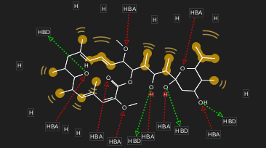 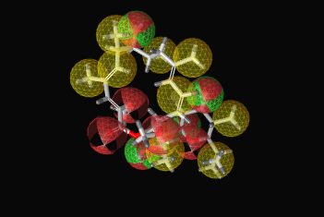

**Fig. 1: Pharmacophore model of bafilomycin A1 (a) 2D model (b) 3D model**

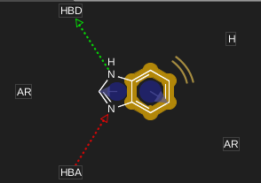 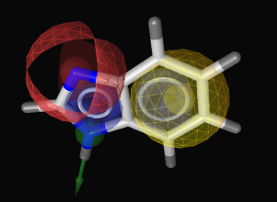

**Fig. 2: Pharmacophore model of Benzimidazole (a) 2D model (b) 3D model**

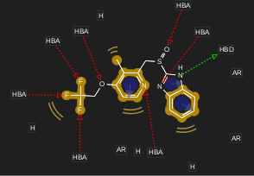 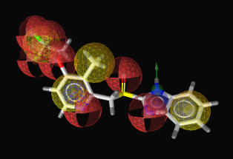

**Fig. 3: Pharmacophore model of Dexlansoprazole (a) 2D model (b) 3D model**

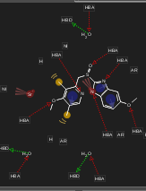 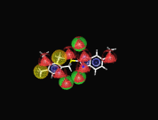

**Fig. 4: Pharmacophore model of Esomeprazole (a) 2D model (b) 3D model**

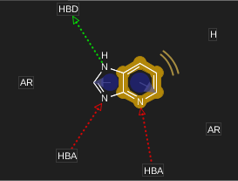 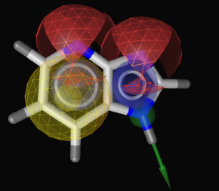

**Fig. 5: Pharmacophore model of imidazopyridine (a) 2D model (b) 3D model**

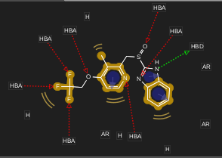 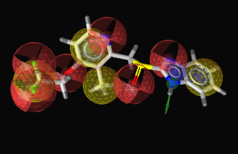

**Fig. 6: Pharmacophore model of Lansoprazole (a) 2D model (b) 3D model**

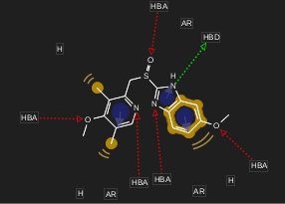 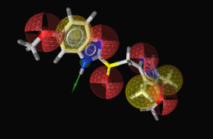

**Fig. 7: Pharmacophore model of Omeprazole (a) 2D model (b) 3D model**

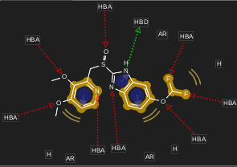 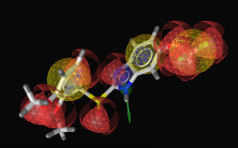

**Fig. 8: Pharmacophore model of Pantoprazole (a) 2D model (b) 3D model**

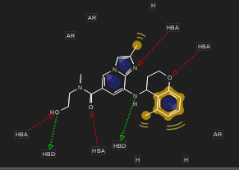 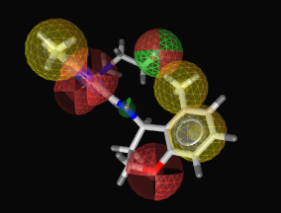

**Fig. 9: Pharmacophore model of PF 3716556 (a) 2D model (b) 3D model**

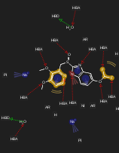 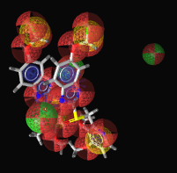

**Fig. 10: Pharmacophore model of Protonix (TN) (a) 2D model (b) 3D model**

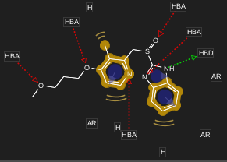 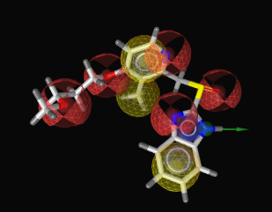

**Fig. 11: Pharmacophore model of Rabeprazole (a) 2D model (b) 3D model**

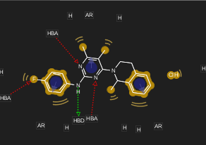 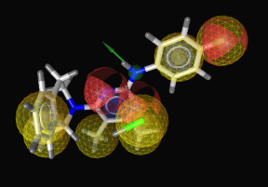

**Fig. 12: Pharmacophore model of Revaprazan (a) 2D model (b) 3D model**

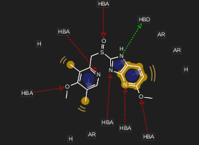 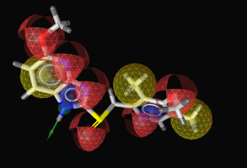

**Fig. 13: Pharmacophore model of Tenatoprazole (a) 2D model (b) 3D model**

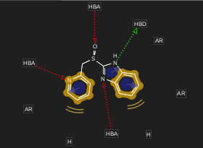 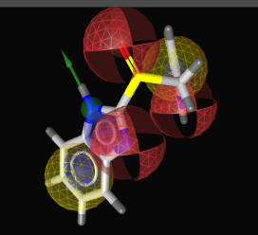

**Fig. 14: Pharmacophore model of Timoprazole (a) 2D model (b) 3D model**

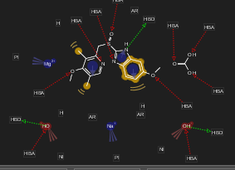 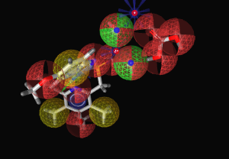

**Fig. 15: Pharmacophore model of Zegerid (a) 2D model (b) 3D model**

Fig. 1 shows the 2D and 3D structure of bafilomycin A1. It consists of one HBA, one HBD, and three hydrophobic domains. Fig. 2 shows the 2D and 3D structure of benzimidazole. It consists of eight HBA's, four HBDs and ten hydrophobic domains. Fig. 3 shows the 2D and 3D structure of dexlansoprazole. It has seven HBA’s, one HBD and seven hydrophobic domains. Fig. 4 shows the structure of Esomeprazole. It has sixteen HBA’s, four HBDs and ten hydrophobic domains. Fig. 5 shows the structure of Imidazopyridine. It has two HBA’s, one HBD and three hydrophobic domains. Fig. 6 shows the structure of Lansoprazole. It has seven HBA’s, one HBD and seven hydrophobic domains. Fig. 7 shows the structure of omeprazole. It has five HBA’s, six HBDs and one hydrophobic domain. Fig. 8 shows the structure of Protonix TN. It has twenty-one HBA’s, three HBDs and ten hydrophobic domains. Fig. 9 shows the structure of pantoprazole. It has eight HBA’s, one HBD and six hydrophobic domains. Fig. 10 shows the structure of PF 3716556. It has four HBA’s, two HBDs and six hydrophobic domains. Fig. 11 shows the structure of rabeprazole. It has five HBA’s, one HBD and six hydrophobic domains. Fig. 12 shows the structure of rev apr azan. It has three HBA's, one HBD and ten hydrophobic domains. Fig. 13 shows the structure of tenatoprazole. It has six HBA’s, one HBDs and six hydrophobic domains. Fig. 14 shows the structure of timoprazole. It has three HBA’s, one HBD and five hydrophobic domains. Fig. 15 shows the structure of Zegerid. It has ten HBA’s, three HBDs and six hydrophobic domains. Fig 16 shows a commonly featured pharmacophore of all compounds. All compounds were aligned at high performance using LigandScout.

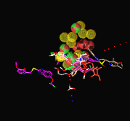

**Fig. 16: Pharmacophore model of all compounds**

## Pharmacophoric Features

The features that were common in the drugs were Hydrophobic Domain, Hydrogen bond acceptor and Hydrogen bond donor. The pharmacophore of all compounds contained one hydrophobic domain, three Hydrogen Bond Acceptors, and one Hydrogen bond donor. The pharmacophoric features of the ligands are listed in Table 2. The distance triangles within a range were selected for each drug as shown in Table 4 Minimum to the maximum range was set which had the least difference.

**Table 2: Pharmacophoric features of each drug**

|  |  |  |  |  |  |
| --- | --- | --- | --- | --- | --- |
| **Compound** | **HBA** | **HBD** | **HP/Ar** | **Positive**  **ionizable** | **Negative ionizable** |
| **Benzimidazole** | **1** | **1** | **3** | **0** | **0** |
| **Bafilomyclin Al** | **8** | **4** | **10** | **0** | **0** |
| **Dexlansoprazole** | **7** | **1** | **7** | **0** | **0** |
| **Esomeprazole** | **16** | **4** | **10** | **0** | **3** |
| **Imidazopyridine** | **2** | **1** | **3** | **0** | **0** |
| **Lansoprazole** | **7** | **1** | **7** | **0** | **0** |
| **Omeprazole** | **5** | **6** | **1** | **0** | **0** |
| **Protonix TN** | **21** | **3** | **10** | **2** | **2** |
| **Pantoprazole** | **8** | **1** | **6** | **0** | **0** |
| **PF 3716556** | **4** | **2** | **6** | **0** | **0** |
| **Rabeprazole** | **5** | **1** | **6** | **0** | **0** |
| **Revaprazan** | **3** | **1** | **10** | **0** | **0** |
| **Tenatoprazole** | **6** | **1** | **6** | **0** | **0** |
| **Timoprazole** | **3** | **1** | **5** | **0** | **0** |
| **Zegerid** | **10** | **3** | **6** | **2** | **2** |

## 

## Distance triangles of Pharmacophoric Features

Table 3 shows the distances calculated by the software Visual Molecular Dynamics. The distances shown are the distances between the common features. Table 4 shows the distance triangles that were within range.

**Table 3: Distance triangles of all compounds**

|  |  |  |  |
| --- | --- | --- | --- |
| **Compound** | **HBA-HBD** | **HBD-HP** | **HP-HBA** |
| **Bafilomycin A1** | 2.33 | 4.59 | 3.81 |
|  | 4.15 | 8.14 | 8.89 |
|  | 6.68 | 8.14 | 4.9 |
|  | 6.26 | 8.14 | 6.37 |
|  | 5.97 | 4.91 | 2.9 |
|  | 4.17 | 6.18 | 5.4 |
|  | 4.84 | 6.18 | 6.15 |
|  | 6.85 | 5.31 | 4.04 |
|  | 4.21 | 4.04 | 6.08 |
|  | 4.02 | 2.46 | 5.41 |
| **Benzimidazole** | 2.22 | 4.1 | 3.74 |
|  | 2.22 | 5.72 | 4.15 |
|  | 2.22 | 2.53 | 3.61 |
|  | 2.22 | 1.37 | 2.28 |
|  | 2.22 | 2.18 | 1.37 |
|  | 2.22 | 3.51 | 2.52 |
| **Dexlansoprazole** | 2.22 | 5.89 | 5.48 |
|  | 2.22 | 4.09 | 3.73 |
|  | 2.96 | 3.51 | 6.03 |
|  | 6.05 | 3.51 | 7.42 |
|  | 8.07 | 3.51 | 10.21 |
|  | 9.98 | 5.23 | 6.54 |
| **Esomeprazole** | 2.93 | 6.18 | 7.27 |
|  | 2.73 | 5.91 | 6.62 |
|  | 1.89 | 4.41 | 3.35 |
| **Imidazopyridine** | 2.22 | 2.54 | 3.6 |
|  | 2.22 | 3.69 | 4.08 |
|  | 2.22 | 4 | 3.58 |
|  | 3.48 | 2.54 | 2.87 |
|  | 3.48 | 3.69 | 2.44 |
|  | 3.48 | 2.54 | 2.87 |
|  | 3.48 | 1.37 | 2.41 |
|  | 3.48 | 1.37 | 3.44 |
| **Lansoprazole** | 2.22 | 4.09 | 3.73 |
|  | 2.96 | 4.09 | 6.89 |
|  | 8.07 | 3.51 | 10.21 |
|  | 6.05 | 7.18 | 2.76 |
| **Omeprazole** | 2.22 | 3.72 | 4.16 |
|  | 4.97 | 3.51 | 4.97 |
|  | 2.95 | 5.91 | 3.57 |
|  | 6.03 | 3.51 | 7.36 |
|  | 8.1 | 3.51 | 10.23 |
|  | 2.22 | 4.09 | 3.73 |
| **Pantoprazole** | 4.96 | 3.51 | 3.64 |
|  | 2.92 | 4.75 | 3.36 |
|  | 2.92 | 5.24 | 2.75 |
|  | 5.42 | 5.24 | 3.69 |
|  | 6.53 | 2.53 | 8.17 |
| **PF3716556** | 3.74 | 4.27 | 3.27 |
|  | 2.96 | 4.23 | 3.56 |
|  | 5.7 | 5.8 | 6.08 |
|  | 6.4 | 7.55 | 7.03 |
|  | 8.09 | 5.29 | 7.77 |
|  | 6.4 | 5.29 | 3.56 |
|  | 5.7 | 5.8 | 6.08 |
| **Protonix TN** | 2.7 | 5.46 | 3.71 |
|  | 4.84 | 8.67 | 7.23 |
|  | 3.67 | 8.29 | 5.65 |
|  | 7.14 | 8.29 | 2.36 |
|  | 9.63 | 10.52 | 2.44 |
| **Rabeprazole** | 2.22 | 3.72 | 4.15 |
|  | 2.94 | 3.51 | 6.03 |
|  | 2.22 | 4.09 | 3.73 |
|  | 7.18 | 3.72 | 8.25 |
|  | 9.04 | 4.09 | 7.23 |
|  | 5.35 | 3.51 | 6.2 |
| **Revaprazan** | 2.39 | 3.55 | 2.73 |
|  | 2.3 | 5.45 | 3.78 |
|  | 2.3 | 4.72 | 3.07 |
|  | 4.63 | 5.45 | 2.86 |
|  | 5.55 | 3.6 | 7.97 |
|  |  |  |  |
| **Tenatoprazole** | 2.23 | 3.69 | 4.07 |
|  | 2.92 | 5.67 | 4.83 |
|  | 6.09 | 5.67 | 2.42 |
|  | 2.23 | 3.99 | 3.57 |
|  | 7.77 | 3.69 | 9.92 |
|  | 5.38 | 5.67 | 8.4 |
| **Timoprazole** | 2.22 | 3.72 | 4.15 |
|  | 2.22 | 4.09 | 3.74 |
|  | 2.94 | 4.38 | 3.13 |
|  | 4.14 | 2.18 | 4.28 |
|  | 2.22 | 3.51 | 2.51 |
| **Zegerid** | 2.23 | 4.09 | 3.74 |
|  | 3.85 | 4.61 | 5.23 |
|  | 4.96 | 3.76 | 7.69 |
|  | 6.57 | 4.92 | 2.38 |
|  | 2.23 | 3.72 | 4.17 |

**Table 4: Distance triangles within range**

|  |  |  |  |
| --- | --- | --- | --- |
| **Compound** | **HBA-HBD** | **HBD-HP** | **HP-HBA** |
| **Bafilomycin A1** | 2.33 | 4.59 | 3.81 |
| **Benzimidazole** | 2.22 | 4.10 | 3.74 |
| **Dexlansoprazole** | 2.22 | 4.09 | 3.73 |
| **Esomeprazole** | 1.89 | 4.41 | 3.35 |
| **Imidazopyridine** | 2.22 | 4.00 | 3.58 |
| **Lansoprazole** | 2.22 | 4.09 | 3.73 |
| **Omeprazole** | 2.22 | 4.09 | 3.73 |
| **Pantoprazole** | 2.92 | 4.75 | 3.36 |
| **PF3716556** | 2.96 | 4.23 | 3.56 |
| **Protonix TN** | 2.70 | 5.46 | 3.71 |
| **Rabeprazole** | 2.22 | 4.09 | 3.73 |
| **Revaprazan** | 2.30 | 4.72 | 3.07 |
| **Tenatoprazole** | 2.23 | 3.99 | 3.57 |
| **Timoprazole** | 2.22 | 4.09 | 3.74 |
| **Zegerid** | 2.23 | 4.09 | 3.74 |

Fig. 17 shows the ranges between the common features. Minimum to the maximum range has been calculated between HBA-HBD, HBD-HP, and HP-HBA. The distance between HBA-HBD is 1.89-2.96A. The range between HBD-HP is 4.00-5.46A and range between HP-HBA is 3.07-3.81A.

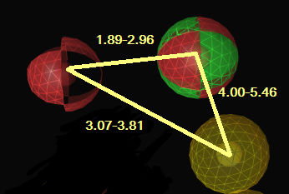

**Fig 17: Distance ranges of common Pharmacophoric Features. Red sphere represents HBA, green sphere represents HBD and yellow sphere represents hydrophobic domain**

# DISCUSSION

Traditional methods of designing a drug are not appreciated because of time-consuming and costly processes. Nowadays computer aided drug designing is a highly adopted method for drug designing as it replaces the drawbacks of conventional methods. A peptic ulcer is among the most prevalent diseases since the 20th century. Numbers of FDA approved drugs are available in the market to treat peptic ulcer. All the drugs belong to different classes are competent and effective to cure the disease. No pharmacophore model has been developed for these drugs against the target H+/K+ ATPase.

Fifteen drugs were selected with the least IC50 values for the generation of pharmacophore model. The model was designed on the latest version of LigandScout that is LigandScout 3.11. For constructing a pharmacophore model, identification of ligand features is necessary. These features are the important binding features that bind to the target and initiate a biological response. The ligand features of the drugs were Hydrogen bond acceptor, Hydrogen bond donor, Aromatic ring, Hydrophobic interactions, Negative and positive ionizable areas. Hydrogen bond acceptor, Hydrogen bond donor, hydrophobic domain were selected as pharmacophoric features. Minimum three features are necessary to form a distance triangle.

The merged pharmacophore model generated had three Hydrogen bond acceptors, one Hydrogen bond donor and one hydrophobic domain. These chemical features have high affinity towards the target hence are the key features of an effective proton pump inhibitor.

The distance between these features was calculated on VMD software. This is competent software and is used to calculate the range of the common features. The range for the pharmacophore was also observed (shown in table 4.4). The distance range observed between HBA-HBD was 1.89-2.96A°. The lower limit (1.89A°) of distance range between HBA-HBD was followed by Esomeprazole whereas upper limit (2.96A°) was observed in Lansoprazole. All other distances lie in between the range. The distance range between HBD-HP was 4.00-5.46A°. The lower limit (4.00A°) was observed in Imidazopyridine and upper limit (5.46A°) was observed in Protonix TN. The distance range between HP-HBA was 3.07-3.81A°. The lower limit (3.07A°) was observed in Revaprazan and upper limit (3.81A°) was observed in Bafilomycin A1. Different scientists such as Wang [10] generated a pharmacophore based on H1 receptor antagonists. Recently a pharmacophore was designed by Valasani et al. [11] for the identification of novel cyclophilin d inhibitors [11].

The difference between the ranges is approximately 1 Angstrom. This is the ideal difference between the ranges in a distance triangle according to different research articles. Hence these ranges are accepted. On the basis of these ranges and features, a further refinement can be done to improve the efficacy of the drugs. Pharmacophore generation is the initial step for discovering a novel proton pump inhibitor. These inhibitors are effectively used in treating peptic ulcer disease.

# CONCLUSION

This study outlines pharmacophore model and the distance range between the common the features of H+/K+ ATPase inhibitors. The model that is designed has three Hydrogen bond acceptors, one Hydrogen bond donor and one hydrophobic domain. The distance range between HBA-HBD is 1.89-2.96A. The range between HBD-HP is 4.00-5.46A and range between HP-HBA is 1.89-2.96A. This will be helpful in designing new and effective drugs for the treatment of peptic ulcer disease.

# ACKNOWLEDGMENT

I extend my deepest and sincerest gratitude to Dr. Shehnaz Choudhry, Dean of Applied Sciences, Head of Department (Biotechnology), Kinnaird College for Women, Lahore, Pakistan for her valuable comment, suggestions and unfailing encouragement. I also want to thank the providers of LigandScout Software for providing a free license for one year.

**CONFLICT OF INTEREST:**

None declared

**REFERENCES**

1. Allain P. H+/K+-ATPase pump. http://www.pharmacorama.com/en/Sections/H-pump-HK-ATPase-1.php
2. Bethesda MD. H. pylori and Peptic Ulcers. NIDDK 2010; 10 (4225): 1-2.
3. Ma LS. A tribute to Dr. Frank I Tovey on his 90th birthday. World J Gastroenterol 2011; 17(31): 3565-6.
4. McKillop T, Schweitzer L. Omeprazole Details. http://www.medschat.com/wiki/Omeprazole/
5. Fock KM, Ang TL, Bee LC, Lee EJ. Proton pump inhibitors: do differences in pharmacokinetics translate into differences in clinical outcomes? Clin Pharmacokinet 2008; 1-6.
6. Kenny T. H2 Blockers. https://patient.info/health/h2-blockers
7. Nishizawa T, Suzuki H, Suzuki M, Takahashi M, Hibi T. Proton pump inhibitor-amoxicillin-clarithromycin versus proton pump inhibitor-amoxicillin-metronidazole as first-line Helicobacter pylori eradication therapy. J Clin Biochem Nutr 2012; 51(2): 114–116.
8. Stauch HB. Methods for the Investigation of Protein-Ligand Complexes. Robinson College University of Cambridge 2013
9. Sangar V. Protein Function: Inferences from Sequence and Structure. Pennsylvania State, USA 2008
10. Wang X, Ren Z, Xiang Y, Zhang YL, Qiao YJ. Pharmacophore Modelling, Molecular Docking and Virtual Screening for Histamine H1 Receptor Antagonists from Traditional Chinese Medicine. Int J Biosci Biochem Bioinforma 2013; 3(5): 438-443.
11. Valasani KR, Vangavaragu JR, Day VW, Yan SS. Structure Based Design, Synthesis, Pharmacophore Modelling, Virtual Screening, and Molecular Docking Studies for Identification of Novel Cyclophilin D Inhibitors. J Chem Inf Model 2014; 54(3): 902–912.
12. Sen D, Chatterjee TK. Pharmacophore modeling and 3D quantitative structure-activity relationship analysis of febrifugine analogs as a potent antimalarial agent. J Adv Pharm Technol Res 2013; 4(1): 50–60.
13. Wolber G, Langer T. Ligand Scout: 3-D Pharmacophores Derived from Protein-Bound Ligands and Their Use as Virtual Screening Filters. J Chem Inf Model 2005; 45(1): 160-169.
14. Seabaugh JL. Guidelines for accurate EC50/IC50 estimation. Pharmaceut Statist 2011; 10(2): 128-34.