**Reviewer’s Comments**

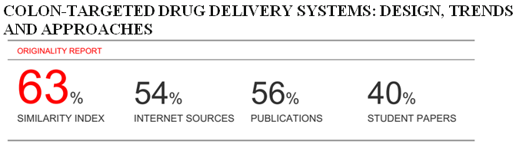

**Colon-targeted drug delivery systems: design, trends and approaches**

**Abstract**

The colon is a site where both local and systemic delivery of drugs can take place. The colon targeted drug delivery system is used for the treatment of various diseases related to colon like Crohn’s disease, ulcerative colitis, etc and systemic delivery of therapeuticpeptides and proteins. It can be possible to target disease site thus lowers the requirement of higher doses of drug and reducing the dosage frequency and cost of the drugs. It also lowers the systemic side effects.

For successful colon targeted drug delivery, a drug needs to be protected from degradation, release and absorption in the upper portion of the gastric intestinal tract and then to be ensured abrupt or controlled release in the proximal colon.

This article gives detail description on anatomy and physiology of the colon andapproaches utilized for colon specific drug delivery like prodrugs, pH and time dependent, prodrug, osmotic pressure controlled drug delivery.

**Keywords-** Colon, Crohn’s disease, prodrugs, osmotic pressure controlled drug delivery.

**Introduction**

Since the past decades research is going on in developing the methods to deliver therapeutic amount of drug to the specific organ so that the desired concentration can be achieved swiftly and then maintained1. Colon targeted drug delivery is used to deliver the substances that are polar and degraded by the digestive enzymes in the gastrointestinal tract. Proteinsand peptides such as insulin, calcitonin and vasopressin, cytokine inhibitors and antibiotics may be delivered systematically via colonic absorption. Anti-asthmatic drugs, antihypertensive drugs and anti-diabetic agents can also be delivered systemically2.

It is also used for the treatment of various diseases like ulcerative colitis, Crohn’s disease, intestinal cancer, diarrhea, for the treatment of diseases sensitive to circadian rhythms like asthma, angina, for the delivery of steroids, etc3. Colon targeted drug delivery system increases the absorption of poorly absorbable drugs due to the high retention time of the colon. Formulations for colonic delivery are also suitable for delivery of drugswhich are susceptible to chemical and enzymatic degradation in the upper GI tract, highly affected by hepatic metabolism, in particular, therapeutic proteins and peptides4.

**Advantages:**

Colon-specific drug delivery system offers the following therapeutic advantages-

1. Reduction of the adverse effects during the treatment of colonic diseases i.e. ulcerative colitis, colorectal cancer, Crohn’s disease etc.

2. Avoidance of first pass metabolism of steroids.

3. Prevention of the gastric irritation produced after oral administration of NSAIDS5.

4. Delayed release of drugs in treatment of diseases i.e. angina,asthma and rheumatoid arthritis.

5. Decreased frequency of drug administration, increased patient compliance6.

6. Provides suitable environment for proteins and peptides that aresensitive to gastric fluid and digestive enzymes7.

7. Increase bioavailability of poorly absorbable drugs8.

**Limitations**

1. Multiple manufacturing steps.

2. Incomplete release of drug.

3. Bioavailability of drug may be low due to potentially binding of drug with dietary residues, intestinal secretions, mucus or fecal matter9.

4. The resident microflora may affect colonic performance through metabolicdegradation of the drug.

5. Non availability of an suitable dissolution testing method to evaluate the dosage form *in-vitro*.

6. It is necessary that drug should be in solution form before absorption and there for rate limiting step for poor soluble drugs10.

**Anatomy of colon**

The GIT consists of parts from mouth to anus. It mainly consists of stomach, small intestine and large intestine. The GIT measures about 5 meters long. The differentparts of GIT are divided into upper and lower gastrointestinal tract. The upper GIT includes oesophagus, stomach, and duodenum. The lower GIT includes small intestine and large intestine11.

The large intestine extending from the ileocecal junction to the anus is divided in to three main parts. These are the colon, the rectum and anal canal. Colon is about 5 feet (150 cm) long, and is divided in to five major segments. The entire peritoneal folds called as mesentery, supported by ascending and descending colon. The right colon consists of the cecum, ascending colon, hepatic flexure and the right half of the transverse colon12. The left coloncontain the left half of the transverse colon, descending colon, splenic flexure and sigmoid.

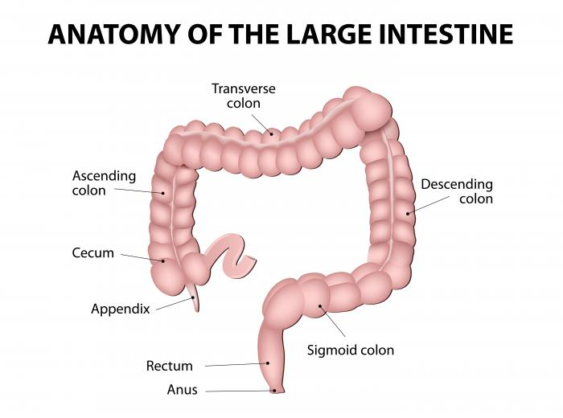

Anatomy of colon

**Criteria for selection of drug for colonic drug delivery drug candidate13, 14, 15-**

1. It should poorly absorb form stomach and small intestine e.g. peptides.
2. It should be compatible with carrier molecule and easily biotransform in large intestine
3. It should be stable at alkaline pH of GIT.
4. It should have both local and systemic effects.
5. Drug use in treatment of various intestinal disorders such as ulcerative colitis, amoebiasis and colon cancer, inflammatory bowel disease, diarrhea are idealcandidates for local colon delivery e.g. sulfasalazine, olsalazine, mesalazine, steroids like fludrocortisone, budesonide, prednisolone and dexamethasone.

**Table 1: Disease and drugs**

|  |  |  |
| --- | --- | --- |
| **S.N.** | **Disease** | **Drugs** |
|  | Inflammatory bowel diseases (IBD), Crohn’s disease, amoebiasis, Ulcerative colitis, irritable bowel diseases | Hydrocortisone, Prednisolone,  Sulfasalazine, Mesalazine, Mercaptopurine Metronidazole, Tinidazole, mebendazole. |
|  | Colorectal cancer, pancreatactomy, chronic pancreatitis, cystic  Fibrosis, | Digestive enzymes, 5- fluorouracil |

**Factors affecting colon targeted drug delivery-**

1. Physiological factors

2. Pharmaceutical factors

**1. Physiological factors**

**a. Gastric emptying**

Drug delivery to the colon upon oral administrationdepends mainly on gastric emptying and bowel transit time. Upon reaching the colon the transit time of dosage form depends on the size of the particles. Smaller particles have more transit time compared to larger particles. Diarrhoea patients have shorter transit time whereas constipation patients have longer transit times16.

**b. pH of colon**

The pH of GIT varies between different individuals. The food intake, diseased state, etc. influences the pH of the GIT. This change in the pH in different parts of GIT is the basis for the

development of colon targeted drug delivery systems. Coatingwith different polymers is done to target the drug to the site17.

**c. Colonic microflora and enzymes**

The GIT contains a variety of microorganisms that produces many enzymes need for metabolism. Growth of this microflora is controlled by the GIT contents and peristaltic movements. The enzymes released by different microorganisms E. coli, Clostridia, Lactobacilli,

Eubacteria, Streptococci are responsible for the various metabolicreactions that take place in

the GIT18.

**2. Pharmaceutical factors**

**a. Drug candidates:**

Due to high retention time of colon, colon causes an increase in the absorption of poorly

**b. Drug carriers:**

The selection of carrier for CDDS depends on the nature of the drug, disease for which the drug is used. The various physicochemical factors of drug that effect the carrier selection includes chemical nature, stability, partition coefficient, functional groups of drug molecule19.

**Approaches for the development of colon targeted drug delivery-**

**Chemical or Prodrug Approach:**

A prodrug is a medication or compound that, after administration, ismetabolized (i.e., converted within the body) into a pharmacologically active drug.

In this method, the prodrugs are designed to undergo minimum absorption and hydrolysis in the upper GIT and undergo enzymatic hydrolysis in the colon, there by releasing the active drug moiety from the carrier20.

**1. Azo bond conjugate:**

In this approach the drug is attached via an azo bond to a carrier. Azo compounds are metabolized by the intestinal bacteria, both by intracellular enzymatic component and extracellular reduction. This azo bond is stable in the upper GIT and iscleaved in the colon by the azo-reductases produced by the microflora. The use of these azo compounds for colon-targeting has been in the form of hydrogels as a coating material for coating the drug cores and as prodrug21.

**2. Cyclodextrin conjugate:**

Cyclodextrin is non toxic and bulky molecule; it has limited absorption from the GIT hence it is used as the carrier for some drug which are unstable in stomach and intestinal environment. Cyclodextrins are cyclic oligosaccharides consisted of six toeight glucose units through -1,4 glucosidic bonds and have been utilized to improve certain properties of drugs such as solubility, stability and bioavailability22.

Interior of these molecules is relatively lipophilic and the exterior relatively hydrophilic, form inclusion complexes with various drug molecules. After oral administration, cyclodextrin form of biphinayl acetic acid were selectively reach in to the colon and releasedrug without absorb form upper GIT23.

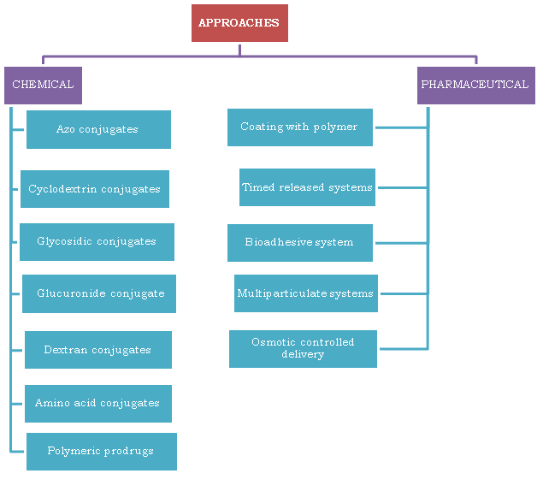 **Approaches for colon targeted drug delivery**.

**3. Glycoside conjugation:**

Some drugs can be conjugated to different sugar moieties to form glycosides. The drug part forms the aglycone and is linked to the sugar part, whichforms the glycone part of the glycoside. Because they are bulky and hydrophilic, these glycosides do not penetrate the biological membranes upon ingestion. Enzyme glycosidases produce by various human microflora are β-D-galactosidase, α-Larabino furanosidase and β –D glucosidase. Steroid glycosides and the unique glycosidase activity of the colonic microflora form the basis of a new colon targeted drug delivery system. Glycosides are hydrophilic and poorly absorb fromGIT because of this properties it use as the carrier for delivering drug to colon. Drug targeted by this approach are lucosides, galactosides, and cellobiosides of dexamethasone, prednisolone,hydrocortisone, and fludrocortisone24.

**4. Glucoronide conjugates:**

Glucuronide conjugation is the major metabolic pathway of drug. Bacteria present in lower GIT secrete β-glucuronidase and can deglucuronidate a variety of drugs in the intestine. Thus, the deglucuronidation process results in the release of the active drugagain and enables its reabsorption. This concept is used to deliver drug to colon, where drug is couple with glucuronid gonjugation after oral delivery25.

**5. Dextran conjugate:**

Dextran prodrug approach can be used for colon-specific delivery of drugs containing a carboxylic acid function. Dextran is the carbohydrate and colonic flora use it as the energy source. Dextrans are polysaccharides of bacterial origin where the monosaccharides are joined to each other by glycoside linkages. Dextranase enzyme responsible for the hydrolysis of these linkages. In the colon, dextran’s glycosidic bonds are hydrolyzed by dextranases to give shorter prodrug oligomers, which are further split by the colonic esterases torelease the drug free in the lumen of the colon26.

**6. Amino acid conjugation:**

Polar groups like -NH2 and –COOH are hydrophilic in nature and are present in the proteins and their basic units (i.e. the amino acids). They reduce the membrane permeability of amino acids and proteins. Increase in hydrophilicity and chain length of carrier amino acid; decrease the permeability of amino acids and proteins. Thus the amino acidconjugate are more enzymatic specificity for hydrolysis by colonic enzymes27.

**7. Polymeric prodrugs :** In newer approaches, polymers are used as drug carriers to deliver it, to the colon. Both synthetic as well as naturally occurring polymers are used for this purpose28.

**Pharmaceutical approach:**

**1. Coating of the drug core with pH sensitive polymers:**

Drug molecule can be coated with the suitable polymers, which degrade only in the colon. In this way the intact drug molecule can be delivered to the colon without absorbing at the upper part of the intestine. The drug core includes tablets, capsules, pellets,granules, microparticles or nanoparticles. The use of pH-sensitive polymers to the tablets, capsules or pellets provide delayed release and protect the active drug from gastric fluid29.

The limitation of this approach is that the intestinal pH is not stable because it is affected by diet, disease and presence of fatty acids, carbon dioxide, and other fermentation products.

2. **Time dependent delivery:**

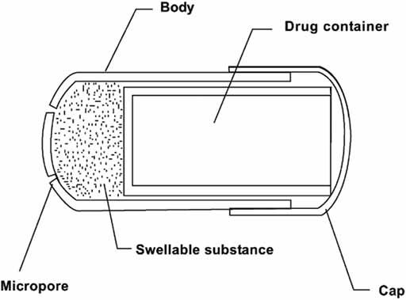

**Time-controlled capsule for colonic delivery**

It also known as pulsatile release, delayed or sigmoidal release system. In this approach, drug release from the system after a predetermined lag time according to transittime from mouth to colon. It is based on the concept of preventing the release of drug 3–5 hr after entering into small intestine i.e. delaying the release of the drug until it enters into the colon30.

These systems consists of a non disintegrating half capsule body sealed at the open end with a hydrogel plug, covered by a water-soluble cap. The entire unit is coated with an enteric polymer to avoid the problem of variable gastric emptying. When thecapsule enters the small intestine, the enteric coating dissolves and the hydrogel plug starts to swell.

These systems are therefore particularly useful in the therapy of diseases, which depend on circadian rhythms31.

**4. Bioadhesive systems:**

Bioadhesion is a process by which a dosage form remains in contact with particular organ for an

specific period of time. This longer residence time of drug would have high local concentration or improved absorption characteristics in case of poorly absorbable drugs. Polycarbophils, polyurethanes and polyethylene oxide-polypropylene oxidecopolymers are used as materials for bioadhesive systems32.

**5. Multiparticulate systems:**

The various multiparticulate approaches include pellets, microparticles, granules and nanoparticles are used as drug carriers in pH-sensitive, timedependent and microbially control systems for colon targeting. Multiparticulate systems enabled the drug to reach the colon quickly and were retained in the ascending colon for a relatively long period of time and hence increased bioavailability. Because of their smaller particle size as compared to single unit dosage forms these systems are capable of passing through the GI tract easily,leading to less inter- and intra subject variability33.

Limitations associated with single unit colon targeted drug delivery system can be avoided like unintentional disintegration of the formulation due to manufacturing deficiency or unusual gastric physiology that may lead to drastically compromised systemic drug bioavailability or loss of local therapeutic action in the colon.

**6. Osmotic controlled drug delivery:**



**Figure 4: Osmotically controlled colon drug delivery system.**

This system consists of osmotic units either singly or as many as 5-6 push pull units that are encapsulated in a hard gelatin capsule. The push pull units arebilayered with outer enteric impermeable membrane and inner semi permeable membrane. In principle semipermeable membrane is permeable to the inward entry of water and aqueous gastrointestinal fluids and is impermeable to the outward exit of the drug. An orifice is drilled into the semipermeable membrane to the drug layer34. Whenever water enters the unit causing the osmotic push compartment to swell forcing the drug out of the orifice into colon.

**Evaluation of CDDS:**

***1.* In-vitroEvaluation:** Different in vitro methods are used to evaluate the colonic drug delivery systems. In in-vitro studies the ability of the coats/carriers to remain intact in the physiological environment of the stomach and small intestine is assessed by drug release studies in 0.1N HCl for two hours (mean gastric emptying time) and in pH 7.4 phosphate buffer for three hours (mean small intestine transit time) using USP dissolution apparatus. In case of microflora activated system dosage form, the release rate of drug is tested in vitro by incubating in a buffer medium in the presence of either enzymes (e.g., pectinase, dextranase) or rat/guinea pig/rabbit caecal contents.The amount of drug released at different time intervals during the incubation is estimated to find out the degradation of the carrier under study35.

**1. *In-vitro* dissolution test**

The dissolution testing is done using the conventional basket method. The dissolution testing is done in different buffers to check the behavior of formulations at different pH levels. Dissolution tests of a colon-specific formulation in various media simulating pH conditions and times likely to be encountered at various locations in the gastrointestinal tract Thedifferent media that are used for the dissolution testing of colon targeted drug delivery are pH 1.2 to simulate gastric fluid, pH 6.8 to simulate small intestine, pH 7.4 to simulate large intestine. Formulations are tested for 2 hr in 0.1N HCl, 3hr in pH 6.8 phosphate buffer and finally at pH 7.4 phosphate buffer. Buffers of the above pH are prepared to evaluate the colon targeted drug delivery systems36.

**2. In-vitroenzymatic test**

There are 2 tests for the *in-vitro* enzymatic test.

i. The carrier drug system is incubated in fermenter containing suitable medium for bacteria. The amount of drug released at different time intervals is determined.

ii. Drug release study is performed in buffer medium containing enzymes pectinase, dextranase or rat or guinea pig or rabbit cecal contents. The amount of drug released in a particulartime is directly proportional to rate of degradation of polymer carrier37.

***3. In-vivo* evaluation:**

The *in-vivo* evaluation of the CDDS is done in dogs, guinea pigs, rats and pigs as they resemble the

anatomic and physiological conditions, micro flora of human GIT. The distribution ofvarious enzymes in GIT of rat and rabbit is comparable to that in human38.

**CONCLUSION**

Colon targeted drug delivery system offers benefits of local and systemic effects. The main advantage of CDDS is that reduced incidence of systemic side effects, lower dose of drug, supply of the drug only when it is required and maintenance of the drug in its intact form as close as possible to the target site. Colon offers near neutral pH, a long transit time,reduced enzymatic activity and increased responsiveness to absorption enhancers.

The novel approaches are more specific compared to the primary approaches. The biodegradable polymers are used for the colon specific delivery of the drug. These systems provide friendlier environment for protein and peptide drugs that reducing the adverse effects in the treatment of colonic diseases, site specific release to treat colonic cancer, amoebiasis,and helminthiasis etc, minimizing the extensive first pass metabolism of steroids and produces delay in absorption of drugs to treat rheumatoid arthritis, angina and nocturnal asthma etc.

For the in vitro evaluation of the system the current dissolution techniques are not suitable. Research is going on to develop suitable dissolution methods to evaluate the colon targeted drug delivery systems.

**References**

1. Davis SS, Hardy JG, Taylor MJ, Fara JW. Transit of Pharmaceutical dosage forms through the small intestine, Gut, 1986, 27:886-892.
2. Ashford M, Fell T. Targeting drugs to the colon: delivery system for oral administration. *J. Drug Targeting* 1994, 2, 241-58.
3. Gang Cheng, Feng An, Mei-Juan Zou, Time and pH dependent colon specific drug delivery fororally administered diclofencac sodium and 5-amino salicylic acid. *World J Gastroenterol*, 2004, 10(12): 1769-1774.
4. Snezana Milojevic, John Michael Newton, John H Cummings. Amylose as a coating for drug delivery to the colon: Preparation and Invitro evaluation using 5-amino salicylic acid pellets." Journal of Controlled Release, 1996, 38: 75-84.
5. Lee F Siew, Abdul W Basit, Michael Newton J. The potential of organic-based Amylose-Ethyl cellulose film coatings as oral colon-specific drug delivery system. AAPS PharmSciTech, 2000, 1(3): 1515-1521.
6. Irit Gliko-Kabir, Boris Yagen, Abrahem Rubinstein . Phosphated cross linked guar for colon-specific drug delivery I. Preparation and physicochemical characterization. Journal of Controlled Release, 2000. 63: 121-127.
7. Orienti I, Trere R and Zecchi V. Hydrogels formed by cross-linked polyvinyl alcohol as colon- specific drug delivery systems." Drug *development and Industrial Pharmacy*, 2001, 27(8): 877-884.
8. Emmanuel O, Akala, Oluchi Elekwachi, Vantoria Chase, Organic Redox- initiated polymerization process for the fabrication of hydrogels for colon-specific drug delivery. Drug Development and Industrial Pharmacy, 2003, 29(4): 375-386.
9. Hideyuka Tozaki, Junko Nishioka, Junta Komoike. Enhanced absorption of Insulin and (Asu1, 7) Eel- calcitonin using novel azo polymer-coated pellets for colon-specific drug delivery." Journal of Pharmaceutical Sciences, 2001. 90(1): 89-97.
10. Norihito Shimono, Toshihto Takatori, Masumi Veda. Multiparticulate chitosandispersed system for drug delivery. Chem.Pharm. Bull, 2003. 51(6): 620-624.
11. Soodabeh Davaran, Jalal Hanaec, Abbas Khosravi. Release of 5-amino salicylic acid from acrylic type polymeric prodrugs designed for colon-specific drug delivery*. Journal of Controlled Release*, 1999. 58: 279-287.
12. Harold W. Nolen III, Richard N. Fedorak and David R. Friend. Steady-state pharmacokinetics of corticosteriod delivery from glucuronide prodrugs in normal and colitic rats." Biopharmaceutics and Drug Disposition, 1997, 18(8): 681-695.
13. Marta Rodriguez, Jose L, Dolores Torres. Design to a new multiparticulate system for potential site-specific and controlled drug delivery to the colonic region. *Journal of Controlled Release*, 1998, 55:67-77. 51.
14. Hideki Yano, Fumitoshi Hirayama, Hidetoshi Arima. Prednisolone-Appended α- Cyclodextrin: Alleviation of systemic adverse effect of Prednisolone after intracolonic administration in 2,4,6-tri-nitro-benzenesulphonicacid-induced colitis rats*. Journal of Pharmaceutical Sciences*, 2001, 90(12): 2103-2112.
15. Norihito Shimono, Toshihito Takatori, Masumi Veda. Chitosan dispersed system for the colon-specific drug delivery. International Journal of Pharmaceutics, 2002, 245: 45-54.
16. Mahkam M, New pH-sensitive glycopolymers for colon-specific drug delivery." Drug Delivery, 2007, 14(3): 147-153.
17. Leopold C S. Coated dosage form for colon specific drug delivery. *Pharm Sci Tech Today*, 1999; 5: 197. 204.
18. Wu B, Shun N, Wei X. Characterization of 5-fluorouracil release from hydroxy propyl methyl cellulose compression-coated tablets. Pharm Dev Technol, 2007,12(2): 203-210.
19. Yang L. Colon-specific drug delivery: new approaches and in vitro/in vivo evaluation. Int J Pharm, 2002; 235.
20. Maestrelli F. Development of enteric-coated calcium pectinate microspheres intended for colonic drug delivery. Eur J Pharm Biopharm, 2008; 69: 508-518.
21. Haddish-Berhane N. A multi-scale stochastic drug release model for polymer-coated targeted drug delivery systems. *J Control Release*, 2006; 110: 314-322.
22. Yunjin Jung, Hak-Hyun Kim, Youngmi Kim. Evaluation of 5-amino salycilyltaurine as a colon-specific prodrug of 5-amino salicylic acid for treatment of experimental colitis. European Journal of Pharmaceutical Sciences, 2006. 28: 26-33.
23. Etienne Schacht, An Gevaert, El Refaie Kenawy, Polymers for colon-specific drug delivery. Journal of Controlled Release, 1996, 39: 327-338.
24. Simpkins JW, Smulkowski M, Dixon R, Tuttle R. Evidence for the delivery of narcotic antagonists to the colon as their glucuronide conjugates. *J Pharmacol Exp Ther*, 1988;244:1:195-205.
25. Harboe E, Larsen C, Johansen M, Olesen HP, Macromolecular prodrugs. XV. Colontargeted delivery--bioavailability of naproxen from orally administered dextran-naproxen ester Prodrugs varying in molecular size in the pig. *Pharm Res*, 1989;6:11:919-23.
26. Zhang S Q, Thumma S, Chen G H, Deng W B, Repka MA, San-Ming Li. In *vitro* and *in vivo* evaluation of tegaserod maleate pH-dependent tablets. European Journal of Pharmaceutics and Biopharmaceutics, 2008; 69:247–254.
27. Lars Hovgaard, Helle Brøndsted, Dextran hydrogels for colon-specific drug delivery. Journal of Controlled Release, 1995;36 :12: 3-198.
28. Laroui H, Dalmasso G, Nguyen HT, Yan Y, Sitaraman SV, Merlin D. Drug-loaded nanoparticles targeted to the colon with polysaccharide hydrogel reduce colitis in a mouse model. Gastroenterology, 2010;138:3843-53.
29. Maestrelli F, Cirri M, Corti G, Mennini N, Mura P. Development of Enteric Coated Calcium pectinate, Microspheres intended for colonic Drug Delivery. *European Journal of Pharmaceutics and Biopharmaceutics* 2008; 69:2:508-518.
30. Salve PS. Development and in vitro evaluation colon targeted drug delivery system using natural gums. Asian J. pharma. Res, 2011;1:4: 91-101.
31. Bronsted H, Hovgaard L, Simonsen L. Dextran hydrogels for colon-specific drug delivery, Part 3. In vitro and in vivo degradation, STP-Pharm-Sciences, 1995, 5(1), 60-64.
32. Ashord M, Fell JT, Attwood D, Sharma H, Woodhead P. An evaluation of pectin as a carrier for drug targeting to the colon. J Control Rel 1993; 26:213- 220.
33. Fukui E, Miyamura N, Verma K, Kobayashi M. Preparation of enteric coated time released press coated tablets and evaluation of their function by in vitro and in vivo tests for colon targeting. *International Journal of Pharmaceutics*, 2000; 204: 7-15.
34. Gazzaniga A, Iamartino P, Maffino G,Sangalli ME. Oral delayed release system for colonic specific drug delivery. International Journal of Pharmaceutics, 1994; 108: 77-83.
35. Evans DF, Pye G, Bramley R, Clark AG, Dyson TJ, Hardcastle JD. Measurement of gastrointestinal pH profiles in normal ambulant human subjects. Gut. 1988; 29: 1035-1041.
36. Yang L, James S, Joseph A. Colon specific drug delivery new approaches and in vitro/ in vivo evaluation. Int J Pharm, 2002; 235:1 -15.
37. Ahmed IS. Effect of simulated gastrointestinal condition on drug release from pectin/ethyl cellulose as film coating for drug delivery to the colon. *Drug Dev Ind Pharm* 2005; 31(4-5): 465-470.
38. Thomas P and Rhodes J, Absorption of Delayed-release Prednisolone in Ulcerative Colitis and Crohn's Disease, *Int J Pharm*, 37, 1985: 757-61.