**Reviewer’s Comments**

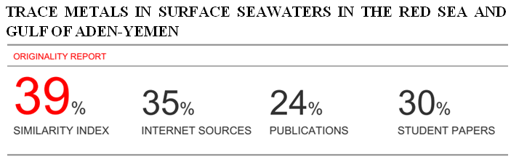

**TRACE METALS IN SURFACE SEAWATERS IN THE RED SEA AND GULF OF ADEN-YEMEN**

**ABSTRACT**

The present work has been done considering the constant spread pollution of heavy metals in water bodies. Pollution among water bodies is a major global problem. This contaminates not only the water but also the sediment and aquatic life such as fish. The water samples were collected from the Three different Cities of Yemeni coasts. Aden, Al-Hodeidah and AL-Mukalla were chosen for the sample collection. The study was carried out in the all three seasons of winter 2011, summer 2012 and winter 2013 in order to check seasonal variation of heavy metal pollution.Total 81 samples of each Water were analyzed. The four heavy metals lead, Cadmium, Mercury and arsenic which are considered highly toxic were detected in the samples in the year 2010, 2012 and 2013. The heavy metal concentrations in the samples were measured using the Atomic Absorption Spectrophotometer.

The obtained results showed that the concentration (mg/l) of the heavy metal in seawater (Pb-0.061±0.005, Cd-0.007±0.001, Hg-0.007±0.0005 and As-0.008±0.0003) mg/l.

The obtained results showed that the heavy metals concentrations were significantly higher, during the summer season for seawater samples in all stations during the study period.

Because of the frequent use of water in the hot summer, resulting in an increase in sewage, as well as to the high rate of environmental variables in the summer. By comparing the results obtained with other data obtained from the local and international studies, in addition to, comparing the results standard levels of these metals contaminated and adopted internationally and domestically and the pollution levels in Yemen is currently within the lower limits of pollution. However, the study recommends continuing the study of these pollutants and other contaminants and their impact on the environment and marine life especially invertebrates.

1. **INTRODUCTION**

The pollution of aquatic systems has become a major concern worldwide**1**. There are a variety of sources that will pollute aquatic systems with heavy metals. These include animal matter, wet and dry fallouts of atmospheric particulate matter and human activities. The concentration, bioavailability and toxicity of heavy metals in aquatic systems can be affected by various factors, including pH and temperature**2**. Poor quality of surface water is caused in two ways. The pollution of surface water can either be due to point source (PS) or nonpoint source pollution (NPS). Point source pollution is mainly municipal sewage discharge and industrial wastewater loads. Municipal sewage discharge is from urban or highly residential areas, while industrial wastewater is from a variety of manufacturers**3**. When rainfall or irrigation water runs over land it will carry and deposit pollutants into rivers, lakes and coastal waters. This is seen as nonpoint source pollution**3**. Heavy metals will be distributed between the aqueous phase and bed sediments in aquatic systems**4**. Only a small percentage of the free metal ions stay dissolved in water. The majority of the ions get deposited in the sediment due to adsorption, hydrolysis and co-precipitation of the free ions**4**.

There are various routes through which heavy metals can pollute aquatic systems. Deposition of atmospheric pollutants on solid surfaces, or on the surface of water bodies as well as the erosion of soil are the more natural routes for heavy metal pollution**5**. The concentration of most metals is usually low in pristine environments**4**. **4**states that the main anthropogenic sources of heavy metal pollution are mining, smelting activities, disposal of untreated and partially treated effluents which contain toxic metals as well as metal chelates from various industries. According to**6** human activities, which include mining, will produce pollutants that are discharged into aquatic systems either in dissolved or suspended form. This can significantly decrease water quality and increase the ecological risk to human health. Pollutants can enter the environment through a variety of ways, such as storm water sinks, surface runoff, leaching and effluent discharge among others.

Heavy metals can be released into aquatic systems either as pulses or discontinuously**6**. When heavy metals are released into aquatic systems it will bind to particulate and organic matter. Eventually the heavy metals will be incorporated into the sediment. Sediment is an important reservoir of heavy metals. Many studies were done that investigated the presence and effects of heavy metals in aquatic ecosystems as well as aquatic organisms**6,7,8**.

**2. MATERIALS AND METHODS**

**2-1 Description of the Study Area**

**2-1-1 Aden City**

Aden is a port city in Yemen, located by the eastern approach to the Red Sea (the Gulf of Aden), some 170 kilometres (110 mi) east of Bab-el-Mandeb.It is a semi island and consists of rocks. Aden's population is 774000 in 2013 (Yemen Statistical Yearbook, 2013), The convenient location of Aden's natural Port on the major sea route between the Far East and Europe has resulted in a rich history as a trading center. Aden's importance as shipping center peaked in early 1960s, when it was the fourth busiest port in the world (Nasr *et al.,* 2006).has a port with an oil refinery and an oil import/ export terminal. This terminal handles around 9.8 million tons per year. Nine, characteristic stations on the coastal area of the Aden port were sampled during this study (Surface seawater and sediments).The nine sites were picked up precisely and according to the importance of each one of the selected sites. The locations are shown on the map presented in the Figure 1.

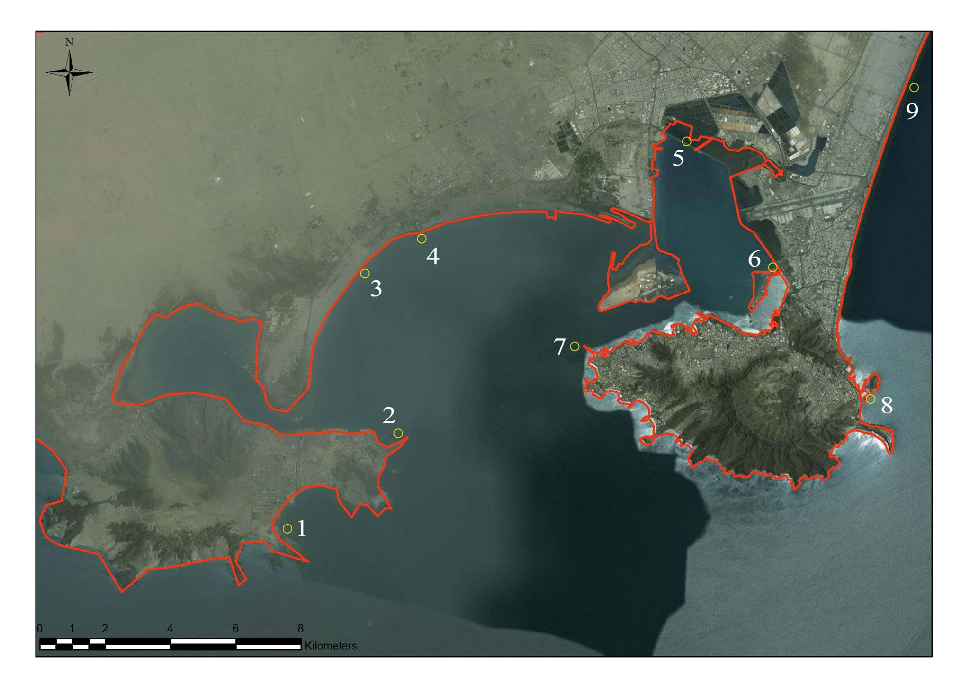

**Figure 1.** Sampling locations (1– 9) along the Coast of Aden, Yemen.

**2-1-2 AL-Hudaydah City**

Location map (Figure 2) shows the study area, AL-Hudaydah Fishery port, from which the samples were collected for the determination of heavy trace metals. The study area was selected depending on many reasons, among which sewage effluent which is located to the south and north of the study area. In addition, the area receives the wastewater from treatment plant, which discharges large quantity of untreated sewage to the south of the Fishery Port, and to the north of Al-Hodiedah Commercial Port.AL-Hudaydahis located along the western coast of Yemen.

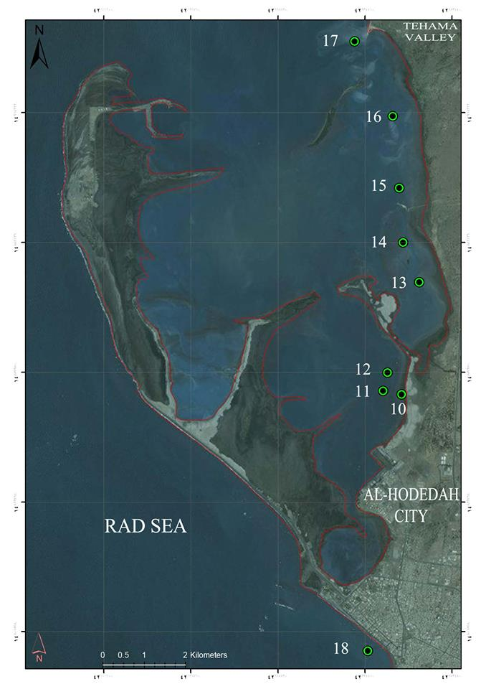

**Figure 2.** Sampling locations (10–18) along the Coast of AL-Hudaydah city , Yemen.

AL-Hudaydah is the largest coastal city in the region, and is one of the major port in Yemen, with the estimated population of 979.000 in 2013 (Yemen Statistical Yearbook, 2013). It is the city having a sewerage system of treatment plants in the region. Its municipal sewage is discharged into a series of eleven oxidation ponds which serves nearly 35% of the residential population, with about 18000 cubic meters daily discharged. It contains several types of industrial liquid effluent and animal waste. About 70% of the municipal sewage is used for agriculture purposes, including windbreaks. The remainder (30 %) is discharged through a small open channel north of the city into the seawater close to khawr Al Kathib.

**2-1-3 AL-Mukalla City**

AL-Mukalla city (Hadhramout governorate, Yemen), about 480 km east of Aden (Figure 3). AL-Mukalla city is the capital of Hadhramout Governorate with a population of 615000 people in 2013 (Yemen Statistical Yearbook, 2013). The native population of the urban and considered relatively civilized society, for the rest of the cities of Yemen, which is the majority of the population of Bedouin and rural areas, is also a meeting place for all people of Hadhramout. AL-Mukalla city overlooking of the Arabian Sea . Extending from the Burum city in the west to Al-Sheher city in the east along the coast.

Experts opinion, indicate that pollution risk in Al Mukalla is increasing day by day because of the non-treatment sewage spill into the sea. More than 150 kilometers from the shores of Al-Mukalla costs have become useless for marine life because it is contaminated by green algae.

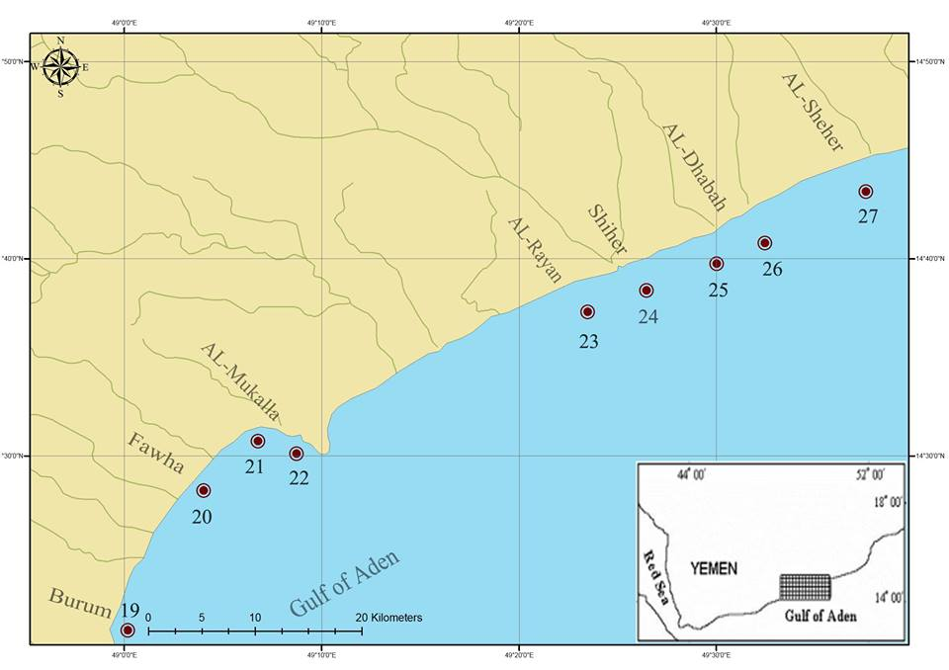

Figure 3. Sampling locations (19–27) along the Coast of AL-Mukalla city , Yemen.

For these problems and others, we chose this thesis to study the concentrations of heavy metals in the environment of Yemen coast (Aden, Al Hodeidah and Al Mukalla) sites, which is considered as the most important indicator of the extent of the pollution. The study also included estimate of the heavy metals in Surface Seawater of Yemen coast .

**2-2 Sampling Stations**

The trial were undertaken for the period of seasons: Winter 2011, Summer 2012 and Winter 2013, during which a total of 81 Sample of Surface Seawater were collected and analyzed.

Three stations were selected for sampling of large main coastal cities. Samples were collected from three stations. Aden city, overlooking the Gulf of Aden and Al Hodeidah, overlooking the Red Sea, and Al Mukalla city , overlooking the Arabian Sea (Table 1).

**Table (1): Information of sites for sea water samples in Aden , AL-Hudaydah and AL-Mukalla**

|  |  |  |  |  |
| --- | --- | --- | --- | --- |
| **Station No.** | **Longitude (E)** | **Latitude (N)** | **Site** | **Location** |
| **1** | **44°88'80"** | **12°73'94"** | **Aden** | **Aden oil refineries** |
| **2** | **44°91'85"** | **12°76'57"** | **Aden** | **Oil Harbour** |
| **3** | **44°90'95"** | **12°80'99"** | **Aden** | **industrial areas** |
| **4** | **44°92'51"** | **12°81'95"** | **Aden** | **Al-Hiswah** |
| **5** | **44°99'80"** | **12°84'63"** | **Aden** | **Caltex** |
| **6** | **45°02'18"** | **12°81'16"** | **Aden** | **Labour Island** |
| **7** | **44°96'72"** | **12°78'98"** | **Aden** | **Ras Marbat Harbour Tawahi** |
| **8** | **45°04'88"** | **12°77'53"** | **Aden** | **Sira Island** |
| **9** | **45°06'07"** | **12°86'12"** | **Aden** | **Sahel Abyen** |
| **10** | **42°94'24"** | **14°85'31"** | **AL-Hudaydah** | **Harbour** |
| **11** | **42°93'84"** | **14°85'39"** | **AL-Hudaydah** | **Harbour** |
| **12** | **42°93'93"** | **14°85'78"** | **AL-Hudaydah** | **Al-Kathib shore** |
| **13** | **42°94'63"** | **14°87'74"** | **AL-Hudaydah** | **Al-Kathib shore** |
| **14** | **42°94'27"** | **14°88'61"** | **AL-Hudaydah** | **Cornish location** |
| **15** | **42°94'19"** | **14°89'79"** | **AL-Hudaydah** | **Cornish location** |
| **16** | **42°94'05"** | **14°91'35"** | **AL-Hudaydah** | **Almehwat site** |
| **17** | **42°93'22"** | **14°92'98"** | **AL-Hudaydah** | **Almehwat site** |
| **18** | **42°93'51"** | **14°79'74"** | **AL-Hudaydah** | **Al-Manjer location** |
| **19** | **48°98'35"** | **14°35'70"** | **AL-Mukalla** | **Burum Harbour** |
| **20** | **49°04'80"** | **14°47'54"** | **AL-Mukalla** | **Fowah** |
| **21** | **49°10'67"** | **14°52'87"** | **AL-Mukalla** | **AL-Mukalla** |
| **22** | **49°14'91"** | **14°52'23"** | **AL-Mukalla** | **Harbour** |
| **23** | **49°38'36"** | **14°65'41"** | **AL-Mukalla** | **Riyyan** |
| **24** | **49°41'50"** | **14°66'36"** | **AL-Mukalla** | **Shiher** |
| **25** | **49°48'71"** | **14°69'14"** | **AL-Mukalla** | **AL-DhabahHarbour** |
| **26** | **49°51'12"** | **14°70'59"** | **AL-Mukalla** | **AL-DhabahHarbour** |
| **27** | **49°61'07"** | **14°75'14"** | **AL-Mukalla** | **Al SheherHarbour** |

**2-3 Surface Seawater Sampling and Analysis**

**1. Surface Seawater Sampling**

Seawater samples were collected seasons for analysis from one levels; the surface Seawater of each station along with sediment samples. In principle, collect seawater samples at high tide and avoid windy or rainy days). Before sampling, the bottles of samples were rinsed at least three times with water from the sampling station. The bottles were immersed to about 20-30 cm below the water surface to prevent contamination of heavy metals from air.

For mercury analysis water samples kept in a sealable glass container that has been well washed before being transported**9**.

For Arsenic analysis water samples were collected according to the Method 1632 USEPA**10**.

A total of 81 of seawater samples were collected using cleaned plastic water sampler. Each sample was taken in 1 liter polyethylene bottles. All water samples were immediately brought to the laboratory where filtered through whatman No.41 (0.45 μm pore size) filter paper. The samples were acidified with 2ml nitric acid to prevent precipitation of metals, reduce adsorption of the analyses onto the walls of containers and to avoid microbial activity, and then stored at 4°C until the chemical analyses.

**2. Surface Seawater Digestion and Analysis**

**i. Surface Seawater Digestion for Pb and Cd Analysis by GFAAS**

Five milliliter of concentrated HCl was added to 250 ml of each surface seawater sample placed in 600 ml beaker and evaporated to 25 ml volume. The concentrate was transferred to a 50 ml volumetric flask and diluted to mark with deionized water. Prior analysis, the solutions were filtered through Whatman No.41 (0.45 μm pore size) filter paper.

Analyzed for Lead (Pb) and Cadmium (Cd) using Buck Model 210 VGP, USA Made - Graphite furnace Atomic Absorption Spectrophotometer (GF AAS) in Seawater samples, before proceeding Method 200.13 US EPA**11**.

Triplicate sub-samples of each sample were aspirated separately to compute mean metal concentrations in a given sea water and sample.

**ii. Surface Seawater Digestion for Hg and As Analysis by Hydride Analyzer**

Forty five millilter of surface seawater sample was measured .A volume of 5 ml of concentrated nitric acid (HNO**3**, 65 %), 1ml of concentrated hydrochloric acid (HCl, 35 %) was added to each sample . Vessels Sealed and placed in microwave system. Samples were heated according to time versus pressure profiles. Vessels allowed cooling to the room temperature and then each sample transferred to a final volume of 25 ml using deionized water. The Sample may represent a safety hazard. Pre-digest sample in a hood, with vessel loosely capped to allow gases to escape, before proceeding Method 3015A US EPA**12**.

Cold Vapor Hg Analyzer (Buck Model 410), U.S.A Made, were used for analysis of Hg in Seawater samples, Perfect for EPA method 245.1US EPA**13**.

Arsenic Hydride Analyzer (Buck Model 411), U.S.A Made, were used for analysis of As in Seawater samples, Perfect for EPA method 206.3US EPA**14**.

Triplicate sub-samples of each sample were aspirated separately to compute mean metal concentrations in a given sea water and sample.

Blanks Three types of blanks are required for the analysis. The calibration blank is used in establishing the analytical curve, the laboratory reagent blank is used to assess possible contamination from the sample preparation procedure, and the laboratory fortified blank is used to assess routine laboratory performance.

This study focused on determination on the levels of selected heavy metals namely: lead, cadmium, mercury and Arsenic in filtered surface Seawater of the major Yemen coast city of Aden, AL-Hudaydah and AL-Mukalla stations. The samples were collected during 2011 to 2013.

Adequate quality assurance control was ensured by inter-laboratory comparison of representative samples carried out at laboratory at the Faculty of Environmental Sciences and Marine Biology, Hadramout University in Yemen (ESMB) , laboratory at the Royal Scientific Society in Jordan (RSS) and laboratory at the Environmental Reserch at the Nanded University in India (ERN).

**3- RESULTS**

Analysis of heavy metals for 81 Sea water samples was carried out, for the study period of three years (three seasons). The overall means results of analysis heavy metals in the filtered water surface for the three seasons, for the study sites in Yemen are presented in Table (2).

The results of the present study showed that there were significant differences (*P<0.01*), using one way ANOVA, regarding the concentration of Pb , Cd and Hg, however, there was no significant difference (*P>0.05*) regarding the concentration of As in the filtered surface water of Aden, for the period of seasons: winter 2011, summer 2012 and winter 2013. The highest concentration of Pb in filtered water surface of Aden was 0.055 mg/L on winter 2011 and the lowest concentration was 0.045 mg/L on summer 2012. The highest concentration of Cd in filtered water surface of Aden was 0.010 mg/L on summer 2012 and the lowest concentration was 0.006 mg/L on winter 2011. The highest concentration of Hg in filtered water surface of Aden was 0.007 mg/L on winter 2013 and the lowest concentration was 0.003 mg/L on summer 2012; however, there were no significant differences (*P>0.05*) regarding the concentration of As in filtered surface water of Aden. The highest concentration of As in filtered surface water of Aden was 0.0061 mg/L on summer 2012 and the lowest concentration was 0.0057 mg/L on winter 2011, as summarized in (Table 2), (Fig. 4).

Further, there was no significant differences (*P*>*0.05*), using one way ANOVA, regarding the concentration of Pb and Cd , however, there was significant difference *(P<0.01*) regarding the concentration of Hg and As in the filtered surface water of AL-Hudaydah, for the period of seasons: winter 2011, summer 2012 and winter 2013 .

The highest concentration of Hg in filtered water surface of AL-Hudaydah was 0.008 mg/L on summer 2012 and the lowest concentration was 0.007 mg/L on winter 2011 and winter 2013.

**Table (2):** The mean of concentration (**mg/L** ) for lead, cadmium, mercury and Arsenic during the seasons in the **filtered surface water** of Aden , AL-Hudaydah and AL-Mukalla stations, Yemen coast.

|  |  |  |  |  |  |
| --- | --- | --- | --- | --- | --- |
| **Site** | **Metal ion** | **Seasons** | | | **Total mean ± SD** |
| **Winter 2011** | **Summer 2012** | **Winter 2013** |
| **Aden** | **Pb** | **0.055 ± 0.004** | **0.045 ± 0.007** | **0.051 ± 0.005** | **0.050± 0.005** |
| **Cd** | **0.006±0.002** | **0.010±0.003** | **0.009±0.001** | **0.008±0.002** |
| **Hg** | **0.005±0.000** | **0.003±0.000** | **0.007±0.002** | **0.005±0.002** |
| **As** | **0.0057±0.000** | **0.0061±0.000** | **0.006±0.000** | **0.006±0.000** |
| **AL- Hudaydah** | **Pb** | **0.080±0.020** | **0.087±0.027** | **0.072±0.021** | **0.080± 0.008** |
| **Cd** | **0.007±0.002** | **0.006±0.001** | **0.007±0.000** | **0.0070±0.000** |
| **Hg** | **0.007±0.001** | **0.008±0.000** | **0.007±0.001** | **0.0073±0.000** |
| **As** | **0.007±0.001** | **0.0082±0.000** | **0.0087±0.000** | **0.008±0.000** |
| **AL- Mukalla** | **Pb** | **0.033±0.002** | **0.064±0.026** | **0.064±0.018** | **0.054± 0.018** |
| **Cd** | **0.006±0.000** | **0.0082±0.000** | **0.0083±0.000** | **0.0075±0.001** |
| **Hg** | **0.009±0.000** | **0.0067±0.000** | **0.0069±0.000** | **0.0075±0.001** |
| **As** | **0.010±0.002** | **0.011±0.002** | **0.010±0.000** | **0.010±0.000** |
| **Total mean ± SD** | **Pb** | **0.056± 0.023** | **0.065± 0.027** | **0.062± 0.018** | **0.061±0.005** |
| **Cd** | **0.006±0.002** | **0.008±0.002** | **0.008±0.001** | **0.007±0.001** |
| **Hg** | **0.007±0.002** | **0.006±0.002** | **0.007±0.001** | **0.007±0.0005** |
| **As** | **0.0077±0.002** | **0.0083±0.002** | **0.0082±0.002** | **0.008±0.0003** |

Results are expressed as mean ± SD. Mean values in the same row with different superscript letters indicate significant (*P<0.05*) difference.

**Fig. (4):** The mean of concentration (mg/L) for lead, cadmium, mercury and Arsenic during the seasons in the filtered surface water of Aden , AL-Hudaydah and AL-Mukalla stations, Yemen coast.The highest concentration of As in filtered water surface of AL-Hudaydah was 0.0087 mg/L on winter 2013 and the lowest concentration was 0.007 mg/L on winter 2011; however, there was no significant differences (*P>0.05*) regarding the concentration of Pb and Cd in filtered surface water of AL-Hudaydah. The highest concentration of Pb in filtered surface water of AL-Hudaydah was 0.087 mg/L on summer 2012 and the lowest concentration was 0.072 mg/L on winter 2013 . The highest concentration of Cd in filtered water surface of AL-Hudaydah was 0.007 mg/L on winter 2011 and the lowest concentration was 0.006 mg/L on summer 2012, as summarized in Table 2.

On the other hand, the results showed that there was significant differences (*P<0.01*), using one way ANOVA, regarding the concentration of Pb, Cd and Hg , however, there were no significant difference (P*>*0.05) regarding the concentration of As in the filtered surface water of AL-Mukalla, for the period of seasons: winter 2011, summer 2012 and winter 2013.

The highest concentration of Pb in filtered water surface of AL-Mukalla was 0.064 mg/L on summer 2012 and the lowest concentration was 0.033 mg/L on winter 2011. The highest concentration of Cd in filtered water surface of AL-Mukalla was 0.0083 mg/L on winter 2013 and the lowest concentration was 0.006 mg/L on winter 2011, but the highest concentration of Hg in filtered water surface of AL-Mukalla was 0.009 mg/L on winter 2011 and the lowest concentration was 0.006 mg/L on summer 2012; however, there was no significant differences (*P>0.05*) regarding the concentration of As in filtered surface water of AL-Mukalla. The highest concentration of As in filtered surface water of AL-Mukalla was 0.011 mg/L on summer 2012 and the lowest concentration was 0.010 mg/L on winter 2011 , as summarized in Table 2.

The results of present study were analyzed by using two ways ANOVA in filtered surface water of Yemen sites during the seasons, it showed that there were significant differences *(P<0.01*) regarding the concentration of Pb, Hg and As , however, there was significant difference (*P<0.05*) regarding the concentration of Cd in the filtered surface water of Aden, AL-Hudaydah and AL-Mukalla station.

The highest concentration of Pb in filtered surface water of AL-Hudaydah was 0.080 mg/L, whereas the lowest concentration was 0.050 mg/L of Aden station; however, the highest concentration of Cd in filtered surface water of Aden was 0.008 mg/L, whereas the lowest concentration was 0.007mg/L of AL-Hudaydah station. The concentration of Hg in filtered surface water had the same patternof Pb and Cd ; but, the highest concentration of Hg in the filtered surface water of AL-Mukalla was 0.0075 mg/L, whereas the lowest concentration was 0.005 mg/L of Aden station.

The highest concentration of As in filtered surface water of AL-Mukalla was 0.010 mg/L, whereas the lowest concentration was 0.006 mg/L of Aden site ,as summarized in Table 2.

In addition, when the results of present study were analyzed by using two ways ANOVA in filtered surface water of Yemen sites during the seasons, it showed that there was significant differences *(P<0.01*) , analyze by using two ways ANOVA, regarding the concentration of Cd and Hg , however, there was significant difference (*P<0.05*) regarding the concentration of As, however, there were no significant difference (*P>0.05*) regarding the concentration of Pb in the filtered surface water of Yemen sites for the period of seasons: winter 2011, summer 2012 and winter 2013 .

The highest concentration of Pb in the filtered surface water was 0.065 mg/L on summer, whereas the lowest concentration was 0.056 mg/L on winter; however, the highest concentration of Cd in filtered surface water was 0.008 mg/L on summer, whereas the lowest concentration was 0.006 mg/L on winter regarding the all Yemen sites (Aden , AL-Hudaydah and AL-Mukalla).

Also, the concentration of Hg in the filtered surface water had the same pattern of Pb and Cd ; but, the highest concentration of Hg in filtered surface water of Yemen sites was 0.007 mg/L on winter, whereas the lowest concentration was 0.006 mg/L on summer, the highest concentration of As in filtered surface water was 0.0083 mg/L on summer, whereas the lowest concentration was 0.0077 mg/L on winter ,as summarized in Table 2.

**4- DISCUSSION**

**HEAVY METALS IN FILTERED SURFACE WATER**

Overall, the results of the present study showed that they were significant differences (P<0.01), using one way ANOVA, regarding the concentration of Pb, Cd, Hg and As in the filtered surface water of Yemen coast (Aden, AL-Hudaydah and AL-Mukalla) sites, except As in Aden and AL Mukallala, and except Pb and Cd in AL-Hudaydah, for the period of seasons: winter 2011, summer 2012 and winter 2013 (Table 2).

On the other hand, thus results were analyzed by using two ways ANOVA, there were significant differences (P<0.01), regarding the concentration of Cd and Hg, however, there was a significant difference (P<0.05) regarding the concentration of As in the filtered surface water of Yemen sites for the period of seasons: winter 2011, summer 2012 and winter 2013.

The highest concentration of Pb, Cd and As were (0.065± 0.027, 0.008±0.002 and 0.0083±0.002 mg/L, respectively) in the filtered surface water of Yemen coast was obtained in the summer, whereas the highest concentration of Hg was 0.007±0.002 mg/L in the filtered surface water of Yemen coast was achieved in winter (Table 2).

This result may be explained by the fact that amount of draining sewage on summer were higher compared with winter and also due to high water temperature on summer season.

The interpretation of these results is comparable to those reported by**15** reported that the concentrations of metals are increased during summer due to increase the water temperature; and**16** reported that the high heavy metal concentration during the summer may be attributed to increased water temperature during the summer that may result in increased metal toxicity. Also Hg has a different character than Pb, Cd and As and has able to evaporate in the air; As supported also by**17** who pointed out that the distribution of Hg was different to the other heavy metals due to Hg is easy to vaporize and to move from one place to another .

Also the above results and the initial interpretation given are comparable to those reported in 2014 by**18** showed that the highest concentration of Pb in summer, but the highest concentration of Hg in the filtered surface water was from Khawr-Mukalla, Hadhramout Coast, Yemen, in Autumn**18** .

However, our results showed low concentration compared with other studies which mentioned by**19** showed that the concentration of Cd was 0.014 mg/L and As was 0.013 mg/L in summer, but the concentration of Pb was 0.012 mg/L and Hg was 0.014 mg/L in Winter from near seashore of Bay of Bengal in Marina, its the longest urban beach in India**19** .

However, our results are in a good agreement with those found by**20** showed that the concentration of Pb was 0.034 ± 0.002 mg/L and Cd was 0.012 ± 0.001 mg/L in water from the Kolleru Lake, India, on summer**20** .

The results of the present study were analyzed by using two ways ANOVA in filtered surface water of Yemen sites during the seasons, it showed that there were significant differences (P<0.01) regarding the concentration of Pb, Hg and As, however, there was a significant difference (P<0.05) regarding the concentration of Cd in the filtered surface water of Aden, AL-Hudaydah and AL-Mukalla station.

The highest concentration of Pb was 0.080± 0.008 mg/L achieved in AL-Hudaydah, however, the highest concentration of Cd was 0.008±0.002 mg/L achieved in Aden, but the Hg was 0.0075±0.001 mg/L and As was 0.010±0.000 mg/L in the filtered surface water were found in AL-Mukalla.

The CSBTS**21**, ANZECC and ARMCANZ**22** and ASEAN**23** guidelines for maximum permissible limit of Lead in Seawater is 0.001, 0.0044 and 0.0085 mg/l. As the range of Lead detected was higher than the permissible limit.

There are several possible explanations for this result perhaps attributed to partially caused also by atmospheric input of local particulates from motor vehicle, mountainous regions which drain its water from Yemen highland to the Red Sea through different vallies, precipitation, petroleum rich substrate of the area, influence of sewage discharge, agricultural and industrial effluents into this site, chemical distribution and partitioning between seawater and the sediment and the vigorous mixing of shallow coastal sediments increases the solubility of Pb in seawater as a result of oxygen saturated water**24, 25, 26, 27** .

The CSBTS**21** and ANZECC and ARMCANZ**22** guidelines for maximum permissible limit of Cadmium in Seawater is 0.001 and 0.0007 mg/l. As the range of Cadmium detected was higher than the permissible limit. But ASEAN**23** guidelines for maximum permissible are limit of Cadmium in Seawater is 0.01 mg/l. As the range of Cadmium detected is below than the permissible limit.

These high concentrations of Cd in Aden may be attributed to point source and non-point source pollution among which are PVC products, runoff from waste Ni-Cd batteries, paint, color pigments and solid waste**28** .

These results further support the idea of Scrap-iron store at Labour Island in Aden site is the most likely source of Pb and Cd in the Seawater**29** .

These results corroborate the ideas of**30** who suggested that when contaminated particulate or sedimentary material is dispersed through an ecosystem, it equilibrates with water, detritus, and living food materials, resulting in ongoing contamination of all environmental compartments**30** . The detected positive correlation between the concentration of Cd in the filtered surface water and sediment, in the present study, supports this argument.

The CSBTS**21**, ANZECC and ARMCANZ**22** and ASEAN**23** guidelines for maximum permissible limit of Mercury in Seawater is 0.00005, 0.0001 and 0.00016 mg/l. As the range of Mercury detected was higher than the permissible limit.

The CSBTS**21** guidelines for maximum permissible limit of Arsenic in Seawater is 0.020 mg/l. As the range of Arsenic detected is below than the permissible limit.

The present high concentration of Hg and As in AL-Mukalla may be due to the petroleum rich substrate of the area, Oil pollution and atmospheric fallout could be responsible for the increased levels, also high values of As in the site may be attributed to agriculture.

Also the above results and the initial interpretation given are comparable to those reported by**27**  pointed out that the concentration of Pb was 0.03±0.004 mg/L and Cd was 0.02±0.004 mg/L in summer from along the coast of Al-Shaykh Younes facing AL- Hudaydah city, Yemen**27** .

The interpretation of these results is comparable to those reported by**18** pointed out that the concentration of Pb was 0.058 - 0.132 mg/L, Cd was 0.014 -0.030 mg/L, Hg was 0.005 -0.008 mg/L in Khawr-Mukalla, Hadhramout Coast, Yemen. This differs from the findings presented here may be attributed to drain sewage at first time into Khawr-Mukalla and non-coastal currents**18** and a good agreement with those are found by **31** pointed out that the concentration of Pb was 0.064 - 0.082 mg/L, Cd was 0.002 -0.005 mg/L in Jeddah Coast, Saudi Arabia**31**.

However, our results are in a good agreement with those found by**32** who reported that the concentration of Hg of filtered surface seawater was 0.002 - 0.005 mg/L in the Langkawi island, Malaysia**32** . Besides**33** pointed out that the concentration of Pb was 0.03- 0.07 mg/L, which is below the permissible limit of 0.1 mg/L set for inland surface water, in the water samples collected from sea water in Międzyzdroje, Baltic coast, Poland**33**.

However, our results were high concentration compared with other studies which mentioned by**26** showed that the concentration of Pb was 0.050 µg/L and Cd was 0.760 µg/L in winter from AL-Hudaydah Coast, Yemen**26** .

Also**25** pointed out that the concentration of Pb was 0.10-2.85 µg/L and Cd was 0.04-2.65 µg/L in summer from Red Sea coast , Al Hodeidah, Yemen**25** .

On the other hand, were high concentration compared with other studies which mentioned by**34** pointed out that the concentration of Pb was 0.0002 - 0.003 mg/L, Cd was 0.0001 -0.002 mg/L in Eastern Coast of Saudi Arabia**34** . Besides**35** pointed out that the concentration of Pb was 0.005-0.021 mg/L, Cd was 0.0001-0.003 mg/L in South East Coast of India**35** . Besides**36** who reported that the concentration of Hg of filtered surface seawater was 0.007-0.287 µg/L in Adriatic Sea, Albania**36** . Besides**37** who reported that the concentration of Hg of filtered surface seawater was 0.03 µg/L in Gökova Bay, Turkey**37** .

However, our results were low concentration compared with other studies which mentioned by**32** who reported that the concentration of Pb of filtered surface seawater was 1.58-4.73 mg/L and Cd was 0.01-0.02 mg/L in the Langkawi Island, Malaysia**32** . Besides**38** pointed out that the concentration of Pb was 1.21 mg/L, Cd was 0.04 mg/L in Isalmic Port Coast, Red Sea, Jeddah, Saudi Arabia**38** . Besides**39** pointed out that the concentration of Pb was 0.065 mg/L, Cd was 0.044 mg/L in northern Delta Lakes, Egypt**39** . Besides **17** pointed out that the concentration of Pb was 0.61 mg/L, Cd was 0.92 mg/L and Hg was 0.030 mg/L in Jinzhou bay, China**17**. Besides**33** pointed out that the concentration of Cd was 0.39- 0.52 mg/L, the values obtained were found to be below the permissible limit of 2.0 mg/L set for inland surface water. Hg was 0.03- 0.05 mg/L which was very much above the maximum limit of 0.01 mg/L set for inland surface water in the water samples collected from sea water in Międzyzdroje, Baltic coast, Poland**33**.

Based on these information's, Yemen coast of the present study is low polluted compared with other locations.

**5- CONCLUSIONS AND RECOMMENDATIONS**

**5-1 CONCLUSIONS**

The following can be concluded from this study results:

The present work has been done considering the constant spread pollution of heavy metals in water bodies. Pollution among water bodies is a major global problem. This contaminates not only the water but also the sediment and aquatic life such as fish.

The water samples were collected from the Three different Cities of Yemeni coasts. Aden, Al-Hodeidah and AL-Mukalla were chosen for the sample collection. The study was carried out in the all three seasons of winter 2011, summer 2012 and winter 2013 in order to check seasonal variation of heavy metal pollution.Total 81 samples of each Water were analyzed. The four heavy metals lead, Cadmium, Mercury and arsenic which are considered highly toxic were detected in the samples in the year 2010, 2012 and 2013.

Heavy metal concentration in Seawater samples shows that high concentration of Lead is found more At Site AL- Hudaydah (0.080± 0.008 mg/l) in Summer 2012, Site AL- Hudaydah is polluted highly. Lead content in all locations in all seasons was higher than the permissible limits according to international standards. The Cadmium in Seawater in the Summer season shows that Site Aden is highly polluted in Summer 2012 with 0.008±0.002 mg/l . As the range of Cadmium detected is below than the permissible limit. The Arsenic concentration was found high at Site AL- Mukalla, 0.010±0.000 mg/l in Year 2012 (Summer season). As the range of Arsenic detected is below than the permissible limit. The Mercury concentration was found high at Site AL- Mukalla, 0.0075±0.001 mg/l in Year 2011 (Winter season). Mercury content in all locations in all seasons was higher than the permissible limits according to international standards.

From the heavy metal concentrations mentioned above we can see that somewhere the concentration is crossing the limits as permissible by the World Health Organization. It suggests a high risk to the health of human being on the consumption of contaminated fish. Therefore it is recommended that the practice of trace element detection should be continued in order to update whether the heavy metal concentration is above or below the permissible limits and if it is above the limit then precautions must be taken to avoid possible consumption of contaminated eatables. It is also recommended that awareness should be spread among the people regarding the hazards on consumption of polluted water and related eatables. It is also essential that farmers should be educated to reduce such contamination and should be encouraged to use the controlled amount of pesticides, to avoid the leaching of waste water and cultivating in a field far away from industrial area as well as areas prone to contamination.

**5-2 RECOMMENDATIONS**

From the study results outcome the following can be recommended:

The following recommendations might be of particular interests

• Enforcement of Marine Protection regulations in Yemen is urgently required.

• Building-up of local capacities is highly recommended to acquire capabilities in assessing and monitoring marine pollution at regular bases.

• There is a need for regulating cooperation among authorities whose major concern is protecting marine environment at national and international levels.

• Initiating strategies for public awareness about marine pollution would be a major contribution in lowering activities that cause marine pollution.

• Strengthening of a data-base information system would be a great help for researchers to carry out scientific studies in subsequent bases.

• Devoting more efforts for carrying out further studies on assessment of contamination in other marine species with other pollutant would help in drawing a complete picture with regards of pollution status in regional sea catchments area of Yemen .

**6- REFERENCES**

1. Abdel-Baki, A. S. ; Dkhil, M. A. and Al-Quraishy, S. Bioaccumulation of some heavy metals in tilapia fish relevant to their concentration in water and sediment of WadiHanifah, Saudi Arabia. African Journal of Biotechnology; 10(2011):2541-2547.
2. Belin, S.; Sany, T. and Salleh, A. Heavy metal contamination in water and sediment of the Port Klang coastal area , Selangor , Malaysia, (2013): 2013–2025.
3. Wu, Y. and Chen, J. Investigating the effects of point source and nonpoint source pollution on the water quality of the East River (Dongjiang) in South China. Ecological Indicators, 32(2013): 294–304.
4. Varol, M.; and Şen, B. Assessment of nutrient and heavy metal contamination in surface water and sediments of the upper Tigris River, Turkey. CATENA, 92 (2012): 1–10.
5. Alhashemi, A. H.; Sekhavatjou, M. S.; HassanzadehKiabi, B. and Karbassi, A. R. Bioaccumulation of trace elements in water, sediment, and six fish species from a freshwater wetland, Iran. Microchemical Journal, 104(2012): 1–6.
6. Harguinteguy, C. A.; Cirelli, A. F. and Pignata, M. L. Heavy metal accumulation in leaves of aquatic plant Stuckeniafiliformis and its relationship with sediment and water in the Suquía river (Argentina). Microchemical Journal, 114 (2014): 111–118.
7. Chourpagar, A. R. and Kulkarni, G. K. Heavy Metal Toxicity to a Freshwater Crab, Barytelphusacunicularis (Westwood) from Aurangabad Region. Recent Research in Science and Technology, 3(3)(2011): 01 – 05.
8. Omoloye, A. Field accumulation risks of heavy metals and uptake effects on the biology of Sitophiluszeamais (Coleoptera: Curculionidae). African Scientist, 10(2)(2009):75-88.
9. Tsuguyoshi, S. (2004). Mercury Analysis Manual. Ministry of the Environment, Japan.
10. US EPA. Method 1632: Chemical Speciation of Arsenic in Water and Tissue by Hydride Generation Quartz Furnace Atomic Absorption Spectrometry. Washington, D.C.: U.S. Environmental Protection Agency(1998).
11. US EPA(2). (1992). Method 200.13: Determination of Trace Elements in Marine Waters by Off-Line Chelation Preconcentration with Graphite Furnace Atomic Absorption. Washington, D.C.: U.S. Environmental Protection Agency.
12. US EPA(3). (2007). Method 3015a Microwave assisted acid digestion of aqueous samples and extracts. Washington, D.C.: U.S. Environmental Protection Agency.
13. US EPA(4). (1994). Method 245.1, Revision 3.0: Determination of Mercury in Water by Cold Vapor Atomic Absorption Spectrometry. Washington, D.C.: U.S. Environmental Protection Agency.
14. US EPA(5). (1974). Method **206.3** Arsenic (AA, Gaseous-Hydride). Washington, D.C.: U.S. Environmental Protection Agency.
15. Ibrahim, A. A. and Omar, H. M. Seasonal variation of heavy metals accumulationin muscles of the African Catfish Clarias gariepinus and in River Nile water and sediments at Assiut Governorate, Egypt. Journal of Biology and Earth Sciences, 3(2), (2013): 236-248
16. Kaur, S. and Mehra, P. Assessment of Heavy Metals in Summer and Winter Seasons in River Yamuna Segment Flowing through Delhi, India, Journal of Environment and Ecology , Vol. 3, No. 1(2012): 149-165
17. Wang, J., Liu, R. H., Yu, , P., Tang, A. K., Xu, L. Q., & Wang. The 18th Biennial Conference of International Society for Ecological Modelling Study on the Pollution Characteristics of Heavy Metals in Seawater of Jinzhou Bay. Procedia Environmental Sciences, 13(2012):1507 – 1516.
18. Al-Dohail[, M.; Bawazir, A. and Al-Hodaifi, N.](http://www.idosi.org/wjfms/wjfms7%283%2915/11.pdf) The effects of lead, cadmium and mercury on Moolgardaseheli and seawater in Khawr-Mukalla, Hadhramout Coast, Gulf of Aden. International Journal of Environmental Monitoring and Protection. Vol. 1, No. 5 (2014): 68-75.
19. Thomas, S.and Mohaideen, J. A. Seasonal Variation of Heavy Metal Distribution in Ennore Sea Shore,Chennai. International Congress on Environmental, Biotechnology, and Chemistry Engineering, vol.64 (2014): 16 – 20
20. Mastan, S. A. Heavy metals concentration in various tissues of two freshwater fishes, Labeo rohita and Channa striatus. African Journal of Environmental Science and Technology.; Vol. 8(2), (2014): 166-170.
21. CSBTS (China State Bureau of Quality and Technical Supervision). 1997. The People’s Republic of China National Standards Seawater Quality Standards (GB 3097-1997), Standards Press of China, Beijing (in Chinese).
22. ANZECC and ARMCANZ. (2000). Australian and New Zealand Guidelines for Fresh and Marine Water Quality. National Water Quality Management Strategy Paper No. 4. Australian and New Zealand Environment and Conservation Council / Agriculture and Resource Management Council of Australian and New Zealand, Canberra.
23. ASEAN Marine Water Quality: Management Guidelines and Monitoring Manual. First Edition. 2008. Australia: New Millennium Pty Ltd. Print.
24. MAFF, 1993. Fifth report of the group co-ordinating sea disposal monitoring. Aquatic Environment Monitoring Report, Lowestoft, 39, 35pp.
25. Heba, H. M.; AL-Edresi, A.M;Al-Saad, H. and Abdolmoneim, A. Background Levels of Heavy Metals in Dissolved, Particulate Phases of Water and Sediment of Al-Hodeidah Red Sea Coast of Yemen. J. King Abdulaziz Univ. Mar. Sci. vol 15(2004 ): 53-71.
26. Al-Shiwafi, N. ; Rushdi, A. I. and Ba-Issa, A., Trace metals in surface seawaters and sediments from various habitats of the Red Sea coast of Yemen, Environ Geol, 48 (2005): 590–598
27. Saleh, Y. S. & Marie, M. A. S, Assessment of metal contamination in water, sediment, and tissues of Arius thalassinus fish from the Red Sea coast of Yemen and the potential human risk assessment, Environ Sci Pollut Res, Springer-Verlag Berlin Heidelberg (2014), DOI 10.1007/s11356-014-3780-0
28. Salim. Taher Abdullah Abdullgabbar. The Environmental Status Of Anthropogenic Heavy Metals In Aden City, Republic Of Yemen. PH.D. thesis , Sana'a University, (2012).
29. [Szefer, P.; Ali](http://www.sciencedirect.com/science/article/pii/S0269749199001086), A. A.; Ba-Haroon, A. A.; Rajeh, A. A.; Gel̵don, J. and Nabrzyski , M. Distribution and relationships of selected trace metals in molluscs and associated sediments from the Gulf of Aden, Yemen. [Environ Pollut.](http://www.ncbi.nlm.nih.gov/pubmed/15093026) Sep;106(3)( 1999):299-314.
30. Pyle GG, Rajotte JW, Couture P (2005) Effects of industrial metals on wild fish populations along a metal contamination gradient. Ecotoxicol Environ Saf 61(3):287**-**312.
31. Montaser, M.; Mahfouz, M. E.; El-Shazly, S. A. M.; Abdel-Rahman, G. H. and Bakry, S.Toxicity of Heavy Metals on Fish at Jeddah Coast KSA: Metallothionein Expression as a Biomarker and Histopathological Study on Liver and Gills. World Journal of Fish and Marine Sciences 2 (3) (2010): 174-185
32. Irwandi, J. and Farida, O. Mineral and heavy metal contents of marine fin fish in Langkawi island, Malaysia, International Food Research Journal 16(2009):105-112
33. Daniszewski, P., Determination of metals in sea water of the Baltic Sea in Międzyzdroje, International Letters of Chemistry, Physics and Astronomy, ISSN: 2299-3843, Vol. 18, (2013): 13-22
34. Al-Sulami, S.; Al-Hassan, A. M.; Daili, M. and Kither Mohd, N. M., Study on the Distribution of Toxic Heavy Metals in the Fishes, Sediments and Waters of Arabian Gulf Along the Eastern Coast of Saudi Arabia, Issued as Technical Report No. APP 3803/96011, October (2002).
35. Anand, J. B. [and Kala, M. J.](http://www.idosi.org/wjfms/wjfms7%283%2915/11.pdf) Seasonal Distribution of Heavy Metals in the Coastal Waters and Sediments along the Major Zones of South East Coast of India. Int. Res. J. Environment Sci. Vol. 4(2) (2015): 22-31
36. Abeshi, J.; Dhaskali, L.; Adhami, M; Canaj, E. and Rada, Z., Evaluation of Heavy Metals in Watar and Sediments of Adriatic Sea, Matura Montenegrina, Podgorica, (7)2 (2007): 475–483
37. Balkis, N.; Aksu, A.; Oku, E and Apak,R, Heavy metal concentrations in water, suspended matter and sediment from Gökova Bay, Turkey, Environ Monit Assess ,Springer (2009): DOI 10.1007/s10661-009-1055-x
38. Ali, A. A.; Elazein, E. M. and Alian, M. A. Determination of Heavy Metals in Four Common Fish, Water and Sediment Collected from Red Sea at Jeddah Isalmic Port Coast. J. Appl. Environ. Biol. Sci.; 1(10)(2011):453-459
39. Saeed, S. M. and Shaker, S. F. Impact of cage-fish culture in the river nile on physico-chemical characteristics of water, metals accumulation, histological and some biochemical parameters in fish. Abbassa Int. J. Aqua.; (1A)(2008): 179-202.