**Reviewer’s Comments**

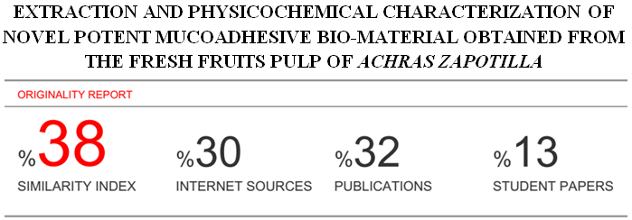

**EXTRACTION AND PHYSICOCHEMICAL CHARACTERIZATION OF NOVEL POTENT MUCOADHESIVE BIO-MATERIAL OBTAINED FROM THE FRESH FRUITS PULP OF *ACHRAS ZAPOTILLA***

**ABSTRACT**

The objective of present investigation was to isolate an effective novel mucoadhesive biomaterial from the pulp of ***Achras Zapotilla***, belonging to [Sapotaceae](http://en.wikipedia.org/wiki/Sapotaceae) family. In the recent years the research in the biomaterial isolation and their use as pharmaceutical excipient become a core area for formulation scientist to develop safe and effective drug delivery system. The biomaterial was isolated by simplified economical method and was subjected to phytochemical, physicochemical, micromeritic as well as spectral analyses like IR, 1HNMR, DSC, SEM and Elemental analysis. The mucoadhesive property of the biomaterial was assessed by shear stress method, falling sphere method and rotating cylinder method using nasal mucosa as substrates. The results were compared with HPMC and sodium CMC as a standard. The formation of hydrogen bond by natural mucoadhesive agent with mucosa was confirmed by FTIR spectra showing carboxyl and hydroxyl groups.The research study revealed that the biomaterial obtained from *fruit pulp of Acarus zapotila* exhibited a promisingpotent natural mucoadhesive property and may be used to develop mucoadhesive transmucosal drug delivery systems.

**Key words** - Nasal Mucosa, Mucoadhesive Property, Shear Stress Testing**,** Achras Zapotilla, X-Ray Diffraction Spectroscopy, Thermal Analysis.

**INTRODUCTION**

Pharmaceutical drug delivery system the excipients play a vital role in the development of dosage forms, suitable for administration to patients. In recent years, excipients development is become core area of research in pharmaceutical drug delivery because it influences the formulation development and drug delivery process in various ways. Biomaterials are choice of research as excipient because of its low cost, nontoxic, relatively wide spread availability, biocompatible, biodegradable, better patient compliance, eco -friendly, renewable in nature and acceptable by the regulating authorities compared to their synthetic counterparts1. Mucoadhesion,an interfacial phenomenon based on two materials, one of which is mucus layer of mucosal tissue, to which the drug is held together by means of interfacial forces for prolonged period of time2. The formation of hydrogen bond by natural mucoadhesive agent with mucosa was confirmed by FTIR spectra showing carboxyl and hydroxyl groups3. In the recent years the interest is growing to develop a drug delivery system with the use of mucooadhesive polymer that will attach to the relative tissue for the targeting various absorptive surface mucosa such as nasal,ocular,pulmonary,buccal,vaginal etc4.The objective of this study is to isolate the biomaterial from the fruit pulp of *acarus zapotilla* and to determine its intrinsic mucoadhesive property.

**MATERIAL AND METHOD**

*Acarus zapotilla fruit* was obtained from the local market Haldwani,Nainital,Uttarakhand and were authenticated from Department of biotechnology Devsthali Vidyapeeth Rudrapur. Sodium CMC & HPMC and Acetone was purchased from S D Fine chemicals. Double distilled water was prepared from the institutional laboratory. All other chemicals used were of analytical grade and were freshly prepared.

**EXTRACTION OF MUCOADHESIVE BIOMATERIAL**

*Acarus zapotilla fruit* pulp was collected after removing the upper most layer as well as seeds and minced with sufficient quantity of water. It was filtered with muslin cloth and filtrate was centrifuged at 3000 rpm for 10 min., the supernatant was collected, filtered and treated with methanol to extract the biomaterial. The extracted biomaterial was washed repeatedly with methanol, collected, purified by dialysis method and dried at 50-600C under vacuum for 12 h. The dried biomaterial was pulverized and passed through 120 mesh sieve to get uniform size particles and stored in desiccators till further use. Percentage yield of isolated biomaterial was calculated. The percentage yield of isolated biomaterial was calculated.5,6,

**PHYSICOCHEMICAL CHARACTERIZATION OF BIOMATERIAL7-13**

The dried biomaterial was studied for percentage yield, appearance, solubility, viscosity, pH, swelling index, and bulk and tapped densities, angle of repose, compression properties.

**Percentage yield**

The percentage yield of biomaterial was calculated on the amount of fruit pulp used for extraction process and amount of dry powder obtains individually depend upon solvents used. The percentage yield was calculated using the formula mentioned below,

**Wt of dried biomaterial obtained**

**Percentage yield= ----------------------------------------------- × 100**

**Wt of leaves powder taken**

**Organoleptic Evaluation**

The Organoleptic evaluation refers to the evaluation of color, odor, shape, taste and special features which include touch and texture. The majority of information on the identity, purity and quality of the material can be drawn from these observations. The result is mentioned in **Table 2.**

**Solubility**

TheSolubility of biomaterial was determined in different common solvents. The results are mentioned in **Table 3.**

**Loss on drying**

Weight loss on drying was determined for an appropriate quantity of biomaterial at 1050C for two hours and percentage loss of moisture on drying was calculated usingformula. The resulted % of LOD is mentioned in **Table 1.**

**Weight of water in sample**

**LOD (%) = ------------------------------------ x 100**

**Weight of dry sample**

**Determination of pH of the polymer**

The pH of 1% solution of the biomaterial was determined using a digital pH meter. The value is mentioned in **Table 1**.

**Density**

A 0.5%w/v solution of dried mucilage was prepared and transferred to a density measurable bottle. An empty bottle with distilled water was weighed. The density of the dried mucilage was calculated.

**Swelling Index**

The Swelling index is the volume in ml occupied by 1g of the substance. The Swelling index of the mucilage powder was determined by according to British Pharmacopoeial method. One gram of biomaterial powder was accurately weighed and transferred to a 100mL stoppered measuring cylinder. The initial volume of the powder in the measuring cylinder was noted. The volume was made up to 100 mL mark with distilled water. The cylinder was stoppered, shaken gently and set aside for 24 h. The volume occupied by the gum sediment was noted after 24 h.

The swelling ratio was calculated by determining the ratio of swollen volume to the initial bulk Volume using the formula**. V2-V1**

**S = -------------**

**V1**

Where;

S = swelling index

V1 = volume occupied by the biomaterial prior to hydration

V2 = volume occupied by the biomaterial after hydration.

The resulted value is mentioned in **Table 1.**

**Powder flow properties**

**Determination of particle size distribution**

Biomaterial was sprinkled on glass slide containing Glycerin and examined through using calibrated eye piece micrometer under microscope. About 100 particles size were counted in different fields and particle size distribution of mucilage shown in Figure no. 1, the particle size distribution result is mentioned in **Table 4.**

**Bulk and tapped density**

A preweighed quantity of dried mucilage was poured into a graduated cylinder, and the volume recorded. The bulk density was obtained by dividing the weight of the sample by volume of the sample contained in the cylinder. Tapped density of biomaterial was determined by USP-II method and it is the ratio of weight of dry powder to its tapped volume. The volume of powdered bed is measured after each increment of 250 drops until the difference of last two volume measurement is zero. The bulk and tapped densities were calculated using the formula

**Bulk density = Mass of biomaterial/Bulk volume**

**Tapped density =Mass of biomaterial/Tapped volume**

The resulted values are mentioned in **Table 1.**

**Angle of repose**

The angle of repose was determined by the fixed height funnel method. The dried biomaterial powder was carefully poured through the funnel until the apex of the conical pile just touched the tip of the funnel. The maximum cone height (h) of the pile and radius (r) of the base of the pile was determined and angle of repose was calculated.

**Angle of repose (ө) = tan-1(h/r)**

The resulted values are mentioned in **Table 1.**

**Carr's Index and Hausner’s Ratio:**

Carr's index and Hausner’s ratio were calculated from the bulk and tapped densities using the formula

**Tapped density- fluff density**

**Carr's Index = ----------------------------------------------× 100**

**Tapped density**

**Hausner’s ratio = Tapped density /bulk density**

The resulted values are mentioned in **Table 1**.

**Viscosity**

The viscosity of freshly prepared 1% w/v solution of biomaterial was determined using Brookfield viscometer. The resulted values are mentioned in **Table 1.**

**Ash Values**

Ash values such as total ash, acid insoluble ash and water-soluble ash were determined according to Indian Pharmacopoeia. The following procedures were used for determination of ash values. The resulted values are mentioned in **Table 5.**

**Total Ash**

Total ash value was determined by taking three grams of biomaterial in a silica crucible The biomaterial powder was spread as a fine, even layer on the bottom of the crucible and ignited by gradually increasing the temperature to 5500C until it is white, indicating the absence of carbon. The crucible was cooled in a desiccator and weighed. The procedure was repeated to get constant weight. The percentage of total ash was calculated with reference to air dried sample. The resulted values are mentioned in **Table 5.**

**Acid Insoluble Ash**

The ash obtained as described above was boiled with 25 mL of dilute Hydrochloric acid for five minutes and filtered through an ash less filter paper. The insoluble ash was transferred into a silica crucible, ignited and weighed. The procedure was repeated to get a constant weight. The percentage of acid insoluble ash was calculated. The resulted values are mentioned in **Table 5.**

**Water-soluble Ash**

The total ash obtained as described above was boiled for 5 min with 25 mL of water and filtered through an ash less filter paper. The insoluble ash was transferred into a silica crucible, ignited for 15 min, and weighed a. The procedure was repeated to get a constant weight. The weight of insoluble matter was subtracted from the weight of the total ash. The difference of weight was considered as water-soluble ash. The percentage of water-soluble ash was calculated. The resulted values are mentioned in **Table 5**.

**Preliminary Phytochemical Screening of Isolated** biomaterial

Aqueous solution of extracted biomaterial was used for phytochemical characterization. Test for carbohydrates, proteins,mucilage, alkaloids, fats, tannins amino acids, gums and polyphenols were perform according to standard procedure mentioned in literatures 13-15. The resulted values are mentioned in **Table 6.**

**ANALYTICAL EVALUATION OF BIOMATERIAL16-19**

**Elemental analysis**

Elemental analysis of carbon, hydrogen and nitrogen was carried using a Leco CHN-2000 determinator. A Perkin-Elmer Elemental Analyzer was used for the determination of oxygen. The resulted values are mentioned in **Table 7**.

**Differential Scanning Calorimetry (DSC)**

DSC curve of *Acarus zapotilla* was obtained by a Differential Scanning Calorimeter at heating rate of 10°C/min from 30 to 300°C in nitrogen atmosphere (30mL/min). The DSC thermogram of biomaterial is shown in **Figure 2.**

**Surface Characteristics by Scanning Electron Microscopy (SEM)**

The SEM photograph of dried isolated biomaterial (powdered sample) was obtained by Scanning Electron Microscope (Jeol, JSM-840A, Japan) with 20Kv accelerating voltage and shown in **Figure 3**.

**PXRD Pattern**

Diffraction pattern of powdered sample was recorded with an X-ray diffractometer.X-ray diffraction was performed at room temperature (25oC) with a diffractometer; target, Cu(λ=1.54Å), filter, Ni; Voltage, 45kV; current 40mA; time constant 10mm/s; scanning rate 20/min; measured from 10-350 at full scale 200 is shown in **Figure 4**.

**FTIR study**

The FTIR spectrum of the sample was recorded using a FTIR spectrometer (Perkin Elmer1600, USA), using potassium bromide (KBr) disc prepared from powdered samples mixed with dry KBr in the ratio 1:200. It was scanned from 4000 to 400 cm-1. Triplicate measurements were made and the spectrum with the clearest identifiable peaks was chosen. It is shown in **Figure 5**. The interpretation is mentioned in **Table 7**.

**NMR Spectrum of Manilkara Zapota Polymer**

NMR spectra of 1H and 13C of mucilage was recorded using NMR (400 MHz) spectrometer (Bruker Avance II 400 NMR Spectrophotometer).

**ACUTE TOXICITY STUDY**

Acute toxicity study was performed according to the Organization for Economic Cooperation Development (OECD) guidelines No 425 (OECD guidelines, 2008). The study protocol was approved by the Institutional Animal Ethical Committee (Registration No 1452/PO/a/11/CPCSEA). Animals were randomly distributed into two groups, each group comprising five animals. Group I consisted of control animals that received equivalent volume of water as vehicle. Group II animals received test dose of 2000 mg/kg body weight The rats were fasted overnight and were then administrated with freshly prepared solution of biomaterials in water. A test dose of 2000 mg/kg body weight was used. Five rats of both sex will be taken to perform acute oral toxicity studies. biomaterials was dissolve in water give per oral to overnight fasted rats and animal will be observed for the sign of acute toxicity for a period of 14 days by observing changes in the skin, corneal reflex, respiratory rate, autonomic symptoms, salivation, diarrhoea, lethargy, sleep, behavioral patterns, and convulsions and compared with the control group animals20,21

**ASSESSMENT OF MUCOADHESIVE PROPERTIES**

**Shear stress measurement**

The mucoadhesive property of biomaterial was determined in vitro by shear stress method,ex-vivo by park and robinson method and rotating basket method. the shear stress measure the force that cause a mucoadhesive to slide with respect to the mucus layer in parallel to their place of contact of adhesion. the test was performed by using different concentration of mucoadhesive solution ranging from 1 to 5%. A specified amount of solution was subjected for measuring the weight required for bond breaking at various contact intervals that is 5, 10, 15, 20,25 and 30 minutes. Similar procedure was employed for HPMC and sodium CMC polymers.22 The resulted values are mentioned in **Table 8** & **Figure 8**.

**Falling Sphere method**

Falling sphere method was studied to determine mucoadhesive strength in terms of time in second required for mucoadhesive agent coated grain to fall 50 divisions in the burette filled with 10 % mucus solution. Mustard grains which retained on sieve no 12 were taken and dipped in isolated biomaterial, HPMC and NaCMC solution of various concentration, 1.0, 2.0 and 3%w/v respectively. Grains were dried at 300C and then Each grains were slowly placed at the top layer of 10 % mucus solution in the burette. Time taken by the grains to fall 50 divisions in the burette was noted and values were tabulated23, 24. The resulted values are mentioned in Table no.9 & Figure no. 9.

**Rotating cylinder method:**

In this method the mucoadhesive property was evaluated by nasal mucosa. The biomaterial film was prepared by solvent casting method. The nasal mucosa was paced around rotating basket and the prepared film was adhered on this labial mucosa. It was allowed for rotation at 100 rpm. The detachment time of film from mucosal substrate was noted at regular intervals and data was compared with standard film of HPMC and sodium CMC polymer25.

**RESULT AND DISCUSSION:**

The percentage yield of biomaterial obtained from the fruit pulp of acarus zapotilla was found to be 39% (w/w).

**Physicochemical Property of *Acarus Zapitilla* Biomaterial-**

The isolated biomaterial was subjected for various physicochemical tests like pH, Swelling Index, Bulk and Tapped density, Carr’s index and Hausner’s ratio, Angle of repose ,%LOD and viscosity.Swelling index of the acarus zapotilla biomaterial was found to be 19**±**0.23%. High value of swelling index shows the high swelling ability of biomaterial. The swelling ability of any biomaterial depends upon its water retention capacity or water absorption capacity. Results were shown in **Table 1**.

**Table 1: Physicochemical property of acarus zapotilla biomaterial**

|  |  |
| --- | --- |
| **Property** | **Results** |
| Bulk density (g/cc) | 0.76 |
| Tapped density(g/cc) | 0..89 |
| True density (g/cc) 0.5%W/v solution | 2.52 |
| Angle of repose | 27.23 |
| Compressibility index (%) | 15 |
| Hausner Ratio | 1.17 |
| pH (1%w/v solution) | 5.5±0.010 |
| Swelling index (%) in DW | 19**±**0.23 |
| Viscosity (1%w/v solution) | 1.028 cp |
| Color Change Temperature | 122-1240c |
| Loss on drying % | 4.3 |

**Organoleptic Evaluation-**

The biomaterial was characterized by various organoleptic properties such as colour, odour, taste, shape, appearance and nature as shown **Table 2**.

**Table 2: Organoleptic evaluation of selected polysaccharide**

|  |  |
| --- | --- |
| **Parameter** | ***Acarus Zapotilla* Biomaterial** |
| Color | Light brown |
| Odour | Odourless |
| Taste | Tasteless |
| Shape | Irregular |
| Appearance | Amorphous |
| Nature | Powder |

**Solubility Analysis**

The solubility behaviour of the biomaterial indicates that it is quickly soluble and forms viscous colloidal solution in warm water, sparingly soluble in cold water, whereas insoluble in ethanol, methanol, acetone, Cyclohexane, Chloroform, Benzene and ether.

Results were shown in **Table 3.**

**Table 3: Solubility Behavior of the Biomaterial**

|  |  |
| --- | --- |
| **Solvent use** | **Solubility behavior** |
| Cold water (8-250c) | Sparingly soluble |
| Warm water (35-400c) | Soluble forming a viscous colloidal solution |
| Ethanol | Insoluble |
| Methanol | Insoluble |
| Acetone | Insoluble |
| Ether | Insoluble |
| Cyclohexane | Insoluble |
| Chloroform | Insoluble |
| Benzene | Insoluble |

**Particle Size Study-**

The particle size distribution of biomaterial was determined and their data are tabulated in **Table 4** and graph was plotted between size range and frequency and graph was shown in **Figure 1**

**Table 4: Particle Size Distribution of *Acarus Zapotilla* Biomaterial**

|  |  |  |
| --- | --- | --- |
| S.No | **Size range (μ m)** | **Number of particles** |
| 1. | 0-20 | 6 |
| 2. | 20-40 | 21 |
| 3. | 40-60 | 39 |
| 4. | 60-80 | 15 |
| 5. | 80-100 | 7 |
| 6. | 100-120 | 12 |

**Figure 1: Graphical Representation of Particle size distribution of *Acarus Zapotilla* Biomaterial**

**Ash Value**

The ash values such as total ash acid, insoluble ash and water–soluble ash of biomaterial was determined and their values are given in **Table 5.**

**Table 5: Ash Values of Acarus Zapotilla Biomaterial**

|  |  |  |
| --- | --- | --- |
| **S.No.** | **Types of Ash** | **Ash Value in %w/w** |
| **1** | Total ash | 4.9 % |
| **2** | Acid insoluble ash | 0.48 % |
| **3** | Water soluble ash | 4.3 % |

**Phytochemical Evaluation-**

The purity of biomaterial was determined by prescribed phytochemical tests, which indicated the absence of alkaloids, steroids, flavonoids, tannins and phenols. Only carbohydrates saponins and mucilage were found to be present, which confirms the purity and results as shown in **Table 6.**

**Table 6: Phytochemical Characterization of Extracted Polymer from *Acarus Zapotilla***

|  |  |  |
| --- | --- | --- |
| **SN** | **TEST** | **RESULT** |
| **1** | Test for alkaloids  **Wagner’s test**  **Mayer test**  **Dragendroff test** | **-**  **-**  **-** |
| **2** | Test for Carbohydrates**( Molisch’s test**) | **+** |
| **3** | **Test for saponin (foam test)** | **+** |
| **4** | Test for proteins **Ninhydrin test**  **Biuret test** | **-**  **-** |
| **5** | Test for Tannins (Ferric chloride test)  (Aquous bromine test) | **-**  **-** |
| **6** | Test for mucilage ( Ruthenium red test) | **+** |
| **7** | Test for reducing sugar (Felhing’s test) | **+** |
| **8** | Test for chlorides( silver nitrate test) | **-** |
| **9** | Test for sulphates (barium chloride test) | **-** |
| **10** | Test for stach (added iodine) | **-** |
| **11** | Test for flavonoid **Shinoda test**  **Alkaline reagent test** | **-**  **-** |

**Elemental analysis-**

From the Elemental analysis it was found that the acarus zapotilla biomaterial have high carbon hydrogen ratio and result are shown in **Table 7**

Table 7: Micro-Elemental Analysis of *Acarus Zapotilla* Biomaterial

|  |  |
| --- | --- |
| **ELEMENT** | **% COMPOSTION** |
| **Carbon** | 36.95 |
| **Nitrogen** | 0.56 |
| **Hydrogen** | 9.14 |

**Differential Scanning Calorimetry (DSC) Study**

Differential Scanning Calorimetry (DSC) measures the heat loss or gain, resulting from physical or chemical changes within a sample as a function of temperature. A sharp symmetric melting endotherm can indicate relative purity, whereas broad asymmetric curve suggests impurities or more than one thermal process. The endothermic peak usually indicates the loss of water present in the compound. the DSC curve of acarus zapotilla showed two broad endothermic peaks at temperature 90.3°C and 215.3°C. DSC graph is shown in **Figure 2.**

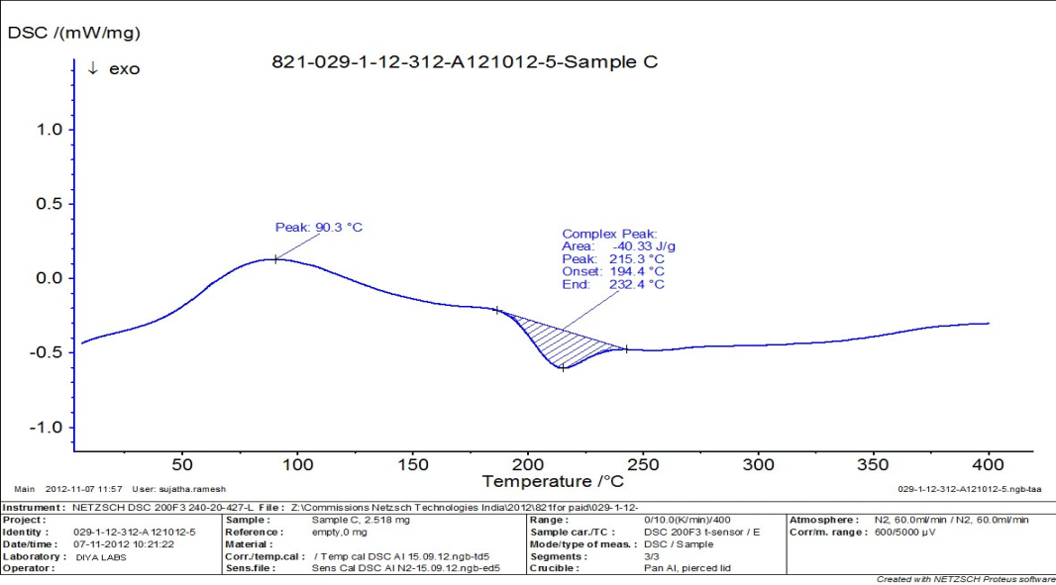

**Figure no-1 DSC curve of acarus zapotilla biomaterial**

**Figure 2: Graphical Representation of Differential Scanning Calorimetry**

**Scanning electron microscopy-**

The SEM photographs of *acarus zapotilla* biomaterial (**Figure 3**) have revealed that the shape of the biomaterial was found to be irregular.

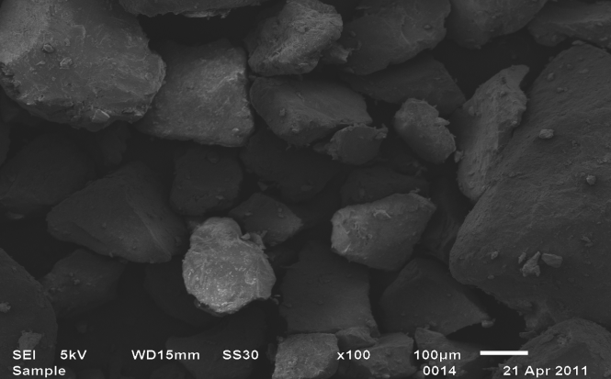

**Figure 3: Surface Characteristics by Scanning Electron Microscopy (SEM)**

**X-Ray Diffraction Analysis**

The X-ray diffraction pattern of biomaterial obtained from *acarus zapotilla* (Figure **4**) did not show any characteristic peak, which indicates amorphous nature.

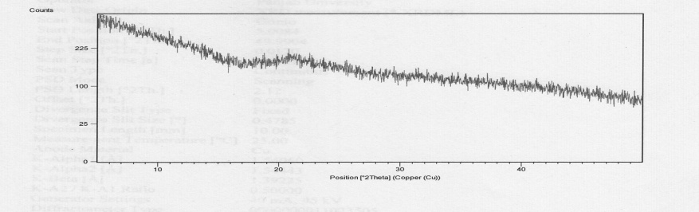

**Figure 4: X-ray Diffraction of the Biomaterial.**

**FTIR Study**

IR spectroscopy is a useful tool in identification as well as purity of a compound. The principal absorption peaks of biomaterial was interpreted (Figure **5**) and data are tabulated in **Table 8**.



**Figure 5: FTIR graph of The Biomaterial**

**Table 8: Interpretation of IR Peaks.**

|  |  |
| --- | --- |
| **IR peaks (cm-1)**  **(*acarus zapotilla*)** | **Interpretation** |
| **1012.66** | **C-H Bending** |
| **1246.06** | **C-O Stretching** |
| **1735.99** | **C=O Stretching** |
| **2742.87** | **CH2 C-H Stretching** |
| **2875.96** | **Alkyl C-H Stretching** |
| **2933.83** | **Alkyl C-H Stretching** |
| **3400** | **O-H (Alcohol) Stretching(broad)** |

**NMR Study**

1H NMR of *acarus zapotilla* biomaterial showed chemical shift at 1.2 ppm (-C≡CH, acetylenic proton), 2.5 ppm (-C≡CH, acetylenic proton),  3.2-4.6 ppm (-CH3OR, ether) proton),  4.6 ppm (-C=CH, vinylic proton),  4.9 ppm (R-OH, hydroxyl proton) and 7.5 ppm (Ar-H, aromatic proton) .It is shown in **Figure 6** .

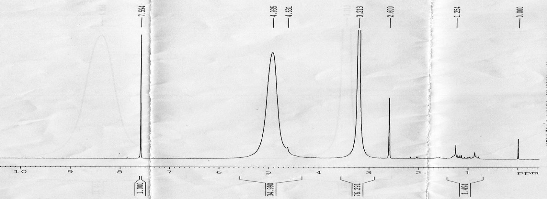

**Figure 6: NMR of the Biomaterial.**

**Acute Toxicity Study**

In acute toxicity studies, the test animals did not reveal any significant change in their body weight, corneal reflex, respiratory rate and autonomic symptoms. No skin reaction, salivation diarrhea, lethargic conditions, sleeping conditions and convulsions were observed on the animals. So it clearly revealed that biomaterial was non toxic in nature.

**Mucoadhesive Assessment-**

**Shear Stress Method***Acarus zapotilla* biomaterial (5%) showed shear stress value 154 gm after 30 minutes, **Figure 6** which was comparable to HPMC 3% & Sodium CMC 3% solution and results are computed in **Table 9**.

**Table 9: Mucoadhesive Property Detrmined By Shear Stress Method**

|  |  |  |  |  |  |  |  |
| --- | --- | --- | --- | --- | --- | --- | --- |
| Polymer | Concentration %w/v | Weight required to detach glass plate(gm)  At the time interval (n=3) | | | | | |
| 05 min | 10 min | 15 min | 20 min | 25 min | 30 min |
| Isolated Biomaterial | 1% | 7.3 | 9.6 | 12.8 | 16.2 | 23.5 | 29.8 |
| 2% | 13.5 | 18.1 | 24.3 | 29.8 | 36.6 | 48.2 |
| 3% | 21.2 | 27.8 | 34.7 | 38.1 | 47.3 | 58.9 |
| 4% | 33.7 | 41.2 | 48.6 | 56.7 | 65.3 | 86.4 |
| 5% | 44.6 | 53.7 | 67.8 | 87.6 | 114.5 | 154.4 |
| HPMC | 3% | 58.3 | 65.1 | 73.7 | 95.2 | 112.3 | 152.8 |
| NaCMC | 3% | 54.7 | 61.4 | 73.9 | 97.6 | 116.7 | 154.8 |

**Figure 7: Graphical Representation of Shear Stress Study.**

**Falling Sphere Method**

In falling sphere method the Coated mustard grains of size 1.0 to 1.1mm were allowed to move top to bottom in 50 ml burettee conating 10% mucus solution. Mucoadhesion time was determined and compared with standard **Figure 8**.from the study it was found that the Isolated mucoadhesive agent was shown comparable mucoadhesion as compared to the standard and data is computed in **Table 10**,

**Table 10: Falling sphere analysis of polymer**

|  |  |  |
| --- | --- | --- |
| **Polymer** | **Concentration** | **Average time(sec) taken (n=3)** |
| **Isolated Biomaterial** | 1% | **10.33** |
| 2% | **28.21** |
| 3% | **33.88** |
| 4% | **43.69** |
| 5% | **56.22** |
| HPMC | 3% | **32.33** |
| NaCMC | 3% | **32.12** |

**Figure 8: Graphical Representation of Falling Sphere Method**

**Rotating basket method-**

Acarus zapotilla biomaterial showed dislodgement time 95 minutes from nasal mucosal substrate of goat, which was more than sodium CMC (90 minutes) and less than HPMC (105 minutes) **Figure 7**. These results suggested that acarus zapotilla biomaterial possessed an appreciable mucoadhesive property.results are mentioned in **Table 11**.

**Table 11: Dislodgement Time Determine by rotating basket Method In Nasal Mucosa**

|  |  |  |
| --- | --- | --- |
| Sl.No | Polymer | Dislodgement time(min) |
|  | Acarus zapotilla biomaterial | 95 |
|  | HPMC | 105 |
|  | NaCMC | 90 |

**Figure.9: Graphical Representation of Dislodgement Time Determine By Rotating Cylinder Method in Nasal Mucosa**

## Conclusion-

In the present study the biomaterial was successfully isolated from acarus zapotilla with a good percentage yield by a simple economic process. The isolated biomaterial shows promising inbuilt mucoadhesion property when compared against HPMC and NaCMC. It is also confirmed by presence of hydroxyl and carbonyl functional groups in FTIR spectrum which are responsible for mucoadhesion.Hence conclusion was drawn that it can serve as a potential excipient for formulating transmucosal drug delivery systems. Since this natural mucoadhesive agent is edible, it is easily biodegradable and may provide an alternative to conventional synthetic/semisynthetic mucoadhesive agents.

References:

1. Singh AV. Biopolymers in Drug Delivery. *Pharmacologyonline* 2011;1: 666-674
2. Gandhi RB,RobinsonJB.Bioadhesion in drug delivery systems.Medical process through technology 1989;15:21-46.
3. Madsen F, Eberth K and Smart J: A rehological assessment of the nature of interactions between mucoadhesive polymers and a homogenized mucus gel, Biomaterials 1998; 19: 1083-1092.
4. Mathiowitz E, Chickering D, Jacob JS, Santos C. In: Mathiowitz E (eds.) Encyclopedia of controlled drug delivery, Vol. 1, New York; John Willey and Sons: 1999; 9-44.
5. Sunil Mistry, Biswal PK, B Mishra, S Sahoo. Isolation, Characterization and Pharmaceutical evaluation of the mucilage from Polyalthia suberosa leaves. International Journal of PharmTech Research 2010; 2: 1455-1459.
6. Ojha A, Satheesh Madhav NV, Isolation and characterization of novel mucoadhesive biomaterial from Phoenix dactylifera, International Current Pharmaceutical Journal, 1 (8), 2012, 205-208.
7. Ramu G, Krishna Mohan G, Jayaveera K N, Preliminary investigation of Patchapassali mucilage (Basella alba) as tablet binder, International Journal of Green Pharmacy, 5(1), 2011, 24-27.
8. Indian Pharmacopeia, Ministry of Health & family welfare, Government of India, Controller of Publications, New Delhi, 1996, A-54.
9. Anonymous, Quality control methods for medicinal plant materials, World Health Organization, Geneva 2002, 8, 28,45, 46.
10. Anonymous, The Ayurvedic pharmacopoeia of India, 1st edition,Ministry of Health and Family Welfare, Government of India, Part-1, vol-3, 2001, 29-31,233-249.
11. Bharadia P D et al., A Preliminary Investigation on Sesbania gum as a Pharmaceutical excipient, International Journal of Pharmaceutical Excipients, 1(4), 2004, 102-105.
12. Sink P J, Martins, Physical Pharmacy & Pharmaceutical sciences, 5 th Edition, B.I publications Pvt. Ltd, New Delhi, 2006, 553-556.
13. Lala, P.K. *Practical Pharmacognosy*. Lina Guha Publication: India,**1981**.
14. Kokate, C.K. *Practical Pharmacognosy*, 3rd ed. New Delhi, India,Vallabh Prakashan, **1991**
15. Gupta MK. Textbook of Natural Products, Volume IV, 1st ed., Meerut; Pragati Prakashan:2009
16. Silverstein RM, Webster FX. Spectroscopic identification of organic compounds, 6th ed.,

New Delhi; Wiley India Pvt. Ltd: 2010.

1. Sharma Y R et al., Elementary Organic Spectroscopy, Principles and chemical applications, S Chand & Co. Ltd, New Delhi, 2010, 89-150.
2. Kalsi PS: Spectroscopy of Organic Compounds. New Age International Publishers, Sixth Edition 2007: 65-183.
3. Beckett AH and Stenlake JB: Practical Pharmaceutical Chemistry, Part II. CBS Publishers, Delhi, Fourth Edition 2004: 72-75.
4. OECD 423 guideline for testing of chemicals.acute oral toxicity-acute oral class method.2001
5. Satheesh Madhav NV, Uma Shankar MS. (A novel smart mucoadhesive biomaterial from Lallimantia royalena seed coat). Science Asia; 2011; 37: 69–71.
6. Peh KK,wong cf.polymeric film as vehicle for buccal drug delivery:mechanical and bioadhesive properties.j pharm pharmaceutics sci1998;2:53-61
7. Teng CL and Ho NF: Mechanistic studies in the simultaneous flow and adsorption of polymer coated latex particles on intestinal mucus-I methods and physical model development. Journal of Controlled Release1987; 6: 133-149.
8. Ranga Rao KV and Buri P: A novel in situ method to test polymers and coated micro particles for bioadhesion. International Journal of Pharmaceutics 1989; 52: 265-70.
9. Satheesh Madhav NV, Yadav AP. (A novel translabial platform utilizing bioexcipients

from Litchi chinesis for the delivery of rosiglitazone maleate). Acta Pharmaceutica Sinica

B; 2013; 3(6): 408–15 .