**Reviewer’s Comments**

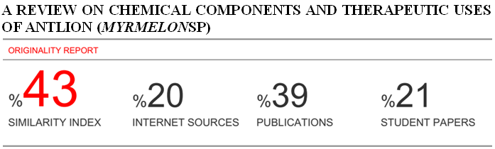

**A Review on Chemical Components and Therapeutic Uses of Antlion (*Myrmelon*sp)**

**Abstract**

Along with the beneficial effects of antlion in agriculture, they have been found to be containing various bioactive components such as polypeptides and alkaloids. They have been proved to be useful as therapeutic agents in treatment of various human ailments such as diabetes, convulsion and also in back pain. This review article summarizes some chemical constituents of the insect and some pharmacological uses as reported by various studies.

**Keywords**: antlion, chemical components, therapeutic uses

**Introduction**

The catalog of antlion taxa, includes about 1500 known species [1]. The most known genus is *Myrmelon* (antlion). The exact meaning of the name "antlion" is uncertain. It has been thought that it refers to the fact that ants form a large percentage of prey insect, the suffix "lion" merely suggesting destroyer or eater. The term Antlion applied to the larval form of insect as it feeds upon arthropods- mainly ants. Its adult is often called doodlebug in North America. Some adults eat small pollen and nectar while others are predator of small arthropods. Antlions are worldwide in distribution, most common in arid and sandy habitats. The larvae of many antlion species construct conical pitfall traps in sand or fine soil. The larva settles down at the bottom, buried in the soil with only the jaws projecting above the surface, often in a wide-opened position on either side of the very tip of the cone. Antlion completes its life cycle in four stages- egg, larva, pupa and adult. Eggs are laid directly into soil .Larvae pass through three instars and then pupate in the soil. Adults are active, weak-flying, nocturnal predators.Antlions are considered as beneficial in agriculture as it helps in paste control.

The larvae of antlion are mainly important because they contain many biologically active chemicals and can be used in treatment and maintenance of various pathological states of human beings. There are many researches focused mainly in distribution, ecology and life cycles of antlion but very few studies have been carried out focusing their therapeutic uses. This article is a review of literatures which focus the chemical constituents and therapeutic uses of antlion.

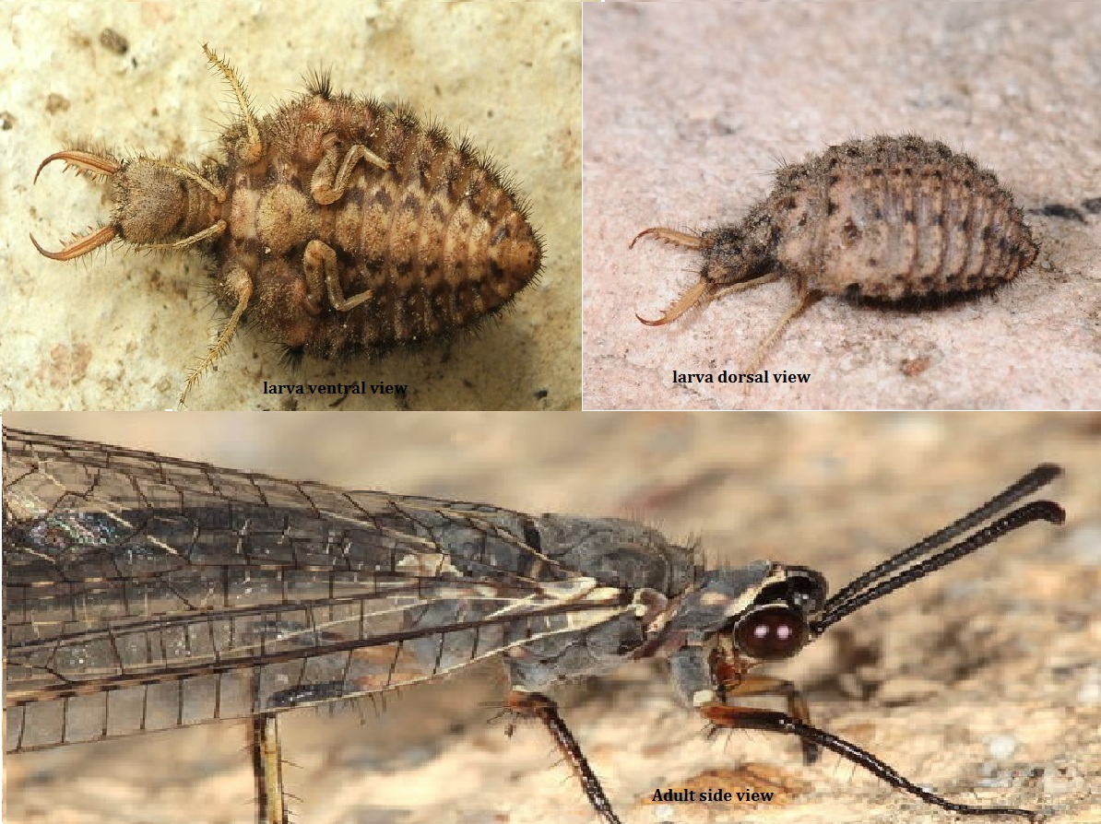

**Chemical components**

Nakatani et al. isolated two isoindoline alkaloids namely 4-hydroxyindoline-1- one and 2-(2-hydroxyethyl)-4-hydroxyisoindoline-1-one from Antlion larva,Myrmeleontide species [2].

HisashiNishiwaki et al isolated bacteria named *Bacillus cereus* from the larvae of *Myrmeleonbore* which was found to secrete proteins that paralyze and kill German cockroaches, *Blattelagermanica*, when injected. One of these active proteins was purified and identified as sphingomyelinase (molecular mass of 34 kDa) [3].

Matsuda and co workers obtained a paralytic polypeptide named AIBT-toxin from live antlions, the larvae of Myrmeleon bore [4, 5]. Similarythe thoracic gland of the antlion *Euroleonnotras* was found to contain nerol oxide and (z)-6-undecen-2-ol (Nostrenol) while the species *grocus*bore contained 10- homonerol oxide and nostrinol. Nerol and 10-homonrol were found in third species, *Myrmeleonformicarius*. The nerol oxides of E. nostrasand the 10-homonerol oxides of *G. bore* were found to be racemic while both species contained optically pure (R) – nostrenol [6]. In addition to this, the thoracic gland of males in two antlion sp. *Synclysisbaetica* and *Acanthaclisisoccitanica* of Isreal were found to contain two component blends of nerol oxide and (R,Z) -6- tridecan-2-ol (approx 1:5) and nerol oxide and 10-homonerol oxide (approx 1:2) respectively [7].

**Structures**







**Therapeutic uses**

The dried bodies of ant lions (the larvae of Myrmeleontidae species) have been used as a traditional Chinese medicine prescribed for the treatment of malaria and childhood convulsions [8]. EndroNugroho et al found combination of bitter guard ethanolic extract with antlion larvae aquousextract as a blood glucose level lowering agent. In this study, human lung acting insulin was intraperitonically injected three times daily for 15 days to insulin resistance conditions in rat. In 16th day, a single dose of drug was orally given and blood glucose levels were checked before and after the administration of drug. The result was analyzed using paired t-test. The bitter gourd and ant lion larvae in ratio 75:25 (w/w percentage) were found to reduce blood glucose level by 32.20±2.57% [9].

A study in Indonesia by TyasKurniasih et al showed that the juice of undur-undur (antlion) significantly (p <0.05) decreased blood glucose levels of aloxan- induced hyperglycemic rats after 14 days of treatment. In this study, 30 male white Wister rats were randomly selected and divided into 6 treatment groups. First group (normal control) included aquabidest injected mice and given treatment with aquabidest at dose of 0.5ml/200g body weight of rat per day, second group (control hyperglycemic) included alloxan- induced hyperglycemic mice and given treatment with aquabidest at dose of 0.5ml/200g body weight of rat per day and third group (positive control) included alloxan induced hyperglycemic mice and given treatment with solution of glibenclamide dose of 0.378 mg/200g body weight of rat per day. Similarly, forth group (treatment 1) were alloxan induced hyperglycemic mice and given treatment with Undur-undur (Antlion) juice at dose of 0.01 ml/200g body weight of rat per day, fifth group (treatment 2) were alloxan induced hyperglycemic rats and given treatment with banana amber juice at dose of 1.16 ml/200g body weight of rat per day and finally sixth group (treatment 3) were alloxan induced hyperglycemic mice and given treatment with combination at dose 0.01ml/200g of antlion juice and at dose 1.16ml/200g of banana juice. Blood glucose content was measured every 7 days until the 35th day. The data obtained were analyzed using ANOVA and test LSD at 95% confidence level [10]. Indicate the results of this study here

Recently, ElzaSundhani et al. also studied anti-diabetic activity of antlion powder andethanolic extract on white Wister male rat.Twenty seven rats were grouped randomly into nine each with 3 animals. Group I and II were given glibenclamide and group III was given glucose. Group IV, V, and VI were given antlion powder with the dose of 5.42 mg/KgBW, 10.84 mg/KgBW, and 21.68 mg/KgBW respectively while group VII, VIII, and IX were given ethanol extract of antlion with the dose of 0.1626 mg/KgBW, 0.3252 mg/kgBW, and 0.6054 mg/KgBW respectively. Blood glucose level was determined and analyzed statistically.The result showed that, both powder and ethanolic extract of antlion can prove to decrease blood glucose level [11].

Antlion was also found to be traditionally used in back pain. Gun powder, two *Aframomummelegueta* rhizomes, two white ant, two ant lion are all grinded in a pestle and mortar and used to make nine incision marks on a man and seven on a woman on the back to treat back pain [12].

**Conclusion**

There are only few studies about the uses of antlion as bioactive agents although there are number of researches focusing on distribution, ecology and life cycles of antlion. Highlight of few researches in this article suggest that there is a need of focusing study on the pharmacological uses of antlion.

**References**

1. Krivokhatsky VK. L. Stange. A Systematic Catalog, Bibliography and Classification of the World Antlions (Insecta: Neuroptera: Myrmeleontidae). Memoirs of the American Entomological Institute 74 (Gainesville, FL 2004), 565 p. Entomological Review. 2005; 85(4): 461-464
2. Nakatani T, Nishimura E and Noda N. Two isoindoline alkaloids from crude drug, the antlion (the larvae of myrmeleontidae species). The Japanese society of Pharmacognosy and spreinger-verleg, 2006; 60: 261-263.
3. Nishiwaki H, Ito K, Otsuki K, yamamoto H, Komal K, Matsuda K. purification and functional characterization of insecticidal sphingomyelinage L produced by Becilluscerus. Eur J Biochem 2004; 271; 601
4. Toshida N, Sugama H, Gotoh S, Matsuda K, Nishimura K, Komai K. “Detection of ALMB-toxin in larval body of Myrmeleon bore by anti N-terminus Peptide antibodies.” Biosci, Biotechnol, Biochem 1999; 63; 232-234
5. Yashido N, oeda K, watanabe E, Mikami T, Fukita k, Nishimura K, Komai K, Matsuda K. Chaperonin turned insect toxin. Nature 2001; 411;44
6. Baeckstrom P, Bergstrom G, Bijorkling F et.al. Structure, absolute configurations, and synthesis of volatile signals from three sympatric antlion species, Euroleonnostras, Grocus bore and Myrmeleonformicarius( Neoptera: myrmeleontidae). J chem. Ecol (1989) 15:61
7. Baekstrom G, Wassgren AB, Hogberg E, Hedenstrom E, Hefetz A, Simon D, Ohlsson T and Lofqvist J. “ species- specific, two component volatile signalsin two sympatric antlion species; synclysisbaetica and Acanthaclisisoccitanica ( NeopteraMyrmeleontidae) Journal of chemical ecology 1992; vol 18 no.7
8. Shogakukan (1985). The dictionary of chinese drugs, vol II. Shanghai Science and Technologic Publishers and Shogakukan, Tokyo, 1042pp.
9. Mujahid MZ, Agistia DD, Saadah M and Nugroho AE. “ A combination of bitter guard ethanolic extract with antlion larvae aqueous extract for a blood glucose lowering agent “ international food research Journal 2013; 20(2) 851-855.
10. Kurniasih T, Isma’il M, Susilowati F and Lestari SP. KajianPotensiUndur-UndurDarat (Myrmeleon Sp.) sebagaiAntidiabetes. PKM Report. Faculty of Biology, UniversitasGadjahMada. Yogyakarta.
11. Rahma HH, Sundhani E, Nurulita NA. ANTIDIABETIC ACTIVITY OF POWDER AND ETHANOLIC EXTRACT OF ANTLION (Myrmeleon sp.) ON WISTAR STRAIN WHITE MALE RATS WITH GLUCOSE PRELOAD. Proceeding ICMHS 2016.
12. Borokini TI, Ighere DA, Clement M, Ajiboye TO, Alowonle AA. Ethnobiological survey of traditional medicine practices in Oyo State. Journal of Medicinal Plants Studies. 2013; 1(5): 1-16.