**Reviewer’s Comments**

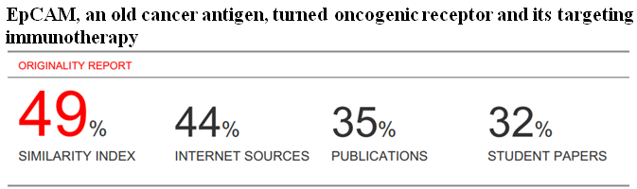

**EpCAM,an old cancer antigen,turned oncogenic receptor and its tageting immunotherapy**

**Abstract**

EpCAM is a cell adhesion molecule.Its structure,its expression and the oncogenic potential,and its signaling network and target therapy were in concise reviewed.In recent advances,in addition to PI3K/akt and Raf/MAPK pathway involving in cell survival,anti-apoptosis and proliferation,and malignant initiation and progression(see figure by Zhu,1986-91),three distict pathway are illustrated:EpCAM/E-cadherin-catenin-actin cytoskeleton,EpCAM/wint-catenin signaling,and its major EpCAM/nuclear signaling presented by Maetzel D in 2009 and Munz M in 2004. Moreover,more accumulated data are needed in detail mechanism.The data may provide its cancer biology and clinical targeting therapy benefits.

**Keyword**:EpCAM,structure,nuclear signaling,target therapy

**Introduction**

In a series of long list of oncogenic receptors which discriminated tumorigenic in partial origin of tumours from receptors in normal health people and then better to potential targeting therapy benefits are presented in clear in previous references[table 1,1-6]. Because It is no need to targeting receptors in normal condition,actually,targeting therapy[7]now is shift mainly toward oncogenic receptors in tumours in tumor hospitals,even if we won't citing in literature.

*Table 1.Receptors with oncogenic potential associated with tumours(also receptor-mediated tumorigenesis)*

Growth factors receptors: Oncogenic receptor EGFRvIII（GB,MLC,SCC）[8-11], Oncogenic receptor MUC1[12] or MUC4[12], Neu oncogenic receptor（breast cancer）[13];Oncogenic receptor IGF-1R; Oncogenic B receptor（HCD,CLL）[14],and other VEGFR2(colorectal cancer,glioma)

Cytokine receptors: Oncogenic growth hormone receptor（gigantism,acromegaly）[15]; GHRH/GHRHR oncogenic signaling（pituitary tumors）; Oncogenic EPOR（PFCP）[16],oncogenic EPOR-IGH/IGK fusion（BCP-ALL）[17]; Oncogenic CSF3R（CNL or aCML）[18]; IL-2-BCM fusion（T cell lymphoma）;IL-3-IgH oncogenic fusion（ALL）; IL-11/IL-11 receptor（gp130 Y757F/Y757F）pro-oncogenic signaling（gastric tumor in mice)[19,20]; IL-21R-BCL6 fusion（DLBCL,lymphoma cell line）;Oncogenic TSHR（thyroid adenoma）

Steroid receptors: Oncogenic thyroid hormone receptor（TR）（PTC）[21],oncogenic THR1/BTR fusion（breast cancer cell line）;oncogenic receptor pml/RARa （APL）[22,23];Oncogenic receptor AR variants（Pca）[24,25]; ER pro-neoplastic signaling[26,27],neoplastic ESR1-CCDC170 fusion(also oncogenic receptor ERalpha fusion)（breast cancer）[7,28];GRβ aberrant signaling（Cushing's disease,erythrocytosis,GR+ breast cancer,Nelson's syndrome）[29-31];FSH/FSH receptor oncogenic signaling（preneoplastic ovarian surface epithelial cells)

Others: Pro-oncogenic receptor CLC1[32];

Tobacco related cancer（toxicology）: nicotinic acetylcholine receptor alpha7-nAchR oncogenic receptor[33]

r

EpCAM molecule,a novel oncogenic receptor[34]is shift toward new member family and targeting its antibodies.In this paper,I am delibrating recent advances on EpCAM in this field.

**EpCAM structure**

The epithelial cell adhesion molecule[EpCAM,35]was originally identified as a tumor associated antigen in discovery in 1970s[36],also known as cluster of differentiation 326（CD326）,and tumor-associated calcium signal transducer 1（TACSTD1）[37].EpCAM is a type I transmembrane protein of 314 amino acids（aa）with apparent molecular weight of 40kd.The extracellular domain（EpEX）contain epidermal growth factor-like domain, a thyroglobin（TY）repeat domain,tansmembrane domain（TM）,and a short 26-amino acid intracellular domain（EpICD）（see figure 1）[34,37]. 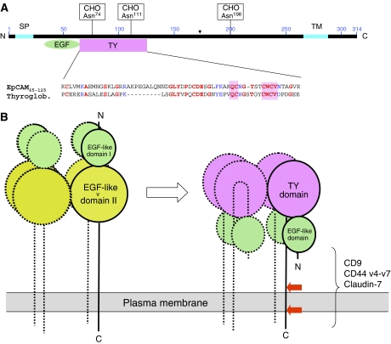

EpCAM is an oncogenic receptor[34]that requires regulated intramembrane proteolysis for activation of its signal transduction capacity. EpCAM cleavage is dependent on cell-to-cell contact.Thus,EpCAM as an oncogenic signaling protein[37]engaged in cell adhesion and nuclear signaling[38].

**EpCAM expression,a dual player**

EpCAM is expressed by the epithelium of health individuals（all simple, pseudo- stratified and transitional epithelia）,except by squamous epithelium,and some specific epithelial cell types,such as hepatocytes and keratinocytes[39].EpCAM is a membrane protein with proto-oncogenic properties that is expressed in most human carcinomas,EpCAM is overexpressed to varying degrees[40].These include the majority of adenocarcinomaas including pancreatic adenocarcinoma, cholangiocarcinoma, node-positive breast cancer, epithelial ovarian cancer,lung cancer,colon carcinoma,prostate cancer,gastric cancer,hepatic carcinoma and squamous cell head and neck cancer[41-43].Recently,EpCAM has been identified as an additional marker for cancer-initiating stem cells[44-46].

The oncogenic potential of EpCAM or EpICD was demonstrated in a mouse xenograft model,in which HEK 293 cells stably expressing EpCAM or EpICD produced nearly equivalent large tumours,whereas control cells only formed a small tumour in a single case[38].EpCAM expressing pancreatic cancer stem cells showed a 100-fold enhanced tumorigenic potential compared with EpCAM-negative pancreatic cancer stem cells[47,48].Similarily,in vivo evaluation of tumorigenicity in hepatocellular carcinoma cell lines,using immunodeficient NOG mice,a smaller number of EpCAM+ cells（minimum 100）than EpCAM- cells are able to tumor formation.The introduction of exogenous EpCAM into EpCAM+ clones,but not into EpCAM- clones,markedly enhanced their tumor-forming ability[45].Also, EpCAM-positive hepatocellular carcinoma stem cells could efficiently initiate tumours in SCID mice[46].Very recent, EpCAM-proliferating ductal cells（PDC）give rise to hepatocellular carcinoma（HCC）in the inflamed liver[48],which provide direct experimental evidence that EpCAM expressing PDC could be a cellular origin of HCC,suggesting the existence of stem/progenitor-derived hepatocarcinogenesis. For breast cancer stem cells,the ability to form tumours in SCID mice was for EpCAM+ cells 50-fold greater compared with the unfractioned tumour cells[47].Therefore,although EpCAM- and EpCAM+ cancer stem cells were able to form tumours,10-fold less EpCAM+ cells than EpCAM- cells were able to induce tumours.Indeed,EpCAM overexpression is associated with decreased overall survival of patients with a broad variety of carcinoma[42,47].

In contrast to its promoting role regarding tumour formation,high EpCAM expression only in two tumour types（renal clear cell carcinoma and thyroid carcinoma）has been consistently associated with improved patient survival[47,49].

**Signal transduction by EpCAM oncogenic receptor and its target pathway**

Several biological function of EpCAM have been described.EpCAM is a cell adhesion molecule,its action was invented in fact,is not limited on adhesion between cell and cell,and also can activate intracellular MAPK and PI3K/Akt signal,to cause tumor cell proliferation,invasion and metastasis etc. biological action（see figure 2,George Zhu,1991; Hu etal,2012）.Recent advances further

uncovers a highlight of new data in its distinct signal pathway.

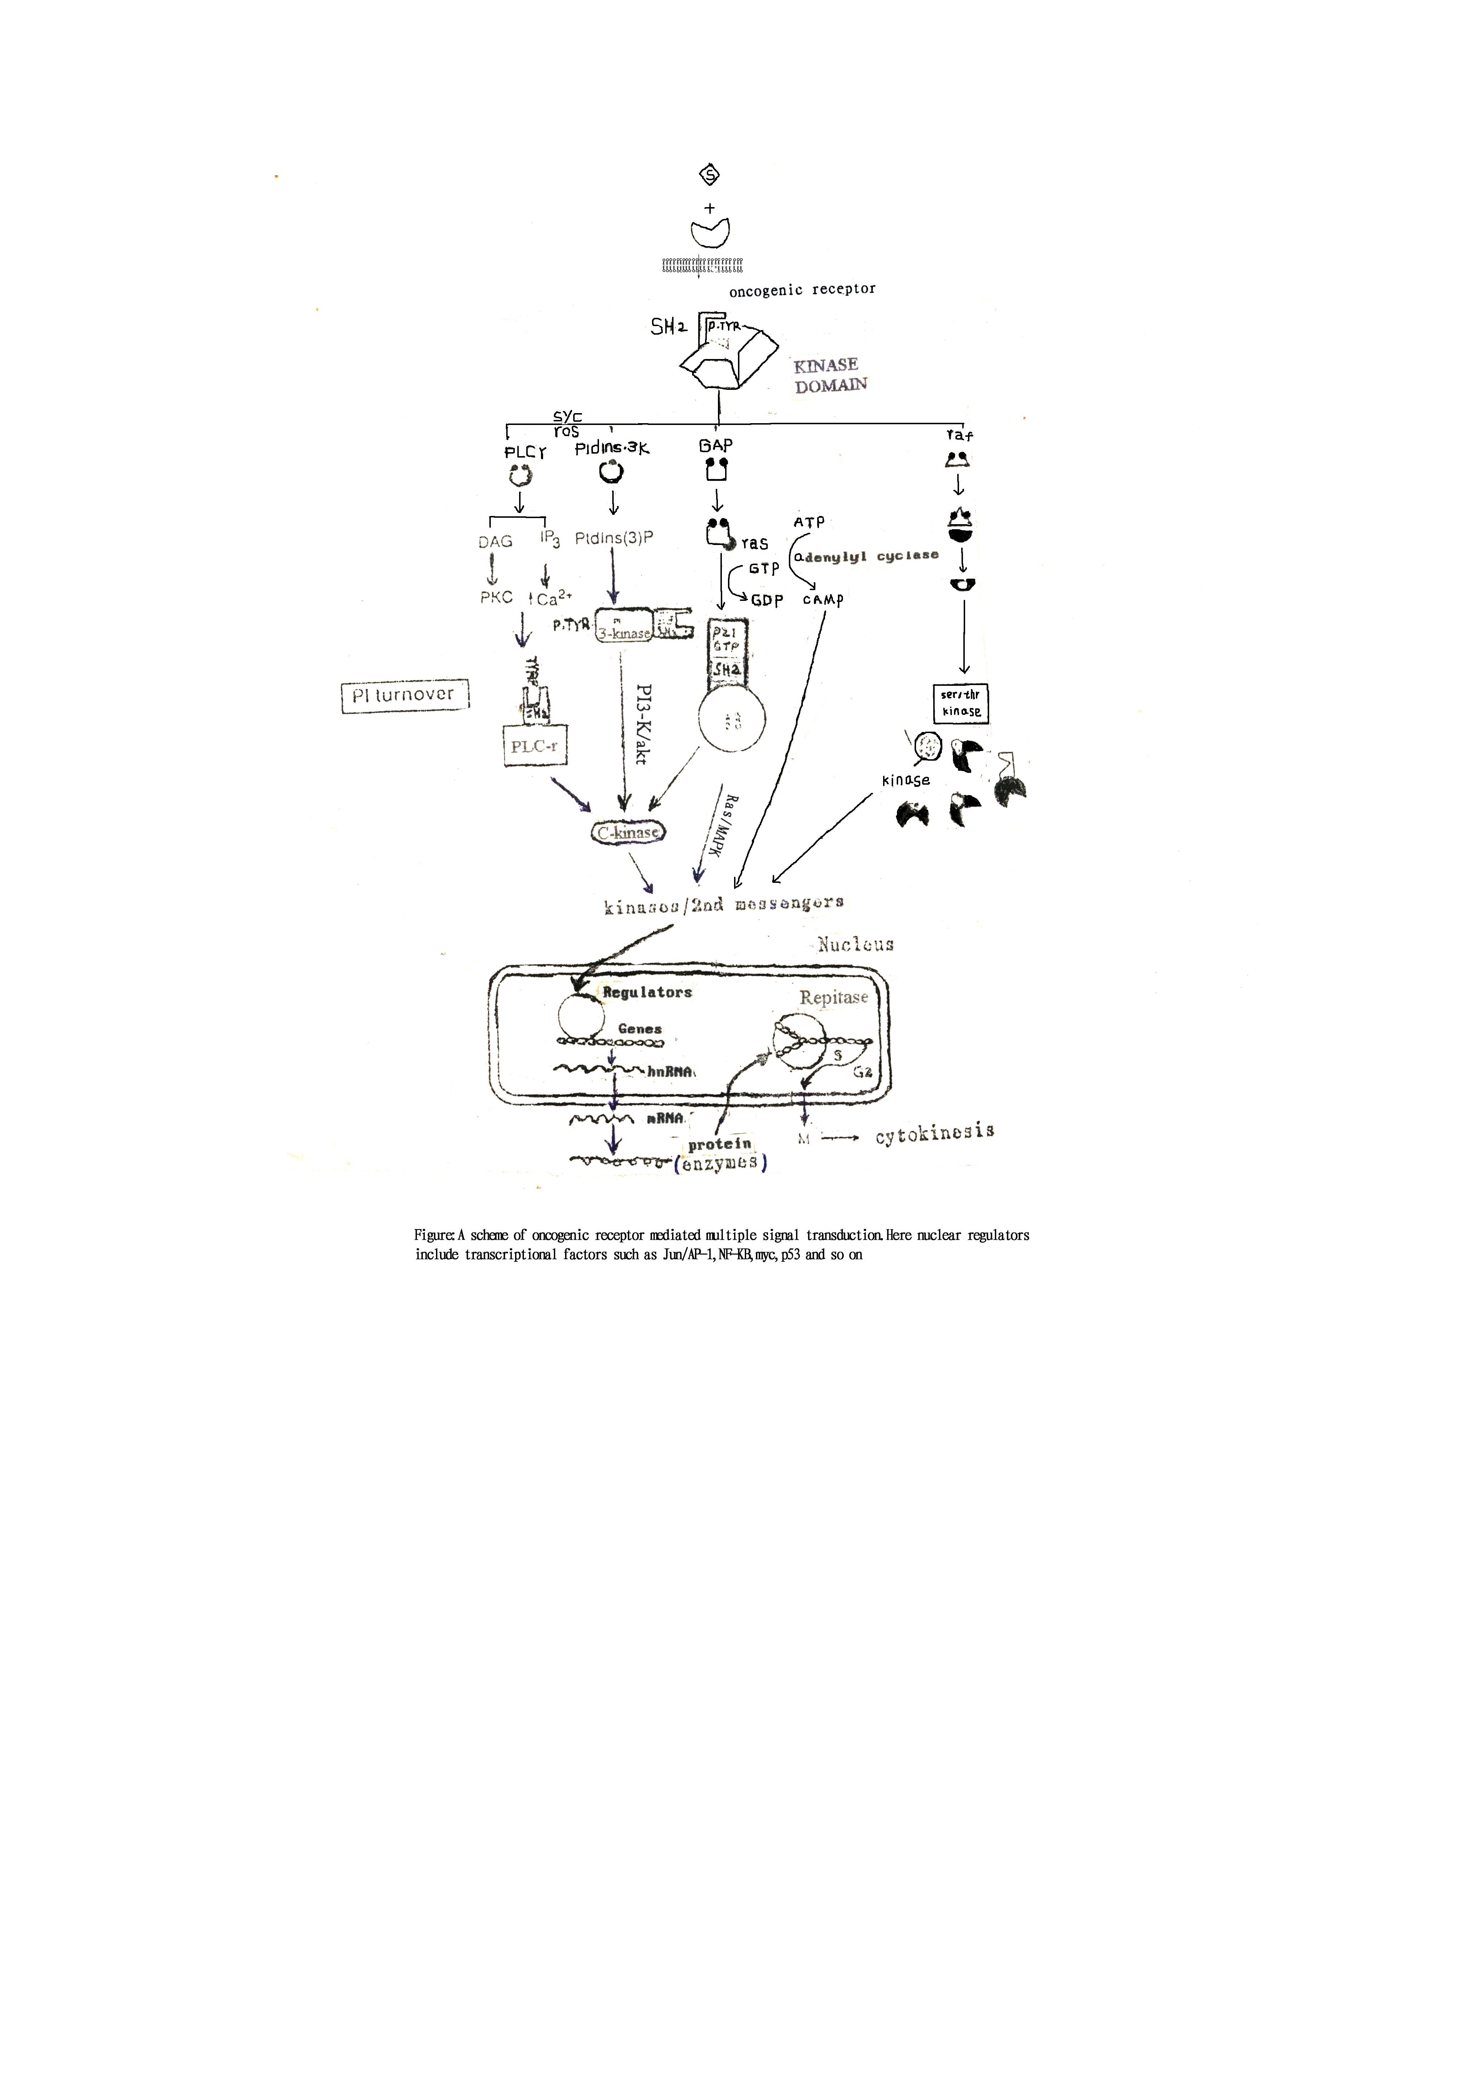



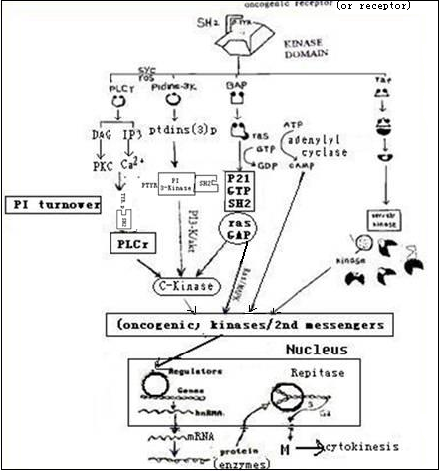

Figure 2. A Scheme of oncogenic receptor (or receptor) mediated multiple signal transduction. Here, nuclear regulators include transcriptional factors such as Jun/AP-1:Fos,NF-KB,myc,p53 and RB so on [Data from George Zhu,1986-91; Science,2002(unpublished data)]

**EpCAM/E-cadherin-catenin-actin cytoskeleton（E-cadherin-mediated adhesion）**

Adhesion molecules are known to play an important role in definiting cell fate,differentiation and other biological characteristics[50].EpCAM is a Ca2+--independent homotypic intercellular adhesion molecule[35],thereby preventing cell scattering and likely to play a role in inhibition of invasion[51].Many studies have demonstrated that cadherin colocalized with EpCAM at the basolateral membrane in epithelial cells decrease adhesions mediated by E-cadherin,a family of Ca2+--dependent homophilic cell-to-cell adhesion molecule.In epithelia,cadherins are crucial for the establishment and maintenance of epithelial cell polarity,morphogenesis of epithelial tissues,and regulation of cell proliferation and apoptosis[50]

Furthermore,the adhesion function of E-cadherin depends on their association with regulatory proteins,such as alpha- and beta-catenin[50,52].Catenins link cadherins with the actin cytoskeleton and can also form complexes with other epidermal growth factor receptor（EGFR）protein[52,53].EpCAM is able to abrogate E-cadherin- mediated cell-cell adhesion by disrupting the link between alpha-catenin and F-actin thereby loosening cell-cell adhesion and to rearrange the cytoskeleton of the cell[39].This negative effect of EpCAM expression on cadherin-mediated adhesion may explain the association of EpCAM expression with invasion and metastasis in epithelial carcinoma[41].EpCAM SiRNA treatment increased the cytoskeleton-anchored fractions of E-cadherin,alpha-catenin and beta-catenin,then markedly decreased cell migration and cell invasion in the breast cancer cell line MDA-MB-231 in vitro[41],which implicated that EpCAM as a regulator of cell adhesion is a potential novel target for breast cancer therapy.

**EpCAM/wnt-beta-catenin signaling[41,54]**

Wnt proteins are a family of highly conserved signaling molecules that regulate cell-to-cell interaction during embryogenesis. Wnt binds to receptors of the Frizzled family on the surface. Through several cytoplasmic relay components,the signal is transduced to beta-catenin,which accumulate initially in the cytoplasm,and then enters the nucleus,where it binds a lymphoid enhancer factor/T-cell factor transcriptional factor. The beta-catenin and lymphoid enhancer factor/T-cell factor complexes activate the expression of many target genes such as c-myc,VEGF and others,are known to be associated with tumor development[54].It has been demonstrated that EpCAM silencing in breast cancer cells decreased the availability of beta-catenin for the wnt pathway and then silencing the activation of its target genes[41].This notion is also supported by Yamashita[46] in patients with hepatocellular carcinoma and Kimura[45]in hepatocellular carcinoma cell lines.Their experiments uncovered that EpCAM-associated tumorigenicity in PLC/PRF/5 cells might be mediated by EpCAM-independent signaling due to the immunostaining failed to detect EpICD and EpCAM molecules in the nuclei of any cell clones from the PLC/PRF/5 cell lines[45].Moreover,the hepatic stem cell marker EpCAM knockdown in EpCAM+ cells reduces their colony-forming ability,suggesting an important role for EpCAM in the EpCAM+ cells,and,regardless of the exogenous expreasion of EpCAM,EpCAM+ clones still had higher expression of c-myc,than the EpCAM-overexpressing EpCAM- clones. Therefore,signals through EpCAM induce Wnt/beta-catenin activation might be involved to another different signaling pathway in tumorigenesis under certain condition[45,46]

**EpCAM nuclear signaling**

A highlight of new data presented by M. Munz that unravelled the entire pathway of EpCAM signalling from the cell membrane into nucleus[55].EpCAM was identified as a signal transducer[38]: regulated transmembrane proteolysis by tumor necrosis factor-alpha-converting enzyme（TACE）cleaves EpEX,and EpICD is cleaved by presenilin-2. Upon cleavage,the extracellular domain EpEX is release as a soluble ligand while the intracellular domain EpICD translocates into the cytoplasm and enter the nucleus. EpICD associates with the adaptor protein FHL2（four and a half LIM domain protein 2）,beta-catenin and the transcription factor Lef-1. This transcription complex binds the DNA at the lef-1 consensus sites inducing target genes c-myc and cyclin A and E expression[38],and drives cell proliferation. This notion is supported by the EpCAM found in nuclei of colon carcinoma but not of normal tissue[38],and HCT（colon）and MCF-7（breast）carcinoma cells[34].In addition,analysis for concomitant presence of claudin 7,Co-029,CD44V6 and EpCAM expression in the presence of all four molecules in a complex formation was initially found in colorectal cancer（CRR）and has been shown to facilitate metastasis[56].

Others,epithelial-specific Ets-1 and Sp1 play an active role in EpCAM promoter regulation [37],while transcription factor nuclear factor-kappa B（NF-KB）and p53 have been described as transcriptional repressor of EpCAM[47].TACE-dependent EGFR axis[57],Claudin-7 and claudin-1 trafficked into lysosomes[58]and presenillins mediate PI3K/akt and ERK activation via select signaling receptors[59],which present a highlight mechanism in cancer.

The emerging function of EpCAM in cell proliferation,migration and possibly cancer initiation broadens the interest to use EpCAM as an immunotarget,antibody-based clinical trials and in 2009,the European Medicines Agency approved the use of trifunctional bispecific antibody Catumaxomab,which binds to EpCAM oncogenic receptor and enhances the immunological response against EpCAM-positive cells in malignant ascites[43]. Effects of monoclonal antibody immunotherapy was initially trials on patients with gastrointestinal adenocarcinoma[60],three of 20 patients with metastasis of gastrointestinal malignancies have no detectable disease for 10,13 and 22 months due to the treatment with an anti-colorectal cancer mouse monoclonal antibody 1083-17-1A of the IgG2a immunotherapy.

In 1989-91,Zhu[1]is the first to conduct that targeting therapy is shift toward oncogenic eeceptor[also surface-to-nucleus molecular missile therapy at that period,Zhu,1980s;34,61]

In 1994,mAb17-1A（later named edrecolomab）was also the first to show clinical efficacy in a human cancer indication in terms of prolonged overall survival[62].

Now, several anti-EpCAM therapeutic antibodies have been developed（edrecolomab,ING-1, 3622W94, adecatumumab）[63].The most prominent examole is adecatumumab（MT201）,a fully human IgG1 antibody that target oncogenic EpCAM,which was well tolerated by patients with hormone-refractory prostate cancer[43]and in patients with rising prostate specific antigen（PSA）levels after radical prostatectomy[43].It is at present reaching phase III trial[64].

In preclinical study,moreover,high doses of chiHEA125-Ama（100ug/kg with respect to alpha-amanitin）administered 1 week apart,lead to complete tumor regression in 9 of 10（90%）mice,suggesting that anti-EpCAM antibody conjugates with alpha-amanitin have the potential to be highly effective therapeutic agents for pancreatic carcinoma and various EpCAM-expressing malignancies[43].Targeting EpCAM oncogenic receptor might be a promising approach to stop tumor initiation,invasion and progression.

**References**

1.Zhu G. Oncogenic receptor hypothesis(1989-91). Voice of America(VOA),1992,12:31

2.Green S,Chambon P. Carcinogenesis:A superfamily of potentially oncogenic hormone receptors. Nature,1986,324:615-617

3.Zhu G,Musumeci F,Byrne P. Induction of thyroid neoplasm following plant medicine marine algae(sargassum）: A rare case and literature. Curr Pharm Biotechnol,2013,14:859-863

4.Singh RR,Kumar R. Steroid hormone receptor signaling in tumorigenesis.  J Cell Biochem,2005,96:490-505

5.Robinson R. Tumor cells share oncogenic receptors. J Cell Biol,2008,181:570

6.Neil JC,Fulton R,McFarlane R,Rigby M,Stewart M,Terry A,etal. Receptor-mediated leukemogenesis:hypothesis revisted. Br J Cancer Suppl,1988,9:76-79

7.Zhu G,Saboor-Yaraghi AA,Yarden Y,Santos J and Neil JC. Downregulating oncogenic receptor:From bench to clinic.  Hematol Med Oncol,2016,1（1）:30-40

8.Al-Nedawi K,Meehan B,Micallef J,etal. Intracellular transfer of the oncogenic receptor EGFRvIII by microvesicles derived from tumor cells. Nat Cell Biol, 2008,10:619-24

9.Miltra S,Han S,Soderstram K,Wong A. Preferential expression of an oncogenic receptor in brain tumor stem cells. Identification and targeting using an engineered antibody.  Cancer Res,2012,p:72

10.Hembrough T,Thyparambil S,Liao WL,Darfler M,Krizman D,etal. Qantitative multiplexed SRM analysis of oncogenic receptors in FFPE colorectal carcinoma tissue.  Cancer Res,2012,72（8）:5537

11.Konduri K,Gallant JN,Chae YK,Giles PS,Gitlitz BJ,etal. EGFR fusions as novel therapeutic targets in lung cancer.  Cancer Discov,2016,6:601-11

12.Gabitova L,Gorin A,Astsaturov I. Molecular pathways:sterols and receptor signaling on cancer. Clin Cancer Res,2014,20:28-34

13.Duarte HO,Bolmafia M,Mereiter S,Osorio H,Gomes J,and Reis CA. Gastric cancer cell glycosylation as a modulator of the ErbB2 oncogenic receptor. Int J Med Sci,2017,18（11）:2262

14.Staudt LM. Therapeutic strategies in lymphoma based on oncogenic B receptor and MYD signaling. International Symposium on childhood,2012,1:1

15.Conway-Campbell BL,Wooh JW,Brooks AJ,etal. Nuclear targeting of the growth hormone receptor results in dysregulation of cell proliferation and tumorigenesis.  Proc Natl Acad Sci USA,2007,104:13331-13336

16.Longmore GD,Pharr P,Neumann D,etal. Both megakaryocytopoiesis and erythropoiesis are induced in mice infected with a tretrovirus expressing an oncogenic erythropoietin receptor.  Blood,1993,82（8）:2386-95

17.Russell LJ,De Cadtro DG,Griffiths M,etal. A novel translocation,t（14;19）（q32;p13）,involving IGH and the cytokine receptor for erythropoietin.  Leukemia,2009,23:614-617

18.Maxson JE,Gollib J,Pollyea DA,etal. Oncogenic CSF3R mutations in chronic neutrophilic leukemia and atypical CML.   N Engl J Med,2013,368:1781-90

19.Merchant JL. What lurks beneath: IL-11,via stat-3,promotes inflammation-associated gastric tumorigenesis. J Clin Invest,2008,118（5）:1628-31

20.Ernst M,Najdovska M,Grail D,etal. STAT3 and STAT1 mediate IL-11-dependent and inflammation-associated gastric tumorigenesis in gp130 receptor mutant mice. J Clin Invest,2008,118:1727-38

21.Park JW,Zhao L,Willingham M,and Cheng SY. Oncogenic mutations of thyroid hormone receptor beta. Oncotarget,2015,6（10）:8115-31

22.Zhu G,Mische E,Seigneres B. Novel treatment of acute promyelocytic leukemia:As2O3,retinoic acid and retinoid pharmacology. Curr Phar Biotechnol,2013,124:849-858

23.Hauksdotti H,Privalsky ML.DNA recognition by the aberrant retinoic acid receptor implicated in human acute promyelocytic leukemia. Cell Growth Differ, 2001,12:85-98

24.Berger R,Febbo PG,Majumder PK,Zhao JJ,Mukherjee S,etal. Androgen-induced differentiation and tumorigenicity of human prostate epithelial cells.  Cancer Res,2004,64:8867-8875

25.Paltoglous S,Das R,Townley SL,etal. Novel androgen receptot co-regulator GRHL2 exerts both oncogenic and antimetastatic functions in prostate cancer.  Cancer Res,May 4,2017,DOI:10.1158/ 0008-5472 CAN-16-1616

26.Ludwik KA,McDonald OG,Brenin DR,etal. ERalpha-mediated nuclear sequestration of RSK2 is required for ER+ breast cancer tumorigenesis.  Cancer Res,January 18,2018 DOI:10.1158/0008-5472 CAN-17-2063

27..EI-shennawy I,Dubrovskyi O,Kastrati I,etal. Coactivation of estrogen receptor and IKKbeta induces a dormant metastatic phenotype in ER-positive breast cancer.  Cancer Res,2017,78（4）:1-11.

28.Veeraraghavan J,Tan Y,Cao XX,etal.Recurrent ESR-CCDC170 rearrangement in an aggressive subset of oestrogen receptor-positive breast cancer. Nat Commun,2014,5:4577

29.Varricchio L, The dominant negative beta isoform of the glucocorticoid receptor is uniquely expressed in erythroid cells expanded from polycythemia vera patients.  Blood,2011,118:425-

30.Melhem A,Yamada SD,Fleming GF,Delgado B,Brickley DR,etal. Administration of glucocorticoids to ovarian cancer patients is associated with expression of the anti-apoptotic genes SGK1 and MKP1/DUSP1 in ovarian tissues.  Clin Cancer Res,2009,15:3196-3204

31.Ebisawa T,Tojo K,Tajima N,Kamio M,Oki Y,etal. Immunohistochemical analysis of 11-beta-hydroxysteroid dehydrogenase type 2 and glucocorticoid receptor in subclinical Cushing's disease due to pituitary macroadenoma.  Endocrine Pathology,2008,19:252-260

32.Murray E,Hernychova L,Scigelova M,etal. Quantative proteomic profiling of pleomorphic human sarcoma identifies CLIC1 as a dominant pro-oncogenic receptor expressed in diverse sarcoma types.  Journal of Proteome Research,2014,13:2543-59

33.Zhao Y. The oncogenic functions of nicotinic acetylcholine receptors.  Journal of Oncology,2016（3）:1-9

34.Denzel S,Maetzel D,Mack B,etal. Initial activation of EpCAM cleavage via cell-to-cell contact. BMC Cancer,2009,9:402

35.Litvinov SV,Bakker HA,Gourevitch,etal.Evidence for a role of the epithelial glycoprotein 40（ EpCAM）in epithelial cell-cell adhesion. Cell Adhes Commun,1994,2:417-28

36.Herlyn D,Herly M,Ross AH,etal. Effective selection of human tumors growth-inhibiting monoclonal antibodies. J Immunol Methods,1984,72:157-67

37.Baeuerle PA and Gires O. EpCAM（CD326）finding its role in cancer. Br J Cancer,2007,96（3）:417-23

38.Maetzel D,Denzel S,Mack B,etal. Nuclear signalling by tumour-associated antigen EpCAM. Nat Cell Biol,2009,11:162-71

39.Winter MJ,etal. Expression of EpCAM shifts the state of cadherin mediated adherins from strong to weak.  Exp Cell Res,2003,285:50-58

40.Went P,etal. Frequent high-level expression of the immunotherapeutic target Ep-CAM in colon,stomach,prostate and lung cancers. Br J Cancer,2006,94:128-35

41.Osta WA,Chen Y,Mikhitarian K,etal. EpCAM is overexpressed in breast cancer and is a potential target for breast cancer gene therapy. Cancer Res,2004,64:5818-24

42.Spizzo G,Went P,Dirnhofer S,etal. High Ep-CAM expression is associated with poor prognosis in node-positive breast cancer. Breast Cancer Res Treat,2004,86:207-213

43.Moldenhauer G,Salnikov AV,Luttgau S,etal.Therapeutic potential of amanitin-conjugated anti-epithelial cell adhension molecule monoclonal antibody agonist pancreatic carcinoma. J Natl Cancer Inst,2012,104:622-34

44.Ng VY,Ang SN,Chan JX,Choo AB. Characterization of epithelial cell adhesion molecule as a surface marker on undifferentiated human embryonic stem cells. Stem Cells,2009,

45.Kimura O,Takahashi T,Ishii N,etal. Characterization of the epithelial cell adhesion molecule（EpCAM）+cell population in hepatocellular carcinoma cell lines. Cancer Science, 101, 2145 -55,2010

46.Yamashita T,Budhu A,Forgues M,etal.Activation of hepatic stem cell marker EpCAM by Wnt-beta-catenin signalling in hepatocellular carcinoma. Cancer Res,2007,67:10831-10839

47.van der Gun BTF,Melchers LJ,Ruiters MHJ,de Leij LFMH,McLaughlin PMJ,etal. EpCAM in carcinogenesis:the good,the bad or the ugly.  Carcinogenesis,2010 Nov,31（11）:1913-21

48.Matsumoto T. Proliferating EpCAM-positive ductal cells in the inflamed liver give rise to hepatocellular carcinoma.  Cancer Res,Nov 2,2017,DOI:10.1158/0008-5472 CAN-17-1800

49.Ensinger C,Kremser R,Prommegger R,etal. EpCAM overexpression in thyroid carcinomas:a histological study of 121 cases. Journal of Immunotherapy,2006,29:569

50.Gumbiner BM. Cell adhesion:the molecular basis of tissue artchitecture and morphogenesis. Cell,1996,84:345-57

51.Basak S,etal. Colorectal carcinoma invasion inhibition by Co17-1A/GA733 antigen and its murine homologue.  J Natl Cancer Inst,1998,90:691-97

52.Takeichi M,Hatta K,Nose A,etal. Cadherin-mediated specific cell adhesion and animal morphogenesis. Ciba Found Sym, 1989,144:243-9;discussion 2504,2505

53.Hosthuetzky H,Aberle A,Kemier R. Beta-catenin mediates the interaction of the cadherin-catenin complex with epidermal growth factor receptor. J Cell Biol,1994,127:1375-80

54.Huelsken J,Behrens J. The Wnt signalling pathway. J Cell Sci,2002,115:3977-8

55.Munz M,etal.The carcinoma-associated antigen EpCAM uregulates c-myc and induces cell proliferation. Oncogene,2004,23:5748-58

56.Kuhn S,Koch M,Nubel T,Ladwein M,Antolovic D,Klingbeil P,etal. A complex of EpCAM,claudin-7,CD44 variant isoforms,and tetraspanins promotes colorectal cancer progression.  Mol Cancer Res,2007,5（6）:553-567

57.Kenny PA & Bissell MJ. Targeting TACE-dependent EGFR ligand shedding in breast cancer. J Clin

Invest,2007,117:337-345

58.Wu CJ,Mannan P,Lu M,etal. Epithelial cell adhesion molecule（EpCAM）regulates claudin dynamics and tight junctiond. The journal of biological chemistry,2013,288:12253-68

59.Kang DE,etal. Presenilins mediate phosphatidylinositol 3-kinase/AKT and ERK activation via select signalling receptors. Selectivity of PS2 in platelet-derived growth factor signalling. J Biol Chem,2005,280:31537-547

60.Sears HF,Herlyn D,Steplwski Z,etal.Effects of monoclonal antibody immunotherapy on patients with gastrointestinal adenocarcinoma J Biol Response Med,1984,3:138-50

61.Carpenter G,Red Brewer M:EpCAM:another surface-to-nucleus missile. Cancer Cell,2009,15:165-66

62.Riethmuller G,Holz E,Schlimok G,Schmiegel W,Raab R,etal. Monoclonal antibody therapy for resected Dukes' colorectal cancer:seven-year outcome of a multicenter randomized trial. J Clin Oncol,1998,16:1788-94

63.Adkins JC,Spencer CM. Edrecolomab（monoclonal antibody 17-1A）. Drugs,56:619-26;discussion 6278,1998

64.Kurtz JE,Dufour P. Adecatumumab:an anti-EpCAM monoclonal antibody,from the bench to the bedside.  Expert Opin Biol Ther,2010,10（6）:951-8