**Reviewer’s Comments**

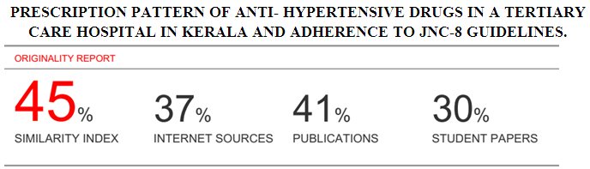

**PRESCRIPTION PATTERN OF ANTI- HYPERTENSIVE DRUGS IN A TERTIARY CARE HOSPITAL IN KERALA AND ADHERENCE TO JNC-8 GUIDELINES.**

**Abstract**

**Objective**: Hypertension is a leading contributor to the global burden of cardiovascular morbidity and mortality. The objective of this study is to investigate utilization pattern of antihypertensive drugs in hypertensive patients and to find its adherence to JNC-8 guidelines for management of hypertension.

**Materials and Methods**: Descriptive drug utilization study was conducted on 266 hypertensive patients for period of 3 months. Data retrieved from patients medical record. The study included all hypertensive patients with or without co-morbidities and above 18 years who attended out patient department.

**Results**: Following classes of antihypertensive drugs were analysed: Angiotensin converting enzyme inhibitors, Angiotensin Receptor blockers, Beta Blockers,Calcium Channel Blockers , Diuretics. Out of 266 patients, 57.5% were males and 42.5% female patients indicating higher prevalence in male population.54.5% and 42.9% of total hypertensive patients belonged to age group above 60 years and 40-60 years respectively. 59% of the total population received combination therapy.40.9% received monotherapy. ACEI/ARB was mostly prescribed which is in adherence to JNC-8 guidelines which recommends the use of ACEI/ARB as the first choice of drug.

**Conclusion**: Hypertension is more prevalent in males than in females. ACEI/ARB are the most frequently prescribed classes of drugs alone or in combination, supporting the medication adherence to JNC-8 guidelines.

KEY WORDS:Antihypertensive drugs,Drug utilization, Hypertension,JNC-8 Guidelines,

Prescription Pattern

**Introduction**

Hypertension is a leading contributor to the global burden of cardiovascular morbidity and mortality. Worldwide prevalence of hypertension is estimated to be as large as one billion and its prevalence is predicted to increase by approximately 60% by 2025.It vary from 4-15% in urban and 2-8% in rural population. Apart from unhealthy lifestyles, lack of awareness, distorted public health systems, physicians treating hypertension also lag behind when compared to standard guidelines. Non-compliance to antihypertensive therapy is also a reason for uncontrolled hypertension. Hypertension is now a strongest modifiable risk factor for Myocardial Infarction, Stroke, heart failure, Chronic kidney diseases and Retinopathy.

Treatment of Hypertension is constantly evolving in response to new evidence published and newer drugs are added at rapid pace. The resultant changes in drug use in time and place may have medical,social and economic implications both for individual patient and for populations3,4.

Recommendations of various guidelines are available for their treatment, one such guideline is JNC 7 which recommends the rationale administration of drugs by providing algorithms for the treatment as per stages of hypertension5. Hypertension is divided into four categories: normal, Pre-hypertension, Stage 1 HTN and Stage 2 HTN6.

JNC8 recommended four medication classes for Hypertension treatment in the general population with thiazide-type diuretics being first line therapy. Recommended classes are thiazide-type diuretics, calcium channel blockers, angiotensin-covering enzyme inhibitors and angiotensin receptor blockers6.

Following study is designed to assess the current trend of the prescription pattern of antihypertensive drugs and to determine the adherence to JNC8 guidelines. This kind of medical audit can help to make prescription pattern more rational and prudent and thereby improve patient health care.

**Materials and Method**

The observational, prospective study was carried out at Azeezia Medical Hospital, Kollam where data regarding the antihypertensive drugs prescribed were collected. The study was approved by Institutional Human Ethical Committee of Azeezia Institute of Medical Sciences & Research, Kollam

**Study design**: This study was observational prospective conducted over 3 months period from May 2016 to July 2016 for assessing prescription pattern and drug utilization study of antihypertensive in the management of hypertension and its adherence to JNC8 Guidelines.

**Study setting**: The study was carried out in the outpatient department of Azeezia Medical Hospital, Kollam for collection of data.

**Study Population**: The study included all hypertensive patients.Inclusion criteria were 1)Age above 18years, 2) Patients with co- morbidities such as Diabetes, risk of cardiovascular disease, Chronic Kidney diseases and Bronchial Asthma. Exclusion criteria were1)Patients with terminal illness.

**Data Collection**: All necessary and relevant information were collected from patients medical records. The data were filled in the proforma prepared which was approved by the Institutional Ethics Committee.The JNC8 Guidelines for the adherence were studied by taking into consideration that the drugs recommended as the first line therapy by JNC8 should be the most frequently prescribed class of drugs and should have high utilization pattern among the patients.

**Statistical Data Analysis**: The data was analysed using SPSS software. A Pvalue 0.05 was declared as statistically significant.

**Results and Discussion**

The results of this analysis shows that out of 266 hypertensive patients included, 57.5% were males while remaining 42.5% were females. This indicates the higher prevalence of hypertension among male population when compared to female.

**Chart 01: Number of patient in each sex groups**

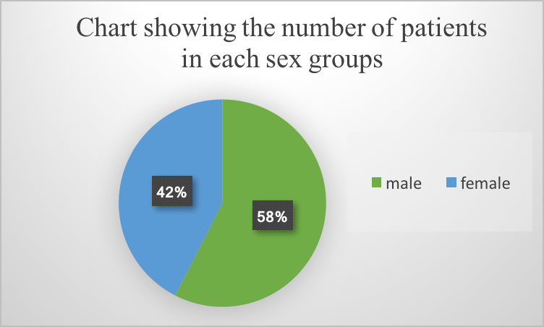

42.9% of people and 54.5% of hypertensive patients were from age group between 45-65 years and above 65 years respectively. Only 7 patients out of 266 (2.6%) were from age group less than 45 years. This data suggests the prevalence of hypertension as the age increases.

**Table 1: Age Distribution of patient**

|  |  |  |
| --- | --- | --- |
| **Age Groups**  **(Years)** | **Number of patient**  **(n = 266)** | **% of patient in each group** |
| Below 45 years | 7 | 26% |
| 45-65 years | 114 | 42.9% |
| Above 65 years | 145 | 54.5% |

Out of 266 , 78.2% of hypertensive patients were found to have other co –morbid conditions. Among the total 208, maximum patients were having diabetes mellitus followed by cardiovascular and kidney disease.

**Table 02: Distribution of patients with co – morbidities**

|  |  |  |
| --- | --- | --- |
| **Co- morbidities** | **Number of patient**  **(n = 208)** | **Percentage distribution** |
| Diabetes | 101 | 48.5% |
| CVD | 64 | 31.2% |
| CKD | 43 | 20.6% |

Considering out of the total 266 patients,109(40.9%) patients received monotherapy while the remaining were put on multidrug regimen. 95 (35.8%) patients were on 2 drug therapy and 62(23.3%) were on 3 drug regimen.

**Chart 02: Type of therapy taken by hypertensive patients**

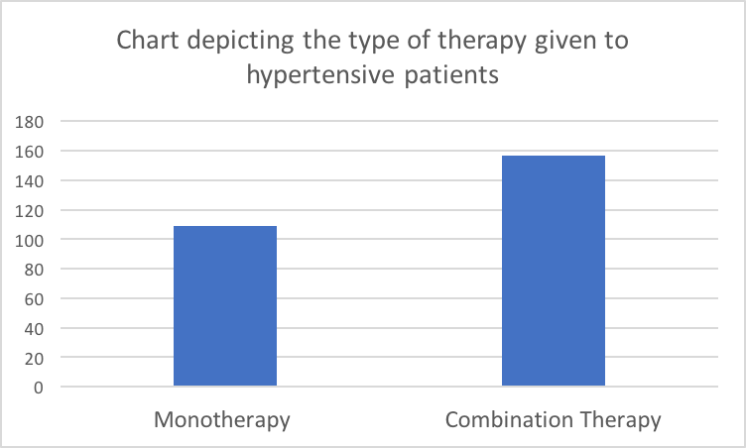

Among the monotherapy, maximum patients were on ARB/ACEI with 31.2% followed with calcium channel blockers with 5.6% and diuretic (4.1%). As a monotherapy Losartan was the most frequently prescribed drug along with Thiazides, Metopropolol.

**Table 03:Utilization pattern of antihypertensive as monotherapy**

|  |  |  |
| --- | --- | --- |
| **Drug** | **Number of patients**  **(n = 109)** | **Percentage Distribution** |
| ARB/ACEI | 83 | 31.2% |
| Diuretics | 11 | 4.1% |
| Calcium channel blockers | 15 | 5.6% |

**Table 04: Utilization pattern of antihypertensive class of drugs**

|  |  |  |
| --- | --- | --- |
| **Type of treatment** | **Number of patients** | **Percentage Distribution** |
| Monotherapy | 109 | 40.9% |
| 2 Drug Combination | 95 | 35.8% |
| 3 Drug Combination | 62 | 23.3% |

The prescription pattern of these antihypertensives were found to be considerately in adherence to Eighth report of Joint National Committee (JNC 8) for prevention, detection , evaluation and treatment of hypertension , which recommends that the choice of treatment for initial hypertension should be ACEI/ARBS , Thiazides, CCBs, BBs alone or in combination may also be preferred. Interview of patients or their representatives suggested that patient compliance to the medication was moderate and was better in females when compared to males

The results of this study suggests that hypertension is more prevalent in males, compared to females.The above pattern is same as the results of analogous study (Jhaj et al.,2001; Malhotra et al.,2001; Krishna Murti et al.,2015) in India. However, the above pattern is same to other studies conducted by (Tiwari et al.,2004) in India, Pittrow et al (2004) in Germany have reported higher incidence of hypertension in females than in males.

This study also reveals that hypertension is more prevalent in elderly patients belonging to age groups 45-65 or more. It also shows that most frequently prescribed classes of drugs were ACEI/ARB alone or in combination.

Since the eighth report of Joint National Committee (JNC8) on detection, evaluation prevention and treatment recommends the use of ACEI/ARB for management of early stage hypertension alone or in combination with other classes, thus suggesting that the above trends is in conformity to the recommendations of JNC 8 guidelines.

Hence this drug utilization data corroborated adherence to JNC 8 guidelines. Among the 2 drug regimen Diuretics + ACEI/ARBSs is the most widely prescribed regimen, While ACEIs/ARBs + CCBs+ Diuretics was the most frequently prescribed three drug regimen.

**Conclusion**

The study concludes that the hypertension is more prevalent in males than in females, with its prevalence increasing with age. ACEIs/ARBs are the most frequently prescribed classes of drugs alone or in combination, supporting the medication adherence to JNC guidelines. Since the prevalence of hypertension depends upon ethnicity, genetic, environmental and physiological factors, therefore further research is critically needed to set up a rationale or pattern for the choice of medication; on the basis of above mentioned factors.

**Conflict of Result**

We declare that we have no conflict of interest.

**Ethics**

This article is original and contains unpublished material. The corresponding author confirms that all of the authors have read and approved the manuscript and no ethical issues involved.

**References**:

1. Johnston A, Stafylas P and Stergiou GS.(2010): Effectiveness, safety and cost of drug substitution in hypertension; BJCP,70(1): 320-334

2. Kearney PM, Whelton M, Reynolds K, Muntner P.(2005):Global burden of hypertension: analysis of worldwide data;Lancet ,36(5): 217-223

3. Khan N A, Hemmelgarn B, Herman RJ, Rabkin SW et al.(2008): Canadian Hypertension education Program; Can J Cardiol, 24(6): 465-75

4. Sharminder K, Seema G, Dinesh K, Mohan L, Zahid G(2012): Prescription pattern of antihypertensive drugs in a tertiary care hospital in Jammu- A descriptive study; JK-Practitioner,17(4):38-41

5. JNC8 hypertension algorithm:

<http://www.nmhs.net/documents/27JNC8HTNGuidelinesBook>; accessed on 29 March 2016

6.Kayce B, June T, Bernie RO: Hypertension-the silent killer,updated JNC8 guideline recommendations; Summer 2015-continuing education/www.aparx.com accessed on 29 march 2016