**Reviewer’s Comments**

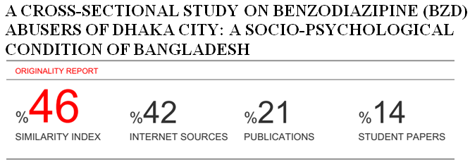

**A CROSS-SECTIONAL STUDY ON BENZODIAZIPINE (BZD) ABUSERS OF DHAKA CITY: A SOCIO-PSYCHOLOGICAL CONDITION OF BANGLADESH.**

**ABSTRACT** Benzodiazepines (BZD) are highly potential drug for abuse among the most frequently prescribed medicine. Different studies say that young-adults are the vulnerable population of BZD misuse in Bangladesh. The aim of the study was designed to evaluate the BZD drug abuser with relation to its impact on socio-psychological condition of Dhaka city. A cross sectional study consisted of 468 current BZD users. The participants were chosen randomly. Structured questionnaires included participant’s personal information; drug use characteristics; physiological and psychological effects of drugs. Verbal consent was taken from each respondent. In this study, 96.15% were male where 40.39 % of respondents were from the age group 23-27 years. 57.70 % participants were single. Here, 34.62 % were student, 40.38 % had monthly family income above 50,000 BDT. BZD was used to relive from stress/pressure by 23.07%, from insomnia by 13.46% of respondents. The drug of choice was diazepam for 44.24% respondents. Most of the users (44.23%) were influenced by friends. 32.69% participant concomitantly used BZD with YABA. The common problem was amnesia, confusion and difficulty in cognition. The withdrawal effects were rebound insomnia, anxiety, headache; restlessness and so on. Drug abuse is a serious public health problem worldwide. Therefore, these findings may help Government or policymakers to take initiative for drug addict. Moreover, there is need of further research on these topics in different area of Bangladesh to get the complete scenario of drug abuse, especially BZD abuse.

***Keywords:*** Benzodiazepines (BZD), Drug abuser, Drug misuse, Withdrawal effects.

**INTRODUCTION** Benzodiazepines (BZD) are psychoactive drugs, used to treat anxiety and sleep disorders as a first line drug therapy. Anxiolytic, sedative, hypnotic, anti convulsant, muscle relaxants are common pharmacological actions. Generally, it is prescribed to the patient in a low to medium doses. Though BZD are central nervous system depressants, inappropriate and unnecessary uses can cause physical and psychological dependence, which is related to public health issue1.

Misuse and abuse of BZD is a serious public health problem in Bangladesh, now a day. Many Pharmaceutical Industries manufacturing BZD in large scale and distributes all over Bangladesh. Expert says that the main illicit drugs are cannabis, heroin and amphetamine-type stimulants (Yaba) in Bangladesh2. However, there is no recent authentic source of data to assess the severity of the problem and the associated factors of BZD misuse.

A study conducted by the International Centre for Diarrhoeal Disease Research, Bangladesh (ICDDR, B) shows that 79.4% of the drug users are male in Dhaka city, 64.8% of the drug users are unmarried, 56.1% are either students or unemployed, and 95.4% are smokers. 85.7% get into consuming drugs under the influence of friends, while 65.8% get addicted to various codeine-laced cough syrups in Bangladesh3.

Misuse of Pharmaceutical is a relatively international experience. Among the most frequently prescribed psychotropic drug, BZD is in top in the world. In USA, South Asia and in Africa, BZD abuse has reached in alarming position2.In Western Europe and North America, use of illicit substances becomes a great concern for large numbers of young people. Moreover, in UK, rate of alcohol and drug users are higher than those reported in outside of Europe4.World Drug Report in 2006 mentioned the non medical use of BZD abuse and dependence remains serious problems in many countries with social and economic consequences5.

As drug abuse is directly related to the socio economic condition of many countries, so this study was designed to collect some data that will help regulatory authority to focus on particular issue.

**MATERIALS AND METHOD**

***Study design & Study Population***

A cross sectional study was done among the BZD users. Where data was collected through face-to-face interviews with a structured questionnaire. The target population were all those who used non-prescription drugs BZD alone or with other drugs. A total number of 468 participants, who were living in different area of Dhaka city, were included in this study. The age range of the participants was 18-37 years old. The duration of collecting data was 2 years (from January, 2015 to December, 2016). Participants were randomly chosen.

As the research focuses on sedative-hypnotics (BZD) drug users, so researcher had to take the support from dispensary, drug seller, sometimes doctors, rehabilitation centers to get the study sample. Personal communication was also played an important role to conduct the study.

***Data collection method***

The structured questionnaire had different segments and accordingly interviewed to participants. The respondents were asked to give the detail information regarding socio-demographic profile with smoking habit. Then asked for participants’ chronic disease, frequency and duration of drug use, purpose of the drug use, name of the drug use, history of multiple drug use and recommended by whom etc. Then also asked for problems (physical and psychological) faced in current context after taking the drug, and withdrawal effect.

This paper consisted of multiple choice and open answer question. After explaining the purpose of the study to the respondents individually and observed about their willingness to participate and with their verbal consent, the researcher interviewed all the respondents by asking questions in Bengali and completing the question paper in English.

***Data analysis***

All the data were checked after collection. Then data were entered into computer from paper format and results were calculated with Microsoft® Excel (97-2003).

**RESULTS**

***Socio-demographic profile of respondents***

Table: 1 shows the socio-demographic characteristics of the respondents. Out of 468 respondents, 96.15% were male and 3.85% were female. Most of the respondents (40.39% & 36.54%) were coming from the age group 23-27 and 28-32 years. Single respondents were 57.70% and married were 40.38%. The educational qualification of the respondents was maximum in university level (48.08%, either completed the course or continuing), then 25% respondents were from higher secondary level and 1.92% was illiterate. Out of 468 participants, student respondents were 34.62% and 28.85% were in service and 17.31% were business people. Therefore, we can say that most of the respondents didn’t have any financial crisis. Above 50,000 (BDT) were monthly family income of the 40.38% respondents. Then, 13.46% respondents have monthly family income was 10,000-20,000 (BDT).

**Table 1: Socio-demographic profile & smoking habit of the respondents.**

|  |  |  |
| --- | --- | --- |
| **Different Variables** | **Frequency** | **Percentage (%)** |
| **Gender** | | |
| Male | 450 | 96.15 |
| Female | 18 | 3.85 |
| **Age Group** | | |
| 18-22 | 81 | 17.31 |
| 23-27 | 189 | 40.39 |
| 28-32 | 171 | 36.54 |
| 33-37 | 27 | 5.76 |
| **Marital Status** | | |
| Single | 270 | 57.70 |
| Married | 189 | 40.38 |
| Divorced | 9 | 1.92 |
| **Level of Education** | | |
| Primary | 36 | 7.69 |
| School | 81 | 17.31 |
| College | 117 | 25.00 |
| University | 225 | 48.08 |
| Illiterate | 9 | 1.92 |
| **Occupation** | | |
| Student | 162 | 34.62 |
| Service | 135 | 28.85 |
| Business | 81 | 17.31 |
| Garment worker | 45 | 9.61 |
| Unemployed | 36 | 7.68 |
| Housewife | 9 | 1.92 |
| **Monthly Family Income (BDT)** | | |
| Below 10000 | 36 | 7.69 |
| 10000-20000 | 63 | 13.46 |
| 20000-35000 | 90 | 1.92 |
| 25000-50000 | 90 | 1.92 |
| Above 50000 | 189 | 40.38 |
| **Smoking** | | |
| Non-smoker | 207 | 44.23 |
| Smoker | 153 | 32.69 |
| Chain-smoker | 108 | 23.08 |

***Health Status of the Respondents***

More than half (55.77%, 261/468) of the drug users were smoker (32.69%, 153/468) and chain smoker (23.08%, 108/468) (Table: 1). Among all the participants, 76.92% had no chronic disease. Hypertension, GIT disorder and diabetes mellitus was found 13.47%, 7.69% and 1.92% of the participants respectively. Figure: 1 presented the remarkable number of side effects when the users started to taking BZD. Each of 54 users had confusion and fatigue, each of 45 users had anxiety and drowsiness, 36 users had insomnia, 27 users had constipation, 18 users had some other side effects and no side effects were found in majority number of respondents (n=189).

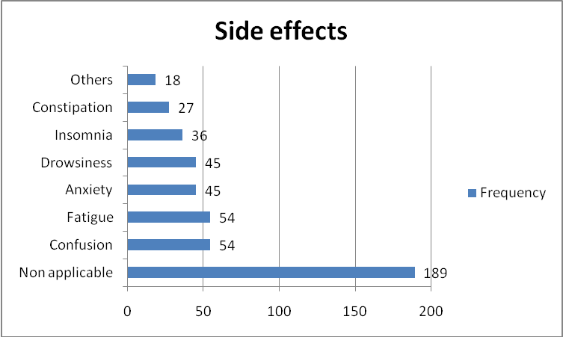

**Figure 1:** **Different side effects of the respondents.**

***Drug Use Characteristics of Respondents***

Most of the respondents (23.07%, 108/468) were taken drug to relieve from stress/pressure, 63(13.46%) were taken to relieve from insomnia, 63(13.46%) were taken to increase the working activity, 54(11.53%) were taken to increase their confidence level, 45(9.61%) were taken to get sound sleep, 36(7.69%) of each were taken for relieve anxiety, depression and to get pleasure; 27(5.76%) were taken the drug for no reason.

Figure 2 presents the percentage of the different drugs taking by the respondents. Majority were taken diazepam (44.24%), then clonazepam (19.24%), then bromazepam (13.47%) and so on. In daily basis, 99(21.15%) respondents were taken drugs, 81(17.31%) were taken almost daily, 108(23.08%) were taken according to their need and highest respondents 135(28.85%) were taken drugs three times in a week. Lastly, there was no fixed time for 9(1.92%) respondents to take drug. Maximum 48 months and minimum 6 months, were the duration for taking drugs by the respondents are shown in (Figure 3).

Most of the drug users were influenced by friends (44.23%, 207/468), recommended by doctor (11.54%, 54/468), by verbal communication with medicine seller/pharmacist (9.60%, 50/468), by their colleague (3.85%, 18/468) and by their family member (3.85%, 18/468). Self medication was done by (19.23%, 90/468) respondents.

Multiple illicit drug use pattern are shown in Table: 2. Majority respondents were taken BZD with YABA (32.69%), then with marijuana (21.15%), with alcohol (17.30%) and with phensedyl (5.76%).

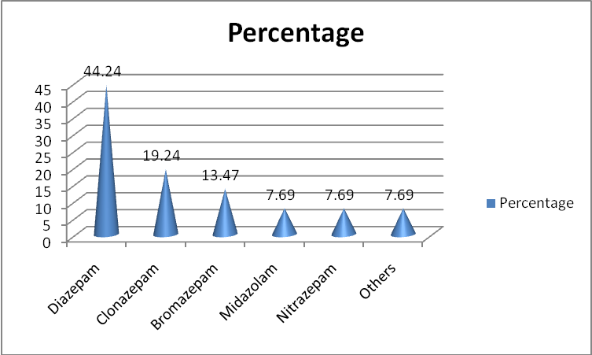

**Figure 2:** **Uses of different drugs by Respondents.**

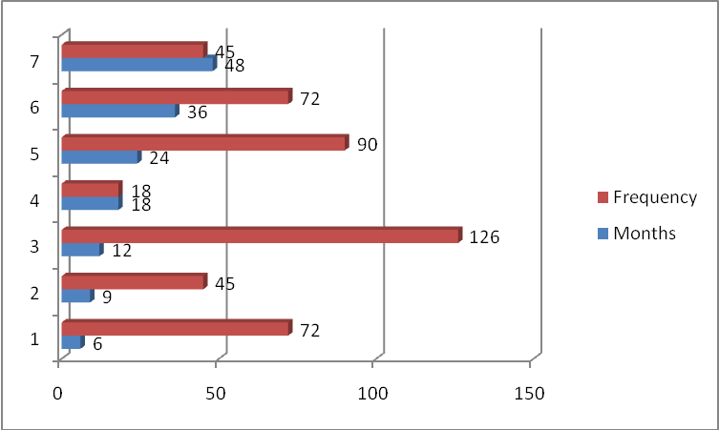

**Figure 3:** **Duration of drug uses by Respondents.**

**Table 2: Intake of BZD with other illicit drugs.**

|  |  |  |
| --- | --- | --- |
| **Other drugs** | **Frequency** | **Percentage (%)** |
| None | 108 | 23.07 |
| Alcohol | 81 | 17.30 |
| YABA | 153 | 32.69 |
| Marijuana | 99 | 21.15 |
| Phensedyl | 27 | 5.76 |

***Physiological, psychological effects and related dependence***

Respondents were faced some problems after taking drugs in current context of life. Development of Antrograde amnesia (19.23%, 90/468), Confusion (9.61%, 45/468), became ill tempered (7.69%, 36/468), having difficulty in cognition (11.53%, 54/468), having daytime drowsiness (11.53%, 54/468), had fatigue (9.61%, 45/468) are common. But 144(30.76%) respondents didn’t face any problems.

Table 3 represents the tendency of the users to stop taking the drugs and face some withdrawal effects. Among 468 participants, 92.30% respondents were tried to stop taking the drug and 7.69% respondents never tried to do so. The most common withdrawal effect was insomnia (17.30%), confusion (15.38%), Headache (13.46%), restlessness (11.53%) was found.

Some psychotic symptoms were developed after long term uses of BZD. Majority (55.76%) respondents denied mentioning it, But 21.15% had anhedonia, 9.61% had social withdrawal symptoms, 7.69% had perceptual distortion and some other effects are also shown in Figure: 4.

**Table 3:** **Withdrawal effects of the respondents.**

|  |  |  |
| --- | --- | --- |
| **Variables** | **Frequency** | **Percentage (%)** |
| **Try to withdrawal** | | |
| Tried | 432 | 92.30 |
| Never tried | 36 | 7.69 |
| **Withdrawal effect (n=432)** | | |
| Insomnia | 81 | 17.30 |
| Headache | 63 | 13.46 |
| Restlessness | 54 | 11.53 |
| Anxiety | 45 | 9.61 |
| Difficulty in cognition | 45 | 9.61 |
| Confusion | 72 | 15.38 |
| Difficulty to function | 27 | 5.76 |
| Fatigue | 18 | 3.84 |
| Palpitation | 18 | 3.84 |
| Convulsion | 9 | 1.92 |

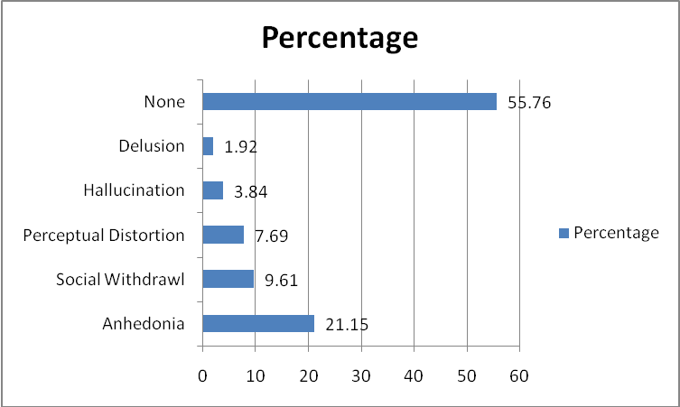

**Figure 4:** **Development different of psychotic symptoms.**

**DISCUSSION**

Ojha et al. found 91% male and only 9% were female respondents shows the similarity with current study6. In Bangladesh, two different studies reported majority drug users were from age group 22-25 years7,and 64.6% of the respondents’ ages were 20-24 years8, these findings are very much close to the age group of current study. Again, from another studies in Bangladesh found almost half (48%) of the participants were in the age group 30-39 years9,a complete a different result of the previous findings.

In 2004, Mahbubur et al found 85.7% respondents get into consuming the drugs under the influence of friends3. Mahbuba Naznin (2010) said that 38.75% respondents were influenced by friends in her study10.Abul Hashem et al mentioned 42.6% respondents were influenced by their peer group or friends8. All the findings strongly support the current research, because the majority (44.23%) of respondents was influenced by friends.

Neilsen et al. (2008), found almost 70% participants used BZD, as a non-prescription drug, most commonly diazepam (55%) and alprazolam (30%) in Queensland, Tasmania, Western Australia and Victoria11.But another study of Australia reported 13% respondents used prescribed BZD12.In Lebanon, ~20% of the young adult population is taking psychoactive substances in nonmedical reason13. Misuse of BZD by 57.2% because of workload and increasing of patients’ stress, accepted by Thai doctors14. This research reveals that only 11.54% were taken BZD based on Doctors’ prescription in Dhaka city.

The most noticeable feature is the common tendency of drug users to take the primary drug and mix it with the multiple drugs for concomitant use. National Institute on Drug Abuse reported the continuous abuse of prescription medications and over the counter products by Adolescent15.The current study revealed the findings of Ahad et al., who stated all the drug addicts were dependent on multiple types of drugs, most commonly cannabis (95.24%), YABA (61.9%), Alcohol (47.62%), tranquilizers & other drugs (50%) etc7.In Nepal, 86% of the sample population used opioids in combination with BZD and antihistamines6.

Purposes of taking drug are more or less common in all studies. Kevin WC et al, shows in a survey that the main reasons for using BZD without a prescription are curiosity (46%), relieving tension or anxiety (41%) and for feeling good (37%)1. Among the Lebanese BZD users, 44.4% were taking for relieving anxiety, for insomnia (22.5%) and for depression (16%)16. Only 17.0% medical students used sedative drugs at some time because of significant psychological stress in King Saud University College of Medicine in 2011 was found in different study17. Another study in Dhaka showed 31.88% users became drug addicted because they are trying to get something new10.

Among all the self-reported BZD users, 60% were confirmed to leave the drug, 11% were tried and 29% had no interest to stop taking drug1. Whereas, according to the current study, 92.30% were tried to stop uses the BZD, which is a good sign for future generation and also for the policy makers. The withdrawal effects were rebound insomnia, anxiety, restlessness, BZD dependence etc. It can occur even when doses are low and consumed over a short period of time mentioned in two different studies18-19.

Abul Hashem et al. reported in their study that the misused substances are alcohol, tobacco, heroin, marijuana, choros, cocaine, morphine and YABA tablets in Dhaka city8. Mahbuba Naznin (2010) said that phencyclidine (52.5%), Heroin (23.12%), Charas (30%), Marijuana (30%), and Ganja (86.87%) were taken by the student from different Private University of Dhaka city10. According to Ahad et al. highest 95.24% are addicted by cannabis and 61.90% involved in YABA addiction in Sylhet7. Again, Shariful et al. reported almost half of the participants (50.8%) taken cannabis and 18.3% started with cough–syrup (phensedyl) in Dhaka9. These all studies are representing the current drug addiction picture of Bangladesh partially. Whereas, the current research emphasizes the uses of BZD; moreover the respondents were also addicted on alcohol, Yaba, Marijuana and Phensedyl simultaneniously. Therefore, more study should be conducted in Bangladesh with large sample to find out the cause of addiction and how to eliminate or reduce the burden of drug addiction from this country.

**CONCLUSION**

Misuse of drugs is associated with easy access of sedative/tranquilizer, use by family member, friends or previous prescription etc. Due to lack of monitoring and easy accessibility, BZD abuse is increasing day by day. The government should take strict action to regulate the availability of misused drugs through implementation of law and regulation and also should take steps to grow awareness among the people especially young about the negative impact of drugs addiction.

**CONFLICT OF INTEREST**

The authors declare that there is no conflict of interest.

**INFORMED CONSENT**

Written informed consent was collected from each and every participant and ensure to maintain participant’s confidentiality.

**REFERENCES**

1. Kevin WC, Christine CB, Darlene PF, Christopher D’A, Eric W, Devang G. Benzodiazepine use and misuse among patients in a Methadone program. BMC Psychiatry.2011; 11:90.

2. Misuse of Prescription Drugs: a South Asia Perspective, United Nations Office on Drugs and Crime (UNDOC). 2011; 3-6.

3. Rahman M, Zaman SUM, Sakamoto J, Fukui T. How much Do Drug Abusers Pay for Drugs

in Bangladesh? Journal of Health, Population and Nutrition. 2004; 22(1):98-99.

4. Frischer M, McArdle P, Crome I. The epidemiology of substance misuse in young People.

Arch Dis Child.2004; 89(8):701-704.

5. World drug report, 2006. United Nation: 2007. United Nation Office on Drug and Crime.

6. Ojha SP, Sigdel S, Meyer-Thompson HG, Oechsler H, Verthein U. ‘South Asian Cocktail’-

the concurrent use of opioids, benzodiazepines and antihistamines among injecting drug users in Nepal and associations with HIV risk behavior. Harm Reduction Journal. 2014; 11(17):2-7.

7. Ahad AM, Chowdhury MD, Islam BM, Alam FM. Socioeconomic Status of Young Drug Addicts in Sylhet City, Bangladesh. *IOSR*- Journal of Humanities and Social Science. 2017; 22(6):84-91.

8. Hashem AM & Mushahid M. Drug Addiction in Urban Life of Bangladesh: A Sociological Study for exploring the causes. Asia Pacific Journal of Multidisciplinary Research. 2017; 5(2): 1-11.

9. Islam SMS, Biswas T, Bhuyiyan AF, Islam SM, Rahman MM, Nessa H. Injecting Drug Users and Their Health Seeking Behavior: A Cross-Sectional Study in Dhaka, Bangladesh. Journal of Addiction. 2015; ID756579:1-8.

10. Naznin MS. Drug Addiction among undergraduate students of Private Universities in Bangladesh. Procedia Social and Behavioral Sciences 2010; 5:498-501.

11. Nielsen S, Bruno R, Carruthers S, Fischer J, Lintzeris N, Stoove M. Investigation of pharmaceutical misuse amongst drug treatment clinics, Final Report, Melbourne: Turning point Alcohol & Drug Center. 2008.

12. Loxly W. Benzodiazepine use and harms among police detainees in Australia. Trends and issues in crime and criminal justice. 2007; 336:1-6.

13. Ghandour LA, El Sayed DS, Martins SS. Prevalence and patterns of com­monly abused psychoactive prescription drugs in a sample of university students from Lebanon: an Opportunity for cross-cultural comparisons. Drug Alcohol Depend. 2012; 121(1–2):110– 117.

14. Srisurapanont M, Garner P, Critchley J, Wongpakaran N. Benzodiazepine prescribing Behavior and attitudes: A survey among general practitioners practicing in northern Thailand. BMC Fam Pract. 2005; 6:27.

15. Extent of the Prescription Drug Abuse Problem. The Community Epidemiology Work Group (CEWG). National Institute on Drug Abuse (NIDA). 2006:3-5.

16. Wijdan HR, Ghada MEK, Mary ED, Marwan ST. Prescription patterns of Benzodiazepines in the Lebanese adult population: A cross-sectional Study. Neuropsychiatr Dis Treat. 2016; 12: 2299–2305.

17. Al-Sayed AA, Al-Rashoudi AH, Al-Eisa AA, Addar AM, Al-Hargan AH, Al-Jerian AA. Sedative Drug Use among King Saud University Medical Students: A Cross-Sectional Sampling Study. Depression Research and Treatment. 2014. ID 378738.

18. Fang SY, Chen CY, Chang IS, Wu EC, Chang CM, Lin KM. Predictors of the Incidence and discontinuation of long-term use of benzodiazepines: a population-based study. Drug Alcohol Depend. 2009; 104(1-2):140–146.

19. Lader MH, Ron M, Petursson H. Computed axial brain tomography in long-term benzodiazepine users. Psychological Medicine 1984; 14:203–206.