**Reviewer’s Comments**

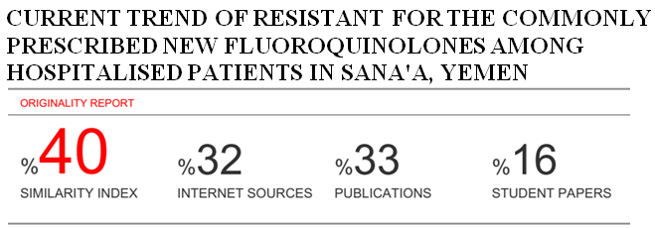

**Current trend of Resistant for the Commonly Prescribed New Fluoroquinolones among Hospitalised Patients in Sana'a, Yemen.**

**Abstract**

**Background:** The new fluoroquinoloneshave demonstrated enhanced activity against the most common bacteria involved in lower respiratory tract infection (LRTI). Moxifloxacin is the most commonly prescribed respiratory flouroquinolone drug in Yemen. Pneumonia is a major and an on-going public health problem globally. With the widely use of fluoroquinolones in the clinical practice, the potential for developing resistance has become a concern.

**The objectives:**The aim of present study was to determine the trend of moxifloxacin resistant and the distribution of resistant for different sample types among hospitalised patients in Sana'a, Yemen.

**Methods:**The study was performed at a private hospital in Sana’a, Yemen. The records were taken from the microbiology department for hospitalised patients. Moxifloxacin susceptibility samples were collected from January, 2017 to December, 2017. The moxifloxacinsusceptibility was studied against several isolates.Full ethical clearance was obtained from the qualified authorities who approved the study design. All data were analyzed using SPSS Statistics version 21.

**Results:** Out of 927 sample isolates, 580 (62.6%) were moxifloxacin resistant isolates and only 30.1% were sensitive. The *Escherichia coli* was observed in 24.4% of total sample isolates, followed by *Pseudomonas aeruginosa* (12.1%). From the study findings, 44.8% of total sample was isolated from sputum cultures.There was a statistically significant difference between bacteria type and culture results (*P-value < 0.001*). Moreover, 96.2% of *Acinetobacter species* and all *Acinetobacterbaumannii isolates* were moxifloxacin resistant. The study findings reported that 70.4% of *Escherichia coli isolates* were resistant for moxifloaxin, followed by *methicillin resistant staphylococcus aureus* (64.7%), *Klebsiella pneumonia* (60.6%), and *Pseudomonas aeruginosa* (46.4%). However, 86.1% of *staphylococcus aureus* isolates were moxifloxacin resistant. Results in this study showed that there was high significantly relationship between culture results and sample type (*P-value*< 0.001). Also 44.8% of sample isolates were from sputum cultures. Moreover, 74.2% of sputum cultures isolates were moxifloxacin resistant.There was a statistically significant difference between culture results with age groups (*P-value* = 0.02). Also 64.1% of males had moxifloxacin resistant and 36.9% of isolate resistant were aged > 60 years

**Conclusion:**This study reveals that varieties of pathogens are responsible for LRTI and moxifloxacin resistance has become a great public health issue. The possibility of reducing resistance by controlling the use of antibiotics is a reasonable approach. Inappropriate and irrational drug usage should be avoided. This study may help the government’s regulatory authority to develop a policy about rational prescription of antibiotics to minimize resistance of new antibiotics and also to ensure the maximum safety to the health of patients.

***Keywords:****Moxifloxacin, Prevalence, Resistance*

**Introduction:**

The classic fluoroquinolones such as ciprofloxacin, norfloxacin, fleroxacin and ofloxacin have had strong activity against Gram-negative bacteria, but the effectiveness of these compounds against Gram-positive bacteria has been debated. The new fluoroquinolones developed during the 1990s, such as levofloxacin and moxifloxacin, have demonstrated enhanced activity against the most common bacteria involved in lower respiratory tract infection (LRTI).The mechanism of newer fluoroquinolone activity is the inhibition of essential bacterial type II topoisomerases (DNA gyrase) and topoisomerase IV**[1]**.All new fluoroquinolones have a bactericidal activity and a post-antibiotic effect. Compared with ciprofloxacin, all new fluoroquinolones have a longer elimination half-life that allows once daily dosing. In addition, these antibiotics have excellent penetration into respiratory tissues, with the highest concentrations found in the epithelial lining fluid and alveolar macrophages**[2]**. The newer fluoroquinolonessuch as levofloxacin and moxifloxacin are currently availablein both IV and oral formulations. With regard to the pharmacodynamic characteristics, the new fluoroquinolones cause concentration-dependent killing**[3]**.

Moxifloxacin (Avelox; Bayer), a “fourth-generation” fluoroquinolone, is often used in the empirical treatment of severe community-acquired pneumonia (CAP), which is one of the most common infectious diseases and among the primary causes of death worldwide**[4].**Streptococcus pneumoniae is the primary pathogen responsible for CAP, but many other microorganisms, including Gram-negative and atypical bacteria (e.g., Legionella pneumophila, Mycoplasma pneumoniae, andChlamydophilapneumoniae), may also be etiological agents**[5].**The recommended dose of moxifloxacin is 400 mg/day (q.d.). No dosage adjustment is required in elderly patients, obese patients **[6]**, or patients with renal or mild hepatic impairment **[7]**. Furthermore, due to the risk of a prolonged QT interval (a measure of the time between the start of the Q wave and the end of the T wave inthe heart’s electrical cycle), it is recommended that the daily dose of moxifloxacin should not exceed 400 mg**[8]**.

The clinical efficacy of the newer fluoroquinolones in the treatment of LRTI has been demonstrated in several randomized, double-blind, prospective studies. In comparative community-acquired pneumonia (CAP)studies, newer fluoroquinolonesalmost havemore activity than the cephalosporins (e.g. ceftriaxone, cefaclor or cefuroxime axetil) and the macrolides (e.g. erythromycin or roxithromycin)**[1]**. Niederman*et al*.**[9]** compared hospitalization and mortality in patients with CAP being treated with moxifloxacin, amoxicillin or clarithromycin. The mortality rate for moxifloxacin-treated patients was significantly better (*P* = 0.045) than for comparator-treated patients. Current treatment guidelines for the management of LRTI in adults recommend fluoroquinolones for empirical treatment in several patient groups. The new fluoroquinolones currently available offer major therapeutic advances compared with previous agents, and the incidence of adverse events is clearly outweighed by their clinically use**[1]**. As with other antimicrobial, the development of resistance is a potential problem associated with their increased use in RTIs. Rational prescribing and continous control of antibiotic resistance levels are needed to keep their future antibacterial efficacy.The new fluoroquinolones have demonstrated enhanced activity against the most common bacteria involved in LRTI. Moxifloxacin is the commonly prescribed respiratory flouroquinolone drug in Yemen. Pneumonia is a major and an on-going public health problem globally. Thus, the aim of present study was to determine the trends of moxifloxacin and the distribution of resistant for different sample types among hospitalised patients in Sana'a, Yemen.

**Methods:**

This retrospective study was performed at a private hospital in Sana’a, Yemen. Moxifloxacin susceptibility samples were collected from January, 2017 to December, 2017from the records ofhospitalised patients. The moxifloxacin susceptibility was studied against several isolates.Full ethical clearance was obtained from the qualified authorities who approved the study design. All data were analyzed using SPSS Statistics version 21.

**Results:**

According to the present study, the mean age of study sample (n=927) was 49year (with SD ± 21.3 year) and ranged between 1 and 120 years. Out of 927 samples, 580 (62.6%) were moxifloxacinresistant isolates and only 30.1% were sensitive. Also (69.0%) of total patients were females and (31.0%) were males. Among 927 of patients, (28.2%) was aged between 41- 60 years and 35.5% more than 60 years. The *Escherichia coli* was observed in 24.4% of total sample isolates, followed by *Pseudomonas aeruginosa*(12.1%). From the study findings, 44.8% of total sample was isolated from sputum cultures (table 1).

**Table 1. Distribution of Study variable**s

|  |  |  |  |
| --- | --- | --- | --- |
| **variable** | **Level of variable** | **Frequency** | **Percent** |
| **Culture Result** | I | 68 | 7.3 |
| R | 580 | 62.6 |
| S | 279 | 30.1 |
| Total | 927 | 100.0 |
| **Sex** | M | 287 | 31.0 |
| F | 640 | 69.0 |
| Total | 927 | 100.0 |
| **Age order** | 1-20 years | 124 | 13.4 |
| 21-40 years | 213 | 23.0 |
| 41-60 years | 261 | 28.2 |
| * 60 | 329 | 35.5 |
| Total | 927 | 100.0 |
| **Type of bacteria** | *Acinetobacterbaumannii* | 24 | 2.6 |
| *Acinetobacter species* | 185 | 20.0 |
| *Alpha Hemolytic Streptococcus* | 2 | 0.2 |
| *B-Hemolytic Streptococcus-Group-A* | 1 | 0.1 |
| *B-Hemolytic Streptococcus-Group-D* | 1 | 0.1 |
| *CitrobacterSpp* | 5 | 0.5 |
| *Coagulase negative Staphylococci* | 57 | 6.1 |
| *EnterobacterSpp* | 3 | 0.3 |
| *Enterococcus Spp* | 19 | 2.0 |
| *Escherichia coli* | 226 | 24.4 |
| *Klebsiellapneumoniae* | 99 | 10.7 |
| *KlebsiellaSpp* | 50 | 5.4 |
| *Moraxella Spp* | 4 | .4 |
| *Methicillin Resistant Staphylococcus aureus(MRSA)* | 17 | 1.8 |
| *Neisseria Spp* | 1 | 0.1 |
| *Nocardia SPP* | 1 | 0.1 |
| *Proteus mirabilis* | 3 | 0.3 |
| *Proteus Spp* | 10 | 1.1 |
| *Proteus vulgaris* | 1 | 0.1 |
| *Pseudomonas aeruginosa* | 112 | 12.1 |
| *SerratiaSpp* | 4 | 0.4 |
| *Staphylococcus aureus* | 72 | 7.8 |
| *Streptococcus pneumoniae* | 3 | .3 |
| *Streptococcus spp.* | 27 | 2.9 |
| Total | 927 | 100.0 |
| **Type of sample** | Aspirated Fluid Culture | 1 | 0.1 |
| Blood Culture | 22 | 2.4 |
| Cerepro Spinal Fluid ( CSF ) C/S | 144 | 15.5 |
| General swab for Culture | 17 | 1.8 |
| Pleural Fluid For Culture & Sensitivity | 27 | 2.9 |
| Ascitic fluid c/s and sensitivity | 6 | 0.6 |
| Pus For Culture & Sensitivity | 91 | 9.8 |
| Sputum Culture | 415 | 44.8 |
| Throat swab Culture | 1 | 0.1 |
| Urine Culture | 120 | 12.9 |
| Wound Swab For Culture | 83 | 9.0 |
| Total | 927 | 100.0 |

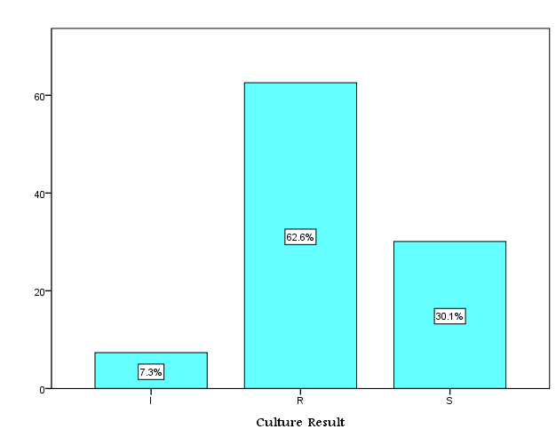

**Figure 1. Distribution of Moxifloxacin Susceptibility among Study Sample**

Results in table 3 indicated that the relationship between bacteria type and culture results was statistically significant (*P-value < 0.001*).In the present study, 96.2% of *Acinetobacter species were moxifloxacin resistant and all Acinetobacterbaumannii isolates were moxifloxacin resistant*. *Also the study findings reported that 70.4% of Escherichia coliisolate*s were resistant for moxifloaxin,followed by *Klebsiellapneumonia* (60.6%),*methicillin resistant staphylococcus aureus* (64.7%),*pseudomonas aeruginosa* (46.4%). However,86.1% of *staphylococcus aureus isolates* weremoxifloxacin resistant.

|  |  |  |  |  |  |
| --- | --- | --- | --- | --- | --- |
| **Table 2. Distribution of bacteria type according to culture results** | | | | | |
| **Type of Bacteria** | **Culture Result** | | | **Total** | **P-value** |
| **I** | **R** | **S** |
| *Acinetobacterbaumannii* | 0 | 24 | 0 | 24 | **0.001** |
| *Acinetobacter species* | 2 | 177 | 6 | 185 |
| *Alpha Hemolytic Streptococcus* | 0 | 1 | 1 | 2 |
| *B-Hemolytic Streptococcus-Group-A* | 0 | 1 | 0 | 1 |
| *B-Hemolytic Streptococcus-Group-D* | 0 | 1 | 0 | 1 |
| *CitrobacterSpp* | 2 | 1 | 2 | 5 |
| *Coagulase negative Staphylococci* | 19 | 14 | 24 | 57 |
| *EnterobacterSpp* | 2 | 0 | 1 | 3 |
| *Enterococcus Spp* | 0 | 18 | 1 | 19 |
| *Escherichia coli* | 7 | 159 | 60 | 226 |
| *Klebsiellapneumoniae* | 10 | 60 | 29 | 99 |
| *KlebsiellaSpp* | 2 | 42 | 6 | 50 |
| *Moraxella Spp* | 0 | 0 | 4 | 4 |
| *Methicillin Resistant Staphylococcus aureus(MRSA)* | 6 | 11 | 0 | 17 |
| *Neisseria Spp* | 0 | 0 | 1 | 1 |
| *Nocardia SPP* | 0 | 0 | 1 | 1 |
| *Proteus mirabilis* | 0 | 3 | 0 | 3 |
| *Proteus Spp* | 2 | 6 | 2 | 10 |
| *Proteus vulgaris* | 0 | 0 | 1 | 1 |
| *Pseudomonas aeruginosa* | 11 | 52 | 49 | 112 |
| *SerratiaSpp* | 0 | 0 | 4 | 4 |
| *Staphylococcus aureus* | 3 | 7 | 62 | 72 |
| *Streptococcus pneumoniae* | 0 | 0 | 3 | 3 |
| *Streptococcus spp.* | 2 | 3 | 22 | 27 |
| ***Total*** | 68 | 580 | 279 | 927 |

There wasnot statistically significant difference between culture resultswith sex (P-value= 0.25). However, there was a statistically significant difference between culture results with age groups (*P-value =* 0.02). Also 64.1% of maleshadmoxifloxacinresistant and 36.9% of isolate resistantwere aged >60 years (table 3).

**Table 3. Distribution of age group and sex according to Culture results**

|  |  |  |  |  |  |  |
| --- | --- | --- | --- | --- | --- | --- |
| **Variable** | | **Culture results** | | | **Total** | ***P-value*** |
| **I** | **R** | **S** |
| **Sex** | **F** | 26 | 170 | 91 | 287 | 0.25 |
| **M** | 42 | 410 | 188 | 640 |
| **Total** | 68 | 580 | 279 | 927 |
| **Age group** | **Less 20** | 14 | 62 | 48 | 124 | 0.02 |
| **21-40** | 12 | 134 | 67 | 213 |
| **41-60** | 13 | 170 | 78 | 261 |
| * **60** | 29 | 214 | 86 | 329 |
| **Total** | 68 | 580 | 279 | 927 |

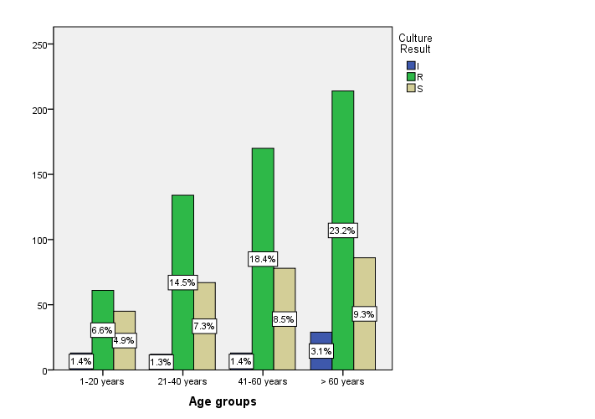

**Figure 2. Distribution of age group and sex according to Culture results**

The relationship between culture results and sample type was analyzed in the table 4. Results in this table showed that there was high significantly relationship (*P-value*<0.001). Also 44.8% of sample isolates were from sputum cultures. Moreover, 74.2% of sputum cultures isolates were moxifloxacin resistant.

**Table 4. Distribution of culture results according to sample type**

|  |  |  |  |  |  |  |  |  |  |  |  |  |  |  |  |
| --- | --- | --- | --- | --- | --- | --- | --- | --- | --- | --- | --- | --- | --- | --- | --- |
| **Sample Type** | **Culture Result** | | | | | | | | | **Total** | | | **P-value** | | |
| **I** | | | **R** | | | **S** | | |
| Ascitic fluid c/s and sensitivity | | 0 | | | 0 | | | 1 | | | 1 | | | 0.001 | |
| Aspirated Fluid Culture | | 0 | | | 8 | | | 14 | | | 22 | | |
| Blood Culture | | 18 | | | 62 | | | 64 | | | 144 | | |
| Cerepro Spinal Fluid ( CSF ) C/S | | 0 | | | 14 | | | 3 | | | 17 | | |
| General swab for Culture | | 2 | | | 18 | | | 7 | | | 27 | | |
| Pleural Fluid For Culture & Sensitivity | | 0 | | | 1 | | | 5 | | | 6 | | |
| Pus For Culture & Sensitivity | | 6 | | | 31 | | | 54 | | | 91 | | |
| Sputum Culture | | 28 | | | 308 | | | 79 | | | 415 | | |
| Throat swab Culture | | 0 | | | 0 | | | 1 | | | 1 | | |
| Urine Culture | | 7 | | | 83 | | | 30 | | | 120 | | |
| Wound Swab For Culture | | 7 | | | 55 | | | 21 | | | 83 | | |
| **Total** | | | 68 | | | 580 | | | 279 | | | 927 | | |  |

**Discussion:**

The primary objective in the development of moxifloxacin was to produce an appropriate spectrum antibiotic for the treatment of community-acquired RTIs with a good tolerability profile, good efficacy against the relevant pathogens, and low propensity for the development of bacterial resistance, thus benefiting patients and helping clinicians to treat these diseases**[10]**.

An effective new antimicrobial agent is necessary in light of the therapeutic problems posed by the increasing prevalence of antibiotic resistance of the common respiratory tract pathogens, which have become increasingly resistant to traditional first-line antibiotics such as penicillins and macrolides**[11]**.

According to study results, 62.6% of study sample were moxifloxacinresistant isolates and only 30.1% were sensitive.

Moxifloxacin treatment failure is being increasingly reported, particularly in the Asia-Pacific region along with increasing detection rates of resistance mutations**[12]**.

Fluoroquinolone resistance is rare in North America.Surveillance studies in the United States from 1987 to2009 demonstrated low rates of resistance to moxifloxacin (0.1%)**[13]**. Similarly,the prevalence of fluoroquinolone resistance in Canadaremained low from 1998 to 2009. Although total per capitaoutpatient use of fluoroquinolones increased during this10-year period, levofloxacin and moxifloxacin resistanceremained unchanged at *<*2% in the *>*26,000 isolates collected**[14]**.

In contrast to study findings in Pakistan, the prevalence of Moxifloxacin resistant was 42.4%**[15]**.From the present study findings, 44.8% of total sample was isolated from sputum cultures. Moreover, 74.2% of sputum cultures isolates were moxifloxacin resistant. The increasing resistance to antibiotics by respiratory pathogens has complicated the use of empirical treatment with traditional agents and a definitive bacteriological diagnosis and susceptibility testing wouldbe required for effective management of LRTI**[16]**.The study findings reported that 70.4% of *Escherichia coli isolates* were resistant for moxifloaxin, followed MRSA (64.7%), *Klebsiella pneumonia* (60.6%), and *Pseudomonas aeruginosa* (46.4%). Also results in this study showed that t there was a statistically significant difference between culture results with age groups and 36.9% of patients with moxifloxacin resistant isolates were aged > 60 years**.**

During the last several years, resistance to fluoroquinoloneshas remained very high among *MRSA*, *P. aeruginosa*andin pathogens isolated from intensivecare unit-patients. In addition, the recent reports ofan overall increase in resistance to fluoroquinolones amongbacteria causing community-acquired infections, such as *E.coli*have a major concern in clinical practice. These surveillance data demonstratethat fluoroquinolone resistance has to be associated with bothparticular bacterial species and patientpopulations**[13]**.

**Conclusion and Recommendation:**

LRTIs comprise a wide range of diseases from acute bronchitis to severe pneumonia leading to death. This study reveals that varieties of pathogens are responsible for LRTI and moxifloxacin resistance has become a great public health issue.The possibility ofreducing resistance by controlling the use of antibioticsis a reasonable approach. Inappropriate and irrationaldrug usage should be avoided.This study may help thegovernment’s regulatory authority to develop a policyabout rational prescription of antibiotics to minimizeresistance of new antibiotics and also to ensure themaximum safety to the health of patients.

**Conflict of Interest:**

The authors declare that they have no competing interests.

**References:**

1. Lode H. &AlleweltM.Role of newer fluoroquinolones in lower respiratory tract infections. Journal of Antimicrobial Chemotherapy. 2002; 49: 709–712
2. Wise, R. &Honeybourne, D. Pharmacokinetics and pharmacodynamics of fluoroquinolones in the respiratory tract. *European Respiratory Journal*. 1999; 221–9.
3. Blondeau, J. M. Clinical utility of the new fluoroquinol- ones for treating respiratory and urinary tract infections. *Expert Opinion on Investigational Drugs. 2002;*10, 213–36
4. Wiemken TL, Peyrani P, Ramirez JA. Global changes in the epidemiology of community-acquired pneumonia. SeminRespirCrit Care Med.2012; 33:213–219.
5. Welte T, Torres A, Nathwani D. Clinical and economic burden of community-acquired pneumonia among adults in Europe. Thorax.2012; 67:71– 79.
6. Kees MG, Weber S, Kees F, Horbach T. Pharmacokinetics of moxifloxacin in plasma and tissue of morbidly obese patients. J AntimicrobChemother.2011; 66:2330 –2335
7. Balfour JA, Lamb HM. Moxifloxacin: a review of its clinical potential in the management of community-acquired respiratory tract infections. Drugs. 2000; 59:115–139
8. O¨ brink-Hansen K, Hardlei TF, Brock B, Jensen-Fangel S, Kragh Thomsen M, Petersen E, Kreilgaard M. Moxifloxacin pharmacokinetic profile and efficacy evaluation in empiric treatment of community-acquired pneumonia. Antimicrob Agents Chemother. 2015; 59:2398 –2404
9. Niederman, M., Church, D., Haverstock, M. &Springsklee, M. Does appropriate antibiotic therapy influence outcome in community-acquired pneumonia (CAP) and acute exacerbations of chronic bronchitis (AECB)? *Journal of Respiratory Medicine*. *2000; Suppl. A*, E23.
10. Christina Krasemann, Jutta Meyer, and Glenn Tillotson.Evaluation of the Clinical Microbiology Profile of Moxifloxacin. Clinical Infectious Diseases 2001; 32(Suppl 1):S51–63.
11. Tillotson G, Blondeau J. Today’s community respiratory tract infections: a challenge appropriate for moxifloxacin. In: Adam D, Finch R, eds. Moxifloxacin in practice. Vol 1. Oxford: Maxim Medical, 1999: 1–11.
12. Gerald L. Murray, Catriona S. Bradshaw, Melanie Bissessor, Jennifer Danielewski, Suzanne M. Garland, Jørgen S. Jensen, Christopher K. Fairley, Sepehr N. Tabrizi. Increasing Macrolide and Fluoroquinolone Resistance in *Mycoplasma genitalium*.Emerging Infectious Diseases. 2017; 23 (5).
13. [Dalhoff A](https://www.ncbi.nlm.nih.gov/pubmed/?term=Dalhoff%20A%5BAuthor%5D&cauthor=true&cauthor_uid=23097666).Global fluoroquinolone resistance epidemiology and implictions for clinical use.InterdiscipPerspect Infect Dis. 2012; 2012:976273.
14. Pillar C. M., Thornsberry C., and Sahm D. F. “Susceptibility of *Streptococcus pneumoniae*and *Haemophilus influenza* collected across Europe and Asia to levofloxacin and other respiratory agents; results from GLOBAL surveillance (1997–2007),” *Penetration*, 2010; 14–22.
15. Ali I, Butt MA. Antibiotic Susceptibility Pattern of Bacterial Isolates from Patients of Respiratory Tract Infection at 43 Centers in Punjab, Pakistan. ClinExpPharmacol. 2017; 7: 229.
16. Anderson H, Esmail A, Hollowell J, Littlejohns P, Strachen D. Epidemiologically based needs assessment: lower respiratory disease. DHA Project Research Prograrnme. 1993; 6-12.