**Reviewer’s Comments**

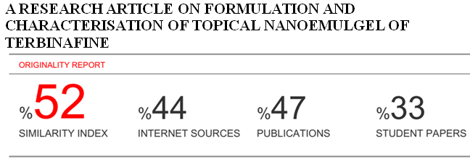

**A Research article on Formulation and Characterisation of Topical Nanoemulgel of Terbinafine**

**ABSTRACT:** The aim is to develop nanoemulgel as a novel drug delivery system using carbopol 934 as a gelling agent. The objective behind the formulation is to avoid dosing frequency and to increase the stability and bioavailability and avoiding the first pass metabolism. The formulation was prepared by using oleic acid, carbopol 934, span 20, propylene glycol in different ratios and analyzed by pseudo tertiary phase diagram. All the prepared nanoemulgel shows satisfactory physiochemical properties. The stability and particle size is been determined by zeta potential. The highest drug release was found in F4 formulation was 82% follows non-fickian mechanism.

**KEY WORDS:** Topical drug delivery, Nano emulsion, Nano emulgel, Antifungal drug, tertiary phase.

**INTRODUCTION**

Nanoemulgel has emerged as one of the most interesting topical delivery system as it has dual release control system i.e. Hydrogeland nanoemulsion. Nanoemulgel having nanosize (10 to 100μm) rapidly penetrates and deliver active substance deeper and quicker. Gelling agent promotes better stability of nanoemulsion by reducing the surface and interfacial tension and also enhancing viscosity of the aqueous phase for drug administration topically1,2. Drug delivered through nanoemulgel has better adhesion on the surface on the surface of the skin and high solubilizing capacity which leads to larger concentration gradient towards the skin, hence influences better skin penetration. Nanoemulsions are thermodynamically stable, transparent, or translucent dispersion of two immiscible liquids, such as oil and water stabilized by an interfacial film of surfactant and cosurfactant molecules having the droplet size of less than 100 nm. It also retard dosing frequency of drug.3,4

Terbinafine [(2E)-6,6-dimethylhept-2-en-4-yn-1yl](methyl)(naphthalene-1-ylmethyl)amineis a broad spectrum antifungal drug active against ermatophytes. Dermatophytes cause infections of the skin, hair and nails, obtaining nutrients from keratinized material. Some of these skin infections are known as ringworm or tinea. Terbinafine has first pass effect due to this shows poor oral bioavailability. It inhibits ergoterol synthesis by inhibiting squalene epoxidase, an enzyme that is a part of fungal cell membrane synthesis pathway. Because terbinafine prevent conversion of squalene to lanosterol, ergosterol cannot be synthesized, and caused fungal cell lysis.5

Theobjective is to develop a most effectivetopical preparation to avoid first pass metabolism of drug, with enhanced pharmacological action on local area, enhanced penetration of drug with the help of penetration enhancer, improved and better drug release profile of the drug by preparing a suitable nanoemulgel for the treatment of fungal infection.6

**MATERIALS AND METHOD**

Terbinafine was obtained from Yarrow chem. product uttarakhand India , Oleic acid, Span 20, propylene glycol, Carbopol 934were obtained from Molychem. pvt. Ltd. All other ingredients, chemicals and solvents used were of analytical grade.

**PREFORMULATION STUDIES**

**Fourier Transform Infrared (FTIR) spectral analysis**

IR analysis was done on IR spectrometer with KBr disc. In IR thespectrum was recorded in the wavelength region of 4000 to 400cm-1. 10mg of drug was mixed with KBr and triturated then it was placed in holder and pressed to form a pellet. It was placed under IR beam and a spectrum was obtained on computer. The IR spectrum of drug exhibit maxima only at the same wavelength as that of similar preparation of the corresponding reference standard, thus IR spectrum of substance being examined should be concordant with the reference spectrum of the drug.

**Solubility Study7**

Solubility of Terbinafine was determined in various oils suchas oleic acid, isopropyl myristate, clove oil, castor oil and olive oil by shake flask method. An excess amount of drug was taken in 10 ml of the oil in vials, and mixed using vortex mixer. The vials were then kept at 25 ± 10C in an isothermal shaker. The samples were then centrifuged at 3,500rpm for 15min. The supernatant was filtered through whatman (no. 41) filter paper. Thefiltrate was suitably diluted. The amount of drug dissolved in the oil was determined using UV spectrophotometer at their respective wavelength.

**Partition coefficient**

It is a ratio of unionized drug distribution between organic and aqueousphase at equilibrium. It was determined in n- octanol: water system, by taking 25ml of both n-octanol and water in separating funnel. Shake this mixture for 30 minutes and keep it for 24 hour. Then 10 mg drug mixed with saturated solution of n-octanol:water in separating funnel. The separating funnel was shaken for 24 hours. The two phases was separated and the amount of the drug in aqueous phase was analyzed by UV at 282.7 nm after appropriate dilution.

**partition coeffiecient=(conc.in oil phsae)/(conc.in aq.phase)**

**SPECTROSCOPIC STUDIES**

**Preparation of standard stock solution** -100mg of drug dissolve in 10ml of methanol in 100ml volumetric flask and volume was adjusted with methanol upto the mark to obtained 1000µg/ml (solution A). The solution was filtered through whatman filter paper No. 41

**Determination of λmax**

A10ml solution was pipette out from solution A in 100ml volumetricflask and diluted with methanol up to the mark to obtained 100µg/ml. The solution was filtered through whattman filter paper No. 41(solution B). From these aliquots of 0.2ml, 0.4ml, 0.6ml, 0.8ml and 1ml were pipette out in to a 10ml volumetric flask and diluted to methanol up to the mark and get the concentration 2 µg/ml, 4 µg/ml, 6 µg/ml, 8 µg/ml, 10 µg/ml respectively. Absorbance of this solution was measured at 282.7nm using UVspectroscopy against blank (methanol).

**Preparation of Phosphate buffer pH 7.4 (PBS)**

Dissolve 2.3gm of disodium hydrogen phosphate, 0.19gm of potassium dihydrogen phosphate and 8gm of sodium chloride in sufficientwater to produce 1000ml. adjust the pH if necessary.

**Calibration curve of terbinafine in Phosphate buffer pH 7.4 solution**

A10mg of drug dissolve in 20ml of methanol and 8ml of phosphate buffer in a 100ml volumetric flask and volume was adjusted up to the mark to obtained 1000µg/ml. The solution was filtered through whatman filter paper No. 41(solution A). From this solution an aliquot of 1ml was withdrawn and diluted to 10ml with PBS pH7.4 to get concentration of 100 µg/ml (solution B), filtered out all solution by whatman filter no. 41. Fromthese aliquots of 0.2ml, 0.4ml, 0.6ml, 0.8ml and 1ml were pipette out in to a 10ml volumetric flask and diluted to PBS pH 7.4 upto the mark and get the concentration 2 µg/ml, 4 µg/ml, 6 µg/ml, 8 µg/ml, 10 µg/ml respectively. Absorbance of this solution was measured at 282.7nm using UVspectroscopy against blank 2:8. (Methanol: PBS pH7.4)

**Preparation of nanoemulgel**

**Table 1. Screening and selection of oil, surfactant and co-surfactant**

|  |  |
| --- | --- |
| **Oils** | |
| **Name of Excipient** | **Solubility(mg/ml)** |
| Olive oil | 32.92 |
| Castor oil | 19.12 |
| **Oleic acid** | **49.22** |
| isopropyl myristate | 43.16 |
| Clove oil | 39.36 |
| **Surfactants** | |
| Tween 80 | 98.42 |
| **Span 20** | **106.31** |
| polyethylene gycol 4000 | 72.18 |
| **Co- Surfactants** | |
| **propylene glycol** | **86.04** |
| Glycerine | 63.82 |

**Construction of pseudo ternary phase diagram8**

The phase diagram was developed using water titration method to determine the appropriate components and their concentration ranges. Oleic acid was used as the oil phase, span 20 and propylene glycol was selected as surfactant and cosurfactant, respectively. Distilled water was used as an aqueous phase. Surfactants and cosurfactant [Smix] were mixed in different weight ratios (1:1, 1:2 and 2:1) to determine the optimum ratio which can result in maximum nanoemulsion area. For each phase diagram, oil and specific Smix were mixed well in different ratios from 1:9 to 9:1 in different vials. The ratio of oil to surfactant varied as 1:9, 2:8, 3:7, 4:6, 5:5, 6:4, 7:3, 8:2, and 9:1. The mixtures weretitrated with the aqueous phase, and visual observations were made for transparent and easily flow able oil-in-water (o/w) nanoemulsion. The physical state of the true nanoemulsion was marked on a pseudoternary phase diagrams with one axis representing the aqueous phase, and the other representing a mixture of surfactant and cosurfactant at fixed weight ratios (Smix ratios).

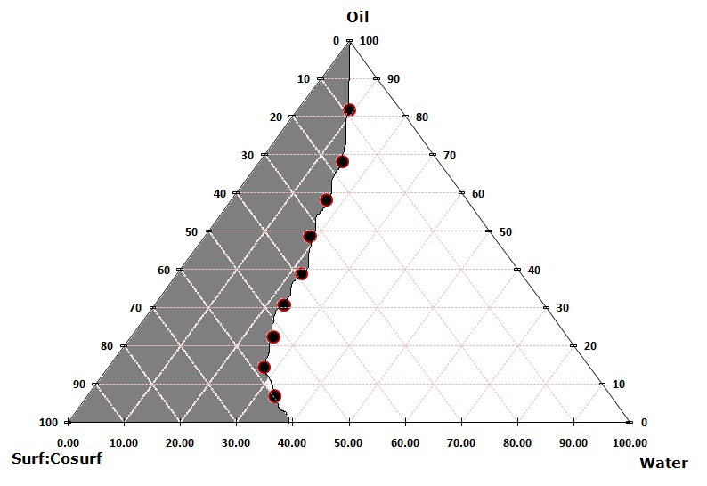

**Figure 1 Pseudo-ternary phase diagram at 1:1 weight ratio of surf:cosurf**

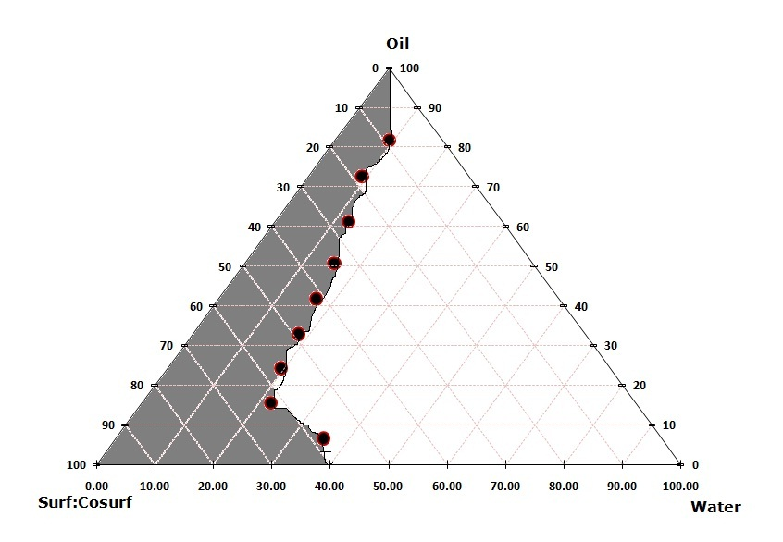

**Figure 2 Pseudo-ternary phase diagram at 2:1 weight ratio of surf:cosurf**

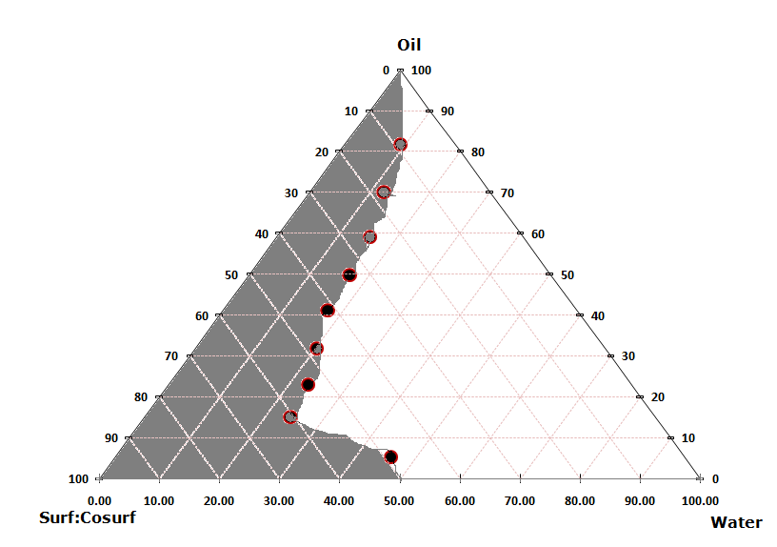

**Figure 3 Pseudo-ternary phase diagram at 1:2 weight ratio of surf:cosurf**

**Formulation of Terbinafine loaded nanoemulsion**

The experimental design based on a three component system: Oil phase (oleic acid), Smix (span20: propylene glycol) and aqueous phase (water). Thetotal conc. of the three phases summed is 100%. Based on the results of pseudo ternary diagram appropriate range of the component was selected. The o/w NE was prepared by water titration method. The formulations were further sonicated (Sonica ultrasonic, 2000 MH,) for 5 minutes and stored at room temperature until their use in subsequent studies.

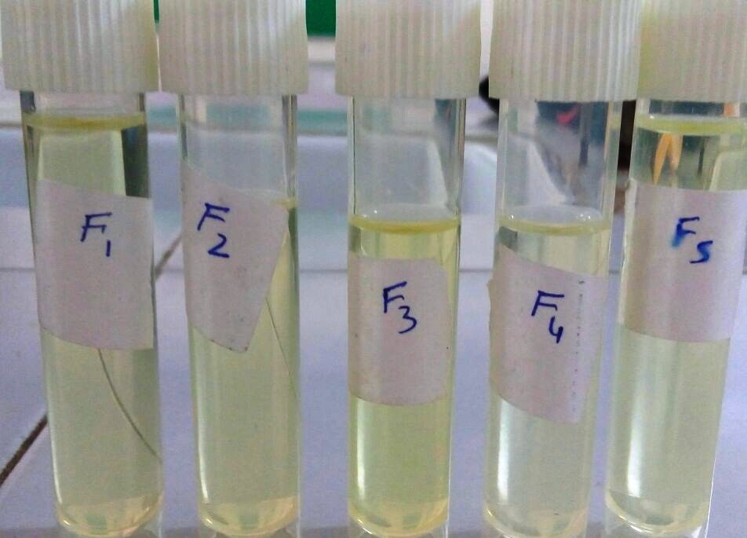

**Figure 4 Different Nanoemulsion formulation**

**CHARACTERIZATION OF NANOEMULSION9**

**Physical Characterization**

The prepared nanoemulsion formulations wereinspected visually for their color, appearance, consistency, phase separation and homogeneity.

**Droplet Size and Size Distribution**

The globules size distribution, polydispersity index and droplet size of the resultant nanoemulsion was determined by dynamic light scatteringwith zetasizer, 1ml of the optimized nanoemulsion formulation was diluted with water to 10mL in a test tube, and gently mixed by glass rod and then analyzes the fluctuations in light scattering due to Brownian motion of the particles. Light scattering was monitored at 25°C at a 90° angle. Globule diameter and distribution was obtained.

**Zeta-Potential Analysis10**

Zeta potential is a technique which is used to measure the surface charge properties and further the long term physical stability of nanoemulsion**.** Thepotential is measure of the electric potential at the slip plane between the bound layer of diluents molecules surrounding the particle and the bulk solution. A higher level of zeta potential results in greater electro-static repulsion between the particles, minimizing aggregation/ flocculation.

**Measurement of pH**

1ml of nanoemulsion was dissolved in 10 mL of distilled water. At first pH meter reading was calibrated using known pH solution (pH4 and pH7) and the electrode was then dipped in to NE formulation and constant reading was noted.

**Measurement of Viscosity**

The viscosity of true nanoemulsion was determined without any dilution using Brookfield viscometer. The sample (30mL) was taken in a beakerand allowed to equilibrate for 5min before measuring the reading using a spindle at 2, 2.5, and 5, 6, 10, 12, 20, 30rpm. At each speed, the corresponding reading on the viscometer was noted.

**Centrifugation**

This technique of centrifugation helps to determine the phase separation of nanoemulsion. 10ml NE was placed in centrifugation tube and put in apparatus at 3000rpm for 30mint and examined for any phase separation.

**Dye Test11**

It is used to check the nature of the nanoemulsion (o/w or w/o). Watersoluble dye is added in o/w NE. The NE takes up the color uniformity. Conversely, if the emulsion is w/o type and the dye being soluble in water, the emulsion takes up the colour only in dispersed phase and emulsion is not uniformly colored.

**FORMULATION OF NANOEMULSION GEL12**

1% carbopol 934 was selected as a gelling agent. Carbopol 934 solution (1% carbopol 934 added in warm water with continuous stirring) added drop wise into the nanoemulsion with continuous stirring until the nanoemulsion convert into nanoemulgel.

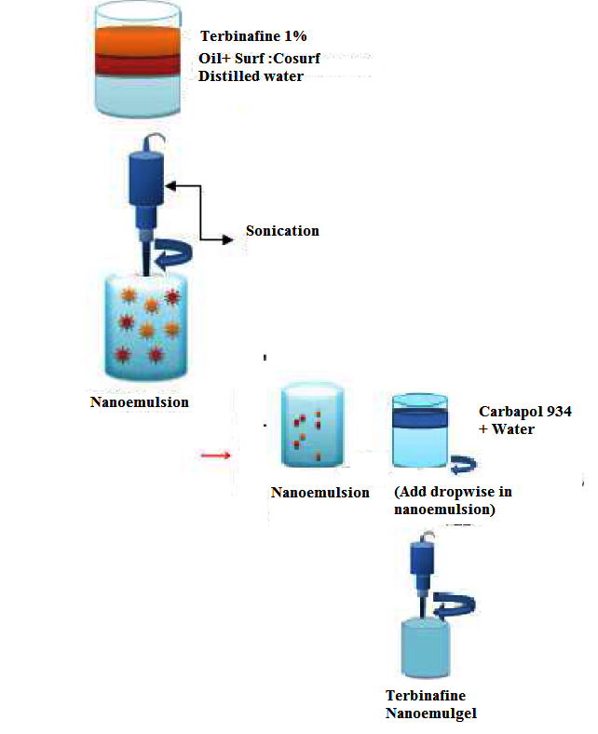

**Figure 5 Preparation of Nanoemulgel**

**CHARACTERIZATION OF NANOEMULGEL**

**pH determination**

One gram of nanoemulgel was dissolved in 10 ml of distilled water and the pH meter was prior standardized with standard buffers of pH 4 and pH 7.

**Viscosity**

The viscosity of formulations is determined using Brookfield DV-III at temperature 25°C. 50grams of the sample is tested using a 50 ml capacity vessel using spindle 5 at different speed.

**Spreadability13**

An excess of emulgel (about 1 g) under study was placed onthis ground slide. The emulgel preparation was then sandwiched between this slide and second glass slide having same dimension as that of the fixed ground slide. The second glass slide is provided with the hook. Weight of 100 g was placed on the top of the two slides for 5 min to expel air and to provide a uniform film of the emulgel between the two slides. Measured quantity of weight (35g) was placed in the pan attached to the pulley with the help of hook. Time in seconds taken by two slides to slip off from emulgel and placed in between the slides under the direction of certain load. Lesser the time taken for separation of two slides, better the spreadability. It is calculated by using the formula.

**S=m×l/t**

Where 𝑆 is spreadability, 𝑚 is weight placed on upper slide, 𝑙 is length of upper slide, and 𝑡 is the time taken

**Drug Content Determination14**

Quantity of Terbinafine in nanoemulsion gel was determined by UV-Spectrophotometer. 1.0 g of formulation was accurately weighed, dissolved in 100 ml of methanol: phosphate buffer (2:8). It was filtered and diluted if required. Absorbance was determined using UV spectrophotometer at 282.7nm.

***In-Vitro* Release Study of Terbinafine Containing Formulation 15,16**

The *In-vitro* drug release studies were carried out using a modified Franz diffusion cell (With effective diffusion area 2.54 cm2 and 20 ml cell volume). The formulation was applied on dialysis membrane (which was previously soaked in Phosphate buffer pH 7.4 for 24 hours) which was sandwiched between donor and receptor compartment of the Franz diffusion cell. Phosphate buffer pH 7.4 was used as dissolution media. Thetemperature of the cell was maintained at 37±0.2ᵒC by kept it in water bath. This whole assembly was kept on a magnetic stirrer and the solution was stirred continuously using a magnetic bead at 50rpm. The samples (1ml aliquots) were withdrawn at suitable time interval and analyzed for drug content by UV visible spectrophotometer at 282.7 nm after appropriate dilutions.



**Figure 6 Franz Diffusion cell**

***In-Vitro* Drug Release Kinetics 17, 18**

To study the release kinetics of in-vitro drug release, data was applied to kinetic models such as zero order, first order, Higuchi and Korsmeyer-Pappas.,

In short, the result obtained from *in-vitro* release studies were plotted in four kinetic models of data treatment as follows:

* Cumulative % drug release Vs. Time (zere order rate kinetics)
* Log cumulative % drug release Vs. Time (First order rate kinetics)
* Cumulative % drug release Vs. Time √T (Higuchi’s classical diffusion equation)
* Log cumulative % drug release Vs. log Time (Korsmeyer Peppas equation)

**RESULTS**

The pre-formulation studies were performed as per given procedures. The results given below:

**Physical examination**

**Color:** White to off white

**Appearance:** Crystalline powder

**Taste:** Tasteless

**Partition Coefficient**

The partition coefficient (log P) was determined byshake flask method. The logP value of drug sample was obtained 5.51.

**Spectroscopy studies**

**Determination of λ max (absorption maxima)**

10mg Terbinafine was dissolve in 10ml of ethanol than 1ml of this solution was taken and diluted upto 10ml with ethanol. This dilution were scanned for determined absorption maxima in range 200-300nm. The observed absorbance maxima were found to be 282.7 nm. UV spectrum of Terbinafine was interpreted absorption maxima (λ max) shown in table:

**Table 2** **Determination of λ max (absorption maxima) of Terbinafine**

|  |  |  |
| --- | --- | --- |
| **Wavelength** | **Interpretation** | **Inference** |
| 200-300 nm | Scanning range | Drug absorption maxima (λ max) 282.7 nm. |
| 282.7nm | Highest peak |

**Standard Calibration curve of Terbinafine in Ethanol**

The calibration curve of terbinafine was determined in the conc. range of 0.5-3.0µg/ml.

**Preparation of Calibration curve of Terbinafine in Ethanol**

|  |  |  |
| --- | --- | --- |
| **S.No** | **Concentration(µg/ml)** | **Absorbance (nm)** |
| 1 | 0 | 0 |
| 2 | 0.5 | 0.0086 |
| 3 | 1.0 | 0.0165 |
| 4 | 1.5 | 0.0274 |
| 5 | 2.0 | 0.0368 |
| 6 | 2.5 | 0.0485 |
| 7 | 3.0 | 0.0573 |

**Preparation of Calibration curve of terbinafine in 7.4 pH Phosphate buffer**

The calibration curve of Terbinafine in 7.4 pH PBS was determined in conc. range of 2-10µg/ml.

**Figure 7 Calibration curve of terbinafine in 7.4 pH Phosphate buffer**

**IR Spectra of Nanoemulsion (Compatibility studies)**

The compatibility of nanoemulsion containingall excipients oleic acid as oily phase, span20 as a surfactant and propylene glycol as a co-surfactants and drug (Terbinafine), by FTIR. It was found that there was no chemical reaction between drug and excipients because in the characteristics peaks of terbinafine, there no any changes wasobserved when compared to the IR spectra of pure drug.

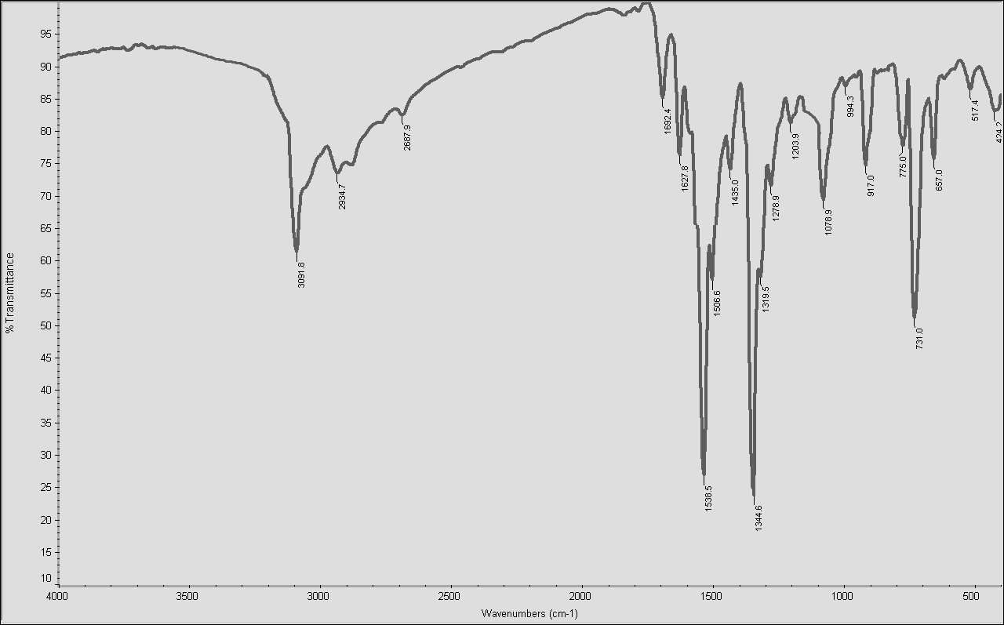

**Figure 8 IR spectra of nanoemulsion (Terbinafine+ Oleic acid+ Span20+ Propylene glycol)**

**CHARACTERIZATION OF NANOEMULSION**

**Particle Size Analysis**

In the all formulation the particle size range were observed from 95.96 to 536 (nm) and the polydispersity index was found to be 0.400 to 0.709. The particle size study explain that the effect of different ratio of surfactant, cosurfactant, oil and water. F4 has 144 nm zeta average due to 1:2 proportion of surfactant and cosurfactant and less amountof oil phase. Higher size average was found to be 536 nm for formulation F1.

**Table 3** **Particle Size Analysis of Drug Loaded Nanoemulsion Formulation**

|  |  |  |  |
| --- | --- | --- | --- |
| **S. No** | **Formulation code** | **Polydispersity Index** | **Particles size (nm)** |
| 1 | F1 | 0.728 | 521 |
| 2 | F2 | 0.709 | 95.96 |
| 3 | F3 | 0.652 | 536 |
| 4 | **F4** | **0.400** | **144** |
| 5 | **F5** | **0.462** | **215.8** |

**Figure 9 Graphical representation of Polydispersity Index**

**Figure 10 Graphical representation of Zeta Average**

From the all 4 formulations, best formulations graphs and figure are given below. First graph is F2, its size was found to be 95.96 nm and polydispersity index was found to be 0.709. Second graph is F4, its size was found to be 144 nm and polydispersity index was found to be 0.400. Third graph is F5, its size was found to be 2.15.8 nm and polydispersityindex was found to be 0.462.

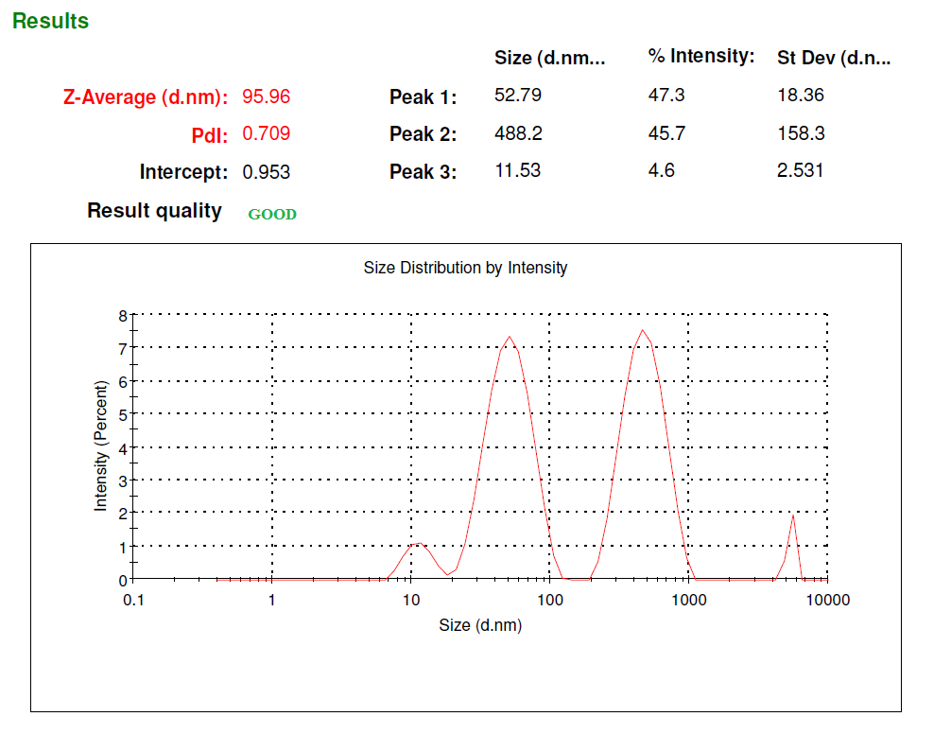

**Figure 11 Particle size Analysis of drug loaded Nanoemulsion (Formulation2)**

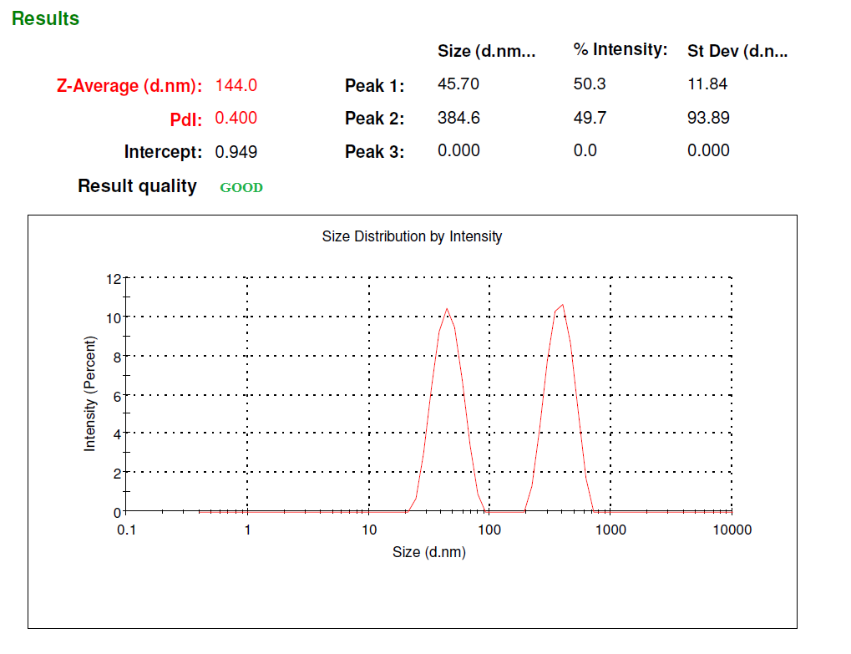

**Figure 12 Particle size Analysis of drug loaded Nanoemulsion (Formulation4)**

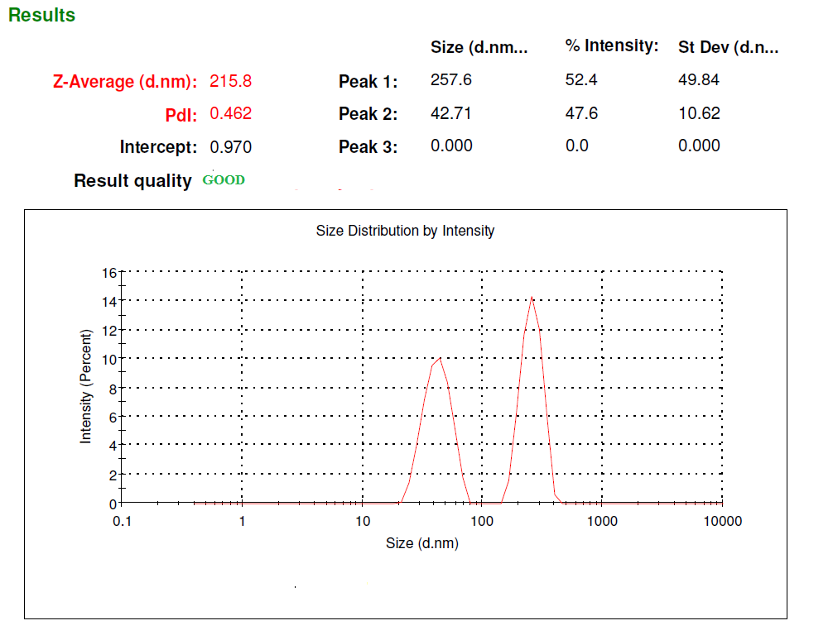

**Figure 13 Particle size Analysis of drug loaded Nanoemulsion (Formulation5)**

**Zeta Potential of Nanoemulsion**

Zeta Potential of all formulation was found to be -4.32 to -32.6. The higher zeta potential of any formulation shows more stability because due to the high zeta potential of particles are not allow getting aggregate because of electrical repulsive force between particles.

**Table 4 Zeta Potential of Nanoemulsion**

|  |  |  |
| --- | --- | --- |
| **S.No** | **Formulation code** | **Zeta potential** |
| 1 | F1 | -10.7 |
| 2 | F2 | -24.8 |
| 3 | F3 | -4.32 |
| 4 | F4 | -32.6 |
| 5 | F5 | -19.7 |

**Figure 14 Graphical representation of Zeta Potential**

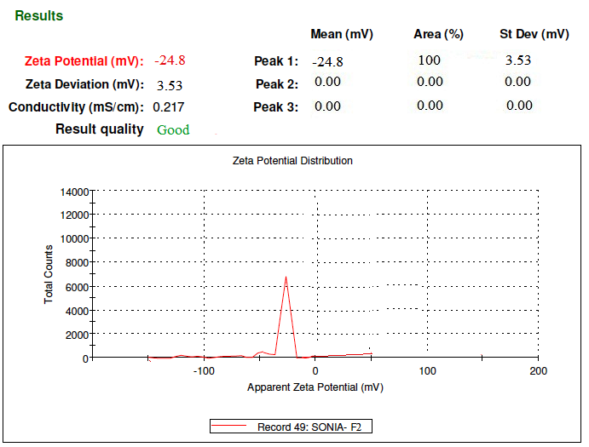

**Figure 15 Zeta potential of drug loaded nanoemulsion F2**

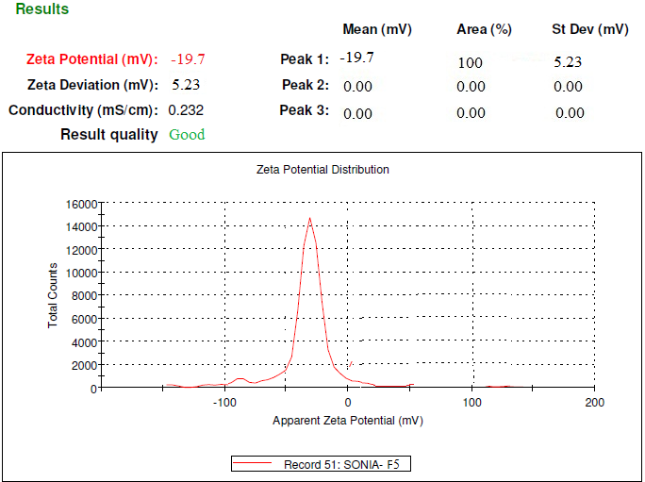

**Figure 16 Zeta potential of drug loaded nanoemulsion**

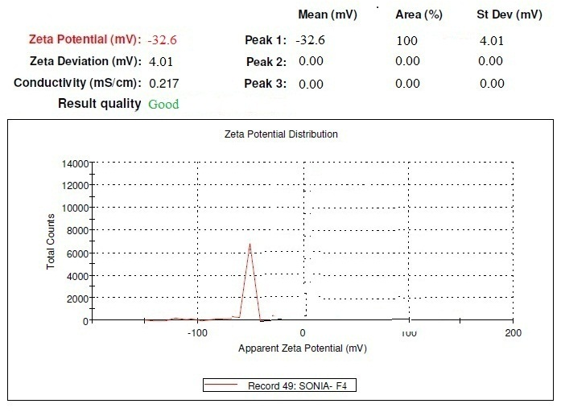

**Figure 17 Zeta potential of drug loaded nanoemulsion**

**pH determination 19**

The pH value for NE formulation was recorded 5.73 to 6.82. The pH of the NE was found to be within the range of pH of skin and would not cause any irritation tothe skin

**Viscosity Measurement20**

A Brookfield Viscometer was used to measure the viscosityof nanoemulsion and nanoemulgel by different spindle speeds. Viscosity reveals the rheological properties of all formulation.

**Table 5 Viscosity of Nanoemulsion Formulation**

|  |  |  |  |  |  |  |
| --- | --- | --- | --- | --- | --- | --- |
| **VISCOSITY OF NANOEMULSION (centipoises)** | | | | | | |
| **Formulation code** | | **F1** | **F2** | **F3** | **F4** | **F5** |
| **Spindle speed (rpm)** | **0.3** | 960 | 982 | 861 | 946 | 883 |
| **0.6** | 829 | 830 | 720 | 871 | 739 |
| **1.5** | 740 | 724 | 648 | 730 | 647 |
| **3** | 629 | 604 | 525 | 627 | 521 |
| **6** | 552 | 526 | 424 | 552 | 458 |
| **12** | 385 | 437 | 335 | 382 | 317 |
| **30** | 240 | 352 | 227 | 218 | 241 |

**Figure 18 Graphical Representation of viscosity Nanoemulsion formulation**

**Table 6 Viscosity of Nanoemulsion Gel Formulation**

|  |  |  |  |  |  |  |
| --- | --- | --- | --- | --- | --- | --- |
| **VISCOSITY OF NANOEMULSION Gel (centipoises)** | | | | | | |
| **Formulation code** | | **F1\*** | **F2\*** | **F3\*** | **F4\*** | **F5\*** |
| **Spindle speed (rpm)** | **0.3** | 9600 | 12000 | 6000 | 8400 | 6500 |
| **0.6** | 4000 | 8000 | 4000 | 6200 | 2200 |
| **1.5** | 2000 | 7600 | 2600 | 2300 | 1650 |
| **3** | 1700 | 3700 | 1820 | 1200 | 940 |
| **6** | 1400 | 2300 | 1300 | 730 | 820 |
| **12** | 1158 | 1600 | 780 | 620 | 760 |
| **30** | 720 | 900 | 480 | 320 | 550 |

**Figure 19 Graphical Representation of viscosity Nanoemulsion Gel formulation**

**Spreadability of Nanoemulsion Gel**

Spreadability of NEG was determined by spreadability apparatus. Spreadability is measured on the basis of ‘slip’ and ‘Drag’ characteristics of nanoemulsion gel. Spreadability is an important property of topical formulation from patient compliancepoint of view.

**Table 7 Spreadability of Nanoemulsion Gel**

|  |  |  |
| --- | --- | --- |
| **Spreadability of Nanoemulsion Gel** | | |
| **S.No** | **Formulation code** | **Spreadability** |
| 1 | F1* | 5.14 |
| 2 | F2* | 5.46 |
| 3 | F3* | 6.15 |
| 4 | F4* | 6.47 |
| 5 | F5* | 6.31 |

**Drug Content of Nanoemulsion Gel**

Drug content is the drug concentration in gellified nanoemulsion, which was measured by UV spectrophotometer. The range of percentage drug content of nanoemulsion gel was 75.3% to 92.7%. The range of percentage drug content of formulations was found to be satisfactory.

**Table 8 Percentage drug content of nanoemulsion gel**

|  |  |  |
| --- | --- | --- |
| **% Drug Content Of NEG** | | |
| **S.No** | **Formulation Code** | **Drug content** |
| 1 | F1* | 88.9% |
| 2 | F2* | 90.3% |
| 3 | F3* | 81.9% |
| 4 | F4* | 92.7% |
| 5 | F5* | 86.3.7% |

***IN-VITRO* PERCENT CUMULATIVE DRUG RELEASE OF NEG**

The*in-vitro* % cumulative drug release studies of NEG were found to be 66.90% to 82.69%. All the formulation shows different release rate because of differentratio of surfactant and co-surfactant. F4* NE shows best drug release 82.69% in 6hrs and F2* shows lowest drug release 66.90% in 6hrs.

**Table 9 *In-vitro* % cumulative drug release of NEG**

|  |  |  |  |  |  |  |  |
| --- | --- | --- | --- | --- | --- | --- | --- |
| **S.No** | **Time (hr)** | **Time (min)** | **% cumulative drug release of NEG** | | | | |
| **F1\*** | **F2\*** | **F3\*** | **F4\*** | **F5\*** |
| **1** | 0 | 0 | 0 | 0 | 0 | 0 | 0 |
| **2** | 0.25 | 15 | 4.08 | 3.55 | 5.36 | 6.73 | 5.11 |
| **3** | 0.5 | 30 | 11.44 | 8.74 | 12.22 | 13.57 | 9.24 |
| **4** | 1 | 60 | 19.35 | 16.32 | 20.08 | 19.73 | 17.32 |
| **5** | 1.5 | 90 | 28.90 | 26.13 | 28.80 | 28.61 | 22.19 |
| **6** | 2 | 120 | 39.21 | 35.99 | 39.21 | 35.91 | 29.04 |
| **7** | 2.5 | 150 | 47.65 | 43.66 | 48.01 | 44.23 | 36.92 |
| **8** | 3 | 180 | 54.41 | 50.49 | 56.17 | 52.07 | 40.12 |
| **9** | 4 | 240 | 60.73 | 56.54 | 63.47 | 61.92 | 48.28 |
| **10** | 5 | 300 | 66.39 | 62.12 | 70.35 | 73.01 | 56.19 |
| **11** | 6 | 360 | 71.58 | 66.90 | 76.96 | 82.69 | 68.19 |

**Figure 20 Graphical representation of % Cumulative Drug Release of NEG**

***In-Vitro* Drug Release Kinetics Modeling of NEG**

For the determination of drug release data of all NEG formulation were fitted into zero order kinetics, first order kinetics, koresymer papas release kinetics, higuchi release kinetics, Bakar losandale release kinetics to know the drug release pattern from theNEG formulation.

The results of model dependent methods for curve estimation were used to develop regression models that have the best R2 values. It is evident from the regression value of NEG followed the drug release of formulation F1* and F2* followed the Baker losandale release pattern because R2 was 0.985 and 0.983 and n value was found to be 0.000 and 0.000 this is may be due to their surf: cosurf ratio. F3* followed the 1st order release pattern because R2 was 0.994 and n value was found to be -0.001. F4* and F5* followed the Koresymer release pattern with non-Fickian anomalous diffusion (0.45<n<0.89) because R2 was 0.996 and 0.997 and n value was found to be 0.781 and 0.805.F4* and F5* shows best R2 value.

**Table No.10 Drug release kinetics eq. and R2 values of all formulation**

|  |  |  |  |  |  |  |
| --- | --- | --- | --- | --- | --- | --- |
| **S.No** | **Formulation code** | **F1\*** | **F2\*** | **F3\*** | **F4\*** | **F5\*** |
| **Zero order** | R2 value | 0.928 | 0.933 | 0.948 | 0.982 | 0.982 |
| n | 0.002 | 0.002 | 0.002 | 0.002 | 0.001 |
| **Ist order** | R2 value | 0.982 | 0.978 | **0.994** | 0.983 | 0.986 |
| n | -0.001 | -0.00 | **-0.001** | -0.001 | -0.000 |
| **Higuchi Model** | R2 value | 0.970 | 0.965 | 0.972 | 0.969 | 0.966 |
| n | 0.043 | 0.040 | 0.045 | 0.046 | 0.036 |
| **Koresymer papas** | R2 value | 0.969 | 0.975 | 0.985 | **0.996** | **0.997** |
| n | 0.885 | 0.932 | 0.838 | **0.781** | **0.805** |
| **Bakar losandale** | R2 value | **0.985** | **0.983** | 0.977 | 0.931 | 0.923 |
| n | **0.000** | **0.000** | 0.000 | 0.000 | 0.000 |

**Graphs of Release kinetics**

1. **First order release kinetics**

First order kinetics graph was plotted between log cumulative% of drug remaining versus time.

**Figure 21 Graphical representation of 1st order release kinetics (F4*)**

1. **Koresymer papas release kinetics**

Koresymer papas release kinetics graph was plotted between log cumulative % drug releases versus log time.

**Figure 22 Graphical representation of Koresymer papas release kinetics (F4*)**

1. **Higuchi release kinetics**

Higuchi release kinetics graph was plotted between cumulative % drug release versus square root of time.

**Figure 23 Graphical representation of Higuchi release kinetics (F4*)**

1. **Zero order release kinetics**

In zero order kinetics graph was plotted between cumulative amount of drug release versus time.

**Figure 24 Graphical representation of Zero order release kinetics (F4*)**

1. **Bakar losandale release kinetics**

In bakar losandale release kinetics graph was plotted between [d(mt/m∞)]/dt versus root of time inverse.

**Figure 25 Graphical representation of Bakar losandale release kinetics (F4*)**

**CONCLUSION**

The principle object of the present experimental work was to make a most effective topical preparation for avoid the first pass metabolism of terbinafine in the treatment of antifungal infections with maximum drug release and reduce g.i.t side effects. The studies showed that changing the concentration of oil, surfactant, cosurfactant and double distilled water as aqueous phase has an impact on the behavior and thermodynamic stability of the nanoemulsion. There was a spontaneous formation of clear nanoemulsion, presumably due to orientation of surfactant and cosurfactant at the interface, which is a direct consequence of high thermodynamic stability at the attained interface of the system. In this study, nanoemulsion and NEG were prepared and evaluated. The results showed that nanoemulsion components had significant effect on the response. The nanoemulsion formulation containing %surf: co surf 48.91, %oil 5.43 and %water 45.65 was best for forming NEG. For all studies the nanoemulsion gel F4* has best release and most effective formulation.

Drug delivery through nanoemulsion gel is a promising area for continued research with the aim of achieving controlled release with enhanced bioavailability and for drug targeting to affected sites.

**FUTURE SCOPE:**

* To carry out *in–vivo* drug release studies and bioavailability studies for the formulated product.
* To perform the clinical trials for making the exercise commercially available.

**REFERENCES**

1. Zhang L.W., Al-Suwayeh S.A., et.al (2011) “Oil components modulate the skin delivery of 5-aminolevulinic acid and its ester prodrug from oil-in-water and waterin- oil nanoemulsions” , .Int J Nanomedicine; 6, PP. 693-704.
2. Jumaa M., Mueller B.W., (2002) “Formulation and stability of benzodiazepines in a new lipid emulsion Formulation”, 57, PP. 740-3.
3. Tamilvanan S., (2004) “Oil-in-water lipid emulsions: implications for parenteral and ocular delivering systems”, Prog Lipid Res., 43, PP. 489-533.
4. Schmidts T., Dobler D., et.al (2009) “Influence of hydrophilic surfactants on the properties of multiple W/O/W emulsions”, J. Colloid Interface Sci., 338, PP. 184-192.
5. Tripathi K.D., “Essentials of Medical Pharmacology”, jaypee brothers medical publishers (P) LTD, 7 edition, PP. 796
6. Kaushal R. Sabu*, Ganesh D. Basarkar, Formulation, Development and *In-vitro* Evaluation of Terbinafine HydrochlorideEmulgel for Topical Fungal Infection, Int. J.
7. Hamid A.M., Harris M.S., et.al(2006) “Once-Daily Tablet Formulation and *In Vitro* Release Evaluation of Cefpodoxime Using Hydroxypropyl Methylcellulose” AAPS Pharm SciTech., 7(3), PP. 4-5.
8. Biradar SV, Dhumal RS, Paradkar A (2009) Rheological investigation of selfemulsification process. J Pharm PharmSci 12: 17-31.
9. Kaushal R. Sabu*, Ganesh D. Basarkar, Formulation, Development and *In-vitro* Evaluation of Terbinafine HydrochlorideEmulgel for Topical Fungal Infection**,** Int. J. Pharm. Sci. Rev. Res., 21(2), Jul – Aug 2013
10. Schmidts T., Dobler D., et.al (2009) “Influence of hydrophilic surfactants on the properties of multiple W/O/W emulsions”, J. Colloid Interface Sci., 338, PP. 184-192.
11. Tripathi K.D., “Essentials of Medical Pharmacology”, jaypee brothers medical publishers (P) LTD, 7 edition, PP. 796
12. Zhang L.W., Al-Suwayeh S.A.,et.al(2011) “Oil components modulate the skin delivery of 5-aminolevulinic acid and its ester prodrug from oil-in-water and waterin- oil nanoemulsions” , .Int J Nanomedicine; 6, PP. 693-704.
13. Jumaa M., Mueller B.W., (2002) “Formulation and stability of benzodiazepines in a new lipid emulsion Formulation”, 57, PP. 740-3.
14. Morales D, Gutie´rrez JM, et.al, A study of the relation between bicontinuous microemulsion and O/W nanoemulsion formulation, Langmuir 2003; (19): 7196-7200
15. Mohamed SD. Optimization of Chlorphenesin Emulgel Formulation. American Association of Pharmaceytical Scientists, 2004; 6(3): 1-7.
16. Khullar R, Kumar D, et.al , Formulation And Evaluation of Mefenamic Acid Emulgel For Topical Delivery, Saudi Pharmaceutical Journal, 2011, 2.
17. British Pharmacopoeia, London, 2, 2007, 1511.
18. Khambete H., Deveda P., et.al (2010) “Emulsion for sustain delivery of Itraconazole for topical fungal disease”, International Journal of Pharmacy and Pharmaceutical Sciences, 2, PP. 105, 107.
19. Hamdy A., Ossama Y.A., Hesham S., (2007) “Formulation Of Controlled-Release Baclofen Matrix Tablets, Influence Of Some Hydrophilic Polymers on The Release Rate and In Vitro Evaluation” AAPS Pharm SciTech., 8(4), PP. 1-11.
20. Hamid A.M., Harris M.S., et.al(2006) “Once-Daily Tablet Formulation and *In Vitro* Release Evaluation of Cefpodoxime Using Hydroxypropyl Methylcellulose” AAPS Pharm SciTech., 7(3), PP. 4-5