**Reviewer’s Comments**

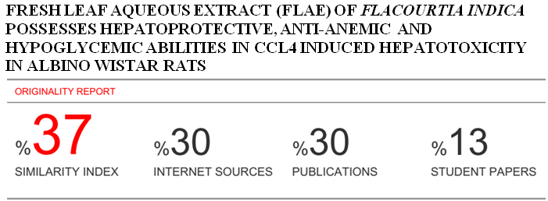

**Fresh Leaf Aqueous Extract (FLAE) of Flacourtia indica Possesses Hepatoprotective, Anti-anemic and Hypoglycemic Abilities in CCl4 Induced Hepatotoxicity in albino wistar Rats**

**ABSTRACT**

Hepatic injury and it associated conditions have been reportedly shown to be managed through herbal remedies. In this study, investigation of the fresh leaf aqueous extract of *Flacourtia indica* as hypoglycemic, anti-anemic and hepatoprotective agent in albino wistar rats induced CCl4 hepatotocxicity was done. Fifteen rats of either sex, weighing 175-295g, divided into five groups (I-V) of three rats each, were used. Group-I is negative control, II-positive control and III –V test groups. Groups II-V were induced 200mg/Kg/bodyweight CCl4, for 3-days, for hepatic injury and anemia. Groups III-V were respectively treated with 400, 600 and 800 mg/Kg/body weight of fresh leaf aqueous extracts (FLAE) of *Flacourtia indica*, for 7-days. Activities of Alanine aminotransferase, Aspartate aminotransferase, Alkaline phosphatase, concentrations of Bilirubin, Albumin, Total protein, blood glucose and packed cell volume (PCV) and hemoglobin were assayed. Results after induction showed significant (p˂0.05) decrease in heamoglobin and PCV, significant (p˂0.05) increase in the liver function enzymes and blood glucose compared with results of liver function enzyme and blood glucose having significant (p˂0.05) decrease, and significant (p˂0.05) increase of PCV and hemoglobin after treatment with FLAE of *Flacourtia indica.* Body weight of rats induced CCl4 was found to increase with FLAE of *Flacourtia indica* treatment.It may be concluded that the potentials exhibited by FLAE of *Flacourtia indica* to manage heperglycemia, hepatic injury and anemia induced by CCl4 are not unassociated with its antioxidant activity and the presence of phytochemicals, minerals and nutrients value.

Keyword: Anti-anemic; Hepatoprotective; hepato-function; hypoglycemia; *Flacourtia indica*; Toxicity

**INTRODUCTION**

Plants have been largely used in the quest of managing health challenges as alternative of nature’s providence. Traditional medicine practice is an age long practice common in developing countries 1. Several bioactive compounds in plants are known with their antioxidant and scavenging abilities 2. Phytochemicals are chemicals in plants with no nutritive value but highly effective in disease prevention and protection when consumed. Most of these bioactive plants’ compounds have been implicated in the treatment, management and prevention of ailments. Several studies have demonstrated the use of plants’ extracts as hepatoprotective and gluco-stabilizer in Albino wistar rats induced Aluminium Chloride hepatic toxicity 3 and4 reported various methods of extraction, isolation, identification and purification of bioactive compounds in plants. *Flacourtia indica’s* leaf, stem bark, fruits and root like other plants, is not exempted from these beneficial characteristics. These have been shown to possess biological, medicinal and pharmacological potentials in the prevention and treatment of hepatic disease 3, cardiovascular diseases, cancer 5, diabetes 6, bacterial infection 1, and other conditions like anemia hyperglycemia and hypercholesterolemia 7, 8. Various researchers have demonstrated that plants are rich sources of antioxidant vitamins such as vitamins A, C and E 4, minerals such as Fe, Mg, Mn, N, P, Ca, Na and K 9 and phytochemicals such as phenolics (tannins, flavonoids), carotenoids, anthocyanins, coumarin glycosides 1.

The liver is an organ with multiple functions. It is involved in circulation of blood, plays major role in metabolic reactions, seen in conversion of excess blood glucose to glycogen, carries out detoxification by secretion of bile, involved in production of blood clotting factor by production of fibrinogen, heparin and prothrombin 10, 11.

Hepatic diseases pose a universal concern to Humans and other animals, contributing a large cause of mortality and morbidity. These include fatty liver, cirrhosis; hepatitis (A, B, C, D and E), drug/chemical induced hepatic injury, hepatic cancer and alcohol induced hepatic injury 11. Chemical/drug induced liver toxicity is reported to be the paramount cause of hepatotoxicity. This has been linked to life style, abuse and misuse of drug, occupational, laboratory and industrial exposure to substances and chemicals like carbon tetrachloride, aluminum chloride, alcohol etc 10. The mechanism through which carbon tetrachloride CCl4 and these other chemical substances exert liver damage is understood to be linked to production of reactive oxygen species. This result in lipid peroxidation of liver tissues as a consequence of the high put of free radicals generated which subdues the liver’s defense system, degenerating to inflammation, hepatic apoptosis, liver cirrhosis and fibrosis 12, 13.

Anemia sets in due to lack of adequate and healthy red blood cells (RBC) and hemoglobin, the oxygen binding component of the blood. Anemia is a condition that is commonly affected by infants, child bearing age women/pregnant women, the young and the elderly 14. Different types of anemia arise from their causes. Anemia is considered to be caused by abnormal RBC production (iron deficiency anemia, vitamin deficiency anemia, aplastic anemia thalasemia etc), destruction of red blood cell (sickle cell anemia, clotting disorder, hemolytic disease etc) and loss of blood through uncontrolled bleeding 15. Anemia has been reported to be induced by several chemical substances such as AlCl3 and phenylhydrazine 14. 16 , reported the prevalence of anemia among the elderly with value of hemoglobin Hb < 12g/dL in women and Hb <13g/dL in men.

This study was carried out to evaluate the potential of fresh leaf aqueous extracts (FLAE) of *Flacourtia indica* as a hepatoprotective, anti-anemic and hypoglycemic agent in CCl4 induced hepatic injury in Albino wistar rats.

**MATERIALS AND METHODS**

**Collection and Preparation of Plant Samples**

Fresh leaf materials of *Flacourtia indica* (Governor’s plum) were collected from around staff quarter of Caritas University, Amorji-Nike, Enugu state, Nigeria. The required plant leaf was authenticated and a voucher number of PSB/109-12.A was given by a botanist in plant tissue culture and biotechnology department, Faculty of Biological Science, University of Nigeria, Nsukka. The aqueous plant extracts were prepared selecting fresh leaf aerial part, weighed and squeezed in a bowl of containing water and filtered and filtrate was used for treatment. The volumes of the extracts to be administered were calculated according to the body weight of the rats using the formula:

Volume to be administered (ml) = weight of rats (kg) x Concentration Dose (mg/kg)

Concentration of the extract (mg/ml)

**Collection and Preparation of Blood Sample**

Three milliliter (3mls) of blood was collected from the rats by capillary pressure insertion into the side of the eye using capillary tubes into a plain bottle, for the collection of serum used for biochemical assay (liver function test) and about 3mls collected in an EDTA sample bottle for hematological assay (PCV and hemoglobin). The samples in bottles were stored at room temperature.

**Study Animals**

Albino Wistar rats of 175-294g weight, of either sex were obtained from university of Nigeria Nsukka. Animals were housed at an ambient temperature and relative humidity in the animals’ house of department of Biochemistry, natural sciences, Caritas University, Amorji – Nike Enugu. The rats were allowed to acclimatize for one week prior to the experiment and had access to standardized pelletized finisher feed and clean water within the period of the acclimatization. The principle of laboratory animals’ care and ethical guidelines for investigation of experimental pain in conscious animals were followed respectively 17, 18.

**Design and Animal Grouping**

**A** total of fifteen (15) Wistar albino rats, divided into five groups (Groups I – V) of three rats each was used for this study.

Group I: Negative control consist of 3 rats, no carbon tetrachloride CCl4 and FLAE of Flacourtia indica were administered.

Group II: Test control (positive control) consist of 3 rats, were administered orally with 200mg/Kg/bodyweight CCl4 without FLAE of Flacourtia indica.

Group III: Consist of 3 rats, administered orally with 200mg/Kg/bodyweight CCl4 and 400mg/kg/body weight FLAE of Flacourtia indica.

Group IV: Consist of 3 rats, administered orally with 200mg/Kg/bodyweight CCl4 and 600mg/kg/body weight FLAE of Flacourtia indica.

Group V: Consist of 3 rats, administered orally with 200mg/Kg/bodyweight CCl4 and 800mg/kg/body weight FLAE of Flacourtia indica.

At the end of induction (three days), blood sample was collected from each group for biochemical and hematological assays before treatment with FLAE of Flacourtia indica. After treatment with FLAE of Flacourtia indica for seven days, blood sample was also collected for biochemical and hematological assays.

**Induction of Liver Injury and Anemia**

Rats of groups II – V were induced with liver injury and anemia by single oral administration with 200mg/kg body weight of CCl4 respectively. A confirmatory test was carried out after induction of anemia by assaying the plasma hemoglobin percentage to show that the rats were anemic.

**Liver Function Assay**

After collection of blood sample from rats, serum was collected by clot retraction. Serum ALT, AST, ALP, Albumin, Total protein and Bilirubin were assayed with the use of kits from Randox Laboratories Ltd, 55 Diamond Road, crumlin, country Antrim, BT29 4QY, United Kingdom, following the manufacturer’s procedure.

**Hematological Assay**

TheHaemoglobin (Hb) and packed Cell Volume (PCV) values were determined using Mindray Haematology Analyser (Mindray BC- 2300, Guangzhou Shihai Medical Equipment Co., Ltd, China) and hematocrite.

**Chemicals**

All chemicals used were pure and of analytical grade. Liver function enzymes assay reagents for Bilirubin(BIL), Alanine Aminotransferase (ALT), Aspartate Aminotransferase (AST), Albumin (ALB), Total Protein (TP) and Alkaline phosphatase (ALP) employed kits obtained from Randox Laboratories Ltd, 55 Diamond Road, crumlin, country Antrim, BT29 4QY, United Kingdom. Aluminium trichloride AlCl3 was purchased from BDH Laboratories/Chemicals Ltd, Poole, England.

**Statistical Analysis**

Results were expressed as mean ± standard deviation and analyzed using one-way ANOVA (analysis of variance), p value (<0.05) was considered significant. A component of graph pad instat 3 software version 3.05 and graphpad prism version 7.04 by graph pad Inc. was employed 19.

**RESULTS**

Table 1 shows the liver function parameters of rats after induction with 200mg CCl4, for liver injury. There was an observed significant (p<0.05) increase in TP, ALB, BIL, ALP, ALT and AST of group I (negative control) compared to group II (positive control) and test groups (III, IV and V).

**Table 1**: **Liver function test of Rats after Induction with 200mg/kg CCl4 body weight of rats**

|  |  |  |  |  |  |  |
| --- | --- | --- | --- | --- | --- | --- |
| Group | TP(g/dl) | ALB(g/dl) | BIL(mg/dl) | ALP(U/L) | ALT(U/L) | AST(U/L) |
| I | 10.70±7.11abcd | 4.58±3.02abcd | 12.88±0.77abcd | 1381.67±71.12abcd | 38.7±5.33abcd | 41.00±6.44abcd |
| II | 7.49±5.48a | 6.56±7.13a | 9.49±1.02a | 2612.00±36.49a | 77.04±2.34a | 76.8±4.33a |
| III | 2.58±0.95b | 3.72±0.23b | 3.38±0.59b | 1453.14±419.60b | 68.00±24.37b | 75.00±10.36b |
| IV | 3.26±0.49c | 3.29±0.62c | 4.09±0.70c | 1927.81±99.46c | 79.50±20.51c | 78.00±15.56c |
| V | 4.23±1.78d | 3.75±0.04d | 4.11±1.39d | 1712.58±212.73d | 79.50±20.51d | 71.50±6.36d |

Results are mean ± standard deviation, Values in the same column bearing similar superscripts are significantly different at P<0.05. (n=3). Key: I: Negative Control Group, II: positive control and III, IV and V: Test groups. TP: Total Protein, ALB: Albumin, BIL: Bilirubin, ALP: Alkaline Phosphatase, ALT: Alanine Transaminase, AST: Aspartate Transaminase.

Table 2 shows liver function assay of rats administered various doses (400mg/kg, 600mg/kg and 800mg/kg) of Fresh Leaf Aqueous Extract (FLAE) of*Flacourtia indica* for seven (7) days. A significant (p<0.05) increase was observed in all parameters assayed in the test groups (III, IV and V) compared to group II (test control) and group I (negative control).

**Table 2:** **Liver function assay of Rats after Treatment with 400, 600 and 800mg/kg/body weight of Fresh Leaf Aqueous Extract (FLAE) of*Flacourtia indica***

|  |  |  |  |  |  |  |
| --- | --- | --- | --- | --- | --- | --- |
| Group | TP(g/dl) | ALB(g/dl) | BIL(mg/dl) | ALP(U/L) | ALT(U/L) | AST(U/L) |
| I | 10.07±10.82abc | 4.73±1.22a | 8.98±1.01ab | 1701.01±173.23abc | 34.01±7.33abc | 35.02±7.24abc |
| II | 6.98±7.63a | 4.52±3.11 | 9.19±0.12a | 2034.01±84.12a | 67.00±2.08a | 72.19±7.12a |
| III | 2.25±1.88b | 2.34±0.97a | 1.54±0.90 | 1003.85±134.52b | 14.33±9.01b | 59.50±0.71b |
| IV | 2.75±0.45c | 1.38±0.58 | 2.15±2.14b | 1565.34±550.95c | 8.33±4.04c | 40.33±2.52c |
| V | 2.26±0.89 | 0.46±0.11 | 0.51±0.33 | 992.22±68.31 | 15.67±4.04 | 48.33±9.87 |

Results are mean ± standard deviation, Values in the same column bearing similar superscripts are significantly different at P<0.05. (n=3). Key: I: Negative Control Group, II: positive control and III, IV and V: Test groups, FLAE: Fresh Leaf Aqueous Extract, TP: Total Protein, ALB: Albumin, BIL: Bilirubin, ALP: Alkaline Phosphatase, ALT: Alanine Transaminase, AST: Aspartate Transaminase.

The packed cell volume (PCV) and hemoglobin of rats after induction with CCl4 and after treatment with Fresh Leaf Aqueous Extract (FLAE) of*Flacourtia indica* for seven (7) days is shown in table 3. The result shows a significant (p<0.05) increase in PCV and hemoglobin after treatment with FLAE of*Flacourtia indica* compared to after induction with CCl4.

**Table 3: Packed Cell Volume and Hemoglobin of rats after induction with CCl4 and after treatment with FLAE of *Flacourtia indica***

|  |  |  |  |  |
| --- | --- | --- | --- | --- |
| Group | After Induction | | After Treatment | |
| **PCV** | **Haemoglobin** | **PCV** | **Haemoglobin** |
| I | 27.36±0.69a | 10.00±4.56u | 39.89±2.09a | 16.03±2.05u |
| II | 34.54±7.15b | 10.78±2.84v | 49.87±15.09b | 20.67±8.15v |
| III | 31.67±2.89c | 10.56±0.96w | 50.50±9.19c | 16.84±3.06w |
| IV | 43.00±4.58d | 14.00±2.00x | 41.00±7.55d | 13.67±2.52x |
| V | 36.50±4.95e | 12.89±1.17y | 45.33±4.16e | 15.11±1.39y |

Results are mean ± standard deviation, Values in the same row bearing similar superscripts are significantly different at P<0.05. (n=3). Key: I: Negative Control Group, II: positive control and III, IV and V: Test groups, FLAE: Fresh Leaf Aqueous Extract.

Blood glucose concentration of rats after induction with CCl4 and after Treatment with Fresh Leaf Aqueous Extract (FLAE) of*Flacourtia indica* for seven (7) days is shown in table 4. After FLAE *Flacourtia indica* was administered, to test groups (III, IV and V),the blood glucose concentrations of test groups were observed to decrease significantly (p<0.05) compared to after induction with CCl4 and thus acerbating induced hypoglycemia.

**Table 4**: **Blood Glucose Concentration (mg/dl) of Rats after Induction with CCl4 and after Treatment with FLAE of *Flacourtia indica***

|  |  |  |
| --- | --- | --- |
|  | After Induction | After Treatment |
| I | 100.39±1.66a | 89.88±25.71a |
| II | 88.26±1.19b | 99.93±2.76b |
| III | 102.33±1.52c | 95.00±5.29c |
| IV | 93.33±4.16d | 80.00±12.29d |
| V | 82.67±15.37e | 81.00±11.14e |

Results are mean ± standard deviation, Values in the same row bearing similar superscripts are significantly different at P<0.05. (n=3). Key: I: Negative Control Group, II: positive control and III, IV and V: Test groups, FLAE: Fresh Leaf Aqueous Extract.

**Table 5: Body Weight of rats before induction with CCl4, after induction with CCl4 and after treatment with FLAE of *Flacourtia indica***

The body weights of rats are shown in table 5 at acclimatization, at induction with CCl4 and at treatment with FLAE of *Flacourtia indica*. There was significant (p<0.05) decrease in body weight of at induction and significant increase in body weight after treatment with FLAE of Flacourtia indica, which may be indicative of recovery from anemia.

|  |  |  |  |
| --- | --- | --- | --- |
| **Group** | **At acclimatization** | **At induction with CCl4** | **Treatment with FLAE of *Flacourtia indica*** |
| **I** | 184.49±11.55a | 218.21±7.70a | 206.45±16.05a |
| **II** | 179.10±13.13b | 221.15±14.42 | 207.55±6.16b |
| **III** | 222.48±13.93c | 187.76±28.90c | 235.10±34.22c |
| **IV** | 246.63±48.53d | 227.95±41.98d | 241.27±63.52d |
| **V** | 227.20±45.07e | 219.63±39.17e | 274.43±38.20e |

Results are mean ± standard deviation, Values in the same row bearing similar superscripts are significantly different at P<0.05. (n=3). Key: I: Negative Control Group, II: positive control and III, IV and V: Test groups, FLAE: Fresh Leaf Aqueous Extract.

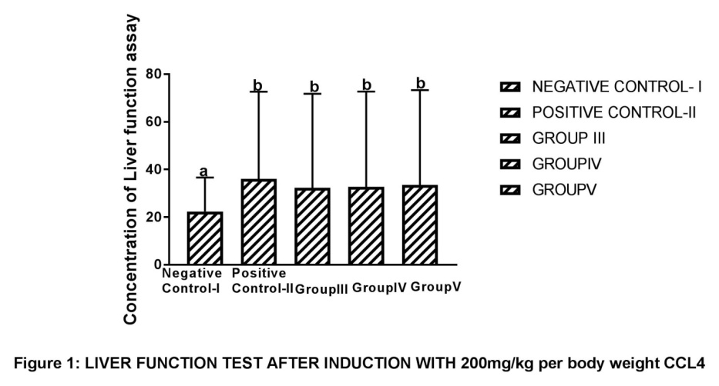Letters a and b indicates significant difference (P < 0.05) when group I was compared with groups II, III, IV and V, respectively after CCl4 induction of liver damage to rats in these groups. Graphs with same letters are not significantly (P < 0.05) different. As shown in figure 1, the results of induction with 200mg/kg CCl4 reveal a significantly higher (P < 0.05) levels of groups II (positive control), III, IV and V compared to group I (negative control).

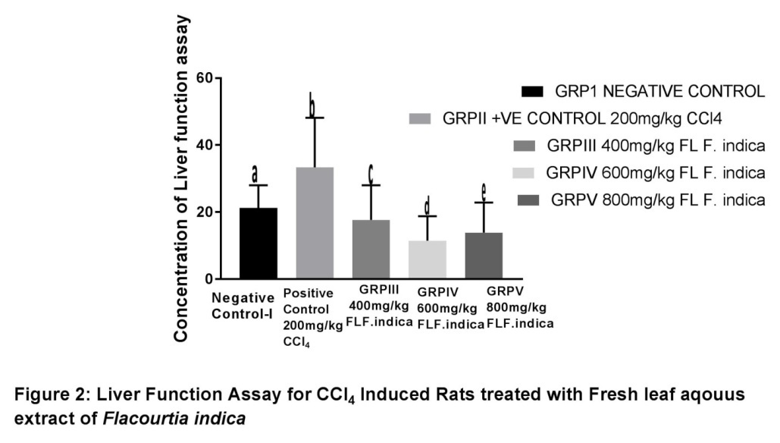

FLF.*indica* ═ fresh leaf of *Flacourtia indica*. Letters a, b, c, d and e indicates significant difference (P < 0.05) when group II was compared with groups I, III, IV and V, respectively for 400mg/kg, 600mg/kg and 800mg/kg FLAE *Flacourtia indica* treated groups. The results show significantly higher (P < 0.05) level of group II rats (positive control) compared to group I (negative control), group III (400mg/kg FLF.*indica*), group IV (600mg/kg FLF.*indica*) and group V (800mg/kg FLF.*indica*). There were significant differences (P < 0.05) observed in comparing group I with groups III, IV and V. Also, significant differences (P < 0.05) were observed when the treated groups (III, IV and V) are compared with one another, not necessary in a dose dependent manner.

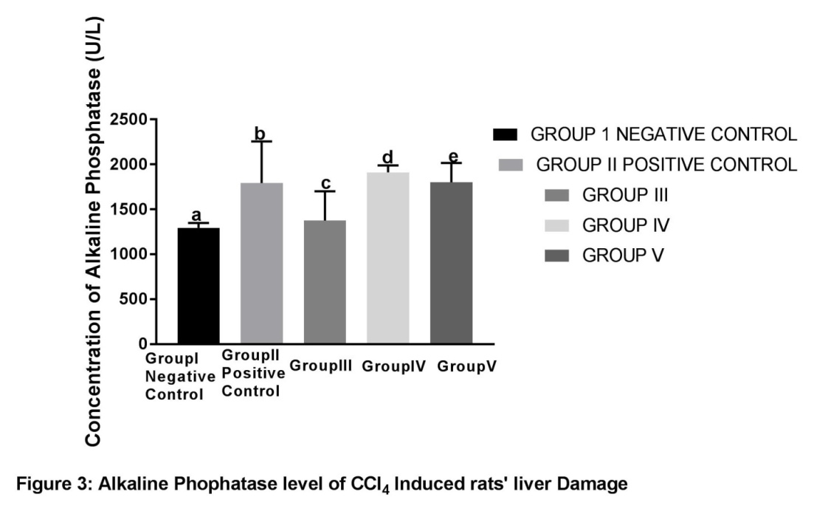

Letters a, b, c, d and e indicates significant difference (P < 0.05) when group I was compared with groups II, III, IV and V, respectively after CCl4 induced liver toxicity.

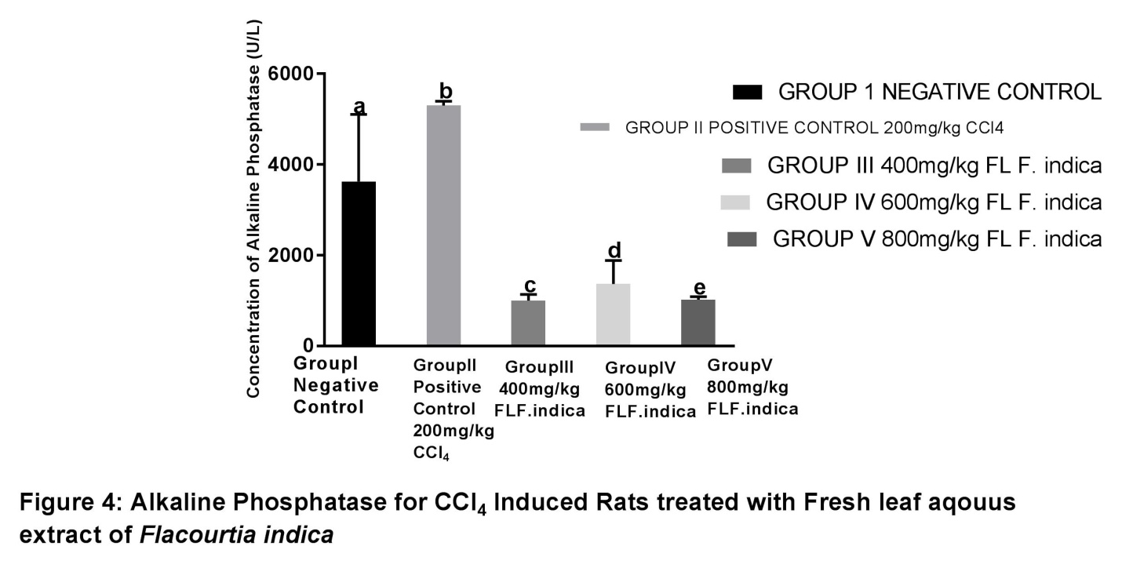

FLF.*indica* ═ fresh leaf of *Flacourtia indica*. Letters a, b, c, d and e indicates significant difference (P < 0.05) when group II was compared with groups I, III, IV and V, respectively for 400mg/kg, 600mg/kg and 800mg/kg *Flacourtia indica* treated groups. Results in figure 4 also reveal significantly higher (P < 0.05) differences in the concentration of Alkaline Phosphatase (ALP) when group I (negative control) is compared with group III (400mg/kg FLF.*indica*), group IV (600mg/kg FLF.*indica*) and group V (800mg/kg FLF.*indica*). When the concentrations of ALP in groups III, IV and V were compared with one another, significant differences (P < 0.05) were observed in a dose dependent pattern.

**DISCUSSION**

Carbon tetrachloride (CCl4) induced hepatic injury is shown in table 1 and (figures 1 & 3). The rise in the level of ALT, AST, ALB, ALP, BIL and TP of groups II, III, IV and V when compared to group I indicates a CCl4 induced liver damage. This is consistence with 20, who reported the use of 1.5ml/kg body weight of CCl4 orally administered to rats to induce liver damage. These liver function enzymes are found to be located in the cytosol of the liver cell and thus, are easily released into the serum after cellular liver damage 21. The mechanism of action involved in CCl4 hepatic injury is understood to be linked to the liver phase II detoxification action. The liver, in the process of detoxification transforms Carbon tetrachloride (CCl4) in the presence and action of cytochrome P450 enzyme component to produce peroxytrichloromethyl and trichloromethyl free radicals 13. These free radicals results in lipid peroxidation by reacting covalently with biomolecules (proteins, nucleic acids, lipids etc) in the presence of oxygen. Thus the liver becomes damaged and obviously its cell membrane becomes degenerate, permeable and licks out its cellular contents of AST, ALT, TP, ALP, BIL and ALB 22. After induction with CCl4, the level of blood glucose was raised (table 4), hemoglobin and PCV (table 3) levels were decreased. This could suggest that CCl4 induced anemia was possible owing from the destruction of red blood cells and shortage of circulating mineral iron and vitamins 15. Hyperglycemia induced by CCl4 could be due pancreatic injury caused by generation of free radical, cell membrane lipid peroxidation and subsequent destruction of pancreatic β- islet cells 3.

Administration of CCl4 induced rats with FLAE of *Flacourtia indica* shows reduction in the concentrations of liver function enzymes (TP, AST, ALT, ALP, and BIL) in the serum and blood glucose (tables 2 & 4 and figures 2 & 4). Similarly, after treatment with FLAE of *Flacourtia indica* the levels of ALB, Hb and PCV increased as shown in table 2 and 4. The reduced serum levels of the liver function enzymes indicate the recuperative, regenerative and healing effect of FLAE of *Flacourtia indica* on the hepatic cells. This is in support of 3, who reported that treatment with *Flacourtia indica*’s ethanol extract stem bark with 500 mg/kg and 700 mg/kg in rats liver revealed regeneration of hepatocytes and absence of inflammation. It appears FLAE of *Flacourtia indica* exert its effects by antioxidant and free radical scavenging strength by furnishing the body with antioxidants phytochemicals (tannins, flavonoids, carotenoids, anthacyanins), minerals (Fe, Mg, Mn, Na, K) and vitamins (A, C and E) 4, 20.

Blood glucose was found to decrease with treatment with FLAE of *Flacourtia indica*. This could be associated with its antioxidant ability of increasing insulin production and regeneration of the β- islet cells of pancreas that was ones destroyed by CCl4 induction 20. 7 buttresses that the presence of minerals in plants enhance effective function of the glycolytic pathway enzymes for the breakdown of glucose. That minerals enhances the phosphorylation conversion reaction of glucose to glucose 6-phosphate by the action of the enzyme hexokinase or glucokinase and phosphorylation of fructose 6-phosphate by the action of phosphofructose kinase (PFK) to fructose 1, 6 –bisphosphate 7.

The hematological indices of PCV and Hb after treating the CCl4 anemia induced rats with FLAE of *Flacourtia indica* revealed increased levels of PCV and Hb. The anti-anaemic and haem regenerating effects of FLAE of *Flacourtia indica* as depicted by the results of this study, could be associated to some extent on the antioxidants phytochemical and mineral elements it contains 14, 9. Antioxidant phytochemicals such as saponins, flavonoids and alkaloids have been reported for their ant-anemic abilities, prevent thrombosis and aggregation of platelet and promote enhanced blood circulation 23, 24. Thus, FLAE of *Flacourtia indica* was able to increase the levels of PCV and Hb because of these phytochemicals and mineral elements contents. This action could be made possible by its enhanced removal of the toxic effects caused by CCl4 and creating flourishing iron utilization for the production of heme and subsequent release of new red blood cells 14. FLAE of *Flacourtia indica* could have exert its effects in the improved production of Hb and PCV by enhancing the production of erythropoietin in the bone marrow stem cells and subsequent synthesis of new blood cells 25. In addition, there was an observed reduced body weight of anemic rats (CCl4 induced groups) when compared to the groups treated with FLAE of *Flacourtia indica* (Table 5). This reduction in body weight of anemic rats and increase or weight gain in the treated group with FLAE of *Flacourtia indica* is consistent with the report of 14. The association of weight loss with anemia is not very clear. However, it appears to be related to defect in carbohydrates digestion in the small intestine of anemic rats due to insufficient amount of the enzyme, disaccharidases, thus leading to undigested carbohydrates 26.

**CONCLUSION**

The use of fresh leaf aqueous extract of *Flacourtia indica* in this study reveals that the plant possesses anti-anemia, hypoglycemic and hepato-healing potentials. This is obviously seen in the reduced levels of blood glucose, liver function assay, and in the raised levels of the hematological parameters, coupled with weight gain after treating CCl4 induced groups with FLAE of *Flacourtia indica*.

**CONFLICT OF INTEREST**

Authors have declared that no conflict of interest is linked with this work.

**REFERENCES**

|  |
| --- |
| 1. Eramma N, Devaraja G. Antibacterial potential and phytochemical analysis of Flacourtia indica (Burm.f.) Merr. root extract against human pathogens. Indo American Journal of Pharm Research. 2013: 3(5). 2. Ihcène B, Asma B, Amel B, Abdelfattah EF, Mahfoud M. Antioxidant Effect of Alpha Lipoic Acid on Hepatotoxicity Induced by Aluminium Chloride in Rats, Int. J. Pharm. Sci. Rev. Res. 2014; 29(2): Pages: 19-25. 3. Idokoa A, Emmanuel UG, Yakubu O, Ugwudike P, Patricia N. Hepatocurative and Gluco-stabilizing Potentials of Ethanol Extract of Stem bark of *Flacourtia indica* in Aluminium Chloride induced Toxicity in Albino Wistar rats. Curr Trends Biomedical Eng & Biosci. 2018; 17(3): 1–7. DOI: 10.19080/CTBEB.2018.17.555965. 4. Ammar A, Naoufal L, Azam B, Dennis G. Watson and David A. Lightfoot. Phytochemicals: Extraction, Isolation, and Identification of Bioactive Compounds from Plant Extracts. Plants. 2017; 6(42): 1-23. 5. Vivekananthan DP, Penn MS, Sapp SK, Hsu A, Topol EJ. Use of antioxidant Vitamins for the prevention of Cardiovascular diseases. Meta-analysis of Randomised trials. Lancet. 2003; 361: 2017-2023. 6. Abubakar SM, Umar SA, Alexander I, Abubakar N, Abdulazeez MA, Sule MS. Evaluation of hypoglycaemic, hypolipidaemic and non toxic effect of hydro-methanolic extracts of Ziziphus mauritiana, Ziziphus spina christi fruit and glibenclamide on alloxan induced diabetic rats, Journal of Drug Delivery and Therapeutics. 2018; 8(3): 82-92. |

1. Idokob A, Ikpe VPO, Rita ON, Nelson NO, Effiong JU, Alhassan AJ, Muhammed IU, Abubakar N, Abubakar SM, Ugwudike PO. Hypoglycermic and Lipid Profile Lowering Effect of Chromolaena Odorata (linn) in Albino Wistar Rats Fed Different Concentrations of Cholesterol Enriched Diet. Universal Journal of Pharmaceutical Research. 2018; 3(1): 37-42.
2. Idoko A, Ikpe VPO, Nelson NO, Effiong JU, Alhassan AJ, Muhammad IU, Abubakar, N, Abubakar SM. Effects of Lime Juice and Honey on Lipid Profile of Cholesterol Enriched Diet Fed Rat Model. Annual Research & Review in Biology. 2017; 20(3): 1-10.
3. Abhishek M, Thangadurai D, Shivanand B, Sangeetha J. Proximate Analysis and Mineral Composition of Potential Minor Fruits of Western Ghats of India, Agronomy. 2017; Series A.Vol. LX: 340-346.
4. Alan F. An overview of the liver: A series of fact sheets written in the field of liver disease, Hepatitis C Support Project (*HCSP publication)*; 2015 version 1; page 1- 5. Reviewed January 2018.
5. Tarasankar M, Surajit M, Nilanjan P, Durgesh RK, Subarna G. A Review on Hepatic Diseases and Development of Herbal Drugs for The Treatment Of Liver Complications. World Journal of Pharmaceutical Research. 2015; 4(6): 677-691.
6. Gupta AK, Ganguly P, Majumder UK, Ghosal S. Hepatoprotective & antioxidant effect & stereoidal saponins of solanum of *Solanum* *xanthocarpum* & *Solanum nigrum* in paracetomol induce hepatotoxicity in rats. Pharmacologyonline 2009; 1: 757-768.
7. Weber LW, Boll M, Stampfl A. Hepatotoxicity and mechanism of action of haloalkanes: carbon tetrachloride as a toxicological model. Crit Rev Toxicol, 2003; 33: 105-36.
8. Luka CD, Abdulkarim M, Adoga GI, Tijjani H, Olatunde A. Anti-anaemic Potential of Aqueous Extract of *Spinacia oleracea* Leaf in Phenylhydrazine-treated Rats. New York Science Journal. 2014; 7(6): 14-18.
9. Hoffman R, Edward B, Leslie S, Helen H, Jeffrey W, John Anastasi. Hematologic aspects of parasitic diseases. In: Hematology: Basic Principles and Practice. 6th ed. Philadelphia, Pa.: Saunders Elsevier; 2012. http://www.elsevier.com. Accessed January 17, 2019.
10. Khoo SB. Haematinics for Anaemia in the Elderly. Malaysian Family Physician. 2011; 6(1):1-8.
11. Zimmerman M. Ethical Guidelines for Investigations of Experimental Pain in Conscious Animals. Pain. 1995;16(2): 109-11.
12. National Institute of Health. Guidelines for the Care and Use of Laboratory Animals, National Academic Press, 1937; 85-23.
13. Graphpad Instat3 and graphpad prism Softwares. 2000. Available: [www.graphpad.com](http://www.graphpad.com). Retrieved on 24th November, 2018.
14. Anindita B, Gangarao B. Flacourtia indica (burm.f.) prevents ccl4 induced rat liver damage by augmenting antioxidant enzyme activity.European Journal of Pharmaceutical and Medical Research. 2016; 3(4): 263-270.
15. Bagban IM, Roy SP, Chaudhary A, Das SK, Gohil KJ, Bhandari KK. Hepatoprotective activity of the methanolic extract of Fagonia indica Burm in carbon tetra chloride induced hepatotoxicity in albino rats. Asian Pacific Journal of Tropical Biomedicine, 2012; 1457-1460.
16. Recknagel RO, Glende EA, Dolak JA, Waller RL. Mechanisms of carbon tetrachloride toxicity. Pharmacol Ther. 1989; 43: 139-154.
17. Shi J, Arunasalam K, Yeung D, Kakuda Y, Mittal G, Jiang Y. Saponins from edible legumes: chemistry, processing, and health benefits. Journal of Medicinal Food. 2004; 7: 67–78.
18. Falcone A, Musto P, Rasario P, Rosella M. Compounds and Methods for treatment of chemotherapy – induced Anemia. European Journal of Haematology. 1997; 58:34 –319.
19. Ganong WF. A review of Medical Physiology Appleton & Lange Pubiisher. 1997:96.
20. Vieira MR, Galzvao LC, Fernandes MIM. Relation of the disaccharidases in the small intestine of the rat to the degree of experimentally induced iron-deficiency anaemia. Braz J Med Biol Res. 2000; 33: 539-544.