**Reviewer’s Comments**

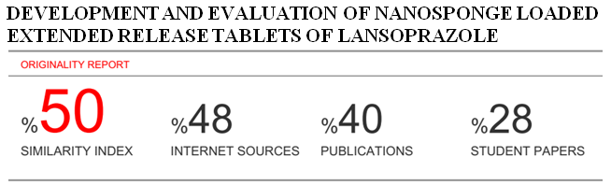

**DEVELOPMENT AND EVALUATION OF NANOSPONGE LOADED EXTENDED RELEASE TABLETS OF LANSOPRAZOLE**

# ABSTRACT

Nanosponges are tiny sponges with an average diameter below 1µm and consist of cavities filled with drug molecules. Lansoprazole is one of the classes of proton pump inhibitors, it reduces gastric acidity, and used in disorders such as gastric ulcer, duodenal ulcer and reflux oesophagitis. In present study for extended delivery of lansoprazole at optimal concentration and to reduce the frequency of dosing and thus to increase patient convenience nanosponges loaded extended release tablets were prepared. Initially four different nanosponges formulations were prepared by solvent evaporation method and evaluated on various parameters. Ethyl cellulose was used as entrapping agent and dichloromethane as cross linking agent in various proportions and evaluated for powder flow properties, % yield, zeta potential, and in-vitro drug release characteristics. Based on the evaluation results, formulation NS1 was selected to prepare five extended release tablets formulations by using HPMC K30 and chitosan as extended release polymers. All five formulations were evaluated for thickness, hardness, friability, % drug content and *in-vitro* drug release. From the results, it was found that all the evaluation results are within pharmacopoeial limits. From this study, we concluded feasibility of extended release of Lansoprazole through nanosponge loaded extended release tablets. Formulation of batch NT1, containing HPMC K30 was found to be optimum formulation.

**Keywords:** Entrapment efficiency, ethyl cellulose, HPMC, in-vitro drug release, lansoprazole, nanosponges.

Introduction

The goal of any drug delivery system is to provide a therapeutic amount of drug to the proper site of action in the body and also to achieve and it maintain the valuable plasma concentration of the drug for a particular period of time1. Nanosponge drug delivery can provide increased efficacy for topically active agents with enhanced safety, extended product stability and improved aesthetic properties in an efficient and novel manner2.

Nanosponges are those porous polymeric delivery systems that contain small spherical particles with large porous surface. Nanosponge is play vital role in targeting drug delivery in a controlled manner3. Lipophilic and hydrophilic drugs are incorporated in Nanosponge4. These are tiny sponges with a size of about a virus. These sponges circulate around the body until they encounter the specific target site, stick onto the surface and begin to release the drug in a controlled and predictable manner5.

Nanosponges can be formulated as parenteral, oral, topical or inhalational dosage forms. For oral administration, Nanosponge can be easily dispersed in the matrix of excipients, diluents, lubricants and anti caking agents which is used for the preparation of tablets or capsules formulation6.

Lansoprazole is a proton pump inhibitor; it is used in the treatment of gastric ulcer, gastro oesophageal reflux disease (GERD), duodenal ulcer, ulcers associated with usage of Nonsteroidal anti-inflammatory drug (NSAID) and long term management Zollinger-Ellison syndrome7. Lansoprazole also exhibits antibacterial activity against Helicobacter pylori. Lansoprazole comes under the BCS II classification drug which has poor aqueous solubility and bioavailability. Regular usage of lansoprazole causes various adverse effects like abdominal pain, diarrhoea, skin rashes, thrombocytopenia, impotence etc8,9.

Since oral route is preferred than other routes with respect to safety, comfort and reliability.

So the aim of the present study was to develop extended release tablets of lansoprazole nanosponges to deliver at controlled rate to its absorptive site, to reduce the frequency of administration and thus to improve patient compliance.

**Materials and methods**

Lansoprazole was obtained from Abumec Pharmaceuticals Ltd, Kaduna State. Ethyl cellulose, Polyvinyl alcohol, was obtained from AC Drugs Limited, Enugu State and Dichloromethane, HPMC K30, chitosan were obtained from Afrik Pharmaceuticals Plc, Awo-Omamma. Magnesium stearate, Talc and MCC pH 102 were  
procured from Avro Pharma Limited, Lagos Nigeria.

**Drug-excipient compatibility studies**

Fouriertransform infrared analysis was conducted to verify the possibility of interaction of chemical bonds between drug and polymers. Samples were scanned in the range from 400-4000 cm-1 and carbon black reference. The detector was purged carefully by clean dry helium gas to increase the signal level and reduce moisture10.

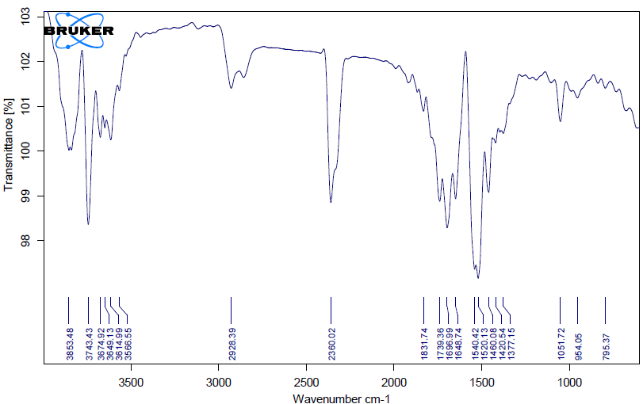

**Figure 1: FTIR spectra of Lansoprazole with polymers**

**Preparation of Lansoprazole nanosponges**

Lansoprazole nanosponges were prepared by the emulsion solvent evaporation method by the use of different proportions of polymers and polyvinyl alcohol11. Ethyl cellulose was used as entrapping agent and dichloromethane as cross linking agent in various proportions. The disperse phase containing Lansoprazole as a dispersing medium and polymer in 20ml of dichloromethane was added slowly to a definite amount of Poly vinyl alcohol in100mL of aqueous continuous phase with 1000 rpm stirring speed using magnetic stirrer for 2hrs. The formed nanosponges were collected by filtration and dried in oven at 40ºC for 24hrs and packed in vials. The preparedNanosponges formulations with three different polymers are listed in Table 1.

**Table 1: Formulation of Lansoprazole nanosponges.**

|  |  |  |  |  |  |
| --- | --- | --- | --- | --- | --- |
| **Batch** | **Lansoprazole (mg)** | **Ethyl cellulose**  **(mg)** | **Polyvinyl**  **alcohol (gm)** | **Dichloromethane (ml)** | **Distilled water**  **(ml)** |
| NS1 | 50 | 100 | 2 | 30 | 20 |
| NS2 | 100 | 200 | 3 | 30 | 20 |
| NS3 | 150 | 300 | 4 | 30 | 20 |
| NS4 | 200 | 400 | 3 | 30 | 20 |

**Evaluation of nanosponges micrometric properties**

Angle of repose, Bulk density, Tapped density, Hausner’s ratio and Carr’s index were determined to assess the flow ability of the prepared nanosponges powder.

**Determination of percentage yield**

It was calculated accurately by using the weight of final product after drying with respect to the initial total weight of the drug and polymer used for preparation of nanosponges12,13.

**Determination of entrapment efficiency**

Nanosponge equivalent to 100 mg of the drug were taken and then crushed into powder followed by transferred into a 100 ml volumetric flask consist of 10ml of methanol and the volume was made up with simulated gastric fluid of pH 1.2. After 24 h, the solution was filtered through Whatmann filter paper and the absorbance was measured spectrophotometrically after suitable dilutions14,15.

**Zeta Potential determination**

The zeta potential was measured for the determination of the movement velocity of the particles in an electric field and the particle charge. In the present work, the nanosponges was diluted 10 times with distilled water and analyzed by Zetasizer using Laser Doppler Micro electrophoresis (Zetasizer nano ZS, Malvern instruments Ltd., UK)16,17.

***In-vitro* dissolution studies**

*In vitro* drug release was carried out by diffusion method using phosphate buffer pH 6.8 as dissolution media. Required quantity of sample (100 mg) was taken and then suspended in required media and then kept in the open ended apparatus. One end of the tube was kept open and the dialysis bag was tied (molecular weight cut off: 12–14kDa, surface area of 22.5cm2) at the other end which was then submerged in a beaker containing 100ml of the phosphate buffer pH 7.2. Temperature of the media was kept at 37±2°C and 100 rpm speed. The samples were withdrawn at predetermined intervals and replaced by fresh medium simultaneously. Aliquots withdrawn were assayed at each time interval for the drug released at λ max of 236 nm using UV‐Visible spectrophotometer18,19.

**Formulation of Lansoprazole nanosponge loaded extended release tablets**

From the results of evaluation studies of nanosponges, the formulation NS1 was selected and Optimized for preparation of nanosponge extended release tablets. Five different extended release tablets formulations were prepared with varying concentrations of polymers by direct compression method20. HPMC K30 and chitosan were used as polymers, talc as lubricant and magnesium stearate acts as glidant and microcrystalline cellulose was used as a directly compressible binder. Compositions of different formulations were given in Table 3.

Lansoprazole nanosponges and all other ingredients were individually passed through sieve number #60 and all the ingredients were mixed thoroughly by triturating up to 15 min followed by lubricated with talc. Finally the lubricated mixture was subjected to direct compression by using RIMEK rotary tablet punching machine.

**Table 2: Preformulation parameters of Lansoprazole nanosponges**

|  |  |  |  |  |  |  |  |  |
| --- | --- | --- | --- | --- | --- | --- | --- | --- |
| **Batch** | **Bulk density (gm/cm3)** | **Tapped density (gm/cm3)** | **Carr’s Index** | **Hausner’s Ratio** | **Angle of repose (θ)** | **% yield** | **% Drug entrapment efficiency** | **Zeta Potential (mV)** |
| **NS1** | 0.53±0.12 | 0.58±0.09 | 8.61±0.13 | 1.09±0.06 | 240.37±0.09 | 97.35±0.08 | 89.43±0.09 | -6.1 |
| **NS2** | 0.49±0.08 | 0.54±0.11 | 9.25±0.08 | 1.04±0.05 | 245.59±0.06 | 81.43±0.12 | 86.25±0.13 | -5.2 |
| **NS3** | 0.51±0.06 | 0.56±0.09 | 8.92±0.06 | 1.09±0.03 | 242.31±0.12 | 85.41±0.09 | 81.42±0.08 | -5.6 |
| **NS4** | 0.55±0.04 | 0.60±0.06 | 8.33±0.14 | 1.08±0.04 | 220.43±0.31 | 90.37±0.06 | 85.43±0.05 | -5.9 |

**Evaluation of tablets**

**Post compression studies**

The manufactured nanosponge loaded tablets were subjected to weight variation, hardness (Pfizer hardness tester), thickness (vernier Calipers) and friability (Roche) studies according to the standard procedures21,22,23,24.

**Drug content**

Ten tablets were weighed, finely powdered andtriturate equivalent to 10 mg of the drug was  
accurately weighed, dissolved in pH 1.2 buffer and volume was made up to 100 ml with the same buffer. Further dilutions were done to get concentration of 10µg/ml and absorbance was read at 236 nm against blank by UV Visible spectrophotometer25,26.

**In-vitro drug release studies of tablets**

900ml of 0.1N HCl was placed in vessel and the USP apparatus-II (Paddle Method) was assembled. The medium was allowed to equilibrate to temperature of 37±0.5°C. Nanosponge loaded tablet was placed in the vessel and operated at 50 rpm. Then the medium was replaced with pH 6.8 phosphate buffer and continued up to 10 h at 50 rpm. At definite time intervals, 5 ml of the receptor fluid was withdrawn and same volume was replaced with fresh medium. The withdrawn fluid was filtered, suitably diluted and analyzed using UV-spectrophotometer27.

**Table 3: Formulation of nanosponge loaded extended release tablets of Lansoprazole.**

|  |  |  |  |  |  |  |
| --- | --- | --- | --- | --- | --- | --- |
| **Batch** | **Lansoprazole Nanosponges (mg)** | **HPMC K30 (mg)** | **Chitosan (mg)** | **Magnesium Stearate (mg)** | **Talc (mg)** | **Microcrystalline cellulose**  **(mg)** |
| NT1 | 200 | 75 | - | 5 | 3 | 60 |
| NT2 | 200 | 50 | - | 5 | 3 | 60 |
| NT3 | 200 | 25 | 20 | 5 | 3 | 60 |
| NT4 | 200 | - | 50 | 5 | 3 | 60 |
| NT5 | 200 | - | 75 | 5 | 3 | 60 |

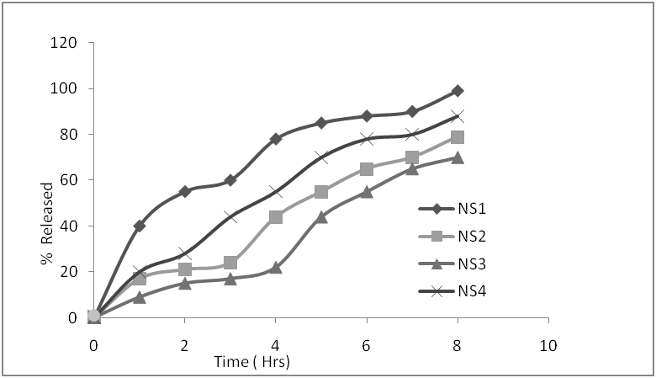

**Figure 2: Dissolution profiles of nanosponges formulations**

**Table 4: Results of post compression parameters of nanosponge loaded extended release tablets of Lansoprazole**

|  |  |  |  |  |
| --- | --- | --- | --- | --- |
| **Batch** | **Weight variation (mg)** | **Hardness (kg/cm2)** | **Thickness (mm)** | **Friability** |
| NT1 | 336±0.38 | 4.8±0.09 | 3.49±0.09 | 0.48±0.09 |
| NT2 | 318±0.45 | 4.7±0.12 | 3.28±0.11 | 0.33±0.12 |
| NT3 | 310±0.61 | 4.2±0.13 | 3.31±0.05 | 0.46±0.15 |
| NT4 | 318±0.28 | 4.9±0.25 | 3.48±0.18 | 0.42±0.08 |
| NT5 | 342±0.39 | 4.1±0.09 | 3.86±0.08 | 0.41±0.14 |

Results expressed in mean (n=3) ± SD (Standard Deviation)

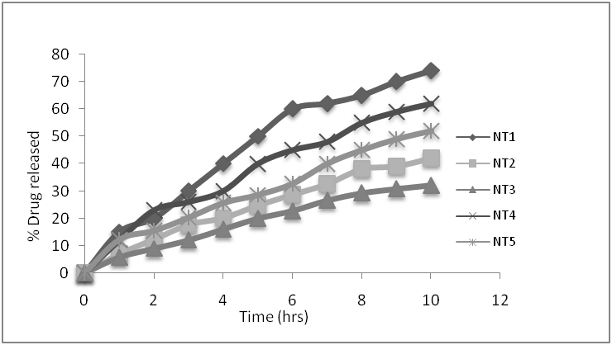

**Figure 3: In-vitro drug release profiles of nanosponge loaded extended release tablets of Lansoprazole**

**Results and discussion**

The present study was aimed for developing Lansoprazole nanosponge loaded extended release tablets using various polymers and excipients. In present study four nanosponges formulations were prepared. Excipients compatibility studies were performed by FT-IR spectroscopy (Figure 1). No significant shifting of the peaks, so polymers used in the study are suitable for the development of Lansoprazole nanosponge formulations.

Percentage yield value of nanosponges was found to be the best for NS1 i.e. 97.35±0.08. It was observed that as the polymer ratio in the formulation increases, the percentage yield also increases. The low percentage yield in some formulations may be due to wastage of the drug-polymer solution.

The % drug entrapment efficiency of the nanosponges was found to be best for the formulation NS1 and it was ranged from 68.86±0.10 to 88.66±0.5 and the results indicated that the ethyl cellulose concentration is directly proportional to the entrapment efficiency but polyvinyl alcohol concentration is indirectly proportional to the entrapment efficiency which is due to the low solubility of polymer in aqueous phase (Table 2). The surface charge of nanosponges was determined by zeta potential and it was found to be in the range of 5.2-6.1mv (±30mv). The *in-vitro* drug release studies of Lansoprazole nanosponges were performed for all the 4 formulations by using USP Type-II i.e. paddle. All the formulations showed drug release for a period of 8 h (Figure 2). Among all the formulations NS1 has shown highest percentage of drug release i.e., 98.35% at the end of 8 h.From the results of evaluation parameters, formulation NS1 has shown acceptable results and hence, it was selected for further studies.

Five different Lansoprazole nanosponge loaded extended release tablets were prepared using HPMC K30 and chitosan and evaluated for flow properties and in-vitro drug release studies.

The powder blend was subjected to pre-compression studies and obtained results were complied with the pharmacopoeial limits (Table 4). The in-vitro drug dissolution studies of nanosponge loaded extended release tablets were performed by taking USP dissolution apparatus-II. In 10 hrs studies, the cumulative percentage drug release was found to be in the range of 42.58±0.09 to 74.81±0.12. Maximum release was shown by the formulations of batch NT1. This may be due hydrophilic nature of HPMC.

**Conclusion**

In present study nanosponge loaded extended release tablets of Lansoprazole showed extended drug release for about 10 h. On the basis of different parameters it is concluded that the nanosponge formulations of batch NS1 and nanosponges loaded extended release tablets of batch NT1 are the optimum formulations.

Study concluded that prolonged drug release and nanosponges loaded extended release tablets of Lansoprazole are suitable option for dose reduction, reduced frequency of administration and avoiding related systemic side effects. However further *in-vivo* study is needed for further estimation of importance of these formulations.

**Conflict of interest**

Authors have declared that no conflict of interest is linked with this work.

**References**

1. Selvamuthukumar S, Anandam S, Kannan K, and Manavalan R. Nanosponges: A novel class of drug delivery system- review. J Pharm Pharm Sci 2012; 15(1): 103-11.
2. Kapoor D, VyasRB, Patel M. A review on Microsponge drug delivery system, J Drug Delivery, 2014; 4(5): 29-35.
3. Kilicarslan M and Baykara T, “The effect of the drug/polymer ratio on the properties of Verapamil HCl loaded microspheres”, Int J Pharm., 2003, 252, 99–109.
4. [Satbir Singh, Tarun Virmani, Reshu Virmani, Pankaj Kumar, Geeta Mahlawat. Fast dissolving drug delivery systems: formulation, preparation techniques and evaluation. Universal Journal of Pharmaceutical Research. 2018; 3(4): 60-69.](http://ujpr.org/index.php/journal/article/view/185)
5. NileshJ., Ruchi J., Navneet T, BrhamPrakash G., Deepak Kumar J., Nanotechnology :A Safe and Effective Drug Delivery Systems, Asian Journal of Pharmaceutical and Clinical Research, vol-3(3), 2010, 159-165.
6. Delattre L., Delneuville I., Biopharmaceutical aspects of the formulation of dermatological vehicles. J Eur Acad Derm Vener, 1995, 5:S70.
7. Rybniker, Jan; et al. (July 2015). "Lansoprazole is an antituberculous prodrug targeting cytochrome bc1". Nature Communications. 6: 7659.
8. Matheson AJ and Jarvis B. Lansoprazole: an update of its place in the management of acid-related disorder. Drugs 61(2), 1801-1833, 2001.
9. Freston, James; Chiu, Yi-Lin; Pan, Wei-Jian; Lukasik, Nancy; Taubel, Jorg (2001). "Effects on 24-hour intragastric pH: a comparison of lansoprazole administered nasogastrically in apple juice and pantoprazole administered intravenously". The American Journal of Gastroenterology. 96 (7): 2058–2065.
10. [Nweje-Anyalowu Paul C, Anyalogbu Ernest AA, White Alalibo Jim. Design and evaluation of chronotherapeutic pulsatile drug delivery system of Cilnidipine. Universal Journal of Pharmaceutical Research. 2017; 2(5): 18-22.](http://ujpr.org/index.php/journal/article/view/84)
11. Jenny A, Merima P, Alberto F, Francesco T. Role of β- cyclodextrin nanosponges in polypropylene photo oxidation, Carbohydrate Polymers,2011, 86: 127– 135.
12. Cavalli R., Ansari K. A., Vavia P.R., Nanosponges formulations as oxygen delivery systems, International journal of pharmaceutics, 402(2010), 254-247.
13. Lala R, Thorat A, Gargote C. Current trends in β- cyclodextrin based drug delivery systems. Int J Res Ayur Pharm, 2(5):2011, 1520-1526.
14. Ansari K., Torne S., Vavia P.R., Trotta F., Cavalli R., Cyclodextrin - Based Nanosponges for Delivery of Resveratrol: In Vitro Characterization, Stability, Cytotoxicity and Permeation Study, AAPS Pharm Sci Tech, 2011,Vol. 12.
15. GarveyJ., Nanosponge drug delivery claimed to work better than direct injection on tumors, Gizmag emerging technology magazine, posted on June 17, 2010.
16. [Ali Alyahawi, Abdulmajed Alsaifi. Quality control assessment of different brands of ciprofloxacin 500 mg tablets in Yemen. Universal Journal of Pharmaceutical Research. 2018; 3(4): 31-36.](http://ujpr.org/index.php/journal/article/view/180)
17. Patel SB, Patel H. J. and Seth AK, “Nanosponge Drug Delivery System: An Overview”, Journal of Global Pharma Tech, 2010., 2(8):1-9.
18. Shishu and Aggarwal N. Preparations of hydrogels of griseofulvin for dermal application, Int J Pharm;2006, 326: 20-24.
19. Zuruzi S., MacDonald N.C., Moskovits M., and Kolmakov A., “Metal oxide nanosponges as chemical sensors: Highly sensitive detection of hydrogen using NanospongeTitania”; Angewandte Chemie International Edition 46 (23):2007, 4298-4301.
20. [Alsaifi A, Alyahawi A. Quality assessment of different brands of paracetamol tablets in Yemeni market. Univ J Pharm Res. 2018; 3(4): 42-47.](http://ujpr.org/index.php/journal/article/view/182)
21. Jenning V, Schafer-Korting M, Gohla S. Vitamin A loaded solid lipid nanoparticles for topical use: drug release properties. J Control Release.1999, 66:115-126.
22. Saboktakin MA, Tabatabaie RM, MaharramovA. Synthesis and in vitro evaluation of thiolated chitosan -dextran sulfate nanoparticles for the delivery of letrozole.JPharmaceutEducat Res 2010; 1: 62-67.
23. [Oyeniran Taiwo Opeyemi, Obanewa opeyemi Adegbenro. Development and  
    characterization of direct compressed matrix mini tablets of naproxen sodium. Universal Journal of Pharmaceutical Research. 2018; 3(5): 68-73.](http://ujpr.org/index.php/journal/article/view/205)
24. Ramnik S, Nitin B, Jyotsana M, HorematS.N., Characterization of Cyclodextrin Inclusion complexes – A Review. J Pharm Sci Tech,, 2010,2(3): 171-183.
25. Guo L, Gao G, Liu X and Liu F, “Preparation and characterization of TiO2 Nanosponge”, Mater. Chem. Phys. 111, 322–325; DOI: 10.1186/1556-276 X-6-551, 2008.
26. [Igwe J. Chibueze, Emenike IV, Oduola AR. Formulation and evaluation of Finasteride sustained-release matrix tablets using different rate controlling polymers. Universal Journal of Pharmaceutical Research. 2016; 1(2): 25-31.](http://ujpr.org/index.php/journal/article/view/24)
27. Maravajhala V., Papishetty S., Bandlapalli S, “Nanotechnology in the development of drug delivery system”, International journal of pharmaceutical sciences & research ,2012, Vol. 3(1).