**Reviewer’s Comments**

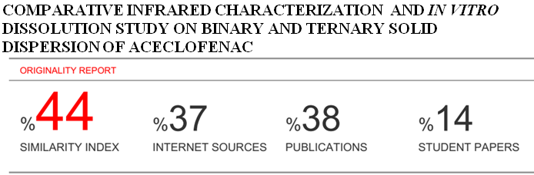

**Comparative Infrared Characterization and *In Vitro* Dissolution Study on Binary and Ternary Solid Dispersion of Aceclofenac**

**ABSTRACT**

The poor aqueous solubility of the drug exhibits in variable dissolution rate & hence poor bioavailability. Aceclofenac is poorly water soluble drug. The aim of the present study was to improve the water solubility & the dissolution rate of Aceclofenac by solid dispersion technique using different water soluble polymers. The term solid dispersions refer to the dispersions of one or more active ingredients in an inert carrier or matrix at solid state. In this study, binary solid dispersion of Aceclofenac were prepared by fusion method using Polyethylene glycol 6000 (PEG 6000), Polyethylene glycol 4000 (PEG 4000), Poloxamer as carrier. Different drug-carrier weight ratio was used for this study. The effect of the carrier on the solubility &*in-vitro* dissolution were studied. It was found the drug was released 26.86% after 5 minutes and only 40.19% within 60 mins from active Aceclofenac on the other hand the release pattern of Aceclofenac from the binary SD formulation containing PEG 6000 in 1:5 ratio (Formulation coding: A5) showed the best result in comparison of other binary and ternary SD formulations which was 62.29% after 5 min & 83.03% within 60 mins. The hydrophilic polymers used for the preparation of solid dispersion are showed significant increase in the solubility of Aceclofenac. Evaluation of the properties of solid dispersions was also performed using Fourier Transform Infrared spectroscopy.

**Key words**: Aceclofenac, Solid Dispersion, In-vitro Dissolution, FTIR, PEG 4000, PEG 6000 and Poloxamer.

**Introduction**

Poorly water-soluble drugs are increasingly becoming a problem in terms of obtaining the satisfactory dissolution within the gastrointestinal tract that is necessary for good bioavailability. It is not only existing drugs that cause problems but it is the challenge of medicinal chemists to ensure that new drugs are not only active pharmacologically but have enough solubility to ensure fast enough dissolution at the site of administration, often gastrointestinal tract.[1]Oral bioavailability of a drug depends on its solubility or dissolution rate, and dissolution may be the rate determining step for the onset of therapeutic activity. Therefore efforts to increase drug dissolution are often needed. FTIR spectra is regarded as more beneficial than other methods because it takes into account the specific absorbance of molecular vibrations in the sample for quality assessment of biomedical materials.[2]Aceclofenac is a new generation NSAID used in the treatment of osteoarthritis, rheumatoid arthritis and other joint diseases. It is chemically designated as 2-[(2,6-diclorophenyl) amine] phenyl acetoxy acetic acid). Solid dispersions of aceclofenac were formulated to overcome problems like gastric irritation and other side effects that are frequently experienced with NSAID drug therapy. Aceclofenac is practically insoluble in water leading to poor dissolution. [3-5]Aceclofenac appears to be well tolerated among NSAIDs with a lower incident of gastro intestinal adverse effects.[6] The biopharmaceutical classification system (BCS) divides all drug candidates into four different groups according to their solubility and permeability. Aceclofenac is an example of BCS class II compound (Highly Permeable & Low Soluble), its oral bioavailability is determined by dissolution rate in the gastro intestinal tract. Therefore the improvement of Aceclofenac dissolution is an important issue for enhancing its bioavailability and therapeutic efficacy. [7]Solubility is the property of a solid, liquid, or gaseous chemical substance called solute to dissolve in a solid, liquid, or gaseous solvent to form a homogeneous solution of the solute in the solvent. Most often, the solvent is a liquid, which can be a pure substance or a mixture. One may also speak of solid solution but rarely of solution in a gas. **[8]**The term solid dispersion refers to a group of solid products consisting of at least two different components, generally a hydrophilic matrix and a hydrophobic drug. The matrix can be either crystalline or amorphous. The drug can be dispersed molecularly, in amorphous particles (clusters) or in crystalline particles. [9]

**PURPOSE OF THE STUDY**

This project work has been designed with purpose to improve the water solubility of Aceclofenac which is insoluble in water at active ingredient. The dissolution rate of Aceclofenac is expected to limit its absoption from the GIT. In this study, fusion method and solubility test has been used to develop solid dispersion of drug. There are various polymers which have been used in this technique to form porous & amorphous micro particle of solid dispersion helps in the reduction of dose of the drug. Aceclofenac has been chosen as a water insoluble model drug PEG 6000, PEG 4000 and Poloxamer have been used as the hydrophillic polymers which were employed as a carrier material for formulation of solid dispersion with model drug.

MATERIALS AND METHODS

Materials used in the study are listed in the below table along with their uses in this study & sources, where they were found from:

|  |  |  |
| --- | --- | --- |
| Name of the materials | Functional Category | Sources of the chemicals |
| Aceclofenac | Active pharmaceuticals Ingredients (API) | ALBION LABORATORIES LTD, cHITTAGONG |
| Polyethylene Glycol 4000 (PEG 4000) | Carrier for solid dispersion | ALBION laboratories Ltd, CHITTAGONG |
| Polyethylene Glycol 6000 (PEG 6000) | Carrier for solid dispersion | Local market |
| Poloxamer | Carrier for solid dispersion | MERCK, GERMANY |
| Potassium di-hydrogen phosphate | Major salt of buffer solution | MERCK, Germany |
| Di-Potassium hydrogen phosphate | Major salt of buffer solution | MERCK, Germany |
| Distilled Water | Dissolution Medium | University Laboratory |

**Preparation of 0.01M Phosphate Buffer solution (PH = 6.8)**

0.58 gm of monobasic potassium phosphate and 8.86 gm of dibasic potassium phosphate anhydrous was dissolved in 1000 ml distilled water and pH 6.8 was adjusted by using pH meter.

***In vitro* dissolution study of Solid Dispersion**

The *in-vitro* dissolution tests were performed for the pure Aceclofenac and solid dispersions, using USP dissolution test apparatus type II using 900 ml of phosphate buffer as dissolution medium with the assay.

We used this media to compare the dissolution profile of pure drug with that of prepared binary and ternary solid dispersion. The temperature of the medium was maintained at 37°C±0.5°C throughout the experiment. The samples containing 50 mg of Aceclofenac or its equivalent solid dispersions were placed in the dissolution medium. Paddle was used at a stirring rate of 50 rpm. A 5 ml solution was withdrawn at predetermined time intervals of at 5, 15, 30, 45 and 60 minutes and then 5 ml of fresh dissolution medium was replaced to maintain the constant volume of dissolution medium. The absorbance of solution was measured at 275 nm by using UV spectrophotometer against dissolution medium as phosphate buffer. Percentage of drug release was calculated.

**RESULTS AND DISCUSSION**

**Aceclofenac**is a poorly water soluble oral dosage form with problems of variable bioavailability and bioequivalence related to its poor water solubility. The present study was aimed to observe release pattern of drug from solid dispersion by using different excipients such as PEG6000, PEG4000 etc.

**Standard curve of Aceclofenacin 0.05M Phosphate buffer) (PH=6.8)**

**Fig: Standard Curve of Aceclofenac**

**Percent release of aceclofenacfrom active drug and solid dispersion (SD) formulations containing different ratio of PEG 6000 with different ratio**

From the above data we can conclude that release pattern from SD formulation A5 shows the best result in comparison to A1, A2 and A3 which was 83.03% within an hour.

**Percent release of Aceclofenac from active drug and solid dispersion (SD) formulations containing different ratio ofPEG4000**

From the above data we can conclude that release pattern from SD formulation A14 shows the best result in comparison to A15 which was 54.13% within an hour.

**Percent release of Aceclofenac from active drug and solid dispersion formulation containing different ratio of PEG 6000 and Poloxamer**

From the above data we can conclude that release pattern from SD formulation A6 shows the best result in comparison to A7, A8 and A9 which was 81.38 % within an hour.

**Percent release of Aceclofenac from active drug and solid dispersion formulation containing different ratio of PEG 4000 and Poloxamer**

From the above data we can conclude that release pattern from SD formulation A10 shows the best result in comparison to A11, A12 and A13 which was 74.55% within an hour.

**Comparison between PEG 6000 and PEG 4000 on release of Aceclofenac at 1:3 ratio (Binary formulation)**

**Average % release of drug from SD formulation containing PEG 4000 and PEG 6000**

The solid dispersion of aceclofenac prepared by PEG 6000 and PEG 4000 at 1:3 ratio was compared with each other. When comparing the solid dispersion of aceclofenac containing two polymer, A3 (with PEG6000) gave the best result.

.**Comparison between PEG 6000 and PEG 4000 on release of Aceclofenac at 1:5 ratio**

The solid dispersion of aceclofenac prepared with PEG6000 and PEG 4000 at 1:5 ratios was compared with each other. When comparing the solid dispersion of aceclofenac containing same polymer, A5 (with PEG6000) gave the best result.

**Comparison among PEG 6000, PEG 4000 andPoloxamer on release of Aceclofenac at 1:1:0.75 ratio (Ternary formulation)**

The solid dispersion of aceclofenac prepared with PEG6000and PEG 4000 and Poloxamer at 1:1:0.75 ratios was compared with each other. When comparing the solid dispersion of aceclofenac containing same polymer, A6 (with PEG6000 and Poloxamer) gave the best result.

**Comparison among PEG 6000, PEG 4000 andPoloxamer on release of Aceclofenac at 1:1:0.25 ratio**

The solid dispersion of aceclofenac prepared with PEG6000and PEG 4000 and Poloxamer at 1:1:0.25 ratios was compared with each other. When comparing the solid dispersion of aceclofenac containing same polymer, A8 (with PEG6000 and Poloxamer) gave the best result.

**From the above result, we can conclude that the dissolution rate of the solid dispersion increases in compared with active drug when aceclofenac was dispersed in different water soluble carrier. As the soluble carriers dissolve, the insoluble drug is exposed to dissolution medium as very fine particles leading to increase in both surface area & solubilization for fast dissolution & absorption**

**Release kinetics study of active Aceclofenac and different solid dispersion formulation**

15 SD formulations (aceclofenac with different polymer) dissolution data were analyzed by Zero order model,First order, Higuchi square root equation and Hixoncrowell cube root law.

**(a)**

**(b)**

**Fig(a, b): Zero order plot of SD formulations**

**Comparative study of First order release kinetics of solid dispersion formulation (PEG 6000 and poloxamer)**

**(a)**

**Table: Comparative study of First order release kinetics of solid dispersion formulation (PEG 4000 and Poloxamer)**

**(b)**

**Fig (a, b): First order plot of SD formulations.**

**Comparative study of Higuchi release kinetics of solid dispersion formulation (PEG 4000 and poloxamer)**

**(a)**

**Table: Comparative study of Higuchi release kinetics of solid dispersion formulation (PEG 4000 and poloxamer)**

**(b)**

**Fig(a,b): Higuchi release kinetics plot of SD formulations**

**Comparative study of Hixoncrowell release kinetics of solid dispersion formulation (PEG 6000 and Poloxamer)**

**(a)**

**Comparative study of Hixoncrowell release of solid dispersion formulation (PEG 4000 and Poloxamer)**

**(e)**

**Fig(a,b) Hixoncrowell release kinetics plot of SD formulations.**

**FTIR spectra of Aceclofenac Solid dispersion with PEG 4000 prepared by Fusion method (A18=Aceclofenac+PEG4000)**

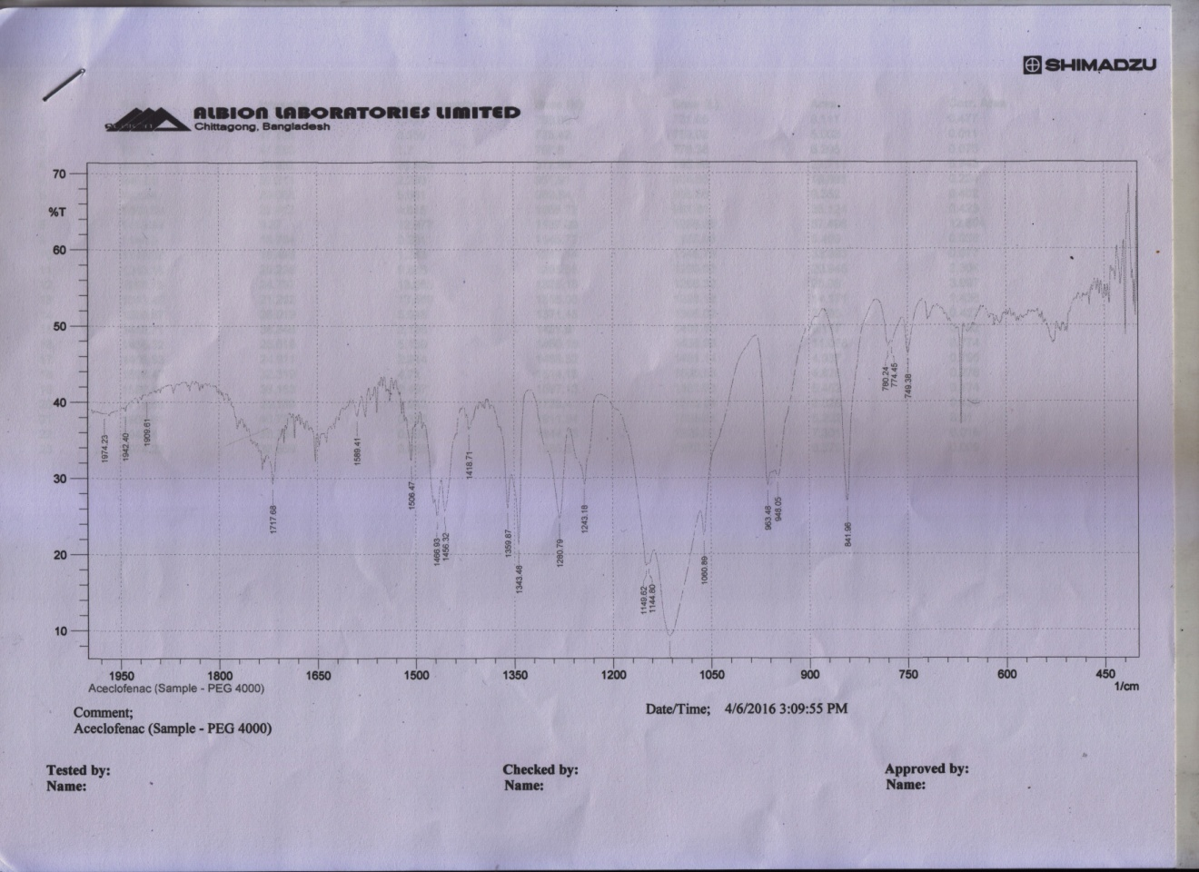

**Fig: FTIR spectra of Aceclofenac containing PEG 4000**

|  |  |  |
| --- | --- | --- |
| **SN.** | **Peak** | **Indications** |
| **01** | 841.96 cm-1 | C-Cl bending |
| **02** | 1506.47 cm-1 | C-C (Stretch) |
| **03** | 1149.62 cm-1 | C-O (bending) |
| 4. | 1717.68 | C=0(Stretch) |

**FTIR spectra of Aceclofenac Solid dispersion with PEG4000 &Poloxamer prepared by Fusion method (A11= ACE+PEG4000+Poloxamer)**

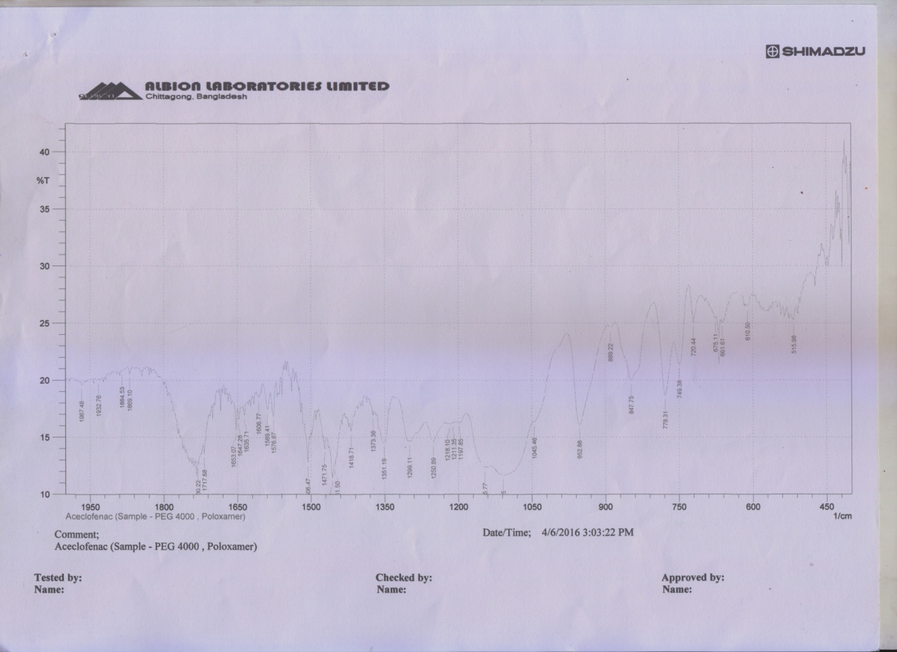

**Fig: FTIR spectra of Aceclofenac containing PEG 4000 and Poloxamer**

|  |  |  |
| --- | --- | --- |
| **SN** | **Peak** | **Indication** |
| **01** | 847.75 cm-1 | C-Cl Bending |
| **02** | 1576.87 cm-1 | C-C (Stretching) |
| **03** | 1299.11 cm-1 | C-O (Aromatic) |
| **04** | 1653.07 cm-1 | C=O (Stretching) |

From the above shown spectrum, we came to conclude that the spectrum seen in the pure Aceclofenac was also found in the case of solid dispersion with PEG4000, PEG 6000 &Poloxamer. The spectrum were at same frequency range but some peaks were shifted to their near values. So we can say that there is no significant interaction between the drugs, PEG4000, PEG6000 & Poloxamer , hence there was no chemical change in the PEG4000, PEG 6000 and Poloxamer , when it was in solid dispersion form.

**Conclusion**

Aceclofenac is a poorly water soluble drug. The enhancement of oral bioavailability of poorly water soluble drugs remains one of the most challenging aspects of drug perfection. Various scientists achieved a complete dissolution of drug from solid dispersions by using different hydrophilic carriers. The carriers acted as dispersing for the liberated drug, thus preventing the formation of any water- insoluble surface layers. In the present study, solid dispersions of Aceclofenac with different hydrophilic carriers in different ratios were prepared by Fusion method to improve water solubility and dissolution characteristics. The preparation of solid dispersion by solvent evaporation techniquehas been proven to be successful. This research showed that when Aceclofenac was dispersed in suitable water-soluble carriers such as PEG 6000, PEG 4000, Poloxamer, its dissolution were enhanced compared with pure drug. Among all water soluble carriers, the SD formulation containing PEG 6000at 1:5 ratios (binary formulation) gave the best result. Fusion method is effective to increase the release rate of Aceclofenac. The water soluble carrier may operate in the micro environment (diffusion layer) immediately surrounding the drug particles in the early stage of dissolution, since the carrier completely dissolves in short time thus enhancing the solubility & dissolution of drug. The drug –polymer interaction were investigated by Fourier Transform Infrared spectroscopy and no considerable drug-polymer interactions were found. However, the shape & surface morphology are important consideration for solid dispersion characterization. So, further studies Differential Scanning Calorimetry, Scanning Electronic Microscopy and X-ray diffractions have to be conducted in this aspect to know the nature of drug whether it is in crystalline form or amorphous. Finally *in vivo* study will require for final selection of carrier and to produce a successful drug delivery system.

**Conflict of interest**

**REFERENCES**

[1] Aulton, M.E. 2002, Pharmaceutics- The Science of Dosage Form Design*. 2nd edition*, Page: 241.

[2] Sapkal, S., Babhulka, M., Rathi, A., Mehetre, G. and Narkhede, M. 2013, An overview on the mechanism of solubility and dissolution rate enhancement in solid dispersion*, International Journal of Pharm Tech and Research*, **5**, 31-39.

[3] Lugar, P., Daneck, K., Engel, W., Trummlitz , G. and Wagner, K. 1996, Structure and physiological properties of Aceclofenac- a new NSAIDs, *Eur J Pharm Sci*., **4**, 175-187.

[4] Aceclofenac [Online] Available from: http://en.wikipedia.org/wiki/generic/Aceclofenac, Accessed on 07-11-2013.

[5] Aceclofenac [Online] Available from: http://www.medicinenet.com/aceclofenac/article.htm, Accessed on 07-11-2013.

[6] Gowda, K.V., Rajan, D. S., Mandal, U., Sam Solomon, P. S., Bose, A., Sarkar, A. K., Pal T.K. and Chattaraj, T.K. 2006*,* Evaluation of bioequivalence of two formulations containing 100 mg of Aceclofenac*, DrugDevelopment and Industrial Pharmacy*, **32**- 19-25.

[7] Samal, H.B., Debata, J., Kumar, N. N., Sneha, S. &Patra, P. K. 2012, Solubility and dissolution Improvement of Aceclofenac using Cyclodextrin , *International journal of drug Development and Research*, **4**(4), 326-333.

[8] Singh, D., Patel, S. R., and Nigam , A. 2014, SOLUBILITY & DISSOLUTION: *A* Review*, International Journal of Research and Reviews in Pharmacy and Applied science,***2**(2), 305-341.

[9] Jatwani, S., Rana, A.C., Singh, G. and Aggarwal, G. 2012*,* An overview on solubility enhancement techniques for poorly soluble drugs and solid dispersion as an eminent strategic approach*, International journal of pharmaceutical sciences and researches,***3**(4), 942-956.