**Reviewer’s Comments**

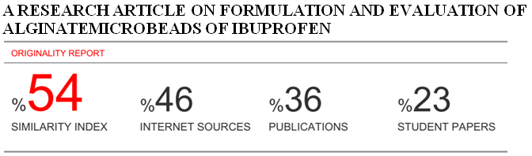

**A Research article on**

**Formulation and Evaluation of AlginateMicrobeads of Ibuprofen**

**ABSTRACT:** The aim of the study was to develop novel drug design of ibuprofen microbeads for sustained drug delivery by oral route which reduces the dosing frequency. Ibuprofen is a NSAIDs commonly used by patients so to reduce the dosing frequency of drug administration the ibuprofen loaded microbeads were prepared with sodium alginate and calcium chloride in different ratios by inotropic gelation technique and characterized by FTIR, drug entrapment efficiency, particle size, swelling Index and release profile. The microbeads show that 3.86% of surface entrapment, drug content 87%, swelling Indexwas found to be 80.76 and 88.72 %drug entrapment of F4 formulation depending on polymer/drug ratio. The IR spectrum shows stable character of ibuprofen in the microbeads and revealed an absence of drug polymer interaction. The prepared microbeads were spherical in shape and had a size range of 125-165µm, the release of the drug was found to be 64.092% in F4 formulation among all formulation in 240 minutes which shows that the drug released by sustained effect and shows kinetic release mechanism the formulation F1 shows fickian diffusion and F2, F3 and F4 shows the supercase Ⅱ transport which depends upon the loss of polymeric chain and the release of drug takes place.

**KEYWORDS:**NSAIDS, gelling agent, ionotropic gelation, microbead

**INTRODUCTION:**

A drug delivery system releases the drug in the particular body compartment at the controlled rate required for a specific treatment. Now a day’s most available drug delivery system uses bio-degradable, biocompatible and natural bio-polymers and are capable of rate-controlled drug release. Now various research efforts are being spent on oral sustained drug delivery system, this system being solid dosage form researchers developed various sustained and controlled release dosage forms by entrapped the drug in natural polymer and forming a gel.1

Micro-beads are defined as the monolithic sphere distributed the whole matrix as a molecular dispersion of particle and molecular dispersion defined as the drug particle are dispersed in to the continuous phase of one or more than one miscible polymer.2Beads loaded with antibiotics to be useful for oral delivery to treatment of different type diseases that is peptic ulcer and for the ulcerative colitis, carcinomas and infections of the intestine. The controlled systemic absorption specifically in the intestinal region offers interesting possibilities for the treatment of diseases such as asthma, arthritis or inflammation.3

It is a small spherical particles with diameters in the micrometer range ( typically 1um 1000 um(1mm) or are greater than 0.1 μm and less than or equal to 5 mm in size, which can vary in chemical composition, size, shape, density, and function. Microbeads are manufactured for specific purposes, including for use in personal care products (such as scrubs, bath products, facial cleaners, toothpastes). They may also be used in other consumer uses including cleaning products and printer toners and in industrial products such as abrasive media (e.g., plastic blasting), industry (e.g., oil and gas exploration, textile printing, and automotive molding), other plastic products (anti-slip, anti-blocking applications) and medical applications.4

Microbeads are small, solid and free flowing particulate carriers containing dispersed drug particles either in solution or crystalline form that allow a sustained release or multiple release profiles of treatment with various active agents without major side effects.

Ibuprofen 2-(p-isobutyl phenyl) propionic acidis a non-steroidal anti-inflammatory drug (NSAID). Ibuprofen is a nonselective inhibitor of cyclooxygenase, an enzyme involved in prostaglandin synthesis via the arachidonic acid pathway. Its pharmacological effects are believed to be due to inhibition of cyclooxygenase-2 (COX-2) which decreases the synthesis of prostaglandins involved in mediating inflammation, pain, fever, and swelling.5

**MATERIAL AND METHOD**

Ibuprofen was obtained from Balaji drugsIndia and sodium alginate was obtained fromCentral drug house,India

**METHOD OF MICROBEADS PREPARATION**:

By ionotropic gelation technique.

1. Weigh accurately all the materials including the drug used, sodium alginate and calcium

chloride.

2. Distilled water is added to the weighed quantity of sodium alginate to make mucilage paste andallowed to heat for 5-10 minutes in a hot plate.

3. After that, distilled water is also added to the weighed quantity of calcium chloride to make asolution.

4. The mucilage pest of sodium alginate is then stirred in a magnetic stirrer at a suitable speed forseveral minutes.

5. The Drug is dispersed in the mucilage pest of sodium alginate and stirred at suitable speed in themagnetic stirrer.

6. The micro-beads are formed by dropping the calcium chloride solution in it through a glass

syringe with the help of a needle.

7. The micro-beads are filtered & washed thoroughly with distilled water.

8. Dried at room temperature subsequently for few hours. 6

**PREFORMULATION STUDIES**

We have carried out some preformulation studies that are needed for established drug like ibuprofen.

**Physical characterization:**

Organoleptic Properties – Ibuprofen

Colour – White Powder

Odour – Odourless

Taste – Bitter

**MELTING POINT:**Melting point of ibuprofen was observed to be 76ºC which is in conformity with the reported range of 75-77ºC.

**SOLUBILITY:**Freely soluble in methanol, ethanol, Chloroform, Acetone and insoluble in water7

**STANDARD CURVE OF IBUPROFEN IN PHOSPHATE BUFFER 7.4:** From the standard curve of ibuprofen it was observed that the drug obeys Beer law in the range of 5-40µg/ml. So accurately weighed quantity of ibuprofen (50mg) was dissolved in little amount (50ml) of phosphate buffer solution.1ml was taken from this solution and volume was makeup to 10ml by phosphate buffer so as to get drug concentrations of 2, 4 ,6, 8, 10 and 12 mg/ml. The absorbance of prepared solutions of ibuprofen in phosphate buffer were measured at λmax 222nm using spectrophotometric against an appropriate blank.8

**IDENTIFICATION OF PURE DRUG**

Identification of ibuprofen was examined by FTIR and was compared with the reference spectrum of ibuprofen.

**Compatibility studies**

Compatibility of ibuprofen with sodium alginate used to formulate microbeads was established by FTIR. Spectral analysis of ibuprofen, sodium alginate and combination of ibuprofen and sodium alginate was carried out to investigate any changes in chemical composition of the drug after combining it with the excipients.9

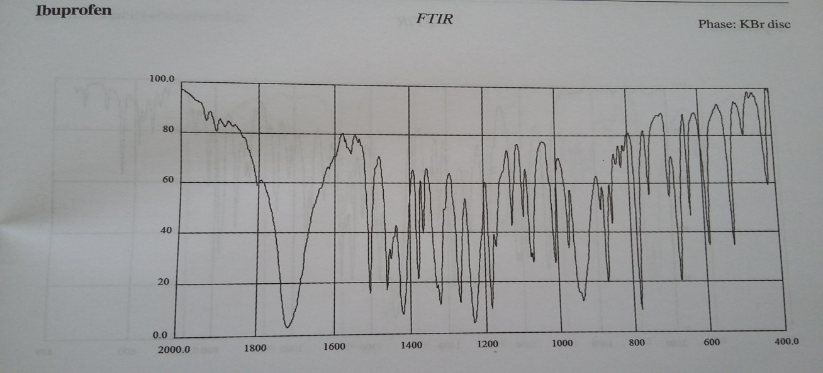FIUGRE 1 Standard FTIR of ibuprofen

**EVALATION PARAMETERS:**

**a) Bulk density/Tapped density**

Both bulk density(BD) and tapped density (TD) were determined. A suitable amount of beads was introduced into a 100ml measuring cylinder. After observing its initial volume, the cylinder in the density tapper instrument and density is measured according to USP method II (upto 1250taps). The tapping was continued until no further change in volume was noted. Volume of packing after tapping was noted. BD and TD were calculated using eq:

**BD=weight of the powder/volume of the packing**

**TD= weight of the powder/tapped volume of the packing**

**b)Hausner’s ratio**

It is the ratio of tapped to bulk density and was calculated by :10

**Hausner’s ratio=TD/BD**

**c) Particle size**

Determination of average particle size of ibuprofen microbeads was carried out by optical

microscopy in which stage micrometer was employed. A minute quantity of microbeads

was spread on a clean glass slide and average size was determined in each batch.11

**d) Percentage Yield**

A positive correlation between the solid content and percentage yield was observed. This may be explained by the fact that, though a constant material is always lost in processing, this loss is proportionately less significant when the solid content is more. The Percentage and theoretical value is determined by which we can calculate the percentage yield.

**e) Drug content**

Microbeads were kept in the phosphate buffer 7.4 solution for 24 hours, then filter it. The absorbance of filtrate was taken at λmax 222nm and concentration was determined.12

**f) Surface area and drug entrapment efficiency**

The capture efficiency of microbeads or the percent drug entrapment can be determined by allowing washed microcapsule to lyse. The lysate is then subjected to determination of active constituents as per monograph. The percent encapsulation efficiency is calculated using following equation .13

**%Entrapment=Actual content/Theoretical content x 10**

**g) Dissolution study**

The 900 ml of phosphate buffer 6.8 was placed in dissolution vessel (USP apparatus type-II paddle method). The sample was then placed in the vessel and the apparatus was operated for 4 hrs. at 50 rpm. At definite time interval 5 ml was withdrawn from the vessel and another 5 ml of the blank was added to the vessel. The withdrawn fluid is then filtered and suitable dilution was made. Samples are then analysed under UV Spectrophotometer at 222 nm.14

**h) Swelling Index**

The weight of the microspheres is taken first and then dissolved in phosphate buffer (pH 7.2) for 24 hrs. The excess liquid is removed using blotting paper and the weight of the swollen microspheres is taken. Swelling index is thus calculated using following formula, Swelling index = [(weight of swollen microspheres – weight of dried microspheres) / weight of swollen microspheres]

**RESULTS:**

**1.Caliberation curve:**

**TABLE 1 Observed data ibuprofen**

|  |  |  |
| --- | --- | --- |
| **S.NO.** | **CONC(µgm/ml)** | **ABSORBANCE** |
| 1 | 2 | 0.1602 |
| 2 | 4 | 0.3187 |
| 3 | 6 | 0.5383 |
| 4 | 8 | 0.7853 |
| 5 | 10 | 0.9816 |
| 6 | 12 | 1.197 |

**FIGURE 2Standard Curve**

The standard curve plot between concentration and absorbance. The value of R2 was found to be 0.997. So, the equation can be used for the further calculations.

**2.SURFACE AND DRUG ENTRAPMENT:**

**TABLE 2 Data of surface and drug entrapment**

|  |  |  |
| --- | --- | --- |
| **Formulation** | **%surface entrapment** | **%drug entrapment** |
| F1 | 4.43 | 78.21 |
| F2 | 4.21 | 80 |
| F3 | 3.98 | 84.04 |
| F4 | 3.86 | 88.72 |

From the result we can conclude that as the amount of polymer in the formulation increases, the surface entrapment decreases as a result of increase in drug entrapment.

**3.BULK AND TAPPED DENSITY:**

**TABLE 3 Data of bulk and tapped density**

|  |  |  |
| --- | --- | --- |
| **Formulation** | **Bulk density (gm/ml)** | **Tapped density(gm/ml)** |
| F1 | 0.13 | 0.20 |
| F2 | 0.25 | 0.29 |
| F3 | 0.30 | 0.33 |
| F4 | 0.41 | 0.34 |

From the formulations we observed that BD and TD for all the formulations were found in the range between 0.13 to 0.41 g/cm3 and o.20 to 0.34 g/cm3 respectively.

**4.DRUG CONTENT:**

**TABLE 4 Data of drug content**

|  |  |
| --- | --- |
| **Formulation** | **Drug content (%)** |
| F1 | 78 |
| F2 | 81 |
| F3 | 85 |
| F4 | 87 |

As the percentage of ibuprofen drug increases the percentage of drug content also increases.

**5.FTIR:** Drug polymer compatibility



FIGURE 3 FTIR of ibuprofen drug.



FIGURE 4 FTIR of ibuprofen and polymer

The result of FTIR spectrum studies showed that there was no significant interaction between the drug and polymer.

**6.. PARTICLESIZE**:

**TABLE 5 Data of particle size**

|  |  |
| --- | --- |
| FORMULATION | PARTICLE SIZE(µm) |
| F1 | 125 |
| F2 | 132 |
| F3 | 140 |
| F4 | 165 |

Formulation 1 Formulation 2

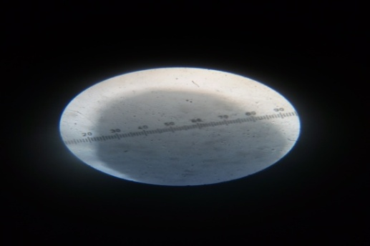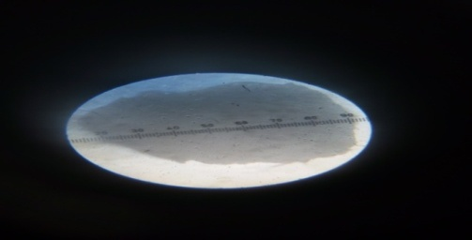  
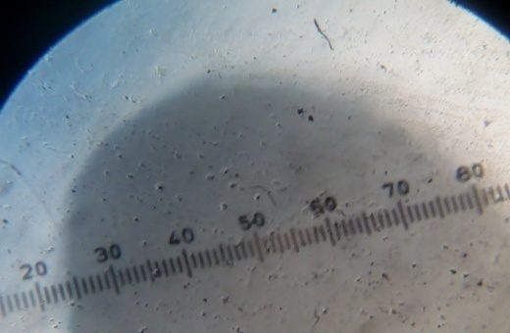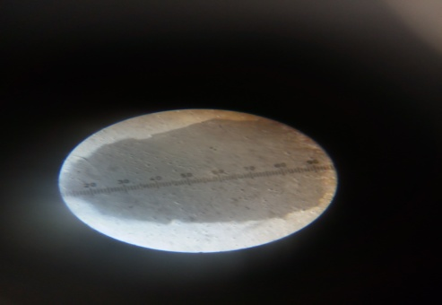

Formulation 3 Formulation 4

FIGURE 5 Particle size of microbeads

The particle size varies from 125 to 165µm

**7.PERCENTAGE YIELD :**

**TABLE 6 Data of percentage yield**

|  |  |  |  |
| --- | --- | --- | --- |
| Formulation | Theoretical yield | Practical yield | Percentage yield |
| F1 | 1.5gm | 1.06gm | 70.6% |
| F2 | 2gm | 1.14gm | 57% |
| F3 | 2.5gm | 1.81gm | 72.4% |
| F4 | 3gm | 2.42gm | 80.6% |

FIGURE 6 percentage yield of ibuprofen microbeads

The formulation F4 was found to be the best among all the other formulation because the percentageyield was found to be 80.6% among all formulation.

**8.Dissolution study**

**Table 7 Data of invitro dissolution study**

|  |  |  |  |  |
| --- | --- | --- | --- | --- |
| **Time (min)** | **F1** | **F2** | **F3** | **F4** |
| **0** | 0.00 | 0.00 | 0.00 | 0.00 |
| **15** | 1.835 | 1.8653 | 3.3349 | 7.9960 |
| **30** | 6.457 | 8.6351 | 7.3571 | 25.579 |
| **60** | 14.06 | 9.6883 | 10.596 | 33.842 |
| **90** | 31.69 | 17.544 | 17.303 | 37.903 |
| **120** | 39.87 | 27.130 | 19.432 | 39.106 |
| **150** | 43.26 | 28.862 | 22.648 | 40.596 |
| **180** | 46.92 | 31.201 | 25.963 | 41.511 |
| **210** | 55.56 | 44.190 | 29.206 | 53.706 |
| **240** | 60.94 | 55.100 | 37.268 | 64.092 |

FIGURE 7 Invitro Dissolution study

The invitro drug release of formulation F1 to F4 were studied. All formulation shows different level of drug release ranging from 37.26% to 64.092%. It has been evaluated that as the different concentration of gelling agent shows the significant drug release F1 & F4 (60.94 % &64.09 %).

**Drug release kinetic with model fitting:**

**Table 8 Data of kinetic study**

|  |  |  |  |  |  |  |
| --- | --- | --- | --- | --- | --- | --- |
| **Formulation**  **Code** | **R2** | | | **n value** | **Best fit model** | **Mechanism of release** |
| **Zero order** | **First order** | **Higuchi matrix** |
| **F1** | 0.9606 | 0.9827 | 0.9825 | 0.5004 | First order | Fickian |
| **F2** | 0.9092 | 0.9245 | 0.9167 | 1.1787 | First order | SupercaseⅡ transport |
| **F3** | 0.9814 | 0.9751 | 0.9656 | 1.6185 | Zero order | SupercaseⅡ transport |
| **F4** | 0.9557 | 0.9639 | 0.9816 | 1.1814 | Higuchi | SupercaseⅡ transport |

Drug release kinetic model are used to illustrate the drug release mechanism. For this various model are used like zero order, higuchi, first order, korsmeyerpeppas to obtain the value of R2 value and n-value for the determination of best fit model. R2 value was compared for all the formulation which shows the best fit model and by noticing n-value which is obtained from korsmeyerpeppas model. Release mechanism was described by an equation: 15

**Mt/M∞ = ktn**

The observed data of kinetic model shows the best fit model for prepared ibuprofen microbeads was determined by regression coefficient(r2) in all formulation. The highest r2 value determine the best fit model, the observed data shows the zero- order release, first order release and higuchi in all formulation. Formulation F1shows fickian diffusion and F2,F3 and F4 shows the supercase Ⅱ transport which depends upon the loss of polymeric chain and the release of drug takes place.

**10. Swelling Index**

**Table 9 Data of swelling index**

|  |  |
| --- | --- |
| **Formulations** | **Swelling Index** |
| **F1** | 69.69 |
| **F2** | 75.00 |
| **F3** | 77.27 |
| **F4** | 80.76 |

It has been observed that formulation 4 i.e. the formulation containing highest sodium alginate which gives the highest swelling index.

**CONCLUSION:** It could be concluded that the sustained release alginate beads of Ibuprofen evaluated by qualitative method gave effective data’s. Microbeads are one of the microparticulate systems and are prepared to obtain prolonged or controlled drug delivery, to improve bioavailability or stability and to target drug to specific sites. Microbeads can also offer advantages like limiting fluctuation within therapeutic range, reducing side effects, decreasing dosing frequency and improving patient compliance. Microbeads of ibuprofen were prepared according to the using modified ion gelation method by selecting concentration of sodium alginate and calcium chloride as independent variables. Increasing polymer concentration led to more sustained release effect whereas, presence of sodium alginate improves the encapsulation efficiency. Calcium chloride can be increased up to certain limit above which encapsulation was decreased. Moreover, the effect of each variable on release characteristic was found to be significant as confirmed by data analysis. Respectively, the mathematical model developed in the present study can be used to design microbeads of desired release characteristic.

**REFERENCES**

1. Durga Devi N, Chandana M, Sindhura A. Comparative Evaluation of Alginate Beads Prepared by Ionotropic Gelation Technique. Pharmacophore 2010; 1(3): 196-213.
2. Mathew Sam T, Devi Gayathri S, Prasanth V, Vinod B. Nsaids as Microspheres. The Internet Journal of Pharmacology 2008; 6(1): 332-338.
3. Anal A, Stevens W. Chitosan–Alginate Multilayer Beads for Controlled Release of Ampicillin. International Journal of Pharmaceutics 2005; 290: 45–54.
4. science summary Canada pg no.5
5. Tripathi K.D essentials of medical pharmacology, 7thedition ,jaypee publications, page no. 193
6. Chakraverty R. Preparation and Evaluation of Sustained Release Microsphere of Norfloxacin Using Sodium Alginate. International Journal of Pharmaceutical Sciences Review and Research 2012; 3(1): 293-299.
7. TapankumarGiri ,Manjusha “Comparative invitro evaluation of conventional ibuprofen marketed formulation”,research article 2013; 2(2):75-80.
8. .Maejima A. Preparation of spherical beads without any use of solvents by a Novel Tumbling melt (TMG) method. Chem Pharm Bull 1997;45:518-24.
9. Indian pharmacopoeia, ministry of health and family welfare.volume 2nd edition 2014
10. Leon Lachman, Herbert A. Liberman, Joseph L. Kang, The Theory and Practice of Industrial Pharmacy, Third Edition, Varghese Publishing House, Bombay, Sustained Release Dosage Forms, 418-419.
11. Thulasi V Menon, CI Sajeeth“ ormulation and evaluation of sustained release sodium alginate microbeads of carvedilol”, vol.5, no.2, pp 746-753,2013.
12. Nayak AK, KhatuaS.,HasnainMS.,SenKK.”Development of diclofenac sodium loaded alginate-PVK K 30 microbeads using cental composite design”, vol.19, no.5 2011
13. Nagpal M,Maheshwari DK, Rakha P, dureja H, Goyal S ,Dhingra G, “Formulation and of development and evaluation of alginate microspheres of ibuprofen”.
14. Varma M.M. and Ch. Rao H.L.N.: Evaluation of aceclofenac loaded alginate mucoadhesive spheres prepared by ionic gelation. International journal of pharmaceutical sciences and nanotechnology 2013; 5:1847-1857
15. Suvakanta Dash, Kinetic modeling on drug release from controlled drug delivery system, Acta Polonia Pharmaceutical-drug research, 2010; 67: 217-223.