**Reviewer’s Comments**

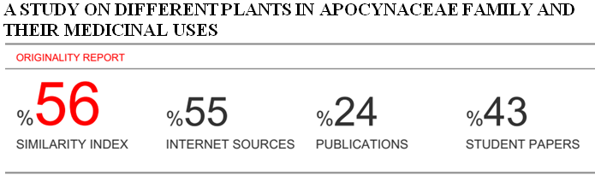

**A study on different plants in Apocynaceae family and their medicinal uses**

**Abstract:**

The apocynaceae family is one of the most medicinally diverse families in the plant kingdom and is a rich source for drugs that have found use both traditionally and in conventional medicine. The medicinal activity of these plants was due to the presence of alkaloids which were either indoline alkaloids or steroidal alkaloids. The family Apocynaceae consists of tropical trees, shrubs and vines. Characteristic features of the family are that almost all species produce milky sap. . In traditional medicine, Apocynaceae species are used to treat gastrointestinal ailments, fever, malaria, pain and diabetes, including skin and ecto-parasitic diseases. Some are important timber species while many are planted as ornamentals. Non-medicinal uses include food, poisons, fodder, wood, ornamentals, dye and perfume. .A total of 4600 species under 415 genera belonging to the family Apocynaceae were collected and identified. Species of Apocynaceae have been reported to possess anticancer and antimalarial properties. Species having cytotoxic activity include those of Catharanthus, Nerium, Plumeria, Tabernaemontana and Ichnocarpus. Catharanthusroseus is the most medicinally important plant in this family due to its use in the treatment of various types of cancers, other agents that have been derived from this family include the alkaloids reserpine and rescinamine which have been used against hypertension, others are the cardiac glycosides.

**Keywords** : Apocynaceae , Medicinal Plants, Activity, Uses.

**Introduction**

Plant is an important source of medicine and plays a key role in world health. Medicinal herbs or plants have been known to be an important potential source of therapeutics or curative aids. The use of medicinal plants has attained a commanding role in health system all over the world. This involves the use of medicinal plants not only for the treatment of diseases but also as potential material for maintaining good health and conditions. Many countries in the world, that is, two-third of the world’s population depends on herbal medicine for primary health care. The reasons for this is because of their better cultural acceptability, better compatibility and adaptability with the human body and pose lesser side effects[1]. From records, most of the used drugs contain plant extracts. Different types of plants used to treat various types of diseases that reveals the most up to date findings in understanding of biological significance of their bioactive compounds used. Recently dramatic changes have taken place in the health care system of world population through the development of science, technology and medical science but till to day 400 crores of people of the world are totally dependent on herbal medicines[2].Human beings have depended on nature for their simple requirements as being the sources for medicines, shelters, food stuffs, fragrances, clothing, flavours, fertilizers and means of transportation throughout the ages[3]. For the large proportions of world’s population medicinal plants continue to show adominant role in the healthcare system and this is mainly true in developing countries, where herbalmedicine has continuous history of long use. The development and recognition of medicinal andfinancial aids of these plants are on rise in both industrialized and developing nations [4].Some contain active ingredients (bioactive components or substances) obtained from plants. Through recent researches, plant-derived drugs were discovered from the study of curative, therapeutic, traditional cures and most especially the folk knowledge of indigenous people and some of these claims and believe of people are irreplaceable despite the recent advancement in science and technology[5].In addition, in the USA, more than 40% of the population recently reported using complementary and [alternative medicines](https://www.omicsonline.org/open-access/alternative-medicine-2167-0412-S3-009.php?aid=73128), including botanical dietary supplements. In the past decade, a remarkable effort has been deployed leading to the isolation of many bioactive drugs from plants. Generally, the synthetic products are considered as unsafe while the plant products appear to symbolize the safety. Nonetheless, the safety, dosage and potential interactions with standard conventional therapies are categorically needed because the plant material could be toxic due the presence of naturally occurring toxic constituents, heavy metals, toxins, pesticides, or bacteria [6].The medicinal plants of Bangladesh South Asian countries have a large number of valuable medicinal plants naturally growing mostly in fragile ecosystems that are predominantly inhabited by rural poor and indigenous community . In Bangladesh 5,000 specie s of angiosperm are reported to occur . The number of medicinal plants included in the ‘materia medica’ of traditional medicine in this subcontinent at present stands at about 2,000.More than 500 of such medicinal plants have so far been enlisted as growing in Bangladesh Dhaka, Rajshahi, Syhlet and Chittagong division is rich in medicinal plants .[7]Apocynaceae  is a large family of [flowering plants](https://en.wikipedia.org/wiki/Flowering_plant) which includes [trees](https://en.wikipedia.org/wiki/Tree), [shrubs](https://en.wikipedia.org/wiki/Shrub), [herbs](https://en.wikipedia.org/wiki/Herb), [stem succulents](https://en.wikipedia.org/wiki/Stem_succulent), and [vines](https://en.wikipedia.org/wiki/Vine), commonly known as the dogbane family, (Greek for "away from dog" since some taxa were used as dog poison). The former family Asclepiadaceae (now known as [Asclepiadoideae](https://en.wikipedia.org/wiki/Asclepiadoideae)) is considered a subfamily of Apocynaceae[8] and the Apocynaceae has 43 Genera and 170 species accepted taxa overall. But Carissa carandas L(Christ’s Thorn) ,Catharanthus roseus (L.) G.Don (Periwinkle) , Nerium oleander Linn.(oleander ), Plumeria alba L.(pagoda tree),Tabernaemontana divaricata (L.) R. Br ex Roem.(wax flower),Ichnocarpus frutescens (L.) R. Br.(Black creeper) are important of this family because these plants shown different activity for different diseases.Plants have remarkable medicinal and traditional uses.

**Objectives of the review:**

Medicinal plants is very much related to our health culture. Most of the people of Bangladesh are directly or indirectly depends medicinal plants for health problem.The review aims to understand the possibility of medicinal plant as a sustainable livelihood option. The specific objectives are to explore the use of locally produced medicinal plants, to explore the market of medicinal plants in Bangladesh, to know about of the habitat,diversity of medicinal plant,to know about the conversation of medicinal plant, to know about the uses of medicinal plant against several diseases.

**MATERIALS AND METHODS:**

The methods and materials were performed through a systematic search related to Euphorbiacea including the ethnomedicinal practices, phytochemistry and pharmacological studies around the world. The data was collected from online journals, research papers and books, all of which were published in different countries. Search engine websites such as Google, Google Scholar, Pub Med, Science Direct, Research gate and other online collections were utilized in this review to obtain information.

**Results and Discussion:**

The total description and the medicinal uses of the plants of the Apocynaceae family are given below**:**.

**1st Species**[9]**:**

* Botanical name: C.carandas L.
* Binomial Name:**Carissa carandas L.**
* Local name: Karamcha
* Family:Apocynaceae
* Status of occurrence: Common

**Taxonomic description:**

Large armed shrub, with long, stout, sharp, horizontal spines at the base of the branchlets. Leaves 3.8-7.5 cm long, coriaceous, elliptic or obovate, obtuse. Flowers white

Habit : Generally shrubs

Habitat: Dry, sunny place, roadsides and thickets

Flower colour: Red, yellow and pink

Flowering season: March- November

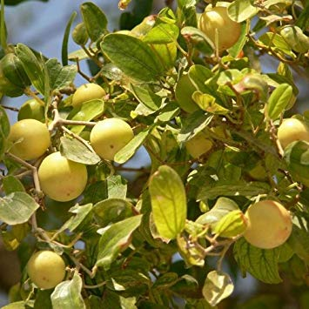

**Fig: Carissa carandas L.**

**Mode of Action:**

The plant materials were collected and the leaves were collected for experiment and experimental results have established a pharmacological evidence.

**Parts Utilized:**

Leaves, fruits, flower, root and root bark.

**Chemical Composition**

|  |  |  |
| --- | --- | --- |
| **Chemical Constituents** | | **Activity** |
| * Lupeol | Anti-inflammatory , Antioxidant,Antibacterial, and Cytotoxicity activity. | |
| * Ursolic acid | Analgesic, Anti-inflammatory ,Antipyretic and Anti-diabetic activity. | |
| * Beta-Sitosterol | Anti-convulsant and Anti-diabetic activity. | |
| * Carinol (Phenolic lignin) | Hypoglycemic,Antinociceptive,Analgesic, Anti-inflammatory and Antipyretic activity. | |
| * Carindone | Anti-bacterial,Anti- diabetic, Analgesic, Anti-inflammatory and Antipyretic activity | |
| * Carissone | Hepatoprotective,Anti-bacterial,Anti-diabetic and Anti-convulsant activity. | |

**Medicinal uses:**

* The root is antiscorbutic, stomachic and anthelmintic. Decoction of the leaves is useful in early stages of remittent fevers.
* Unripe fruit is astringent, appetizer and antipyretic. Ripe fruit is cooling and acid; useful in bilious complaints.
* Root paste is insect repellent; paste of root bark is useful in diabetic ulcer.
* The roots of the plant are heavily branched, making it valuable for stabilizing eroding slopes. It has medicinal value too, it is taken for urine-related problems.

**2nd Species**[10]**:**

* Botanical name: C. roseus (L.) G. Don.
* Binomial Name: Catharanthus roseus (L.) G. Don
* Local name: Nayantara
* Family:Apocynaceae
* Status of occurrence: Very common

**Taxonomic description:**

Habit:  Herb or sub-shrub.

Habitat: Gardens where it is cultivated as an ornamental plant.

Flower colour: White and pink

Flowering season: Flowering almost throughout the year.

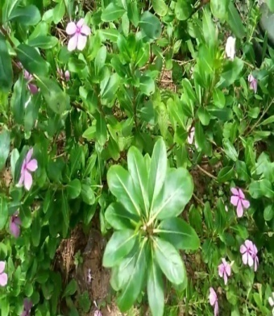

**Fig: Catharanthus roseus (L).**

**Mode of Action:**

Healthy plant Red Periwinkle was collected and this used for further phytochemical analysis.

**Parts Utilized:**

Whole plant, flowers leaves and roots.

**Chemical composition:**

|  |  |
| --- | --- |
| Chemical Constituents | Activity |
| Ursolic acid | Anti-diabetic and anti-oxidant activity. |
| Daucesterol | Leukemia,anti-oxidant,anti- diabetic,cyto-toxic ,biological activity. |
| Tetrahydroalstonine | Antinoradrenergic , ATPase activity,anti-convulsant,enzyme activity. |
| Beta- sitosterol | Hypoglycemic activity,Metabolic activities,Pharmacological activity,Anti-diabetic actIvity, Cortisol lowering activity and Antiproliferative activity. |
| Vindoline | D4H enzyme activity,AVLB synthase activity, Dimerization activity, peroxidase activity ,Enzymatic activity Secologanin synthase activity … Antioxidant and Antidiabetic activity |

|  |
| --- |
|  |
|  |

**Medicinal uses:**

* The plant has been used as a folk remedy for diabetes.
* The root is considered tonic and stomachic.
* Alkaloids also possess hypertensive, sedative and tranquillizing properties. They also cause relaxation of plain muscles and depression of the central nervous system.
* Leaves and latex are given for blood dysentery and piles.

**3rdSpecies**[11]**:**

* Botanical Name: N.oleander Linn
* Binomial Name: Nerium oleander Linn
* Local name: Korobi
* Family:Apocynaceae
* Status of occurrence: Common

**Taxonomic description:**

Habit:Shrub

Habitat:Grows in the clayey, loamy and sandy soil

Flower colour: red, purple, pink, and orange colour

Flowering season: Flowering: January-July

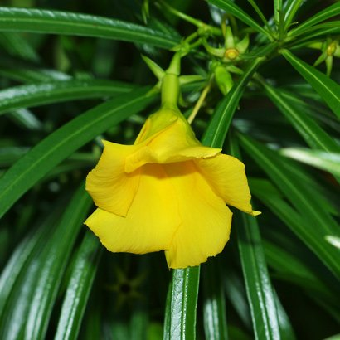

**Fig: Nerium oleander Linn**

**Mode of Action:**

The samples including leaves and stems of *N. oleander* were collected. The plant materials were used for phytochemical analysis and antimicrobial activity.

**Parts Utilized:**

Leaves, flowers, roots and seeds.

**Medicinal uses:**

* All parts of the plants are poisonous.
* Leaf decoction is used to reduce swellings.
* Macerated leaves are used for itch and fall of hair.
* The flowers are good for inflammations, chronic pains in the muscles and the joints, lumbago, headache, and scabies.

**4thSpecies**[12]**:**

* Botanical Name: P.alba L.
* Binomial Name: Plumeria alba L.
* Local name: Kathgolap
* Family: Apocynaceae
* Status of occurrence: Common

**Taxonomic description:**

Habit:Evergreen shrub

Habitat : Grown in rich,Dry to medium moisture,Coastal thickets and limestone forests.

Flower colour: White

Flowering season: May-November

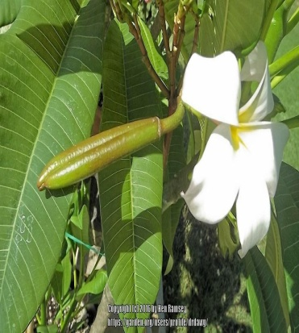

Fig: Plumeria alba L. :Leaves, flowers.

**Mode of Action :**

The stem bark were collected. This extract showed the antibacterial activity.

**Parts Utilized:**

Seed, leaves, flowers and roots.

**Chemical Composition:**

|  |  |
| --- | --- |
| **Chemical Constituents** | **Activity** |
| Linalool | Antioxidant activity,Antimicrobial activity, Peptidase.and.keratinase activity,Antibiofilm activity and Cytotoxic activity. |
| n-nonanal | Biochemical activity,Wound-healing activity,Anti-ulcer activity and Antimicrobial activity. |
| Phenyl acetaldehyde | Biological activity,AntI-inflam-matory activity,Synthesis and cytotoxic activity,Antibiotic activity,Antioxidative activity,Antifungal activity ,Anti-ulcer activity. |
| Neryl acetone | Antifungal activity,Protective activity,Cytotoxic activity,Antimicrobial activity, Optical activity ,Antioxidant, and Hypolipidemic activity. |

**Medicinal uses:**

* In addition, the flowers are edible and eaten as fritters, while the heart of the wood is part of a traditional medical preparation taken as a [laxative](https://en.wikipedia.org/wiki/Laxative).
* The root bark is depurative and purgative, causing thirst. It is used in the treatment of herpes and syphilis.
* The root bark is used externally as a lotion on syphilitic ulcers, administered as powder macerated in sugar-water, wine.
* The latex from the stem is caustic. It is used for treating ulcers, dartre (skin diseases) and scabies.
* The seeds are used in the treatment of dysentery .

**5th  Species**[13]**:**

* Botanical Name: T. divaricata (L.) R. Br ex Roem
* Binomial Name: Tabernaemontana divaricata (L.) R. Br ex Roem
* Local Name: Tagar
* Family:Apocynaceae
* Status of occurrence: Rare

**Taxonomic description:**

Habit : A Small shrub with milky juice.

Habitat : Grown as a brushwoods,sparse forests,house/glasshouse plant.

Flower colour: White

Flowering season: May-January.

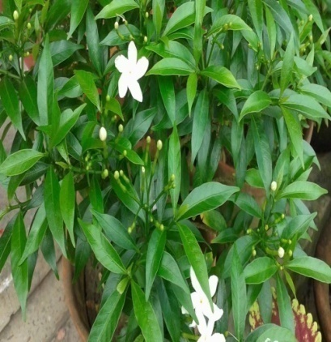

**Fig: Tabernaemontana divaricata (L.)**

**Mode of Action:**

The leaves of Wax Flower were collected and the extract showed anticancer activity.

**Parts Utilized:**

Root, bark, leaves, sap and flowers.

**Chemical Composition:**

|  |  |
| --- | --- |
| **Chemical Constituents** | **Activity** |
| Alpha-amyrin | Anti-diarrheal activity, Anti-cancer activity,Antiproliferative activity, Anti-bacterial activity. |
| Alpha-amyrin acetate | Anti-diarrheal activity Anti-inflammatory activity. |
| Alpha amyryl octadecanoate | Anti-asthmatic activity,Antidiabetic activity,cytotoxic activity,  Catalase activity and Anti- oxidant activity. |
| Taraxasterol acetate | Anti-oxidant activity ,Anti-diabetic activity. |

**Medicinal uses:**

* Grape jasmine is widely used as a medicinal herb in the tropics and the plant may well be classified as a panacea for gastro-intestinal and skin affections.
* The roots are astringent
* A decoction is used in the treatment of diarrhoea and abdominal complaints.  
  The roots, leaves, and flowers are all used in the treatment of snake and scorpion poisoning. An infusion is applied as a remedy for jungle fever.
* The roots are used in modern medicine to treat hypertension, headache and scabies.

**Conclusion:**

The present study is to explore medicinal aspects of this family and focusing on medicinal plants and their local uses for the healthcare. The ethnobotanical also point out some specific medicinal plant species and their properties to the local inhabitants who are unknown from value of medicinal plants in the environment. The use of herbal medicine for treatments is one component of balancing body systems .In conclusion ,it was obtained that different plant of this family have showed different activities like ant-microbial, antioxident, anti-bacterial, antidiabetic, anti-tumor, anti-inflammatory, anti-asthmatic activity, anti-cancer activity, anti-ulcer activity, wound healing activity, anti-convulsant activity, biological activity, anti-diarrheal activity, anti-pyretic activity ,pharmacological activity etc. in human being and animal.

**Reference:**

1. Sandberg F, Corrigan D. Natural Remedies. Their Origins and Uses. Abingdon: Taylor & Francis; 2001.
2. http;//[www.plants](http://www.plants) journal.com/journal of medicinal plants studies.
3. Schulz V, Hänsel R. Tyler VE. Rational Phytotherapy. A Physician’s Guide to Herbal Medicine. 4th ed. Berlin: Springer-Verlag; 2001. p. 306.
4. WHO, (1998). Regulatory situation of herbal medicines. A worldwide review. Pp 1-5. Geneva, Switzerland.
5. Ahn, K. (2017). "The worldwide trend of using botanical drugs and strategies for developing global drugs". BMB Reports. 50 (3): 111–116. doi:10.5483/BMBRep.2017.50.3.221. PMC 5422022. PMID 27998396.
6. Medicinal and aromatic plants trade programme". Traffic.org. Re1. WHO, (1998). Regulatory situation of herbal medicines.
7. Srivastava, J., Lambert J. and Vietmeyer N. (1996). Medicinal plants : An expanding role in development. World bank. Agriculture and Forestry Systems, Washington, D.C
8. Nazia Nazar, David J. Goyder, James J. Clarkson, Tariq Mahmood and Mark W. Chase, 2013, "The taxonomy and systematics of Apocynaceae: Where we stand in 2012," [Bot. J. Linnean Soc.](https://en.wikipedia.org/wiki/Botanical_Journal_of_the_Linnean_Society), 171(3, March), pp. 482–490, see [[1]](http://onlinelibrary.wiley.com/doi/10.1111/boj.12005/abstract), accessed 22 June 2015.Ganeshan A. The impact of natural products upon modern drug discovery. Curr Opin Chem Biol. 2008;12:306–17. [PubMed](https://www.ncbi.nlm.nih.gov/pubmed/18423384)
9. Rahman AHMM. Ethno-medicinal investigation on ethnic community in the northern region of Bangladesh. American Journal of Life Sciences. 2013;1:77-81.. http;//www.ukassays.com/essays/biology/introduction to-different-mecinal-plants- and use-of-biology-easy.php.
10. Rahman AHMM. Ethno-medico-botanical investigation on cucurbits of the Rajshahi Division, Bangladesh. Journal of Medicinal Plants Studies. 2013:1:118-125 https://www.jpcbs.info/2014_01_01_04_Jena.pdf/Research Article - Journal of Pharmaceutical, Chemical and Biological Sciencecs
11. Li, Bingtao; Leeuwenberg, Antony J. M.; Middleton, David J. (2008) [1995]. Wu, Z. Y.; Raven, P. H., eds. ["Ichnocarpus frutescens, Apocynaceae, Vol. 16"](http://www.efloras.org/florataxon.aspx?flora_id=2&taxon_id=200018399). [Flora of China](http://www.efloras.org/flora_page.aspx?flora_id=2). Online access. [eFloras.org](http://www.efloras.org/). St. Louis, MO & Cambridge, MA.: Missouri Botanical Garden Press and Harvard University Herbaria. Retrieved 9 Mar 2013.
12. [Jump up to:a](https://en.wikipedia.org/wiki/Ichnocarpus_frutescens#cite_ref-adhi_3-0) [b](https://en.wikipedia.org/wiki/Ichnocarpus_frutescens#cite_ref-adhi_3-1) Adhikari, B. S., et al. (2010). [Medicinal Plants Diversity and their Conservation Status in Wildlife Institute of India (WII) Campus, Dehradun.](http://ethnoleaflets.com/leaflets/dehradun.htm) Ethnobotanical Leaflets 14 46-83.
13. .[Jump up to:a](https://en.wikipedia.org/wiki/Ichnocarpus_frutescens#cite_ref-dash_4-0) [b](https://en.wikipedia.org/wiki/Ichnocarpus_frutescens#cite_ref-dash_4-1) Dash, D. K., et al. (2007). Evaluation of hepatoprotective and antioxidant activity of Ichnocarpus frutescens (Linn.) R.Br. on paracetamol-induced hepatotoxicity in rats. Tropical Journal of Pharmaceutical Research 6:3 755-65.