Reviewer’s Comments
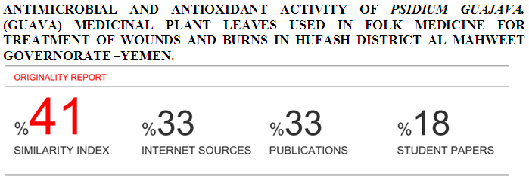
Antimicrobial and Antioxidant Activity of Psidium guajava. (Guava) Medicinal Plant Leaves Used In Folk Medicine For Treatment of Wounds and Burns in Hufash District Al Mahweet Governorate –Yemen.
Abstract
In this study methanolic and aqueous extracts of one plant namely Psidium guajava , were screened for the presence of phytochemical constituents and tested for their antimicrobial and antioxidant activity. The qualitative phytochemical analysis revealed the results showed presence of alkaloids, terpenoids, glycosides, resins, saponins, tannins, flavonoids, phenols, and amino acid were present in the methanol extract, with absence of glycosides, and amino acids in the aqueous extracts in leaves plant . TLC tests conducted revealed Rf values in the leaves for alkaloids, Flavonoids, Tannins, Phenols and Saponins(0.96-0.97-0.99-0.97-0.99) respectively. The antimicrobial activity extracts against four bacterial isolates Staphylococcus aureus, Escherichia coli , Pseudomonas aeruginosa and Klebsiella sp. and a single fungal isolate Candida albicans with concentrations (0.5 mg/ml, and 1,0 mg/ml) of the extract were added to the disc and respective solvent was used as negative control. The antioxidative activity of leaf was evaluated by using 1,1- diphenyl-2 picrylhydrazyl (DPPH), the results showed are 88.4%, highest from standard, ascorbic acid 87.5%.
Key word: phytochemical, antimicrobial ,antioxidative ,Psidium guajava.
Introduction
Plant have been utilized as important sources of medicinal drugs and health products since ancient time, In the area (Hufash-Al-mahweet), although the existence of rural health center), most people resort, in the treatment of wounds and burns, folk medicine. Many studies confirm that, the prosperity of herbal medicine in Yemen is related to the variety and abundance of vegetation, where there are three thousand species of plants on land; 415 species of endemic plants and 236 species found only on the island of Socotra, whose vegetation cannot be found elsewhere in the world. (4). Psidium guajava (PG) belongs to the family Myrtaceae, which is considered to have originated in tropical South America. Guava crops are grown in tropical and subtropical areas of the world like Asia, Egypt, Hawaii, Florida, Palestine and others. The genus Psidium comprises approximately 150 species of small trees and shrubs in which only 20 species produce edible fruits and the rest are wild with inferior quality of fruits (15) Psidium guajava contains different secondary metabolites, so considered a medicinal plant used in tropical and subtropical countries to treat many health disorders. It has indeed been variously reported that Psidium guajava leaves extract has a wide spectrum of biological activities such as anticough, antibacterial, haemostasis, antidiarrhoeal and narcotic properties. (22) . Psidium guajava is a phytotherapic plant used in folk medicine that is believed to have active components that help to treat and manage various diseases. The many parts of the plant have been used in traditional medicine to manage conditions like malaria, gastroenteritis, vomiting, diarrhea, dysentery, wounds, ulcers, toothache, coughs, sore throat, inflamed gums, and a number of other condition (1). Psidium guajava leaves extract has a wide spectrum of biological activities such as anticough, antibacterial, haemostasis, antidiarrhoeal and narcotic properties. (22) . There are bioactive components in the guava leave that can fight against pathogens, regulate blood glucose levels, and can even aid in weight loss. The leaves of guava contain an essential oil rich in cineol, tannins, triterpenes, flavonoids, resin, eugenol, malic acid, fat, cellulose, mineral salts, and a number of other fixed substances (18). In a study that attempted to investigate antioxidant activity of Psidium Guajava leaves extract by DPPH (2, 2- diphenyl-1-picrylhydrazyl) free radical scavenging method using ascorbic acid as standard, it was found that the extract of P. Guajava leaves extract was found to possess strong antioxidant activity ,this activity of P. Guajava extract may be attributed to their free radical-scavenging ability. The extent of antioxidant activity of P. Guajava extract was found significant as compared to standard value for P. Guajava linn leaves extract was found to be 45.5 μg/ml. Thus P. Guajava linn leaves possess moderate antioxidant activity as compared as standard (13).

Materials and Methods
Sampling: Fresh leaves of Psidium guajava , were collected from Hufash District-Mahaweet-Yemen. The fresh leaves were properly rinsed with tap water. The leaves were dried under room temperature and then were blended to fine powder using electric blender. Powder stored at 4ºC and protected from light prior to future uses. Samples extraction: The extraction process was carried out in the Central laboratory For Pesticides Residue Analysis of Plant Protection Department - Sana'a. Ministry of Agriculture. For each plant. Samples of 100g of the grinded powder were put in sterilized flasks together with 400 ml of pure methanol for methanolic extraction treatments, while for aqueous extraction treatments, samples of 100g of grinded powder were put in sterilized flasks with 400 ml of distilled water each. All flasks were covered with transparent nylon and tin and then all were put on a rotary shaker machine for 24 hours, the speed of the device was 200 r/m at the laboratory temperature (22.7 ºC). The filtration process for each sample was carried out using filter paper to obtain a pure solution. The evaporation process for each methanol solution and distilled water was conducted separately in the evaporator (methanol solution at 42 ºC and pressure 337. The distilled water solution at 45 ° C and pressure 72 for 2 hours for methanol solution and 4 hours for distilled water solution. Then the obtained extracts were kept in dark conditions in the refrigerator at 4°C until used in the experiment ( 11).

Qualitative Tests
Phytochemical screening of plant extracts:
The methanolic and aqueous extracts subjected to phytochemical screening were alkaloids, terpenoids, glycosides, resins, saponins, tannins, flavonoids, phenols, and amino acids.

Alkaloids: Dragendorff’s Test
In a test tube, 2-3 drops of Dragendorff’s reagent was added to 0.1 ml of the extract ,orange precipitate indicated the presence of alkaloids. (9).

Terpenoids: Salkowski Test
In a test tube 5ml of extract was mixed in 2 ml of chloroform and then 3 ml of concentrated sulfuric acid was added to form a layer. A reddish brown coloration forms at interface. (9).

Glycosides: Keller-Killani Test
Concentrated sulfuric acid in a test tube and extract sample were mixed with glacial acetic acid containing 1 drop of Ferric chloride (1:1:1volume). A brown ring appears in the presence of glycosides. (9) .

Resins: Turbidity test
To 5ml extract 5ml distilled water was added, the occurrence of turbidity shows the presence of resins. (9).

Saponins: Foam Test
A 5ml extract was shaken with 2 ml of distilled water. If foams are produced and persists for ten minutes this indicates the presence of saponins. (9).

Tannins: Fecl₃ Test
A 4 ml extract was treated with 4 ml FeCl₃ ,the formation of green colour was taken as positive for tannin. (23).

Flavonoids: Shinoda Test
Extract was mixed with magnesium ribbon fragments, and concentrated hydrochloric acid was added drop wise. Orange, red, pink, or purple coloration indicates the presence of flavonoids. (23).

Phenols: Fecl₃ Test
Extract was mixed with 2 ml of 2% solution of FeCl₃. A blue-green or black coloration indicated the presence of phenols. (23).

Amino acids: Biuret test
Extracts and 1 drop 2% Copper sulphate solution and 1 ml 95% ethanol excess of potassium hydroxide were mixed. Pink or yellow color in ethanol layer appears (23).

Thin layer chromatographic test for Alkaloids.

One gram of Psidium guajava, powdered samples were boiled with 15ml H₂SO₄ in rounded flasks, heated for 15 minutes, cooled then filtered. TLC plates were prepared (Layer: silica gel layers 0.25 mm ,thickness 10 cm length and 5cm wide). The filtrate obtained was evaporated to dryness in a water bath at 37° C. The residue was dissolved by 0.2ml methanol. The solution was used for spotting the TLC by capillary tube making by only one centered spot. The TLC plate was put inside a saturated tank, and development was waited. When the mobile phase reached two thirds of plate's length, the plate was lifted out from the tank and let to dry in air. The plate was examined under U.V. lamp at the wave length 365nm. The colors of florescence appeared. The plate was then sprayed carefully by Dragendorff reagent, and was let dry for 10 min. Then sprayed with 10% (w/v) sodium nitrite solution ,Then plate was examined under U.V. lamp at the wave length 365nm. (11).
Calculation of RF of each spot was as follows:
RF=
Thin – layer chromatographic (TLC)test for Flavonoides.
One gram of Psidium guajava, powder was boiled with of 70% ethanol in rounded flask, heated for 10 minutes, cooled then filtered. A TLC plate was prepared as such : (Layer : silica gel layers 0.25 mm thickness, 10 cm length and 5cm wide). The filtrate obtained was evaporated to dryness in a water bath at 37° C.The residue was dissolved by 0.2ml methanol. The solution was used for spotting the TLC by capillary tube by only one centered spot. The TLC plate was put inside a saturated tank, and development was waited. When the mobile phase reaches two thirds of plate’s length, the plate was lifted out from the tank and let to dry in air. The plate was examined by U.V. lamp at the wave length 365nm. The colors of florescence appeared and recorded. The plate was sprayed carefully by Aluminum chloride reagent, and let to dry for 10 min. Then spray et with 10%(w/v) ammonia solution Then plate was examined under U.V. lamp at the wave length 365nm. (11).

Calculation of RF of each spot was as follows:
RF=
Thin layer chromatographic test for Tannins.
One gram of Psidium guajava, powdered drug was boiled with 25 ml water for 5 minutes, cooled then filtered. A TLC plate was prepared (Layer : silica gel layers 0.25 mm thickness, 10 cm length and 5cm wide). The filtrate obtained was evaporated to dryness in a water bath at 37° C.The residue was dissolved by 0.2ml methanol. The solution was used for opting the TLC by capillary tube by only one centered spot. The TLC plate was put inside a saturated tank, and development was waited. When the mobile phase reached two thirds of plate’s length, the plate was lifted out from the tank and let to dry in air. The plate was examined by U.V. lamp at the wave length 365nm. The colors of florescence appear and recorded. The plate was sprayed carefully by 10%FeCl₃ reagent, and the plate was let to dry for 10 min. Then heated over a hot plate and the resolution colors were recorded Then plate was examined under U.V. lamp at the wave length 365nm. (11).
Calculation of RF of each spot was as follows:
RF=
Thin layer chromatographic test for Saponins.
Materials And Methods

One gram of Psidium guajava, powdered drug was boiled with 10ml of 70% ethanol in rounded flask, heated for 10 minutes, cooled then filtered. A TLC plate was prepared (Layer : silica gel layers 0.25 mm thickness, 10 cm length and 5cm wide). The filtrate obtained was evaporated to dryness in a water bath at 37° C.The residue was dissolved by 0.2ml methanol. The solution was used for spotting the TLC by capillary tube making by only one centered spot. The TLC plate was put inside saturated tank, and development was waited. When the mobile phase reaches two thirds of plate’s length, the plate was lifted out from tank let dry in air. The examine the plate was examined by U.V. lamp at the wave length 365nm. The colors of florescence appeared and recorded. The plate was sprayed carefully by Vanillin sulfuric acid reagent, and the plate was let to dry for 10 min. then heated over a hot plate and the resolution colors was recorded Then plate was examined under U.V. lamp at the wave length 365nm. (11).
Calculation of RF of each spot was as follows:
RF=

Thin layer chromatographic test for Phenols.
One gram of Psidium guajava, powdered drug was boiled with 25 ml water for 5 minutes, cooled then filtered. A TLC plate was prepared (Layer : silica gel layers 0.25 mm thickness, 10 cm length and 5cm wide). The filtrate obtained was evaporated to dryness in a water bath at 37° C.The residue was dissolved by 0.2ml methanol. The solution was used for opting the TLC by capillary tube by only one centered spot. The TLC plate was put inside a saturated tank, and development was waited. When the mobile phase reached two thirds of plate’s length, the plate was lifted out from tank and let to dry in air. The plate was examined by U.V. lamp at the wave length 365nm. The colors of florescence appeared and The plate was sprayed carefully by 10% KOH reagent, and let to dry for 10 min. then heated over a hot plate. (11).

Calculation of RF of each spot was as follows:

RF=
Antimicrobial Activity of Plants extracts.
Microbial Cultures: Fresh plates of the four bacterial isolates Staphylococcus aureus, Escherichia coli , Pseudomonas aeruginosa and Klebsiella sp. and a single fungal isolate Candida albicans were obtained from the National Center of Public Health Laboratories, Sana’a. Media Use: The bacterial test were spread over the nutrient ager(56g/1000ML distilled Water) was weight into separate flask and dispensed into distilled water make a total volume of 1 liter .Then the fungal test were spread over the sabouraud dextrose ager(65g/1000ML distilled Water) was weighted into separate flask and dispensed into distilled water to make a total volume of 1 liter. These powders were dissolved in distilled water and used for evaluation of their antibacterial and Antifungal activities. The mixture was heated in an electric water bath (GFC, 1083, Germany) until the Agar melted to form a homogenous solution. The prepared medium was separately transferred to Durum medium bottle and sterilized by autoclaving at 121⁰ C for 30 minutes. The sterile medium was allowed to cool to about 45ºC before being poured aseptically in an inoculation. chamber (Ceslab England) in15 ml portions, into sterile petri dishes to cool and gel into solids. (19). Antimicrobial activity assay: Two different concentrations (0.5 mg/ml, and 1,0 mg/ml) of the extract were added to the disc and respective solvent was used as negative control. Zone of Inhibition : The bacteria plates were incubated at37ºC for 24hrs while the fungal plates were incubated at for 72 hours, and observed for the zone of inhibition of growth, The zones were measured with a transparent ruler and the result recorded.

Determination of antioxidant activity
The scavenging ability of the natural antioxidants of the leaves towards the stable free radical DPPH was measured by the method of (16). The leaf extracts (20μl) were added to 0.5ml of methanolic solution of DPPH (0.3mM in methanol) and 0.48ml of methanol. The mixture was allowed to react at room temperature for 30 min. Methanol served as the blank and DPPH in methanol, without the leaf extracts, Served as the positive control. After 30 min of incubation, the discolouration of the purple colour was measured at 517 nm in a spectrophotometer). The radical scavenging activity was calculated as follows:
Radical Scavenging Activity( RSA100%)=

100
Statistical Analysis.
Analysis of variance was made for all data using (SPSS) version(25) computer program.
Results and Discussion:
In this study methanolic and aqueous extracts of one plants namely Psidium guajava , were screened for the presence of phytochemical constituents and tested for their microbial and antioxidant activity.
Yield from different solvents
Yield of methanolic extract of Psidium guajava, extracted with 100% methanol produced 32.40(g). While yield of distilled water extract of psidium guajava produced 27.62(g).

Table(1): Yields of Psidium guajava leaves extracts from Methanolic and Aqueous extracts.
Extract yield/(g)* | Volume of the solvent used (ml) | Solvent | Amount of samples used (g) | Powder of plants | M
32,40±0.08 | 400 | Pure Methanol | 100 | Psidium guajava | 1-
27,62±0.06 | 400 | distilled Water | 100 | Psidium guajava | 2-
Mean values of the yield are presented as mean ± SEM. Values are statistically significant when p≤ 0.05.
A similar investigation done by (10) revealed that aqueous extracts (16.35%) of Psidium guajava gave high yields than of methanolic extracts (14.22%), which is contrary to our findings. Similarly, (12) also reported a 16.35% yield in aqueous extracts from Psidium guajava . Yet the percentages of yields in both studies were less than of the present study.

Phytochemical Composition of the Methanolic and Aqueous Leaves Extracts.
The summarized phytochemical screening of chemical constituents of Psidium guajava extract is shown in Table (2). The results revealed the presence of active compounds in the two different extracts. As the table shows, the methanol and aqueous extracts indicate the presence alkaloids, terpenoids, glycosides, resins, saponins, tannins, flavonoids, phenols, and amino acid were present in the methanol extract, with absence of glycosides, and amino acids in the aqueous extracts in all three plants .

Table(2): Phytochemical composition of the methanolic and aqueous Leaves Extracts of
Psidium guajava.
Plant | Psidium guajava L.
Chemical  Compounds  Solvents | Alkaloids | Terpenoids | Glycosides | Resins | Saponins | Tannins | Flavonoids | Phenols | Amino acids
Methanolic extract | + | + | + | + | + | + | + | + | +
Aqueous extract | + | + | - | + | + | + | + | + | -
Absence (+) Presence (-).
In a study done by (5), methanolic extracts of psidium guajava revealed the presence of alkaloids, tanins, flavonoids and glucosides . Similary ( 2) showed the presence of tannins ,
saponins, flavonoids ,alkaloids and phenols as our study.
Thin layer chromatography (TLC)
Five secondary metabolites (alkaloids, flavonoids , tannins, phenols and saponins) were used for (TLC) thin layer chromatographic analysis .
Table(3): Thin layer chromatography of alkaloids in leaves HCL extract of Psidium guajava.
M | Powder of plants | Extract | Mobile phase | RF/ Value
1 | Psidium guajava | 1 ml HCL+9 ml water | Acetone:water:26%ammonia  (90:7:3) | 0.96

Table(4): Thin layer chromatography of flavonoids in leaves 70% ethanol extract of Psidium guajava.
M | Powder of plants | Extract | Mobile phase | RF/ Value
1 | Psidium guajava | 70% ethanol | Chloroform: Ethyl acetate (6:4) | 0.97

Table(5): Thin layer chromatography of Tannins in leaves water extract of Psidium
guajava .
M | Powder of plants | Extract | Mobile phase | RF/ Value
1 | Psidium guajava | 25ml water | Toluene: Acetone: Formic acid (60:60:10) | 0.99

Table(6): Thin layer chromatography of phenols in leaves Methanol extract of Psidium
guajava .
M | Powder of plants | Extract | Mobile phase | RF/ Value
1 | Psidium guajava | Methanol | Ethyl acetate | 0.97
Table(7): Thin layer chromatography of saponins in leaves Methanol extract of Psidium
guajava .
M | Powder of plants | Extract | Mobile phase | RF/ Value
1 | Psidium guajava | Methanol | Ethyl acetate | 0.99

TLC tests conducted revealed Rf values in the leaves of Psidium guajava for alkaloids, Flavonoids, Tannins, Phenols and Saponins(0.96-0.97-0.99-0.97-0.99) respectively. In a study done by (20) through TLC profiling proved that different Rf values represent different chemical constituents present within methanol leaf extract of Psidium guajava. There were six visible spots. The Rf values (spot1RF=0.98), (spot2RF=0.78), (spot3RF=0.62), (spot4RF=0.54) (spot5RF=0.32) and (spot6RF=0.19). Similar Rf values were in agreement with this investigation.

Antibacterial and Antifungal Activity of Plants extracts
Antimicrobial activity of standard antibiotics discs against tested bacterial and Fungal are displayed in Table(8) Figure(1) .The results of the study indicated that control Antibiotics against bacteria and Fungi showed different inhibitory zones. Antibiotics activity of AM (10ug) ,CIP(25ug) ,CF(30ug) , PZ (75ug) and PC (100ug) against Staphylococcus aureus were 19,26,20,21,20 mm ; E.coli 17,28,18,20,19 mm; Pseudomonas aeruginosa 18,30,17,21,18 mm; Klebsilla sp. 20,33,22,23,17 mm, and Candida albicans 21,31,20,19,22 mm respectively.

Table(8): Antimicrobial activity of standard antibiotics discs against tested bacterial and
fungal.
Inhibition zones diameter (mm) of tested antibiotic
PC(100ug) | PZ (75ug) | CF(30ug) | CIP(25ug) | AM(10ug) | Antibiotic
 |  |  |  |  | Organisms
20 | 21 | 20 | 26 | 19 | Staphylococcus aureus.
19 | 20 | 18 | 28 | 17 | Escherichia coli.
18 | 21 | 17 | 30 | 18 | Pseudomonas aeruginosa.
17 | 23 | 22 | 33 | 20 | Klebsiella sp.
22 | 19 | 20 | 31 | 21 | Candida albicans.
Note: AM=Amoxycillin.CIP= Ciprofloxacin. CF=cefazllin. PZ=Cefoperazone.PC=piperacillin.

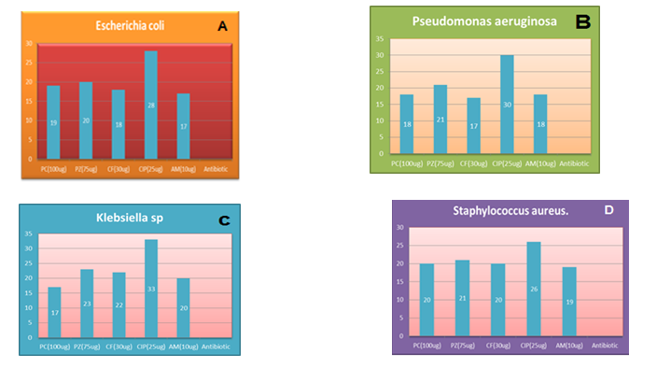

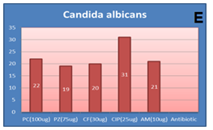
Figures (1): Antimicrobial activities (inhibition zones mm.) of standard antibiotics discs against tested bacterial and fungal .

Table(9): Antimicrobial activity of the methanolic extracts of leaves of (Psidium guajava) and standard antibiotics discs against tested bacterial and fungal.
Zone of inhibition (mm)
Antibiotic |  |  |  |  | Extract |  |  | Organisms
PC(100ug) | PZ(75ug) | CF(30ug) | CIP(25ug) | AM(10ug) |  | 1.0g/ml | 0.5g/ml | Organisms
20 | 21 | 20 | 26 | 19 |  | 17 | 18 | Staphylococcus aureus.
19 | 20 | 18 | 28 | 17 |  | 15 | 17 | Escherichia coli.
18 | 21 | 17 | 30 | 18 |  | 14 | 15 | Pseudomonas aeruginosa.
17 | 23 | 22 | 33 | 20 |  | 15 | 14 | Klebsiella sp.
22 | 19 | 20 | 31 | 21 |  | 17 | 15 | Candida albicans.
The antimicrobial activity of the methanolic extracts of Psidium guajava compared to the selected antibiotics against selected microorganism Table (9) and Plate (1) showed that all antibiotics gave higher inhibition zones than the two extract concentrations . Yet, the activity of the two concentrations was closest to Amoxycillin activity, but much lower than the resistant.( Staphylococcus aureus & Escherichia.colia ).

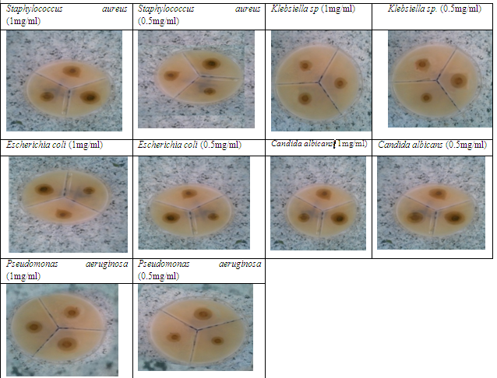

Plate (1): Inhibition zones observed with leaves methanolic extracts of Psidium guajava.

Table(10): Antimicrobial activity of the Aqueous extract of leaves(Psidium guajava) and standard antibiotics discs against tested bacterial and fungual.
Zone of inhibition(mm) Antibiotic |  |  |  |  |  |  | Organisms
PC(100ug) | PZ(75ug) | CF(30ug) | CIP(25ug) | AM(10ug) | 1.0g/ml | 0.5g/ml | Organisms
20 | 21 | 20 | 26 | 19 | 15 | 13 | Staphylococcus aureus.
19 | 20 | 18 | 28 | 17 | 16 | 14 | Escherichia coli.
18 | 21 | 17 | 30 | 18 | 15 | 11 | Pseudomonas aeruginosa.
17 | 23 | 22 | 33 | 20 | 16 | 14 | Klebsiella sp.
22 | 19 | 20 | 31 | 21 | 17 | 13 | Candida albicans.
The antimicrobial activity of the aqueous extracts of Psidium guajava against selected microorganisms was less in activity compared to all the selected antibiotics Table (10) and Plate (2) .

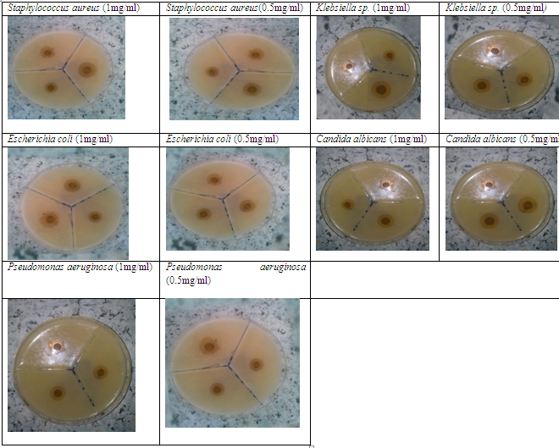
Plate (2): Inhibition zones observed with leaves aqueous extracts of Psidium guajava.
This study showed that Ciprofloxacin (30µg) gave the highest inhibition zone among all antibiotics with the selected organisms 26, 28, 30 mm against Staphylococcus aureus, E.coli, Pseudomonas aeruginosa respectively. In similar other study (6). Ciprofloxacin (25µg) gave high diameter of inhibition zone which reached up 19, 23, 23 mm against Staphylococcus aureus, E.coli, Pseudomonas aeruginosa respectively. The majority of the antibacterial activity in this study was found in the methanolic rather than the aqueous extracts, and the highest activity was found in the methanolic extracts from Psidium guajava. Similar results were achieved by (21). Results from this study provide evidence for the medicinal values of the tested plants. It was showed that the antimicrobial activity of the methanolic & aqueous extracts of Psidium guajava leaves achieved different diameters of the bacterial growth inhibition zone against Klebsiella sp & E.colia, while (21) mentioned that, the extract of Psidium guajava leaves had no any activity against Klebsiella sp & E.coli. (7) explained that the methanol extract of Psidium guajava leaves had an antibacterial activity with mean zones of inhibition of 12.3 mm, against S. aureus, while, in this study, high diameter of 17mm was achieved from methanol extract of Psidium guajava leavesTable (9) and Plate (1). In this study, the results from water extract of Psidium guajava leaves against E.coli. showed that the diameter of inhibition zone reached up 14mm (Table (10) and Plate (2), these are similar result achieved by (3), who mentioned that, the antibacterial effects of water extracts from P. guajava (guava) leaves demonstrated mean exhibited zones of inhibition of 13.7mm on E. coli.
Antioxidant activity
Results showed are 88.4%, highest from standard, ascorbic acid 87.5%. Table (11) and Figures (2).

Table(11) :Antioxidant activities of the selected extracts and L- ascorbic acid using the
(DPPH) free radical-scavenging assay.
Plants | Antioxidant activity DPPH (g/ml)
L- ascorbic acid | ±0.05
psidium guajava | ±0.20

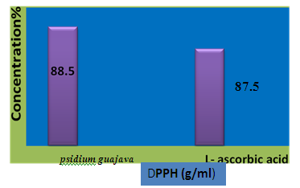
87.5
psidium guajava

DPPH (g/ml)

Figures(2): Antioxidant activities of the selected extracts and L- ascorbic acid using
the (DPPH) free radical-scavenging assay.

These results revealed that the value of the Psidium guajava leaves extract was superior to the control (88.4%). Another study carried out by (8). showed that the value of antioxidant activity in the guava extract was 94.4% at a concentration of 100 μg/ml, and the guava dried fruit extracts exhibited weaker antioxidant effects than did the leaf extracts. A study carried out by (17) to estimate the antioxidants in psidium guajava leaves extract, showed a significant role of plant leaves as an antioxidant. Similar results obtained by (12), where the antioxidants reached 82% in the full concentration of the leaves extract.

CONCLUSION:
The present study showed that Psidium guajava are rich sources of useful secondary metabolites , It is strongly recommended of using them for general medicinal purpose and specially for treat wounds and burns diseases. It is strongly recommended of using them for production of effective pharmaceutical compounds and can be used as natural products of antimicrobial to treat wounds and burns diseases instead of chemical drugs. It is noticeable that the leaves of Psidium guajava are very rich in antioxidant content and therefore are good sources and safe and cheap for that .
References
(1)-Abdelrahim, S. I., Almagboul, A. Z., Omer, M. E. A., & Elegami, A. (2002).
"Antimicrobial activity of Psidium guajava L Fitoterapia", Journal List.Int
Microbiol73(7-8), 713-715.
(2)-Abubakar, E. M. M. (2009). "Antibacterial activity of crude extracts of Euphorbia hirta against some bacteria associated with enteric infections" Journal of Medicinal Plants Research, 3(7), 498-505.
(3)-Adefuye, A., Samie, A. & Ndip, R. (2011). "In-vitro evaluation of the antimicrobial activity of extracts of Bridelia micrantha on selected bacterial pathogens". Journal of Medicinal Plants Research, 5, 5116-5122.
(4)-Al-Dubai, A. S., & Al-Khulaidi, A. A. (1996)." Medicinal and aromatic plants of Yemen". Obadi Center for studies and Publishing: Sana’a, Yemen.‏ Avicenna J Phytomed.;3:254–71.

(5)- Anbuselvi, S.,& Rebecca, J. (2017). Phytochemical Biochemical Antimicrobial
Activty of Psidium Guajava Leaf Extract. Journal of Pharmaceutical
Sciences and Research, 9(12), 2431-2433.
(6)-Bhalodia, N. R., & Shukla, V. J. (2011). "Antibacterial and antifungal activities from leaf extracts of Cassia fistula l.: An ethnomedicinal plant". Journal of advanced pharmaceutical technology & research, 2(2), 104.
(7)-Bipul Biswas, Kimberly Rogers, Fredrick M, Dwayne Borde, V. U., Pawar, D. P., Shelar, S. R., Apturkar R. M. (2013). "Antimicrobial activity of some medicinal plants". Science Research Reporter, 3(1), 33-37.‏
(8)-Chen, H. Y., & Yen, G. C. (2007). "Antioxidant activity and free radical-scavenging capacity of extracts from guava (Psidium guajava L.) leaves". Food chemistry, 101(2), 686-694.‏
(9)-Ciulci, I. (1994). "Methodology for the analysis of vegetable drugs, Chemical industries branch, Division of industrial operations". UNIDO Romania: 24, 26 and 67.
(10)-Gitika, Manoj Kumar,(2016). "Antibacterial Activity of Psidium guajava L. leaves extracts against some gram-positive and gram-negativebacteria ejpmr". 2016,3(10), 261-266.
(11)-Gokhale SB, Kokate CK, Purohit AP. Shah, B. N., & Seth, A. K. .(2007). "Pharmacognostic studies of the Lagenaria siceraria (Molina) Standley". International Journal of PharmTech Research, 2(1), 121-124.‏
(12)-Kangogo K. Geoffrey1, Kagira M. John2, Maina Naomi3 and Karanja M. Simon3 (2014). "Qualitative Phytochemical Screening of Camellia sinensis and Psidium guajava Leave Extracts from Kericho and Baringo Counties". Vol5, Is sue3, 2014, p506-512. 3(1), 33-37.‏
(13)-Keservani, R. K., Kesharwani, R. K., Vyas, N., Jain, S., Raghuvanshi, R., & Sharma, A. K. (2010). "Nutraceutical and functional food as future food: a review". Der Pharmacia Lettre, 2(1), 106-116. List.Intj Microbiol73(7-8), 713-715.‏
(14)-Mahfuzul Hoque, M. D., Bari, M. L., Inatsu, Y., Juneja, V. K., & Kawamoto, S. (2007). "Antibacterial activity of guava (Psidium guajava L.) and neem (Azadirachta indica A. Juss.) extracts against foodborne pathogens and spoilage bacteria". Foodborne pathogens and disease, 4(4), 481-488.‏
(15)-Mani, A., Mishra, R., & Thomas, G. (2011). "Elucidation of diversity among Psidium species using morphological and SPAR methods". Journal of Phytology.‏
(16)-Mensor, L. L., Menezes, F. S., Leitão, G. G., Reis, A. S., Santos, T. C. D., Coube, C. S., & Leitão, S. G. (2001). "Screening of Brazilian plant extracts for antioxidant activity by the use of DPPH free radical method". Phytotherapy research, 15(2), 127-130.‏
(17)-Mishra, R., Tiwari, P., Srivastava, M., Singh, C. S., & Ghoshal, S. (2017). "A Comprehensive Review On Psidium Guajava Linn (Amaratafalam)". World, 7, 8.‏
(18)-Ncube, N. S., Afolayan, A. J., & Okoh, A. I. (2008). "Assessment techniques of antimicrobial properties of natural compounds of plant origin: current methods and future trends". African journal of biotechnology, 7(12).‏
(19)-Puntawong, S., Okonogi, S., & Pringproa, K. (2012). "In vitro antibacterial activity of Psidium guajava Linn. leaf extracts against pathogenic bacteria in pigs". Chiang Mai Univ J Nat Sci, 11, 127-34.
(20)- Siti Nur. S, Kamaruzaman. S, .(2012). Antibacterial activity of psidium guajava L. Methanol leaf extract against plant pathogenic bacteria in the genera Pectobacterium and Xanthomonas. Int J Appl Biol Pharmac Technol, 3, 246-252.
(21)-Rabe, T., & Van Staden, J. (1997). "Antibacterial activity of South African plants used for medicinal purposes". Journal of ethnopharmacology, 56(1), 81-87.‏
(22)-Ramírez, J. C., Cura, C. I., da Cruz Moreira, O., Lages-Silva, E., Juiz, N., Velázquez, E., ... & Muñoz-Calderón, A. (2015). "Analytical validation of quantitative real-time PCR methods for quantification of Trypanosoma cruzi DNA in blood samples from Chagas disease patients". The Journal of Molecular Diagnostics, 17(5), 605-615.
(23)-Tanko, Y., Abdelaziz, M. M., Adelaiye, A. B., Fatihu, M. Y., & Musa, K. Y. (2008)." Effects of Hydromethanolic leaves extract of Indigofera pulchra on blood glucose levels of normoglycemic and alloxan-induced diabetic Wistar rats". International Journal of Applied Research in Natural Products, 1(4), 13-18.‏

