Reviewer’s Comments
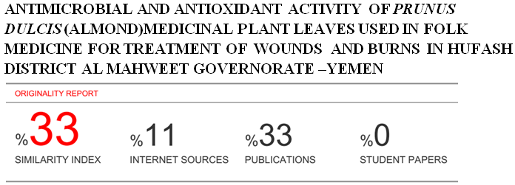
Antimicrobial and Antioxidant Activity of Prunus dulcis (Almond)Medicinal Plant Leaves Used In Folk Medicine For Treatment of Wounds and Burns in Hufash District Al Mahweet Governorate –Yemen.
Abstract
In this study methanolic and aqueous extracts of one plant namely Prunus dulcis were screened for the presence of phytochemical constituents and tested for their antimicrobial and antioxidant activity. The qualitative phytochemical analysis revealed the results showed presence of alkaloids, terpenoids, glycosides, resins, saponins, tannins, flavonoids, phenols, and amino acid were present in the methanol extract, with absence of glycosides, and amino acids in the aqueous extracts in leaves plant . TLC tests conducted revealed Rf values in the leaves for alkaloids, Flavonoids, Tannins, Phenols and Saponins(0.92-0.96-0.96-0.95-0.96) respectively. The antimicrobial activity extracts against four bacterial isolates Staphylococcus aureus, Escherichia coli , Pseudomonas aeruginosa and Klebsiella sp. and a single fungal isolate Candida albicans with concentrations (0.5 mg/ml, and 1,0 mg/ml) of the extract were added to the disc and respective solvent was used as negative control. The antioxidative activity of leaf was evaluated by using 1,1- diphenyl-2 picrylhydrazyl (DPPH), the results showed are 85.5%, lowest from standard, ascorbic acid 87.5%.
Key word: phytochemical, antimicrobial ,antioxidative , Prunus dulcis.
Introduction:
Plant have been utilized as important sources of medicinal drugs and health products since ancient time, In the area (Hufash-Al-mahweet), although the existence of rural health center), most people resort, in the treatment of wounds and burns, folk medicine. Many studies confirm that, the prosperity of herbal medicine in Yemen is related to the variety and abundance of vegetation, where there are three thousand species of plants on land; 415 species of endemic plants and 236 species found only on the island of Socotra, whose vegetation cannot be found elsewhere in the world. (1). Prunus dulcis (Almond) belongs to the family Rosaceae, which is a widely grown fruit tree that is commercially important throughout the world. It is native to mountainous regions of Central Asia (2). The skin of the Prunus dulcis nut accounts for 4% of the total nut weight and is rich in polyphenols, including hydroxybenzoic acids and aldehydes, flavonol and flavanone aglycones, and glycosides (3). Antioxidant activity of almond extract was investigated by DPPḢ, ABTṠ+, OḢ radical scavenging, metal chelating activity and dletermination of lipid peroxidation levels (TBARS). Almond extract scavenged 89.50% of the ABTS radical, 66.77% of the hydroxyl radical, and 87.30% of the DPPH radical(4).

Materials and Methods:
Sampling: Fresh leaves of Prunus dulcis, were collected from Hufash District-Mahaweet-Yemen. The fresh leaves were properly rinsed with tap water. The leaves were dried under room temperature and then were blended to fine powder using electric blender. Powder stored at 4ºC and protected from light prior to future uses. Samples extraction: The extraction process was carried out in the Central laboratory For Pesticides Residue Analysis of Plant Protection Department - Sana'a. Ministry of Agriculture. For each plant. Samples of 100g of the grinded powder were put in sterilized flasks together with 400 ml of pure methanol for methanolic extraction treatments, while for aqueous extraction treatments, samples of 100g of grinded powder were put in sterilized flasks with 400 ml of distilled water each. All flasks were covered with transparent nylon and tin and then all were put on a rotary shaker machine for 24 hours, the speed of the device was 200 r/m at the laboratory temperature (22.7 ºC). The filtration process for each sample was carried out using filter paper to obtain a pure solution. The evaporation process for each methanol solution and distilled water was conducted separately in the evaporator (methanol solution at 42 ºC and pressure 337. The distilled water solution at 45 ° C and pressure 72 for 2 hours for methanol solution and 4 hours for distilled water solution. Then the obtained extracts were kept in dark conditions in the refrigerator at 4°C until used in the experiment (5).

Qualitative Tests
Phytochemical screening of plant extracts:
The methanolic and aqueous extracts subjected to phytochemical screening were alkaloids, terpenoids, glycosides, resins, saponins, tannins, flavonoids, phenols, and amino acids.

Alkaloids: Dragendorff’s Test
In a test tube, 2-3 drops of Dragendorff’s reagent was added to 0.1 ml of the extract orange precipitate indicated the presence of alkaloids. (6).

Terpenoids: Salkowski Test
In a test tube 5ml of extract was mixed in 2 ml of chloroform and then 3 ml of concentrated sulfuric acid was added to form a layer. A reddish brown coloration forms at interface. (6).

Glycosides: Keller-Killani Test
Concentrated sulfuric acid in a test tube and extract sample were mixed with glacial acetic acid containing 1 drop of Ferric chloride (1:1:1volume). A brown ring appears in the presence of glycosides. (6) .

Resins: Turbidity test
To 5ml extract 5ml distilled water was added, the occurrence of turbidity shows the presence of resins. (6).
Saponins: Foam Test
A 5ml extract was shaken with 2 ml of distilled water. If foams are produced and persists for ten minutes this indicates the presence of saponins. (6).

Tannins: Fecl₃ Test
A 4 ml extract was treated with 4 ml FeCl₃ ,the formation of green colour was taken as positive for tannin. (7).

Flavonoids: Shinoda Test
Extract was mixed with magnesium ribbon fragments, and concentrated hydrochloric acid was added drop wise. Orange, red, pink, or purple coloration indicates the presence of flavonoids. (7).

Phenols: Fecl₃ Test
Extract was mixed with 2 ml of 2% solution of FeCl₃. A blue-green or black coloration indicated the presence of phenols. (7).

Amino acids: Biuret test
Extracts and 1 drop 2% Copper sulphate solution and 1 ml 95% ethanol excess of potassium hydroxide were mixed. Pink or yellow color in ethanol layer appears (7).

Thin layer chromatographic test for Alkaloids.

One gram of Prunus dulcis, powdered samples were boiled with 15ml H₂SO₄ in rounded flasks, heated for 15 minutes, cooled then filtered. TLC plates were prepared (Layer: silica gel layers 0.25 mm ,thickness 10 cm length and 5cm wide). The filtrate obtained was evaporated to dryness in a water bath at 37° C. The residue was dissolved by 0.2ml methanol. The solution was used for spotting the TLC by capillary tube making by only one centered spot. The TLC plate was put inside a saturated tank, and development was waited. When the mobile phase reached two thirds of plate's length, the plate was lifted out from the tank and let to dry in air. The plate was examined under U.V. lamp at the wave length 365nm. The colors of florescence appeared. The plate was then sprayed carefully by Dragendorff reagent, and was let dry for 10 min. Then sprayed with 10% (w/v) sodium nitrite solution ,Then plate was examined under U.V. lamp at the wave length 365nm. (8).
Calculation of RF of each spot was as follows:
RF=
Thin – layer chromatographic (TLC)test for Flavonoides.
One gram of Prunus dulcis, powder was boiled with of 70% ethanol in rounded flask, heated for 10 minutes, cooled then filtered. A TLC plate was prepared as such : (Layer : silica gel layers 0.25 mm thickness, 10 cm length and 5cm wide). The filtrate obtained was evaporated to dryness in a water bath at 37° C.The residue was dissolved by 0.2ml methanol. The solution was used for spotting the TLC by capillary tube by only one centered spot. The TLC plate was put inside a saturated tank, and development was waited. When the mobile phase reaches two thirds of plate’s length, the plate was lifted out from the tank and let to dry in air. The plate was examined by U.V. lamp at the wave length 365nm. The colors of florescence appeared and recorded. The plate was sprayed carefully by Aluminum chloride reagent, and let to dry for 10 min. Then spray et with 10%(w/v) ammonia solution Then plate was examined under U.V. lamp at the wave length 365nm. (8).

Calculation of RF of each spot was as follows:
RF=

Thin layer chromatographic test for Tannins.
One gram of Prunus dulcis, powdered drug was boiled with 25 ml water for 5 minutes, cooled then filtered. A TLC plate was prepared (Layer : silica gel layers 0.25 mm thickness, 10 cm length and 5cm wide). The filtrate obtained was evaporated to dryness in a water bath at 37° C.The residue was dissolved by 0.2ml methanol. The solution was used for opting the TLC by capillary tube by only one centered spot. The TLC plate was put inside a saturated tank, and development was waited. When the mobile phase reached two thirds of plate’s length, the plate was lifted out from the tank and let to dry in air. The plate was examined by U.V. lamp at the wave length 365nm. The colors of florescence appear and recorded. The plate was sprayed carefully by 10%FeCl₃ reagent, and the plate was let to dry for 10 min. Then heated over a hot plate and the resolution colors were recorded Then plate was examined under U.V. lamp at the wave length 365nm. (8).
Calculation of RF of each spot was as follows:
RF=
Thin layer chromatographic test for Saponins.
Materials And Methods

One gram of Prunus dulcis, powdered drug was boiled with 10ml of 70% ethanol in rounded flask, heated for 10 minutes, cooled then filtered. A TLC plate was prepared (Layer : silica gel layers 0.25 mm thickness, 10 cm length and 5cm wide). The filtrate obtained was evaporated to dryness in a water bath at 37° C.The residue was dissolved by 0.2ml methanol. The solution was used for spotting the TLC by capillary tube making by only one centered spot. The TLC plate was put inside saturated tank, and development was waited. When the mobile phase reaches two thirds of plate’s length, the plate was lifted out from tank let dry in air. The examine the plate was examined by U.V. lamp at the wave length 365nm. The colors of florescence appeared and recorded. The plate was sprayed carefully by Vanillin sulfuric acid reagent, and the plate was let to dry for 10 min. then heated over a hot plate and the resolution colors was recorded Then plate was examined under U.V. lamp at the wave length 365nm. (8).
Calculation of RF of each spot was as follows:
RF=

Thin layer chromatographic test for Phenols.
One gram of Prunus dulcis, powdered drug was boiled with 25 ml water for 5 minutes, cooled then filtered. A TLC plate was prepared (Layer : silica gel layers 0.25 mm thickness, 10 cm length and 5cm wide). The filtrate obtained was evaporated to dryness in a water bath at 37° C.The residue was dissolved by 0.2ml methanol. The solution was used for opting the TLC by capillary tube by only one centered spot. The TLC plate was put inside a saturated tank, and development was waited. When the mobile phase reached two thirds of plate’s length, the plate was lifted out from tank and let to dry in air. The plate was examined by U.V. lamp at the wave length 365nm. The colors of florescence appeared and The plate was sprayed carefully by 10% KOH reagent, and let to dry for 10 min. then heated over a hot plate. (8).

Calculation of RF of each spot was as follows:

RF=
Antimicrobial Activity of Plants extracts.
Microbial Cultures: Fresh plates of the four bacterial isolates Staphylococcus aureus, Escherichia coli , Pseudomonas aeruginosa and Klebsiella sp. and a single fungal isolate Candida albicans were obtained from the National Center of Public Health Laboratories, Sana’a. Media Use: The bacterial test were spread over the nutrient ager(56g/1000ML distilled Water) was weight into separate flask and dispensed into distilled water make a total volume of 1 liter .Then the fungal test were spread over the sabouraud dextrose ager(65g/1000ML distilled Water) was weighted into separate flask and dispensed into distilled water to make a total volume of 1 liter. These powders were dissolved in distilled water and used for evaluation of their antibacterial and Antifungal activities. The mixture was heated in an electric water bath (GFC, 1083, Germany) until the Agar melted to form a homogenous solution. The prepared medium was separately transferred to Durum medium bottle and sterilized by autoclaving at 121⁰ C for 30 minutes. The sterile medium was allowed to cool to about 45ºC before being poured aseptically in an inoculation. chamber (Ceslab England) in15 ml portions, into sterile petri dishes to cool and gel into solids. (9). Antimicrobial activity assay: Two different concentrations (0.5 mg/ml, and 1,0 mg/ml) of the extract were added to the disc and respective solvent was used as negative control. Zone of Inhibition : The bacteria plates were incubated at37ºC for 24hrs while the fungal plates were incubated at for 72 hours, and observed for the zone of inhibition of growth, The zones were measured with a transparent ruler and the result recorded.
Determination of antioxidant activity
The scavenging ability of the natural antioxidants of the leaves towards the stable free radical DPPH was measured by the method of (10). The leaf extracts (20μl) were added to 0.5ml of methanolic solution of DPPH (0.3mM in methanol) and 0.48ml of methanol. The mixture was allowed to react at room temperature for 30 min. Methanol served as the blank and DPPH in methanol, without the leaf extracts, Served as the positive control. After 30 min of incubation, the discolouration of the purple colour was measured at 517 nm in a spectrophotometer). The radical scavenging activity was calculated as follows:
Radical Scavenging Activity( RSA100%)=

100
Statistical Analysis.
Analysis of variance was made for all data using (SPSS) version(25) computer program.
Results and Discussion:
In this study methanolic and aqueous extracts of one plants namely Prunus dulcis, were screened for the presence of phytochemical constituents and tested for their microbial and antioxidant activity.
Yield from different solvents
Yield of methanolic extract of Prunus dulci, extracted with 100% methanol produced 28,65 (g). While yield of distilled water extract of Prunus dulcis produced 25.33(g).

Table(1): Yields of Prunus dulcis leaves extracts from Methanolic and Aqueous extracts.
Extract yield/(g)* | Volume of the solvent used (ml) | Solvent | Amount of samples used (g) | Powder of plants | M
28,65±0.07 | 400 | Pure Methanol | 100 | Prunus dulcis | 1-
25,33±0.06 | 400 | distilled Water | 100 | Prunus dulcis | 2-
Mean values of the yield are presented as mean ± SEM. Values are statistically significant when p≤ 0.05.

Unfortunately no literature was found on yield of methanolic nor aqueous extracts of leaves of Prunus dulcis .

Phytochemical Composition of the Methanolic and Aqueous Leaves Extracts.
The summarized phytochemical screening of chemical constituents of Prunus dulcis extract is shown in Table (2). The results revealed the presence of active compounds in the two different extracts. As the table shows, the methanol and aqueous extracts indicate the presence alkaloids, terpenoids, glycosides, resins, saponins, tannins, flavonoids, phenols, and amino acid were present in the methanol extract, with absence of glycosides, and amino acids in the aqueous extracts in all three plants .

Table(2): Phytochemical composition of the methanolic and aqueous Leaves Extracts of Prunus dulcis.
Plant | Prunus dulcis
Chemical Compounds  Solvents | Alkaloids | Terpenoids | Glycosides | Resins | Saponins | Tannins | Flavonoids | Phenols | Amino acids
Methanolic extract | + | + | + | + | + | + | + | + | +
Aqueous extract | + | + | - | + | + | + | + | + | -
Absence (+) Presence (-).
In a study done by (11) in their study to detect chemical constituents of the leaves of P. dulcis by the approach based on liquid chromatography-mass spectrometry (LC–MS) combined with isolation and structure elucidation of pure compounds by Nuclear Magnetic Resonance (NMR) analysis detected phenolics, terpenoids and a cyanogenic glycoside which is more specific than our findings . The almond (P.dulcis) extract studied by (12) indicated the presence of phytochemicals including phenolic compounds and flavonoids.

Thin layer chromatography (TLC)
Five secondary metabolites (alkaloids, flavonoids , tannins, phenols and saponins) were used for (TLC) thin layer chromatographic analysis .

Table(3): Thin layer chromatography of alkaloids in leaves HCL extract of Prunus dulcis.
M | Powder of plants | Extract | Mobile phase | RF/ Value
1 | Prunus dulcis | 1 ml HCL+9 ml water | Acetone:water:26%ammonia  (90:7:3) | 0.92

Table(4): Thin layer chromatography of flavonoids in leaves 70% ethanol extract of Prunus dulcis.
M | Powder of plants | Extract | Mobile phase | RF/ Value
1 | Prunus dulcis | 70% ethanol | Chloroform: Ethyl acetate (6:4) | 0.96

Table(5): Thin layer chromatography of Tannins in leaves water extract of Prunus dulcis.
M | Powder of plants | Extract | Mobile phase | RF/ Value
1 | Prunus dulcis | 25ml water | Toluene: Acetone: Formic acid (60:60:10) | 0.96

Table(6): Thin layer chromatography of phenols in leaves Methanol extract of Prunus dulcis.
M | Powder of plants | Extract | Mobile phase | RF/ Value
1 | Prunus dulcis | Methanol | Ethyl acetate | 0.95

Table(7): Thin layer chromatography of saponins in leaves Methanol extract of Prunus dulcis.
M | Powder of plants | Extract | Mobile phase | RF/ Value
1 | Prunus dulcis | Methanol | Ethyl acetate | 0.96
TLC tests conducted revealed Rf values in the leaves of Prunus dulcis for alkaloids, Flavonoids, Tannins, Phenols and Saponins(0.92-0.96-0.96-0.95-0.96) respectively. Prunus dulcis leaves have been reported to exert some biological activity, in particular potent free radical-scavenging capacity, but so far there is limited information on their chemical composition(11).

Antibacterial and Antifungal Activity of Plants extracts.
Antimicrobial activity of standard antibiotics discs against tested bacterial and Fungal are displayed in Table(8) Figure(1) .The results of the study indicated that control Antibiotics against bacteria and Fungi showed different inhibitory zones. Antibiotics activity of AM (10ug) ,CIP(25ug) ,CF(30ug) , PZ (75ug) and PC (100ug) against Staphylococcus aureus were 19,26,20,21,20 mm ; E.coli 17,28,18,20,19 mm; Pseudomonas aeruginosa 18,30,17,21,18 mm; Klebsilla sp. 20,33,22,23,17 mm, and Candida albicans 21,31,20,19,22 mm respectively.

Table(8): Antimicrobial activity of standard antibiotics discs against tested bacterial and
fungal.
Inhibition zones diameter (mm) of tested antibiotic
PC(100ug) | PZ (75ug) | CF(30ug) | CIP(25ug) | AM(10ug) | Antibiotic
 |  |  |  |  | Organisms
20 | 21 | 20 | 26 | 19 | Staphylococcus aureus.
19 | 20 | 18 | 28 | 17 | Escherichia coli.
18 | 21 | 17 | 30 | 18 | Pseudomonas aeruginosa.
17 | 23 | 22 | 33 | 20 | Klebsiella sp.
22 | 19 | 20 | 31 | 21 | Candida albicans.
Note: AM=Amoxycillin.CIP= Ciprofloxacin. CF=cefazllin. PZ=Cefoperazone.PC=piperacillin.
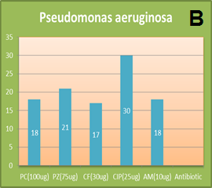
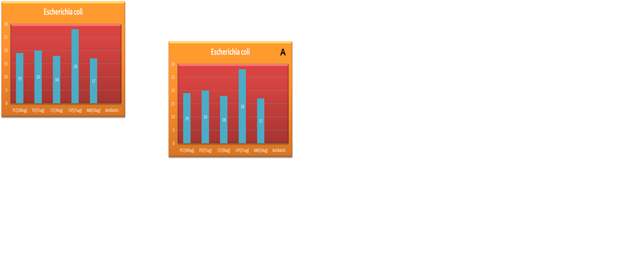

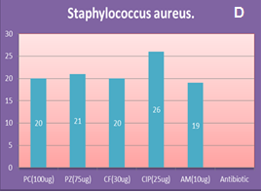
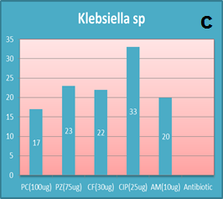

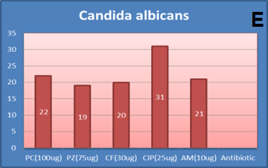

Figures (1): Antimicrobial activities (inhibition zones mm.) of standard antibiotics discs against tested bacterial and fungal .

Table(9): Antimicrobial activity of the methanolic extracts of leaves of (Prunus dulcis)
and standard antibiotics discs against tested bacterial and fungal.
Zone of inhibition(mm) Antibiotic |  |  |  |  |  |  | Organisms
PC(100ug) | PZ(75ug) | CF(30ug) | CIP(25ug) | AM(10ug) | 1.0g/ml | 0.5g/ml | Organisms
20 | 21 | 20 | 26 | 19 | 13 | 15 | Staphylococcus aureus.
19 | 20 | 18 | 28 | 17 | 14 | 14 | Escherichia coli.
18 | 21 | 17 | 30 | 18 | 14 | 13 | Pseudomonas aeruginosa.
17 | 23 | 22 | 33 | 20 | 14 | 12 | Klebsiella sp.
22 | 19 | 20 | 31 | 21 | 11 | 13 | Candida albicans.
It is clear from Table (9) and Plate (1) that the antimicrobial activity of the two methanol concentrations of Prunus dulcis gave lower inhibition zones than all antibiotics used in the study.
Staphylococcus aureus (1mg/ml) | Staphylococcus aureus (0.5mg/ml) | Klebsiella sp (1mg/ml) |  | Klebsiella sp. (0.5mg/ml)
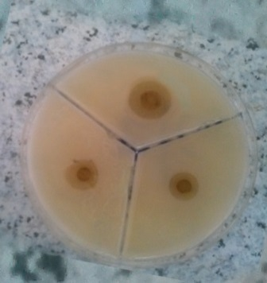 | 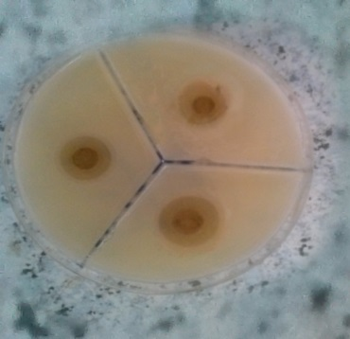 | 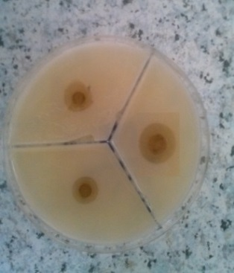 |  | 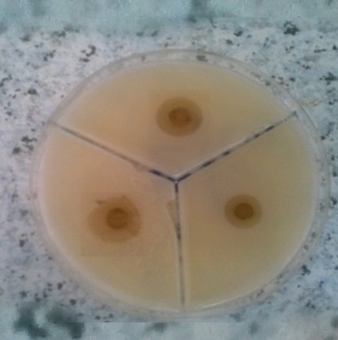
Escherichia coli (1mg/ml) | Escherichia coli (0.5mg/ml) | Candida albicans( 1mg/ml) | Candida albicans (0.5mg/ml)
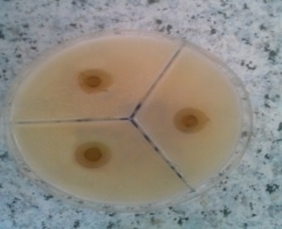 | 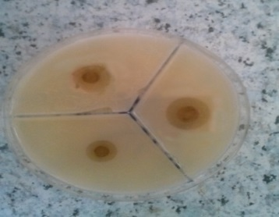 | 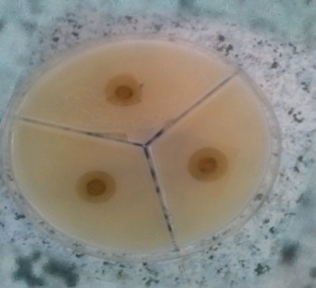 | 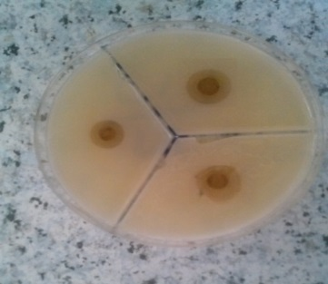
Pseudomonas aeruginosa (1mg/ml) | Pseudomonas aeruginosa (0.5mg/ml)
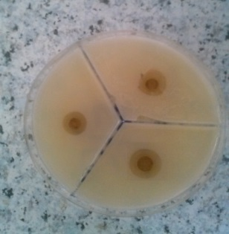 | 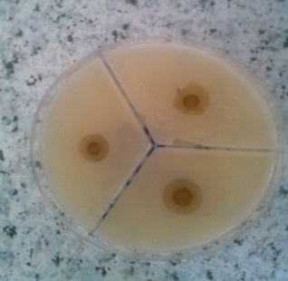

Plate (1):Inhibition zones observed with leaves methanolic extracts of Prunus dulcis.

Table(10): Antimicrobial activity of the Aqueous extract of leaves(Prunus dulcis) and
standard antibiotics discs against tested bacterial and fungual.
Zone of inhibition(mm) Antibiotic |  |  |  |  |  |  | Organisms
PC(100ug) | PZ(75ug) | CF(30ug) | CIP(25ug) | AM(10ug) | 1.0g/ml | 0.5g/ml | Organisms
20 | 21 | 20 | 26 | 19 | 17 | 18 | Staphylococcus aureus.
19 | 20 | 18 | 28 | 17 | 16 | 17 | Escherichia coli.
18 | 21 | 17 | 30 | 18 | 16 | 16 | Pseudomonas aeruginosa.
17 | 23 | 22 | 33 | 20 | 14 | 13 | Klebsiella sp.
22 | 19 | 20 | 31 | 21 | 18 | 16 | Candida albicans.
As shown in Table (10) and Plate (2) The antimicrobial activity of both aqueous concentrations of Prunus dulcis were lower in inhibition zones than all antibiotics except E. coli which had the closest activity to AM Staphylococcus aureus..a nearly to AM and candida albicans. nearly to PZ.
Staphylococcus aureus (1mg/ml) | Staphylococcus aureus (0.5mg/ml) | Klebsiella sp (1mg/ml) |  |  | Klebsiella sp. (0.5mg/ml)
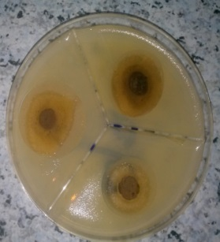 | 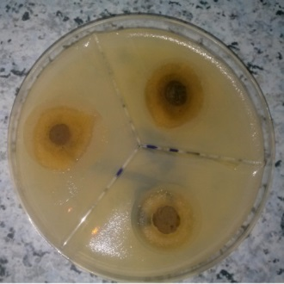 | 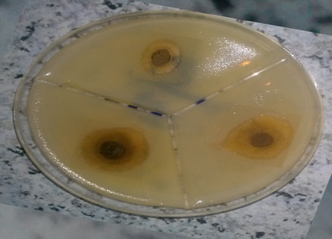 |  |  | 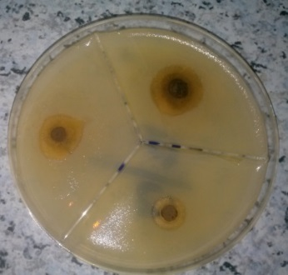
Escherichia coli (1mg/ml) | Escherichia coli (0.5mg/ml) | Candida albicans( 1mg/ml) |  | Candida albicans (0.5mg/ml)
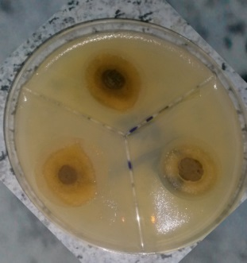 | 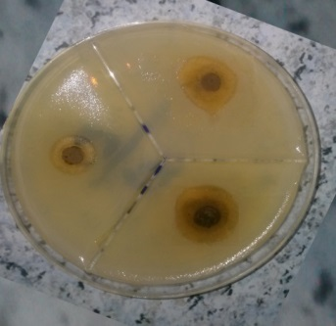 | 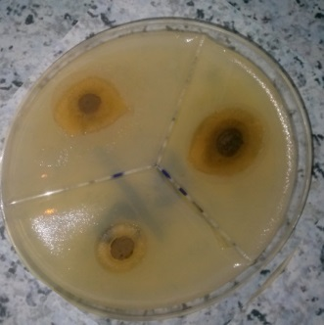 |  | 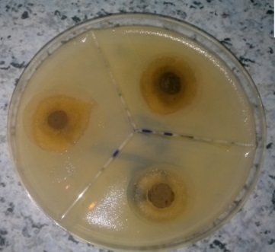
Pseudomonas aeruginosa (1mg/ml) | Pseudomonas aeruginosa (0.5mg/ml)
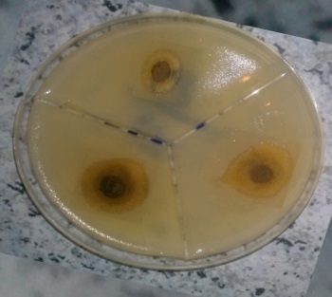 | 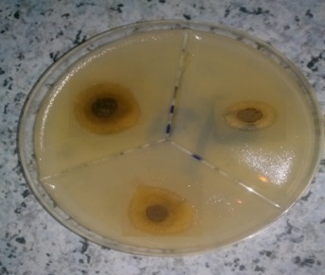

Plate (2):Inhibition zones observed with leaves Aqueous extracts of Prunus dulcis.

This study showed that Ciprofloxacin (30µg) gave the highest inhibition zone among all antibiotics with the selected organisms 26, 28, 30 mm against Staphylococcus aureus, E.coli, Pseudomonas aeruginosa respectively. In similar other study ( 13). Ciprofloxacin (25µg) gave high diameter of inhibition zone which reached up 19, 23, 23 mm against Staphylococcus aureus, E.coli, Pseudomonas aeruginosa respectively. The majority of the antibacterial activity in this study was found in the methanolic rather than the aqueous extracts, and the highest activity was found in the methanolic extracts from Prunus dulcis . Similar results were achieved by (14). In the present study it was observed that the extract of Prunus dulcis leaves showed antimicrobial activities, with varies values, against all the tested organisms, as indicated in Table (10) and Plate (2). Unfortunately no literature was found on extracts of methanolic nor aqueous extracts of leaves of Prunus dulcis in antimicrobial activities.
Antioxidant activity
Results showed are 85,5%, lowest from standard, ascorbic acid 87.5%. Table (11) and Figures (2).

Table(11) :Antioxidant activities of the selected extracts and L- ascorbic
acid using the (DPPH) free radical-scavenging assay.
Plants | Antioxidant activity DPPH (g/ml)
L- ascorbic acid
Prunus dulcis

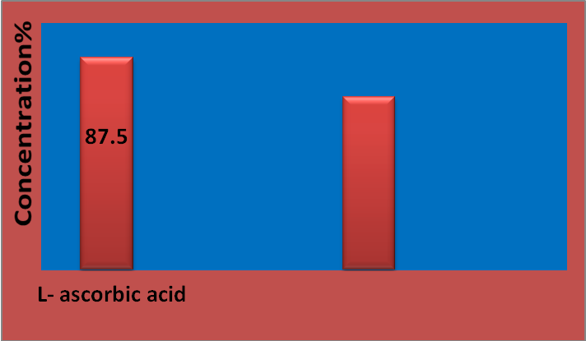
Prunus dulcis
85.5
DPPHg/ml
Figures(2): Antioxidant activities of the selected extracts and L- ascorbic acid using the (DPPH) free radical- scavenging assay.
In a study done by (15) found that the total antioxidant activity of prunus amygdalus leaves extract was 1377 mg/ml while 85.5% of prunus dulcis in present study.
CONCLUSION:
The present study showed that prunus dulcis are rich sources of useful secondary metabolites , It is strongly recommended of using them for general medicinal purpose and specially for treat wounds and burns diseases. It is strongly recommended of using them for production of effective pharmaceutical compounds and can be used as natural products of antimicrobial to treat wounds and burns diseases instead of chemical drugs. It is noticeable that the leaves of prunus dulcis are very rich in antioxidant content and therefore are good sources and safe and cheap for that .

References
1-Al-Dubai, A. S., & Al-Khulaidi, A. A. (1996)." Medicinal and aromatic plants of Yemen". Obadi Center for studies and Publishing: Sana’a, Yemen.‏ Avicenna J Phytomed.;3:254–71.
2-Grasselly, C. H. (1976). "Origine et évolution de l’amandier cultivé". Options Méditerr, 32, 45-49.‏
3-Monagas, M., Urpi-Sarda, M., Sánchez-Patán, F., Llorach, R., Garrido, I., Gómez-Cordovés, C., ... & Bartolomé, B. (2010). "Insights into the metabolism and microbial biotransformation of dietary flavan-3-ols and the bioactivity of their metabolites". Food & function, 1(3), 233-253.‏
4-Keser, S., Demir, E., & Yılmaz, Ö. (2014). "Phytochemicals and Antioxidant Activity of the Almond Kernel (Prunus dulcis Mill.) from Turkey". Journal of the Chemical Society of Pakistan, 36(3).‏

5-Gomaa, E.Z., (2013). In vitro antioxidant antimicrobial, and antitumor activities of bitter almond and sweet apricot (Prunus armeniaca L) kernels. Food .
6-Ciulci, I. (1994). "Methodology for the analysis of vegetable drugs, Chemical industries branch, Division of industrial operations". UNIDO Romania: 24, 26 and 67.

7-Tanko, Y., Abdelaziz, M. M., Adelaiye, A. B., Fatihu, M. Y., & Musa, K. Y. (2008)." Effects of Hydromethanolic leaves extract of Indigofera pulchra on blood glucose levels of normoglycemic and alloxan-induced diabetic Wistar rats". International Journal of Applied Research in Natural Products, 1(4), 13-18.‏
8-Gokhale SB, Kokate CK, Purohit AP. Shah, B. N., & Seth, A. K. .(2007). "Pharmacognostic studies of the Lagenaria siceraria (Molina) Standley". International Journal of PharmTech Research, 2(1), 121-124.‏
9-Puntawong, S., Okonogi, S., & Pringproa, K. (2012). "In vitro antibacterial activity of Plants leaf extracts against pathogenic bacteria in pigs". Chiang Mai Univ J Nat Sci, 11, 127-34.‏
10-Mensor, L. L., Menezes, F. S., Leitão, G. G., Reis, A. S., Santos, T. C. D., Coube, C. S., & Leitão, S. G. (2001). "Screening of Brazilian plant extracts for antioxidant activity by the use of DPPH free radical method". Phytotherapy research, 15(2), 127-130.‏

11-Alfredo Bottone,Paola montoro(,2018) "Metabolomics and antioxidant activity of the leaves of Prunus dulcis Mill". (Italian cvs. Toritto and Avola),https://doiorg/1016/jba. Volume 158, 5 September 2018, Pages 54-65.
12-Keservani, R. K., Kesharwani, R. K., Vyas, N., Jain, S., Raghuvanshi, R., & Sharma, A. K. (2010). "Nutraceutical and functional food as future food: a review". Der Pharmacia Lettre, 2(1), 106-116. List.Intj Microbiol73(7-8), 713-715.‏
13-Bhalodia, N. R., & Shukla, V. J. (2011). "Antibacterial and antifungal activities from leaf extracts of Cassia fistula l.: An ethnomedicinal plant". Journal of advanced pharmaceutical technology & research, 2(2), 104.‏

14-Rabe, T., Van Staden, J. (1997). "Antibacterial activity of South African plants used for medicinal purposes". Journal of ethnopharmacology, 56(1), 81-87. Science and Biotechnology, 22 pp.455-463.

15-Tiwari, U., Dubey, N., & Kaushik, S. (2015)." Antibacterial and antioxidant efficacy analysis of leaves extracts of Prunus amygdalus (Badam) in different solvents". Int. J. Curr. Microbiol. App. Sci, 4(5), 728-736.‏

