Reviewer’s Comments

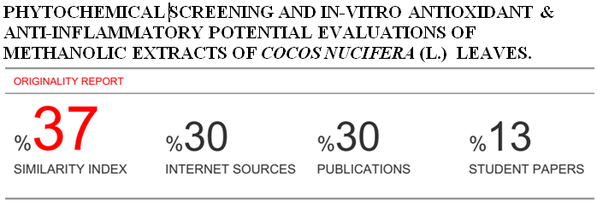

Phytochemical Screening and *In-vitro* Antioxidant & Anti-inflammatory Potential Evaluations of Methanolic Extracts of *Cocos nucifera* (L.) Leaves.

Abstract

*Cocos nucifera* (L.) (Arecaceae) is commonly called the ‘‘coconut tree’’ and is the most naturally widespread fruit plant on Earth. Throughout history, humans have used medicinal plants therapeutically, and minerals, plants, and animals have traditionally been the main sources of drugs. The objective in the present study was to screen the phytochemical profile and pharmacological activities of methanolic extract ofcoconut leaves. Because each part of *C. nucifera* has different constituents, the pharmacological effects of the plant vary according to the part of the plant evaluated. To investigate pharmacological activities, DPPH scavenging assay &HRBC membrane stabilization methods were performed for antioxidant and anti-inflammatory potential respectively.The phytochemical analysis of methanolic extract ofcoconut leavesshowed that they contained significant presence of flavonoids, phenols, saponins, terpenoids&triterpenes . Alkaloids, glycosides & tannins are also moderately present.Quantitative evaluations show significant presence of phenols, which was more than tannin content.The pharmacological studies revealed that the plant extracts may have significant antioxidant effect which is probably mediated by inhibition of DPPH free radical.which is responsible for oxidation. The IC50 values by DPPH scavenging assay observed for standard &leaves were 97.29µg/ml & 486.78µg/ml respectively.So,this plant extracts have significant antioxidant effect. There is also moderate anti-inflammatory activity.The IC50 values for anti-inflammatory activity by standard & coconut leaves were 21.46 µg/ml & 831.21 µg/ml respectively. These findings suggest that this plant may be a possible source for the development of a new drug.

**Keywords:** *Cocos nucifera*, phenols, tannin content, antioxidant, anti-inflammatory, IC50 values.

Introduction:

Plants, which have one or more of its parts having substances that can be used for treatment of diseases, are called medicinal plants.[1] Medicines derived from plants are widely famous due to their safety, easy availability and low cost .[2]Throughout the ages, humans have relied on nature for their basic needs, for the production of food, shelter, clothing, transportation, fertilizers, flavours,fragrances, and medicines.[3] Plants have formed the basis of sophisticated traditional medicine systems that have been in existence for thousands of years and continue to provide mankind with new remedies. Although some of the therapeutic properties attributed to plants have proven to be erroneous, medicinal plant therapy is based on the empirical findings of hundreds and probably thousands of years of use. The first records, written on clay tablets in cuneiform, are from Mesopotamia and date from about 2 600 BC.[4] Among the substances that were used are oils of *Cedrus*species (cedar) and *Cupressussempervirens*(cypress), *Glycyrrhizaglabra*(licorice), *Commiphora*species (myrrh) and *Papaver somniferum*(poppy juice), all of which are still in use today for the treatment of ailments ranging from coughs and colds to parasitic infections and inflammation. In ancient Egypt, bishop’s weed (*Ammimajus*) was reported to be used to treat vitiligo, a skin condition characterized by a loss of pigmentation .[5-6] More recently, a drug, (-methoxypsoralen) has been produced from this plant to treat psoriasis and other skin disorders, as well as T-cell lymphoma.[6]The interest in nature as a source of potential chemotherapeutic agents continues. Natural products and their derivatives represent more than 50% of all the drugs in clinical use in the world today. Higher plants contribute no less than 25% of the total.[7] In the last 40 years, many potent drugs have been derived from flowering plants; including for example *Dioscorea*species (diosgenin), from which all anovulatory contraceptive agents have been derived; reserpine and other antihypertensive and tranquilizing alkaloids from *Rauwolfia*species; pilocarpine to treat glaucoma and ‘dry mouth’, derived from a group of South American trees (*Pilocarpus*spp.) in the Citrus family; two powerful anti-cancer agents from the Rosy Periwinkle (*Catharanthusroseus*); laxative agents from *Cassia* sp. and a cardiotonic agent to treat heart failure from *Digitalis* species .[8]

Although discovered through serendipitous laboratory observation, three of the major sources of anti-cancer drugs on the market or completing clinical trials are derived from North American plants used medicinally by native Americans: the papaw (*Asimina*spp); the western yew tree (*Taxusbrevifolia*), effective against ovarian cancer and the mayapple (*Podophyllumpeltatum*) used to combat leukaemia, lymphoma lung and testicular cancer .[9]*Cocos nucifera*(L.) is originally from Southeast Asia (Malaysia, Indonesia, and the Philippines) and the islands between the Indian and Pacific Oceans. From that region, the fruit of the coconut palm is believed to have been brought to India and then to East Africa. After the discovery of the Cape of Good Hope, this plant was introduced into West Africa and, from there, dispersed to the American continent and to other tropical regions of the globe. [10]*C. nucifera* has been called the ‘tree of life’ or ‘tree of heaven’ because of its value as provider of so many useful products. This species provides food, water, oil, medicine, fibre, timber, and fuel for many people living on islands in the Pacific Ocean. [11]

Materials and methods:

Total Phenolic Content (TPC)

The total phenolics of the extracts were determined using the Folin and Ciocalteu reagent, following the method described.The test sample (0.2 mL) was mixed with 0.6mL of water and 0.2mL of Folin-Ciocalteu’s phenol reagent (1 : 1). After5min, 1mL of saturated sodium carbonate solution (8%w/v in water) was added to the mixture and the volume was made up to 3mL with distilled water. The reaction was kept in the dark for 30min and after centrifuging the absorbance of blue color from different samples was measured at 760 nm.

Standard curve preparation:

Gallic acid was used here as standard. The phenolic content was calculated as gallic acid equivalents GAE/g of dry plant material on the basis of a standard curve of gallic acid.

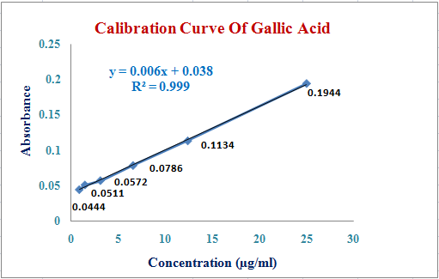

Figure 1: Standard curve of Gallic acid.

Table-1: Total phenolic content (TPC) of *Cocos nucifera*

|  |  |  |  |  |
| --- | --- | --- | --- | --- |
| Test sample | Absorbance | TPC (mg of GAE/g) | Average | TPC (mg of GAE/g) ± SEM |
|  | 0.202 | 26.306 |  |  |
| Leaves | 0.209 | 27.435 | 26.951 | 26.951 ± 0.33 |
|  | 0.207 | 27.113 |  |  |

Total Tannin Content (TTC) Determination:

Fifty micro liters (µl) of tannins extract for each sample was taken in test tube and volume was made to 1.0 ml with distilled water. Then, 0.5 ml FolinCiocalteu reagent was added and mixed properly. Then 2.5 ml 20 per cent sodium carbonate solution was added and mixed it and kept for 40 minutes at room temperature. Optical density was taken at 725 nm in spectrophotometer and concentration was estimated.

Standard curve preparation:

In this method Tannic acid was used as standard and tannin contents were measured as tannic acid equivalent. For this purpose, the calibration curve of tannic acid was drawn.

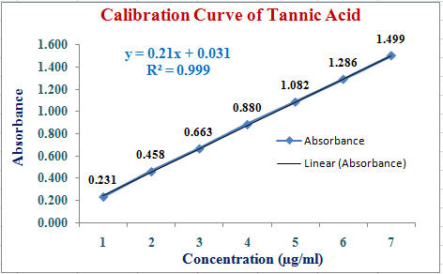

Figure 2: Standard curve of Tannic acid.

Results

Table-2: Total tannin content (TTC) of *Cocos nucifera.*

|  |  |  |  |  |
| --- | --- | --- | --- | --- |
| Test sample | Absorbance | TTC (mg of TAE/g) | Average | TTC (mg of TAE/g) ± SEM |
|  | 0.364 | 1.585 |  |  |
| Leaves | 0.358 | 1.557 | 1.577 | 1.577 ± 0.010 |
|  | 0.365 | 1.590 |  |  |

Where is your methodology for phytochemical screening, including their refernces?

TheFollowing tests were done to find the presence of the active chemical constituents such as alkaloids, flavonoids, glycosides, phenols, saponins, tannins, terpenoids and triterpenes.

Table-3:Test of different metabolites:

|  |  |  |
| --- | --- | --- |
| Secondary metabolites | Name of the test | Results |
| Alkaloids | Wagner test | ++ |
| Flavonoids | Specific test | +++ |
| Glycosides | General test | ++ |
| Phenols | Litmus test | +++ |
| Saponins | Froth test | +++ |
| Tannins | Ferric chloride test | ++ |
| Terpenoids | General test | +++ |
| Triterpenes | Salkowski’s test | +++ |

From above qualitative evaluations showed significant presence of flavonoids, phenols, saponins, terpenoids, &triterpenes.Alkaloids, glycosides & tannins are also moderately present in the methanolic extract of leaves of *Cocos nucifera*.

Results and Discussions:

Anti-inflammatory Assay

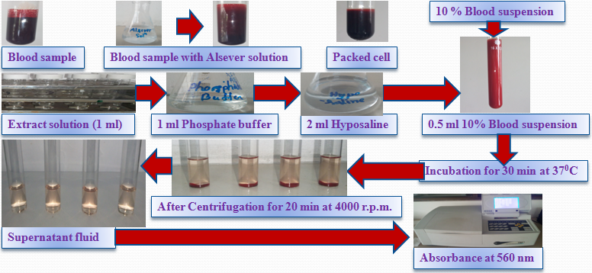

Figure 3: Pictorial representation of Anti-inflammation by HRBC membrane stabilization method.

Percent inhibition of protein denaturation was calculated as follows:

% inhibition = (Control - Sample / Control) × 100

Table 4:Spectroscopic Determination of Anti-inflammatory Activity of Leaves of *Cocos nucifera*

|  |  |  |  |  |  |
| --- | --- | --- | --- | --- | --- |
| Concentration (µg/ml) | Absorbance | % Inhibition | Average | % Inhibition ± SEM | IC50 (µg/ml) |
| 125 | 0.443 | 1.34 | 1.56 | 1.56 ± 0.5 |  |
| 0.446 | 0.67 |
| 0.437 | 2.67 |
| 250 | 0.405 | 9.80 | 11.43 | 11.43 ± 0.9 | 831.21 |
| 0.391 | 12.92 |
| 0.397 | 11.58 |
| 500 | 0.239 | 46.77 | 46.77 | 46.77 ± 0.5 |  |
| 0.235 | 47.66 |
| 0.243 | 45.88 |
| 1000 | 0.213 | 52.56 | 53.53 | 53.53 ± 0.48 |  |
| 0.207 | 53.90 |
| 0.206 | 54.12 |

Graphical Representation

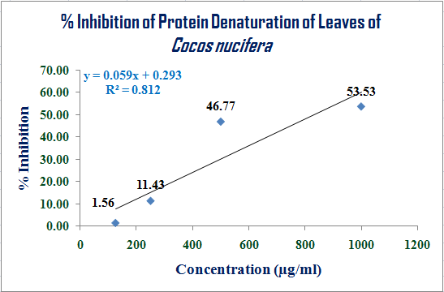

Figure 4: Graphical Representation of Anti-inflammatory Activity of Leaves of *Cocos nucifera.*

Table 5: Spectroscopic Determination of Anti-inflammatory Activity of Standard Compound (Diclofenac- Na)

|  |  |  |  |  |  |
| --- | --- | --- | --- | --- | --- |
| Concentration (µg/ml) | Absorbance | % Inhibition | Average | % Inhibition ± SEM | IC50 (µg/ml) |
| 125 | 0.243 | 45.88 | 46.62 | 79.51 ± 0.46 |  |
|  | 0.239 | 46.77 |  |  |  |
|  | 0.237 | 47.22 |  |  |  |
| 250 | 0.161 | 64.14 | 64.07 | 85.97 ± 0.25 |  |
|  | 0.159 | 64.59 |  |  | 21.46 |
|  | 0.164 | 63.47 |  |  |  |
| 500 | 0.101 | 77.51 | 76.91 | 89.31 ± 0.46 |  |
|  | 0.107 | 76.17 |  |  |  |
|  | 0.103 | 77.06 |  |  |  |
| 1000 | 0.057 | 87.31 | 87.45 | 93.47 ± 0.19 |  |
|  | 0.053 | 88.20 |  |  |  |
|  | 0.059 | 86.86 |  |  |  |

Graphical Representation:

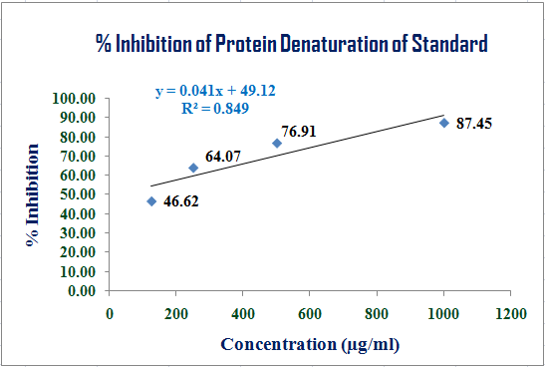

Figure 5: Graphical Representation of Anti-inflammatory Activity of Standard.

Table 6: Comparative % Inhibition of Protein Denaturation

|  |  |  |
| --- | --- | --- |
| Concentration | Leaves | Standard |
| 125 µg/ml | 1.56 | 46.62 |
| 250 µg/ml | 11.43 | 64.07 |
| 500 µg/ml | 46.77 | 76.91 |
| 1000 µg/ml | 53.53 | 87.45 |

Graphical Representation:

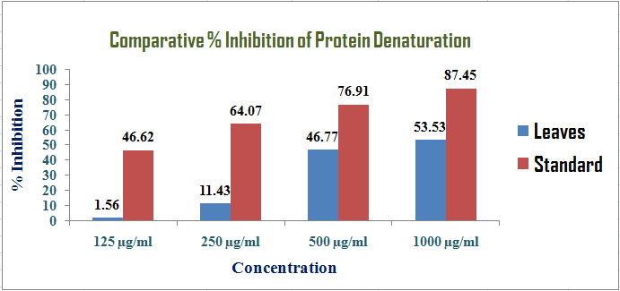

Figure 6: Comparative % Inhibition of Protein Denaturation.

Table 7: Comparative study based on IC50

|  |  |
| --- | --- |
| Test Sample | IC50 |
| Leaves | 831.21 |
| Standard | 21.46 |

Graphical Representation:

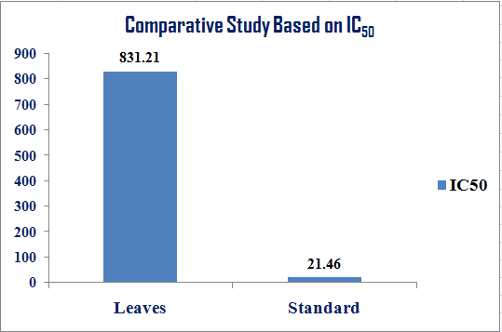

Figure 7: Comparative study based on IC50.

By analyzing the above data, it revealed that the plant extracts may have moderate anti-inflammatory effect which is probably mediated by HRBC membrane stabilization.

Anti Oxidant Activity:

The free radical-scavenging activity of extracts was evaluated with the DPPH assay based on the measurement of the reducing ability of antioxidants toward the DPPH radical. One milliliter of diluted extract was added to 3 ml of the methanolic DPPH solution (4 × 10−5M). The mixture was then shaken and allowed to stand at room temperature in the dark. After 30 min, the decrease in absorbance was measured at 517 nm against a blank (methanol solution). A mixture consisting of 1 ml of methanol and 3 ml of DPPH solution was used as the control. Ascorbic acid was used as positive control.

|  |  |  |
| --- | --- | --- |
|  | Absorbance | Average |
|  | 0.891 |  |
| Control | 0.903 | 0.896 |
|  | 0.895 |  |

Table 8: Spectroscopic Determination of Antioxidant Activity of Leaves of *Cocos nucifera*

|  |  |  |  |  |  |
| --- | --- | --- | --- | --- | --- |
| Concentration (µg/ml) | Absorbance | % SCV | Average | % SCV ± SEM | IC50 (µg/ml) |
| 62.5 | 0.803 | 10.38 | 10.71 | 7.40 ± 0.51 |  |
| 0.806 | 10.04 |
| 0.791 | 11.72 |
| 125 | 0.679 | 24.22 | 24.67 | 20.20 ± 0.26 |  |
| 0.675 | 24.67 |
| 0.671 | 25.11 |
| 250 | 0.425 | 52.57 | 52.86 | 52.86 ± 0.54 | 486.78 |
| 0.429 | 52.12 |
| 0.413 | 53.91 |
| 500 | 0.291 | 67.52 | 67.52 | 67.52 ± 0.26 |  |
| 0.287 | 67.97 |
| 0.295 | 67.08 |
| 1000 | 0.107 | 88.06 | 88.91 | 88.91 ± 0.46 |  |
| 0.093 | 89.62 |
| 0.098 | 89.06 |
| 2000 | 0.049 | 94.53 | 94.46 | 94.46 ± 0.39 |  |
| 0.056 | 93.75 |
| 0.044 | 95.09 |

Graphical Representation:

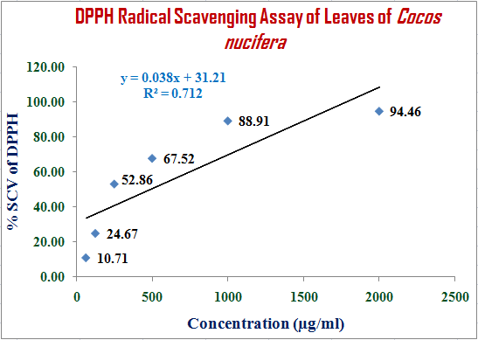

Figure 9 : Antioxidant Activity of Leaves of *Cocos nucifera*by DPPH SCV assay.

Table 10: Spectroscopic Determination of Antioxidant Activity of Standard Compound (L- Ascorbic Acid)

|  |  |  |  |  |  |
| --- | --- | --- | --- | --- | --- |
| Concentration (µg/ml) | Absorbance | % SCV | Average | % SCV ± SEM | IC50 (µg/ml) |
| 62.5 | 0.343 | 61.72 | 61.90 | 61.90 ± 0.30 |  |
| 0.345 | 61.50 |
| 0.336 | 62.50 |
| 125 | 0.257 | 71.32 | 70.76 | 70.76 ± 0.36 |  |
| 0.268 | 70.09 |
| 0.261 | 70.87 |
| 250 | 0.195 | 78.24 | 78.83 | 78.83 ± 0.49 | 97.29 |
| 0.181 | 79.80 |
| 0.193 | 78.46 |
| 500 | 0.119 | 86.72 | 87.24 | 87.24 ± 0.27 |  |
| 0.113 | 87.39 |
| 0.111 | 87.61 |
| 1000 | 0.047 | 94.75 | 94.49 | 94.49 ± 0.16 |  |
| 0.052 | 94.20 |
| 0.049 | 94.53 |
| 2000 | 0.021 | 97.66 | 96.91 | 96.91 ± 0.54 |  |
| 0.025 | 97.21 |
| 0.037 | 95.87 |

Graphical Representation:

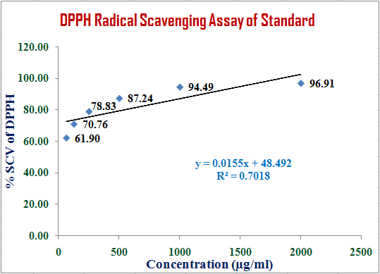

Figure 10 : Antioxidant Activity of Standard by DPPH SCV assay.

Table 11 : Comparative % SCV of DPPH

|  |  |  |
| --- | --- | --- |
| Concentration | Leaves | Standard |
| 62.5 µg/ml | 10.71 | 61.9 |
| 125 µg/ml | 24.67 | 70.76 |
| 250 µg/ml | 52.86 | 78.83 |
| 500 µg/ml | 67.52 | 87.24 |
| 1000 µg/ml | 88.91 | 94.49 |
| 2000 µg/ml | 94.46 | 96.91 |

Graphical Representation:

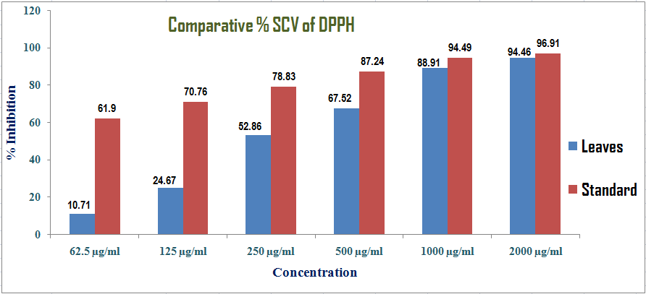

Figure 12 : Comparative Antioxidant Activity by DPPH SCV assay.

Table 12: Comparative study based on IC50

|  |  |
| --- | --- |
| Test Sample | IC50 |
| Leaves | 486.78 |
| Standard | 97.29 |

Graphical Representation:

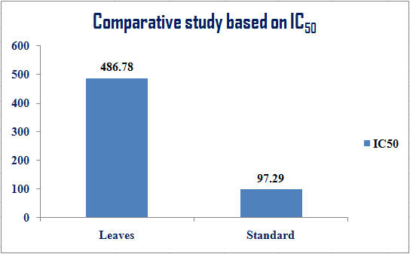

Figure 13 : Comparative study of Antioxidant Activity based on IC50.

By analyzing the above data, it revealed that the plant extracts may have significant antioxidant effect which is probably mediated by inhibition of DPPH free radical, which is responsible for oxidation.

Conclusion & Future Directions:

From this research work it was found that qualitative evaluations show significant presence of flavonoids , phenols , saponins , terpenoids& triterpenes . Alkaloids, glycosides & tannins are also moderately present.Quantitative evaluations show significant presence of phenols than tannin content.The IC50 values by DPPH scavenging assay observed for standard &leaves were 97.29µg/ml & 486.78µg/ml respectively. So,there is an excellent antioxidant activity in the methanolic extract.There is also moderate anti-inflammatory activityin the methanolic extract ofcoconut leaves. The IC50 values for anti-inflammatory activity by standard & coconut leaves were 21.46 µg/ml & 831.21 µg/ml respectively.So the future motive is to find out a comparative information for not only *in-vitro* but also *in-vivo* approaches of the methanolic extract ofcoconut leaves.

Discussion

References:

1. Sofowora A. *Medicinal Plants and Traditional in Afirica*. John willy, New York. 1982. p.289-290.

2. Iwu MM, Duncan AR, Okunji CO. New antimicrobials of plant origin. In: Janick J. ed. *Prospective on new crops and new uses.* ASHS press, Alexandria, V.A. 1999. p.457-462.

3. Cragg, G.M. and Newman, D.J. Biodiversity: A continuing source of novel drug leads. Pure Appl. Chem. 2005. 77 (1):p.7-24.

4. Heinrich, M., Barnes, J., Gibbons, S., Williamson, E.M. Fundamentals of Pharmacognosy and Phytotherapy. Churchill Livingstone, Elsevier Science Ltd., UK. 2004.

5. Staniszewska, I., Królicka, A., Malinski, E., Łojkowska, E. and Szafranek, J. Elicitation of secondary metabolites in *in vitro* cultures of *Ammimajus*L. Enzymes Microb. Technol. 2003. 33: p.565-568.

6. Beissert, S. and Schwarz, T. Role of immunomodulation in diseases responsive to phototherapy. 2002. Methods 28 (1):p.138-144.

7. Farnsworth, N., Akerele, A.O., Bingel, A.S., Soejarto, D.D., Guo, Z., Bull. WHO 1985. 63:p.965-981.

8. Newman, D. J., Cragg, G.M. and Snader, K.M. The influence of natural products upon drug discovery, Nat. Prod. Rep. 2000. 17 (3):p.215-234.

9. Gurib-Fakim, A. Medicinal plants: Tradition of yesterday and drugs of tomorrow. Review article. Mol. Aspects Med. 2006.27 (1):p.1-93.

10. Purseglove JW. Tropical crops: monocotyledons. London: Longman; 1972.

11. Chan E, Elevitch CR, 2006. *Cocos nucifera* (coconut), ver. 2.1. Species profiles for Pacific island agroforestry [ed. by Elevitch, C. R.]. Honolulu, Hawaii, USA: Permanent Agriculture Resources (PAR).