Reviewer’s Comments
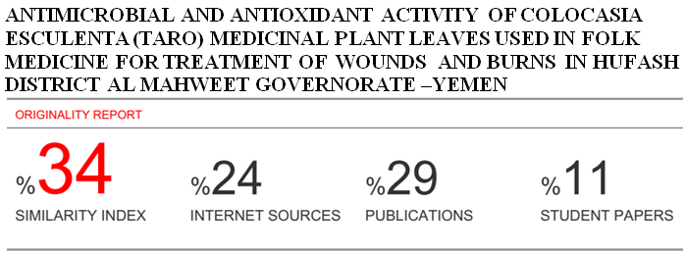
Antimicrobial and Antioxidant Activity of Colocasia esculenta (Taro) Medicinal Plant Leaves Used In Folk Medicine For Treatment of Wounds and Burns in Hufash District Al Mahweet Governorate –Yemen.
Abstract
In this study methanolic and aqueous extracts of one plant namely Colocasia esculenta, were screened for the presence of phytochemical constituents and tested for their antimicrobial and antioxidant activity. The qualitative phytochemical analysis revealed the results showed presence of alkaloids, terpenoids, glycosides, resins, saponins, tannins, flavonoids, phenols, and amino acid were present in the methanol extract, with absence of glycosides, and amino acids in the aqueous extracts in leaves plant . TLC tests conducted revealed Rf values in the leaves for alkaloids, Flavonoids, Tannins, Phenols and Saponins(0.95-0.96-0.97-0.96-0.97) respectively. The antimicrobial activity extracts against four bacterial isolates Staphylococcus aureus, Escherichia coli , Pseudomonas aeruginosa and Klebsiella sp. and a single fungal isolate Candida albicans with concentrations (0.5 mg/ml, and 1,0 mg/ml) of the extract were added to the disc and respective solvent was used as negative control. The antioxidative activity of leaf was evaluated by using 1,1- diphenyl-2 picrylhydrazyl (DPPH), the results showed are 86.5%, lowest from standard, ascorbic acid 87.5%.
Key word: phytochemical, antimicrobial ,antioxidative , Colocasia esculenta.
Introduction
Plant have been utilized as important sources of medicinal drugs and health products since ancient time, In the area (Hufash-Al-mahweet), although the existence of rural health center), most people resort, in the treatment of wounds and burns, folk medicine. Many studies confirm that, the prosperity of herbal medicine in Yemen is related to the variety and abundance of vegetation, where there are three thousand species of plants on land; 415 species of endemic plants and 236 species found only on the island of Socotra, whose vegetation cannot be found elsewhere in the world. (1). Colocasia esculenta (CE) Linn. (Family: Araceae) is an annual herbaceous plant with a long history of usage in traditional medicine in several countries across the world, especially in the tropical and subtropical regions. The herb has been known since ancient times for its curative properties and has been utilized for treatment of various ailments such as asthma, arthritis, diarrhea, internal hemorrhage, neurological disorders, and skin disorders. The juice of CE corm is widely used for treatment of body ache and baldness (20) Colocasia esculenta is Phytochemically, these also contain flavones, apigenin , luteolin , and anthocyanins (9). In a study, it was found that the most common isolates were K. pneumoniae (34.40%), followed by P. aeruginosa (23.94%), S. aureus (22.94%), E. coli (7.34%), Acinetobacter species (2.75%), P. mirabilis (2.75%), Citrobacter species (1.38%), and Candida species (4.59%) (16). Methanol extract of Colocasia esculenta leaves has shown higher antioxidant activity81,77%.(15).

Materials and Methods:
Sampling: Fresh leaves of Colocasia esculenta, were collected from Hufash District-Mahaweet-Yemen. The fresh leaves were properly rinsed with tap water. The leaves were dried under room temperature and then were blended to fine powder using electric blender. Powder stored at 4ºC and protected from light prior to future uses. Samples extraction: The extraction process was carried out in the Central laboratory For Pesticides Residue Analysis of Plant Protection Department - Sana'a. Ministry of Agriculture. For each plant. Samples of 100g of the grinded powder were put in sterilized flasks together with 400 ml of pure methanol for methanolic extraction treatments, while for aqueous extraction treatments, samples of 100g of grinded powder were put in sterilized flasks with 400 ml of distilled water each. All flasks were covered with transparent nylon and tin and then all were put on a rotary shaker machine for 24 hours, the speed of the device was 200 r/m at the laboratory temperature (22.7 ºC). The filtration process for each sample was carried out using filter paper to obtain a pure solution. The evaporation process for each methanol solution and distilled water was conducted separately in the evaporator (methanol solution at 42 ºC and pressure 337. The distilled water solution at 45 ° C and pressure 72 for 2 hours for methanol solution and 4 hours for distilled water solution. Then the obtained extracts were kept in dark conditions in the refrigerator at 4°C until used in the experiment ( 8).

Qualitative Tests
Phytochemical screening of plant extracts:
The methanolic and aqueous extracts subjected to phytochemical screening were alkaloids, terpenoids, glycosides, resins, saponins, tannins, flavonoids, phenols, and amino acids.

Alkaloids: Dragendorff’s Test
In a test tube, 2-3 drops of Dragendorff’s reagent was added to 0.1 ml of the extract orange precipitate indicated the presence of alkaloids. (3).

Terpenoids: Salkowski Test
In a test tube 5ml of extract was mixed in 2 ml of chloroform and then 3 ml of concentrated sulfuric acid was added to form a layer. A reddish brown coloration forms at interface. (3).

Glycosides: Keller-Killani Test
Concentrated sulfuric acid in a test tube and extract sample were mixed with glacial acetic acid containing 1 drop of Ferric chloride (1:1:1volume). A brown ring appears in the presence of glycosides. (3) .

Resins: Turbidity test
To 5ml extract 5ml distilled water was added, the occurrence of turbidity shows the presence of resins. (3).
Saponins: Foam Test
A 5ml extract was shaken with 2 ml of distilled water. If foams are produced and persists for ten minutes this indicates the presence of saponins. (3).

Tannins: Fecl₃ Test
A 4 ml extract was treated with 4 ml FeCl₃ ,the formation of green colour was taken as positive for tannin. (19).

Flavonoids: Shinoda Test
Extract was mixed with magnesium ribbon fragments, and concentrated hydrochloric acid was added drop wise. Orange, red, pink, or purple coloration indicates the presence of flavonoids. (19).

Phenols: Fecl₃ Test
Extract was mixed with 2 ml of 2% solution of FeCl₃. A blue-green or black coloration indicated the presence of phenols. (19).

Amino acids: Biuret test
Extracts and 1 drop 2% Copper sulphate solution and 1 ml 95% ethanol excess of potassium hydroxide were mixed. Pink or yellow color in ethanol layer appears (19).
Thin layer chromatographic test for Alkaloids.
One gram of Colocasia esculenta, powdered samples were boiled with 15ml H₂SO₄ in rounded flasks, heated for 15 minutes, cooled then filtered. TLC plates were prepared (Layer: silica gel layers 0.25 mm ,thickness 10 cm length and 5cm wide). The filtrate obtained was evaporated to dryness in a water bath at 37° C. The residue was dissolved by 0.2ml methanol. The solution was used for spotting the TLC by capillary tube making by only one centered spot. The TLC plate was put inside a saturated tank, and development was waited. When the mobile phase reached two thirds of plate's length, the plate was lifted out from the tank and let to dry in air. The plate was examined under U.V. lamp at the wave length 365nm. The colors of florescence appeared. The plate was then sprayed carefully by Dragendorff reagent, and was let dry for 10 min. Then sprayed with 10% (w/v) sodium nitrite solution ,Then plate was examined under U.V. lamp at the wave length 365nm. (8).
Calculation of RF of each spot was as follows:
RF=
Thin – layer chromatographic (TLC)test for Flavonoides.
One gram of Colocasia esculenta, powder was boiled with of 70% ethanol in rounded flask, heated for 10 minutes, cooled then filtered. A TLC plate was prepared as such (Layer : silica gel layers 0.25 mm thickness, 10 cm length and 5cm wide). The filtrate obtained was evaporated to dryness in a water bath at 37° C.The residue was dissolved by 0.2ml methanol. The solution was used for spotting the TLC by capillary tube by only one centered spot. The TLC plate was put inside a saturated tank, and development was waited. When the mobile phase reaches two thirds of plate’s length, the plate was lifted out from the tank and let to dry in air. The plate was examined by U.V. lamp at the wave length 365nm. The colors of florescence appeared and recorded. The plate was sprayed carefully by Aluminum chloride reagent, and let to dry for 10 min. Then spray et with 10%(w/v) ammonia solution Then plate was examined under U.V. lamp at the wave length 365nm. (8).

Calculation of RF of each spot was as follows:
RF=
Thin layer chromatographic test for Tannins.
One gram of Colocasia esculenta, powdered drug was boiled with 25 ml water for 5 minutes, cooled then filtered. A TLC plate was prepared (Layer : silica gel layers 0.25 mm thickness, 10 cm length and 5cm wide). The filtrate obtained was evaporated to dryness in a water bath at 37° C.The residue was dissolved by 0.2ml methanol. The solution was used for opting the TLC by capillary tube by only one centered spot. The TLC plate was put inside a saturated tank, and development was waited. When the mobile phase reached two thirds of plate’s length, the plate was lifted out from the tank and let to dry in air. The plate was examined by U.V. lamp at the wave length 365nm. The colors of florescence appear and recorded. The plate was sprayed carefully by 10%FeCl₃ reagent, and the plate was let to dry for 10 min. Then heated over a hot plate and the resolution colors were recorded Then plate was examined under U.V. lamp at the wave length 365nm. (8).
Calculation of RF of each spot was as follows:
RF=
Thin layer chromatographic test for Saponins.
Materials And Methods

One gram of Colocasia esculenta, powdered drug was boiled with 10ml of 70% ethanol in rounded flask, heated for 10 minutes, cooled then filtered. A TLC plate was prepared (Layer : silica gel layers 0.25 mm thickness, 10 cm length and 5cm wide). The filtrate obtained was evaporated to dryness in a water bath at 37° C.The residue was dissolved by 0.2ml methanol. The solution was used for spotting the TLC by capillary tube making by only one centered spot. The TLC plate was put inside saturated tank, and development was waited. When the mobile phase reaches two thirds of plate’s length, the plate was lifted out from tank let dry in air. The examine the plate was examined by U.V. lamp at the wave length 365nm. The colors of florescence appeared and recorded. The plate was sprayed carefully by Vanillin sulfuric acid reagent, and the plate was let to dry for 10 min. then heated over a hot plate and the resolution colors was recorded Then plate was examined under U.V. lamp at the wave length 365nm. (8).
Calculation of RF of each spot was as follows:
RF=

Thin layer chromatographic test for Phenols.
One gram of Colocasia esculenta, powdered drug was boiled with 25 ml water for 5 minutes, cooled then filtered. A TLC plate was prepared (Layer : silica gel layers 0.25 mm thickness, 10 cm length and 5cm wide). The filtrate obtained was evaporated to dryness in a water bath at 37° C.The residue was dissolved by 0.2ml methanol. The solution was used for opting the TLC by capillary tube by only one centered spot. The TLC plate was put inside a saturated tank, and development was waited. When the mobile phase reached two thirds of plate’s length, the plate was lifted out from tank and let to dry in air. The plate was examined by U.V. lamp at the wave length 365nm. The colors of florescence appeared and The plate was sprayed carefully by 10% KOH reagent, and let to dry for 10 min. then heated over a hot plate. (8).

Calculation of RF of each spot was as follows:

RF=
Antimicrobial Activity of Plants extracts.
Microbial Cultures: Fresh plates of the four bacterial isolates Staphylococcus aureus, Escherichia coli , Pseudomonas aeruginosa and Klebsiella sp. and a single fungal isolate Candida albicans were obtained from the National Center of Public Health Laboratories, Sana’a. Media Use: The bacterial test were spread over the nutrient ager(56g/1000ML distilled Water) was weight into separate flask and dispensed into distilled water make a total volume of 1 liter .Then the fungal test were spread over the sabouraud dextrose ager(65g/1000ML distilled Water) was weighted into separate flask and dispensed into distilled water to make a total volume of 1 liter. These powders were dissolved in distilled water and used for evaluation of their antibacterial and Antifungal activities. The mixture was heated in an electric water bath (GFC, 1083, Germany) until the Agar melted to form a homogenous solution. The prepared medium was separately transferred to Durum medium bottle and sterilized by autoclaving at 121⁰ C for 30 minutes. The sterile medium was allowed to cool to about 45ºC before being poured aseptically in an inoculation. chamber (Ceslab England) in15 ml portions, into sterile petri dishes to cool and gel into solids. (18). Antimicrobial activity assay: Two different concentrations (0.5 mg/ml, and 1,0 mg/ml) of the extract were added to the disc and respective solvent was used as negative control. Zone of Inhibition : The bacteria plates were incubated at37ºC for 24hrs while the fungal plates were incubated at for 72 hours, and observed for the zone of inhibition of growth, The zones were measured with a transparent ruler and the result recorded.
Determination of antioxidant activity
The scavenging ability of the natural antioxidants of the leaves towards the stable free radical DPPH was measured by the method of (11). The leaf extracts (20μl) were added to 0.5ml of methanolic solution of DPPH (0.3mM in methanol) and 0.48ml of methanol. The mixture was allowed to react at room temperature for 30 min. Methanol served as the blank and DPPH in methanol, without the leaf extracts, Served as the positive control. After 30 min of incubation, the discolouration of the purple colour was measured at 517 nm in a spectrophotometer). The radical scavenging activity was calculated as follows:
Radical Scavenging Activity( RSA100%)=
100
Statistical Analysis.
Analysis of variance was made for all data using (SPSS) version(25) computer program.

Results and Discussion

In this study methanolic and aqueous extracts of one plants namely Colocasia esculenta, were screened for the presence of phytochemical constituents and tested for their antimicrobial and antioxidant activities.
Yield from different solvents
Yield of methanolic extract of Colocasia esculenta, extracted with 100% methanol produced 29,14 (g). While yield of distilled water extract of Colocasia esculenta produced 26,45 (g).
Table(1): Yields of Colocasia esculenta leaves extracts from Methanolic and
aqueous extracts.
Extract yield/(g)* | Volume of the solvent used (ml) | Solvent | Amount of samples used (g) | Powder of plants | M
29,14±0.07 | 400 | Pure Methanol | 100 | Colocasia esculenta | 1-
26,45±0.06 | 400 | distilled Water | 100 | Colocasia esculenta | 2-
Mean values of the yield are presented as mean ± SEM. Values are statistically significant when p≤ 0.05.
A similar investigation done by (5) new reference stated that leaves of Colocasia esculenta gave 6.2%yeild when extracted with methanol ,a far less amount than our findings(29.14%) while (14) in their study estimated a 50% yield in aqueous extracts of Colocasia esculenta leaves which is nearly double the amount found in this study. (5), as well as many authors attributed the variation in yield percentages to the extraction method as well as solvent composition.

Phytochemical Composition of the Methanolic and Aqueous Leaves Extracts
The summarized phytochemical screening of chemical constituents of Colocasia esculenta extract is shown in Table (2). The results revealed the presence of active compounds in the two different extracts. As the table shows, the methanol and aqueous extracts indicate the presence alkaloids, terpenoids, glycosides, resins, saponins, tannins, flavonoids, phenols, and amino acid were present in the methanol extract, with absence of glycosides, and amino acids in the aqueous extracts in all three plants .

Table(2): Phytochemical composition of the methanolic and aqueous Leaves Extracts of Colocasia esculenta.
Plant | Colocasia esculenta
Chemical Compounds  Solvents | Alkaloids | Terpenoids | Glycosides | Resins | Saponins | Tannins | Flavonoids | Phenols | Amino acids
Methanolic extract | + | + | + | + | + | + | + | + | +
Aqueous extract | + | + | - | + | + | + | + | + | -
Absence (+) Presence (-).
In a qualitative phytochemical screening of Colocasia esculenta tubers methanolic and aqueous extract showed that alkaloids, glycosides, flavonoids, terpenes, saponins and phenol are present. The results also showed the absence of tannins in both the extracts. (10). Additionally, (2) demonstrated that Colocasia esculenta leaves had a wide range of phytochemical compounds including flavonoids identified by phytochemical and analytical studies. All previous findings were in harmony with our findings.

Thin layer chromatography (TLC)
Five secondary metabolites (alkaloids, flavonoids , tannins, phenols and saponins) were used for (TLC) thin layer chromatographic analysis .

Table(3): Thin layer chromatography of alkaloids in leaves HCL extract of Colocasia
esculenta.
M | Powder of plants | Extract | Mobile phase | RF/ Value
1 | Colocasia esculenta | 1 ml HCL+9 ml water | Acetone:water:26%ammonia  (90:7:3) | 0.96
Table(4): Thin layer chromatography of flavonoids in leaves 70% ethanol extract of Colocasia esculenta.
M | Powder of plants | Extract | Mobile phase | RF/ Value
1 | Colocasia esculenta | 70% ethanol | Chloroform: Ethyl acetate (6:4) | 0.97
Table(5): Thin layer chromatography of Tannins in leaves water extract of Colocasia
esculenta.
M | Powder of plants | Extract | Mobile phase | RF/ Value
1 | Colocasia esculenta | 25ml water | Toluene: Acetone: Formic acid (60:60:10) | 0.99
Table(6): Thin layer chromatography of phenols in leaves Methanol extract of Colocasia
esculenta.
M | Powder of plants | Extract | Mobile phase | RF/ Value
1 | Colocasia esculenta | Methanol | Ethyl acetate | 0.97
Table(7): Thin layer chromatography of saponins in leaves Methanol extract of Colocasia
esculenta.
M | Powder of plants | Extract | Mobile phase | RF/ Value
1 | Colocasia esculenta | Methanol | Ethyl acetate | 0.99

Concerning Colocasia esculenta (6), in a study using thin layer chromatographic separation of methanol extracts gave three spots each with Rf values ranging from 0.60 – 0.70 these results were less than of this investigation. RF values of tubers of Colocasia esculenta in TLC analysis were low , in methanol extract (0.57-0.8) and in aqueous extract (0.51-0.52) (17) ,compared to RF higher values in methanol extract (0.96-0.97) and in aqueous extract (0.51-0.52) of leaves of Colocasia esculenta of the present study. This supports the fact that phytochemical constituents are more in quantity in the leaf parts of the plant.
Antibacterial and Antifungal Activity of Plants extracts.
Antimicrobial activity of standard antibiotics discs against tested bacterial and Fungal are displayed in Table(8) Figure(1) .The results of the study indicated that control Antibiotics against bacteria and Fungi showed different inhibitory zones. Antibiotics activity of AM (10ug) ,CIP(25ug) ,CF(30ug) , PZ (75ug) and PC (100ug) against Staphylococcus aureus were 19,26,20,21,20 mm ; E.coli 17,28,18,20,19 mm; Pseudomonas aeruginosa 18,30,17,21,18 mm; Klebsilla sp. 20,33,22,23,17 mm, and Candida albicans 21,31,20,19,22 mm respectively.

Table(8): Antimicrobial activity of standard antibiotics discs against tested bacterial and
fungal.
Inhibition zones diameter (mm) of tested antibiotic
PC(100ug) | PZ (75ug) | CF(30ug) | CIP(25ug) | AM(10ug) | Antibiotic
 |  |  |  |  | Organisms
20 | 21 | 20 | 26 | 19 | Staphylococcus aureus.
19 | 20 | 18 | 28 | 17 | Escherichia coli.
18 | 21 | 17 | 30 | 18 | Pseudomonas aeruginosa.
17 | 23 | 22 | 33 | 20 | Klebsiella sp.
22 | 19 | 20 | 31 | 21 | Candida albicans.
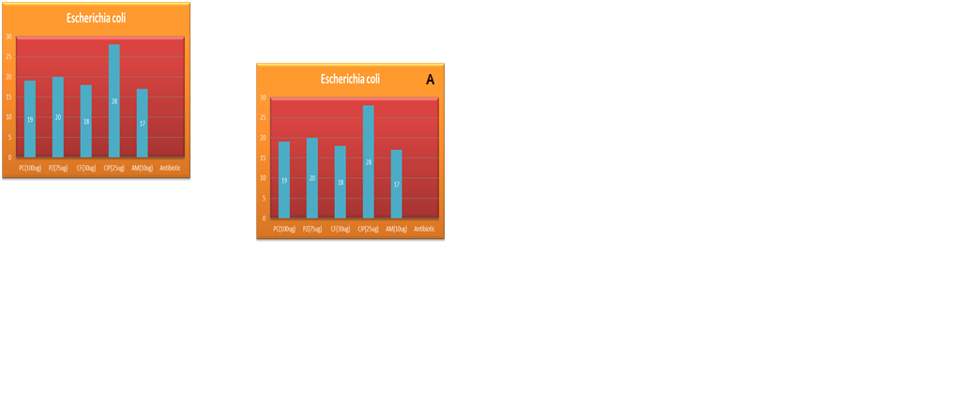
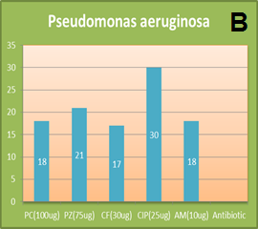
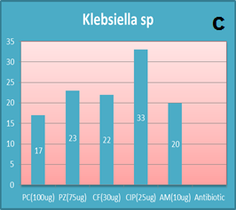
Note: AM=Amoxycillin.CIP= Ciprofloxacin. CF=cefazllin. PZ=Cefoperazone.PC=piperacillin.
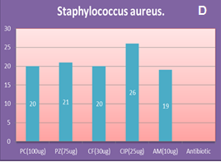
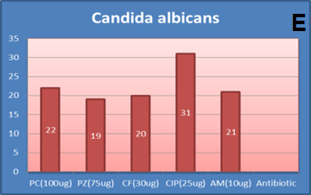

Figures (1): Antimicrobial activities (inhibition zones mm.) of standard antibiotics discs against tested bacterial and fungal .
Table(9): Antimicrobial activity of the methanolic extracts of leaves of (Colocasia esculenta) and standard antibiotics discs against tested bacterial and fungal.
Zone of inhibition(mm) Antibiotic |  |  |  |  |  |  | Organisms
PC(100ug) | PZ(75ug) | CF(30ug) | CIP(25ug) | AM(10ug) | 1.0g/ml | 0.5g/ml | Organisms
20 | 21 | 20 | 26 | 19 | 21 | 23 | Staphylococcus aureus.
19 | 20 | 18 | 28 | 17 | 21 | 20 | Escherichia coli.
18 | 21 | 17 | 30 | 18 | 16 | 17 | Pseudomonas aeruginosa.
17 | 23 | 22 | 33 | 20 | 16 | 17 | Klebsiella sp.
22 | 19 | 20 | 31 | 21 | 14 | 13 | Candida albicans.
The antimicrobial activity of the methanolic extracts of Colocasia esculenta against Staphylococcus auerus & Escherichia..coli gave a higher inhibition zone compared to antibiotics except CIP. However, lower values were recorded with all antibiotics against Pseudomonas aeruginosa and Klebsiella. sp. except close values to CF and PC. respectively. Accordingly both extracts showed lower effects against Candida albicans than all antibiotics used Table (9) and Plate (1).
Staphylococcus aureus (1mg/ml) | Staphylococcus aureus (0.5mg/ml) | Klebsiella sp (1mg/ml) |  |  | Klebsiella sp. (0.5mg/ml)
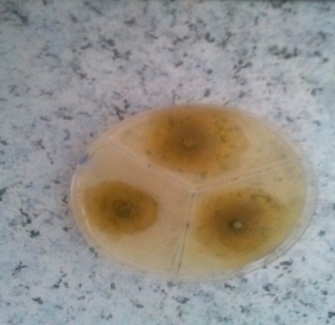 | 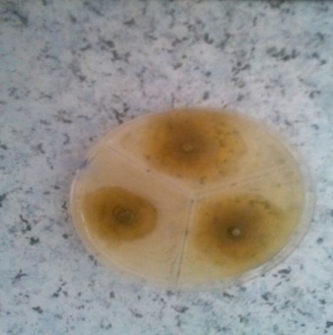 | 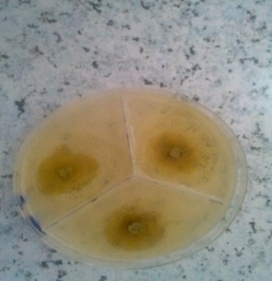 |  |  | 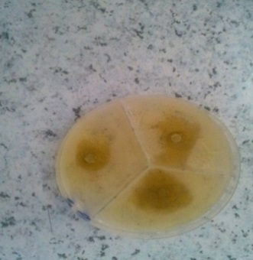
Escherichia coli (1mg/ml) | Escherichia coli (0.5mg/ml) | Candida albicans( 1mg/ml) |  | Candida albicans (0.5mg/ml)
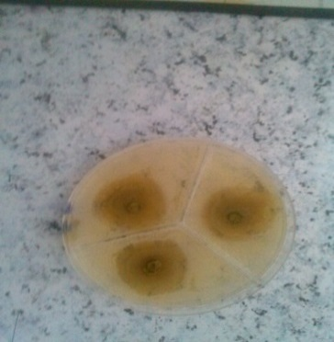 | 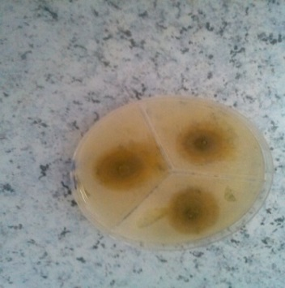 | 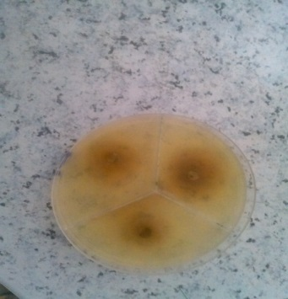 |  | 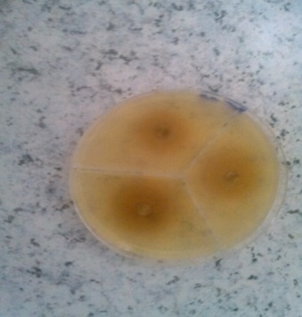
Pseudomonas aeruginosa (1mg/ml) | Pseudomonas aeruginosa (0.5mg/ml)
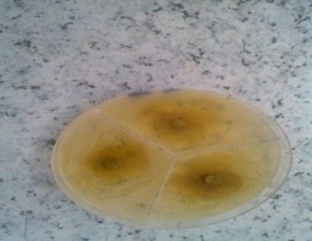 | 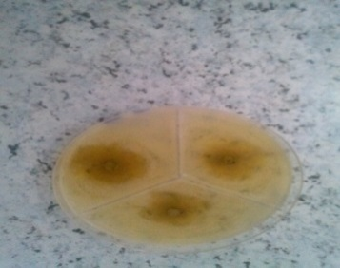

Plate (1):Inhibition zones observed with leaves methanolic extracts of
Colocasia esculenta.
Table(10): Antimicrobial activity of the Aqueous extract of leaves(Colocasia esculenta).
and standard antibiotics discs against tested bacterial and fungual.
Zone of inhibition(mm) Antibiotic
PC(100ug) | PZ(75ug) | CF(30ug) | CIP(25ug) | AM(10ug) | 1.0g/ml | 0.5g/ml | Organisms
20 | 21 | 20 | 26 | 19 | 15 | 12 | Staphylococcus aureus.
19 | 20 | 18 | 28 | 17 | 17 | 13 | Escherichia coli.
18 | 21 | 17 | 30 | 18 | 20 | 16 | Pseudomonas aeruginosa.
17 | 23 | 22 | 33 | 20 | 12 | 13 | Klebsiella sp.
22 | 19 | 20 | 31 | 21 | 15 | 12 | Candida albicans.

The antimicrobial activity of the aqueous extracts of Colocasia esculenta against Staphylococcus. aureus & Escherichia. coli Table (10) and Plate (2) gave lower diameters in inhibition zone compared to all standard antibiotics with the except of AM with E.coli which gave same value. However, higher values were recorded than all antibiotics against P. aeruginosa except CIP &PZ. On the other hand both extracts showed lower effects against Klebsiella sp.&Candida albicans than all other antibiotics.
Staphylococcus aureus (1mg/ml) | Staphylococcus aureus (0.5mg/ml) | Klebsiella sp (1mg/ml) |  |  | Klebsiella sp. (0.5mg/ml)
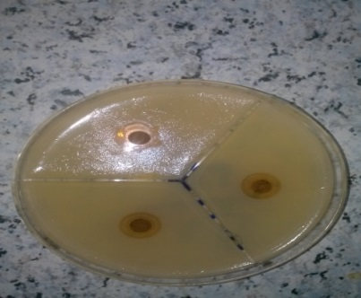 | 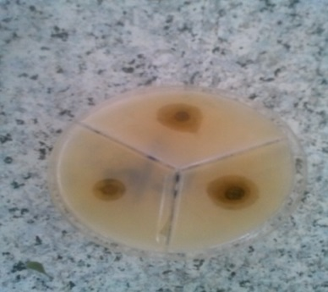 | 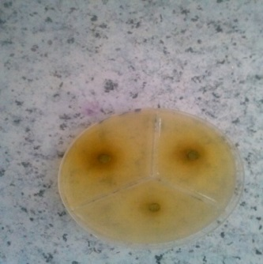 |  |  | 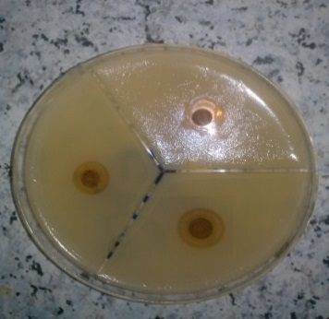
Escherichia coli (1mg/ml) | Escherichia coli (0.5mg/ml) | Candida albicans( 1mg/ml) |  | Candida albicans (0.5mg/ml)
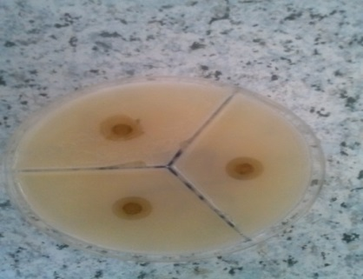 | 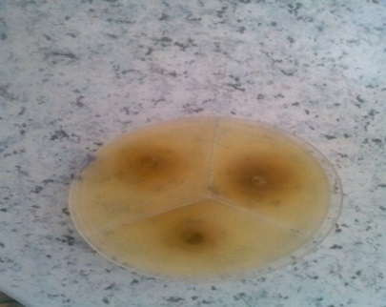 | 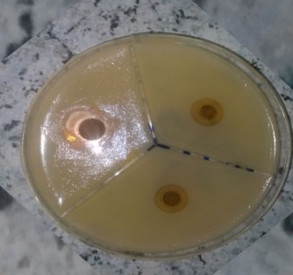 |  | 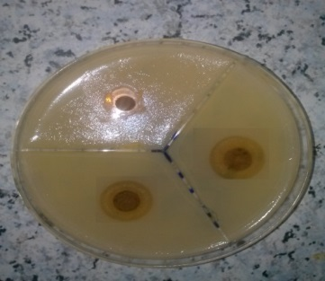
Pseudomonas aeruginosa (1mg/ml) | Pseudomonas aeruginosa (0.5mg/ml)
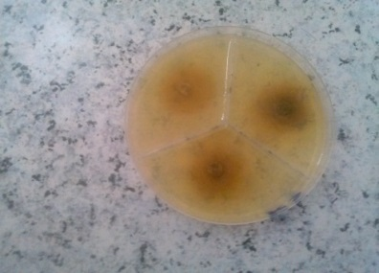 | 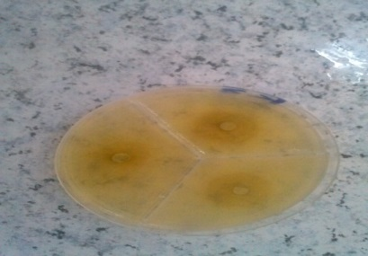

Plate (2):Inhibition zones observed with leaves aqueous extracts of
Colocasia esculenta.
(12) explained that the leaves of C. esculenta extracted using distilled water showed antimicrobial activity against all the 5 strains of Vibrio spp. In the present study it was observed that that the extracts of C. esculenta leaf, extracted using distilled water, showed antimicrobial activity against all the tested bacterial isolates Table (10) and Plate (2) . (6) I n study the methanolic aqueous extract at (50,100mg) concentration inhibited Staphylococcus aureus,E.coli (50 ,100mg) concentration inhibited Staphylococcus aureus,E.coli ,Pseudomonas aeruginosa,(16,10,10mm)and(20,13,11mm) respectively. . (2) I n study the methanoli extract at 50,100 mg concentration inhibited Staphylococcus aureus(11,14mm).E.coli (8,11mm),Pseudomonas aeruginosa(10,14mm) Klebsiella sp(8,11mm). (13) I n study the I n study the methanoli and aqueous extract at100 mg concentration inhibited Staphylococcus aureus(10,7mm).E.coli (8,7mm),Pseudomonas aeruginosa(0,0mm) Klebsiella sp(10,11mm)
Antioxidant activity
Results showed are 86.5%, lowest from standard, ascorbic acid 87.5%. Table (11) and Figures (2).
Table(11) :Antioxidant activities of the selected extracts and L- ascorbic
acid using the (DPPH) free radical-scavenging assay.

Plants | Antioxidant activity DPPH (g/ml)
L- ascorbic acid | ±0.05
Colocasia esculenta | ±0.73

86.5
Colocasia esculenta

DPPH (g/ml)
Figures(2): Antioxidant activities of the selected extracts and L- ascorbic acid using the (DPPH) free radical-scavenging assay.
Methanol extract of Colocasia esculenta leaves has shown higher antioxidant activity81,77%. (15).
CONCLUSION:
The present study showed that Colocasia esculenta are rich sources of useful secondary metabolites , It is strongly recommended of using them for general medicinal purpose and specially for treat wounds and burns diseases. It is strongly recommended of using them for production of effective pharmaceutical compounds and can be used as natural products of antimicrobial to treat wounds and burns diseases instead of chemical drugs. It is noticeable that the leaves of Colocasia esculenta are very rich in antioxidant content and therefore are good sources and safe and cheap for that .

References
(1)-Al-Dubai, A. S., & Al-Khulaidi, A. A. (1996)." Medicinal and aromatic plants of Yemen". Obadi Center for studies and Publishing: Sana’a, Yemen.‏ Avicenna J Phytomed.;3:254–71.
(2)-Chakraborty, P., Deb, P., Chakraborty, S. Chatterjee, B ., Abraham, J.
Abraham, J. (2015). Cytotoxicity and antimicrobial activity of Colocasia
esculenta. J. Chem. Pharm. Res,7(12), 627-635.‏
(3)-Ciulci, I. (1994). "Methodology for the analysis of vegetable drugs,Chemical
industries branch, Division of industrial operations". UNIDO Romania: 24,
26 and 67.
(4)-Dhanani, T., Shah, S., Gajbhiye, N. A., & Kumar, S. (2017). Effect of extraction methods on yield, phytochemical constituents and antioxidant activity of Withania somnifera. Arabian Journal of Chemistry, 10, S1193-S1199.‏
(5)-Dzotam, García-de-Lomas, J., Verloove, F., García-Ocaña, D., Gámez, V., Alcaraz, J., & Ortiz, J. M. (2017). Colocasia esculenta (L.) Schott (Araceae), an expanding invasive species of aquatic ecosystems in the Iberian Peninsula: new records and risk assessment. Limnetica, 36(1), 15-27.‏
(6)-Elekwa, I., Okereke, S. C., & Ekpo, B. O. (2009). "Preliminary phytochemical and antimicrobial investigations of the stem bark and leaves of Psidum guajava L." Journal of Medicinal Plants Research, 3(1), 045-048.‏
(7)-El-Mahmood, M. A. (2009). Antibacterial efficacy of stem bark extracts of
esculenta. J. Chem. Pharm. Res, 7(12), 627-635.‏
(8)-Gokhale SB, Kokate CK, Purohit AP. Shah, B. N., & Seth, A. K. .(2007). "Pharmacognostic studies of the Lagenaria siceraria (Molina) Standley". International Journal of PharmTech Research, 2(1), 121-124.‏
(9)-Khare, C. P. (2007)." Indian Medicinal Plants 1sted". Ny: Springer Internatinol Publication, 370.‏
(10)-Krishnapriya, T. V., & Suganthi, A. (2017). "Biochemical and phytochemical analysis of colocasia esculenta (L.) Schott tubers". International Journal of Research in Pharmacy and Pharmaceutical Sciences, 2(3), 21-25.‏
Mangifera indica, 1031-1037.‏
(11)-Mensor, L. L., Menezes, F. S., Leitão, G. G., Reis, A. S., Santos, T. C. D., Coube, C. S., & Leitão, S. G. (2001). "Screening of Brazilian plant extracts for antioxidant activity by the use of DPPH free radical method". Phytotherapy research, 15(2), 127-130.‏
(12)-Najiah, M., Nadirah, M., Lee, K. L., Lee, S. W., Wendy, W., Ruhil, H. H., & Nurul, F. A. (2008)." Bacteria flora and heavy metals in cultivated oysters Crassostrea iredalei of Setiu Wetland, East Coast Peninsular Malaysia". Veterinary research communications, 32(5), 377-381.
(13)-Nakade, D. B. (2013). Bacterial diversity in Sugarcane (Saccharum officinarum)
rhizosphere of saline soil. Int Res J Biol Sci2, 60-64. ‏
(14)-Okoli, C. O., Ezike, A. C., Agwagah, O. C., & Akah, P. A. (2010). "Anticonvulsant and anxiolytic evaluation of leaf extracts of Ocimum gratissimum, a culinary herb". pharmacognosy research, 2(1), 36.‏
(15)-Prajapati, R., Kalariya, M., Umbarkar, R., Parmar, S., & Sheth, N. (2011). "Colocasia esculenta: A potent indigenous plant". International Journal of Nutrition, Pharmacology, Neurological Diseases, 1(2), 90.‏
rhizosphere of saline soil. Int Res J Biol Sci, 2, 60-64.‏
(16)-Sahoo, K. P., Kasera, P. K., & Mohammed, S. (2012). "Secondary metabolites produced during different seasons in some arid medicinal plants". Asian Journal of Plant Science and Research, 2(6), 650-652.
(17)-Subhash, Y., Sasikala, C., & Ramana, C. V. (2014). "Pontibacter ruber sp. nov. and Pontibacter deserti sp. nov., isolated from the desert". International journal of systematic and evolutionary microbiology, 64(3), 1006-1011.‏
(18)-Puntawong, S., Okonogi, S., & Pringproa, K. (2012). "In vitro antibacterial activity of Plants leaf extracts against pathogenic bacteria in pigs". Chiang Mai Univ J Nat Sci, 11, 127-34.‏
(19)-Tanko, Y., Abdelaziz, M. M., Adelaiye, A. B., Fatihu, M. Y., & Musa, K. Y. (2008)." Effects of Hydromethanolic leaves extract of Indigofera pulchra on blood glucose levels of normoglycemic and alloxan-induced diabetic Wistar rats". International Journal of Applied Research in Natural Products, 1(4), 13-18.‏
(20)-Wiersema JH, Leon B (1999). Méditerranée: Regards Croiséssur la Domestication, Dialogue Entre la Biologie et l’Ethnobiologie, Biologie des Populations,” Université Montpellier 2, Mo World Economic Plants, A standard reference. New York: CRC Press; p. 143.

