**Reviewer’s Comments**

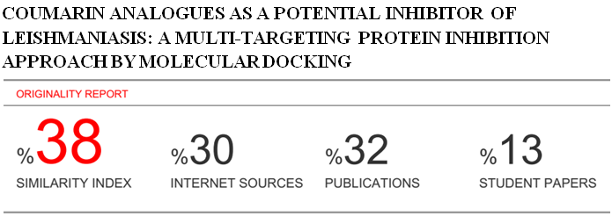

**Coumarin Analogues as a Potential Inhibitor of Leishmaniasis: A Multi-Targeting Protein Inhibition Approach by Molecular Docking**

**Abstract**

Leishmaniasis is one of the most dreadful diseases as a leading cause of death in most of the developed countries. In the given study molecular docking study was performed on the library of coumarin analogues as anti-leishmaniasis agents. Total 300 coumarins analogues were taken from Pubmed and were studied using a molecular docking study on trypanothione reductase from *Leishmania infantum*(PDB code: 2JK6 and 2P18)and *Leishmania mexicana* (PDB code: 3PP7)*.* Molecular docking result revealed that most active compound COU-130 and COU-220 bind to the active site of the protein with amino acids present in the various proteins. In PDB 2JK6 the active compound binds to the amino acid thr-51 and ser-14 were binding to the active site, and in PDB 3PP7 the active compound binds amino acid thr-26 and in PDB 2P18 the active compound binds to the amino acid phe-219 and try-212. Further in vitro and in vivo study of selected coumarin analogues can be studied for their therapeutic potential in treating leishmaniasis.

Keywords: Leishmaniasis, Molecular Docking, Coumarins.

**Introduction**

Leishmaniasis is one of the most dreadful diseases and is a leading cause of deaths in developing countries[1]. Compared to chemical synthesis, plant derived natural products represents an attractive source of biologically active agents since they are natural and are economic to afford. Objective of the given work is to identify more potent and highly effective novel compound for the treatment of leishmaniasis, which could be further used as a therapeutic agent in treating leishmaniasis.

**Materials and Methods**

Molecular Docking: Molecular docking was performed by Molegro Virtual Docker 6.0, molecular docking was employed to identify the best geometry of ligand-receptor complex. In the present study 300 coumarin analogue were docked on the active site of three different [PDB code 2JK6[2]; 3PP7[3]; 2P18[4]] retrieved from protein data bank.

**Result and Discussion**

Molecular docking results revealed that most active compound COU-130 and COU-220 binds to the active site of the protein [PDB code: 2JK6, 2P18 and 3PP7]. In PDB 2JK6 the active compound binds to the amino acid thr-51 and ser-14 were binding to the active site **Fig 1a**, and in PDB 3PP7 the active compound binds amino acid thr-26 **Fig. 1b** and in PDB 2P18 the active compound binds to the amino acid phe-219 and try-212 **Fig. 1c.**

The Molecular docking score was obtained as follows.

Table 1a [PDB code: 2JK6]

|  |  |  |
| --- | --- | --- |
| Compound Name | Moldock score | Rerank score |
| COU-130 | -172.948 | -122.454 |

Table 1b [ PDB code: 3PP7]

|  |  |  |
| --- | --- | --- |
| Compound name | Moldock score | Rerank score |
| COU-130 | -127.413 | -100.061 |

Table 1c [PDB code: 2P18]

|  |  |  |
| --- | --- | --- |
| Compound Name | Moldock score | Rerank score |
| COU-220 | -116.818 | 84.5171 |

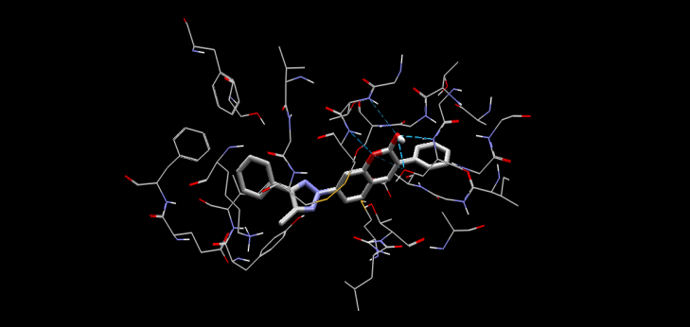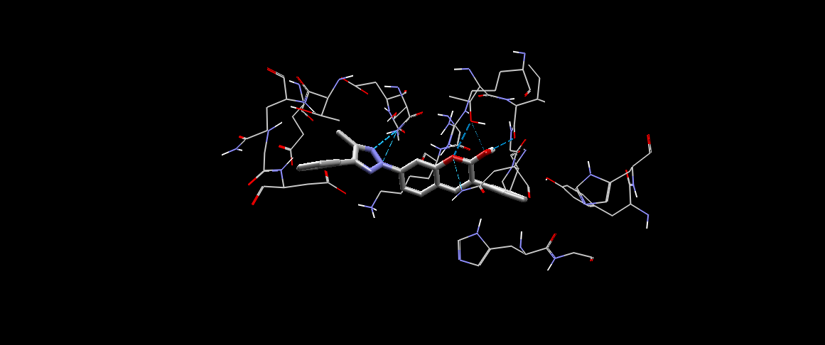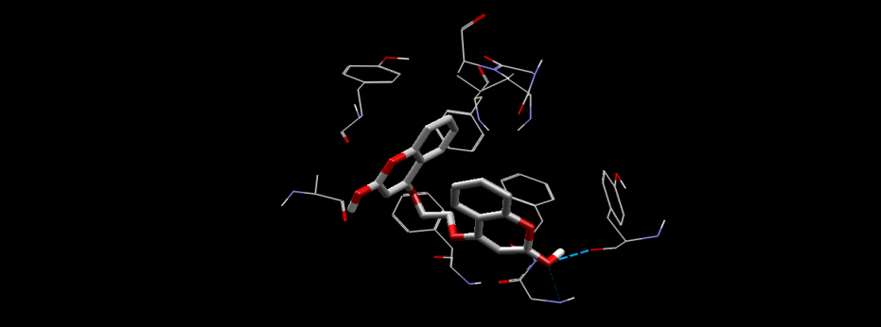

Fig.1a Fig.1b Fig. 1c

The crystal structure superposition of the structure and the final conformations suggests that the ligands were docked into the same site of binding and have a close resemblance to the pose of the ligand which was present in the crystal structure.



COU-130





COU-220

**Conclusion**

The given study is valuable, inexpensive and important for further *in vitro* and *in vivo* studies. Selected coumarins analogues can be studied for their therapeutic potential in treating Leishmaniasis.

**Acknowledgment**

I would like to thank Prof. Rajesh Sharma Head, School of Pharmacy, DAVV, Indore for providing the facility for the work. I would also like to thank Dr. E.Manivannanfor guidance on this topic.

**References**

1 Desjeux P. Leishmaniasis: current situation and new perspectives. Comp Immunol Microbiol Infect Dis 2004; 27: 305-318.

2 Paola B, Gianni C, Molecular Basis of Antimony Treatment in Leishmaniasis, J. Med. Chem. 2009, 52, 2603–2612.

3 Hugh P. , Iain W., The Trypanocidal Drug Suramin and Other Trypan Blue Mimetics Are Inhibitors of Pyruvate Kinases and Bind to the Adenosine Site, The journal of biological chemistry vol. 286, no. 36, pp. 31232–31240, september 9, 2011 .

4 Marta S, Lı´dia B, Catalysis and Structural Properties of Leishmania infantum Glyoxalase II: Trypanothione Specificity and Phylogeny, Biochemistry 2008, 47, 195-204.