**Reviewer’s Comments**

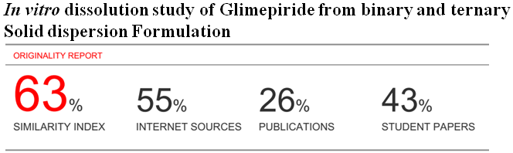

**In vitro dissolution study of Glimepiride from binary and ternary Solid dispersion Formulation**

Abstract:

Glimepiride (GMP) is poorly water soluble drug, so solubility is the main constraint for its oral bioavailability. Because, poor aqueous solubility and slow dissolution rate of the glimepiride lead to irreproducible clinical response or therapeutic failure in some cases due to sub therapeutic plasma drug levels. In this study, binary and ternary solid dispersion of glimepiride were prepared withpoloxamer 407, polyethylene glycol 6000 (PEG 6000), polyethylene glycol 4000 (PEG 4000), and eudragit at different weight ratios using the solvent evaporation and melting method. Fusion method of thepoloxamer 407 and Eudragit with glimepiride at different ratios were also used. It was found the drug was released 0.46% after 5 minutes and only 15.83% within 60 minutes from active glimepiride on the other hand the release pattern of glimepiride from the binary formulation containing PEG 4000 in 1:5 (Formulation coding: G5) showed the best result. It was found that the ternary different SD formulation containing ( PEG4000:Glimepiride:Povidon) In ratio 1:1:0.25(Formulation coding were : G13) showed the best result. It was also studied that the release kinetics of glimepiride of different SD formulation with different ratio such as, First order release kinetics, Higuchi, Krosmeyer, Hixoncrowell plot, and also be noted the MDT calculation for improving the solubility of glimepiride. Formulations were characterized by Fourier transform infrared (FTIR) and X-ray diffraction (XRD). No any chemical interaction was observed between polymer and drugs from IR spectrum. The drug was changed to amorphous form after solid dispersion. Itwas also evident that solid dispersions improve solubility of drug particles thus enhancing dissolutioncharacteristics of drugs they increase the oral bioavailability.

**Key words:** Glimepiride, Fusion Method,DissolutionStudy, Formulation**,** IR spectrum.

*Corresponding Author: Md. Shahidul Islam, Assistant Professor, Department of Pharmacy, University of Science &Technology Chittagong, Bangladesh. E-mail: s_i_liton@yahoo.com

**Introduction**

Ithas studied that, improving oral bioavailability of drugs those given as solid dosage forms remains achallenge for the formulation scientists due to solubility problems. Most of the newly inventedchemical entities are poorly water soluble. As a result formulating them as oral solid dosage formsis a hurdle to the specialists. Many techniques have been exercised to improve oral bioavailabilityof drugs(1).The rate of dissolution and solubility should not be confused as they are different concepts, kinetic and thermodynamic, respectively. The solubilization kinetics, as well as apparent solubility can be improved after complexation of an active ingredient with cyclodextrin. This can be used in the case of drug with poor solubility(2).The oral route of administration is the most preferred and widely acceptable route of delivery due to ease of ingestion for many drugs. Drugs with slow dissolution rate show the incomplete absorption leading to low bioavilability when orally administered (3). Many of the drugs belong to class II of the biopharmaceutical classification system showing poor solubility and high permeability Glimepiride shows low, pH dependent solubility. In acidic and neutral aqueous media, glimepiride exhibits very poor solubility at 370oc (<0.004 mg/ml). In media pH>7, solubility of drug is slightly increased to 0.02 mg/ml. These poorly water soluble drugs provide challenges to deliver them in an active and absorbable form to the desired absorption site using physiologically safe excipients Therefore, one of the most important steps in the development of dosage forms for these drugs is to improve their solubility and/or dissolution rate. Chiou and Rigelman and Serajuadin *et al*. have used the solid dispersion (SD) technique for dissolution enhancement of poorly water-soluble drugs (4). Among the various approaches, the SD technique has often proved to be the most successful in improving the dissolution and bioavailability of poorly soluble active pharmaceutical ingredients because it is simple, economic, and advantageous. Sekiguchi and Obi were the first to propose the SD method using water-soluble carriers to improve the dissolution characteristics of poorly water-soluble drugs. Many water-soluble carriers have been employed for preparation of SD of poorly soluble drugs(5). The most common are polyethyleneglycols, polyvinyl pyrrolidone, mannitol and hydroxypropyl methylcellulose. Due to poor solubility in GI fluids, it results in low and erratic oral bioavailability(6). Glimepiride was selected as a model drug for dissolution enhancement studies in the present investigation. Attempts were made to enhance the dissolution of GMP using a SD technique. SDs of GMP with PVP K 30 was prepared in different ratios using solvent evaporation method and then tablets of best formulation of SD were formulated by using direct compression method (7). Tablet formulations were prepared by direct compression technique using super disintegrates povidone in different concentrations. SDs were evaluated for FTIR, XRD, SEM, *in vitro* dissolution profiles and developed tablet formulations were evaluated for various pharmaceutical characteristics viz. hardness, % friability, weight variation, drug content, disintegration time, in vitrodissolution profiles (8). Priyanka Shrestha, *et al*, has studied that,Glimepiride is a poorly water-soluble oral hypoglycemic drug exhibiting poor dissolution pattern (9). The purpose of this work is to increase the dissolution rate of glimepiride by formation of solid dispersion with different water soluble carriers. Solid dispersion of glimepiride were prepared with polyvinyl pyrrolidone k-30, poloxamer 407, polyethylene glycol 6000 (PEG 6000), polyethylene glycol 4000 (PEG 4000), sodiumstarch glycolate, ludiflash and lactose at different weight ratios using the solvent evaporation and melting method(10). Physical mixtures of the poloxamer 407 and povidone K-30 with glimepiride at different ratios were also used. In compare to physical mixtures with povidone K-30 and poloxamer 407, drug release from physical mixture PM (1/9) PVP K-30 was higher (65.93% within 5 min) than drug release from physical mixture with poloxamer 407 (56% within 5 min) the drug release from pure drug was 6.84% with in 5 minute(11). With the recent development in the screening of potential therapeutic agents, the number of poorly water soluble drugs have risen sharply and gained large interest due to the challenges in the oral solubility of the drug which leads to the major cause for which the techniques are meant to be implemented. One amongst such techniques is the formulation of solid dispersion for the solubility enhancement(12).

**Materials and Methods:**

**Chemicals Used**

Table 1: List of ingredients used in experiment

|  |  |  |
| --- | --- | --- |
| Name of the materials | Functional category | Sources of the chemicals |
| Glimepiride powder | Active pharmaceutical ingrident (API) | ESKAYEF BANGLADESH LTD, GAZIPUR. |
| Polyethylene glycol 4000(PEG 4000) | Carrier for solid dispersion | ALBION LABOROTORIES LTD. |
| Polyethylene glycol 6000(PEG 6000) | Carrier for solid dispersion | ALBION LABOROTORIES LTD. |
| PVP(Polyvinyl pyrrolidone) | Carrier for solid dispersion | LOCAL MAEKET |
| Eudragit | Carrier for solid dispersion | THE ACME LABORATORIES LTD. |
| Poloxomer 407 | Carrier for solid dispersion | BASF |
| Potassium dihydrogen phosphate | Major salt of buffer solution | MERCK, MUMBAI. |
| Di-sodium hydrogen phosphate | Major salt of buffer solution | MERCK, MUMBAI. |
| Methanol | Aqueous Solvent | UNIVERSITY LABORATORY |
| Distilled water | Solvent for buffer solution, used as washing agent too. | UNIVERSITY LABORATORY |

**Fusion Method**

Fusion method of solid dispersion of glimepiride is given below:

1. Desired amount out of drug and polymer were weighted out accurately e.g. PEG 4000
2. They were taken in a beaker
3. And placed it into water bath for melting at 70 0c.
4. After melting, accurately weighted amount of drug was added in that glass beaker containing PEG
5. Then they were mixed by glass rod to obtain a viscous mass.
6. The mixture was stirred vigorously for uniform mixing and was kept in normal room temperature for 72 hour until a solid mass was formed.
7. Solidified mixture was then grinded thoroughly with the help of mortar and pestle.
8. Then the powdered particle passed through a sieve (mesh size 40).
9. The resulted samples (Solid dispersion) were weighted and transferred in a fresh vial with proper labeling.
10. Finally, the SD formulation were kept in a desiccator until further investigation.

**Table 2: Formulation of binary and ternary solid dispersion of glimepiride prepared by fusion method using different polymer at different ratio**

|  |  |  |  |  |  |  |
| --- | --- | --- | --- | --- | --- | --- |
| Serial no | Carriers | Drug  polymer ratio | Summarized form | Dispensing(mg) | Formulation coating | Method |
| 1 | PEG4000 | 1:1 | Glim:PEG4000 | 300:300 | G1 | Fusion method |
| 2 | PEG4000 | 1:2 | Glim:PEG4000 | 300:600 | G2 | Fusion method |
| 3 | PEG4000 | 1:3 | Glim:PEG4000 | 300:900 | G3 | Fusion method |
| 4 | PEG4000 | 1:4 | Glim:PEG4000 | 300:1200 | G4 | Fusion method |
| 5 | PEG4000 | 1:5 | Glim:PEG4000 | 300:1500 | G5 | Fusion method |
| 6 | PEG6000 | 1:1 | Glim:PEG6000 | 300:300 | G6 | Fusion method |
| 7 | PEG6000 | 1:2 | Glim:PEG6000 | 300:600 | G7 | Fusion method |
| 8 | PEG6000 | 1:3 | Glim:PEG6000 | 300:900 | G8 | Fusion method |
| 9 | PEG600 | 1:4 | Glim:PEG6000 | 300:1200 | G9 | Fusion method |
| 10 | PEG6000 | 1:5 | Glim:PEG6000 | 300:1500 | G10 | Fusion method |
| 11 | PEG4000:GLM:POVIDON | 1:1:0.75 | PEG4000:G11:POVIDON | 200:200:150 | G11 | Fusion method |
| 12 | PEG4000:GLM:POVIDON | 1:1:0.50 | PEG4000:G12:POVIDON | 200:200:100 | G12 | Fusion method |
| 13 | PEG4000:GLM:POVIDON | 1:1:0.25 | PEG4000:G13:POVIDON | 200:200:50 | G13 | Fusion method |
| 14 | PEG4000:GLM:POVIDON | 1:1:00 | PEG4000:G14:POVIDON | 200:200:00 | G14 | Fusion method |
| 15 | PEG6000:GLM:POVIDON | 1:1:0.75 | PEG6000:G15:POVIDON | 200:200:150 | G15 | Fusion method |
| 66 | PEG60000:GLM:POVIDON | 1:1:0.50 | PEG6000:G16:POVIDON | 200:200:100 | G16 | Fusion method |
| 37 | PEG600:GLM:POVIDON | 1:1:0.25 | PEG6000:G17:POVIDON | 200:200:50 | G17 | Fusion method |
| 38 | PEG600:GLM:POVIDON | 1:1:00 | PEG6000:G18:POVIDON | 200:200:00 | G18 | Fusion method |

**Preparation of 0.01 M phosphate buffer solution (pH=7.8)**

0.58g of monobasic potassium phosphate and 8.86g of dibasic sodium phosphate anhydrous was dissolved in sufficient amount of distilled water. Then pH 7.8 was adjusted by adding 1N Sodium Hydroxide (NaOH) for the preparation of 1000ml buffer solution.

**Preparation of Standard Curve of Glimepiride**

1. 10mg of Glimepiride was accurately weighed and taken in 100ml volumetric flask.
2. Then phosphate buffer was added upto the mark to prepare primary stock solution.
3. Then 10 ml of this solution was taken in another100ml volumetric flask and added buffer solution up to the mark. This solution was called stock solution.
4. Then serial dilution was carried out to get different drug concentration.
5. Then 1,2,3,4,5,6,7,8,9 and 10ml of stock solution was gradually taken to the test tube.
6. And 9,8,7,6,5,4,3,2,1 and o ml of buffer solution were added respectively to more 10 ml volume in each test tube.
7. These were then analyzed by UB spectrophotometer at 228 nm and the absorbance value were noted.
8. The absorbance value were plotted against drug concentrations.
9. Finally the standard curve of Glimepiride was produced.

***In-vitro* dissolution test for Glimepiride and solid dispersion formulation**

The *in vitro* dissolution studies for Glimepiride drug and SD formulation were performed using USP dissolution test apparatus type II (paddle type) method using 900 ml of phosphate buffer (pH 7.8) as dissolution medium. The temperature of the medium was maintained at (37 ± 0.5)oc throughout the experiment. The samples contained glimepiride or its equivalent solid dispersion were placed in the dissolution medium. Paddle was used at a stirring rate of 75 rpm. A 5ml aliquot was withdrawn at predetermined time intervals of 5,15,30.45, and 60 min and then 5ml of fresh dissolution medium was replaced to maintain the constant volume of dissolution medium. The absorbance values of the collected samples was measured at 273nm using UV-visible spectrophotometer against dissolution medium as blank. The percent release of drug was calculated using the equation obtained from the standard curve in the media. **[15].**

**Fourier transform Infra-red (FTIR) Spectroscopy**

Infra-red studies was carried out to rule out interaction between drug and carrier used in formulation of solid dispersion by potassium bromide disc method using Infra-red spectrophotometer. FT-IR spectroscopy used to study the possibility of an interaction between drug and polymer in solid-state.

Fourier-transform infrared **(**FT-IR) spectra were obtained by using a Shimadzu IR 20 Spectrophotometer. The samples (Glimepiride or SDs) were previously grounded and mixed thoroughly with potassium bromide, an infrared transparent matrix, at 1:5 (Sample: KBr) ratio, respectively. The KBr discs were prepared by using corresponding machine. Scans were obtained at a resolution of 4 cm-1, at wave numbers from 4000 to 500 cm -1.

**Results and Discussion**

Glimepiride is an oral blood sugar-lowering drug in a class of medicine for controlling diabetes called Sulfonylurea. The aims of present investigation was to enhance the dissolution rate of poorly water soluble drugs glimepiride by preparing the solid dispersion using poloxomer 407, povidon, PEG 4000, PEG 6000. In this study solvent evaporation method and fusion/melting method was used for the preparation of solid dispersion of glimepiride**.**

**Standard curve of glimepiride (Media: Phosphate buffer, pH 7.8)**

**Fig: 18 Standard curve of glimepiride**

**Dissolution profile of active Glimepiride**

10 mg of pure Glimepiride was used for dissolution study. It was found that only 0.46% drug was released after 5 minutes and 15.83% was released within 60 minutes time interval. This showed that dissolution profile of glimepiride was very poorly.

**Fig: 2Dissolution profile of glimepiride (API)**

***In vitro* dissolution study of binary and ternary solid dispersion of glimepiride (fusion method)**

**Comparative dissolution profile of active glimepiride and solid dispersion (SD) formulation (Glimepiride+PEG 4000) for their different ratio**

Solid dispersion of glimepiride with PEG 4000 at different ratio G1 (1:1), G2 (1:2), G3 (1:3), G4 (1:4), G5 (1:5) and active glimepiride (API) were used for dissolution study. It was found that only 0.46% from active glimepiride, 21.46% from formulation G1, 56.30% from G2, 77.30% from G3, 64.15% from G4 and 76.84% from G5, were released after 5 min and 60.77% from G1, 83.66% from G2, 88.83% from G3, 65.47% from G4, 94.36% from G5, 15.29% from active glimepiride were released after 45min. Finally 72.88% from G1, 97.27% from G2, 90.91% from G3, 75.75% from G4, 99.76% from G5 were released within an hour time interval. Whereas only 15.83% was released from active glimepiride within an hour time interval.

**Fig: 3. Average % release of drug from binary SD formulation containing PEG 4000 with different ratio**

From the above data we can conclude that, the release pattern of drug from SD formulation containing PEG 4000 has increased gradually when the amount of PEG 4000 was increased. It was observed that solid dispersion formulation G5 showed substantially better result in 1:5 ratio in comparison to those of G1, G2, G3, and G4.

**Comparative dissolution profile of active glimepiride and solid dispersion formulation (Glimepiride + PEG 6000) for their different ratio.**

Solid dispersion of glimepiride with PEG 6000 at different ratio G6 (1:1), G7 (1:2), G8 (1:3), G9 (1:4), and G10 (1:5) were used for dissolution study. It was found that 24.46% from G6, 37.86% from G7, 25.84% from G8, 38.53% from G9, 53.76% from G10 were released after 5 min and 60.36% from G6, 68.30% from G7, 70.72% from G8, 50.28% from G9, and 64.82% from G10 were released after 45min. Finally 71.31% from G6, 88.99% from G7, 91.87% from G8, 51.01% from G9 and 49.71% from G10 were released within an hour time interval.

**Fig: 4. Average % release of drug from SD formulation containing PEG 6000 with different ratio**

From the above data it was found that, the release pattern from SD formulation containing PEG 6000 has increased gradually when the amount of PEG 6000 was decreased. It was observed that solid dispersion formulation G8 showed their better result in 1:3 ratios in comparison to those of G6, G7, G9, and G10.

**Comparative dissolution profile of active glimepiride and solid dispersion (Glimepiride+ PEG 4000+ Povidon) for their different ratio**

Ternary SD formulation of Glimepiride containing PEG 4000 and Povidon at different ratios of G11 (1:1:0.75), G12 (1:1:0.50), G13 (1:1:0.25), G14 (1:1:0) and API were used for dissolution study. It was found that 6% from G11, 1.38% from G12, 64.15% from G13, 21.46% from G14 and 0.46% from API were released after 5 min and 11.48% from G11, 14.19% from G12, 65.47% from G13, 60.77% from G14, 15.29% from API were released after 45 min. Finally 24.69% from G11, 19.35% from G12, 75.75% from G13, 72.88% from G14 and 15.83% from API were released in an hour time interval.

**Fig: 5 Average % release of drug from ternary SD formulation containing PEG 4000 and Povidone.**

From the above data we can conclude that the release pattern from the glimepiride containg two water soluble polymer PEG 4000 and Povidone have increased gradually when the amount of second polymer povidone were decreased in different ratio. It was observed SD formulation G13 (1:1:0.75) gave the best result in comparison to those of G11, G12, G14.

**Comparative dissolution profile of pure glimepiride and solid dispersion formulation (Glimepiride+ PEG 6000+ Povidone) for their different ratio**

Ternary SD formulation of Glimepiride containing PEG 6000 and Povidone at different ratio of G15 (1:1:0.75), G16 (1:1:0.50), G17 (1:1:0.25), G17 (1:1:0) and API were used in dissolution study. It was found that 63.46% from G15, 63.92% from G16, 23.90% from G17, 24.46% from G18 and 0.46% from API were released after 5 min and 73.71% from G15, 69.14% from G16, 61.84% from G17, 60.36% from G18, 15.29% from API were released after 45 min. Finally 75.50% from G15, 72.06% from G16, 69.09% from G17, 71.31% from G18 and 15.83% from API were released in an hour interval.

**Fig: 6 Percent release from ternary SD formulations of glimepiride containing**

**PEG 6000 and Povidone.**

From the above data we can conclude that the release pattern from the glimepiride containg two water soluble polymer PEG 6000 and Povidone has increased gradually when the amount of second polymer povidone were increased in different ratio. It was observed SD formulation G15 (1:1:0.75) gave the best result in comparison to those of G16, G17, G18.

**Release kinetics study of pure glimepiride and different solid dispersion formulations**

We have chosen five SD formulation G5 (Glim + PEG 4000), G8 (Glim + PEG 6000), G13 (Glim+ PEG 4000 + Povidone), SE2 (Glim + Eudragit), SE9 (Glim + Poloxamer), which were given most significant effect on the improvement of dissolution rate. There dissolution data were analyzed by zero order model, First order, Higuchi square root equation, Hixon crowell cube root law and Krosmeyer Kinetics.

**Zero order kinetics**

**Table 3 Comparative study of zero order kinetics of five solid dispersion formulations**

|  |  |  |  |
| --- | --- | --- | --- |
| Time | Percent release (%) G5 | Percent release (%)G8 | Percent  release (%)G13 |
| 0 | 0 | 0 | 0 |
| 5 | 76.84615 | 25.84615 | 64.15385 |
| 15 | 80.73462 | 26.22051 | 61.04872 |
| 30 | 89.02692 | 50.36538 | 71.77051 |
| 45 | 94.36282 | 70.72051 | 65.47308 |
| 60 | 99.2641 | 91.87949 | 75.75385 |

**First order release kinetics**

**Table 4: Comparative study of first order release kinetics of active glimepiride and five solid dispersion formulations**

|  |  |  |  |  |
| --- | --- | --- | --- | --- |
| Time (min) | Log of % remaining drug(G5) | Log of % remaining drug (G8) | Log of % remaining drug(G13) | Log of % remaining drug(API) |
| 0 | 2 | 2 | 2 | 2 |
| 5 | 1.364623 | 1.870134 | 1.554443 | 1.997991 |
| 15 | 1.284778 | 1.867936 | 1.590522 | 1.989849 |
| 30 | 1.040328 | 1.695785 | 1.450703 | 1.963352 |
| 45 | 0.751062 | 1.466564 | 1.538158 | 1.927929 |
| 60 | -0.13318 | 0.909583 | 1.384643 | 1.92512 |

**Higuchi release kinetics**

**Table 5: Comparative study of Higuchi release kinetics of active glimepiride and five solid dispersion formulations**

|  |  |  |  |  |
| --- | --- | --- | --- | --- |
| Square root of time (SQRT) | %release of drug(G5) | %release of drug(G8) | % release of drug(G13) | % release of drug(API) |
| 0 | 0 | 0 | 0 | 0 |
| 2.236068 | 76.84615 | 25.84615 | 64.15385 | 0.461538 |
| 3.872983 | 80.73462 | 26.22051 | 61.04872 | 2.310256 |
| 5.477226 | 89.02692 | 50.36538 | 71.77051 | 8.092308 |
| 6.708204 | 94.36282 | 70.72051 | 65.47308 | 15.29103 |
| 7.745967 | 99.2641 | 91.87949 | 75.75385 | 15.83718 |

**Hixon crowell release kinetics**

**Table 6. Comparative study of Hixon crowell release kinetics of active glimepiride and five solid dispersion formulations**

|  |  |  |  |  |
| --- | --- | --- | --- | --- |
| Time (min) | Cubic root of % remaining drug (G5) | Cubic root of % remaining drug(G8) | Cubic root of % remaining drug (G13) | Cubic root of % remaining drug (API) |
|  |  |  |  |  |
| 0 | 4.641589 | 4.641589 | 4.641589 | 4.641589 |
| 5 | 2.850194 | 4.201244 | 3.297217 | 4.634437 |
| 15 | 2.680768 | 4.194162 | 3.389799 | 4.605566 |
| 30 | 2.222164 | 3.675036 | 3.044862 | 4.512847 |
| 45 | 1.779729 | 3.082155 | 3.256262 | 4.391806 |
| 60 | 0.90283 | 2.009992 | 2.894327 | 4.382347 |

**Krosmeyer release kinetics**

**Table 7: Comparative study of korsmeyer release kinetics of active glimepiride and five solid dispersion formulations**

|  |  |  |  |  |
| --- | --- | --- | --- | --- |
| Log time=Log T | Log fraction of drug release=log( % release/100)G5 | Log fraction of drug release=log( % release/100)G8 | Log fraction of drug release=log( % release/100)G13 | Log fraction of drug release=log( % release/100)API |
| 0.69897 | -0.11438 | -0.5876 | -0.19278 | -2.33579 |
| 1.176091 | -0.09294 | -0.58136 | -0.21432 | -1.63634 |
| 1.477121 | -0.05048 | -0.29787 | -0.14405 | -1.09193 |
|  |  |  |  |  |
| 1.653213 | -0.0252 | -0.15045 | -0.18394 | -0.81556 |
| 1.778151 | -0.00321 | -0.03678 | -0.1206 | -0.80032 |

**Successive fractional dissolution time**

**Table 8: Table for Mean Dissolution Time (MDT) calculation**

|  |  |  |  |  |
| --- | --- | --- | --- | --- |
| Formulation Code | T25% | T50% | T80% | MDT |
| Pure Drug | 69.89354 | 110.7925 | 151.4168 | 105.5033 |
| G5 | 0.000124 | 0.100156 | 9.39399 | 7.609336 |
| G8 | 0.115755 | 0.427337 | 1.036083 | 0.546968 |
| G13 | 7.09E-07 | 0.124536 | 448.1191 | 1186.845 |

Mean dissolution time (MDT) value was used to characterized the drug release rate form the dosage forms and the retarding efficiency of the polymer. Form the above Table 8, it was found that, a higher MDT value for the SD formulation G13 ( glimepiride + PEG 4000 + Povidone) which was indicated that higher drug retarting ability of the polymer in the formulation.

**Interpretation of Y equation ( Y= ax + b) and correlation co efficient ( R2) value for different release kinetics of active glimepiride and SD formulation**

**Table: 9 Y equation and R2 values of five SD formulations and active glimepiride**

|  |  |  |  |  |  |  |  |  |
| --- | --- | --- | --- | --- | --- | --- | --- | --- |
| Formulation coding | Zero Order | | 1st Order Kinetics | | Higuchi model | | Hixon Crowell model | |
|  | Y equation | R2 Value | Y equation | R2 Value | Y equation | R2 Value | Y equation | R2 Value |
| Pure drug | 0.3007x-0.77 | 0.957 | -0.0041x+2.0041 | 0.955 | 2.3177x+3.0603 | 0.861 | -0.0049x+4.6553 | 0.956 |
| G5 | 1.1172x+44.512 | 0.508 | -0.0288x+1.7956 | 0.903 | 11.038x+25.468 | 0.751 | -0.0484x+3.7632 | 0.822 |
| G8 | 1.401x+7.9786 | 0.966 | -0.0161+2.0509 | 0.896 | 11.22x-4.5245 | 0.939 | - 0.0396x+4.6578 | 0.947 |
| G13 | 0.7739x+22.763 | 0.419 | -0.0067x+1.7584 | 0.525 | 7.8884x+22.13 | 0.66 | -0.0185x+3.8993 | 0.487 |

The above data showed that R2 value of active glimepiride, (R2 = 0.957) and SD formulation G8 (R2 = 0.966) were found substantially highest result in case of Zero order kinetics than other release kinetics. These R2 value is near about 01, so it can be said that, active glimepiride, SD formulation G8 were followed zero order release pattern.

Another SD formulation G13 (R2= 0.66) was displayed best fitting with Higuchi release kinetics pattern. Because R2value of G13 was showed better value in case of Higuchi release kinetics.

Only one SD formulation G15 was best fitted with first order release pattern.

It was also observed that, in all case no formulation was fitted with Hixon Crowell kinetics model.

**Glimepiride & polymer interaction study using FT**-**IR Spectroscopy:**

Fourier Transform Infrared Spectroscopic (FTIR) study was concluded four samples-

1.Pure drug/API (Glimepiride)

2. Polymer (PEG 4000)

3. Polymer (Poloxamer 407)

4. Solid Dispersion (G3=Glimipiride+PEG4000, 1:3)

5. Solid Dispersion (G13=Glimepiride+Povidone+PEG 4000, 1:5)

FT-IR was used to characterize possible interactions between the drug and the carrier in solid Diclofenac Sodium.

**FT-IR spectra of Pure Glimepiride**

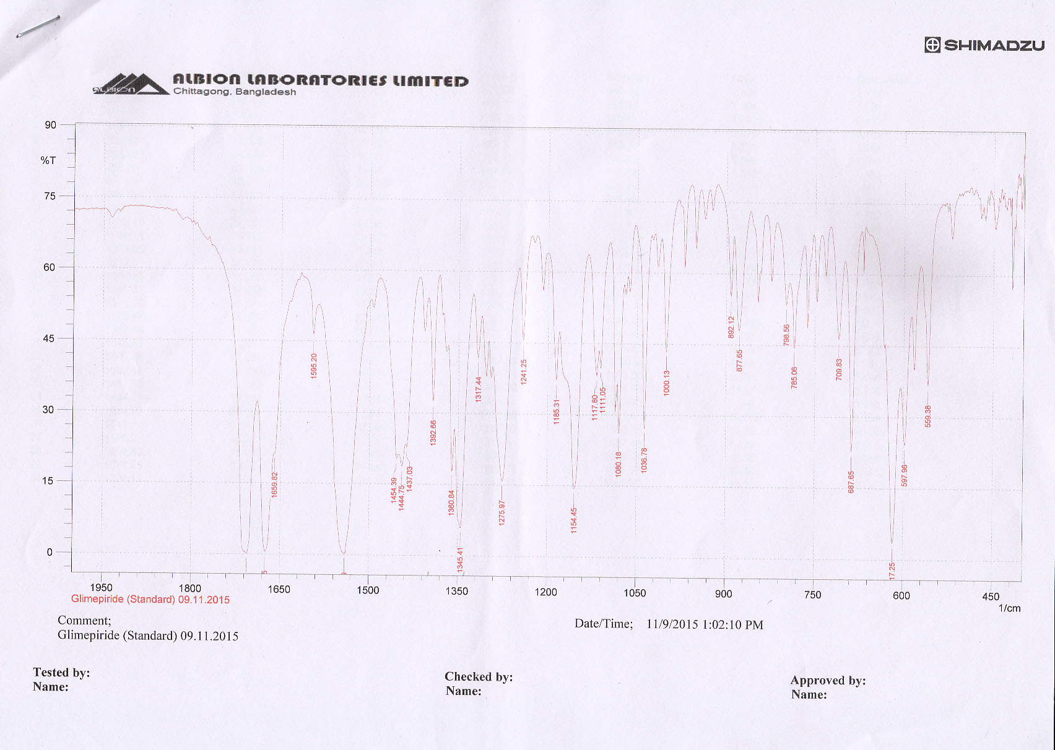

|  |  |  |
| --- | --- | --- |
| **SN.** | **Peak** | **Indication** |
| **01** | 1454.39 cm-1  1444.75 cm-1  1437.03 cm-1 | C-H bending |
| **02** | 1659.82 cm-1 | C=C Stretching |
| **03** | 1595.20 cm-1 | C=O Asymmetric Stretching |
| **04** | 1345.41 cm-1 | C-N Stretching |
| **05** | 1317.44 cm-1 | S=O Asymmetric Stretching |
| **06** | 1150.59 cm-1 | S=O Symmetric Stretching |
| **07** | 1472.71 cm-1 | NH2 bending |

**FTIR spectra of Glimepiride Solid dispersion with PEG4000 prepared by Fusion method (G3=Glim+PEG4000)**

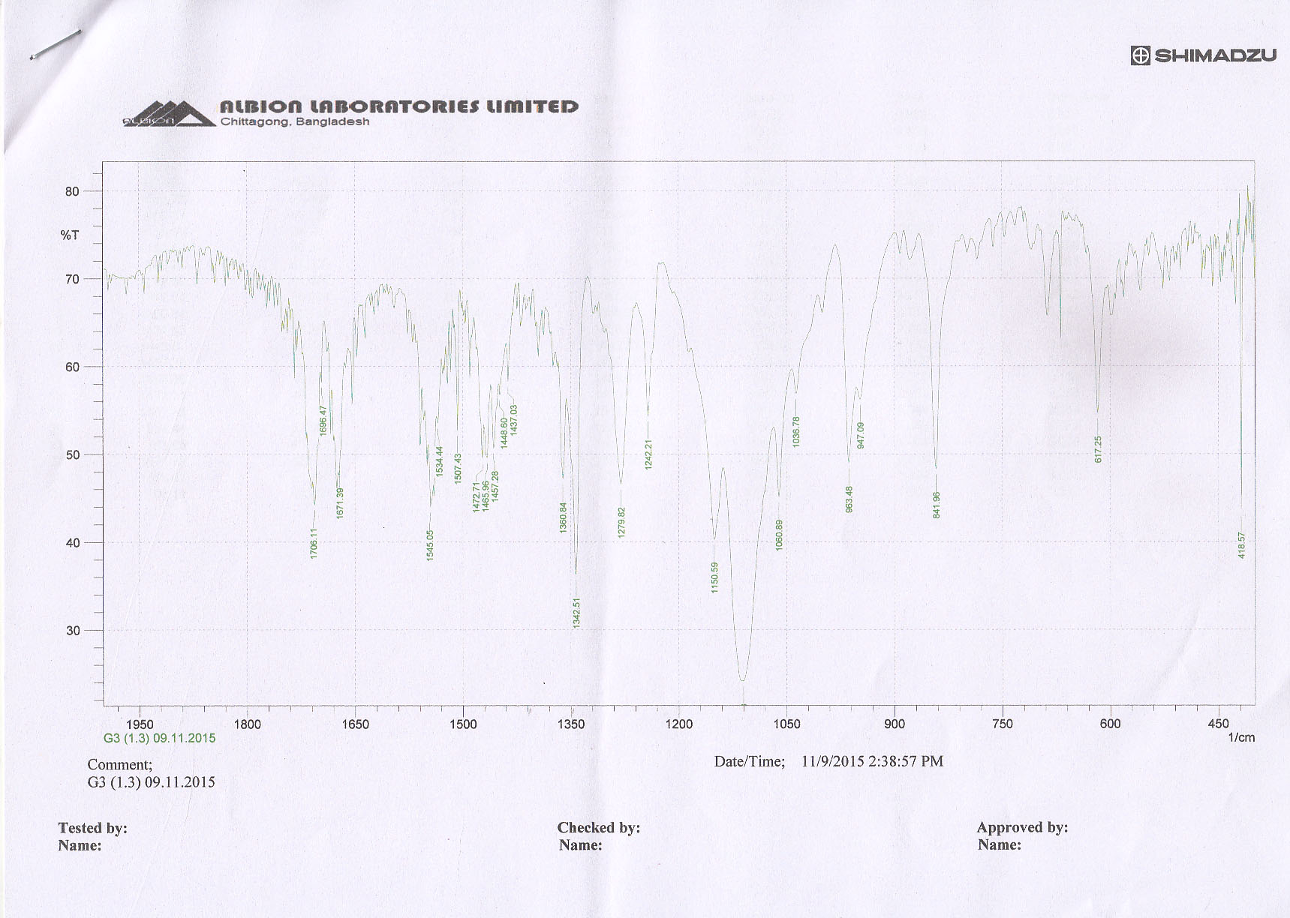

**Fig: 4. FTIR of G3 (Glim+PEG4000)**

|  |  |  |
| --- | --- | --- |
| **SN.** | **Peak** | **Indication** |
| **01** | 1150.59 cm-1 | C=O (stretch) |
| **02** | 1360.84 cm-1,  1465.96 cm-1,  1472.71 cm-1, | C-H (bending) |
| **03** | 1671.39 cm-1 | C=C (Stretch) |
| **04** | 1671.39 cm-1,  1696.47 cm-1,  1706.11 cm-1, | C=O (Stretch), Carbonyl |
| **05** | 1242.21 cm-1,  1279.82 cm-1, | C-O (Stretch), Acid |
| **06** | 1706.11 cm-1 | Acyclic (Stretch), Ketone |

From the above shown spectrum, we came to conclude that the spectrum seen in the pure glimepiride was also found in the case of solid dispersion with PEG4000. The spectrum were at same frequency range but some peaks were shifted to their near values. So we can say that there is no significant interaction between the drug & PEG4000, hence there was no chemical change in the PEG4000 when it was in solid dispersion form.

**FTIR spectra of Glimepiride Solid dispersion with PEG4000 & Povidon prepared by Fusion method (G13= Glim+PEG4000+Povidon)**

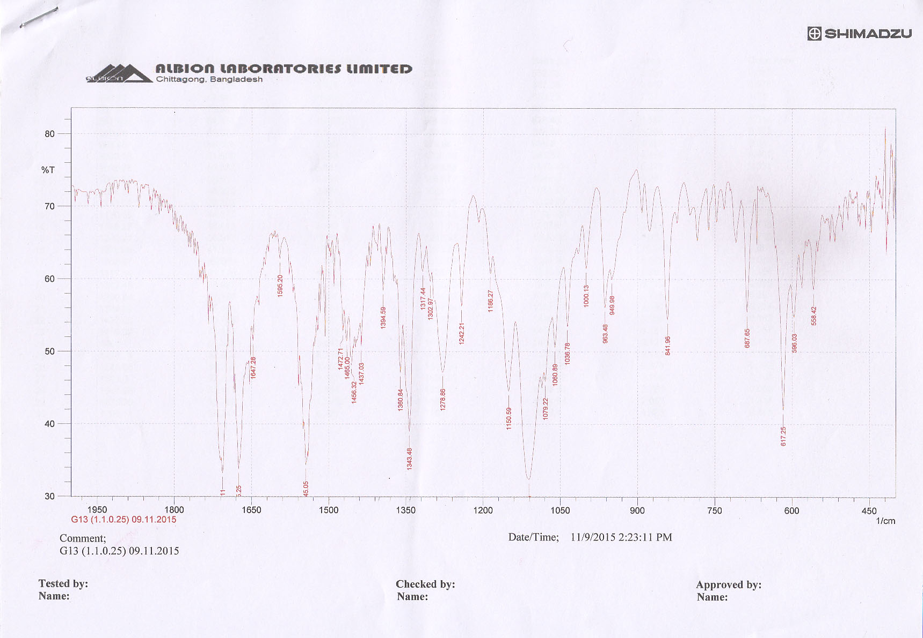

**Fig: 5 FTIR of G13 (Glim+PEG4000+Povidone)**

|  |  |  |
| --- | --- | --- |
| **SN.** | **Peak** | **Indication** |
| **01** | 1060.89 cm-1,  1079.22 cm-1,  1150.59 cm-1, | C-O (Stretch) |
| **02** | 1360.84 cm-1,  1394.59 cm-1,  1437.03 cm-1,  1456.32 cm-1,  1465.00 cm-1, &  14.72.71 cm-1, | -C-H (bending) |
| **03** | 687.65 cm-1,  841.96 cm-1,  949.98 cm-1,  963.98 cm-1, &  1000.13 cm-1 | =C-H (Stretch) |
| **04** | 1437.03 cm-1,  1456.32 cm-1,  1465.00 cm-1,  14.72.71 cm-1,&  1595.20 cm-1 | C=C (Stretch) |

From the above shown spectrum, we came to conclude that the spectrum seen in the pure glimepiride was also found in the case of solid dispersion with PEG4000 & Povidone. The spectrum were at same frequency range but some peaks were shifted to their near values. So we can say that there is no significant interaction between the drugs, PEG4000, & Povidone, hence there was no chemical change in the PEG4000, and Povidone, when it was in solid dispersion form.

**Conclusion**

Solid dispersion has attracted considerable interest as an efficient means of improving the dissolution rate and bioavailability of hydrophobic drugs. In the present study, solid dispersions of Glimepiride with different hydrophilic carriers in different ratios were prepared by physical mixing and fusion method to improve water solubility and dissolution characteristics. The preparation of solid dispersion of Glimepiride by fusion method has been proven to be successful. This research showed that when Glimepiride was dispersed in suitable water-soluble carriers such as PEG 6000, PEG 4000 and Eudragit E-100, Poloxomer 407 and Povidone. Its dissolution were enhanced compared with pure drug. Fusion method of the poloxamer 407 and Eudragit with glimepiride at different ratios were also used. It was found the drug was released 0.46% after 5 minutes and only 15.83% within 60 minutes from active glimepiride on the other hand the release pattern of glimepiride from the binary formulation containing PEG 4000 in 1:5 (Formulation coding: G5) showed the best result. It was found that the ternary different SD formulation containing (PEG4000: Glimepiride:Povidon) in ratio 1:1:0.25 (Formulation coding were : G13) showed the best result. It was also studied that the release kinetics of glimepiride of different SD formulation with different ratio such as, First order release kinetics, Higuchi, Krosmeyer, Hixon crowell plot, and also be noted the MDT calculation for improving the solubility of glimepiride.. *In-vitro* dissolution data also proves that percent release of drug from binary SDs was not similar with ternary SDs. Ternary SDs is more effective to increase the diclofenac sodium release rate. The water soluble carrier may operate in the micro environment (diffusion layer) immediately surrounding the drug particles in the early stage of dissolution, since the carrier completely dissolves in short time thus enhancing the solubility & dissolution of drug.

**REFERENCES**

1. [Dahlberg C](http://www.ncbi.nlm.nih.gov/pubmed?term=Dahlberg%20C%5BAuthor%5D&cauthor=true&cauthor_uid=18577450), [Millqvist-Fureby A](http://www.ncbi.nlm.nih.gov/pubmed?term=Millqvist-Fureby%20A%5BAuthor%5D&cauthor=true&cauthor_uid=18577450), [Schuleit M](http://www.ncbi.nlm.nih.gov/pubmed?term=Schuleit%20M%5BAuthor%5D&cauthor=true&cauthor_uid=18577450). Surface comparison and contact angle relationship for differently prepared solid dispersion. European Journal of Pharmacy and bio-pharmacy, 2008; 70(2): 478-485.

2. Singh S, Baghel RS, Yadav L. A review on solid dispersion. International Journal of Pharmacy and Life Sciences, 2011; 2(9): 1078-1095.

3. Costantino HR, Firouzabadian L, Wu C, Carrasquillo KG, Griebenow K, Zale SE et al. Protein spray freeze drying. Effect of formulation variables on particle size and stability. Journal of Pharmaceutical Science, 2002;91(2): 388-395.

4. Arunachalam A, Karthikeyan M, Konam K, Prasad PH, Sethuraman S, Ashutoshkumar A. A review on solid dispersion. Current Pharmaceutical Research, 2010; 1(82): 82-90.

5. [Deepti](http://www.ncbi.nlm.nih.gov/pubmed?term=Deepti%5BAuthor%5D&cauthor=true&cauthor_uid=17479717), [Dureja H](http://www.ncbi.nlm.nih.gov/pubmed?term=Dureja%20H%5BAuthor%5D&cauthor=true&cauthor_uid=17479717), [Madan AK](http://www.ncbi.nlm.nih.gov/pubmed?term=Madan%20AK%5BAuthor%5D&cauthor=true&cauthor_uid=17479717). Solid dispersion adsorbates for enhancement of dissolution rates of drugs. [PDA Journal of Pharmaceutical Science and Technology](http://www.ncbi.nlm.nih.gov/pubmed/17479717), 2007; 61(2): 97-101.

6.Bandarkar FS, Khattab IS. Lyophilized Gliclazide poloxamer solid dispersions for enhancement of in vitro dissolution and in vivo bioavailability. International Journal of Pharmacy and Pharmaceutical Sciences, 2011; 3: 122-127.

7.Chiou WL, Riegelman S. Pharmaceutical applications of solid dispersion systems. [Journal of Pharmaceutical Sciences](http://www.google.com.bd/url?sa=t&rct=j&q=&esrc=s&source=web&cd=1&cad=rja&ved=0CCwQFjAA&url=http%3A%2F%2Fonlinelibrary.wiley.com%2Fjournal%2F10.1002%2F%28ISSN%291520-6017&ei=3vJGUsDdJ4_PsgbFloGYDQ&usg=AFQjCNEeBnvShf8sESHCjvIQXLEnpeuOkA&bvm=bv.53217764,d.Yms),1971; 60: 1281–1302.

8. Nasir ASM, Aarti MJ, Manoj M, Bari, Randhir B, Chavhan, Barhate SD.New dimensions to Solid Dispersion. Indo American Journal of Pharmaceutical Research, 2013; 3(4): 3247.

9. Chiou WL, Riegelman S. Preparation and dissolution characteristics of several fast-release solid dispersions of griseofulvin. [Journal of Pharmaceutical Sciences](http://www.google.com.bd/url?sa=t&rct=j&q=&esrc=s&source=web&cd=1&cad=rja&ved=0CCwQFjAA&url=http%3A%2F%2Fonlinelibrary.wiley.com%2Fjournal%2F10.1002%2F%28ISSN%291520-6017&ei=3vJGUsDdJ4_PsgbFloGYDQ&usg=AFQjCNEeBnvShf8sESHCjvIQXLEnpeuOkA&bvm=bv.53217764,d.Yms), 1969; 58: 1505–1510.

10. Sonpal RN, Lalwani AN, Darji VC, Patel KR. Solid dispersion; an efficient tool for increasing bioavailability of poorly soluble drugs.International Journal of Pharmaceutical Sciences Review and Research, 2011; 8(1): 44-45.

11.Costantino HR, Firouzabadian L, Wu C, Carrasquillo KG, Griebenow K, Zale SE et al. Protein spray freeze drying. Effect of formulation variables on particle size and stability. Journal of Pharmaceutical Science, 2002;91(2): 388-395.

12. [Dahlberg C](http://www.ncbi.nlm.nih.gov/pubmed?term=Dahlberg%20C%5BAuthor%5D&cauthor=true&cauthor_uid=18577450), [Millqvist-Fureby A](http://www.ncbi.nlm.nih.gov/pubmed?term=Millqvist-Fureby%20A%5BAuthor%5D&cauthor=true&cauthor_uid=18577450), [Schuleit M](http://www.ncbi.nlm.nih.gov/pubmed?term=Schuleit%20M%5BAuthor%5D&cauthor=true&cauthor_uid=18577450). Surface comparison and contact angle relationship for differently prepared solid dispersion. European Journal of Pharmacy and bio-pharmacy, 2008; 70(2): 478-485.

13. Rani KS, Poornima G, Krishnaveni A, Brahmaiah B, Nama S. A review on solid dispersions. Asian Journal of Pharmaceutical Research, 2013; 3(2): 93-98.

14. Nagarajan K, Rao MG. Formulation and Dissolution Studies of Solid Dispersions of Nifedipine. Indian Journal of Novel Drug Delivery, 2010; 2: 96-98.

15. Kalpana P, Manish S, Sharma K, Dinesh, Jain K, Surendra. Solid dispersion: Approaches, technology involved unmet need and Challenges. Drug Invention Today, 2010; 2(7): 349-357.