Reviewer’s Comments
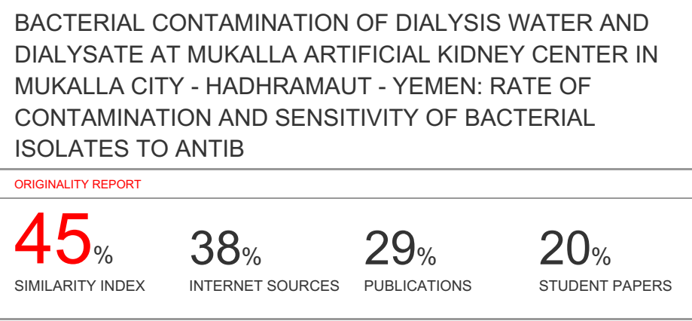
BACTERIAL CONTAMINATION OF DIALYSIS WATER AND DIALYSATE AT MUKALLA ARTIFICIAL KIDNEY CENTER IN MUKALLA CITY - HADHRAMAUT - YEMEN: RATE OF CONTAMINATION AND SENSITIVITY OF BACTERIAL ISOLATES TO ANTIBIOTICS

ABSTRACT
Water treatment systems are a critical factor in dialysis therapy and rigorous control of hemodialysis water bacteriological quality is particularly important in order to guarantee a better quality of life of the hemodialysis patients. The purpose of this study was to detect the level of bacterial contamination in hemodialysis water and dialysate in Mukalla Artificial Kidney Center and antimicrobial resistance patterns of isolated bacteria. Forty-eight samples of water and dialysate were collected weekly over a period of 3 months from 4 points. Bacteriological analysis of samples was performed then antimicrobial susceptibilities patterns of isolated bacteria were determined by disk diffusion method. The mean of total count of bacteria for dialysis water and dialysate were higher than the recommended values (100 CFU/ ml). The isolated bacteria which colonized the hemodialysis systems were mostly Gram-negative bacilli as Pseudomonas sp., Serratia sp., Citrobacter sp. and Enterobater sp. In general, most of the isolated bacteria were poorly responsive to antibiotics. In conclusion: Dialysis water and dialysate failed to meet the bacteriological requirements for hemodialysis. To minimize the risk of contaminants for hemodialysis patients, an adequate system for water treatment, disinfection of hemodialysis system, and bacteriological contamination monitoring of the water and dialysate are necessary.
Keywords: Hemodialysis, dialysis water, Dialysate, Bacterial contamination, Yemen.

INTRODUCTION
Hemodialysis patients suffer from abnormalities of immune system as a direct result of uremia and its metabolic consequences, making them more susceptible to infections. Such abnormalities include impairment of the action of neutrophils, lymphocytes B and T and monocytes, leading to defective antigen processing, antibody production and cell mediated immune response and thus to an increased incidence of microbial infections ¹. These infections are the second leading cause of death among HD patients, with an attributed mortality rate of 14% ^{2, 3}. The morbidity and mortality of patients with ESRD are serious problems in Yemen as in the world ⁴. In addition, hemodialysis is the most common method of renal replacement therapy for patients with either acute renal injury in the failure stage or end stage renal failure. Hemodialysis is the process of removing toxins directly from the blood using diffusion across a semipermeable membrane ⁵. Removing the harmful wastes and extra salt and fluids helps control the blood pressure and keep the proper balance of electrolytes ⁶.
Each patient using HD machine is exposed to large volume of water (400 L per week) used for production of dialysate, from which, if it is not properly treated, all the low molecular weight substances present in water as chemical, bacterial and toxic contaminants have direct access through the semipermeable membrane of dialyzer to HD patient’s blood stream ^{7, 8, 9, 10}. To prevent patients from risks of water contaminants there is a number of standards for quality of dialysis water and dialysate have been proposed ¹¹.
There are several national and regional guidelines with respect to maximally acceptable limits of bacterial contamination of dialysis water. The American Association of Medical instrumentation (AAMI) recommends the maximum acceptable levels of viable bacteria count to be 200 colony forming units (CFU) per milliliter of water and endotoxin concentrates of < 2 IU/ml, while The European Pharmacopoeia (Ph. Eur.) limit is set at 100 CFU/ml and endotoxin concentrates of < 0.25 IU/ml ^{5, 12, 13} .
However, no data are available regarding bacterial contamination in the Hadramout dialysis water distribution systems. Therefore, it is important to explore the possibility of contamination of dialysis water circulation systems in the dialysis center in Hadramout. In addition to that, this study was specially carried out to detect level of bacterial contamination and bacteriological quality of hemodialysis water and dialysate in Mukalla Artificial Kidney Center (MKC) in Mukallah city , Hadhramout, Yemen.
METHODS
The samples were collected from MKC in Ibn Sena General Hospital in Hadhramout. The center consists of four rooms and having about 18 HD machines and performs approximately 1305 hemodialysis sessions monthly in three shifts a day. The water samples were collected weekly over a period of 3 months from four measurement points (sampling were repeated from the same points each month). As shown in figure (1), the measurement points were:

- Municipal water.
- Return line of reverse osmosis loop.
- Water prior to the machine.
- Dialysate solution.

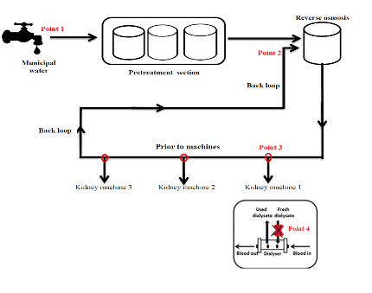
Figure (1): diagram of water treatment plant and distribution system

The samples had been collected in clean sterilized glass bottles of 250 ml capacity. These bottles were autoclaved before sampling at 121°C temperature for 15 minutes. At each point of collection the valve was disinfected by heat and using 70% isopropanol, then opened and water was allowed to flow for a minimum of 2 minutes at normal pressure and flow rate before the samples was drawn ^{13, 14, 15}. Samples were then processed at Dar Alshifa Medical Specialized Center Laboratory.
Total enumeration of bacteria
The determination of total bacteria count in water samples was done by using pour plate method. Serial dilutions of water samples were made with peptone water and inoculated on to plate count agar. Plates were incubated at 37°C for 24 to 48 hours. The plates selected for counting were that producing 30 -300 CFU / ml with some modulations ⁵.
Test for total coliform bacteria:
The total coliform bacteria were determined by utilizing the most probable number (MPN) method. Aliquots of 10, 1 ml and 0.1 ml of water samples and dialysate were collected from the four points mentioned earlier were added to tubes containing MacConkey broth. Test tubes were incubated at 37 °C for 48 hours. After incubation, the production of acid and gas formation was considered positive. Number of the positive tubes was recorded and MPN was calculated according to MPN tables Positive tubes were selected for the confirmed test procedures to detect the indicator bacteria of fecal origin E.coli. EMB media was be used ¹⁶. The tubes that only showed turbidity were plated on MacConky agar, blood agar and nutrient agar to be tested for non-fermentive bacteria ¹⁷.
Identification and characterization of isolating bacteria
The bacteria were isolated from developing colonies in the plate count agar as well as from MacConky broth were submitted to Gram stain and set of biochemical tests including the following: citrate test , urease test , kligler iron agar (KIA), oxidase test, catalease test, sulfide –indole – motility test (SIM) and coagulase test.
Antimicrobial resistance
Antimicrobial susceptibilities were determined by using Kirby-Bauer disk diffusion method on the Mueller-Hinton agar ¹⁸. The antibiotic discs under study were: ceftazidime (CAZ 30 mcg), cefepime (CPM 30 mcg), ciprofloxacin (CIP 5mcg), amikacin (AK 30mcg), ceftriaxone, (CTR 30mcg), piperacillin (PI 100mcg) and trimethoprim (TR 5mcg).
RESULTS AND DISCUSSION
The contamination of dialysis water and dialysate were above the (Ph. Eur.) recommended level: 100 CFU/ ml. This indicates that there is a problem of biological contamination during water- treatment processes. In line with our finding studies by Pisani et al., 2000 ¹⁹ and Heidarieh et al., 2016 ¹⁰ reported that the viable count always exceeded the recommended values .
The maximum total count of bacteria was related to the back loop (1.816 ×10³ ± 2615.3 CFU/ ml) (Table 1). The minimum number of total bacteria was observed in the prior to machine (1.78 × 10² ± 222.1 CFU /ml). These results agreed with a similar study conducted by Oumokhtar et al., (2013) ⁷ that the maximum total bacterial count was related to back loop. These results have been found in our study suggest that dialysis system and tubing along the fluid pathways within dialysis supplies are the main source of contamination and biofilm development and result in the high levels of the bacterial contamination at different sampling points.
In our study, the maximum total count of coliforms was related to municipal water (3.41 ± 3.1 MPN/ 100 ml). The results refers to the presence of Enterobacteriaceae in water samples, and the contamination level of Enterobacteriaceae in municipal water was more than it in dialysis water and dialysate and there was significant differences between them (P-value = 0.030).
Ninety-eight bacteria were isolated from all water samples in MKC. The water samples were contaminated by both gram-positive and gram-negative bacteria. Gram-negative bacteria (85.7%) were the main contaminants of water in MKC, while the gram-positive bacteria represented only (14.2%). This results agreed with Oumokhtar et al.,(2013) ⁷ and Okunola and Olaitan, (2016) ⁵ who reached that most isolated bacteria were gram- negative bacteria.
The maximum number of isolated bacteria was for Pseudomonas sp. (55.1%), followed by Serratia sp. (9.18%), Citrobacter sp. (7.14%), non-coagulase Staphylococcus sp. (7.14%), Enterobater sp. (6.12%), Salmonella sp. (4.08%), S. aureus (4.08%) , E.coli (3.06%), Micrococcus sp. (3.06 %) and Proteus sp.( 1,02%) (Figure 2). The highest percentage of isolated bacteria was from the municipal water (30.6%), followed by prior to machine (24.4%), then dialysate solution 23.4% and the lowest percentage of isolated bacteria was from Back loop (21.4%) (Table.2). The most predominant isolated bacteria was Pseudomonas sp. (55.1%), this finding was in agreement with other studies conducted by Pisani et al., (2000) ¹⁹ and Lima et al., (2005) ²⁰, where the percentage of Pseudomonas sp. was the highest among the isolates. Also Arvanitidou et al., (2003) ²¹, Borges et al.,(2007) ²², Montanari et al.,(2009) ¹, Oumokhtar et al.,(2013) ⁷ and Okunola and Olaitan, (2016) ⁵ reported that Pseudomonas sp. was the most prevalent isolated bacteria as following: (27%), (32.5%), (44%), (52.8%) and (55%), respectively. This finding was attributed to that Pseudomonas sp. is known to rapidly proliferate in dialysis fluids and this result gives cause for concern, in view of the well-known resistance to biocides and antibiotics shown by bacteria of this genus, which is often cited as the causative agent in reports of septicemia and endotoxemia ^{2, 23}. Our results showed that machine No. 5 was the most polluted among machines. The bacteria isolated from Machine No. 5 were as follows: Pseudomonas sp., Staphylococcus non-coagulase., S. aureus, Micrococcus sp. and Enterobacter sp. This device may be out of date or use more or more polluted.
We suggest that there was a problem with the effectiveness of disinfectant used, also the biofilm development within the dialysis machine led to contamination of the dialysate. The contamination level of the second month was the highest (52.9%), followed by the third month (33.8%) and the first month was (13.2%), with a statistically significant difference in the level of pollution between the three months (value of P = 0.432). Also, there was a rapid increase in the level of bacteria numbers after the second periodic chemical disinfection of the water treatment system. This result agreed with study conducted by Oumokhtar et al.(2013) ⁷. The second chemical disinfection of the system has been done in the 2sd month. Our finding suggest that the municipal water contamination rate was high in the 2sd month also the biofilm have been installed in the water treatment system and hemodialysis machines despite the disinfection procedure routinely applied. Three membranes of the RO device were replaced in the third month and therefore we expected that this was the reason for decrease bacteria level to (33.8%) and thus the reduction of biofilm. Nazemi et al. (2016) asserted that after each period of disinfection, there was observed increased contamination, which was due to the bacterial biofilms generated in the water pipes ¹⁷. In addition, Nystrand (2003) mentioned that the presence of a biofilm on the pipes leads to a rapid regrowth of bacteria after a few hours of disinfection of the water system ²⁴.
The 98 bacterial isolates showed variable resistance patterns. Antibiotic test results showed that a higher resistance was 98.9% against Ceftazidime (30 mcg). Ciprofloxacin (5 mg) and amikacin (30 mg) were the antibiotics that showed the lowest number of resistance isolates, 9.1% and 1.02%, respectively. In general, most of the isolated bacteria were poorly responsive to antibiotics. The most resistant bacteria were Proteus sp. and E. coli, they showed resistance to all antibiotics except Ciprofloxacin (Figure 3). The random use of antibiotics and transmission of resistant bacteria between patients were the main factors increasing antimicrobial resistance prevalence ²⁵.
This study reached to about 100% of E.coli were resistant to all antibiotics except Amikacin and Trimethoprim 66.6% while Ciprofoxacine 0% (100% of E.coli were sensitive to Ciprofloxacin). This finding was in line with the work of Romanus et al. (2013); finding that 81% of E. coli were sensitive to Ciprofloxacin, 73% resistant to Trimethoprim ²⁶. Also Arvanitidou et al.(2003) showed that 0% of E.coli were resistant to Ciprofloxacin, while 100% were sensitive to Amikacin, Cefepime and Ceftazidime ²¹. Proteus sp. isolate showed 100% resistant to all antibiotics except Ciprofloxacin. This finding was closed to a study by Omoya and Ajayi (2016), finding that 100% of Proteus sp. showed resistance to Ceftriaxone while 0% showed resistance to Ciprofloxacin ²⁷. Also Yah et al. (2007) reported that Proteus sp. showed low resistance against Ciprofloxacin (6.1%) ²⁸. Pseudomonas sp. showed the resistance to Amikacin (9.2%), Cefepime (83.3%), Ceftazidime (98.1%), Ceftriaxone (16.6%), Ciprofloxacin (1.8%), Piperacillin (46.2%) and Trimethoprim (70.3%). This finding was closed to what Romanus et al. (2013) reached, that Pseudomonas sp. were sensitive to Ciprofloxacin and Amikacin as 83%, 100% respectively ²⁶. Borges et al.(2007) also found that Pseudomonas sp. were sensitive to Amikacin and Ciprofloxacin as 64% and 77% respectively ²². A study conducted by Khan et al. (2013) reported that 80% of Pseudomonas sp. were resistant against Ceftazidime ²⁹ .
CONCLUSION
Hemodialysis water distribution systems in MKC were colonized with both gram negative and gram positive bacteria, which display multi- resistance to antibiotics. The CFU values for dialysis water and dialysate exceeded the limit of 100 CFU /ml. Therefore, an adequate water-treatment system, the efficient disinfection of haemodialysis equipment and dialysers, and the microbiological monitoring of water and dialysate are key points in maintaining the quality of the renal replacement therapy service offered to patients with chronic renal disease.
CONFLICTS OF INTEREST
There are no any conflicts of interest.
AUTHORS’ CONTRIBUTION
The manuscript was carried out, written, and approved in collaboration with all authors.
ACKNOWLEDGEMENT
Thank you very much to the Dar Al Shifa Specialist Medical Center and Al Mukalla Al Sheriani Center at Ibn Sina General Hospital in Hadhramaut.

REFERENCES
1-Montanari, L. ; Sartori, F. ; Cardoso, M. ;Varo,S. ; Pires, R. ; Leite, C. ; Prince, K. and Martins, C.. Microbiological contamination of a hemodialysis center water distribution system. Journal of the Institute of Tropical Medicine of São Paulo, 2009; 51(1): 37 – 43.
2-Jaber, B. Bacterial infections in hemodialysis patients: pathogenesis and prevention .Kidney International. 2005; 67: 2508- 2519.
3-Quori, A. ; Baamonde-Labroda, E. ; Garcia-Canton ,C. ; Lago-Alonso, M. ; Toledo-Gonzalez, A. ; Monzon-Jimenez, E. ; Jimenez-Diaz, D. ; checa de Andres, M. and Molina –Cabrillana, J. Surveillance for infections and other adverse events in dialysis patients in southern Gran Canaria. Revista Nefrologia, 2011; 31(4): 457- 463 .
4-Rodriguez, J. and Crespo, R. Study of chronic renal failure in Miltary hospital Sana’a. Yemen. Electronic Bilingual Journal, 2008; 2: 27.
5-Okunola, O. and Olaitan, J. Bacterial contamination of hemodialysis water in three randomly selected centers in South Western Nigeria. The Nigerian Journal of Clinical Practice 2016; 19: 491 – 495.
6-Ibrahim, M. ; Ahmed, H. and Magbool, F. Quality Control of the Fluids Utilized in Dialysis with the Study of the Hemodialysis Status in Khartoum State. International Research Journal of Pharmacy and Medical Sciences, 2019; 2(2): 1-5.
7-Oumokhtar, B. ; Lalami, A. ; Mohmoud, M. ; Berrada, S. ; Arrayhani, M. and Houssaini, T. Prevent infection linked to the dialysis water in a hemodialysis center in Fez city (Morocco). Pan African medical journal, 2013; 16:122- 126.
8-Asserraji, M.; Maoujoud, A.; Belarbi , M. and Elfarouki, R. Monitoring the microbiological quantity of dialysate and treated water. Saudi journal of Kidney Diseases and Transplantation, 2014; 25(1): 91-95.
9-Manjunath, V. ; Chandrakanth, C. ; Amaranath, S. ; Rangarajan, D. ; Ramakrishan and Anushree, C. Outbreak of Burkholderia cepacia bacteremia in a hemodialysis unit. Medical Innovatica, 2014; 3(2):33- 35.
10-Heidarieh, P. ; Shaharaki, A. ; Yaghoubfar, R.; Hajehasani, A. and Mirsaeidi, A. Microbiological analysis of hemodialysis developing country. American Society for Artificial Internal Organs, 2016; 62(3): 332- 339.
11-Shahryari, A. ; Nikaeen, M.; Hatamzadeh, M. ; Dastjerd, M. and Hassanzadeh, A. Evaluation of bacteriological and chemical quality of dialysis water and fluid in Isfahan, Central Iran. Iran J public health. 2016; 45(5): 650 -656.
12-Pontoriero, G. ; Pozzon, P. ; Andrulli, S. and Locatelli, F. The quality of dialysis water. Nephrology Dialysis Transplantation, 2003;18(7): 21-25.
13-Glorieux, G. ; Neirynck, N. Veys, N. and Vanholder, R. Daialysis water and fluid purity: more than endotoxin. Nephrology Dialysis Transplantation 2012; 27: 4010 – 4021.
14-Gorke, A. and Kittel, J. Routine disinfection of the total dialysis fluid systems . EDTNA-ERCA Journal. 2002; 28(3): 130- 133.
15-Verma,S. ; Indumathi, V. ;Gurudev, K. and Naik, S. Bacteriological quality of treaded water and dialysate in hemodialysis unit of a Tertiary Care Hospital. Journal of Clinical and Diagnostic Research 2005; 9(10): 14-16.
16-Ahmed, T. ; Baidya, S. ; Acharjee, M. and Rahman, T. Qualitative analysis of drinking water through the most probable number (MPN) method. Stamford Journal of Microbiology 2013; 3(1): 9- 16.
17-Nazemi, S. ; Mirzaii, M. ; Yaslianifard, S. ; Sarokhalil, D. ; Khoramrooz, S. ; Norozi, P. and Davardoost, F. Microbiological qualification of air, water and dialysate in a haemodialysis center: a new focus on Legionella spp. Iranian journal of microbiology, 2016; 8(4): 219 – 225.
18-Bauer, A.; Kirby,W. ; Sherris, J. and Turch, A. Antibiotic susceptibility testing by standardized single disk method. American Journal of Clinical Pathology 1966; .45(4): 493- 496.
19-Pisani B, Simoes, M. ; Prandi, M. ; Rocha, M. ; Goncalves, C. ; Vaz T. ; Irino K. Outbreak of Pseudomonas aeruginosa bacteremia in a Hemodialysis Center in Campinas, São Paulo, Brazil. A Revista do Instituto Adolfo Lutz, 2000;59(1/2): 51-56.
20-Lima, J. ; Marques, S. ; Gonçalves, A. ; Filho, N. ; Nunes, P. ; Silva, H. ; Monteiro, S. and Costa, J. Microbiological analyses of water from hemodialysis services in Sao Luis, Maranhao, Brazil. Brazilian Journal of Microbiology 2005; 36(2):103-108.
21-Arvanitidou, M. ; Vayona, A. ; Spanaki, N. and Tsakris, A. Occurrence and antimicrobial resistance of Gram –negative bacteria isolated in hemodialysis water and dialysate of renal units: result of a Greek multicentre study. Journal of applied microbiology 2003; 95: 180- 185
22-Borges, C. ; Lascowski, K. ; Filho, N. and Pelayo, J. Microbiological quantity of water and dialysate in a haemodialysis unit in Ponta Grossa-PR ,Brazil. Journal of applied microbiology. 2007; 103:1791-1797.
23-Vanholder, R. ; Vanhaecke, E. and Ringoir, S. Waterborne Pseudomonas septicemia. American Society for Artificial Internal Organs Transactions 1990; 36(3): 215-6.
24-Nystrand, R. Thoughts about biofilm in dialysis water systems. EDTNA/ERCA J. 2003; 29(3):127-30.
25-Berns, J.S. and Tokars, J.I. Preventing Bacterial Infections and Antimicrobial Resistance in Dialysis Patients. Am. J. Kidney Dis 2002; 40(5): 886-898.
26-Romanus, I. ; Emmanuel, N. ; Ngozi, A. ; Onyinyechi, U. ; Chidiebube, N. ; Egwu, O. and Nnenna, N. Antibiotic susceptibility patterns of bacterial isolates from hospitalized patients in Abakaliki. International Research Journal of Basic and Clinical Studies, 2013; 1(4) p: 46-52.
27-Omoya, F. and Ajayi, K. Antibiotic resistance pattern of pathogenic bacteria isolated from poultry droppings in Akure, Nigeria. Futa Journal of Research in Sciences, 2016; 12 (2): 219 -227.
28-Yah, S. ; Eghafona, N. ; Oranusi, S. and Abouo A. Widespread plasmid resistance genes among Proteus species in diabetic wounds of patients in the Ahmadu Bello university teaching hospital (ABUTH) Zaria. African Journal of Biotechnology 2007; 6 (15): 1757-1762
29-Khan,S. ; Feroz, F. and Noor, R. Study of extended-spectrum b-lactamase-producing bacteria from urinary tract infections in Bangladesh. Tzu Chi Medical Journal 2013; 25: 39- 42

P value | Total count of bacteria CFU / ml
0.023 | Dialysate | prior to machine | Back loop | Sampling points
0.023 | 1.835 × 10² ± 267.6 | 1.78 × 10² ± 222.1 | 1.816 × 10³ ± 2615.3 | Mean values ± SD
Table 1: Mean values of total bacteria in treated water and dialysate
SD: standard deviation
P value: ≤ 0.05
Table 2: Bacteria isolated from the four points and their percentage at each point
Isolated bacteria |  |  | No.( % )
Isolated bacteria | Municipal water | Back loop | prior to machine | Dialysate solution | Total
Pseudomonas sp. | 11 (11.2%) | 14(14.2%) | 16(16.3%) | 13(13.2%) | 54
Proteus sp. | 0 | 1(1.02%) | 0 | 0 | 1
Salmonella sp. | 1(1.02%) | 1(1.02%) | 0 | 2 (2.04%) | 4
non-coagulase Staphylococcus sp. | 3 (3.06%) | 1(1.02%) | 2(2.04%) | 1(1.02%) | 7
S. aureus | 0 | 1(1.02%) | 2(2.04%) | 1(1.02%) | 4
Micrococcus sp. | 0 | 1(1.02%) | 0 | 2(2.04%) | 3
Citrobacter sp. | 5 (5.10%) | 0 | 2 (2.04%) | 0 | 7
Enterobacter sp. | 3(3.06%) | 1(1.02%) | 0 | 2(2.04%) | 6
E.coli | 3(3.06%) | 0 | 0 | 0 | 3
Serratia sp. | 4(4.08%) | 1(1.02%) | 2(2.04%) | 2(2.04%) | 9
Total  (%) | 30  (30.6%) | 21  (21.4%) | 24  (24.4%) | 23  (23.4%) | 98
P- value |  |  | 0.96
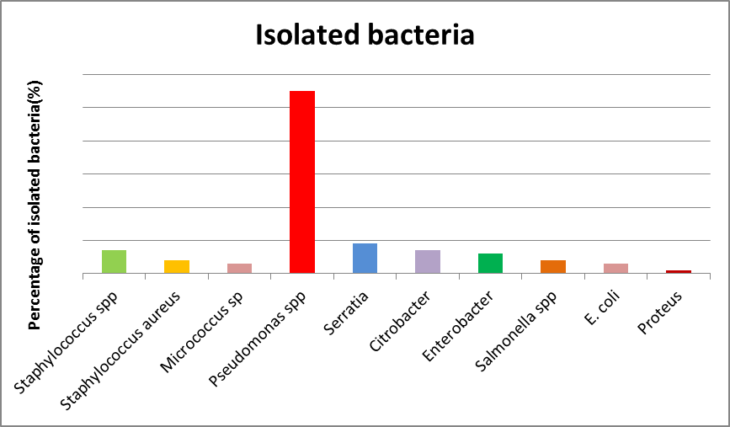
Figure (2 ): Isolated bacteria from hemodialysis center

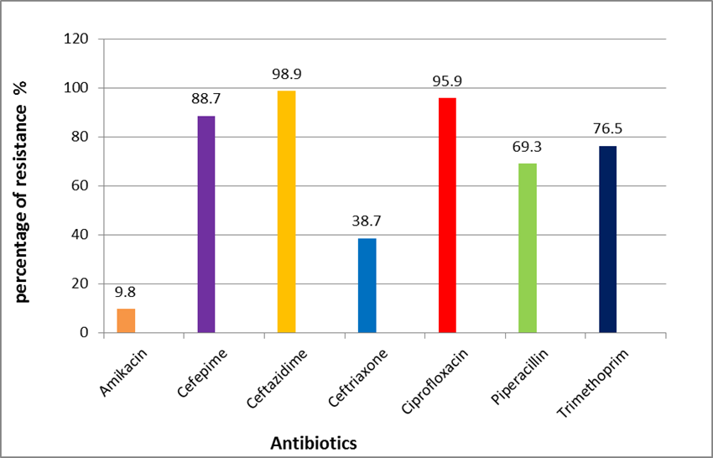

Figure (3): Antibiotic susceptibility of isolated bacteria in MKC

