**Reviewer’s Comments**

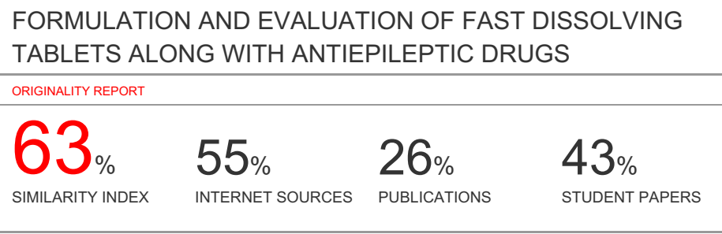

**FORMULATION AND EVALUATION OF FAST DISSOLVING TABLETS ALONG WITH ANTIEPILEPTIC DRUGS**

**Abstract**

The objective of present study was to prepare and evaluate the mouth dissolving tablet of **l**acosamide using **s**uper disintegrant like Guar Gum, and other excipients like **m**icrocrystalline **c**ellulose and **m**annitol in different concentrations by **d**irect **c**ompressionmethod. Lacosamide has been shown to be an effective antiepileptic agent appropriate for epilepsy patients. Effect of different formulation variables**; asamount and type of polymer were studied,**on release profile and other characteristics. The mouth dissolving tablets were prepared by single punch machine using powder blend of **superdisintegrant** and **l**acosamide. Post-compression parameters like **h**ardness, weight variation, friability,***in-vitro***dispersion, **d**rug content uniformity and ***i****n-****v****itro* drug releasestudies were carried out for all formulations. All **f**ormulations**resultswere within**official limits.**Fast disintegration time obtained between 35sec. and 128 sec,was within official limit.**Different drug **release kinetic models**were applied for selecting batches**for** stability studies.These showed that there was no any significant change in residual drug content **in**mouth dissolving tablets. By the *in-vitro* disintegration, it is concluded that formulation prepared by Guar Gum (10%) showed**faster** disintegration time than **that of**MCC.**This indicates that the use of super disintegrants increases the release of drug from the formulation.** Therefore, it **can** be concluded that**such mouth dissolving tablets aresuitable delivery system forl**acosamide. **Thus; the objective of this study was achieved**. Thus, the “patient-friendly dosage form” especially for **pediatrics**, geriatric**s**, bedridden and non-cooperative patients, can be successfully formulated using this technology, **providing** faster and better drug release, thereby, improving the bioavailability of drug **compared** to **conventional** marketed formulation**s**.

**Keywords:** Lacosamide, Epilepsy, Fast dissolving tablet, Superdisintegrants, Bioavailability, Pre-compression parameters, Post-compression parameters.

**Introduction**

Epilepsy is one of the most **common** central nervous system (neurological) disorders, resulting from stagesof **abnormal, excessive generation**of neuronal disturbances in the brain. Epilepsyis a brain disorder that is identifiedby chronic epileptic seizures. Epileptic **seizures result from** sudden repetitiveoccurrence of sensory disturbance, **causing**loss of consciousness, or convulsions, associated with abnormal electrical activity in the brain.**About90% of epilepsy patients are found in developing countries**.

**Causes of epilepsy**

There are defined causes of epilepsy that are common in different age groups;

1. In neonatal period and early infancy, the most common causes are hypoxic–ischemic encephalopathy, CNS infections, trauma, congenital CNS abnormalities and metabolic disorder.

2. In late infancy and early childhood, the most common febrile seizures may be caused by CNS infections and trauma.

**Pathophysiology of epilepsy**

Seizures are paroxysmal manifestations **of cerebral cortex**. **Theyoccur**when a sudden imbalance occurs between the excitatory and inhibitory forces within the network of cortical**n**eurons. **Cell membraneinstability or its physiological changes in its adjacent supporting cells represent the main pathophysiology of seizures**.

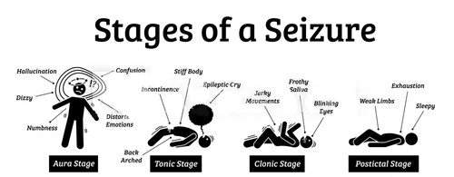

**Fig.1 Stages of Seizure**

**Classification of seizures**

**1. Generalized Seizures**

A. Absence seizures (formerly called petit mal)

B. Myoclonic seizures

C. Clonic seizures

D. Tonic seizures

E. Tonic clonic seizures (formerly called grand mal)

F. Atonic seizures (drop attacks)

**2. Partial Seizures**

**A. Simple partial seizures (consciousness not impaired)**

1. with motor symptoms

2. with sensory symptoms

3. with autonomic symptoms

4. with psychic symptoms

**B. Complex partial seizures (with impaired consciousness)**

l. simple partial seizures followed by impairment of consciousness

2. with impairment of consciousness at seizure onset

**C. Partial seizures evolving to secondarily generalized seizures**

1. simple partial secondarily generalized

2. complex partial secondarily generalized

3. simple partial evolving to complex partial evolving to generalized

**Fast dissolving tablet**

**Although, tablets are themost** commonly used dosage form because of **itssimplicity of**self-administration, **ease of preparation**, **and accuracy of dose delivery,however;pediatrics and geriatricsmay suffer difficulty in swallowing**(dysphasia) or chewing.

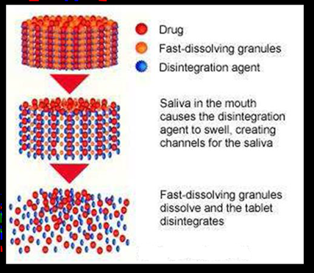

**Fig. 2 Conceptual diagram of FDT**

**Need for Development of fast dissolving tablets FDTs:**

**Table 1. Patients related factors for development of FDTs**

|  |  |
| --- | --- |
| **Taste masking** | As large amount of drugs are unpleasant, fast disintegrating drugs usually contain medicament in a taste-masked form. The rapid disintegrating drugs break downing patient’s oral cavity, thus, releasingactive ingredients which directly come in contact with taste buds. |
| **Amount of**  **Drug** | As amount of the drug is an important parameter in the formulation of fast dissolving tablet i.e. an optimized amount should be taken during the formulation of these tablets, quantity of dose of the drug must be lesser than 400 mg forinsoluble drugs and less than 60 mg for solubledrugs. |
| **Mouth feel** | As good mouth feel considered as the important consideration in the formulation of FDT’s. So it is important to note that ODT should leave minimal or no residue in the mouth after oral administration. |
| **Sensitivity to**  **environmental**  **conditions** | It should be kept in mind during the formulation of FDTs that they generally should show low sensitivity to environmental conditions such as humidity and temperature. |
| **Hygroscopicity** | Hygroscopicity is one the parameter that should be considered in FDT’s as many orally disintegrating dosage forms loose physical integrity under standard conditions of temperature and humidity as they are hygroscopic. |
| **Size of tablet** | The size of the fast dissolving tablet should also consider as prior parameter to be considered. The easiest size to handle was larger than 8 mm. Therefore, the tablet size that is both easy to take and handle is difficult to reach. |

**Various effectiveness factors are as follows:**

* Increased bioavailability and faster onset of action are major claim of these formulations.

**Various Manufacturing and marketing factors are as follows:**

* Developing new drug delivery technologies and utilizing them in product development is critical for pharmaceutical industries to survive, regardless of their size.

**Materials and Methods**

**Drug profile: Lacosamide**

**Synonyms:** Erlosamide, Harkoseride, Lacosamida.

**Chemical Structure:**

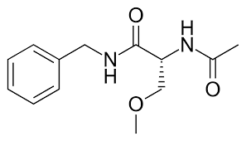

**Chemical Name:** (2R)-N-benzyl-2-acetamido-3-methoxypropanamide

**Molecular Formula:** [C13H18N2O3](https://pubchem.ncbi.nlm.nih.gov/search/#query=C13H18N2O3)

**Generic Name:** Lacosamide

**Molecular Weight:** 250.298 g/mol

**Category:** Anti-epileptic Agents

**Sub-category:** Sodium channel Inhibitor

**Percentage Purity:** 98.0% - 101.0%

**Description:** Lacosamide is a white amorphous powder.

**Solubility:** Completely solubilize in Phosphate buffer of Saliva pH 6.8, sparingly soluble in [water](https://pubchem.ncbi.nlm.nih.gov/compound/water) and slightly soluble in [acetonitrile](https://pubchem.ncbi.nlm.nih.gov/compound/acetonitrile) and [ethanol](https://pubchem.ncbi.nlm.nih.gov/compound/ethanol).

**Stability:** Stable under ordinary conditions

**pKa:** 12.47

**Log P:** 0.728 (Octanol/Water)

**Melting point:** 140-146˚C

**Storage:** To be stored in well closed, away from heat and damp places.

**Mechanism of action**

* It works by selectively enhancement of slow inactivation of voltage gated sodium channels, and helps in the stabilizing of the hyperexcitable neuronal brain membranes and also inhibits the neuronal firing.
* As other antiepileptic drugs works by fast inactivation of the sodium channels and hence this lacosamide drug is having its unique mode of action.

**Absorption**

Lacosamide is administered by oral route and shows the complete absorption of the drug with having no first pass metabolism. In-vivo studies show that lacosamide is having 100% bioavailability. The absorption rate and extent are not affected by food intake. It shows the reaching of peak plasma concentrations within 4hr after taking a single dose (100–800 mg).

**Distribution**

As Lacosamide is having low affinity to bound with plasma protein i.e. less than 15% and hence the risk of drug-drug interaction is very low. The volume of distribution of lacosamide is near about 0.8 L/kg.

**Elimination**

The half-life of this drug was found to be near about 13 hr, allowing convenient BID dosing. The elimination process follows the first order kinetics which is described by the one compartment modelling. Lacosamide is mainly excreted by renal route

## Formulations:

Lacosamide is a drug used in the treatment of partial onset seizures and [diabetic neuropathic pain](https://en.wikipedia.org/wiki/Diabetic_neuropathy).Vimpat is the brand name of the lacosamide drug.

**Polymer Profile**

**Guar gum**

It is a natural occurring polymer, completely soluble in buffer, and is also approved by FDA for use as food additive. It has a formula of C10H14N5Na2O12P3

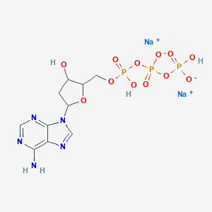

.

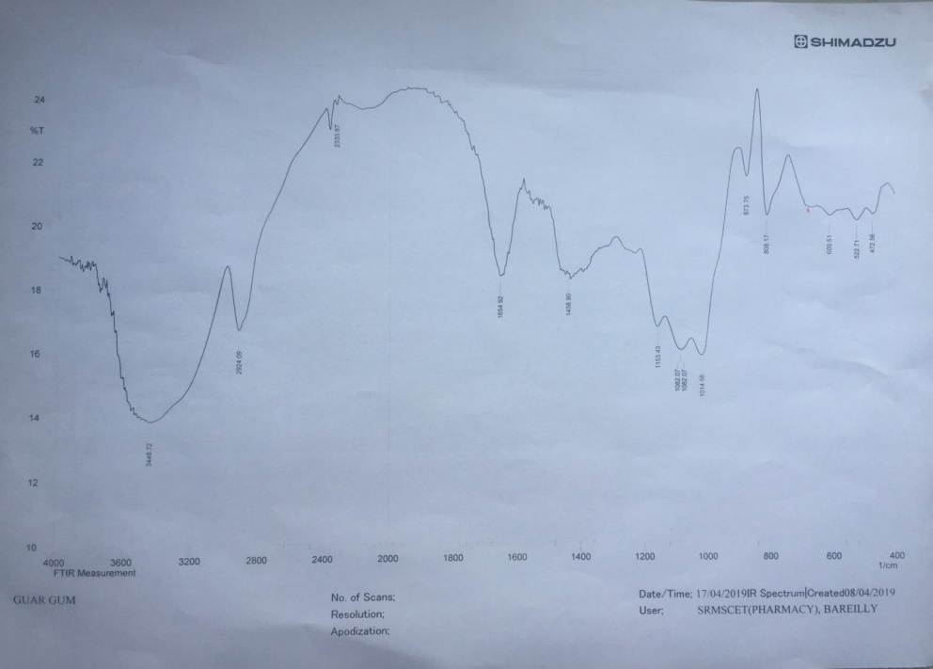

**Fig 3FTIR range of Guar Gum**

**Table No1: Interpretation of FTIR spectra of Guar Gum**

|  |  |  |
| --- | --- | --- |
| **S.No.** | **Peak cm-1** | **Groups** |
| **1.** | 3448 | Ar-NH2 |
| **2.** | 873 | P=O-Ar Stretching |
| **3.** | 522 | P=O-Ar bending |
| **4.** | 808 | P-O-Ar stretching |
| **5.** | 472 | P-O-Ar Bending |
| **6.** | 1014 | C-O Acyclic ring |
| **7.** | 2924 | CH**2**OH- Ar Stretching |
| **8.** | 1654 | N-H Bending |
| **9.** | 1153 | C-N |

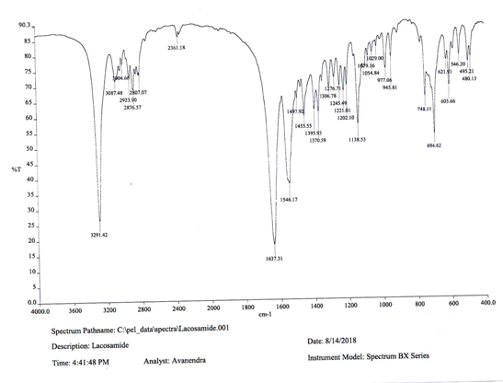

**Fig 4 FTIR Spectra of Lacosamide**

**Mannitol**

Mannitol is widely used as pharmaceutical excipients such as used as diluent in the formulation of tablet and capsule, used as sweetening agent in the mouth dissolving tablets mainly, used as a tonicity agent. Mannitol is extracted by the sugar fructose and its taste is as sweet as sucrose. Mannitol shows the cooling effect and hence helps in the masking of the bitter tastes.

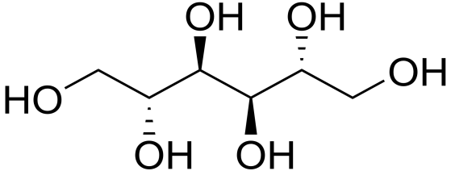

|  |  |  |  |
| --- | --- | --- | --- |
| **Synonyms** | |  |  | | --- | --- | |  | D-Mannitol, mannite, manna sugar | |
| **IUPAC Name** | (2R,3R,4R,5R)-hexane-1,2,3,4,5,6-hexol |
| [Molar mass](http://en.wikipedia.org/wiki/Molar_mass) | 182.172 g·mol−1 |
| **Appearance** | White crystalline powder. |
| [Odor](http://en.wikipedia.org/wiki/Odor) | Odorless |
| [Solubility](http://en.wikipedia.org/wiki/Solubility) | Soluble in alcohol; water. |

**Application in Pharmaceutical formulation:**

* Mannitol is widely accepted excipients used in various pharmaceutical formulations.
* It is used as tablet diluent in different pharmaceutical formulations and since it is used in combination with moisture sensitive active ingredients because of its non-hygroscopic nature.

**Stability and Storage Conditions:**

Mannitol is stable when stored in a well closed amber colored container. It should also protect by variations in the environmental temperature.

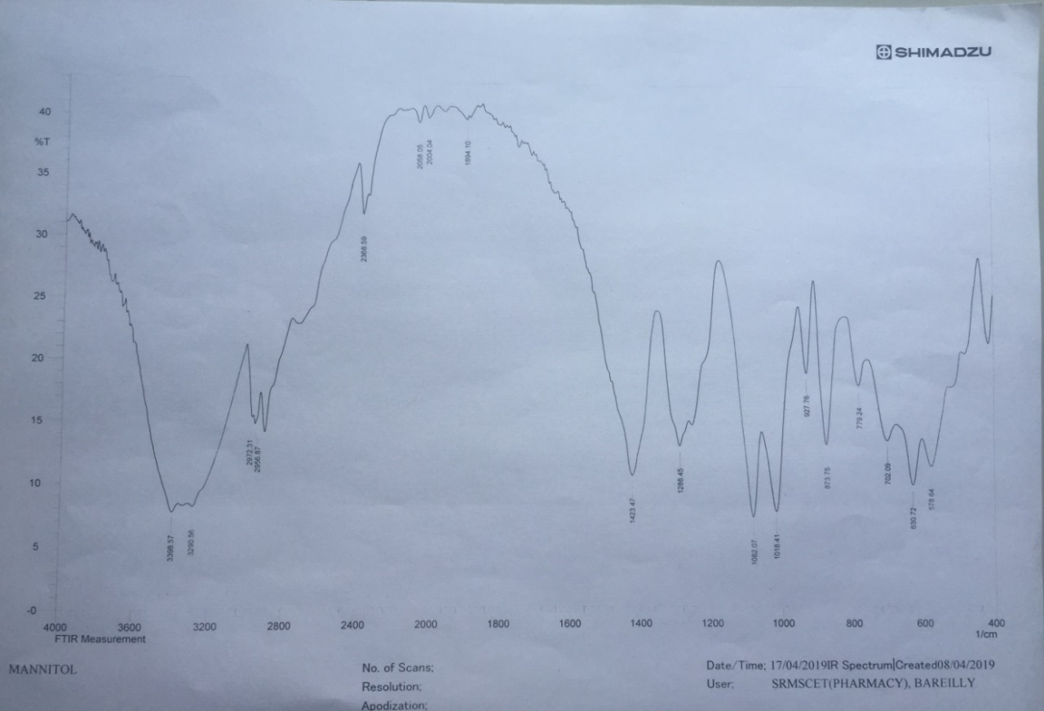

**Fig 5 FTIR ranges of Mannitol**

**Table No: 2 Spectra showing wave no. of Mannitol**

|  |  |  |
| --- | --- | --- |
| **S.No.** | **Peak cm-1** | **Groups** |
| **1.** | 3398 | C-OH Aliphatic |
| **2.** | 1288 | C-C stretching |
| **3.** | 2972 | C-H stretching |
| **4.** | 1423 | C-O stretching |

**Microcrystalline cellulose: (Frone et al, 2011; Laka et al, 2007)**

Microcrystalline cellulose is widely accepted excipients used as a disintegrants in the fast dissolving tablets and used as bulking agent in the food production.



**Stability and Storage condition:**

MCC is completely stable in nature, but it is one of the hygroscopic materials. Hence it should be stored in the well-closed container in a cool and dry place.

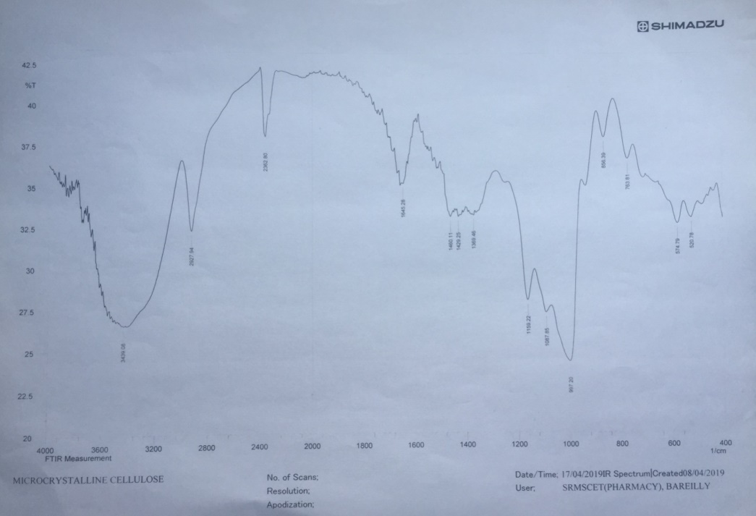

**Fig 6 FTIR Spectra of MC**

**Table No 3: Interpretation of MCC by FTIR spectra**

|  |  |  |
| --- | --- | --- |
| **S.No.** | **Peak cm-1** | **Groups** |
| **1.** | 2362 | CH2-OH |
| **2.** | 2927 | CHO aromatic |
| **3.** | 1645 | C-H stretching |
| **4.** | 1460 | C-OH Symmetric |
| **5.** | 997 | C-OH Asymmetric |
| **6.** | 1159 | C-O Stretching |
| **7.** | 574 | C-O-C bending |
| **8.** | 763 | C-C-O bending |

**Starch**

Starch is one of the widely found substances which are stored in plants. Starch is widely accepted excipients have been very useful in tablet production due to their inertness, cheapness and utilization as fillers, binders, disintegrants and glidants. Starch is mainly used in the formulation of tablet as binders, and disintegrants.

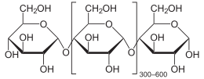

**Functional category of Starch:**

* Glidant.
* Tablet and capsule diluent.
* Tablet and capsule disintegrants.

**Application in Pharmaceutical formulation or Technology:**

1. Starch is mostly or commonly used excipients in the tablet formulation.

2. It is used as food additive and is generally regarded as an essentially non-toxic and non-irritant material.

**Stability and Storage Conditions:**

Starch should be stored in an amber colored container & in a cool & dry place.

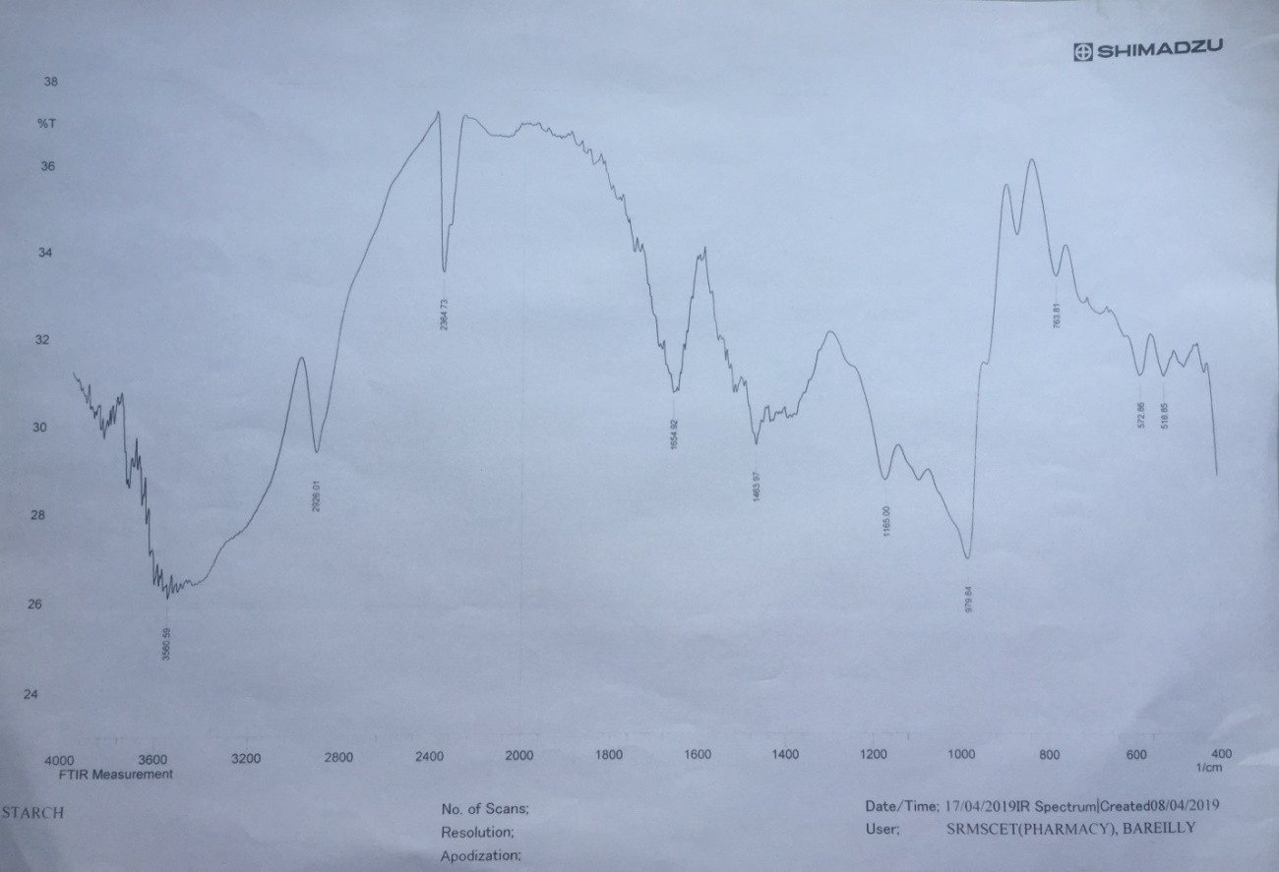**Fig .7 FTIR Spectra of Starch**

**Table No 4: Interpretation of Starch by FTIR spectra**

|  |  |  |
| --- | --- | --- |
| **S.No.** | **Peak cm-1** | **Groups** |
| **1.** | 2364 | CH2-OH stretching |
| **2.** | 1463 | C-H2 stretching |
| **3.** | 1450 | C-OH symmetric |
| **4.** | 1165 | C-O stretching |
| **5.** | 979 | C-OH Asymmetric |
| **6.** | 763 | C-C-O bending |
| **7.** | 572 | C-O-C bending |

**Talc**

Talc is a mineral commonly occurring and consists of magnesium, silicon and oxygen. It is a substance mainly found in various cosmetic products such as baby powder, adult body powders and facial powders.

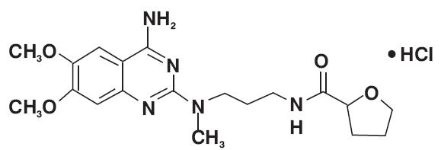

|  |  |
| --- | --- |
| **Chemical Name** | Altalc, hydrous magnesium calcium silicate, hydrous magnesium silicate, |
| **IUPAC Name** | dioxosilane;oxomagnesium;hydrate |
| [Molecular formula](http://en.wikipedia.org/wiki/Chemical_formula) | Mg3Si4O10(OH)2 |
| **Molar weight** | 379.259 g/mol |
| **Appearance** | White to grayish-white very fine crystalline powder. |
| [Density](http://en.wikipedia.org/wiki/Density) | 2.70-2.80 g/cm3 |
| [Melting point](http://en.wikipedia.org/wiki/Melting_point) | 900-1000 °C |
| **Solubility** | Freely soluble in water. |

.

**Stability and Storage condition:** Talc is very stable in nature and it can be sterilized by heating process at 160°C for not less than 1hour**,** it may also be sterilized by exposure to ethylene oxide or gamma irradiation. It should be stored in well closed container.

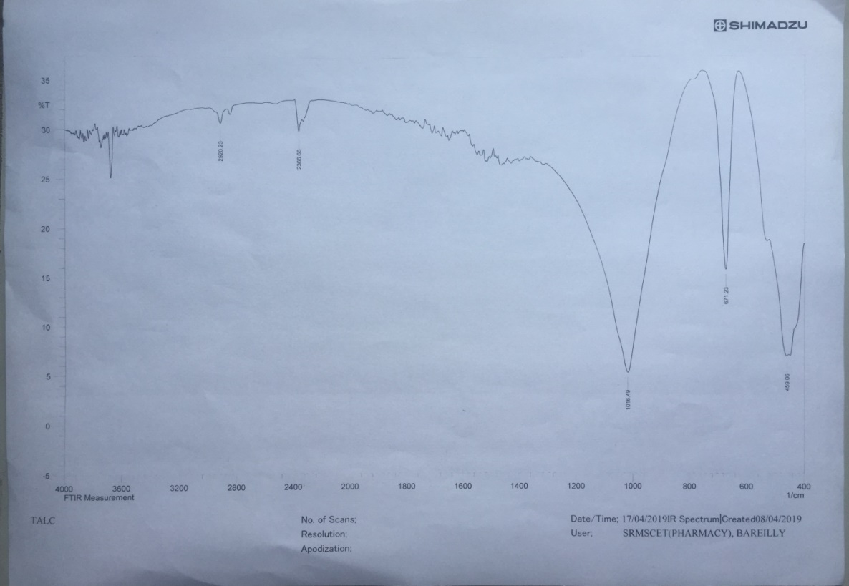

**Fig 8 FTIR Spectra of Talc**

**Table No 5: Interpretation of Talc by FTIR spectra**

|  |  |  |
| --- | --- | --- |
| **S.No.** | **Peak cm-1** | **Groups** |
| **1.** | 1016 | C-O stretching |
| **2.** | 1670 | C=O stretching |
| **3.** | 2920 | N-H-bending |
| **4.** | 2366 | N-CH3 stretching |
| **5.** | 671 | C-N bending |
| **6.** | 650 | O-CH3 |

**Magnesium Stearate**

Magnesium stearate is the compound which is chemically produced having molecular formula Mg (C18H35O2)2.  It consists of salt containing 2 anions of stearic acid and one magnesium cation.

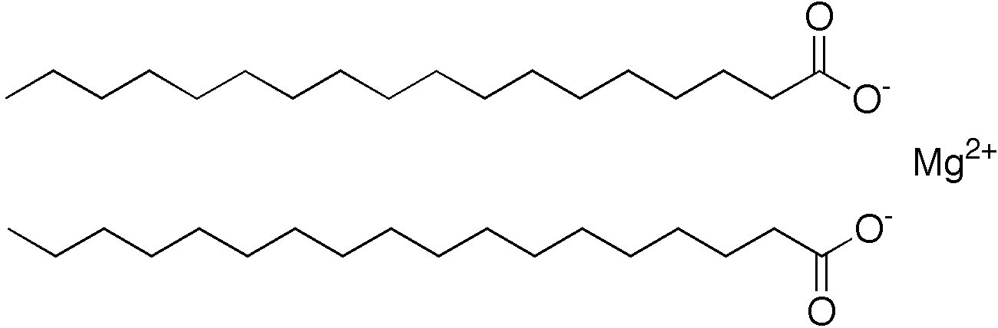

**Application in Pharmaceutical formulation**

* Magnesium stearate is often used as an [anti-adherent](https://en.wikipedia.org/wiki/Excipient#Fillers_and_diluents)in the manufacture of medical tablets, capsules and powders.

.

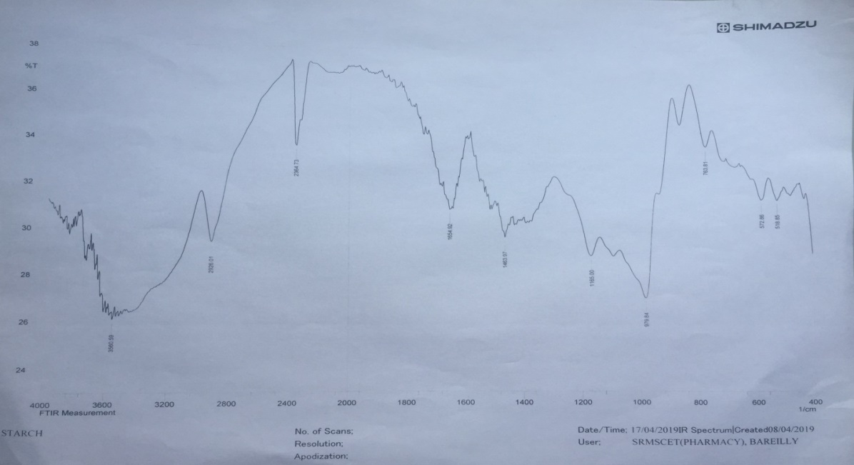

**Fig.9 FTIR Spectra of Magnesium Stearate**

**Table No 6: Interpretation of Magnesium Stearate by FTIR spectra**

|  |  |  |
| --- | --- | --- |
| **S.No.** | **Peak cm-1** | **Groups** |
| **1.** | 3380 | O-H stretching |
| **2.** | 3470 | N-H stretching |
| **3.** | 3080 | C-H aromatic |
| **4.** | 1740 | C=O stretching |
| **5.** | 1540 | C=C aromatic |

**Vanillin**

Vanillin is a widely used flavouring agent in tablet formulation to provide good feel. The molecular formula of vanillin is C8H8O3

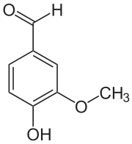

|  |  |
| --- | --- |
| **IUPAC Name** | 4-Hydroxy-3-methoxybenzaldehyde |
| [Molecular formula](http://en.wikipedia.org/wiki/Molecular_formula) | C8H8O3 |
| [Molar mass](http://en.wikipedia.org/wiki/Molar_mass) | 152.15 g mol−1 |
| **Appearance** | White crystalline form |
| [Odor](http://en.wikipedia.org/wiki/Odor) | Vanilla, Sweet, Balsamic, Pleasant |
| [Density](http://en.wikipedia.org/wiki/Density) | 1.056 g cm−3 |
| [Melting point](http://en.wikipedia.org/wiki/Melting_point) | 81-83 °C, 354-356 K, 178-181 °F |
| [Boiling point](http://en.wikipedia.org/wiki/Boiling_point) | 285 °C, 558 K, 545 °F |
| [Solubility](http://en.wikipedia.org/wiki/Solubility) **in** [water](http://en.wikipedia.org/wiki/Water) | 10 g dm−3 |

**Table No 7: List of equipments**

|  |  |  |
| --- | --- | --- |
| **S.No.** | **Name of instrument** | **Source** |
| **1** | Fourier Transform Infrared Spectroscopy | IR Affinity 1, Shimadzu, Japan |
| **2** | UltravioletVisible Spectrophotometer | U.V. 1800, Shimadzu, Japan |
| **3** | Tablet compression machine | Rimek Mini- Press- I, Gujarat, India |
| **4** | Dissolution apparatus | TDT-08L, Electrolab, Dissolution Tester USP, Mumbai, India |
| **5** | Monsanto Hardness Tester | Vinsyst Technologies, Mumbai, India |
| **6** | VernierCaliper | Mitutoyo Corporation, China |
| **7** | Test Sieve (60) | Scientific Engineering Corp, Delhi. |
| **8** | Digital Balance | AW 120, Shimadzu Corporation, Japan |

**Methodology**

During development of any formulation; its exact analytical technique and its details are highly desirable, so for the same, firstly pure drug was studied for its characteristics and its standard curve was prepared.

**Preparation of Lacosamide Calibration Curve**

The standard curve of lacosamide is prepared by firstly preparing the stock solution of 100 mcg/ml. The stock solution was prepared by taking accurately weighed 5 mg of drug (Lacosamide) and dissolve in the 50 ml of phosphate buffer of pH 6.9 in a volumetric flask. From the above prepared stock solution, different dilutions such as (2, 4, 6, 8, 10, 12 mcg/ml) were prepared and the absorbance at which calibration curve has to be obtained was scanned at 206 nm in UV Spectrophotometer.

**Results and Discussion**

**Preformulation studies:**

**Identification of drug**

Lacosamide was identified by several methods like infrared spectroscopy and ultraviolet spectroscopy.

**Infrared spectrum:**

In FTIR spectroscopy, firstly the pellets of KBr and drug were prepared and then examined under Shimadzu8400S (4000-400/cmIR spectrophotometer (Shimadzu, Japan).

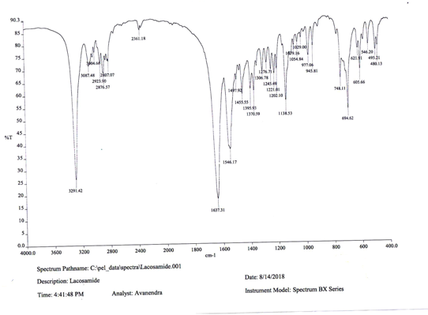

**Figure 10: FTIR spectra of Lacosamide**

**Table No 8: Interpretation of FTIR spectra of Lacosamide**

|  |  |  |
| --- | --- | --- |
| **S.No.** | **Peak cm-1** | **Groups** |
| **1.** | 3400cm-1 | O-H stretching |
| **2.** | 3300cm-1 | N-H stretching |
| **3.** | 3040cm-1 | C-H aromatic |
| **4.** | 1640cm-1 | C=O stretching |
| **5.** | 1550cm-1 | C=Caromatic |
| **6.** | 1540cm-1 | N-H bending |
| **7.** | 1240cm-1 | C-N stretching |
| **8.** | 1220cm-1 | C-O stretching |
| **9.** | 1160cm-1 | C-F stretching |

**Melting point determination:**

The Lacosamide melting point can be measured by using thieles tube method. In this method 300 ml of heavy paraffin was filled in thieles tube, and the drug filled in a capillary tube of which one end is sealed with the help of flame, and was tied with the thermometer and was suspended in thieles tube filled with paraffin.

**Table No 21: Melting Point of Lacosamide**

|  |  |  |
| --- | --- | --- |
| **S.No.** | **Reported** | **Observed** |
| **1.** | 140-146ºC | 145ºC |

**Solubility determination:**

The solubility study of drug was performed in different solvent (e.g. Ethanol, Phosphate buffer pH6.8 etc).A known quantity of drug, i.e.10 mg was transferred in a series of different solvents having volume 5 ml in different test tubes.

**Procedure:**

The partition coefficient of drug (Lacosamide) was determined in solvent system: n-octanol/phosphate buffer pH (6.8). Accurately weighed quantity of drug (10 mg) taken in one stoppered glass vial containing 5 ml ofoctanol, 5ml of phosphate buffer was added to the vial.

**Pw/o =(C aqueous / C organic)**

Where,

C organic - Concentration of drug in organic phase.

C aqueous - Concentration of drug in aqueous phase.

Po/w - Partition coefficient of drug in oil in water system.

Pw/o - Partition coefficient of drug in water in oil system.

Same process was applied with n-octanol / distilled water system partition coefficient determination.

**Methods of Analysis**

**Preparation of calibration curve:**

The standard curve is prepared by preparing the stock solution of 100 mcg/ml by dissolving accurately weighed 5 mg of Lacosamide in 50 ml of Phosphate buffer pH- 6.8 in a volumetric flask

**1) Formula for preparing fast dissolving tablet using Guargum, Mannitoland MCC**

|  |  |
| --- | --- |
| **Ingredients (mg)** | **Formulation code**  **F1** |
| Lacosamide | 50 |
| Guar gum | 10 |
| Mannitol | 100 |
| Microcrystalline cellulose | 10 |
| Aspartame | 4 |
| Starch | 20 |
| Talc | 4 |
| Magnesium stearate | 2 |
| Vanilline | q.s. |
| **Total weight (mg)** | 200 |

**2) Formula for preparing fast dissolving tablets using Guargum and increasing concentration of Mannitol**

|  |  |
| --- | --- |
| **Ingredients (mg)** | **Formulation code**  **F2** |
| Lacosamide | 50 |
| Guar gum | 10 |
| Mannitol | 110 |
| Aspartame | 4 |
| Starch | 20 |
| Talc | 4 |
| Vanilline | q.s |
| **Total weight (mg)** | 200 |

**Method of preparation of fast dissolving tablets:**

**By Direct Compression Technique:**

Tablets containing Lacosamide were formulated using various superdisintegrants like Guar gum, MCC in concentrations ranging from 5-10%. The tablets were prepared by direct compression method.

**Procedure:**

1. All the ingredients were passed through a sieve number 40 prior to mixing.
2. Lacosamide, MCC, Mannitol and the superdisintegrants were properly mixed for 30min in a suitable container to obtain a uniform blend. The blend was further lubricated with magnesium stearate and talc for 5min

**Evaluation of fast dissolving tablets**

**Weight variation:**

Weight variation was determined to know whether different batches of tablets have uniformity.

**Table No 9: Weight variation specification**

|  |  |  |
| --- | --- | --- |
| **IP/BP** | **Limit** | **USP** |
| 80 mg or less | 10% | 130mg or less |
| More than 80mg or Less than 250mg | 7.5% | 130mg to 324mg |
| 250mg or more | 5% | More than 324mg |

**Tablet Thickness and Diameter:**

Thickness and diameter of tablets were important for uniformity of tablet size. Thickness and diameter were measured using VernierCalipers.

**Friability (F):**

Friability of the tablet determined using Roche friabilator. This device subjects the tablet to the combined effect of abrasion and shock in a plastic chamber revolving at 25 rpm and dropping a tablet at a height of 6 inches in each revolution. Pre weighted sample of tablets was placed in the friabilator and were subjected to the 100 revolutions.

**W initial – W final**

**F = --------------------- X 100**

**W initial**

**Table No 10: Friability of different formulation**

|  |  |  |
| --- | --- | --- |
| **S.No** | **Formulation code** | **Friability** |
| **1.** | F1 | 0.42 |
| **2.** | F2 | 0.49 |
| **3.** | F3 | 0.58 |
| **4.** | F4 | 0.55 |
| **5.** | F5 | 0.56 |

**Figure 11: Friability of different formulation**

**Wetting time**

Two circular tissue papers of 10 cm diameterwere placed in a petri dish having the sameinner diameter. 10 mL of phosphate buffersolution pH 6.8 containing a watersolubledye, was added to petri dish.

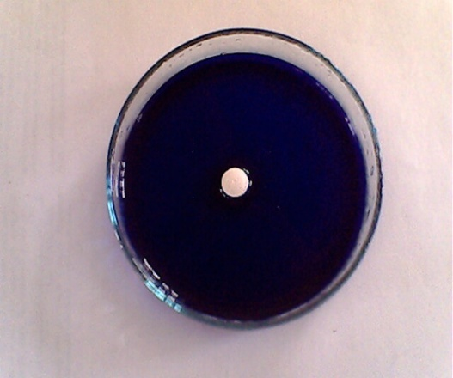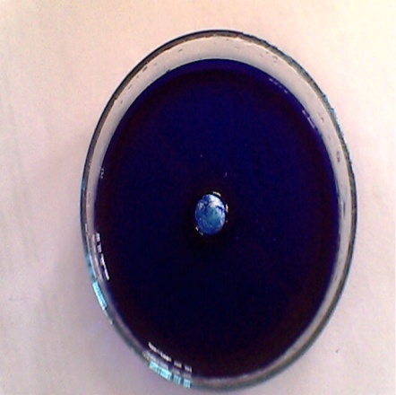

**Figure 12Before wetting** **Figure 13After wetting**

**Water absorption ratio**

A piece of tissue paper folded twice was placed in a small petri dish containing 6 ml of water. A tablet was put on the paper & the time required for complete wetting was measured.

**R = 100 x [Wa – Wb] / Wb**

Where, Wa = weight of tablet after absorption

Wb = weight of tablet before absorption

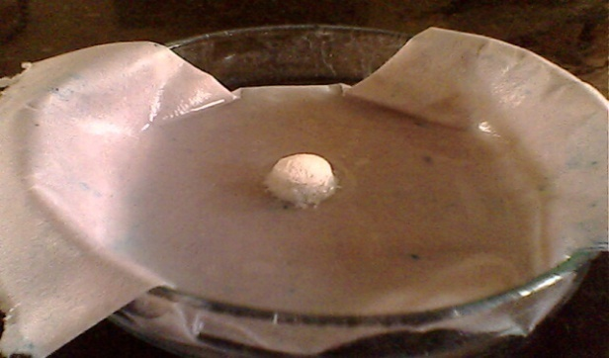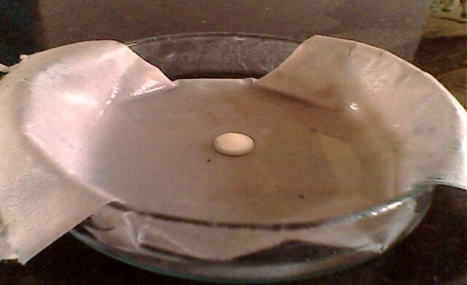

**Figure 14Before Absorption Figure 15After Absorption**

***In-vitro* dispersion time**

*In-vitro*dispersion time was measured by dropping a tablet into a Petri dish containing 10 ml of phosphate buffer solution pH 6.8 at 37±0.50C. Three tablets from each batch were randomly selected and tested.

**TableNo 11: *In-vitro* dispersion time of different formulation**

|  |  |  |
| --- | --- | --- |
| **S.No** | **Formulation code** | ***In-vitro* dispersion time (sec)** |
| **1.** | F1 | 56.0±2.28 |
| **2.** | F2 | 50.16±1.32 |
| **3.** | F3 | 54.33±2.73 |
| **4.** | F4 | 52.83±2.56 |
| **5.** | F5 | 50.83±1.70 |

Mean ± S.D. (n=3)

**Figure 16*In-vitro* dispersion time of different formulation**



**Figure 17*In-vitro* dispersion time**

**Dissolution Studies**

The release rate of **l**acosamide from mouth dissolving tablets was determined using USP Dissolution Testing Apparatus II (Paddle type).

**Table 12:Details of Dissolution Test**

|  |  |  |
| --- | --- | --- |
| **S.No** | **Requirement** | **Specification** |
| **1.** | Apparatus | USP Type II |
| **2.** | Volume of medium | 900 ml |
| **3.** | Temperature | 37±0.50C |
| **4.** | Paddle Speed | 50 rpm |
| **5.** | Dissolution medium used | 6.8 phosphate buffer |
| **6.** | A liquid taken at each time interval | 5 ml |

**Table 13: Comparative cumulative drug release of different formulations**

|  |  |  |  |  |  |  |
| --- | --- | --- | --- | --- | --- | --- |
| **S. No** | **Time (Min)** | **Comparative Cumulative Release of Different Formulations** | | | | |
| **F1** | **F2** | **F3** | **F4** | **F5** |
| **1.** | 0 | 0 | 0 | 0 | 0 | 0 |
| **2.** | 2 | 15.15±0.73 | 18.96±0.73 | 28.34±1.26 | 18.21±0.67 | 20.21±0.77 |
| **3.** | 4 | 29.53±0.32 | 35.14±0.39 | 40.08±0.32 | 35.85±0.31 | 42.85±0.40 |
| **4.** | 6 | 44.79±0.96 | 50.71±0.50 | 52.7±0.77 | 48.93±0.49 | 60.90±0.50 |
| **5.** | 8 | 60.09±0.73 | 62.64±0.57 | 64.05±0.95 | 56.24±0.31 | 72.20±0.55 |
| **6.** | 10 | 74.74±0.44 | 78.80±0.37 | 76.25±0.50 | 78.8±0.81 | 84.10±0.27 |
| **7.** | 12 | 92.94±0.69 | 99.86±0.54 | 90.17±1.14 | 92.66±0.47 | 95.66±0.50 |

aMean ± S.D.(n=3)

**Figure 18Comparative study of cumulative release of different formulations**

**Figure 19 Comparative study of cumulativerelease of different formulations**

**Conclusion**

The fast dissolving tablets were successfully prepared bydirect compression method of the Lacosamideusing superdisintegrants and the objective of this study was achieved. By the *in-vitro* disintegration, it is concluded that formulation preparedby Guar Gum (10%)showed the fast disintegration time than the MCC. So it represent that the use of superdisintegrants, it increases the release of the drugLacosamide. Therefore, it may be concluded that mouth dissolving tablet was suitable drug delivery system forLacosamide. Thus, the “patient-friendly dosage form” especially for pediatric, geriatric, bedridden, and non-cooperative patients, can be successfully formulated using this technology, and also provides faster and better drug release, thereby, improving the bioavailability of drug as compared to the conventional marketed formulation.The objective of present study was to prepare and evaluate the mouth dissolving tablet of Lacosamideusing Super disintegrants like Guar Gum, and Microcrystalline Cellulosein different concentrations by Direct Compression method.Lacosamide mouth dissolving tablets prepared were evaluated for Pre-compressional and Post compressional parameters. The Pre-compressional parameters evaluated are bulk density, true density, angle of repose and Carr’s index. The various evaluation parameters are studied such as Hardness, weight variation, friability, In-Vitro dispersion, Drug content uniformity and In-vitro drug release studies were carried out for all the formulation. All the Formulations gave the result within the official limits. The prepared mouth dissolving tablet shows the properties of fast disintegration time (35sec. to128 sec). Different drug release kinetics model were applied for selecting batches stability studies, showed that there was no any significant change in residual drug content mouth dissolving tablets.

**References**

**1**. Commission on Epidemiology and prognosis; 2013.International League against Epilepsy, Guidelines for epidemiologic studies on epilepsy, Epilepsia, 34(4):592-96.

**2.** Blume W; Luders H; Mizrahi E;Tassinary C; Van Emde Boas W;Enjel J;2017. Glossary of descriptive terminology for ictal semiology; report of the ILAE taskforce on classification and terminology, Epilepsia; 42(9):1212-18.

**3.** Gregory L H; Yehezkiel Ben-A. 2017. *The Neurobiology and Consequences of Epilepsy in the Developing Brain*. Pediatric Research; 49(3):320-25.

4. Gidal BE; 2005. Garnett WR; Epilepsy. In: Dipiro J T, Talbert RL, Yee GC, Matzke GR, Wells BG, Posey LM, eds. Pharmacotherapy: a pathophysiologic approach. USA: McGraw-Hill Companies Inc, 6thed: 1023-46.

5. The National Society for Epilepsy, what is epilepsy: 2009. Available at: http: //www.epilepsynse.org.kk/ about epilepsy/what is epilepsy (Accessed on 15 February 2009).

6. Marieb EN, 2006.Human anatomy and physiology. New Delhi Pearson Education Inc and Dorling Kindersley Publishing Inc, 6th edition: 430-88.

7. MariebEN.2006 Human anatomy and physiology. New Delhi Pearson Education Inc and Dorling Kindersley Publishing Inc, 6th ed: 430-88.

8. Meisler MH, Kearney JA. Sodium channel mutations in epilepsy and other neurological disorders. Journal of Clinical Investigation 2005; 115(8):2010-17.

9. Hirtz D, Thurman DJ, Gwinn-Hardy K, Mohamed M, Chaudhury AR, Zalutsky R. How common are the 'Common' neurologic disorders, Neurology 2007; 68 (5):326-37.

10. Block JH, Beale JM. Wilson and Gisvold's text book of organic medicinal and pharmaceutical chemistry. 11th ed. Lippincott Williams and Wilkins, 2010:503.

11. Wanare RS and Murkute RS. Formulation and evaluation of fast dissolving tablets of azithromycindihytdrate using different superdisintegrants.*IJCP*. 2012; 4(5):1-4.

12. Siddiqui N, Garg G and Sharma P. Fast dissolving tablets: preparation, characterization and evaluation: an overview. *International Journal of Pharmaceutical Science Review and Research*. 2010;4(2):87-96

13. Deshmukh V. N.Mouth Dissolving Drug Delivery System: A Review. *International*

*Journal of PharmaceuticalTechnology and Research*.2012;4(1):412-421.

14. Rajesh Roshanrai, PavithraChirra, VenkataramuduThanda: Fast Dissolving Tablets: A Novel ApprochTo Drug Delivery -A Review, *International Journal Of Preclinical And Pharmaceutical Research.* 2012, Vol 3 Issue I: 23-32.

15. Reddy LH and Ghosh BR. Fast dissolving drug delivery systems: A review of the literature,*Indian Journal of Pharmaceutical Science*. 2002; 64(4):331-336.

18. Bi Y, Sunada K, YonezawaY,Danjo K, Otsuka A and lida K. Preparation and evaluation of a compressed tablet rapidly disintegrating in the oral cavity. Chem Pharm Bull. 1996;44:2121-2127.

19. Siddiqui N, Garg G and Sharma P. Fast dissolving tablets: preparation, characterization and evaluation: an overview. *International Journal of Pharmacy Science Review and Research*. 2010;4(2):87-96.

20. Fix JA. Advances in quick-dissolving tablets technology employing Wowtab. Paper presented at: IIR Conference of drug delivery systems. 1998 Oct.; Washington DC, USA.

21. Virely P, Yarwood R. Zydis-a novel, fast dissolving dosage form. Manuf. Chem. 61, 1990; 36-37.

22. Debjit, B., Chiranjib, B., Krishnakanth, Pankaj, R.MargretChandira, Fast Dissolving Tablet: An Overview,*J Chemical and Pharma Res,***2009**, 1(1), 163-177.

23. Belet MH and Derle DV: Analysis of patents pertaining to superdisintegrants used in tablet manufacturing. Journal of intellectual Property Rights 2008; 13: 601-604.

24. Omidian H and Park K: Swelling agents and devices in oral drug delivery. Journal of Drug Delivery Science and Technology 2008; 18 (2): 83-93.

25. Bhardwaj S, Jain V, Sharma S, Jat RC and Jain S: Orally disintegrating tablets: a review. Drug Invention Today 2010; 2(1): 81-88.

26. Bhowmik, D., Chiranjib, B., Krishnakanth, Pankaj, Chandira, R.M., 2009. Fast dissolving tablets: An overview.*Journal of Chemical and PharmaceuticalResearch.* Vol.1, Issue 1, pp. 163-177.

27. Kaur, T., Gill, B., Kumar, S., Gupta, G.D., 2011. Mouth Dissolving Tablets: A Novel Approach To Drug Delivery. *International Journal of Current Pharmaceutical Research.* Vol.3, Issue1, pp. 1-7.

28. Bharti, N., Bhandari, N., Sharma, P., Singh, K., 2012. Fast Dissolving Tablets: A New Era in Novel Drug Delivery System. *International Research Journal ofPharmacy.*Vol. 3, Issue 9, pp. 59-64.

29. Srivastava, S., Bala, R., Joshi, B., Rana, A.C., Singla, V., 2012. Mouth Dissolving Tablets: A Future Compaction. *International Research Journal Of Pharmacy.* Vol. 3, Issue 8, pp. 98-109.

30. Niraj, Pandey, S., Gupta, M.M., Chauhan, B.S., 2013. A brief discussion on fast dissolving tablet- A recent technology. *American Journal of PharmTech Research*. Vol.3, Issue 1, pp. 28-52.

31. Chowdary, Y.A., Soumya, M., MadhuBabu, M, Aparna, K., Himabindu, P., 2012. A Review On Fast Dissolving Drug Delivery Systems- APioneering Drug Delivery Technology.  *Bulletin of Environment, Pharmacology and Life Sciences*.Vol.1, Issue 12, pp. 8-20.

32. Sayeed, A., Mohiuddin, M.H., 2011.Mouth dissolving tablets: An overview*. InternationalJournal of Research in Pharmaceutical and Biomedical Sciences.* Vol.2, Issue 3, pp. 959-970.

33. Pawar, P.B., Mansuk, A.G., Ramteke, K.H.,Sharma, Y.P., Patil, S.N., 2011. Mouth Dissolving Tablet: A Review. *International Journal of Herbal Drug Research*. Vol. 1, Issue 2, pp.22-29.

34. Sayeed, A., Mohiuddin, M.H., 2011.Mouth dissolving tablets: An overview*. InternationalJournal of Research in Pharmaceutical and Biomedical Sciences.* Vol.2, Issue 3, pp. 959-970.

35. Halakatti, P.K., Gupta, V.R.M., Narasu, M.L., 2013. Mouth dissolving tablets- An innovative technology: A Review.*American Journal of PharmTechResearch.*Vol. 3, Issue 1, pp. 69-86.

36. Khairnar, D., Anantwar, S., Chaudhari, C., Valavi, A., 2013. Orodispersible Tablets – An Overview.*International Journal Of Pharmaceutical Research And Bio-Science.* Vol.2, Issue 6, pp. 305-331.

37. VenkatalakshmiRanganathan, Development and Evaluation of Mouth Dissolving Tablets using Natural Super Disintegrants.J Young Pharm, 2017; 9(3): 332-335.

38. Raghavendra Kumar Gunda, J. N. Suresh Kumar, Formulation Development and Evaluation of Carbamazepine Fast Dissolving Tablets. *Journal of Pharmacy Research 2016, 10(5), 216-225*

# 39.[Arti Mohan](https://www.ncbi.nlm.nih.gov/pubmed/?term=Mohan%20A%5BAuthor%5D&cauthor=true&cauthor_uid=25599034) and [RohitGundamaraju](https://www.ncbi.nlm.nih.gov/pubmed/?term=Gundamaraju%20R%5BAuthor%5D&cauthor=true&cauthor_uid=25599034),*In vitro* and *in vivo* evaluation of fast-dissolving tablets containing solid dispersion of lamotrigine. [Int J Pharm Investig](https://www.ncbi.nlm.nih.gov/pmc/articles/PMC4286836/). 2015 Jan-Mar; 5(1): 57–64.

40. Samar A. Afifi, Development of promising fast dissolving tablets of Stiripentol: a novel antiepileptic drug. *Journal of Pharmacy Research 2014, 8(6), 812-817.*