**Reviewer’s Comments**

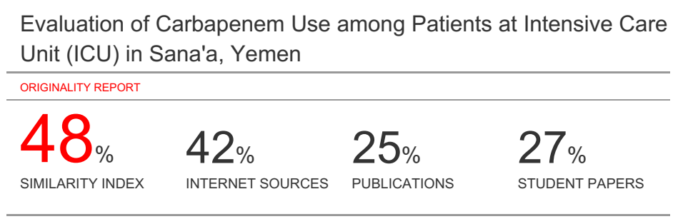

**Evaluation of Carbapenem Use among Patients at Intensive Care Unit (ICU) in Sana'a, Yemen**

**Abstract**

***Background:*** Drug Utilization Evaluation (DUE) studies are designed to evaluate and improve the rational use of medications. In this study, DUEhas focused on drugs used in high risk patients such as critically ill cases. Carbapenems are beta-lactam type antibiotics with broad-spectrum of activity which cover Gram-positive, Gram-negative and anaerobic bacteria. The heavy use of carbapenems (imipenem or meropenm) could increase the risk of multi-drug resistant (MDR) pathogens.

***Methods:*** This study was a prospective and cross sectional study performed at intensive care unit (ICU) of Al-Matwakel hospital in Sana'a, Yemen. The study was conducted from September 2018 to March 2019. All of the patients were on imipenem or meropenem as an empiric treatment or based upon microbiology culture results included in the study.

***Results:*** Total of 80 patients at ICU were evaluated. The results of the study showed that empiric therapy was in most cases (91.25%; *P < 0.001*).In addition; about 36.3% of the patients required dosage adjustment according to glomerular filtration rate(GFR) stages. Also according to GFR calculation, 43.8% of the patients were in stage 3. In the present study, the frequency of therapeutic duplication of ceftriaxone with carbapenem was reported in 38 patients. The major drug-drug interactions were observed with tramadol-imipenem, tramadol-meropenem, and amlodipine-simvastatin

***Conclusion:*** The result of the study showed that empiric therapy was unjustified in most cases (91.25%).In addition, about 36.3% of the patients required dosage adjustment according to GFR stages. According to GFR calculation, 43.8% of the patients were in stage 3. In the present study, the frequency of therapeutic duplication and drug-drug interactions were observed.

***Keywords****: Carbapenem, Empirical, GFR, MDR*

1. **Introduction:**

One of the most important elements in patient care process is to evaluate the appropriateness of medication use. Medications review studies are aimed to evaluate and improve the rational use of drugs. They have mostly focused on drugs with higher cost, higher dispensing, relatively narrow therapeutic margin and also broad spectrum antibiotics. They also focus on medicationsprescribed in specialized populations such as elderly, critically ill, post-surgical and cancer patients**(1)**.Carbapenem (imipenem/cilastatin and meropenem) drugs are beta-lactam type antibiotics with a broad spectrum of activity and coverage of Gram-positive and Gram-negative aerobic and anaerobic bacteria.Imipenem/cilastatin and meropenemuse have increased as a result of high resistant rates to other antibiotics**(2**Like other broad spectrum antibiotics, carbapenems are prescribed as a part of empiric therapy in most serious hospitalised infections. Imipenem is a semisynthetic carbapenem co-administrated with cilastatin, to prevent renal metabolism of imipenem by dehydropeptidase Ι (DHP Ι). In contrast, this co-administration with the renal dehydropeptidase inhibitor, cilastatin is not necessarywith meropenem, because this agent is not hydrolyzed by DHP Ι**(1)**. The incidence of imipenem/cilastatin and meropenem resistance is increasing. One of the reasons could be the overuse of these broad spectrum antibiotics in hospitalized patients including Intensive Care Units (ICUs)**(3)**. Improving the ICU environment involves education of critical care staff regarding the rational use of these drugs**(1)**. According to a study conducted in in Sana'a, Yemen by alyahawi et al. 2018**(4)**, the resistant rate ofmeropenembased on culture results was seen in 25.3% of all collected isolates.In this study, we reviewed the utilization of these antibiotics in critically ill patients.

1. **Methods:**

The study was performed in ICU at a private hospital in Sana’a, Yemen. All the patients on carbapenem drugsfrom September, 2018 to March, 2019 were included. A total of 80 of the patientson carbapenem drugs were collected from ICU at the mentioned study period.The study protocol was approved by the institutional ethical committee. The data was analyzed in order to identify dosage adjustment accordingGFR stages, carbapenem selection according to culture results or empirical therapy, major and moderate drug-drug interactions according to Drugs.com and Medscape.com, andantibiotic use in combination with carbapenem. Full ethical clearance was obtained from the qualified authorities who approved the study design.Statistical analysis included usage of Chi-square testsusing the software package SPSS 21.0.

1. **Results:**

Total of 80 patients at ICU were evaluated. The results of the study showedthat 78.8% of the study sample were men and 21.3% were women. Also 43.8 of the study sample were aged >= 60 years old. In the present study, 80% of the patients were onmeropenem and 20% of total patients on imipenem drug. According to the glomerular filtration rate (GFR) classification, 43.8% of patients had chronic kidney diseases (CKD) stage 3.

**Table 1. Distribution of the study variables**

|  |  |  |  |
| --- | --- | --- | --- |
| **Variable** | | **Frequency** | **%** |
| **Gender** | **M** | 63 | 78.8% |
| **F** | 17 | 21.3% |
| **Age group** | **0-19** | 4 | 5% |
| **20-39** | 21 | 26.3% |
| **40-59** | 20 | 25% |
| **>=60** | 35 | 43.8% |
| **Imipenem** | | 16 | 20% |
| **Meropenem** | | 64 | 80% |
| **CKD Stage** | **1** | 12 | 15.0 % |
| **2** | 11 | 13.8% |
| **3** | 35 | 43.8% |
| **4** | 19 | 23.8% |
| **5** | 3 | 3.8% |

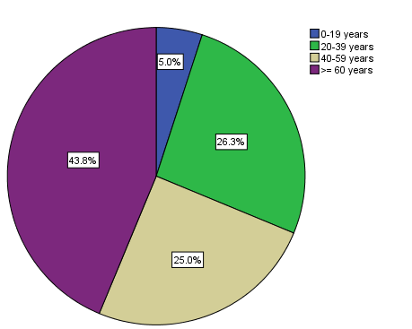

**Figure 1. Distribution of age groups among the study sample**

From the study findings, 36 of patients with chest infection (45%) were onimipenem/cilastatinor meropenem, followed by patients with sepsis (25%).

**Table 2. Distribution of Carbapenem drugs used according to Diagnosis**

|  |  |  |  |  |
| --- | --- | --- | --- | --- |
| **Variable** | | **Carbapenem used** | | **Total** |
| **Imipenem/cilastatin** | **Meropenem** |
| **Diagnosis** | Brain Infection | 1 | 2 | 3 |
| Chest Infection | 9 | 27 | 36 (45%) |
| CSF Infection | 0 | 1 | 1 |
| Head Infection | 0 | 1 | 1 |
| Meningitis | 1 | 6 | 7 |
| Osteomyelitis | 0 | 5 | 5 |
| SBP | 0 | 1 | 1 |
| Sepsis | 2 | 18 | 20 (25%) |
| UTI | 3 | 3 | 6 |
| **Total** | | 16 | 64 | 80 |

According to glomerular filiation rate, there was 36.3% of carbapenem drugs (imipenem/cilastatin or meropenem) were needed dosage adjustment according to GFR stages. In addition, one carbapenem drug is not recommended by evidence used for patient. However, 8.8% of carbapenem drugs were used in low doses (table 3).

**Table3.Dosage Adjustment according to GFR stages**

|  |  |  |
| --- | --- | --- |
| **Variable** | **Frequency** | **%** |
| **Need dosage adjustment** | 29 | 36.3% |
| **Not need dosage adjustment** | 43 | 53.8% |
| **Low dose** | 7 | 8.8% |
| **Not recommended** | 1 | 1.3% |
| **Total** | 80 | 100.0 |

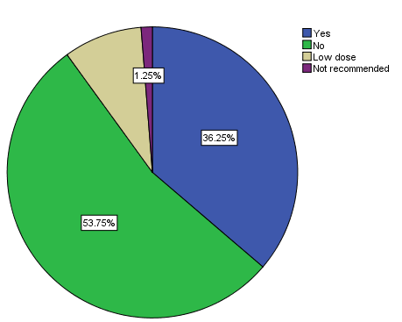

**Figure2. Dosage adjustment according to GFR Stages**

Table 4 showed the frequency of moderate drug-drug interactions in the present study.According to the drugs.com and Medscape, the frequency of moderate drug-drug interactions between all the patients' drugs was observed in 11types. Detailed comments were reported in table 4.

**Table4. Moderate Drug-Drug Interaction**

|  |  |  |
| --- | --- | --- |
| **Type of Drug-drug interaction** | **Frequency** | **Comments** |
| **Aspirin-Clopidogrel** | 3 | Increase the bleeding. |
| **Aspirin-Heparin** | 1 | The coadministration of nonsteroidal anti-inflammatory drugs (NSAIDs) and heparin or low molecular weight heparin (LMWH) may potentiate the risk of bleeding. NSAIDs interfere with platelet adhesion and aggregation and may prolong bleeding time in healthy individuals. |
| **Azithromycin-Simvastatin** | 1 | Macrolide antibiotics that inhibit CYP450 3A4 may significantly increase the plasma concentrations of HMG-CoA reductase inhibitors. |
| **Captopril-Heparin** | 1 | The concomitant use of angiotensin converting enzyme (ACE) inhibitors or angiotensin receptor blockers (ARBs) and heparin or low molecular weight heparins may increase the risk of hyperkalemia. ACE inhibitors, ARBs, and some heparins individually have been associated with increased potassium levels or hyperkalemia. |
| **Ceftriaxone-Warfarin** | 1 | Prothrombin time and INR should be monitored and the patient closely observed for signs of bleeding. The anticoagulant dose may be adjusted as indicated. |
| **Metronidazole-Phenytoin** | 2 | Coadministration with a metronidazole may increase the serum concentrations of phenytoin. The interaction has been reported with metronidazole, and the proposed mechanism is inhibition of phenytoin metabolism via CYP450 2C9. |
| **Phenytoin-Insulin** | 1 | Caution is advised when drugs that can interfere with glucose metabolism are prescribed to patients with diabetes. Close clinical monitoring of glycemic control is recommended following initiation or discontinuation of these drugs, and the dosages of concomitant antidiabetic agents adjusted as necessary. |
| **Phenytoin-Nifedipine** | 1 | Nifedipine may increase plasma phenytoin levels. Toxicity has been reported. The proposed mechanism is inhibition of CYP450 3A4 metabolism. In addition, phenytoin may significantly decrease calcium channel blocker (CCB) serum levels by inducing first-pass metabolism and the systemic clearance. |

The frequency of major drug-drug interactionswas demonstrated in table 5.According to the drugs.com and Medscape, the frequency of major drug-drug interactions between all the patients' drugs was observed in three patients. Detailed major drug-drug interactions were reported in table 5.

**Table5.Major Drug-Drug Interaction**s

|  |  |  |
| --- | --- | --- |
| **Type of Drug-drug interaction** | **Frequency** | **Comments** |
| **Amlodipine-Simvastatin** | 1 | Coadministration with amlodipine may significantly increase the plasma concentrations of simvastatin and its active metabolite, simvastatin acid, and potentiate the risk of statin-induced myopathy. The proposed mechanism is amlodipine inhibition of simvastatin metabolism via intestinal and hepatic CYP450 3A4. |
| **Tramadol-Imipenem** | 1 | The risk of seizures may be increased during coadministration of tramadol with any substance that can reduce the seizure threshold, such as carbapenems.These agents are often individually epileptogenic and may have additive effects when combined. |
| **Tramadol-Meropenem** | 1 | The risk of seizures may be increased during coadministration of tramadol with any substance that can reduce the seizure threshold, such as carbapenems.These agents are often individually epileptogenic and may have additive effects when combined. |

In this study, there were 91.3% of patients on carbapenem drugs as empirical therapy (*P* < 0.001) However, 8.8% of patients used carbapenem drugs according to culture results.

**Table6.Carbapenem Selection according to culture or empirical therapy**

|  |  |  |
| --- | --- | --- |
| **Variable** | **Frequency** | **Percent** |
| Empirical Therapy | 73 | 91.3% |
| According to culture results | 7 | 8.8% |
| Total | 80 | 100.0 |

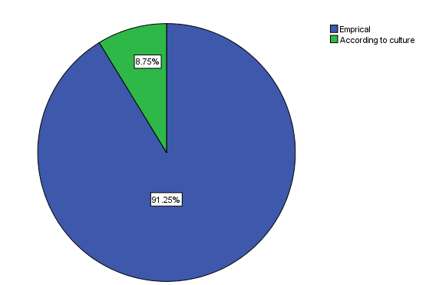

**Figure3. Distribution of carbapenem selection according to culture results or empirical therapy**

Figure 4 showed the percentage of antibiotics used before carbapenem administration for the study sample. Carbapenem drugs were administered in 75% of the patients as the first line. In contrast, 25% of patients used other antibiotics before carbapenemadminstration.

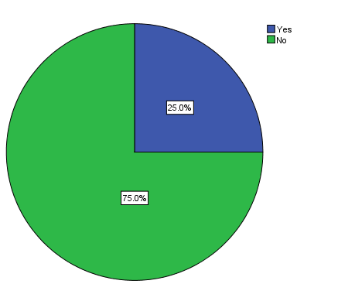

**Figure4.Antibiotics used before carbapenemdrug**

The review of the patients'drugsshowed different drugs related problems. According to the study findings, the frequency of therapeutics duplication with carbapenem drugs was in 41 (51.3%) of patients. Moreover, the therapeutic duplication of ceftriaxone with carbapenem drugs was in 38(92.7%) of these patients. In addition, one patient with urinary tract infection (UTI) was on moxifloxacin drug (less effective for UTI). Carbapenem drugs have a broad spectrum of activity, so most other antibiotics are unnecessaryas combination to carbapenemdrugs (table 7).

|  |  |  |  |  |  |  |  |  |  |  |  |  |  |  |
| --- | --- | --- | --- | --- | --- | --- | --- | --- | --- | --- | --- | --- | --- | --- |
| **Table 7. Distribution of Other Antibiotics Use in Combination with Carbapenem according to Diagnosis** | | | | | | | | | | | | | | |
| **Type of Antibiotic** | **Chest Infection** | | **Head Infection** | | | **Meningitis** | | **Osteomyelitis** | | | **Sepsis** | | **UTI** | |
| Amoxicillin-Clavulanic Acid | 1 | **D** | 0 |  | | 0 |  | 0 | |  | 0 |  | 0 |  |
| Azithromycin | 1 |  | 0 |  | | 0 |  | 0 | |  | 0 |  | 0 |  |
| Cefepime | 0 |  | 0 |  | | 0 |  | 0 | |  | 1 | D | 0 |  |
| Ceftriaxone | 8 | D | 0 |  | | 3 | D | 0 | |  | 6 | D | 1 | D |
| Cefuroxime | 1 | D | 0 |  | | 0 |  | 0 | |  | 0 |  | 0 |  |
| Ciprofloxacin | 1 |  | 0 |  | | 0 |  | 0 | |  | 0 |  | 0 |  |
| Doxyxcycline-Ceftriaxone | 0 |  | 0 |  | | 0 |  | 0 | |  | 1 | D | 0 |  |
| Levofloxacin | 1 |  | 0 |  | | 0 |  | 0 | |  | 0 |  | 0 |  |
| Levofloxacin-Metronidazole | 1 |  | 0 |  | | 0 |  | 0 | |  | 0 |  | 0 |  |
| Linezolid | 0 |  | 0 |  | | 0 |  | 0 | |  | 1 |  | 0 |  |
| Metronidazole | 2 |  | 0 |  | | 1 |  | 2 | |  | 2 |  | 1 |  |
| Metronidazole-Ceftriaxone | 4 | D | 0 |  | | 1 | D | 1 | | D | 2 | D | 1 | D |
| Metronidazole-Ciprofloxacin | 1 |  | 0 |  | | 0 |  | 0 | |  | 0 |  | 0 |  |
| Metronidazole-Moxifloxacin | 0 |  | 0 |  | | 0 |  | 1 | |  | 0 |  | 0 |  |
| Moxifloxacin | 3 |  | 0 |  | | 0 |  | 0 | |  | 3 |  | 1 | N |
| Moxifloxacin-Ceftriaxone | 8 | D | 0 |  | | 0 |  | 0 | |  | 2 | D | 0 |  |
| Moxifloxacin-Metronidazole | 0 |  | 0 |  | | 0 |  | 0 | |  | 1 |  | 0 |  |
| Vancomycin | 1 |  | 1 |  | | 1 |  | 0 | |  | 0 |  | 0 |  |
| Vancomycin-Ampicillin | 0 |  | 0 |  | | 1 | D | 0 | |  | 0 |  | 0 |  |
| Vancomycin-Ceftriaxone | 0 |  | 0 | |  | 1 | D | 0 |  | | 0 |  | 0 |  |
| Vancomycin-Levofloxacin | 0 |  | 0 | |  | 0 |  | 1 |  | | 0 |  | 0 |  |
| **D: Therapeutic Duplication; N: Not Recommended** | | | | | | | | | | | | | | |

1. **Discussion:**

Applying standard treatment guidelineswith training and supervision may be helpful in guiding physicians in the appropriate use of carbapenem drugs in hospital.

Generally, most physicians used carbapenem drugs empirically for patients admitted to the ICU without the identification the exact infection. They might think that all patients admitted to ICU have a severe infection (5).

Continuous drugs education by therapeutic committee and regular drug utilization evaluation programs could help in the rational medication use. The various clinical conditions and severity of infection for patient in ICU need the use of drugs from different classes(6).

The results of this study revealed that the majority of patients (43.8%) received carbapenem drugs were equal or above 60 years old. Similarly, a study conducted to evaluation of meropenem utilization in intensive care unit in Sudan by Sanhoury et al.,**(5)** which found majority of patient, above 60 years old, received meropenem drug.

In the current study, 91.3% of carbapenemdrugs were prescribed without culture results; which means that these drugswereprescribed depending on physician' experience or on the severity of infection, but not according to isolated bacteria. This was not in agreement with a study conducted to evaluate the use of carbapenem in a French University hospital by Jary et al., which found 60% of meropenem was prescribed empirically **(7)**.

The irrational utilization of broad-spectrum antibiotics such as carbapenem drugs can lead to the development of several resistant strains of microbes. These attribute significantly towards increase in the costs of health care and patient morbidity and mortality**(8)**. So, monitoring and evaluation of antimicrobial agents are one of the recommended strategies to prevent, control resistance, and to improve the rational use of these drugs**(5)**.

The high prevalence of resistance in intensive care units (ICUs) is a key factor to increase the severity of illness of the patients, prolonged hospital stays, and the increase use of broad spectrum antibiotics.The choice of antimicrobial therapy for nosocomial infections is often governed by hospital resistance patterns and surveillance of bacterial susceptibility. This canassist in clinical decisions regarding empirical antimicrobial therapy at each hospital**(9)**.

The demand for the increased use of antibiotics such as carbapenem drugs as well as noncompliance with infectious disease guidelines both contribute to the rise of bacterial resistance. In United States,20% of resistance rates were reported to imipenem/cilastatin. It was frequently usedfor infection of high suspected*P. aeruginosa***(10)**.

The choice of appropriate dose of imipenem/cilastatin should be based on the location and severity of the infection, the sus­ceptibility of the isolated pathogen(s), and the renal function of the patient. Adult patients with impaired renal function, as defined by creatinine clearance (CrCl) <70 mL/min/1.73 m2, require dosage adjustment**(11)**.

According to our study results, there was 36.3% of carbapenem drugs (imipenem/cilastatinandmeropenem) were required dosage adjustment according to GFR stages.

This is similar to the results by a study conducted in Iran by Shiva et al.**(12)**, which found that the dosage of imipenem was inappropriate in 36% of patients, and the dosage adjustment (when needed) was either not done or done inappropriately in 64.3% of patients.

Shiva et al.,also evaluated the utiliza­tion of imipenem/cilastatin in an educational hospital in Iran and found that there was a high empirical prescription of imipenem/cilastatin without considering culture and anti­microbial susceptibility results, and they observed there was a lack of attention to dosage adjustments in patients with renal insufficiency. Furthermore, in another study conducted by Sakhaiyan et al. **(13)**,reported that the dosage adjustment of imipenem/cilastatin was not prescribed appropriately at their institution, and the researchers concluded that there was a need to more education for the health care pro­fessionals regarding the carbapenem dosage adjustment and their adjustment depends on the weight and the renal function of the patient. Central nervous system (CNS) disorders and renal insufficiency were risk factors for seizure occur­rence. Therefore, the patients who received imipenem/cilastatin at higher than recommended doses had an increased risk of seizures, especially in patients with renal insufficiency**(14)**.

Some studies found that the high consumption of carbapenems drugs was attributed for the prevalence of Carbapenem-resistant Gram-negative bacterial pathogens**(15)**.

In March 2017, the National Health and Family Planning Commission (NHFPC) launched a special stewardship in the clinical use of carbapenems**(16)**.

According to the evaluation of drug-drug interactions in the present study, the major drug-drug interactions between all the patients' drugs were observed in three patients (table 5). Coadministration with amlodipine may significantly increase the plasma concentrations of simvastatin and its active metabolite, simvastatin acid, and potentiate the risk of statin-induced myopathy. The proposed mechanism is amlodipine inhibition of simvastatin metabolism via intestinal and hepatic CYP450 3A4.Limit simvastatin dose to no more than 20 mg/day when used concurrently.In addition, the risk of seizures may be increased during coadministration of tramadol with any substance that can reduce the seizure threshold, such as carbapenems (imipenem/cilastatin or meropenem). These agents are often individually epileptogenic and may have additive effects when combined**(17, 18)**.

The evaluation of patients' drugs showedthe frequency of therapeutics duplication with carbapenemdrugs (beta-lactam antibiotics) was in 41 (51.3%) of patients. In addition, the therapeuticduplication of ceftriaxone with carbapenem drugs was seen in 38 (92.7%) of these patients.Furthermore, carbapenem drugs have a broad spectrum of activity, so most other antibiotics are unnecessary as combination to carbapenem drugs such as levofloxacin and moxifloxacin.

In this study, one patient with urinary tract infection (UTI) was on moxifloxacin drug.

Not all fluoroquinolones can be used for urinary tract infections based on their pharmacokinetic profiles. Moxifloxacin achieve considerably lower concentrationsin the urine than other quinolones and are notapproved for this indication**(19)**.

In the current study, carbapenem drugs were administered in 75% of the patients as the first line. Interestingly, the prior use of antibiotics with broad-spectrum coverage, such as carbapenem drugs, was significantly associated with the acquisition of resistance**(20)**. Carbapenemdrugs should be reserved for the treatment of infections due to MDR pathogens**(21)**.

***Conclusion:*** The study resultsshowed that empiric therapy was prescribed in most cases (91.25%).In addition, about 36.3% of the patients required dosage adjustment according to GFR stages. Dosage adjustment, however, was not done as appropriate, mainly in patients who did not have a stable GFR. The need for interventional actions on carbapenems use is essential in the various units of the hospital.In the present study, the frequency of therapeutic duplication and drug-drug interactions were observed.More stringent controls and the implementation of stewardship principles are necessary to reduce the inappropriate use of carbapenem drugs.

**Conflict of Interest:**

The authors declare that they have no competing interests

* **References:**

1. MahiniSh, Hayatshahi A, Torkamandi H, Gholami K, Javadi MR. Carbapenem Utilization in Critically Ill Patients. J Pharm Care 2013; 1(4): 141-144.)
2. Hawkey PM, Jones AM. The changing epidemiology of resistance. J AntimicrobChemother 2009; 64(suppl 1):i3-10.
3. Akinci E, Colpan A, Bodur H, Balaban N, Erbay A. Risk factors for ICU-acquired imipenem resistant gram-negative bacterial infections. J Hosp Infect 2005; 59:317.
4. Alyahawi A, Alkaf A, Alnamer R, Alnosary T. Study of resistance for recently marketed carbapenem drug among hospitalised patients in Sana'a, Yemen. Universal Journal of Pharmaceutical Research. 2018; 3(5):58-62.
5. Sanhoury OM, Eldalo AS (2016) Evaluation of Meropenem Utilization in Intensive Care Unit in Sudan. Int J ClinPharmacolPharmacother 1: 106.
6. Farooq JA, Ajaz M, Pandita KK, Rehana KMS, Yattoo GH, et al. (2013) Drug Utilization at SKIMS-A Tertiary Care Hospital. JK-Practitioner. 18: 35- 40. 18
7. Jary F, Kaiser JD, Henon T, Leroy J, Patry I, et al. (2012) Appropriate use of carbapenems in the Besançon university hospital. Med Mal Infect 42: 510-516.
8. Pulcini C, Pradier C, Samat-Long C, Hyvernat H, Bernardin G, et al. (2006) Factors associated with adherence to infectious diseases advice in two intensive care units. J AntimicrobChemother 57: 546-550.
9. Gaynes R. Antibiotic resistance in ICU’s: a multifaceted problem requiring a multifaceted solution. Infect Control HospEpidemiol 1995; 16:328-30.
10. National Nosocomial Infections Surveillance System. National Nosocomial Infections Surveillance (NNIS) System Report, data summary from January 1992 through June 2004, issued October 2004. Am J Infect Control. 2004; 32:470.
11. Kabbara et al. Evaluation of imipenem/cilastatin in a tertiary care hospital. Infection and Drug Resistance 2015:8.
12. Shiva A, Salehifar E, Amini M, et al. Drug utilization evaluation of imipenem in an educational hospital in Mazandaran Province. J Pharm Sci. 2014;20(1):12–17.
13. Sakhaiyan E, Hadjibabaie M, Gholami K, et al. Drug utilization evalu¬ation of imipenem in patients undergoing bone marrow transplantation. Int J HematolOncolStem Cell Res. 2009;3(2):10–13.
14. Calandra G, Lydick E, Carrigan J, et al. Factors predisposing to seizures in seriously ill, infected patients receiving antibiotics: experience with imipenem/cilastatin. Am J Med. 1988; 84:911–918.
15. Zhang et al. Antimicrobial Resistance and Infection Control (2019) 8:5
16. . National Health and Family Planning Commission of the people's Republic of China. Notice regarding to further strengthen the use of antibiotics and reduce antibiotic resistance http://www.nhfpc.gov.cn/yzygj/s7659/201703/ d2f580480cef4ab1b976542b550f36cf.shtml
17. www.Drugs.com
18. www.Medscape.com
19. Jancel T, Dudas V. Management of uncomplicated urinary tract infections. West Journal of Medicine, 2002; 176:51-5.
20. Lepelletier D, Cady A, Caroff N, Marraillac J, Reynaud A, Lucet JC, et al. Imipenem-resistant Pseudomonas aeruginosa gastrointestinal carriage among hospitalized patients: risk factors and resistance mechanisms. DiagnMicrobiol Infect Dis 2010;66(1):1–6.
21. Philippine, 2016. Philippine Clinical Practice Guidelines. https://www.pcp.org.ph/index.php/latest-news-announcements/899-clinical-practice-guidelines.