**Reviewer’s Comments**

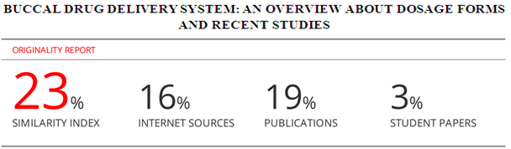

**BUCCAL DRUG DELIVERY SYSTEM: AN OVERVIEW ABOUT**

**DOSAGE FORMS AND RECENT STUDIES**

**ABSTRACT**

Buccal drugadministarion and delivery has attracted important interest inrecent years especially in terms of possibility of buccal administration of already existing medicines administered *via* different routesand as well as to develop various formulations for administration of novel pharmaceutical active agents. The advantages of oral mucosahas gain importance for local and systemic drug delivery due to its high blood flow, prevention of hepatic first-pass effect, rapid recovery and good absorption profile. This review provides information about the potential of buccal drug delivery systems, different dosage forms and recent studies.

**Keywords:** Buccal drug delivey, buccal dosage forms, advantages, disadvantages.

**INTRODUCTION**

Drug research and development has been progressing in improving the quality of life of patients as well as contributing to the treatment of diseases [1,2]. Buccal drug administration has remarkable advantages such as prevention of elimination and first-pass effect in the gastrointestinal tract, having a more favorable enzymatic environment for the absorption of certain drugs, easy to administer to pediatric, geriatric patients and patients with intellectual disabilities and having low cost. [2-4] The oral mucosa is highly vascularized, drugs absorbed through the mucosa bypass the first-pass metabolism and enter the systemic circulation directly. Furthermore, the high blood flow and permeability of the oral mucosa makes it an ideal site of administration for the rapid systemic delivery of a drug in the treatment of pain, seizures and angina pectoris [6-7]. When transmucosal drug administration routes are compared among themselves, buccal route is prominent with patient compliance. Rectal and vaginal delivery systems are in part less acceptable ways for patients. In terms of drug administration, rectal and vaginal administration may sometimes lead to slow and sometimes incomplete drug absorption and may vary in the same person or between individuals [5]. For nasal application; The limited area of ​​the nasal cavity, the rapid removal of the administered drug, and the variable physiological functions of the nasal cavity are among the disadvantages of this application. [7].

With the development of mucoadhesive formulations, the local and systemic effects of drug delivery systems have increased. The likelihood of using biological agents such as genes, peptides and antibodies that can be reduced by the administration of oral mucosa may increase [7,8]. Pharmaceutical researchers are conducting further research on the development of novel drug delivery systems to enhance the therapeutic effects of existing molecules relative to novel drug molecules. At this point, buccal drug systems are thought to have great potential and this review summarizes general information about buccal drug delivery systems and provides information about recent studies.

**Anatomical Structure of Oral Cavity**

The oral cavity consists of the lips, cheeks, tongue, hard palate, soft palate and the base of the mouth, and its surface consists of oral mucosa (Figure 1). Oral mucosa; buccal, sublingual, gingival, palatal and labial mucosa, buccal mucosal tissues (buccal), the bottom of the mouth (sublingual) and the ventral surface of the tongue accounts for about 60% of the oral mucosal surface area (Figure 2) [9]. Buccal and sublingual tissues are suitable site for buccal administration and these are the regions with the highest permeability in the oral mucosa [10]. The epithelium of the oral cavity resembles the skin epithelium, but exhibits distinct characteristics from the skin in terms of keratinization, protective and lubricating mucus. Mucus is a translucent and viscous secretion that forms a thin and continuous gel layer that adheres to the mucosal epithelial surface. Generally, mucus components; water (95%), glycoproteins and lipids (0.5-5%), mineral salts (1%) and free protein (0.5-1%). Saliva produced by the salivary glands in the oral cavity and as part of the saliva, mucus secreted from the major and minor salivary glands are present, allowing the adhesion of mucoadhesive drug delivery systems during drug administration [11,12].

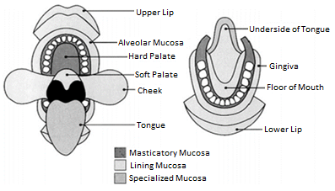

**Figure 1.** Schematic representation of the different linings of mucosa in mouth [9].

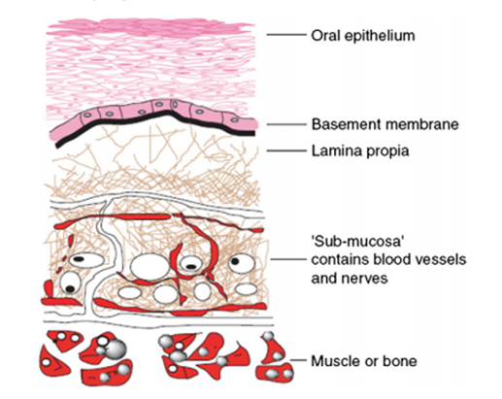

**Figure 2.** Structure of the oral mucosa [9].

**The Advantages and Disadvantages of Buccal Drug Administration**

The buccal area has a highly vascularized tissue and a neutral environment. The route of drugs through the buccal mucosa is like a slow i.v. infusion. Thus higher bioavailability of some medicines may be achieved with less doses compared to conventional oral dosage forms. Absorption, the size of the drug molecule, its sensitivity to hydrophilicity, its enzymatic degradation, and its application to the oral cavity need to be taken into consideration to accomplish the above mentioned achievement [13-15].The advantages and disadvantages of buccal drug deliveryis summarized in Table 1.

**Table 1.** The advantages and disadvantages of buccal drug delivery [16].

|  |  |
| --- | --- |
| **Advantages of buccal drug delivery** | **Disadvantages of the buccal drug delivery** |
| * Easy application and termination of dosage form. * The drug remains in the oral cavity for a long time. * It is applicable to pediatric, geriatric and unconscious patients. * Drugs can be protected from the first-pass metabolism. * Higher bioavailability of drug can be achieved. * Allows lower doses and decrease side effects. * Permeability is higher than in skin. Therapeutic serum concentrations of the drug can be achieved more rapidly. * Since enzymatic activity is prevented, the active agents such as peptides, proteins and ionized forms can be incorporated to buccal dosage forms. | * Drug administration *via* this route has certain limitations. * Drugs that are irritant, having unpleasant taste or odor is not suitable. * Drugs that are unstable at buccal pH cannot be administered. * Only drugs with a small dose requirement can be administered. * Only drugs that are absorbed by passive diffusion can be administered. * Drugs that have passed into swallowed saliva follow the peroral route need to be consider. * Hydration may result in the unwanted deformation of buccal dosage form. * The buccal mucosa is less permeable than the small intestine, rectum, etc. Surface area available for absorption is less.   Possibility of swallowing of the buccal dosage form, thus eating and drinking may be restricted. |

**BUCCAL DOSAGE FORMS AND APPLICATIONS**

Numerous dosage forms are available for buccal administration, such as tablets, films, lozenges, sprays, gels, lollipops, gums and powders. In addition, new formulations such as sponges can be used for buccal drug administration [17,18]. Various types of buccal dosage forms are presented inFigure 3 [19].

Buccal dosage forms include dry dosage forms that need to be moistened before buccal tablets are administered [12]. In recent years, various mucoadhesive buccal tablet formulations have been prepared by direct compression for local or systemic effect. Buccal tablets can be developed to release the active ingredient into the saliva either unidirectionally or multidirectionally by targeting the buccal mucosa [18]. The buccal films / patches comprise an impermeable layer of the active substance / formulation, a reservoir layer containing the formulation in which the active substance is released in a controlled manner, and a mucoadhesive surface for attachment to the mucosa. Compared to creams and ointments, they are more advantageous in delivering a certain dose of the drug to the site [20]. Buccal films are more preferred than buccal tablets. Because buccal tablets are more flexible and can be applied more easily. In addition, they can reduce pain by protecting the wound surfaces and improve treatment efficacy [21].Buccal films are particularly designed for pediatric patients [22].

Buccal gels and ointments are semi-solid dosage forms and have the advantage of easy administration to the buccal mucosa. The problem of low adhesion of the gels in the field of application was overcome by the preparation of mucoadhesive formulations [2]. Buccal gels or ointments are less preferred by patients than buccal tablets and films, but are generally administered for local effect [12].

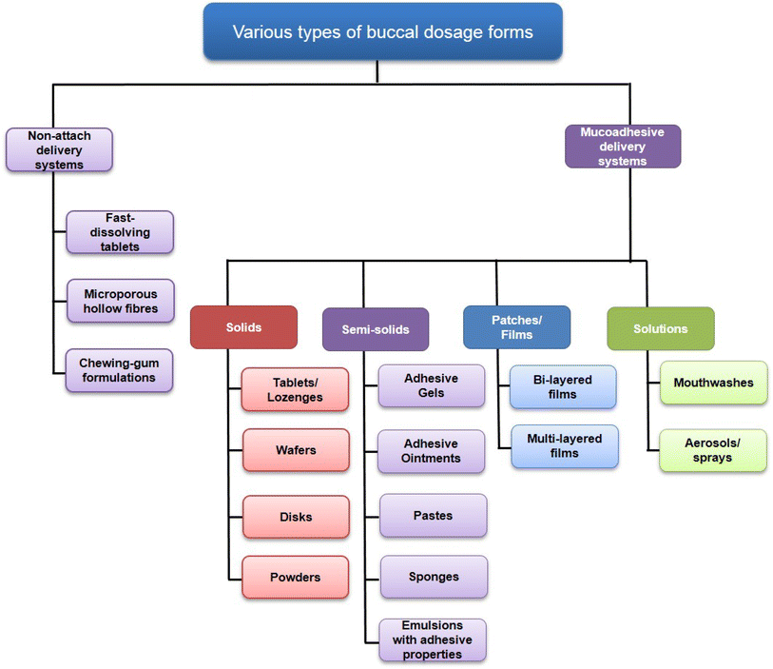

**Figure 3.**Various types of buccal dosage forms [19].

Buccal dosage forms may be developed for systemic effect or for local treatment of the oral mucosa. When selecting the dosage form, the target site of action and the properties of the active substance should be considered [23]. For mucosal and transmucosal administration, conventional dosage forms cannot provide therapeutic drug levels in the mucosa and circulation due to the physiological nature of the oral cavity (the presence of saliva and the effect of mechanical stress). The constant flow of saliva and the mobility of tissues within the mouth makes it difficult to keep the dosage form in the oral cavity. The residence time of medications administered to the oral cavity is generally between 5 and 10 minutes. Since the dosage form remains in the absorption area for a very short time, an unpredictable distribution is observed. In order to achieve the desired therapeutic effect, it is important to increase the contact time between the formulation and the mucosa. For this purpose, mucoadhesive buccal formulations are developed using mucoadhesive polymers. To develop an ideal mucoadhesive buccal drug delivery system, it is important to identify and understand the forces responsible for adhesive bond formation [24]. There are three sites that are effective for the formation of adhesive bonds between the polymer and mucus:

* Surface of bioadhesive material
* First layer of mucosa
* Interface between mucosa and bioadhesive material

The adhesion mechanisms of polymers to mucosal surfaces have not yet been fully understood. However, various theories such as adsorption theory, wetting theory, electrical theory, diffusion theory and fracture theory have been proposed[11,25];

In particular, buccal systems are needed to treat local diseases of the mucosa [24,26]. In order to provide therapeutic requirements, buccal dosage forms include; penetration enhancers to increase the permeability of the active substance by transmucosal administration or mucosal administration; enzyme inhibitors to protect the active substance from degradation by mucosal enzymes. Due to the limited absorption area with respect to the site of administration of the buccal dosage form, they are generally preferred for a buccal delivery system of 1-3 cm2 and for active ingredients with a daily dose of 25 mg or less. The ellipsoidal shape is most preferred in films / patches and the thickness of buccal drug delivery systems is generally limited to a few millimeters [27]. Many diseases can affect the thickness of the buccal epithelium and ultimately alter the barrier property of the mucosa. Some diseases or treatments may also affect mucus secretion and properties [11]. Due to these physiopathological conditions, changes in the mucosal surface may make it difficult to administer and retain a buccal delivery system. Therefore, it is necessary to evaluate the structure of the mucosa under the relevant disease conditions in order to develop an effective buccal release system. In addition, it should be noted that active substances that have the potential to alter the physiological conditions of the oral cavity may not be suitable for buccal administration [27].

**RECENT STUDIES AND ON BUCCAL DRUG DELIVERY AND FUTURE APPROACHES**

Pather *et al.* summarized challenges for the development and approval of buccal dosage forms and they briefly summarized them as; including low dose drugs, biology and permeability issues and the complexity of them, need a special mechanismto enhance the absorption of the drug without causing undue side effects, the taste of the drug and patient acceptability, dose titration for in vivo studies may prove to be difficult,

difficulties related with regulations, authorities and economical circumstances [28]

The major obstacle to the use of many hydrophilic macromolecules is inadequate and irregular oral absorption. With the development of recombinant DNA technology, buccal administration is thought to be important in order to develop protein and peptide formulations in the future and deliver them to the systemic circulation by a non-parenteral administration [26]. In line with recent developments in buccal drug delivery systems such as lipophilic gel, buccal spray and phospholipid vesicles, numerous studies have been conducted on the buccal administration of peptides. In particular, some researchers have proposed the use of glyceryl monooleate phases of cubic and lamellar liquid crystals as buccal drug delivery systems for peptide-structured drugs [29]. Some researchers have developed liquid crystal systems for the buccal administration of KSL-W, an antimicrobial decapeptide to treat multispecific oral biofilms [30]. In addition, a new insulin liquid aerosol formulation has been developed. This formulation has been shown to allow metered dose insulin administration in the form of aerosolized droplets for buccal administration. Compared to conventional dosage forms, a significant increase in the level of the active ingredient has been shown in the buccal dosage form. Studies have shown that this oral aerosol formulation is rapidly absorbed from the buccal mucosa and provides the necessary postprandial plasma insulin levels in diabetic patients. This new, painless, oral insulin formulation; rapid absorption, an application technique with high patient compliance and full dosing have been reported to have many advantages [31]. Another interesting novel buccal formulation used gold nanoparticle technology to form a film soluble in buccal mucosa. Clinical trials have been reached in two approaches to insulin buccal administration: oromucose sprays of the peptide, a permeability enhancing film, and gold nanoparticles embedded in a soluble film [32,33].

In another study, soy lecithin and propanediol were used for insulin buccal spray formulation. Soy lecithin has a high affinity for biological membranes, but its solubility is low and the solubility of propandiol and soy lecithin could be increased. Insulin buccal spray was applied to diabetic rabbits and the hypoglycemic effect of the formulation was investigated. When the results were examined, it was shown that there was a significant decrease in blood glucose levels of rabbits treated with insulin buccal spray compared to the control group. To investigate insulin delivery from the buccal mucosa, the distribution of fluorescence probe in the epithelium using confocal laser scanning microscopy and fluorescence probe isothiocyanate-labeled insulin penetration were examined. The results demonstrated that the fluorescent probe isothiocyanate-labeled insulin can pass through the buccal mucosa, and that insulin passes through the epithelium, which includes both intracellular and paracellular pathways [34]. The world's first approved transbuccal release system for testosterone replacement therapy in men is a mono-convex, tablet-like mucoadhesive buccal system, with a recommended dose of 30 mg at a 12-hour interval. This transbuccal delivery system is presented as an alternative to patches, gels or injectable testosterone formulations [21,35]. Biodegradable mucoadhesive drug technology has been developed to provide both local and systemic effects of drugs in mucosal tissues, and includes a small disc with biodegradable layers that enable rapid release of the active ingredient over a period of time. This disc adheres to the buccal mucosa and transmits the active ingredient to the mucosa while eroding in the mouth [36]. Transmucosal administration is also thought to provide significant benefit in the application of new classes of biological drugs, such as nucleic acids, antibodies, and proteins [26].A recent study was showed succeded results which wereaimed to design and evaluate zolpidem nanoparticle-impregnated buccal films for the treatment of insomnia with a prolong drug action. Zolpidem-loaded PLGA nanospheres were succeded in vitro and in vivo tests. [37]. In another recent study it was shown that nabumetone, nonsteroidal anti-inflammatory drug, including buccal films were prepared using polymers like HPMC, Eudragit, sodium alginate, and sodium CMC in varying proportions were subjected to in vitro quality control parameters ex-vivo permeation and stability studies and the formulations showed optimum results and good control over dug release along with correlation between in-vitro and ex-vivo studies [38].

Although there are many formulation studies have been reported in the literature, particularly to improve retention and absorption in the buccal and sublingual regions, very few of them have translated to the clinical phase. This is because it needs to be a clear benefit of efficacy and/or safety with any new drug formulation compared to clinically available dosage forms [39]. In addition, comprehensive evaluations of the pharmacokinetics, stability, efficacy, and safety of the formulations are required in appropriate animal models as well as in clinical studies, based on regulatory standards and protocols. [40]

Gilhotra et al. has overwieved mucoadhesive buccal drug delivery systems in terms of a clinical perspective and studies have shown that buccal drug delivery will be increase for the treatment of cardiovascular diseases, migraine, epilepsy and antimicrobial, anti-inflammatory, hypoglycaemia, muscle relaxation, emesis concomitant chemotherapy, smoking deterrent therapies and also for protein and hormone delivery [41]. An ongoing clinical studies a buccal film study has begun ion April 13 2019 for the treatment of epilepsy as diazepam containing buccal film [42].

Nanoparticulate systems have been incorporated into various dosage forms for buccal drug delivery, including gels [43], sprays [44], tablets [45,46], films [47,48,49] and patches [50]. These nanoparticulate formulations have been shown to: (i) improve drug permeability across the epithelium; (ii) modify drug release kinetics (e.g., controlled release or sustained release); (iii) provide solubilization (i.e., to deliver compounds which have physicochemical properties that strongly limit their aqueous solubility); and/or (iv) protect compounds that are sensitive to degradation (e.g., peptides). These factors all aim to promote higher sublingual or buccal bioavailability of drugs for subsequent systemic absorption [39,51].

**CONCLUSION**

The buccal mucosa provides many advantages for local and systemic drug administration. Buccal drug administration is an important field of research as it allows for systemic administration of drugs with low oral bioavailability. It is also a suitable alternative in the delivery of peptides and protein-structured drugs. Pediatric population still great need of developing flexible and appropriate drug dosage forms, it is expected to develop new and more buccal dosage forms especially designed for pediatric applications that can improve transepithelial drug permeability and improve existing therapies and allow new forms of treatment.

**REFERENCES**

1. Santanu RC, Pooja S. Floating Drug Delivery System - A New Era in Novel Drug Delivery System. Int J Pharma Chem Res Bio-Sci (IJRBS) 2012;1(5): 91-107.
2. Verma S, Kaul M, RawatA, Saini S. An Overview On Buccal Drug Delivery System.Int J Pharm Sci Res. 2011;2(6):1303-1321.
3. Lin L, Wong H. Predicting oral drug absorption: Mini review on physiologically-based pharmacokinetic models. Pharmaceutics. 2017;9(4): 41. doi:10.3390/pharmaceutics9040041
4. Madhavi BR, Murthy VSN, Rani AP, Kumar GD. Buccal Film Drug Delivery System-An Innovative and Emerging Technology. J Mol Pharm Org Process Res 2013;1(3): 107. doi: 10.4172/2329-9053.1000107
5. Dodou K. Rectal and vaginal drug delivery.In: Aulton's Pharmaceutics: The Design and Manufacture of MedicinesEdition: 5th EditionPublisher: Elsevier Editors: Michael Aulton, Kevin Taylor. 2013: 732-751.
6. De Caro V, Giandalia G, Siragusa MG, Sutera FM, Giannola LI. New prospective in treatment of Parkinson’s disease: Studies on permeation of ropinirole through buccal mucosa. Int J Pharm. 2012;429(1-2)78-83.
7. Hearnden V, Sankar V, Hull K, Juras DV, Greenberg M, Kerr AR, Lockhart PB, Patton LL, Porter S, Thornhill MH. New developments and opportunities in oral mucosal drug delivery for local and systemic disease. Adv Drug Deliv Rev. 2012;64(1):16-28. doi:10.1016/j.addr.2011.02.008
8. Smart JD. Buccal drug delivery. Expert Opin Drug Deliv. 2005;2(3):507-517. doi:10.1517/17425247.2.3.507
9. Patel VF, Liu F, Brown MB. Advances in oral transmucosal drug delivery. J Control Release. 2011;153(2):106-116. doi:10.1016/j.jconrel.2011.01.027
10. Zhang H, Zhang J, Streisand JB. Oral mucosal drug delivery: clinical pharmacokinetics and therapeutic applications. Clin Pharmacokinet. 2002;41(9):661-680. doi:10.2165/00003088-200241090-00003
11. Shinkar DM, Dhake AS, Setty CM. Drug delivery from the oral cavity: A focus on mucoadhesive buccal drug delivery systems. PDA J Pharm Sci Technol. 2012;66(5):466-500. doi:10.5731/pdajpst.2012.00877
12. Reddy RJ, Anjum M, Hussain MA. A Comprehensive Review on Buccal Drug Delivery System.American Journal of Advanced Drug Delivery www.ajadd.co.uk. Accessed September 24, 2019.
13. Costa JSR, de Oliveira Cruvinel K, Oliveira-Nascimento L. A mini-review on drug delivery through wafer technology: Formulation and manufacturing of buccal and oral lyophilizates. J Adv Res. 2019;20:33-41.
14. Çelik B. Risperidone mucoadhesive buccal tablets: formulation design, optimization and evaluation. Drug Des Devel Ther. 2017;11:3355-3365.
15. Campisi G, Paderni C, Saccone R, Fede O, Wolff A, Giannola L. Human buccal mucosa as an ınnovative site of drug delivery. Curr Pharm Des. 2010;16(6):641-652.
16. Patel, Manish P, Bharadia PD, Chhabria MT. A Systemic Review on Buccal Drug Delivery Systems. SciFed Mater Res Lett. 2017;1(3):1-7.
17. Çelik B, Özdemir S, Demirkoz AB, Üner M. Optimization of piribedil mucoadhesive tablets for efficient therapy of Parkinson’s disease : physical characterization and ex vivo drug permeation through buccal mucosa. Drug Dev Ind Pharm 2017; 43(11): 1836-1845.
18. Hao J, Heng PWS. Buccal delivery systems. Drug Dev Ind Pharm. 2003;29(8):821-832.
19. Barua S, Kim H, Jo K, Seo CW, Park TJ, Lee KB, Yun G, Oh K, Lee J.Drug delivery techniques for buccal route: formulation strategies and recent advances in dosage form design. Journal of Pharmaceutical Investigation. 2016; 46(7): 593-613.
20. Chinna Reddy P, Chaitanya KSC, Madhusudan Rao Y. A review on bioadhesive buccal drug delivery systems: Current status of formulation and evaluation methods. J Pharm Sci. 2011;19(6):385-403.
21. Venkatalakshmi R, Sudhakar Y, Madhuchudana Chetty C, Sasikala C, Mohan Varma M. Buccal drug delivery using adhesive polymeric patches. Int J Pharm Sci. 2012;3(1):35-41.
22. Trofimiuk M, Wasilewska K, Winnicka K. How to Modify Drug Release in Paediatric Dosage Forms? Novel Technologies and Modern Approaches with Regard to Children’s Population. Int J Mol Sci. 2019; 20(13); 1-22. doi:10.3390/ijms20133200
23. Khanvilkar K, Donovan MD, Flanagan DR. Drug transfer through mucus. Adv Drug Deliv Rev. 2001;48:173-193.
24. Rençber S, Yaprak S, Yılmaz FF, Eraç B, Nenni M, Gurer-Orhan H, Hoşgör Limoncu M, Güneri P, Ertan G. Formulation and evaluation of fluconazole loaded oral strips for local treatment of oral candidiasis. J Drug Deliv Sci Technol. 2019;49:615-621.
25. Boddupalli BM, Mohammed ZN, Nath RA, Banji D. Mucoadhesive drug delivery system: An overview. J Adv Pharm Technol Res. 2010;1(4):381–387.
26. Puratchikody A, Prasanth VV., Mathew S, Balaraman AS. Buccal drug delivery: Past, present and future - A review. Int J Drug Deliv. 2011; 3(2): 171-184.
27. Salamat-Miller N, Chittchang M, Johnston TP. The use of mucoadhesive polymers in buccal drug delivery. Adv Drug Deliv Rev. 2005; 57: 1666-1691.
28. Pather SI, Rathbone MJ, Şenel S. Current status and the future of buccal drug delivery systems. Expert Opinion on Drug Delivery. 2008; 5(5): 531-542.
29. Lee J, Kellaway IW. Buccal permeation of [D-Ala2 , D-Leu5 ]enkephalin from liquid crystalline phases of glyceryl monooleate. 2000; 195(1-2): 35-38.
30. Bernegossi J, Calixto GM, Sanches PR, Fontana CR, Cilli EM, Garrido SS, Chrolli M.al. Peptide KSL-W-loaded mucoadhesive liquid crystalline vehicle as an alternative treatment for multispecies oral biofilm. Molecules. 2015; 21(1): 1-14.
31. Modi P, Mihic M, Lewin A. The evolving role of oral ınsulin in the treatment of diabetes using a novel RapidMist Systems. Diabetes Metab Res Rev. 2002; 18(1): 38-42.
32. Easa N, Alany RG, Carew M, Vangala A. A review of non-invasive insulin delivery systems for diabetes therapy in clinical trials over the past decade. Drug Discov Today. 2019; 24(2): 440-451.
33. Morales JO, Brayden DJ. Buccal delivery of small molecules and biologics: of mucoadhesive polymers, films, and nanoparticles.Curr Opin Pharmacol. 2017; 36: 22-28.
34. Bhati R, Nagrajan RK. A detailed review on oral mucosal drug delivery system. Int J Pharm Sci Res. 2012; 3(3): 659-681.
35. Wang C, Swerdloff R, Kipnes M, Matsumoto AM, Dobs AS, Cunningham G, Katznelson L, Weber TJ, Friedman TC, Snyder P, Levine HL. New Testosterone buccal system (Striant) delivers physiological testosterone levels : pharmacokinetics study in hypogonadal men. J Clin Endocrinol Metab. 2004; 89(8): 3821-9.
36. Batchelor H. Novel bioadhesive formulations in drug delivery. Drug Deliv Co Rep Autumn/Winter, Pharma Ventur Ltd. 2004.
37. Al-Dhubiab BE. In vitro and in vivo evaluation of nano-based films for buccal delivery of zolpidem. Braz. Oral Res. 2016; 30(1): e126. http://dx.doi.org/10.1590/1807-3107bor-2016.vol30.0126
38. Tangri P, Jawla S, Mishra R. Constitution and assessment of nabumetone loaded buccal films. Chronicles of Pharmaceutical Science 2019; 4(1): 22-29.
39. Hua, S., de Matos, M. B. C., Metselaar, J. M., Storm, G. Current Trends and Challenges in the Clinical Translation of Nanoparticulate Nanomedicines: Pathways for Translational Development and Commercialization. Front. Pharmacol. 2018; 9: 790. doi: 10.3389/fphar.2018.00790
40. Hua S. Advances in Nanoparticulate Drug Delivery Approaches for Sublingual and Buccal Administration. Front. Pharmacol. 2019; 10:1328. doi: 10.3389/fphar.2019.01328
41. Gilhotra, R. M., Ikram, M., Srivastava, S., & Gilhotra, N. (2014). A clinical perspective on mucoadhesive buccal drug delivery systems. Journal of biomedical research, 28(2), 81.
42. Diazepam Buccal Film - Diastat Rectal Gel Crossover Study ClinicalTrials.gov Identifier: NCT03953820, Date of access is 14.11.2019 on https://clinicaltrials.gov/ct2/show/NCT03953820
43. Marques, A. C., Rocha, A. I., Leal, P., Estanqueiro, M., Lobo, J. M. S. Development and characterization of mucoadhesive buccal gels containing lipid nanoparticles of ibuprofen. Int. J. Pharm. 2017; 533 (2): 455–462. doi: 10.1016/j.ijpharm.2017.04.025
44. Baltzley, S., Malkawi, A. A., Alsmadi, M., Al-Ghananeem, A. M. Sublingual spray drug delivery of ketorolac-loaded chitosan nanoparticles. Drug Dev. Ind. Pharm. 2018; 44 (9): 1467–1472. doi: 10.1080/03639045.2018.1460378
45. Gavin, A., Pham, J. T., Wang, D., Brownlow, B., Elbayoumi, T. A. Layered nanoemulsions as mucoadhesive buccal systems for controlled delivery of oral cancer therapeutics. Int. J. Nanomed. 2015; 10: 1569–1584. doi: 10.2147/IJN.S75474
46. El-Nahas, A. E., Allam, A. N., El-Kamel, A. H. Mucoadhesive buccal tablets containing silymarin Eudragit-loaded nanoparticles: formulation, characterisation and ex vivo permeation. J. Microencapsul. 2017; 34 (5): 463–474. doi: 10.1080/02652048.2017.1345996
47. Masek, J., Lubasova, D., Lukac, R., Turanek-Knotigova, P., Kulich, P., Plockova, J., et al. (). Multi-layered nanofibrous mucoadhesive films for buccal and sublingual administration of drug-delivery and vaccination nanoparticles - important step towards effective mucosal vaccines. J. Control Release 2017: 249: 183–195. doi: 10.1016/j.jconrel.2016.07.036
48. Castro, P. M., Baptista, P., Madureira, A. R., Sarmento, B., Pintado, M. E. (2018). Combination of PLGA nanoparticles with mucoadhesive guar-gum films for buccal delivery of antihypertensive peptide. *Int. J. Pharm.* 2018; 547 (1-2): 593–601. doi: 10.1016/j.ijpharm.2018.05.051
49. Al-Nemrawi, N. K., Alsharif, S. S. M., Alzoubi, K. H., Alkhatib, R. Q. Preparation and characterization of insulin chitosan-nanoparticles loaded in buccal films. *Pharm. Dev. Technol.* 2019; 24 (8): 967–974. doi: 10.1080/10837450.2019.1619183
50. Mahdizadeh Barzoki, Z., Emam-Djomeh, Z., Mortazavian, E., Akbar Moosavi-Movahedi, A., Rafiee Tehrani, M. Formulation, *in vitro* evaluation and kinetic analysis of chitosan-gelatin bilayer muco-adhesive buccal patches of insulin nanoparticles. *J. Microencapsul.* 2016; 33 (7): 613–624. doi: 10.1080/02652048.2016.1234513
51. Morales, J. O., Brayden, D. J. Buccal delivery of small molecules and biologics: of mucoadhesive polymers, films, and nanoparticles. *Curr. Opin. Pharmacol.* 2017; 36: 22–28. doi: 10.1016/j.coph.2017.07.011