**Reviewer’s Comments**

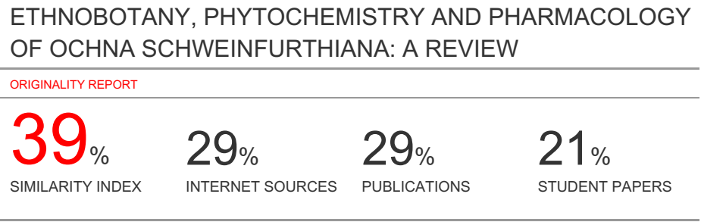

**ETHNOBOTANY, PHYTOCHEMISTRY AND PHARMACOLOGY OF *OCHNA SCHWEINFURTHIANA*: A REVIEW**

**Abstract**

***Ochna schweinfurthiana***(*Os*, Family: Ochnaceae) is a small evergreen tree used in ethnomedicine to treat different ailments; it is also used in agri-horticulture and as ornaments, dyes among others. Chemical investigations conducted on the different parts of the plant have been confined to phenolic compounds majorly bioflavonoids, glycosides, steroids and terpenes. The plant, *Os* have shown a wide spectrum of biological and pharmacological properties which include antimicrobial, cytotoxic/antiproliferative, genotoxicity, antinociceptive, anti-inflammatory, antioxidant and antiplasmodial. This review comprehensively summarize the potential effects of the plant *Os* chemically and pharmacologically (*in vitro and in vivo*).

However, more researches in the aspect of phytochemical and biological studies are needed to exhaustively isolate bioactive compounds and evaluate their effects on other ailments as claimed by the traditional healers.

**Keywords:** *Ochnaceae*, antimicrobial, antiproliferative, anti-inflammatory, antiplasmodial, bioflavonoids, glycosides, steroids, toxicity

1. **Introduction**

*Ochna schweinfurthiana*(*Os*)belonging to the *Ochnaceae*family is a small tree that was named after a German botanical collector and taxonomist Dr. Georg August Schweinfurth; it is an attractive tropical small tree that measures up to 4 m tall and the plant is commonly known as the brick-red Ochna in English, Jan-taru in Hausa language, Hiéké in Yoruba and Sa’aboule in Foufouldé (Burkill, 1985; Messi e*t al.,* 2016).The plant can be used as medicine, for agricultural, social and religious purposes (Burkill, 1985). This review will focus on the phytochemical and pharmacological properties of *Os*.

1. **Main text**

**2.1 Botanical Description**

*Ochna* originated from a Greek word “*Ochne*which means wild pear”. It was named by Linnaeus in 1951 as *Ochna* because of the resemblance of their leaves with those of wild pear (Muema, 2015). Itis an old world genus of mainly trees, shrubs and shrublets which comprises of about 85 species (Verdcourt, 2005) and it is widely distributed widely in tropical Asia, Africa and America (Rendle, 1952) of which eleven (11) species occur in India (Kirtikar, 2012). *Ochna’s* are usually called Mickey Mouse plants, as a result of the appearance of their black druplets fruits sitting.The *Ochnaceae*family is mainly comprised of trees and shrubs with about 33 genera and 550 species (Christenhusz and Byng, 2016) which are highly distributed around the globe; the species are mostly found in Tropical Africa, Asia, Australia, Madagascar, the Mascarene island and America (Mabberley, 2008). They are notably known for their unusual leaves that are shiny, with closely spaced, parallel veins, toothed margins, and conspicuous stipules (Burkill, 1985; Christenhusz and Byng, 2016). The largest genera are *Ouratea*, *Ochna*,*Campylospermum*,*Sauvagesia*and*Quiina*with(200, 85, 65, 39 and 34 species) respectively (Table 1).

Table 1: Ochnaceae subfamilies and their estimated number of species

|  |  |
| --- | --- |
| **Subfamily** | **Estimated number of species** |
| Ouratea | 200 |
| Ochna | 85 |
| Campylospermum | 65 |
| Sauvagesia | 39 |
| Quiina | 34 |
| Total | 423 |

Source: (Simpson, 1979)

**2.2 Morphology**

*O.schweinfurthiana* is a shrub or small evergreen treethat grows up to 4 m tall and it has a dark grey bark that is fissured and cracked, separating into square segments (Hyde *et al*., 2019). The leaves are olive-green (1-13.5 x 1.7-5.5cm)that oblanceolate to oblong or elliptic, apex somewhat rounded, base tapers into the petiole, margins rather bluntly toothed (serrulate), sometimes appearing almost scalloped, net-veining conspicuous on the upper surface and young leaves are coppery (Burkill, 1985; Anonymous, 2019).It bears bright yellow flowers (1.5 cm diameter) which are sweetly-scented from September to November, very short-lived, normally appearing before or with the young leaves (Hyde *et al.,* 2019). In addition, it appeared in a condensed receme with 4 – 10 flowers on a short central stem and the petals fall very early (Anonymous, 2019). The fruits of *Os*are 1-5 ovalappear between August and January, attached at the base are 2 – 4 black berries when ripe; they are enlarged, borne on brick-red persistent sepals turning cherry to brick-red. The bark is dark grey, thick, and deeply fissured into a grid-like pattern (Anonymous, 2019; Hyde *et al.,* 2019).

**2.3 Taxonomy**

**Kingdom:** Plantae

**Order:** Malpighiales

**Family:** Ochnaceae

**Subfamily:** Ochnoideae

**Genus:** Ochna

**Species:***O. schweinfurthiana*(Simpson, 1979)

**2.4 Common names**

**English:** Brick-red Ochna

**Hausa:**Jan-taru

**Yoruba:**Hiéké

**Foufouldé:**Sa’aboule

**2.5 Habitat, Distribution and Ecology**

The plant grows in open deciduous woodland in tropical regions in Africa from Guinea to northern and Southern Nigeria and across central Africa to Sudan, Uganda, Zimbabwe, Mozambique, Tanzania and Angola. It has medium water requirement when young and growths fast, flowers from September to November. It required low maintenance and attracts insects and birds (Verdcourt 2005;Hyde *et al*., 2019).

**2.6 Picture of *O. schweinfurthiana***

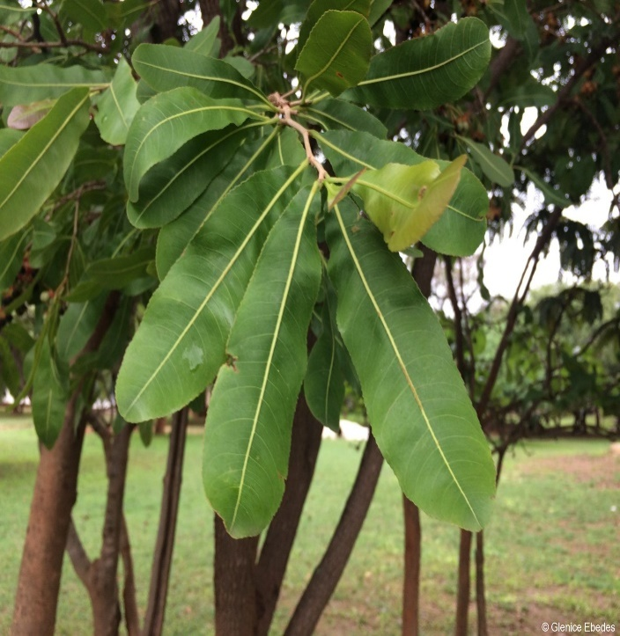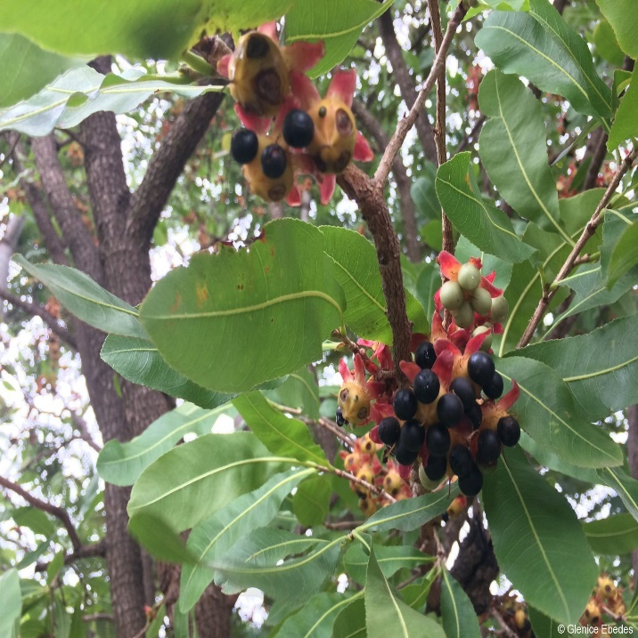

Figure 1 & 2

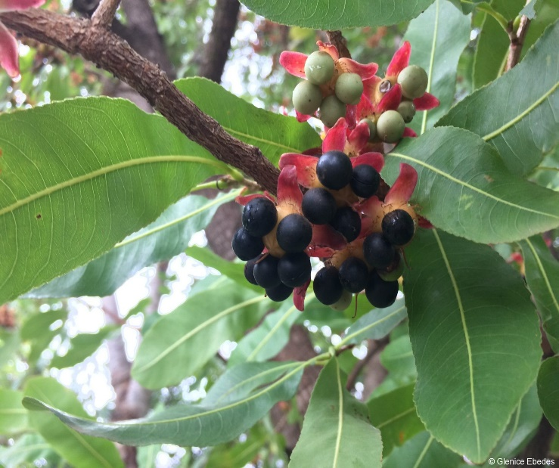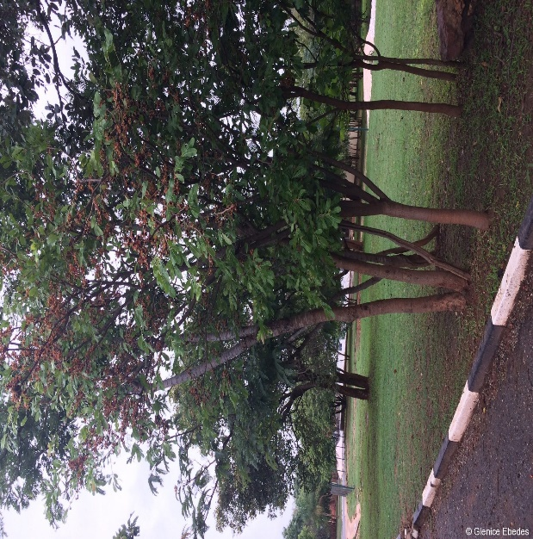

Figure 3 & 4

**Legends &Captions**

Figure 1 & 2: Leaf and fruits of *O. schweinfurthiana* (Photograph by GleniceEbedes)

Figure 3 & 4: Branch with fruits and whole plant of *O. schweinfurthiana* (Photograph byGleniceEbedes)

1. **Uses**

**3.1 Ethnomedicinal uses**

Several preparations (powdered and decoction) of the leaves and/or root of the *Os* have found a general use as an antimicrobial (wound dressing, eye infection), analgesic, anti-inflammatory and anthelmintic agents (Burkill, 1985). The leaf is also used as a laxative, enema, febrifuge, antiseptic, stimulant, among others (Burkill, 1985). In Northern Cameroon, *Os* is used to treat different metabolic diseases such as rubella, burns, stomachache and multiple sclerosis (Abdullahi *et al.,* 2010); the root of the plant is also used to treat headache, stomach and eye aches while the leaves are used in the treatment of toothaches (Messi*et al*., 2016).

The powdered bark is used as antimalarial, febrifuges and anthelminthic, while the decoction of the root, leaves or bark is used in dressing wounds (Abdullahi *et al*., 2010). In Northern Nigeria, the plant is used for the treatment of measles, typhoid fever and fungal skin infections (Abdullahi *et al*., 2010). The macerated roots of *Os* has been reportedly used to induce/speed the delivery process and for miscarriage (Bruschi*et al*., 2011).

**3.2 Other uses**

The plant is used in agri-horticulture; the bark and flowers *Os*are cultivated for ornaments, dyes, stains, inks, tattoos and mordent among others. The wood is used for farming, forestry, hunting and fishing apparatus. The leaf has social, religious, superstitious and magic values among others (Burkill, 1985).

1. **Phytochemistry**

**4.1 Phytochemical screening**

Abdullahi *et al*.(2010)reported the presence of flavonoids, steroids/terpenes and saponins in the acetone leaf extract of *Os* and the methanol leaf extract indicated the presence of flavonoids and saponins. However, flavonoids, saponins, glycosides, tannins and steroids/terpenes were reported on the methanol stem extract of *Os*(Danmusa*et al*., 2015).A study conducted by Ibrahim *et al*. (2015) reported the presence of carbohydrates, steroids/triterpenes, glycosides, saponins, tannins and flavonoids in the methanol leaf extract of *Os*.

* 1. **Bioactive constituents**

The main bioactive constituents isolated from *Os* fall under the following class of secondary metabolites; phenolic – flavonoids,glycosides and sugars.

*Os* have been reported to contain phenolic derivatives (such as flavonoids, bioflavonoids)which appear as free or in polymerized forms. Isolation and characterization of quercetin-3-*O*-β-D-glucopyronosyl-(1→6)-α-rhamnoside (**1**) (quercetin rutinoside) from the *n*-butanolsoluble fraction of methanolicleaf extract of *Os* was reported (Abdullahi *et al*., 2011). A novel compound, tri-methoxy lophirone (**2**) was isolated from the chloroform soluble fraction of the methanol root extract of *Os* (Abdullahi *et al*., 2014).

Ndongo*et al*. (2015)reported the isolation of seven flavonoids, hemerocallone (**3**), 6,7-dimethoxy-3',4'-dimethoxyisoflavone(**4**), amentoflavone (**5**), agathisflavone (**6**), cupressuflavone (**7**), robustaflavone (**8**), and epicatechin (**9**), and three other compounds including, lithospermoside (**10**), β-D-fructofuranosyl-α-D-glucopyranoside (**11**) and 3β-*O*-D-glucopyranosyl-β-stigmasterol (**12**) from the ethyl acetate extract of the stem bark of *Os*.

The roots of *Os* were reported to contain three new compounds viz; 4'''-methoxylophirone A (**13**), 4,4',4'''–trimethoxylophirone A (**14**) and (4E,7Z)-3,8-dicarboxy-1-(*O*-β-D-glucopyranosyl-(1→6)-*O*-β-D-glucopyranosyl-2,9-dihydroxyhexeicosa-4,7-diene (**15**). Six known compounds were also identified, including calodenone (**16**), calodenine B (**17**), lophirone A (**18**), gerontoisoflavone A (**19**), 16α,17-dihydroxy-ent-kauran-19-oic acid (**20**) and 3β-*O*-D-glucopyranosyl-β-sitosterol (**21**) (Messi*et al.,* 2016).

Six known compounds were isolated from the powdered bark of *Os* and they include, hemerocallone (**3**), 6,7-dimethoxy-3'-4'-dimethoxyisoflavone (**4**), lithospermoside (**10**), amentoflavone (**5**), agathisflavone (**6**) and 𝛽-D-fructofuranosyl-𝛼-D-glucopyranoside (**11**) (Djova*et al*., 2019).

|  |  |  |
| --- | --- | --- |
| (**1**) | (**2**) | (**3**) |
| (**4**) | (**5**) | (**6)** |

|  |  |  |
| --- | --- | --- |
| (**7**) | (**8**) | (**9**) |
| (**10**) | (**11**) | (**12**) |
| (**13**) | (**14**) | (**15**) |
| (**16**) | (**18**) | (**19**) |
| (**19**) | (**21**) |

1. **Biological and Pharmacological activities**

**5.1 Antimicrobial activity**

The acetone and methanol leaf extracts of *Os* had a remarkable antibacterial effect against *S. aureus*, *S. typhi*, *K. pneumonia* and *P. aeruginosa* with a mean zone of inhibition range of 15 – 21 mm; the extracts had an MIC and MBC values of 10 – 20 mg/mL and 20 – 40 mg/mL, respectively (Abdullahi *et al*., 2010).

Quercetin-3-*O*-β-D-glucopyranosyl(1🡪6)-α-rhamnoside(**1**) from the *n*-butanol soluble fraction of methanolic leaf extract of *Os* showed an *in vitro* inhibitory effect against some bacterial isolates such as *S. aureus*,*MRSA*, *S. pyogenes*, *E*. *coli*,*K. pneumonia*, *S. typhi*and*P. aeruginosa* with an MIC and MBC range between 2.5 – 5.0 and 5 – 20 µg/mL, but there was no effect against *B*.*subtilis*, *C*.*ulcerans*and *C*.*albicans* (Abdullahi *et al*., 2011).

Earlier studies showed that tri-methoxy lophirone A (**2**) from the chloroform soluble fraction of the methanol root extract of *Os* inhibited the growth of some selected human pathogens including *S. aureus*, *S. pyogenes*, *P. aeruginosa*, *K. pneumonia* and *S. typhi* with an MIC and MFC values of 5 µg/mL and 20 µg/mL (Abdullahi *et al*., 2014).

Crude methanol stem extract of *Os* and its chloroform (CF), ethylacetate (EF) and *n*-butanol (BF) fractions inhibited the growth of *MRSA*, *S. aureus*, *S.pyogenes*, *S. typhi*,*S. dysenteriae*, *K. pneumonia*, *N.gonnorhea*,*P. aeruginosa*, *C. albican*, *C. tropicalis*; the mean zone of inhibition of extract and fractions ranges from 20 – 29 mm; moreover, chloroform fraction showed greater antimicrobial activity with an MIC value of 1.25 mg/mL against all the test organisms except *P. aeruginosa* (Danmusa*et al*., 2015).

* 1. **Cytotoxic and Antiproliferative effect**

The methanol and ethylacetate stem bark extracts of *Os* demonstrated cytotoxicity against HeLa cells; amentoflavone (**5**) and agathisflavone (**6**) were also active (Ndongo*et al*., 2015).

Antiproliferative effect of *Os*extract was evaluated against Glioblastoma multiforme (GBM U-1242 MG) cell line and the extract reduce cell count by 20 % with an IC50 value 823.51 µg/mL (Abdullahi *et al*., 2016).

The aqueous stem bark of *Os* did not show any cytotoxic effect on Vero monkey kidney cell line after 48 h incubation with an LC50 value 50±1 µg/mL (Djova*et al*., 2019).

* 1. **Genotoxicity**

Djova*et al*. (2019) reported that the extracts of *Os*were nongenotoxic in a study he carried out; this is because none of the plant extracts demonstrated a dose dependent increase or revertent colonies ≥ the number of negative control revertent colonies; thus, the plant*Os* is devoid of any genotoxic substances that can lead to mutations either by substitution or by reversion in the genetic material.

* 1. **Antinoceptive and Anti-inflammatoryeffect**

The methanol leaf extract of *Os* significantly inhibited the writhing response induced by acetic acid in a dose dependent manner; the highest dose exhibited maximum inhibition of pain (84.3 %). In addition, the extract was also able to attenuate pain response in a similar manner though with a slower onset of action in the tail flick model (Ibrahim *et al*., 2015a).

The aqueous bark extract of *Os* exhibited good anti-inflammatory effect in both ferrous oxidation-Xylenol Orange (Fox) and BSA denaturation assays; the extract demonstrated good 15-lipoxygenase inhibitory effect with an IC50 value of 32.2±0.36µg/mL, however, an IC50 of 130±5.78µg/mL was recorded by the extract in the inhibition of heat induced albumin denaturation (Djova*et al*., 2019).

* 1. **Antioxidant effect**

Messi*et al*. (2016) evaluated the antioxidant activity ofsome compounds including 4'''-methoxylophirone A (**13**), calodenone (**16**), calodenine B (**17**), lophirone A (**18**), gerontoisoflavone A (**19**) from the roots of *Os*using DPPH radical scavenging and ferric reducing-antioxidant power (FRAP) assays. In the DPPH radical scavenging, calodenine B (**17**) showed prominent effect with SC50 = 0.17±0.04 µM and EC50 = 4.25 µM,gerontoisoflavone A (**19**) exhibited weak activity in all the models applied with SC50 = 19.00 µM and SC50 = 78.67 µg EAA/mg/dw in DPPH and FRAP respectively.

The antioxidant property of the leaf, stem bark and fraction of *Os* was conducted (Nyegue*et al*., 2016).

* 1. **Antiplasmodial effect**

An *in vivo* study showed that the methanol leaf extract of *Os*exerted a suppressive effect against *Plasmodium berghei* at a lower dose (50 mg/kg); Ibrahim *et al*. (2015b) concluded that, the ability of the extract to suppress malaria at the early stage is an indication that, it possess blood schizonticidal activity. Moreso, the extract reduced the level of parasitaemia with 100 % cure at the lowest dose (50 mg/kg); the percentage inhibition of parasitaemia was higher than the chemo suppression due to non-selectivity of the extract to the proliferative process of the parasite (Salawu*et al*., 2010; Ibrahim *et al*., 2015b).

Antiplasmodial effect of the ethylacetate roots extract of *Os* and some compounds 4'''-methoxylophirone A (**13**),(4E,7Z)-3,8-dicarboxy-1-(*O*-β-D-glucopyranosyl-(1→6)-*O*-β-D-glucopyranosyl-2,9-dihydroxyhexeicosa-4,7-diene (**15**), calodenine B (**17**), lophirone A (**18**) and gerontoisoflavone A (**19**) were investigated *in vitro*; 4''-methoxylophirone A (**13**) showed good antiplasmodial effect against *Plasmodium falciparum* strain 3D7; this effect as explained by Messi*et al*. (2016) might be related to the presence of a methoxy group on position C-4''' which has been known to enhance lipophilicity thereby enhancing its movement into the cells (Monks *et al*., 2002); other compounds were inactive (Messi*et al*., 2016).

Cold and hot aqueous leaf extracts of *Os* possess inhibitory effect against *P. falciparum in vitro*; thus there was significant reduction of parasitaemia. The high dose (80 µg/mL) exhibited 86.42 % (cold extract) and 85.06 % (hot extract) reduction of parasitaemia. On the other hand, no any significant difference was observed on the plasmodium lactate dehydrogenase (PLDH) activity of the treated extract when compared with the standard drug (Omoniwa, 2017).

* 1. **Toxicity**

Toxicity level of *Os* was assessed in mice both orally and intraperitoneally. The methanol leaf extract of the plant produced an LD50 774.6 mg/kg, *i. p*. while the oral LD50 value for the extract was 5000 mg/kg; according to this study, the plant is toxic intraperitoneally and safe orally (Ibrahim *et al*., 2015b).

**Conclusion**

*Os* exhibit a variety of biological effects; the plant is considered to be effective against cancer, malaria, oxidative stress, pain, inflammation and a wide range of microbes; thus, the pharmacological actions have been attributed to the presence of different classes of secondary metabolites such as biflavonoids, glycosides, steroids and terpenes among other. In addition, the mechanism of action of the observed effects and evaluation of other pharmacological properties of *Os* still need attention and it should be the objective of new researches on *Os*.

**References**

Abdullahi, M.I, Musa, A.M., Haruna, A.K., Pateh, U.U., Sule, M.I., Abdulmalik, I.A., Abdullahi, S.M., Abimiku, A.G., Iliya I. (2014). Isolation and characterization of anti-microbial biflavonoid from the chloroform-soluble fraction of methanol root extract of *Ochna schweinfurthiana* (*Ochnaceae*). *African Journal of Pharmacy and Pharmacology*, 8(4): 93 – 99. DOI: 10.5897/AJPP2013.3520 <http://www.academicjournals.org/ajpp>.

Abdullahi, M.I, Musa, A.M., Haruna, A.K., Sule, M.I., Abdullahi, S.M., Abdulmalik, M., Akinwande, Y., Abimiku, A.G., Iliya I. (2011). Anti-microbial flavonoid diglycoside from the leaf of *Ochna schweinfurthiana*Hoffm. (*Ochnaceae*). *Nigerian Journal of Pharmaceutical Sciences*, 10(2): 1 – 7.

Abdullahi, M.I, Musa, A.M., Tajuddeen, N., Mohammed, G.M., Yusuf, A.J., Iliya I. (2016). Anti-proliferative study and isolation of Ochnaflavone from the ethylacetate-soluble fraction of *Ochna kibbiensis* Hutch &Dalziel. *Natural Product Research*, DOI:10.1080/14786419.2016.1274892.

Abdullahi, M.I., Iliya, I., Haruna A.K., Sule, M.I., Musa, A.M., Abdullahi, S.M. (2010). Preliminary phytochemical and antimicrobial investigations of leaf extracts of *Ochna schweinfurthiana*. *African Journal of Pharmacy and Pharmacology*, 4(2): 083 -086. Available online at <http://www.academicjournals.org/ajpp>.

Anonymous (2019). *Ochna schweinfurthiana*: PLANT BOOK. Available online at [www.plantbook.co.za/ochna-schweinfurthiana](http://www.plantbook.co.za/ochna-schweinfurthiana) retrieved 28 September, 2019

Bruschi, P., Morganti, M., Mancini, M., Signorini, M.A. (2011). Traditional healers and laypeople: A qualitative and quantitative approach tolocal knowledge on medicinal plants in Muda (Mozambique). *Journal of Ethnopharmacology*, 138: 543 – 563.

Burkill, M.H. (1985). The Useful Plants of West Tropical Africa, Families J–L, vol. 4. Royal Botanic Gardens Kew, pp. 4: 275.

Christenhust, M. J. M., Byng, J. W (2016). The number of known plants species in the world and its annual increase. *Phytotexa*. 261(3): 201-217

Danmusa, U.M, Nasir, I.A., Abdullahi, M.I., Ahmad, A.A., Abdulkadir, I.S. (2015). Phytochemical analysis and antimicrobial activities of methanolic stem extracts of *Ochna schweinfurthiana* F. Hoffm. *Journal of Pharmacy and Pharmacognosy*, 3(6): 171 – 182. Available online at <http://jppres.com/jppres>.

Djova, S.V., Nyegue, M.A., Messi, A.N., Afagnigni, A.D., Etoa, F-X. (2019). Phytochemical study of aqueous extract of *Ochna schweinfurthiana* F. Hoffm powder bark and evaluation of their anti-inflammatory, cytotoxic and genotoxic properties. *Hindawi Evidence-Based Complementary and Alternative Medicine*, <https://doi.org/10.1155/2019/8908343>.

Hyde, M.A., Wursten, B.T., Ballings, P., Coates, P.M. (2019). Flora of Zimbabwe: Species information: *Ochna schweinfurthiana* F. Hoffm. *Available online at*[www.zimbabweflora.co.zw/speciesdata/species.php?species_id=140320](http://www.zimbabweflora.co.zw/speciesdata/species.php?species_id=140320), retrieved 28 September, 2019.

Ibrahim, Z.Y.Y., Abdullahi, M.I., Musa, A.M., Maje, I.M., Yusuf, A.J, Aliyu, I.M. (2015b). Acute toxicity profile and *Plasmodium berghei* inhibitory activity of *Ochna schweinfurthiana* (F. Hoffm) Ochnaceae leaf extract in Laboratory animals. *International Journal of Pharma Sciences and Research*, 6(10): 1302 – 1306.

Ibrahim, Z.Y.Y., Musa, A.M., Abdullahi, M.I., Uba, A., Yusuf, A.J, Aliyu, I.M., Ya’u, J. (2015a). Phytochemical and antinociceptive studies on the *Ochna schweinfurthiana* (Ochnaceae). *International Journal of Advances in Pharmacy, Biology and Chemistry*, 4(4): 838 – 843.

Kirtikar, K. R. and Bussu, B. D. (2012). Indian medicinal plants, vol. 2, periodical expert book agency, Delhi. Pp. 1539.

Mabberley, D. J. (2008). Mabberley’s plant-book. A portable dictionary of plants, their classification and uses. Cambridge university press, Cambridge. Pp 342.

Messi, A.N., Mbing, J.N., Ndongo, J.T., Nyegue, M.A., Tchinda, A.T., Yemeda, M.F., Pegnyemb, D.E. (2016). Phenolic compounds from the roots of *Ochna schweinfurthiana* and their antioxidant and antiplasmodial activities. *Phytochemistry Letters*, 17: 119 – 125. Available online at <http://dx.doi.org/10.1016/j.phytol.2016.07.011>.

Monks, M.R., Ferraz, A., Bordgnon, S.A., Machado, K.R., Richter, M.F., da Rocha, A.B. (2002). In vitro cytotoxicity of extracts from Brazilian Asteraceae. *Pharm. Biol*. 40, 494–500.

Muema, M. J. (2015). Phytochemical and antimicrobial investigation of *Ochna thomasianaEngl. and Gilg. MSc* Thesis, Department of Chemistry, Kenyata University. Pp. 30 – 35.

Ndongo, J.T., Issa, M.E., Messi, A.N., Ngo Mbing, J., Cuendet, M., Pegnyemb, D.E., Bochet, C.G. (2015). Cytotoxic flavonoids and other constituents from the stem bark of *Ochna schweinfurthiana*. *Natural Product Research*, 17, 1684–1687.

Nyegue, M.A., Ngo Mbing, J., Djova, S.V. et al. (2016). Evaluation of the antioxidant activity of the leaves, stem-barks extracts and fractions of *Ochna schweinfurthiana* F. Hoffm (Ochnaceae). *African Journal of Pharmacy and Pharmacology*, 10(17): 370–378.

Omoniwa, B.P. (2017). *In-vitro* antiplasmodial activity of cold and hot aqueous extracts of *Ochna schweinfurthiana*leaf. *Journal of BacteriolParasitol*, 8(5 Suppl): pp 30.

Rendle, A. B. (1952). The classification of flowering plants. Vol 2, Cambridge University Press, London. Pp 12-18.

Salawu, O.A., Tijani, A.Y., Babayi, H., Nwaeze, A.C., Anagbogu, R.A., Agbakwuru, V.A. (2010). Anti-malarial activity of ethanolic stem bark extract of *Faidherbiaalbida* (Del) a. Chev (Mimosoidae) in mice. *Arc App Sci Res*, 2: 261-268.

Simpson, D.P. (1979). Cassell's Latin Dictionary (5 ed.). London: Cassell Ltd. p. 883. [ISBN](https://en.wikipedia.org/wiki/International_Standard_Book_Number) [0-304-52257-0](https://en.wikipedia.org/wiki/Special:BookSources/0-304-52257-0).

Verdcourt, B. (2005). Ochnaceae. Flora of Tropical East Africa. Royal Botanic Gardens, Kew, Richmond, United Kingdom. Pp 60.