**Reviewer’s Comments**

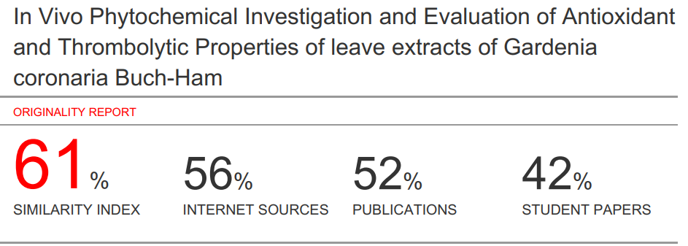

***In Vivo* Phytochemical Investigation and Evaluation of Antioxidant and Thrombolytic Properties of Leave extracts of *Gardenia coronaria* Buch-Ham**

**Abstract**

The objective of the present study was to assess the diverse pharmacological efficacies of methanolic extracts of the whole plant of *Gardenia* *coronaria* Buch.-HamThis study will disclose the Phytochemicals, antioxidants and thrombolytic activity which have the possibility to be used in the coming future to open a new line of investigation. The *Gardenia* *coronaria*, one of the necessary traditional medicinal plants in Bangladesh. In the rural area this plant is used by a lot of people as a treatment from various disease. Total sum of the flavonoids was spectrophotometrically ascertained by aluminum chloride colorimetric assay while total phenolic and tannin content by Folin Chiocalteu’s reagent. Antioxidant activity, ascertained by DPPH free radical scavenging assay giving some comparison between the resultant activities with the standard. The thrombolytic activity was assessed based on the method of minor alterations. The percentage of clot lysis was 87.58% when 100 μl of streptokinase (30,000 I.U.), and the methanolic extract displayed the least clot lysis activity (26.79%), much less compared to the standard. It can be elicited that the extract of *Gardenia* *coronaria* Buch.-Hamcontains antioxidant and thrombolytic activity. The potential of these activities probably because of the availability of most of the phytochemicals supporting previous claims and verify its uses as an expected folk medicine.

**Keyword:** *Gardenia* *coronaria,* traditional medicine, flavonoid, antioxidant, thrombolytic

**Introduction**

Medicinal plants is used as traditional health care systems for a long time. Still it’s the most vital health care sources for a large number of humans. The WHO (World Health Organization) enumerated that more than 75% peoples are extensively used herbal drugs for their regular primary healthcare requirements 1,2.

Gardenia, belonging to the genus of flowering plants in the coffee family Rubiaceae, being endemic to the tropical and subtropical regions of Africa, Southern Asia, Australasia and Oceania 3, *Gardenia coronaria* is an evergreen shrub and small tree of about1-15 meters tall. In Bangladesh it is originated in forests of Chittagong, Chittagong Hill Tracts, Cox’s-Bazar, Sylhet and Moulvi Bazar districts. Locally the plant is recognized as Bela (Sylhet region) and Connari or Kannyari (Chittagong region). Traditionally the established use of the plant as a remedy for sicknesses of several diseases such as bronchitis, haemoptysis, haematemesis, melena, diarrheal diseases and skin disorders. The leaves of the plant possess coronalolide, coronalolic acid, coronalolide methyl ester, ethyl coronalolate acetate triterpenes (secocycloartanes) and so forth 4. Antioxidants are the substances, found in certain foods and may confine some of the damage due to free radicals through neutralizing them 5. The normal biochemical reactions within the body with elevated exposure to the nature, and the sum of the levels of dietary xenobiotic's upshots in the reproduction of reactive oxygen species (ROS) and reactive nitrogen species (RNS). The ROS and RNS generate oxidative stress in miscellaneous pathophysiological conditions 6. Most of the natural antioxidants of interest are of plant origin belonging to the phenolic and polyphenolic class of compounds including carotenoids and antioxidant vitamins 7. A lot of physiological and biochemical processes in the human body, probably produced oxygen-centered free radicals and other reactive oxygen species as byproducts 8. Antioxidant-based drug formulations, used to prevent and treat of intricated diseases as in atherosclerosis, stroke, diabetes, Alzheimer’s disease and cancer 9. Thrombolysis, also acquainted as thrombolytic therapy, act as a remedy of dissolving excessive clots in blood vessels, enhance blood flow, and obstruct damaging to tissues and organs. Thrombolysis probably involved the injection of clot-busting drugs through an intravenous (IV) line or using a long catheter delivering drugs straight away to the site of the blockage. The application of thrombolysis as an emergency treatment to dissolve blood clots forming in arteries feeding the heart and brain -- the main reason of heart attacks and ischemic strokes and in the arteries of the lungs (acute pulmonary embolism). Thrombolysis, wonted to treat blood clots. If a blood clot is enumerated as life threatening, thrombolysis may work as an option if inclined as soon as possible -- ideally between one to two hours -- after the commencement of symptoms of a heart attack, stroke, or pulmonary embolism 10,11.

**Materials and Methods**

**Plant Materials**

Gardenia plants, prized for the strong sweet odor of their flowers. It has the ability to develop at a large size several species. The leaves of the plant of *Gardenia* *coronaria* Buch.-Ham, collected from the forest of Chittagong, Bangladesh. Bangladesh National Herbarium marked out and authenticated the plant.

**Chemicals and Reagents**

Streptokinase, Folin-Ciocalteu phenol reagent DPPH (2,2-diphenyl-1-picryldydrazyl), Gallic acid, Quercetin and Ascorbic acid were used.

**Preparation of Plant Extract**

First of all, a clean flat flat-bottomed glass container was taken. After the addition of about 400 gm of powdered sample into the container, 1500 mL of 90% methanol added into the container and drenched the powder into the methanol. Then, sealed it with the contents and deposited for approximately 10 days accompanying occasional shaking and stirring. Afterwards, the desired parts that are discreted from the mixture using white cotton. After that, the liquid portion was also filtered three times with the help of white cotton. Then the filtration process was repeated using what man filter paper. Then the filtrate was placed in rotary evaporator machine. The machine functions through separating the solvent and desirable crude extract was attained.

**Phytochemical screening**

Diverse phytochemical groups for instance alkaloids, glycosides, flavonoids, tannins, gums, saponins, steroids were allotted by individual color changes or alterations with the help of the standard chemical tests. Several tests are there that can be carried out to detect the presence of different compounds for example, Molisch Test and Fehling’s Testfor carbohydrate, Biurets’s Test for Proteins, Flavonoid Test for flavonoids, Dragendroff’s, Mayer’s and Hager’s test for alkaloids, tests like potassium dichromate test, ferric chloride, and lead acetate tests for tannin, Keller- Kiliani tests for glycosides, Frothing Test for saponins,Sulphuric acid test for steroid and Molisch test , for the availability of gum in the samples 12

**Determination of total flavonoid content**

Total flavonoid content, ascertained using the aluminium chloride colorimetric assay. The reaction mixture contain 1 ml of extract and 4 ml of distilled water. The mixture was taken in a 10 ml volumetric flask. To the flask, 0.30 ml of 5 % sodium nitrite was added. After a period of about 5 minutes, 0.3 ml of 10 % aluminium chloride was diluted to the flask. After the suggested time period, 2 ml of 1M Sodium hydroxide was added and then diluted to 10 ml with distilled water. A set of reference standard solutions of quercetin (20, 40, 60, 80 and 100 μg/ml), readied using the process as described earlier. The absorbance for test and standard solutions were discerned against the reagent blank at 510 nm with an UV/Visible spectrophotometer. The total sum of the flavonoid was displayed as mg of QE/g of extract 13,14.

**Determination of total phenolic content**

The concentration of phenolics in plant extracts was ascertained by the application of spectrophotometric method. Folin-Ciocalteu assay method was used to determine the total phenol content. The reaction mixture containing 1 ml of extract and 9 ml of distilled water. Then the mixture was deposited in a volumetric flask (25 ml). One millilitre of Folin-Ciocalteu phenol reagent was applied to the mixture and shaken well. Approximately 5 minutes later, 10 ml of 7 % Sodium carbonate (Na2CO3) solution was added to the mixture. Thus, the volume, prepared up to 25 ml. A set of standard solutions of gallic acid (20, 40, 40, 60, 80 and 100 μg/ml) were readied using the same process as described earlier. After incubation for 90 min at room temperature and the absorbance for test and standard solutions were determined against the reagent blank at 550 nm with an Ultraviolet (UV)/visible spectrophotometer. Total phenol content was shown as mg of GAE/gm of extract 15,16.

**Determination of tannin Content**

The tannins were ascertained by the application of Folin - Ciocalteu method. Addition of about 0.1 ml of the sample extract to a volumetric flask (10 ml) pertaining to 7.5 ml of distilled water and 0.5 ml of Folin-Ciocalteuphenol reagent, 1 ml of 35 % Na2CO3 solution and dilute to 10 ml with distilled water. With continuous shaking, the mixture was placed at room temperature for 30 min. A set of reference standard solutions of gallic acid (20, 40, 60, 80 and 100 μg/ml) were readied in the same manner as described earlier. Absorbance for test and standard solutions were determined against the blank at 725 nm with an UV/Visible spectrophotometer. The tannin content was displayed as mg of GAE /g of extract 17,18.

**DPPH radical scavenging assay**

The radical scavenging activity of the extract, accounted quantitatively based on its capacity of scavenging the free radical 2,2-diphenyl-1-picryl hydrazyl (DPPH). Firstly, the stock solution (1024 μg/mL) of the samples was readied. From that solution, sample of various concentrations (512–1 μg/mL) were prepared. In 1 mL of each concentration, 3 mL of 0.1 mM alcoholic DPPH solution was treated. After about 30 min of incubation in dark at room temperature, absorbance was recorded at 517 nm. To use as standard, ascorbic acid was used. The percentage of DPPH free radical scavenging activity of each extract and standard were calculated like the following:

DPPH radical−scavenging activity (**1%)**

**= [A0−A/A0] x 100**

Where, A0 is the absorbance of the control solution pertaining to all reagents without plant extracts, A is the absorbance of DPPH solution containing plant extract. Ultimately, the concentration of sample that needs to scavenge 50% DPPH free radical (IC50) was estimated from the plot of inhibition (%) against the concentration of the extract 19

**Thrombolytic activity test**

Thrombolytic test, effectuated by percentage of clot lysis method. Shortly, blood was stretched from healthy volunteers (n=3) without a history of oral contraceptive or anticoagulant therapy and transference of 1.0 ml of venous blood was done to each pre-weighed microcentrifuge tubes and incubated at 37° C for 45 min and was allowed to clot. The thrombolytic activity of all extracts was assessed with streptokinase (SK) as the standard substance. The extractive (100 mg) from each plant, suspended in 10 ml of distilled water. Then it was placed the whole night. After that, blending and filtration of the soluble supernatant were done respectively using a syringe filter of about 0.22 micron. After clot formation, the serum was entirely diminished without disturbing the clot and each tube that contain the clot, weighed again to appoint the clot weight (clot weight = weight of clot containing tube – weight of tube alone). To each microcentrifuge tube with the pre-weighed clot, 100 μl aqueous solution of crude extract was added in particular. Then, addition of 100 μl of streptokinase (30,000 IU) and 100 μl of distilled water were separately to the positive and negative control tubes, gradually. Incubation of all the tubes were done at 37° C for 90 min and observed for lysis of the clot. After incubation, the released fluid was removed, and the tubes were weighed repeatedly to look on the dissimilation in weight after clot disruption 20.

**Result**

In the phytochemical screening the extracts revealed the availability of some of the pharmacologically active phytochemicals. After the completion of a wide range of chemical test to ascertain the major classes of therapeutically important compounds, alkaloid, carbohydrate, Glycoside, tannins, flavonoids, Saponin protein and diterpenes Triterpenoids. Biochemical screening results expressed both of the availability and the existence of compounds for instance alkaloids, carbohydrates, glycosides, steroids and gums though saponins, flavonoids, tannins and reducing sugars are absent.

Total sum of the Flavonoid of the extract, enumerated by the use of the equation that were found to be 0.8366±0.476837 QE/g dry extract respectively. Besides, the absorbance values that are attained in the total tannin content test with the help of different concentrations of quercetin, plotted against respective concentrations. A standard calibration curve, commonly known as standard curve, obtained with the equation y = 0.3533× - 0.3998 (R2 = 0.4802). In case of total phenolic content, the absorbance values from the test using different concentrations of gallic acid were plotted against respective concentrations. In the same manner, a standard calibration curve was attained again with the equation y = 0.1124x -0.1586 (R2 = 0.4155). Total phenolic content of the methanolic extracts of *Gardenia* *coronaria* was enumerated by the equation that were found to be 0.2348±0.163106 GAE/g dry extract gradually. Total sum of tannin of the extracts was then calculated by the equation and found to 0.1408±0.073519 mg QE/g dry extract respectively. In the DPPH radical scavenging assay, antioxidant activity, gradually elevated with increasing concentration of the extract and the IC50 value was found to be 0.3046±0.024371μg/mL. Also the absorbance values attained in the total tannin content test by the use of different concentrations of quercetin, plotted against respective concentrations. A standard calibration curve, attained with the equation y = 0.979× + 0.1529 (R2 = 0.8866). [Figure 1, 2, 3 and 4]

**Thrombolytic Activity:**

From this observation, the significant clot lysis that is percentaged by extracts of the plant, thrombolytic standard (Streptokinase) and control (water) was observed. The percentage of clot lysis was 87.58% when 100 μl of streptokinase (30,000 I.U.), while in case of control (water) the percentage of clot lysis was kind of insignificant (4.18%). The methanolic extract (concentration 1 mg/ml), displayed a minimum activity of clot lysis (26.79%) that seems to be much less compared to the standard. [Table 1]

**Discussion**

The medicinal plants, can be proposed as a source of well accessible, economical and efficient medicine from antique time. Different ethnomedicinal plants have been investigated to prepare neurobehavioral state and operate as an alternative option of modern medicine. Phenolic and flavonoid compounds, considered, very important secondary metabolites for biological activities 21. Phenolic compounds have therapeutic potential against several disorders due to their antioxidant property. Flavonoids are a group of poly phenolic substances. They exist in most plants and also are recognized as liable for different biochemical activities. Antioxidants properties of flavonoids from plant extracts have been reported in different studies 22. It exerts the antioxidant activity through radical scavenging, metal ion chelation, and membrane protective efficacy 23. So the experimental extracts pertaining to a good amount of phenol, flavonoids and tannin contents. These secondary metabolites possibly be responsible for bioactivities of the extracts. DPPH assay has been largely used as a swift, reliable, and reproducible parameter to screen in vitro antioxidant activity of plant extracts. DPPH radical scavenging activity of test extracts displayed the proton donating capability and thereby acting as antioxidant 24. In a previous study, the existence of alkaloid, tannin, glycosides, flavonoid and saponins in the extracts of *Gardenia* *coronaria*, disclosed by phytochemical tests. The existence of these phytochemical compounds can be correlated to the biological activities of *Gardenia* *coronaria* Buch.-Ham.

**Conclusions**

Plant is an indispensable source of medicine keeping a vital figure in world health.From the thousands of years, nature is giving us medicinal gift that act as a natural source of modern drugs. One of those gifts is *Gardenia* *coronaria* Buch.-Hamcontaining so many pharmacological activities. The result also displays the availability of a potent anti-oxidant activity and thrombolytic activity in this plant. So it is obvious that our experimental plant possess anti-oxidant and thrombolytic activity and requires further investigation for the identification of active compounds**.**

**Acknowledgement**

The authors are thankful to the Department of Pharmacy, Daffodil International University for giving permission and all sort of supports to conduct the research.

**Conflict of Interest:** There is no conflict of interest.

**Authors’ contribution**

This research work is part of M.Sc. thesis. The candidates are the first and second author MMR and FI who conducted the works and the experiments and wrote up the thesis. The corresponding author MMR supervised the experimental work, revised and edited the thesis draft and the manuscript. MAKA, TA, NRN, MRS, KSA and MF were co-advisor of the work helped in revised, edited the thesis draft and the manuscript and in the laboratory works.

**Reference**

**1.** WHO Expert Committee on Specifications for Pharmaceutical Preparations, World Health Organization. WHO Expert Committee on Specifications for Pharmaceutical Preparations: Thirty-ninth Report. World Health Organization, 2005; Nov 11.

2.Sagnia B, Fedeli D, Casetti R, et al. Antioxidant and anti-inflammatory activities of extracts from Cassia alata, Eleusine indica, Eremomastax speciosa, Carica papaya and Polyscias fulva medicinal plants collected in Cameroon. PloS one. 2014;9:e103999.

3. Chen, T. and Taylor, C.M. 1761. Gardenia J. Ellis, Philos. Trans. 51, 935.

4. Al Faruq A, Ibrahim M, Chowdhury MM, Adib M, Haque MR, Rashid MA. Pharmacological and Biological Activities of Different Fractions Methanol Extracts of Gardenia coronaria Buch.-Ham. Leaves. Bangladesh Pharmaceutical Journal. 2017;20(2):139-47.

5. Better Health. Antioxidants. Available from https://www.betterhealth.vic.gov.au/health/healthyliving/antioxidants.

6. Nimse SB, Pal D. Free radicals, natural antioxidants, and their reaction mechanisms. Rsc Advances. 2015;5(35):27986-8006.

7. Chang SS, OSTRIC‐MATIJASEVIC BI, Hsieh OA, Huang CL. Natural antioxidants from rosemary and sage. Journal of Food Science. 1977 Jul;42(4):1102-6.

8. Cai Y, Luo Q, Sun M, Corke H. Antioxidant activity and phenolic compounds of 112 traditional Chinese medicinal plants associated with anticancer. Life sciences. 2004 Mar 12;74(17):2157-84.

9. Khalaf NA, Shakya AK, Al-Othman A, El-Agbar Z, Farah H. Antioxidant activity of some common plants. Turkish Journal of Biology. 2008 Feb 19;32(1):51-5.

10. Huang T, Li N, Gao J. Recent strategies on targeted delivery of thrombolytics. Asian Journal of Pharmaceutical Sciences. 2019 Feb 4.

11. Geerts WH, Pineo GF, Heit JA, Bergqvist D, Lassen MR, Colwell CW, Ray JG. Prevention of venous thromboembolism: the Seventh ACCP Conference on Antithrombotic and Thrombolytic Therapy. Chest. 2004 Sep 1;126(3):338S-400S.

**12.** Uma C, Sekar KG. Phytochemical analysis of a folklore medicinal plant Citrullus colocynthis L (bitter apple). Journal of pharmacognosy and Phytochemistry. 2014 Mar 1;2(6).

13 .Tiliaceus H. RESEARCH AND REVIEWS: JOURNAL OF PHARMACOGNOSY AND PHYTOCHEMISTRY.

14. Har L, Intan SI. Antioxidant activity, total phenolics and total flavonoids of Syzygium polyanthum (Wight) Walp leaves. International Journal of Medicinal and Aromatic Plants. 2012;2(2):219-28.

15.Ghasemzadeh A, Jaafar HZ, Rahmat A. Antioxidant activities, total phenolics and flavonoids content in two varieties of Malaysia young ginger (Zingiber officinale Roscoe). Molecules. 2010;15(6):4324-33.

16.Stankovic MS. Total phenolic content, flavonoid concentration and antioxidant activity of Marrubium peregrinum L. extracts. Kragujevac J Sci. 2011 Jan 1;33(2011):63-72.

17.Singh R, Verma PK, Singh G. Total phenolic, flavonoids and tannin contents in different extracts of Artemisia absinthium. Journal of Intercultural Ethnopharmacology. 2012 Jan 1;1(2):101-4.

18.Afify AE, El-Beltagi HS, El-Salam SM, Omran AA. Biochemical changes in phenols, flavonoids, tannins, vitamin E, β–carotene and antioxidant activity during soaking of three white sorghum varieties. Asian Pacific Journal of Tropical Biomedicine. 2012 Mar 1;2(3):203-9.

19. Gulcin I, Tel AZ, Kirecci E. Antioxidant, antimicrobial, antifungal, and antiradical activities of Cyclotrichium niveum (Boiss.) Manden and Scheng. International Journal of Food Properties. 2008 Apr 18;11(2):450-71.

20.Azad AK, Lasker S, Irfan-Ur-Rahaman OI, Sharmin Akter M, Khairuzzaman MI, Sultana C, Das N, Ahmeda N, Hossain S, Haque S, Biswas K. COMPARATIVE STUDIES ON ANTIOXIDANT AND THROMBOLYTIC ACTIVITIES OF METHANOL AND ETHYLACETATE EXTRACTS OF TREMA ORIENTALIS

21. Ghasemzadeh A, Ghasemzadeh N. Flavonoids and phenolic acids: Role and biochemical activity in plants and human. Journal of medicinal plants research. 2011 Dec 16;5(31):6697-703.

22. Lopez-Lazaro M (2009) Distribution and biological activities of the flavonoid luteolin. Mini Rev Med Chem 9(1):31–59

23. Zhang LL, Lin YM (2008) Tannins from Canarium Album with potent antioxidant activity. J Zhejiang Univ Sci B 9(5):407–415.

24. Kumar S, Kumar R, Dwivedi A, Pandey AK. In vitro antioxidant, antibacterial, and cytotoxic activity and in vivo effect of Syngonium podophyllum and Eichhornia crassipes leaf extracts on isoniazid induced oxidative stress and hepatic markers. BioMed research international. 2014;2014.

**Table 1: Comparative view of percent of clot lysis activity**

|  |  |  |  |  |  |
| --- | --- | --- | --- | --- | --- |
| **Sample** | **1st clot + tube weight (gm)** | **1st clot weight (gm)** | **2nd clot + tube weight (gm)** | **2nd clot weight (gm)** | **% of Lysis** |
| **Standard (Streptokinase)** | 1.652 | 0.822 | 0.9321 | 0.1021 | 87.58 |
| **Control**  **(Distil water)** | 1.452 | 0.622 | 1.4261 | 0.596 | 4.18 |
| ***Gardenia* *coronaria***  **Extracts** | 1.39 | 0.56 | 1.24 | 0.41 | 26.79 |

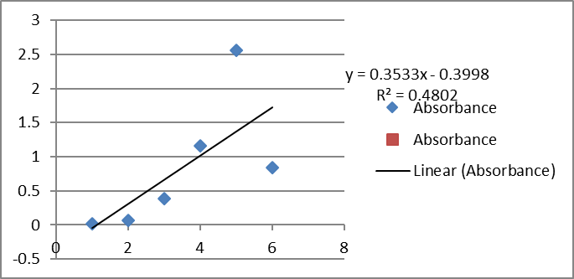

**Figure 1: Total flavonoid content**

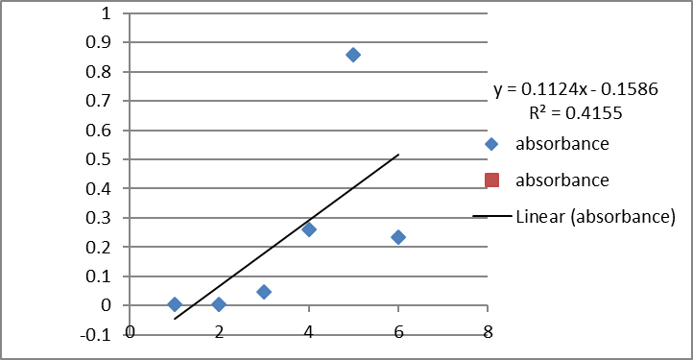

**Figure 2: Total phenolic content**

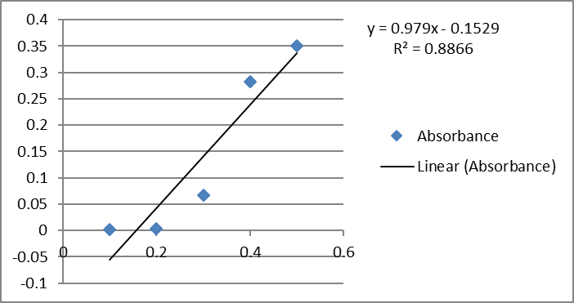

**Figure 3: Total tannin content**

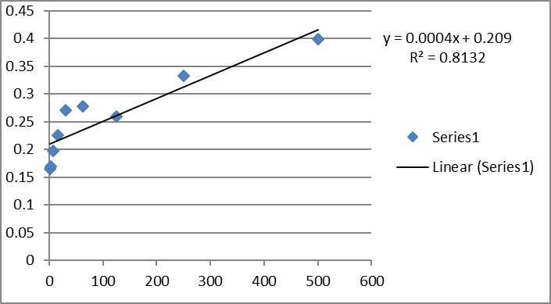

**Figure 4: DPPH scavenging Antioxidant activity.**