Reviewer’s Comments
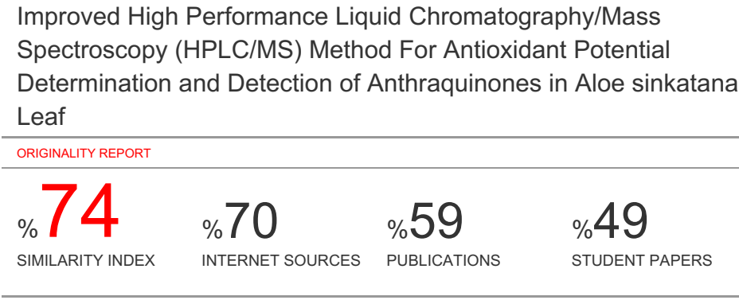
Improved High Performance Liquid Chromatography/Mass Spectroscopy (HPLC/MS) Method For Antioxidant Potential Determination and Detection of Anthraquinones in Aloe sinkatana Leaf

Abstract
Medicinal plants, either as an extract, pure compound or as a derivative, offer limitless opportunities for the discovery of new drugs. Sudan are very rich source of medicinal plants which are used in treatment of wide range of disease. Aloe sinkatana, has great potential to be developed as drug by pharmaceutical industries.
This study investigated the antioxidant activity and analysis of Aloe sinkatana leafs extract. The study also performed for the detection of Anthraquinones in Aloe sinkatana leafs by High Performance Liquid Chromatography/Mass Spectroscopy technique.
The plant was extract by successive method (PE, chloroform ,ethyl acetate, butanol, methanol and water), the result showed that methanolic extract of the plant, exhibited a great antioxidant effect at 50 μg/ml, and also the methanol extract detection by HPLC/MS which reveled 9 compounds. UV spectroscopy detected the presence of two flavonoids.
Due to stronger antioxidant potential and phytochemical composition, Aloe sinkatana could prove as valuable prospect in pharmaceutical formulations by taking part in the antioxidant defense system against generation of free radicals.

Key words: Aloe sinkatana, HPLC/MS, Anthracene ,Antioxidant ,Aloeacae

INTRODUCTION
Medicinal plants, either as an extract, pure compound or as a derivative, offer limitless opportunities for the discovery of new drugs. Sudan are very rich source of medicinal plants which are used in treatment of wide range of disease. Plant-derived substances have recently become of great interest owing to their versatile applications. Medicinal plants are the richest bio-resource of drugs of traditional systems of medicine, modern medicines, nutraceuticals, food supplements, folk medicines, pharmaceutical intermediates and chemical entities for synthetic drugs ^{[1]}.
The study of plants used in traditional medicine requires the effective integration of information on chemical composition of extracts, pharmacological activities of isolated compounds, as well as indigenous knowledge of traditional healers.
According to the World Health Organization more than 80% of the world’s people depend on traditional medicine for their primary healthcare needs. The beneficial medicinal effects of these plant materials typically result from the combinations of secondary products present in the plant making the medicinal actions of plants unique to particular plant species or groups ^{[2]}.
The recently revised family, Aloeacae, in the order Liliaceae, Liliflorae, was one of the widely distributed families of flowering plants. It consisted of 250 genera comprising 3700 species, mostly perennial herbs with rhizomes or bulbs ^{[3]}. When Dahlgren and Clifford (1982) made a major revision of superorders, orders and families within the monocotyledons, this family was sub-divided into several other families. Several free anthraquinones occur in roots and leaves of Aloe species. Aloe-emodin ^{[3]} is typical leaf constituent and is wide spread in the genus. Chrysophanol ^{[4]} occurs both in roots and leaves^{[4,5]}, while nat aloe-emodin ^{[5]} has been reported only from leaves ^{[6]}. Two main types of anthraquinones are present in Aloe, these are 1.8 dihydroxyanthraquinnone e.g chrysophanol and 7- hydroxyl aloe – emodin ^{[6]}.
This study investigated the antioxidant activity and analysis of Aloe sinkatana leafs extract. The study also performed for the detection of Anthraquinones in Aloe sinkatana leafs by High Performance Liquid Chromatography/Mass Spectroscopy technique.
MATERIALS AND METHODS
Plant Material
leaves of Aloe sinkatana were collected in Erkawiet (East of sudan) in March 2009. They were kindly identified by dr. Aalyia Awad, botanist and a voucher specimen was deposited under the registration in the herbarium of the University of EL-Neelain. The different parts of the plant collected were separately dried under ventilation at room temperature then finely ground with an electrical grinder.
Chemicals and Solvents
All chemicals and solvents used were HPLC grade.
METHODS
Extraction and Fractionation
Leaves (50 g ) were extracted for 3hours by using soxhlet apparatus. The filtrate of this methanol extract was concentrated under reduced pressure until all the methanol had evaporated. The concentrate was redissolved in distilled water and lyophilized.
Determination of Antioxidant Activity (Scavenging Activity of DPPH Radical)
The DPPH free radical scavenging assay was carried out for the evaluation of the antioxidant activity. This assay measures the free radical scavenging capacity of the investigated extracts. DPPH is a molecule containing a stable free radical. In the presence of an antioxidant, which can donate an electron to DPPH, the purple colour typical for free DPPH radical decays, and the absorbance change at λ = 517 nm is measured. This test provides information on the ability of a compound to donate a hydrogen atom, on the number of electrons a given molecule can donate, and on the mechanism of antioxidant action. The method was carried out as previously described by ^{[7]}. The methanolic and aqueous extracts were redissolved in methanol and 5% ethanol, respectively, and various concentrations (10, 50, 100, 500 and 1000 μg/ml) of each extract were used. Similar concentrations of ascorbic acid were used as positive control. The assay mixture contained in a total volume of 1 ml, 500 μl of the extract, 125 μl prepared DPPH (1 mM in methanol) and 375 μl solvent (methanol or 5% ethanol). After 30 min incubation at 25°C, the decrease in absorbance was measured at λ = 517 nm. The radical scavenging activity was calculated from the equation:
% of radical scavenging activity = Abs_{control} - Abs_{sample}/Abs_{control} × 100

borntraeger reagent for anthraquinons and etc. were used in the detection according to previously published methodology ^{[8]}.

High Performance Liquid Chromatography HPLC/MS
HPLC is a development of column chromatography. To improve resolution, HPLC columns are packed with small sized particles (3, 5, 10 m) with a narrow size distribution. Flow rate and column dimensions can be adjusted to minimize band broading. The required pressures are supplied by pumps that could withstand the involved chemicals. In addition to the normal phase columns, (non-polar solvent and polar surface such as silica), there are reverse phase (RP) columns as well. The latter, normally, involves the use of a polar solvent (water, methanol, acetonitrile etc.) and a non-polar surface. The commonly used detector (UV detector) in HPLC systems not only places constraints on the solvents that can be used but also is limited to absorbing compounds. Refractive index detectors although considered “universal” cannot easily be used with solvent gradients. However, recently, the evaporative light-scattering detector has emerged as a universal detector ^{[9]}.
RESULTS AND DISCUSSION
Radical Scavenging Activity
The extracts of Aloe sinkatana showed a high effective free radical scavenging in the DPPH assay (table 2). These extracts exhibited a noticeable antioxidant effect at low concentrations. So the methanolic extract of the plant, exhibited a great antioxidant effect at 50 μg/ml (table 2).
Various medicinal properties have been ascribed to natural herbs. Extractive value useful for the evaluation of a crude drug and at the same time give idea about the nature of the chemical constituents present, which is helpful for the estimation of specific constituents ^{[10]}.

Medicinal plants constitute the main source of new pharmaceuticals and healthcare products. A whole range of plant derived dietary supplements, phytochemicals, and pro – vitamins that assist in maintaining good health and combating disease are now being described as functional foods and nutriceuticals. Plant- derived products are also increasingly accepted and used in the cosmetic industry.

The roles of herbal plants in disease prevention and cure have been attributed, in part, to the antioxidant properties of their constituents of liposoluble and water soluble vitamins, and a wide range of amphipathic molecules, broadly termed phenolic compounds.
The antioxidant effect of phenolic compounds is mainly due to their redox properties, and as a result of various possible mechanisms, which allow them to act as reducing agents, hydrogen donators, free radical scavengers, singlet oxygen quenchers, and / or metal chelators ( transition- metal- chelating activity).
Plant phenolic compounds especially flavonoids are currently of growing interest owning to their supposed properties in promoting health (anti-oxidants) ^{[11]}. Flavonoids have been demonstrated to have anti-inflammatory, antiallergenic, anti-viral, anti-aging, and anti-carcinogenic activity ^{[11]}. The broad therapeutic effects of flavonoids can be largely attributed to their antioxidant properties. In addition to an antioxidant effect, flavonoid compounds may exert protection against heart disease through the inhibition of cyclooxygenase and lipoxygenase activities in platelets and macrophages ^{[11]}.
Anthraquinones are structurally built from an anthracene ring (tricyclic aromatic) with a keto group each on carbon atom nine and ten. In plants, anthraquinones are found in a wide range of species ^{[11]}. The effects of anthraquinones and anthrones are very diverse ^{[11]}.
Anthraquinones and anthrones are very reactive and have a broad pharmacological activities including, they are potent anticancer, antidiabetic, antimicrobial, antiinflammatory, and cathartic properties as well as its cardio-, hepato-, and neuroprotective qualities. Anthraquinones and xanthones contain an aromatic core that serves as a scaffold for the attachment of diverse functional groups, resulting in a wide variety of molecules with distinct biological and biochemical characteristics ^{[11]}.

CONCLUSION
Our results show that medicinal plants can be promising sources of natural products with potential antioxidant activity. The results will guide the selection of some plant species for further pharmacological and phytochemical investigations.

ACKNOWLEDGEMENT
The authors are thankful to wish to Department of Pharmacogency, Faculty of Pharmacy, Nile University, Khartoum ,Sudan.

COMPETING INTERESTS
The authors declare that they have no competing interests.
REFERENCES
1. Fatehalrahman F. Magbool, Elamin Ibrahim Elnima, Shayoub M E and 4Salah Eldin Omar Hussein. Phytochemical and Antimicrobial Screening of Stem Bark and Leaves Extract From Ficus sycomorus. World Journal of Pharmaceutical and Medical Research, 2017,3(11), 234-239.
2. Fatehalrahman F. Magbool. Quercus infectoria galls: Phytomedicine Promising for Treating Candidiasis – An A review. World Journal of Pharmaceutical Research, Vol 6, Issue 17, 2017.
3. Hutchinson, J. (1973). The Families of Flowering Plants, 3rd edition. Clarendon pess, Oxford.
4. Yagi, A., Makino, K. and Nishioka, I. (1977). Studies on the constituents of Aloe saponaria HAW. III. The structures of phenol glucosides. Chem. Pharm. Bull. 25,
5. Dagne, E. and Alemu, M. (1991). Constituents of the leaves of four Aloe species from Ethiopia. Bull. Chem. Soc. Ethiop. 5, 87-91.
6. Conner, J. M., Gray, A.I., Reynolds, T. and Waterman, P.B. (1989) Anthraceme and chromone dervativatives in the exudates of Aloe cremnophila and A. jacksonij leaf excudates. Phytochemistry 29, 941-944.
7. Brand WW, Cuvelier HE, Berset C. Use of a free radical method to evaluate antioxidant activity. Food Sci Technol. 1995;82:25–30
8. Wagner H, Bladt S. Plants Drug Analysis: A Thin Layer Chromatography Atlas. Berlin: Springer; 1996. pp. 306–364
9. A.Braithwaitere &f.J. Smith, Chromatographic methods,fifth edition 1999,Kluwer academic publisher,ISBN0751401587
10. Fatehalrahman F. Magbool, Elamin Ibrahim Elnima, Shayoub M. E., Elnazeer I. Hamedelniel, Muddathir S. Alhassan. Pharmacognostic, physicochemical standardization and phytochemical analysis of Quercus infecoria galls. American Journal of Research Communication, 2018, 6(10): 1-17.
11. Fatehalrahman F. Magbool, Elamin Ibrahim Elnima, Shayoub M E and Salah Eldin Omar Hussein. Preliminary Phytochemical Screening of Quercus infectoria galls. World Journal of Pharmacy and Pharmaceutical Sciences, Vol 7, Issue 1, 2018.

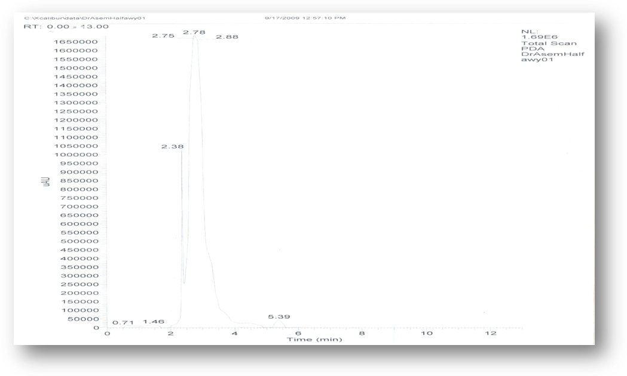
Figure 1: HPLC Spectrum of methanol extract of Aloe sinkatana leaf

Table 1: Analysis of methanol extract of Aloe sinkatana by using HPLC/MS
The analysis of. | Name | Structure | Molucular weight
1- | Anthiaergostan – 5, 7, 9, 22- tetra one, 3- semicarbazone |  | 449
2- | 5,5′-150 propylidenebis [2-(benzogloxy) toluene |  | 464
3- | P- Benzoquinone, 2, 5-bis (P-fluorophenyl) -3, 6- diphenyl- |  | 448
4- | 5- [[7-chloro-4-quinolinyl]amino] |  | 449
5- | 1, 8-Dihydroxy-3methylanthraquinone di TMS |  | 398
6- | Chlorfluazuron |  | 539
7- | Acetophenone, 2-[(P-nitrophenylinmino)] |  | 254
8- | Cyclohexanamine, N- (benzoyloxy) |  | 219
9- | Bezoic anhydride mono- [(1,1,1, 5.5,5 hexafluoro -4- oxopent -2-en-2-N) hydrazone] |  | 415

Table 2: Antioxidant activity of different extract of Aloe sinkatana leaf
Type of extract | Conc(mg/ml) | % Inhibition | IC50+_SD(mg/ml0
Petrolum ether | 5 | 48.0+_0.02 | -
Chloroform | 5 | 36.3+_0.03 | -
Ethylacetate | 5 | 40.8+_0.02 | -
Butanol | 5 | 46.4+_0.02 | -
Methanol | 5 | 51.9+_0.01 | 3.5+_0.01
Water | 5 | 60.3+_0.01 | 2.02+_0.01

