**Reviewer’s Comments**

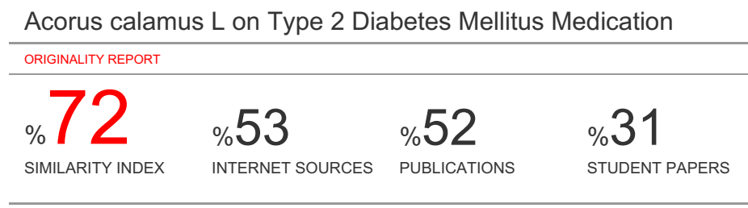

***Acorus calamus* L on Type 2 Diabetes Mellitus Medication**



**Abstract:** Diabetes is one of the metabolic diseases characterized by hyperglycemia resulting from defects in insulin secretion, insulin action, or both. Type 2 diabetes, which accounts for ~90–95% of those with diabetes, the cause is a combination of resistance to insulin action and an inadequate compensatory insulin secretory response. Adequate glycemic control is thus one of the key factors to treat and/or reduce the diabetes and many plants have been used to reduce the glucose level by inhibiting the α-glucosidase that breaks down starch and disaccharides to glucose. *Acorus calamus* L (AC), a folk medicine to treat type 2 diabetes. *In vitro* α-glucosidase assay were carried out by measuring the release of p-nitrophenol, the insulin sensitizing activity, AC significantly decreased fasting serum glucose, and suppressed the increase of blood glucose levels after 2g/kg glucose loading in normal mice, *in silico* study showed that chemical compound on AC can inhibit α-glucosidase and the present study is designed to investigate the effects and molecular mechanisms of AC on glucagon-like peptide-1 (GLP-1) expression and secretion related to its hypoglycemic effects.

**Keywords:** *Acorus calamus L*, folk medicine, type 2 diabetes, *in vitro*, α-glucosidase, i*n silico*, molecular mechanism

**1. INTRODUCTION**

Diabetes mellitus is a syndrome of disordered metabolism, usually due to a combination of hereditary and environmental causes, resulting in hyperglycemia due to defects in either insulin secretion or insulin action in the body. Chronic hyperglycemia during diabetes causes glycation of body proteins that in turn lead to secondary complications affecting eyes, kidneys, nerves and arteries[1].

Diabetes mellitus (DM) is a common endocrine system disease that causes metabolic disorders and which leads to multiple organ damage syndrome. Clinical admiral diabetes is divided into two types, with more than 90% of patients having Type II diabetes [2]. The number of diabetes cases was 171 million in 2000 and is expected to rise to 366 million in 2030 [3]. Acting as a key enzyme for carbohydrate digestion, intestinal α-glucosidase is a glucosidase located at the epithelium of the small intestine. α- glucosidase has been recognized as a therapeutic target for the modulation of postprandial hyperglycemia, which is the earliest metabolic abnormality that occurs in Type 2 DM [4].

**1.1. Type 2 DM**

Type II diabetes is the major form of diabetes, accounting for approximately 90–95% of all diabetic cases. This form of diabetes usually begins with insulin insensitivity, a condition in which muscle, liver and fat cells do not respond to insulin properly. The pancreas eventually loses the ability to produce and secrete enough insulin in response to food intake. Gestational diabetes is caused by hormonal changes during pregnancy or by insulin insufficiency. Glucose in the blood fails to enter cells, thereby increasing the glucose level in the blood. High blood glucose, also known as hyperglycemia, can damage nerves and blood vessels, leading to

complications such as heart disease, stroke, kidney dysfunction, blindness, nerve problems, gum infections and amputation [5].

Type 2 diabetes mellitus is a complex, multifactorial disease. Oxidative stress has been suggested to be a contributory factor in development and complication of diabetes [6,7]. In recent years, natural antioxidants are used in dietary, pharmaceutical and cosmetic to replace synthetic antioxidants [8]. Research founded that some antioxidant compounds isolated and identified from medicinal plants had good effect on autoxidation in vitro and in vivo [9,10]. Postprandial hyperglycemia is the most important health issue in the 21st century. α-Glucosidase inhibitor reduce postprandial glucose level. Screening for potent natural glycosidase inhibitors is very important for diabetes [11].

**1.2. Diagnostic criteria for diabetes**

The blood glucose levels of a healthy man are 80 mg/dLl on fasting and up to 160 mg/dL in the postprandial state. Diabetes mellitus is characterized by recurrent or persistent hyperglycemia, and is diagnosed by demonstrating one of the following :

fasting plasma glucose level at or above 126 mg/dL or 7.0 mmol/l. plasma glucose at or above 200 mg/dL or 11.1 mmol/L two hours after a 75 g oral glucose load in a glucose tolerance test. plasma glucose at or above 200 mg/dL or 11.1 mmol/l. Two fasting glucose measurements above 126 mg/dL or 7.0 mmol/l or random blood sugar level

>200mg/dL on two occasions is considered diagnostic for diabetes mellitus. Patients with fasting sugars between 6.1 and 7.0 mmol/L (110 and 125 mg/dL) are considered to have imparied fasting glucose and patients with plasma glucose at or above 140 mg/dL or 7.8 mmol/L two hours after a 75 g

*Department Pharmacognosy Phytochemistry, Faculty of

Pharmacy, Universitas Muslim Indonesia, Makassar-South 

Celebes, Indonesia. Zip Code 90132. Tel/Fax: +62-411-425619,

+62-81524045514; E-mails: a[hmad.najib@umi.ac.id](mailto:najib@umi.ac.id)

oral glucose load are considered to have impaired glucose tolerance [2]

**2. TYPE 2 DIABETES MELLITUS MEDICATION**

After decades of research unraveling complex metabolic control networks, medicines capable of a safe reversal of type

2 diabetes are still not available. Historically, complex diseases have repeatedly proven to be defiant to the best mono-therapeutic approaches. Several examples of combination therapies have largely overcome such

challenges, notably for the treatment of severe hypertension and tuberculosis. Obesity and its consequences, such as type

2 diabetes, have proven to be equally resistant to therapeutic approaches based on single medicines. Appropriate management of type 2 diabetes often requires adjunctive medications, and the recent registration of a few compound mixtures has set the precedent for combinatorial treatment of obesity. On the other hand, double or triple therapeutic combinations are more difficult to advance to regulatory approval. Following an improved understanding of the

molecular basis for metabolic benefits following bariatric surgery interventions, several classes of novel unimolecular or independent combination therapeutics were discovered. These new classes of drug candidates are based on gastrointestinal hormones, offer efficacy superior to currently prescribed options and seem to have potential to fully reverse

human obesity and type 2 diabetes. Moreover, gut peptide- based cell-specific targeted delivery of small molecules offers additional potential for novel metabolic precision

medicines and reduced systemic side effects. In this presentation the discovery, pre-clinical validation and first clinical tests of peptide hormone poly-agonist drug candidates as well as of combinatorial single molecule therapeutic candidates will be summarized, including previously unpublished observations [16].

**2.1. MECHANISM OF ANTIDIABETIC TERAPHY**

Western diabetic drugs correct hypoglycemia by supplementing insulin, improving insulin sensitivity, increasing insulin secretion from the pancreas and/or glucose uptake by tissue cells. Under normal conditions, pancreatic β-cells secrete sufficient insulin to maintain blood glucose concentration within a narrow range (72–126 mg/dL). The insulin stimulation followed by cascade signaling enhances glucose intake, utilization and storage in various tissues. In diabetic patients, the body loses insulin producing capacity as a result of pancreatic β-cell apoptosis or insulin insensitivity. The cytokines, lipo-toxicity and gluco-toxicity are three major stimuli for β- cell apoptosis [15]

The treatments of diabetes include diet, exercise, use of oral hypoglycemic agents and insulin is the primary forms of treatment for diabetes. Currently available synthetic antidiabetic agents besides being expensive produce serious side effects. Apart from currently available therapeutic options, many herbal medicines have been recommended for the treatment of diabetes mellitus, medicinal plants have the advantage of having no side effects [13]. Traditional plant treatments have been used throughout the world for the therapy of diabetes mellitus. History showed that medicinal plants have been used in traditional healing around the world for a long time to treat diabetes; this is because such herbal plants have hypoglycemic properties and other beneficial properties, as reported in scientific literatures [14].

**2.2. TRADITIONAL PLAT FOR ANTIDIABETIC**

Ethno pharmacological surveys indicate that more than

1200 plants are used in traditional medicine for their alleged hypoglycemic activity [17]. Medicinal plants, since times immemorial, have been used in virtually all cultures as a source of medicine. A study of ancient literature indicates that diabetes was fairly well known and well-conceived as an entity in ancient India. The knowledge of the system of diabetes mellitus, as the history reveals, existed with the Indians since prehistoric age. Its earliest reference (1000 BC

in the Ayurvedic literature) is found in mythological form where it is said to have originated by eating Havisha [2,18].

The NAPRALERT database lists over 1200 species of plants representing 725 genera in 183 families ex- tending from the marine algae and fungi with antidiabetic activity. Over half of these have been used ethno- pharmacologically in traditional medicine as antidiabetics, and some 50% of these traditional remedies have been studied experimentally [19]. The use of traditional medicine and medicinal plants in most developing countries, as a normative basis for the maintenance of good health, has been widely observed. Furthermore, an in- creasing reliance on the use of medicinal plants in the industrialized societies has been traced to the extraction and development of several drugs and chemotherapeutics from these plants as well as from traditionally used herbal remedies [2].

Certain herbs may lower blood glucose [20, 21]; however, their test results are subject to several factors. Firstly, each herb contains thousands of components, only a few of which may be therapeutically effective [22]. Secondly, different parts of an herb have different ingredient profiles. Moreover, different extraction methods may yield different active ingredients. Thirdly, herbal formulae containing multiple herbs may have synergistic effects [15].

In Canada, following plants are used in the treatment of diabetes by the tribal people *Abies balsamea* (L.) Mill. *Achillea millefolium* L., *Acorus calamus* L., *Aralia nudicaulis* L., *Aralia racemose* L., *Arisaema triphyllum* (L.), *Asarum canadense* var. *acuminatum* Ashe, *Celastrus scandens* L., *Cornus stolonifera* Michx., *Corylus cornuta* Marsh., *Dirca palustris* L., *Gaultheria procumbens* L., *Heracleum lanatum* Michx., *Juniperus communis* L., *Juniperus virginiana* L., *Kalmia angustifolia* L., *Ledum groenlandicum* Oeder., *Nuphar variegatum* Durand, *Picea glauca* (Moench) Voss., *Picea mariana* (Mill.), *Populus balsamifera* L., *Populus tremuloides* Michx., *Prunus serotina* Ehrh., *Quercus alba* L., *Quercus rubra* L., *Rhus hirta* f. *typhina* (L.), *Sassafras albidum* (Nutt.) Ness., *Smilacina racemosa* (L.) Desf., *Solidago canadensis* L., *Sorbus Americana* Marsh, *Taraxacum officinale* Weber., *Taxus canadensis* Marsh., *Thuja occidentalis* L., *Tsuga canadensis* (L.) and *Verbascum thapsus* L [23,24].

Study from the Rhizomes of *Acorus Calamus* L. is widely used in the therapy of diabetes in traditional folk medicine of America [25] and it prevails in Merak, Banten, Indonesia to improve diabetes. However, the antidiabetic effects of *Acorus Calamus* L. have not been fully studied as yet. The hypolipidemic activity of *Acorus Calamus* L. in rats has been reported by Parab and Mengi [26].

**3. *Acorus calamus* L**

*Acorus calamus* L (AC), also known as ‘Vacha or Sweet flag’, it has been an important herb in the Ayurvedic medicine and indigenous medical system for over 100 years. AC rhizomes have been used as a single drug or as a component of certain compound drug preparations in the Indian Ayurvedic system of medicine for psychoneurosis, insomnia, hysteria, epilepsy and loss of memory [27, 28, 29]. It is also use in the treatment of cough, fever, bronchitis, inflammation, depression and other mental disorders, tumors, haemorrhoids, skin diseases, numbness and general debility [30], stimulant, emetic, carminative, stomachic, as antidotes for several poisoning [29]. AC can be found growing in Central Asia or India, Central Europe and North America. In India it is common in areas that surround the Himalayas. Indian AC from the Jammu area is triploid and tetraploid; and The European as well as American variety of the AC is diploid [28, 29,31].

**3.1. TAXONOMICAL CLASSICATION**

Kingdom : Plantae Subkingdom : Tracheobionta Superdivision : Spermatophyta Division : Magnoliophyta Class : Liliopsida Subclass : Arecidae

Order : Arales Family : Acoracae Genus : Acorus

Species : *Acorus calamus* L. [32]

Part used: Roots and Rhizomes Synonyms: Sanskrit: Vacha, Sadgrantha; English: Calamus, Sweet Flag; Marathi: Vekhand; Hindi: Bach, Gorbach; Tamil: Vashambu; Telgu: Vadaja, Vasa; Bengal: Bach. Botanical description: Calamus is a semi aquatic herb and is widely distributed by the edges of ponds and slow flowing waterways, growing in shallow water or in a very moist loamy soil. Prefers a pH in the range 5.5 to 7.5. It is perennial herb; the rhizomes commonly occur in pieces about 5 to 15 cm in length and 1 to 2 cm in thickness. They are covered with a thin brownish epidermis and cork and are much shrunken, bearing brief longitudinal wrinkle. They are mark on the upper surface with large triangular leaf scare that encircle the rhizome, springing from each side alternately; from these scars fibrous leaf trace bundle frequently project. The under surface bears an irregular zigzag line of small raised root scars that are circular and exhibit a central stele surrounded by a narrow cortex. The rhizome breaks with a short corky fracture, and is pale brown or nearly white and spongy internally. The section exhibit a large stele separated by a yellowish line, the endodermis from a thick cortex; numerous small, oval, vascular bundles are scattered thought the section. The freshly fractured rhizome has an agreeable aromatic odor. Leaves are right green having sword-shaped, based equitant, thickened in middle, margins wavy. Flowers are apeared in June and July and are yellow/green in color. The flowers are hermaphrodite (have both male and female organs) and are pollinated by Insects [28, 29, 33].

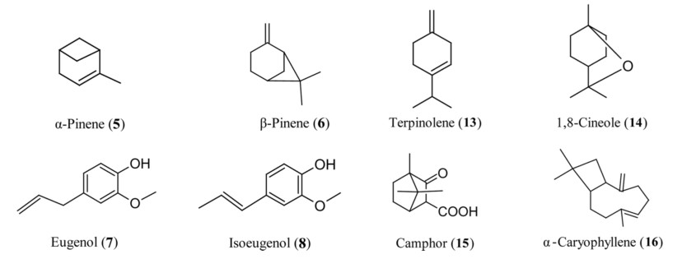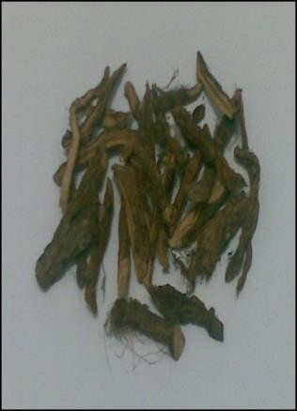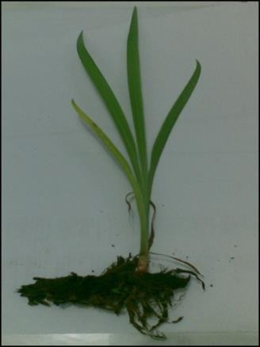

a b

Figure 1. *Acorus calamus* L; Plant (a) Root (b)

**3.2. CHEMICAL CONSTITUEN**

A wide variety of chemical constituents have been reported from the rhizomes of AC. The oil of AC rhizomes has been

analyzed by various workers for their chemical constituents.

The oil was found to contain varying concentrations of a- asarone (1), b-asarone (2), c-asarone (3), calamene, calamenenol, calameone (4), a-pinene (5), b-pinene (6), camphene, p-cymene, eugenyl acetate, eugenol (7), isoeugenol (8), methyl isoeugenol (9), calamol, azulene (10), eugenol methyl ether, dipentene (11), methyleugenol,

asaronaldehyde (12), terpinolene (13), 1,8-cineole (14),

camphor (15), a-caryophyllene (16), and hydrocarbons (Fig.1) The oil also contains fatty acids such as palmitic acid and its ester, heptylic acid, an ester of butyric acid.first reported the synthesis of asarone from 1,2,4- trimethoxybenzene. Fractionation from the volatile oil by gas chromatography resulted in the isolation of a-asarone and b-asarone, which are the trans- and cis-isomers, respectively, of 2,4,5-trimethoxy-l-propenylbenzene. [33].

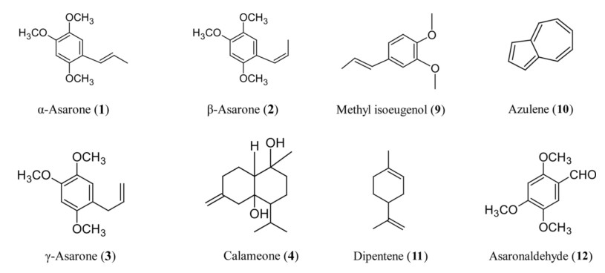

Figure 2. Phytoconstituents of *Acorus calamus* L.

**4. *Acorus calamus* L on TYPE 2 DIABETES MELLITUS MEDICATION**

Wu *et al* reported that ethyl acetate fraction of *Acorus*

*calamus* L (ACE) but not other fractions of AC could

enhance 3T3-L1 cells differentiation [35], they detected the effects of ACE on glucose consumption of L6 cells, which are sensitive to insulin. Their results shown in rosiglitazone enhanced glucose consumption of L6 cells in an insulin dependent manner (*p* < 0.01 *vs.* vehicle with insulin), whereas metformin elevated glucose consumption independent of insulin (*p* < 0.01 *vs*. vehicle either with or without insulin). 12.5 and 25 g/ml of ACE lowered the glucose of culture media in the presence but not in the absence of insulin (*p* < 0.05 and *p* < 0.01 *vs.* vehicle in the presence of insulin, *p* > 0.05 in the absence of insulin), and similar results were observed in rosiglitazone groups. ACE obviously increased insulin mediated glucose consumption in L6 skeletal muscle cells, suggesting that ACE may antagonize diabetes by improving the insulin sensitivity [36].

**4.1. INSULIN SENSITIZING EFFECTS**

To conﬁrm the insulin sensitizing effects of ACE in

vivo, insulin resistant diabetic db/db mice were orally

administrated for 3 weeks. As a result, the values of serum glucose in the different treated groups (10 mg/kg rosiglitazone, 100 mg/kg ACE, and 5 mg/kg rosiglitazone combined with 100 mg/kg ACE) declined by 40.1%,

34.1% and 49% after 2 weeks, and by 70.1%, 54.5% and

76.1% after 3 weeks, comparing with vehicle control

respectively (p < 0.001). Serum triglyceride decreased signiﬁcantly in all treatment groups after 1–3 weeks’ administration comparing with vehicle control. After 3 weeks’ administration, 100 mg/kg ACE showed no signiﬁcant inﬂuence to serum total cholesterol (p > 0.05), while 10 mg/kg rosiglitazone decreased it after 2 and 3 weeks’ administration (p < 0.05), and a combination of

100 mg/kg ACE and 5 mg/kg rosiglitazone markedly

decreased total cholesterol after 3 weeks’ treatment (p <

0.01). These results indicate that ACE depresses not only

blood sugar but also triglyceride in obese diabetic mice, and improves the lowering effect of total cholesterol caused by rosiglitazone [36].

**4.2. INHIBITORY OF α-GLUCOSIDASE**

Our investigation showed that the potency of

fraction *n*-butanol AC extract. as inhibitory agent on α- glucosidase enzyme. This study using the fraction from *n-*butanol AC extract. with column chromatography method to separated it. We use the resin to separated fraction because it suitable with the crude extract with

high polarity (hydrophilic). The result of inhibition assay for α-glucosidase activity of The result of inhibition assay for α-glucosidase from fraction show that the 5th fraction most active with IC50 value 4.87 µg ML-1 and the other fraction has not activity [37]

Our investigation use a koji extract as control from

*Apergillus terreus* is an especially prolific producer of secondary metabolites has biological activities such as inhibitory of α-glucosidase and it has a most potential activity therefore examined the effect on postprandial blood glucose level after a meal in mice. Triana’s research on inhibition mode koji extract against α- glucosidase was investigated. Inhibition mode of koji extract had a combination of non-competitive and uncompetitive inhibition [38]. In their study inhibition mode of AC extract had a non-competitive inhibition, non-competitive inhibition of AC extract may be having different structure from the compound that has α- glucosidase inhibitory activity on competitive mode like acarbose [37]. On the next research we find that one of isolate from this fraction can inhibit the α-glucosidase with IC50 17.89 µg/mL [39]. For the additional research we have been use HPTLC method to find out the fingerprint of AC compound on leaf and rhizome. This research showed that β-asarone is the major compound on the leaf [40].

**4.3. DECREASED FASTING SERUM GLUCOSE**

AC and ACE increased insulin secretion in HIT-T15

cells as gliclazide did. As in vivo results, ACE (400 and

800mg/kg) significantly decreased fasting serum glucose,

and suppressed the increase of blood glucose levels after

2g/kg glucose loading in normal mice. In addition, ACE

as a mixed-type inhibitor inhibited alpha-glucosidase activity in vitro with an IC50 of 0.41μg/ml, and 100mg/kg of it clearly reduced the increase of blood glucose levels after 5g/kg amylum loading in normal mice. Apart from its insulin sensitizing effect, ACE may have hypoglycemic effects via mechanisms of insulin releasing and alpha-glucosidase inhibition, and thus improves postprandial hyperglycemia and cardiovascular complications [41].

**4.4. *IN SILICO* STUDY**

Model of the enzyme α-glucosidase was obtained through

the protein data bank with the code **1lwj** in the donwload NCBI website. Models of chemical compounds contained in dringo (*A. Calamus* L) obtained through the site Take out "jamu" Knapsack[42] and made in the formula structures of 2D and 3D using the program ACD / Chemsketch. Then docking used Argus lab. Docking results as shown on table 1 and figure 3 and figure 4

Tabel 1 Docking Results on AC Compound

|  |  |  |  |  |
| --- | --- | --- | --- | --- |
| No | Ligan / chemical compound | Receptor α-Glukosidase | Free energy (∆H) | Information |
| 1. | (-)-Cadala-1,4,9-triene | α-Glukosidase | 0 | (-) |
| 2. | Ac ola mone | α-Glukosidase | 0 | (-) |
| 3. | Ac oradin | α-Glukosidase | 0 | (-) |
| 4. | Ac oragenmacrone | α-Glukosidase | 0 | (-) |
| 5. | Ac orenon | α-Glukosidase | 0 | (-) |
| 6. | Acorid acid | α-Glukosidase | -7,26053 kcal/mol | (+) |
| 7. | Ac orenene | α-Glukosidase | 0 | (-) |
| 8. | Aristolene | α-Glukosidase | 0 | (-) |
| 9. | Beta - acarone | α-Glukosidase | -7,62818 kcal/mol | (+) |
| 10. | Beta - Guanine | α-Glukosidase | 0 | (-) |
| 11. | Calacone | α-Glukosidase | -7,65883 kcal/mol | (+) |
| 12. | Calamusenone | α-Glukosidase | 0 | (-) |
| 13. | Calarene | α-Glukosidase | -2,9378 kcal/mol | (+) |
| 14. | 1-ethenyl-1-methyl-2,4-di(prop-1-en-2-yl)cyclohexane | α-Glukosidase | -8,04385 kcal/mol | (+) |
| 15. | Delta - cadienene | α-Glukosidase | 0 | (-) |
| 16. | Apihsyobunon | α-Glukosidase | -7,74775 kcal/mol | (+) |
| 17. | Isoacolamone | α-Glukosidase | 0 | (-) |
| 18. | Isocaespitol | α-Glukosidase | -8,28388 kcal/mol | (+) |
| 19. | Isocalame ndiol | α-Glukosidase | 0 | (-) |
| 20. | Isoshyobunon | α-Glukosidase | 0 | (-) |
| 21. | Methylsoegenol | α-Glukosidase | -7,92367 kcal/mol | (+) |
| 22. | Preisocalamendiol | α-Glukosidase | 0 | (-) |
| 23. | Shyobunon | α-Glukosidase | -7,75501 kcal/mol | (+) |

Note (+) : Inhibited Enzyme

(-) : Non InhibitedEnzyme

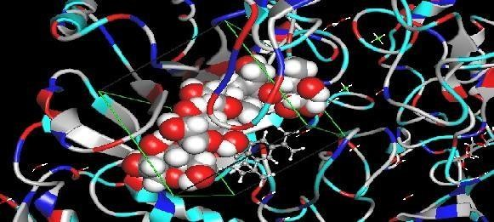

Figure 3: 1-ethe nyl-1-methyl-2,4-di(prop-1-e n-2-yl)cyclohexane

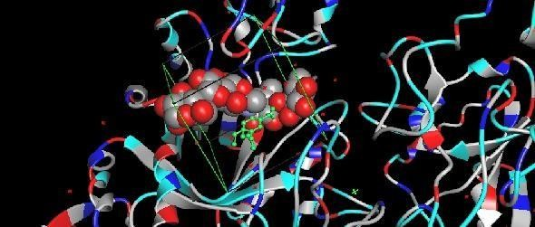

Figure 4 : Isocaespitol

Recently, *In silico* has play an important role in drug design and discovery. In which small molecule are virtually docked in to a drug target and the binding affinities are estimated using simplified free energy calculation method. Many programs capable of carrying out virtual screening have been developed, most of them are pay ware. One, freely available docking software package potentially capable is ArgusLab. Argus lab was originally developed as molecular modeling software. It provides users with molecular building analyses, the ability to perform various molecular calculation and molecular structure visualization capabilities [43].

Molecular docking analysis capability was added to latest version of ArgusLab(ver.4.0.1). ArgusLab can be easily used even by beginner in computational docking and can run using windows (Microsoft Corp)[43].The enzyme α-glucosidase is the enzyme responsible for the conversion of carbohydrates into glucose. Carbohydrates are digested by enzymes in the mouth and intestines into simpler sugars which will then be absorbed into the body and improve blood sugar [44].

AC obtained several compounds such as Beta asarone, Acoradine, Methylsoegenol, 1-ethenyl-1-methyl-2,4-di(prop-

1-en-2-yl)cyclohexane, Isocaespitol, Acoragermacrone, Preisocalamendiol, Shyobunon, Epishyobunone, Isocalamone,

Acolamone, Aristolene, (-)-Cadala-1,4,9-triene, Isocalamendiol, Calacone, Beta-gualene, Calamusenon, Acoronene, Acorid acid, Calarene, Acorenone through the site

Take out "jamu" Knapsack and made in the formula structures of 2D and 3D using the program ACD / Chemsketch. Then docking used Argus lab Program are visualized by Pymol program.Docking results showed activity in the compound 1- ethenyl- 1-methyl-2,4-at (prop-1-en-2-yl) Cyclohexane with free energy - 8.04385 kcal / mol, and the compound Isocaespitol with a free energy - 8.28388 kcal / mol. Chemical

component that has the lowest free energy showed the most stable affinity that is expected to have good medicinal properties as well. Docking results showed activity in the compound 1-ethenyl- 1-methyl-2,4-at (prop-1-en-2-yl) Cyclohexane with free energy - 8.04385 kcal / mol, and the compound Isocaespitol with a free energy - 8.28388 kcal / mol [43].

**4.5. MOLECULAR MECHANISMS ON GLUCAGON- LIKE PEPTIDE-1 (GLP-1)**

ACE acts as an antidiabetic through insulin sensitizing, insulin releasing and alpha-glucosidase inhibitory activities. The present study is designed to investigate the effects and molecular mechanisms of ACE on glucagon-like peptide-1 (GLP-1) expression and secretion related to its hypoglycemic effects. The hypoglycemic effect of ACE (100mg/kg, i.g.) was confirmed by testing blood glucose levels or via oral glucose tolerance test (OGTT) in streptozotocin (STZ) induced hyperglycemic mice, db/db diabetic mice and diet-induced obese (DIO) mice. Plasma insulin, GLP-1 levels and intestinal GLP-1 related gene expression were determined in STZ-

*Department Pharmacognosy Phytochemustry, Faculty of

Pharmacy, Universitas Muslim Indonesia, Makassar-South **© 2014 Bentham Science Publishers**

Celebes, Indonesia. Zip Code 90132. Tel/Fax: +62-411-425619,

+62-81524045514; E-mails: a[hmad.najib@umi.ac.id](mailto:najib@umi.ac.id)

induced and db/db diabetic mice. The in vitro effects of ACE (12.5μg/ml) on the expression and secretion of GLP-1 were detected in NCI-H716 intestinal L-cells, and the correlation between ACE and molecules in the Wnt signaling pathway was further explored.

ACE (100mg/kg) significantly lowered fasting blood glucose in STZ-induced and db/db diabetic mice and improved the OGTT in DIO mice. Insulin releasing and islet protective effects, along with the increased secretion of GLP-1, were observed. The expression of proglucagon gene (gcg) and post- translational processing gene prohormone convertase 3 (pc3) and the GLP-1 content in the culture medium of L-cells notably increased after the ACE treatment (12.5μg/ml). At the same time, β-catenin nuclear translocation occurred, and its downstream protein cyclin D1 was activated, showing the involvement of Wnt signaling. ACE might activate Wnt signaling to increase the gene expression of gcg and pc3 and exert incretin effects, including insulinotropic and islet protection, to lower blood glucose levels via elevated GLP-1 secretion either directly or indirectly [45].

**CONCLUSION**

*Acorus calamus* L. have been proofed as folk medicine that can cure type 2 diabetes mellitus on many mechanism and can be use as antidiabetic related with many experiment methods.

**CONFLICT OF INTEREST**

The author(s) confirm that this article content has no conflict of interest.

**REFERENCES**

[1] S. Elavarasi, K. Saravanan, and C. Renuka, A Systematic Review On

Medicinal Plants Used To Treat Diabetes Mellitus, IJPCBS. 2013 (3); 3:

983–992.

[2] Jarald, E., Balakrishnan Joshi, S., & Chandra Jain, D. Diabetes and Herbal

Medicines, 2008 (7); 1: 97–106. Retrieved from <http://ijpt.iums.ac.ir>

[3] Si MM, Lou JS, Zhou CX, *et al.* Insulin releasing and alpha-glucosidase inhibitory activity of ethyl acetate fraction of Acorus calamus in vitro and in vivo. J. Ethnopharmacol. 2010; 128: 154-159

[4] Yao Y, Sang W, Zhou M, Ren G. Antioxidant and alpha- glucosidase inhibitory activity of colored grains in China. J. Agric. Food Chem. 2010;

58: 770-774.

[5]_American Diabetes Association: All about diabetes. [http://www.diabetes.org/about-diabetes.jsp.](http://www.diabetes.org/about-diabetes.jsp) [cited: 14th Jan 2017].

[6] Itoi BM, Ikegami H, Fujisawa T, *et al*. Fatty liver and obesity: phenotypically correlated but genetically distinct traits in a mouse model of type 2 diabetes. Diabetol. 2007; 50: 1641-1648.

[7] Pidaran M, Leelavinothan P. Antioxidant effect of tetrahydrocurcumin in streptozotocin-nicotinamide induced diabetics rats. Life Sci. 2006;

79: 1720-1728.

[8] Riadh K, Hanen F, Wided M, *et al*. Antioxidant and antimicrobial activities of the edible medicinal halophyte Tamarix gallica L. and related polyphenolic constituent. Food Chem. Toxicol. 2009; 47: 2083-

2091.

[9] Lee SH, Sancheti SA, Bafna1 MR, Sancheti SS, Seo

SY.Acetylcholineterase inhibitory and antioxidant properties of

Rhododendron yedoense var. Poukhanense bark. J. Med. Plant Res.2011;

5: 248-254.

[10] Sharma B, Balomajumder C, Roy P. Hypoglycemic and hypolipidemic effects of flavonoid rich extract from Eugenia jambolana seeds on streptozotocin induced diabetic rats. Food Chem. Toxicol. 2008; 46:

2376-2383.

[11] Shibano M, Kakutani K, Taniguchi M, Yasuda M, Baba K.Antioxidant constituents in the dayflower (Commelina communis L.) and their α- glucosidase-inhibitory activity. J. Nat. Med. 2008; 62: 349-353.

[12] E. Jarald, S. Balakrishnan Joshi, and D. Chandra Jain, Diabetes and Herbal

Medicines. , 2008 (7); 1: 97–106.

[13]Ayodhya S, Kusum S and Saxena A. Hypoglycaemic activity of different extracts of various herbal plants, Int. J. Res. Ayur. Pharm. 2010; 1: 212.

[14] Donga J J, Surani V S, Sailor G U, Chauhan S P & Seth A K, A systematic review on natural medicine used for therapy of diabetes mellitus of some Indian medicinal plants, Int. J. Ph. Sci. 2011; 2 : 36.

[15] Hui H, Tang G, Go VL. Hypoglycemic herbs and their action mechanisms.

Chinese Medicine. 2009 (4); 1 :11.

[16] Tschöp M. Diabetes Type 2 Treatments. Drug Research. 2016; 66: 01-10. [17] Kesari AN, Kesari S, Santosh KS, Rajesh KG, Geeta W. Studies on the glycemic and lipidemic effect of Murraya koenigii in ex- perimental

animals. J Ethnopharmacol 2007(112); 2 :305-11.

[18] Latha M, Pari L. Antihyperglycaemic effect of Cassia auriculata in experimental diabetes and its effects on key metabolic en- zymes involved in carbohydrate metabolism. Clin Exp Pharma- col Physiol 2003 (30); 1-

2:38-43.

[19] Marles RJ, Farnsworth N. Antidiabetic Plants and their Active

Constituents: An update. Prot J Bot Med 1996; 1:85-135.

[20] Yin J, Zhang H, Ye J: Traditional Chinese medicine in treatment of metabolic syndrome. Endocr Metab Immune Disord Drug Targets 2008 (8) ; 2 :99-111

[21] Vuksan V, Sung MK, Sievenpiper JL, *et al.* Korean red ginseng (*Panax ginseng*) improves glucose and insulin regulation in well-controlled, type

2 diabetes: results of a randomized, double-blind, placebo-controlled study of efficacy and safety. Nutr Metab Cardiovasc Dis 2008 (18); 1:46-56

[22] Angelova N, Kong HW, Heijden R van der, *et al.* Recent methodology in the phytochemical analysis of gin- seng. Phytochem Anal 2008, (19); 1:2-

16.

[23] McCune LM, Johns T. Antioxidant activity relates to plant part, life form and growing condition in some diabetes remedies. JEthnopharmacol 2007;

112:461-9.

[24] Leduc C, Coonishish J, Haddadb P, Cuerrier A. Plants used by the Cree Nation of Eeyou Istchee (Quebec, Canada) for the treatment of diabetes: A novel approach in quantitative ethno- botany. J Ethnopharmacol 2006;

105:55–63.

[25] Cesspooch, L.. Native American Traditional Medicine and Diabetes: *Acorus calamus* L. A Sacred Medicinal Plant of the Native Cree.<http://hlunix.hl.state.ut.us/diabetes/telehealth/2005> archives.htm [cited:

14th Jan 2017].

[26] Parab, R S., Mengi, S A., Hypolipidemic Activity of *Acorus calamus* L. in rats. Fitoterapia, 2002; 73: 451–455.

[27] The Ayurvedic pharmacopoeia of India. (Government of India, Ist edition,

1999) part I, Vol. II pp.169-170

[28] N. D. Prajapati. S. S. Purohit, D. D. Sharma, K. Tarun, A Handbook of Medicinal Plants, Section II (Agrobiaos (india) 2003) pp. 13-14.

[29] K.M. Nadkarni, Indian Materia Medica, (Popular prakashan, Bombay

1998), Vol I, pp. 35-37.

[30] P.S. Vaidyaratnam, Varier’s Indian medicinal plants, (Oriental

Longman Ltd, Arya Vaidya Sala, Kottakal, 1994 pp.51.

[31] P. Rev, S. R. Yende, U. N. Harle, D. T. Rajgure, T. A. Tuse, and N. S.

Vyawahare, “PHCOG REV .: Plant Review Pharmacological profile of

*Acorus calamus* : An Overview, 2008 (2); 4 : 23–26.

[32] Integrated Taxonomic Information System. November 14, 2010.<http://www.itis.gov/>[cited: 14th Jan 2017].

[33] T.E. Wallis, Textbook of Pharmacognosy, 5th edition, CBS publication, New Delhi, 1997, pp 396-397.

[34] P. K. Mukherjee, V. Kumar, M. Mal, and P. J. Houghton, *Acorus calamus*

.: Scientific Validation of Ayurvedic Tradition from Natural Resources, Pharm. Biol., 2007 (45); 8 : 651–666.

[35] Wu, H.S., Li, Y.Y., Weng, L.J., *et al*. A fraction of *Acorus calamus* L. extract devoid of β-asarone enhances adipocyte differentiation in 3T3-L1 cells. Phytotherapy Research, 2007; 21: 562–564.

[36] Wu, H., Zhu, D., Zhou, *et al .*Insulin sensitizing activity of ethyl acetate fraction of *Acorus calamus* L . in vitro and in vivo, 2009; 123: 288–292.

[37] n-Butanol Fraction of *Acorus calamus* Rhizome Extract to Inhibit the

Activity of α-Glucosidase, Journal of Trop Med Plants, 2010(11) 2: 2001-

2004.

[38] Triana R D., Iskandar Y.M., Hanafi M., *et al* , Inhibitory Effect of Koji *Aspergillus terreus* on α-Glucosidase Activity and Postprandial Hyperglycemia, Pakistan Journal of Biological Science, 2007; 18: 3131-

3135.

[39] In Vitro Bioassay of n-buthanol Isolate of *Acorus calamus* L. on Inhibitory of Activity α-Glucosidase International Journal of PharmTech Research,

20011(3); 4: 2085-2088.

[40] Malik, A., Kurniawan, A., Najib, A. Comparative study of HPTLC finggerprint of  β-asarone content between leaves and rhizome of Acorus calamus L. International Journal of PharmTech Research, 2014 (6); 2:

829–833.

[41] Si, M., Lou, J., Zhou, C.-X., *et al*. Insulin releasing and alpha-glucosidase inhibitory activity of ethyl acetate fraction of *Acorus calamus* in vitro and in vivo. Journal of Ethnopharmacology, 2010(128); 1: 154–159.

[42] Farit, Plant and Cell Phsyiology: Press Oxford University, L.A<http://www> K NApSAcK Family Databases: Integrated metabolite- plant species databases for multifaceted plant researches1.htm .(2011).

[43] Yuliana, D., Mursalin, Najib. A., In silico screening of chemical compounds from Sweet flag (*Acorus calamus* L) as α-Glucosidase inhibitor. Int. Res. J. Pharm, 2013(4); 3:110-112.

[44] Bösenberg, L.H. The Mechanism Of Action Of Oral Antidiabetic Drugs: A Review Of Recent Literature. The Journal Of Endocrinology, Metabolism And Diabetes Of South Africa, 2008 (13); 3: 80-88.

[45] Liu, Y.-X., Si, M.-M., Lu, W., *et al* (2015). Effects and molecular mechanisms of the antidiabetic fraction of Acorus calamus L. on GLP-1 expression and secretion in vivo and in vitro. Journal of Ethnopharmacology, 2015 ; 166: 168–175.

Received: Revised: Accepted: