**Reviewer’s Comments**

**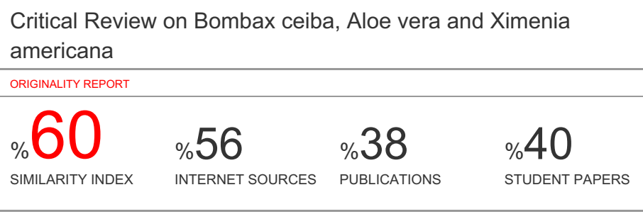**

**Critical Review on *Bombax ceiba*, *Aloe vera* and *Ximenia americana***

**Running title: Medicinal plants and review**

**Abstract**

Therapeutic plants are extensively increased in scenery with their efficient therapeutic properties. The medicinal plants such as *Bombax ceiba*, *Aloe vera* and *Ximenia americana*. The *plants are* well known to cure several diseases therefore used in different Ayurvedic preparation somehow they are lagging behind in the list of medicinal plants for their applications in drug preparations. These plants has great ethnopharmaceutical and pharmacological properties with therapeutic applications therefore present review gives different aspects of *Bombax ceiba*, *Aloe vera* and *Ximenia americana* and may help to create awareness in society.

**Key words:** *Bombax ceiba*, *Aloe vera* and *Ximenia americana*, ecology, ethnobotany, pharmacology

**Introduction**

The term "biodiversity hotspot" was coined by the British biologist Norman Myers in 1988. He described them as a biogeographic region by characterizing their exceptional levels of plant endemism and serious levels of habitat loss1. Further, in between 1989-1996, Conservation International (CI) adopted ‘Myers hotspots criteria’ and they made one organization for the reassessment of the hotspots concept and in 2005 they have published an updated titled Hotspots Revisited: Earth's Biologically Richest and Most Endangered Terrestrial Ecoregions 2. According to the CI report, there is the total of thirty-five biodiversity hotspots in the world, amongst them, four are in India. Mainly these three biodiversity hotspots are situated in the Himalaya, Indo-Burma, Sundaland, and the Western Ghats3. Total 17000-18000 flowering plant species, 8000 medicinal plants, are documented in folk and Ayurveda, Unani, Siddha, and Homoeopathy4. Medicinal plants are a great resource base for the traditional medicine & herbal industry and also it provides livelihood and health security to a large segment of Indian inhabitants. India has the greater natural ecosystem from past two decades, there has been a marvelous augment in the use of herbal medicines; though there is still a noteworthy deficiency in the research of medicinal plants and it has the great resources of medicinal plants which are noteworthy to human beings in many ways5. According to the World Health Organization, medicinal plants are used as the best resource to obtain a variety of bioactive compounds in the development of different drugs, those are effective as an antimicrobial, anti-tuberculosis, antioxidant, anticancerous, anti-inflammatory, antidiabetic, anthelmintic, hepatoprotective activity, larvicidal activity6-9. By taking above background in the present review total of three medicinal plants revealed with their critical information.

In the present study total of three medicinal plants were under study and their information is as follows.

1. ***Bombax ceiba* Linn:**

*Bombax ceiba* belongs to the family Bombacaceae is a bulky, deciduous, elegant tree inhabiting Africa, Australia, temperate and tropical Asia1**.** It has been applied in traditional medicine for its versatility nature against pathogens 2-4. These plant roots and flowers were used to treat different aliments. The plant has different vernacular names such as Semal, Semar (Hindi), Silk-cotton tree (English), Moca (Sanskrit), Sembhal (Urdu), Shemalo (Gujarati) Buruga (Telugu), Simalu (Assam), Shimool (Bengali)4.

The plant botanical classification is as follows:

Kingdom : Plantae

Division : Magnioliophyta

Class : Magniolipsida

Order : Malvales

Family : Bombacaceae

Genus : Bombax

Species : ceiba

*Bombax ceiba* is extensively originated in moderate Asia, tropical Asia, Africa and Australia. In India, it can be originate at altitudes upto1500m. In peninsular India, the tree is extremely usually seen in the arid and wet deciduous forests and also by rivers. This tree is a huge light-eater and rapid rising tree. *Bombax ceiba* grows finest on bottomless grimy loams, especially in valleys, in the regions that are getting 50 to 460 cm5. The morphology is shown in figure 1.

The dissimilar piece of *B. ceiba* similar to leaves, roots, stems bark, seed, flower, gum and fruit are revealed to hold various therapeutic behaviors in ethnobotanical surveys. In February, *B. ceiba* begins plummeting every one of its foliage. It is time for blossoming and follows a amazing exhibit of great silky red flowers at the tips of naked branches. In May, white cottony strands, from opened fruits, float downward, settling on the ground, houses and whatever else is in their mode. It displays spiky twigs orderly in horizontal tiers which are rough, straight and spiny with buttress roots 1-3.

The body parts of the plant contain different chemicals. Bark contains lupeol, saponins, tannins, gums and 4,5,7- trihydroxyflavone- 3-O-β-D-glucopyranosyl(1-4)-α-L-rhamnopyranoside, nhexacosanol, shamimicin; Seeds contains palmitic acid; roots contains lactone, Hemigossypol-6-methyl; flowers contains polysaccharides with backbone of 4(1-4)- β-linked D-galactopyranose and 2 (1-3)- β-linked Larabinopyranose units, 5-isopropyl-3-methyl-2, 4, 7-trimethoxy-8; Leaves contain a flavonols, C-glycoside shamimin, Xanthone, 7-hydroxy-5-isopropyl-2-methoxy-3-methyl-1, 4-naphthoquinone**.** The plant has different medicinal activities such as anti-inflammatory, antidiabetic, anti-diarrheal, anti-helnintic activities, treating leprosy, muscular injury, wounds, asthma, birth control, sexual diseases 1-5.

***2. Aloe vera*:**

The *Aloe vera* belongs to Asphodelaceae family. It is shrubby perennial xerophytic, succulent, pea green colored plant. It grows mainly in the dry regions of Africa, Asia, Europe and America. In India, it is found in Rajasthan, Andhra Pradesh, Gujarat, Maharashtra and Tamil Nadu6. The plant has triangular, fleshy leaves with jagged edges, yellow tubular flowers and fruits that contain frequent seeds7. The morphology is shown in figure 2.

Each leaf is composed of three layers:

1) An inner clear gel that contains 99% water and rest is made of glucomannans, amino acids, lipids, sterols and vitamins.

2) The middle layer of latex which is the bitter yellow sap and contains anthroquinones and glycosides.

3) The outer thick layer of 15–20 cells called as rind which has protective function and synthesizes carbohydrates and proteins. Inside the rinds are vascular bundles accountable for transport of substances such as water (xylem) and starch (phloem)8.

**Taxonomy7**

Kingdom- Plantae

Order- Asparagales

Division- Spermatophyte

Subdivision- Angiospermae

Class- Monocotyledoneae

Genus- Aloe

Species- Barbadensis Mill

**Synonyms:** Aloe, Musabbar, Kumari

Aloe contains two classes of Aloins: (1) Nataloins, which yield picric and oxalic acids with nitric acid, and do not give a red coloration with nitric acid; and (2) barbaloins, which yield aloetic acid (C7H2N3O5), chrysammic acid (C7H2N2O6), picric and oxalic acids with nitric acid, being reddened by the acid. This second group may be divided into a-barbaloins, obtained from Barbados aloes, and reddened in the cold, and barbaloins, obtained from Socotrine and Zanzibar aloes, reddened by ordinary nitric acid only when warmed or by fuming acid in the cold. Nataloin forms bright yellow scales. Barbaloin forms yellow prismatic crystals6-8. The plant produces at least 6 antiseptic agents such as lupeol, salicylic acid, urea nitrogen, cinnamonic acid, phenols and sulphur. All of these substances are recognized as antiseptics because they kill or control mold, bacteria, fungus and viruses, explaining why plant has the ability to eliminate many internal and external infections. Lupeol and salicylic acid present in the juice are two very effective pain-killers. It contains at least three anti-inflammatory fatty acids, cholesterol, campesterol and β-sitosterol. These are highly effective in treatment of burns, cuts, scrapes, abrasions, allergic reactions, rheumatoid arthritis, rheumatic fever, acid indigestion, ulcers, plus many inflammatory conditions of the digestive system and other internal organs, including the stomach, small intestine, colon, liver, kidney and pancreas. β- sitosterol is also a powerful anti-cholesterol which helps to lower harmful cholesterol levels, helping to explain its many benefits for heart patients6-9.

***3. Ximenia americana***

The *Ximenia americana* tree belongs to the family Olecaceae. It is widely distributed in different regions. It is originate in Darfur (Jabal Marra, Radom); Blue Nile (Ingessena Hills); Kordofan (Nuba Mountains, Nuhud); Red Sea Hills (Erkwit); Bahar Ghazal, Upper Nile and Equatoria (Torit). *X. americana* bark, fruit and leaves have numerous uses in local medicine for people and flora and fauna10**.** The leaves and twigs are used for fever, cold, as mouth wash for tooth aches, as laxative and an eye lotion11. The leaves are used for headaches and poison antidote11. The morphology is shown in figure 3.

Roots treat skin aches and problems, headaches, leprosy, hemorrhoids, sexually transmitted diseases, guinea worm, sleeping thickness, oedema and act as an antidote to poison. The fruit is useful in treating habitual constipation. The bark is used dried, powdered and applied to skin ulcers. The fruits are eaten in large quantities and act as a vermifuge. *X. americana* pulp, seed and fruit contain hydrocyanic acid. Bark contains approximately 17% oils, heartwood and flowers contain essential oils. Fruits, fruits pulp, leaves, twigs and roots contain constituents used in folk medicines13. It was reported that *X. americana* seed oil contained oleic, linoleic, linolenic, arachidonic, eicosatrienoic, erucic and nervonic acids. The major constituents of the volatile oil of the leaves of *X. americana* were benzaldehyde, hydroxy benzyl cyanide and isophorone12.

*X.* americana, stem ethanolic extract afforded steroids (stigmasterol and sitosterol), triterpenoids (betulinic acid, oleanolic acid, 28-O-(-D-glucopyranosyl) oleanolic acid, 3-oxo-oleanolic acid, 3β–hydroxycicloart-24(*E*)-ene-26-oic acid and sesquiterpenoids (furanoic and widdrane type). A large number of sesquiterpenes are constituents of essential oils of higher plants and seem to intervene in the pharmacological properties attributed to these volatile fractions. It has been clarified that the biological activities of the liverworths are due to terpenoids and lipophilic aromatic compounds. Steroids and triterpenes with therapeutic interest and manufacturing employment are a group of secondary metabolites of outstanding importance. Considerable recent work strongly indicates the great potential of the triterpenoids as source of use medicinal. Investigations in the past 10 years showed that the constituents of *X. americana* have shown several biological activities such as, antimicrobial, antifungal, anticancer, antineoplastic, antitrypanosomal, antirheumatic, antioxidant, analgesic, moluscicide, pesticidal, also having hepatic and heamatological effects11. In general, the compounds found in *X. americana* were saponins, glicosydes, flavonoids, tannins, phenolics, alkaloids, quinones and terpenoids types. In addition, the plant is potentially rich in fatty acids and glycerides and the seeds contain derivatives cyanide. The identified compounds did not demonstrate a representative pattern of each class. For example, the sesquiterpenes were furanoic and widdrane while, triterpenes exhibited oleanane and cycloartane skeletal type. Concerning the fatty acids, in addition to common C16, C18 and C22, a distinctive feature is the presence of acetylene, as well as, very long chain fatty acids10-13.

**Conclusion**

*Present plants are* the ill-intentioned, invasive, a deleterious weed, present worldwide however due to insufficient knowledge and myths weed is lagging behind in the list of medicinal plants. The Ethanopharmaceutical and pharmacological studies revealed different aspects of *Bombax ceiba*, *Aloe vera* and *Ximenia americana* therefore present study may helpful to create awareness in society about the plant.

**References**

1. Ravi V, Patel SS, Verma K, Dutta D, Saleem TS. Hepatoprotective activity of *Bombax ceiba* Linn against Isoniazid and Rifampicin induced toxicity in experimental rats, Int J Appl Res Nat Prod; 2010: **3**(3), 19-26.
2. Sarita K, Greindra G, Shailsh G. Pharmacognostic and pharmacological profile of *Bombax ceiba*, Asian J Pharm Educ Res; 2017: **6**(3), 16-27.
3. Pankaj HC, Somshekhar SK. *Bombax ceiba* Linn.: Pharmacognosy, ethnobotany and phyto-pharmacology, Pharmacog Commun; 2012: **2**(3), 2-9.
4. Verma R, Devre K, Gangrade T, Gore S, Gour S. A Pharmacognostic and pharmacological overview on *Bombax ceiba*, Sch Acad J Pharm; 2014: **3**(2), 100-107.
5. Kumar A, Lingadurai S, Jain A, Barman NR. *Erythrina Variegata* Linn: A review on morphology, phytochemistry and pharmacological aspects, Pharmacogn Rev; 2010: **4**(8), 147-152.
6. Chithra P, Sajithlal G, Chandrakasan G. Influence of aloe vera on the glycosaminoglycans in the matrix of healing dermal wounds in rats. J Ethnopharmacol. 1998; 59: 179–86.
7. Roberts DB, Travis EL. Acemannancontaining wound dressing gel reduces radiationinduced skin reactions in C3H mice. Int J Radiat Oncol Biol Phys. 1995; 32: 1047–52.
8. Sato Y, Ohta S, Shinoda M. Studies on chemical protectors against radiation XXXI: Protective effects of Aloe arborescens on skin injury induced by xirradiation. Yakugaku Zasshi. 1990; 110: 876–84.
9. Byeon S, Pelley R, Ullrich SE, Waller TA, Bucana CD, Strickland FM. Aloe barbadensis extracts reduce the production of interleukin after exposure to ultraviolet radiation. J Invest Dermtol. 1988; 110: 811–7.
10. Mahato SB, Nandy AK, Roy G. Triterpenoids. *Phytochemistry*. 1992; 7 (10): 180-187.
11. Maikai VA, Maikai BV, Kobo PI. Antimicrobial Properties of Stem Bark Extracts of *Ximenia americana*. *Journal of Agricultural Science*. 2009; 1(2): 30-34.
12. Fatope MO, Adoum OA, Takeda Y. C18 Acetylenic Fatty Acids of *Ximenia americana* with Potential Pesticidal Activity. *Journal of Agricultural and Food Chemistry*, 2000; 48: 1872-1874.
13. Visuthikosol V, Chowchuen B, Sukwanarat Y, Sriurairatana S, Boonpucknavig V. Effect of aloe vera gel to healing of burn wound a clinical and historic study. J Med Assoc Thai. 1995;78:403–9.

|  |  |
| --- | --- |
| **C:\Users\kupp\Desktop\20180112125409_BOMBAX_CEIBA7T.jpg** | **C:\Users\kupp\Desktop\Ph.D\Ph.D photos\BC pix\IMG_20190331_161615.jpg** |
| **Figure 1: *Bombax ceiba*** | |

|  |  |
| --- | --- |
| C:\Users\kupp\Desktop\Aloe-Vera-Plant.jpg | C:\Users\kupp\Desktop\aloeverabarbadensismilleredible6.jpg |
| **Figure 2: *Aloe vera*** | |

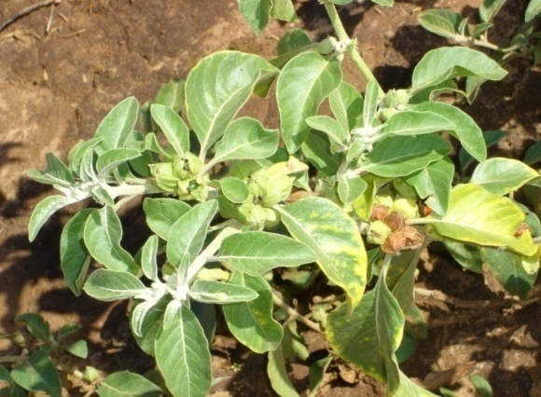

**Figure 3: *Ximenia americana***