**Reviewer’s Comments**

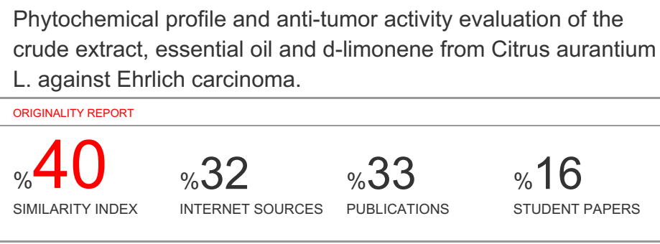

**Phytochemical profile and anti-tumor activity evaluation of the crude extract, essential oil and d-limonene from *Citrus aurantium*L. against *Ehrlich carcinoma*.**

**ABSTRACT**

Plant based drugs have been a solution in the search for more cost-effective and less harmful drugs for the treatment of neoplasia. *Citrus aurantium* L. (Rutaceae) is abundant in Brazil and d-limonene,a monoterpene used in the prevention and treatment of neoplasia, was identified as a major compound in the oilof this specie. This study aims to evaluate the anti-tumor activity of the crude extract,essential oil and d-limonene from*Citrus aurantium* L. (Rutaceae) against Ehrlich carcinoma, as well as the phytochemical evaluation of the essential oil and d-limonene. This is a randomized non-clinical trial in which were used adult male mice(Balb-C). The animals were divided into four groups (n=6). All groups were inoculated with the Ehrlich tumor and then received the treatment (control, crude extract, essential oil and d-limonene) by oral route daily (X day treatment). The chemical constitution of the essential oil (obtained by hydro-distillation) and d-limonene was analyzed by gas chromatography attached to mass spectrometry (GC-MS). A hemogram was performed at the end of the experiment.Animals treated with the essential oil has shown no significant differencecompared to the group treated with d-limonene. The group treated with crude extract had a growth inhibition close to the essential oil and d-limonene groups. It´s concluded that the essential oil and the crude extract of *Citrus aurantium*, L. (Rutaceae) can become therapeutic agents because of their anti-tumor activity with no toxicity to the blood cells and have low cost of production. Further studies are necessary, so they can be used in the treatment of neoplasia in humans. The chromatographic and spectrometric analyzes indicated the presence of other components in smaller amounts in the essential oil, which suggests that they could have a synergic activity to the d-limonene.

Key words: *Rutaceae*; *Citrus aurantium* L.; d-limonene; Ehrlich carcinoma; cancer; spectrometry.

**INTRODUCTION**

Plant based drugs have been a solution in the search for more cost-effective and less harmful drugs for the treatment of neoplasia. Several species originated medicines such as *Taxus brevifolia* (Paclitaxel®), *Catharanthus roseus* (vincristine and vimblastine), *Curcuma longa* (curcumin) and others. *Citrus aurantium* L. (Rutaceae), commonly known as orange, is a traditional fruit abundant in Brazil. From it peels, d-limonene, a chemical marker was identified. This compound is a monoterpene used in the prevention and treatment of neoplasia. Limonene is a cheap, effective and promising compound with a broad spectrum of anticancer activity1. Moreover, the anticancer of orange essential oil and other compounds present, were investigated in cancer cell lines A549 (human lung) and 22RV-1 (prostate). The essential oil, comprised mainly with D-limonene (74.6%) has shown a positive effect on the proliferation and inhibition of these cells line2.

The constituents of the essential oils are originated by the mevalonic acid pathway. Preferentially, monoterpenes and sesquiterpenes are synthetized, which are hydrocarbons with the general formula (C5H8)n, known as isoprene. These are oxygenated compounds derived from hydrocarbons including alcohols, esters, aldehydes, ethers, phenols, ketones and oxides. There are several activities reported for this class, like as antibacterial, antifungal, antiviral and antioxidant properties3. In Brazil, the genus Citrus is one of the most important commercial fruit crops. The genus includes several species of oranges, tangerines, limes, mandarins, grapefruit and lemons.

Limonene (1-methyl-4-isopropyl-cyclohexene) consists of two isoprene units, that comprises more than 90% of citrus essential oil and it exists in many fruits and vegetables. Although, the anticancer activity of d-limonene has identified nearly two decades ago, it has recently attracted much more attention in translational medicine4.

D-limonene comprises more than 90% of the orange peel oil. It has shown to have chemopreventive activity against lung, liver, skin and forestomach cancers5. It has been demonstrated to induce apoptosis on tumor cells6. Moreover, perillyl alcohol, a hydroxylated limonene analog, has present chemopreventive activity against liver, pancreas, mammary gland and colon cancer in rodent7.

The principal [metabolites](https://en.wikipedia.org/wiki/Metabolites) of limonene are (+)- and [(−)-trans–carveol](https://en.wikipedia.org/wiki/Carveol" \o "Carveol), a product of 6-hydroxylation) and (+)- and (−)-perillyl alcohol, a product of 7-hydroxylation by CYP2C9 and CYP2C19 [cytochromes](https://en.wikipedia.org/wiki/Cytochrome) in human [liver](https://en.wikipedia.org/wiki/Liver) [microsomes](https://en.wikipedia.org/wiki/Microsomes)8.The enantiomers of [perillyl alcohol](https://en.wikipedia.org/wiki/Perillyl_alcohol)have been investigated for their pharmacological activities as dietary chemotherapeutic agents. They are viewed as novel therapeutic options in some CNS [neoplasms](https://en.wikipedia.org/wiki/Neoplasm) and other solid tumors, particularly for the treatment of gliomas9.The [cytotoxic](https://en.wikipedia.org/wiki/Cytotoxic) activities of [perillyl alcohol](https://en.wikipedia.org/wiki/Perillyl_alcohol) and limonene metabolites are likely due to their [antiangiogenic](https://en.wikipedia.org/wiki/Antiangiogenic) activities, [hyperthermia](https://en.wikipedia.org/wiki/Hyperthermia) inducing effects as well asnegative [apoptosis](https://en.wikipedia.org/wiki/Apoptosis) regulation and Ras pathways10.

The study of orange oil, limonene and extracts has shown an interesting effect of these compounds upon cancer and several illnesses associated to antioxidant activity. Some enzymes activity wasanalyzed and the increase of glutathione-S- transferase (GST), glutathione content (GSH), and lipid peroxidation (LPO) has been demonstrated, supporting the antitumor effect of these compounds11.

Considering the exposed above, it is important to study all possibilities associated to orange oil and cancer, once this is a cheap product, with high production in Brazil and well seeing all over the world as a promising agent in this filed.

The present study aims to evaluate the anti-tumor activity of the crude extract, essential oil and d-limonene against Ehrlich carcinoma as well as the phytochemical analyses of the essential oil and d-limonene of *C. aurantium* and the comparison among these products.

**MATERIALS AND METHODS**

Essential oil gas chromatography/ mass spectrometry (GC-MS)

GC analysis was carried out using an Shimadzu gas chromatograph GC-2012 Plus equipped with flame ionization detector and an DB-5 (fused silica) column (30 m× 0.25 mm I.D., film thickness 0.25 μm) and split ratio, 1:25. The GC settings were as follows: initial oven temperature was held at 40 °C for 1 min, rising to 250 °C at 5 °C/min. The injector temperature was maintained at 250 °C. The detector temperature was at 230 °C. The carrier gas used was Helium at a flow rate of 1,37 ml/min. GC-MS was performed on Agilent Technology 5973 mass selective detector connected with an Shimadzu GC-2012 Plus gas chromatograph. The oil and d-limonene of *C. aurantium* was analyzed using an DB-5 (Fused silica) with the same column and temperature programmed as above. The MS operated from 10 to 200 eV ionization energy. Quantitative data were obtained from the electronic integration of the Flame Ionization Detector (FID) peak areas12.

Animals

Mice (Balb-C, 20–28 g) of 8 weeks of age were used for the experiment and were kept in polyacrylic cages. The animals were grouped in three per cage. The animals were maintained in standard laboratory conditions with controlled temperature (20 + 2 Co), relative humidity (55+ 5%) and with the dark/light cycle (12/12 h). Food (standard dry pellet diet) and water were provided *ad libitum*. Mice were obtained from the Central Biotery ofFMABC. All the described procedures were reviewed and approved by FederalUniversity of São Paulo Animal Ethics Committee (CEUA # 415527).

Ehrlichtumor model

EAC cells were collected by sterile disposable syringe from donor mice (Balb-C) of 20–28 g body weight and suspended in sterile isotonic saline. The viability of the cells was 99% as judged by trypan blue exclusion assay.To asses a solid mass of Ehrlich tumor, a fixed number of viable cells 0.2 mL EAC cells containing 5 × 105 cells/mouse were inoculated intraperitoneally and left for 28 days to allow tumor to grow.

Treatment schedule

Seven days after the inoculation of the Ehrlich cells, the treatments have started. The animals (n=24) were divided into four groups, each containing six mice.They received their treatment orally by gavage daily, as follow:

Group I (control group): treated with 0.3 ml of 0.9%saline solution.

Group II: Treated with 0.3% of crude extract of *C.aurantium*diluted in 0.50 ml of 0.9% saline solution.

Group III: animals treated with 0.3 ml of essential oil from *C. aurantium.*

Group IV: animals treated with 0.3 ml of d-limonene diluted in 0.50 ml of 0.9% saline solution.

In order to measure the tumor growth, the animals were measured weekly with a digital pachymeter.

At the end of the 28 days of experiment, mice were sacrificed by cervical decapitation. Blood was collected and storage in EDTA tubes for hemogram analyses.The tumor mass were weighed, storaged and frozen in liquid nitrogen.

Statistical analysis

All data are presented as the mean ± standard error of mean (SEM). Shapiro-Wilk test was used for data distribution. For the correlation regarding body size and body weight between moments in the groups was used the Spearman test. The difference regarding body weight and size in the initial and final moments among groups was analyzed using the Kruskall-Wallis test was used. Experiment was performed using Stat 11.0 software. Results were considered significant when P < 0.0513.

**RESULTS AND DISCUSSION**

Natural products have a long history of use in traditional medicines and their activities against different diseases have been the focus of many basic and clinical researches in past few decades. The essential oils, volatile liquid containing aroma compound from plants, are known as active ingredients in the herbal medicine. Perillyl alcohol (POH) is usually available through dietary sources and is being explored for its cancer chemoprevention, tumor growth suppression, and regression14. Citrus peels are the waste product of juice manufacturing industries and have been considered as a critical problem for environmental green ecology policies for years. One of the most well-known approaches to overcome this problem is transformation of these monoterpene by the use of specific strains of bacteria or yeasts. Limonene (1-methyl-4-isopropyl-cyclohexene) is a monoterpene, as other monoterpenes consists of two isoprene units, that comprises more than 90% of citrus essential oil and it exists in many fruits and vegetables. Although, the anticancer activity of d-limonene has identified nearly two decades ago, it has recently attracted much more attention in translational medicine4.

Chemical constituents were evaluated in terms of qualitative and quantitative analyses by gas chromatography/mass spectrometry. Fifty-four components were identified in the essential oil and 44 in the extracts. In all cultivars, the main component was D-limonene (73.9 - 97%). Discrete percentages of linalool, geraniol and nerol were also found. Cluster analysis based on essential oils composition showed a certain degree of affinity between cultivars of the same type. The antimicrobial activity was investigated against three micro-organisms (*Staphylococcus aureus*, *Listeria monocytogens* and *Pseudomonas aeruginosa*). 'Sanguinello' and 'Solarino Moro' essential oils were significantly active against *L. monocytogenes*, while 'Valencia' hexanic extract against all the tested micro-organisms was not15.

Characteristic mass spectra with many diagnostic ions were obtained from the extract analysis, allowing a fast and reliable identification of these species. Tandem mass spectrometry (MS/MS) was employed to confirm the identity of specific metabolites. HPTLC/DESI-MS imaging is a relatively fast, versatile, and efficient technique for natural product analysis, since many more ions are observed than with the direct infusion ESI-MS. The MS/MS technique provided information about the component structures, revealing the presence of important bioactive components. The application of DESI-MS imaging may contribute to the improvement identification and characterization of pharmacologically active compounds in phytochemistry16.

The chromatographic analyses of the essential oil of *C. aurantium* have shown 14 components: β-pinene, β-mircene, 3-carene, d-limonene, α-pinene, cis-β-ocimene, γ-terpinene, β-linalol, α-terpineol, nerill acetate, linalil acetate, lavandulol acetate, geraniol acetate and α-bisabolene. The major compound identified in the oil was D-limonene and β-pinene. The chromatographic profile and the spectrometric results where the components were identified using the GC-Solution software are below.

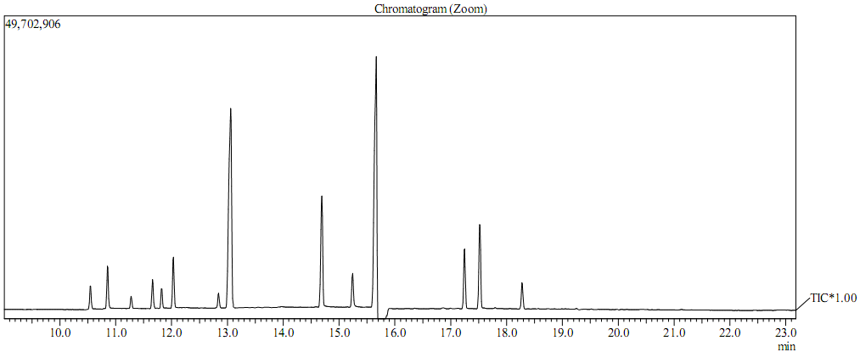

**Figure 1.** *C. aurantium* Essential oil chromatographic profile

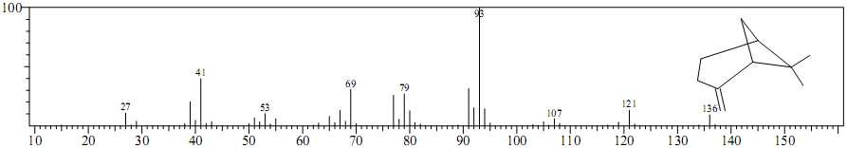**Figure 2.** β-pinene mass spectrum.

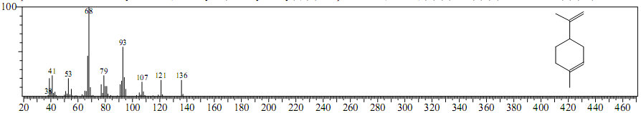**Figure3.** D-limonene mass spectrum.

The chemical characterization of d-limonene from *C. aurantium* using GC-MS has made possible to properly identify the component. The chromatographic profile and mass spectrum obtained using the GC Solution software is below.

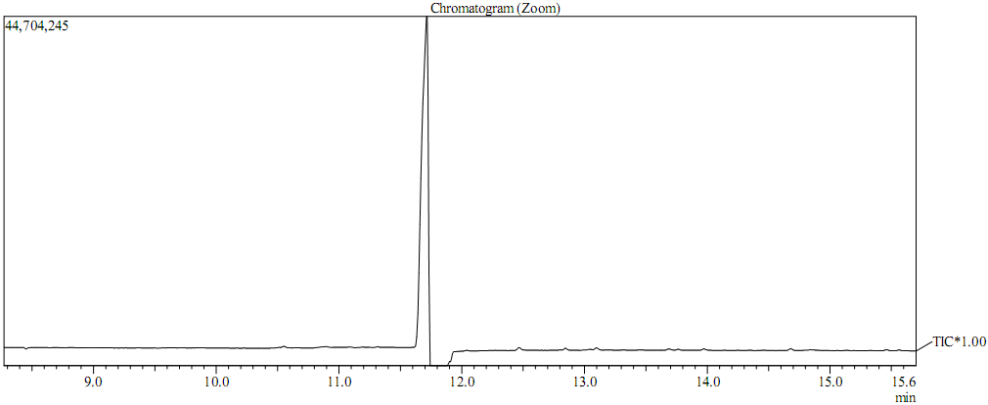**Figure 4.** D-limonene chromatographic profile.

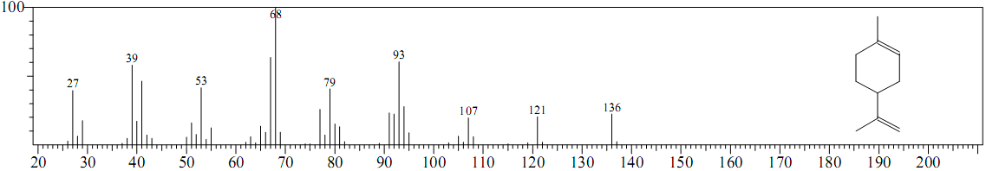

**Figure 5.** D-limonene mass spectrum.

Contemporary nutrition regime has focused the attention of the researchers on phytochemicals enriched spices to mitigate various oncological threats. Numerous chemopreventive strategies against malignancy have been developed considering the anticancer perspectives of allied nutraceutical constituents. Current evidences have proven an inverse association of spices with that of oncological incidences. The high antioxidant activity of spices derived bioactives triggers the free radicals scavenging ability at cellular level thereby alleviating various metabolic syndromes. Promising compounds including curcumin and curcuminoids (turmeric), limonene (cardamom), allicin, allyl isothiocyanate (garlic), cinnamic aldehyde, 2-hydroxycinnamaldehyde and eugenol (cinnamon), gingerol, zingiberone, zingiberene (ginger), dipropyle disulfides and quercetin (onion), piperidine piperine, limonene, α- and β-pinene (black pepper), crocetin, crocin and safranal (saffron) have been identified as chemopreventing agents against various malignancies17.

D-limonene is considered to have fairly low toxicity. It has been tested for carcinogenicity in mice and rats. Although initial results showed d-limonene increased the incidence of renal tubular tumors in male rats, female rats and mice in both genders showed no evidence of any tumor. Subsequent studies have determined how these tumors occur and established that d-limonene does not pose a mutagenic, carcinogenic, or nephrotoxic risk to humans. In humans, d-limonene has demonstrated low toxicity after single and repeated dosing for up to one year18. As a cholesterol solvent, d-limonene has been used clinically to dissolve cholesterol-containing gallstones. Because of its gastric acid neutralizing effect and its support of normal peristalsis, it has also been used for relief of heartburn and gastroesophageal reflux (GERD). D-limonene has well-established chemopreventive activity against many types of cancer. Evidence from a phase I clinical trial demonstrated a partial response in a patient with breast cancer and stable disease for more than six months in three patients with colorectal cancer19.

# **Table 1**. Lifespam and weighs of the animals at the begginig and end of the experiment.

|  |  |  |  |  |
| --- | --- | --- | --- | --- |
|  | ANIMAL | lifespam | Initial weight | Final weight |
| CONTROL | C1 | 28 | 26 | 28 |
| C2 | 28 | 24 | 28 |
| C3 | 28 | 24 | 24 |
| C4 | 28 | 24 | 26 |
| C5 | 28 | 22 | 26 |
| C6 | 28 | 22 | 28 |
| CRUDE EXTRACT | C1 | 28 | 28 | 30 |
| C2 | 28 | 26 | 20 |
| C3 | 28 | 26 | 28 |
| C4 | 28 | 26 | 28 |
| C5 | 28 | 24 | 28 |
| C6 | 28 | 24 | 30 |
| ESSENTIAL OIL | C1 | 28 | 24 | 26 |
| C2 | 28 | 24 | 26 |
| C3 | 28 | 24 | 26 |
| C4 | 28 | 26 | 28 |
| C5 | 28 | 28 | 30 |
| C6 | 28 | 26 | 20 |
| D-LIMONENE | C1 | 28 | 28 | 32 |
| C2 | 28 | 24 | 26 |
| C3 | 28 | 26 | 30 |
| C4 | 28 | 26 | 28 |
| C5 | 28 | 24 | 26 |
| C6 | 28 | 26 | 28 |

The animals were measured at the beginning and at the end of the experiment in order to identify possible abnormalities. To analyze the data distribution, we used the Shapiro-Wilk test. To analyze the correlation of weight between moments in the groups, the Spearman correlation test was used. The Kruskall-Wallis test was used to analyze the difference between weights in the initial and final moments between the groups. The level of confidence was 5% and the software used was Stata11.0. No significant differences were observed in all analyzes on body weight.

The animals were weighed on analytical balance at the beginning and at the end of the experiment in order to identify possible abnormalities. The data distribution was analyzed using the Shapiro-Wilk test. The correlation of weight between moments in the groups was analyzed using the Spearman correlation test was used. The Kruskall-Wallis test was used to analyze the difference between weights in the initial and final moments between the groups. The level of confidence was 5% and the software used was Stata11.0. No significant differences were observed in all analyzes on body weight.

# **Table 2**. Body measures in centimeters­­.

|  |  |  |  |  |
| --- | --- | --- | --- | --- |
|  | ANIMAL | Lifespam (days) | Initial | Final |
| CONTROL | C1 | 28 | 9.53 | 17.78 |
| C2 | 28 | 8.90 | 13.85 |
| C3 | 28 | 13.12 | 20.35 |
| C4 | 28 | 8.89 | 7.27 |
| C5 | 28 | 6.87 | 10.07 |
| C6 | 28 | 8.59 | 10.69 |
| CRUDE EXTRACT | C1 | 28 | 8.63 | 9.34 |
| C2 | 28 | 19.22 | 22.24 |
| C3 | 28 | 10.01 | 13.19 |
| C4 | 28 | 7.25 | 10.69 |
| C5 | 28 | 8.04 | 7.16 |
| C6 | 28 | 11.03 | 18.66 |
| ESSENTIAL OIL | C1 | 28 | 7.05 | - |
| C2 | 28 | 8.16 | 10.34 |
| C3 | 28 | 5.78 | 6.95 |
| C4 | 28 | 16.88 | 22.68 |
| C5 | 28 | 4.75 | 13.57 |
| C6 | 28 | 21.93 | 21.505 |
| D-LIMONENE | C1 | 28 | 17.44 | 15.26 |
| C2 | 28 | 10.61 | 12.62 |
| C3 | 28 | 11.59 | 18.56 |
| C4 | 28 | 9.76 | 7.44 |
| C5 | 28 | 11.01 | 11.37 |
| C6 | 28 | 11.17 | 5.35 |

In the hemogram, the red and white blood series were evaluated, and the statistical analysis was performed for each blood parameter.

The cells identified with (-) indicate loss of the animal during the experiment, making it impossible to collect blood.

In general, lymphocytes, neutrophils, leukocytes and monocytes had higher levels in those in the control group than those in the treatment groups. However, when analyzing the data by the Analysis of Variance (ANOVA) and then by the comparison test of Dunnett averages, it was not possible to observe, with 95% confidence, statistical difference between the groups tested.

The Neutrophil / Lymphocyte Ratio (RLL) was evaluated and we could verify that, on average, the RLL of the control group is higher than that of the treatment groups, and that the ratio of the group that received extract is higher than that of the group receiving d-limonene. However, this difference was not considered statistically significant by ANOVA statistical methods followed by Dunnet's means comparison test at 95% confidence level.

**Table 3**. Hemogram performed after euthanasia.

|  |  |  |  |  |  |  |  |  |  |
| --- | --- | --- | --- | --- | --- | --- | --- | --- | --- |
|  | ANIMAL | Lc | Hc | Hb | Ht | Plt | Neut | Linfo | Mono |
| CONTROL | C1 | 4.3 | 10.05 | 15.3 | 44.7 | 672 | 0.56 | 3.77 | 0.05 |
| C2 | 3.9 | 10.42 | 17.1 | 48.4 | 661 | 0.54 | 3.34 | 0.01 |
| C3 | 3.7 | 9.46 | 15.5 | 44.0 | 609 | 0.62 | 4.70 | 0.06 |
| C4 | 3.9 | 9.34 | 16.5 | 45.3 | 643 | 0.56 | 4.37 | 0.02 |
| C5 | 4.1 | 9.53 | 15.4 | 44.8 | 646 | 0.51 | 3.82 | 0.00 |
| C6 | 3.7 | 10.22 | 16.2 | 48.8 | 576 | 0.49 | 4.54 | 0.03 |
| CRUDE EXTRACT | C1 | 2.2 | 9.55 | 15.5 | 44.6 | 633 | 0.13 | 3.68 | 0.01 |
| C2 | 2.1 | 9.23 | 15.1 | 42.6 | 641 | 0.14 | 3.12 | 0.01 |
| C3 | 1.8 | 9.03 | 14.9 | 43.6 | 650 | 0.16 | 3.46 | 0.01 |
| C4 | 2.2 | 9.08 | 15.2 | 43.1 | 675 | 0.08 | 3.08 | 0.00 |
| C5 | 2.3 | 9.96 | 15.8 | 46.0 | 689 | 0.11 | 3.43 | 0.01 |
| C6 | 2.4 | 9.31 | 15.0 | 43.5 | 672 | 0.29 | 3.31 | 0.04 |
| ESSENTIAL OIL | C1 | 1.8 | 9.41 | 15.8 | 44.4 | 689 | 0.14 | 2.26 | 0.00 |
| C2 | 2.1 | 9.85 | 15.4 | 44.9 | 719 | 0.10 | 2.01 | 0.00 |
| C3 | 2.4 | 9.80 | 15.6 | 45.8 | 693 | 0.11 | 2.24 | 0.00 |
| C4 | 2.3 | 9,74 | 15.2 | 43,9 | 698 | 0.14 | 2.33 | 0.01 |
| C5 | 2.7 | 8.93 | 14.7 | 42.7 | 657 | 0.18 | 2.32 | 0.03 |
| C6 | 2.4 | 9.29 | 14.9 | 44.1 | 693 | 0.17 | 2.48 | 0.02 |
| D-LIMONENE | C1 | 1.9 | 9,12 | 14.9 | 45.6 | 684 | 0.14 | 2.66 | 0.02 |
| C2 | 1.9 | 9.71 | 14.6 | 45.7 | 644 | 0.13 | 2.72 | 0.02 |
| C3 | 2.5 | 10.00 | 15.2 | 46.0 | 659 | 0.19 | 3.02 | 0.04 |
| C4 | 2.3 | 9.32 | 15.6 | 44.7 | 599 | 0.18 | 2.85 | 0.01 |
| C5 | 2.1 | 10.29 | 16.1 | 47.5 | 703 | 0.17 | 2.51 | 0.00 |
| C6 | 3.8 | 9.12 | 15.4 | 45.4 | 617 | 0.14 | 2.63 | 0.01 |

Lc (leukocytes); Hc (red blood cells); Hb (hemoglobin); Ht (hematocrit); Plt (platelets); Neut (neutrophils); Lymphocytes and Mono (monocytes).

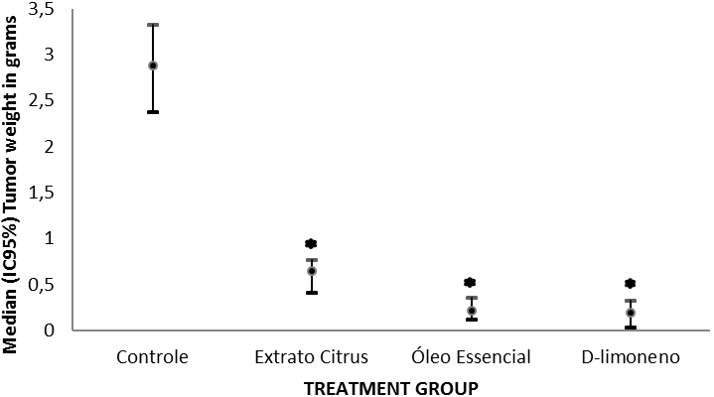

CONTROL CRUDE EXTRACT ESSENTIAL OIL D-LIMONENE

**Figure 6** – Inhibitory effect of crude extract, essential oil and d-limonene of *C. aurantium* against Ehrlich ascites carcinoma. Tumor weight in grams.

*Citrus bergamia (*A.K.A. bergamot) has shown the potential to increase autophagy triggered by serum starvation and rapamycin. These findings indicate that the underlying mechanism is mTOR independent. In the other hand it did not affect the ULK1 and p70(S6K) phosphorylation, two downstream targets of mTOR. Moreover, the active major constituents for these effects, d-limonene and linalyl acetate, were also tested. The results have demonstrated that D-limonene rapidly increases LC3II and reduces p62 levels20. D-limonene epoxide had been tested for analgesic and anti-inflammatory activities. It has inhibited both the release and activity of inflammatory mediators, decreasing vascular permeability and neutrophils migration. In the analgesic assays, it has displayed systemic and peripheral analgesic-dependent effects of the opioid system21.

D-limonene has suppressed the viability of LS174T cells, resulting in a apoptotic cell death. It activates caspase-3 and -9 and PARP cleavage. Moreover, an increase in Bax protein and cytosol cytochrome c from mitochondria and a decrease in bcl-2 protein were observed following treatment with d-limonene. Also, D-limonene decreased the levels of p-Akt, p-Akt and p-GSK-3β. These results suggest that D-limonene induces apoptosis via the mitochondrial death and the suppression of the PI3K/Akt pathway22. The essential oil of *Citrus sinensis* inhibited colon cancer cells proliferation and induced apoptosis. Immunoblotting of colon cancer cells dose-dependent induction of Bax/Bcl2 and inhibition of vascular endothelial growth factor (VEGF). The antiangiogenic activity of this oil was also confirmed by inhibition of in vitro tube formation in human umbilical vein endothelial cells23.

D-limonene has been demonstrated to exert antiproliferative effects on a lymphoma cell, increasing the nitric oxide levels by inducing cell apoptosis or through H2O2 production and ERK pathway activation at low concentrations. In high concentrations, it has inhibited the farnesylation of proteins and O2- production24.

The tumor growth was evaluated measuring the tumor weight in an analytical scale. The survival analysis was performed after the death of the animals. The control group has presented tumors weighing 2.89 + 0.34g. All treated groups were significantly different from the control group (P <0.05). The treatment with crude extract (0.61 + 0.14 g) was effective in reducing the tumor compared to the control. Furthermore, the groups treated with the essential oil (rich in limonene) have presented a significant difference from the control group but not among them. The treatment with D-limonene has shown the best result, with a weigh about 0.19 + 0.09 g.

Considering the data above, the use results present in this study are in agreement with the literature about D-limonene and its potential as an anticancer drug or precursor (like limonene epoxide). This compound shows several mechanistic approach, related both to enzyme or genetic regulation, with high potential of obtention and no environment degradation since it is a waste product from orange crops and low cost.

**Conflict of interest-**

**Author’s Contribution**

**CONCLUSIONS**

It has been concluded that the essential oil and the crude extract of *Citrus aurantium*, L. (Rutaceae) can become therapeutic agents because they have anti-tumor activity with no toxicity to the blood cells and have low cost of production. Moreover, the use of D-limonene as a precursor for new medicines using semi synthetic approaches. The chromatographic and spectrometric analyzes indicated the presence of other components in smaller amounts in the essential oil, what suggests that they could have a synergic activity to the d-limonene. Further studies are necessary, so they can be used in the treatment of neoplasia in humans.

No conflict of interest associated with this work.

**REFERENCES**

1. Hafidh, RR. Hyssein SZ. MalAlla, MQ. Abdulamir AS. Bakar FA. A high-throughoutput quantitative expression analysis of cancer-related genes in human HepG2 cells in response to Limonene, a potential anticancer agent. Current Cancer Drug Targets; 2017: Vol 17 (ePub).
2. Yang, C. Chen, H. Chen, H. Zhong, B. Luo, X. Chun J. Antioxidant and Anticancer Activities of Essential Oil from Gannan Navel Orane Pell. Molecules; 2017: 22(8).
3. Prabuseenivasan, S. Jayakumar, M. Ignacimuthu, S. In vitro antibacterial activity of some plant essential oils. BMC Complementary and Alternative Medicine; 2006: 6(1): 39-44.
4. Shojaei, S. Kiumarsi, A. Moghadam, AR. Alizadeh, J. Marzban, H. Ghavami, S. Perillyl Alcohol (Monoterpene Alcohol), Limonene. Enzymes; 2014: 36:7-32. doi: 10.1016/B978-0-12-802215-3.00002-1.
5. Crowel, PL. Prevention and therapy of cancer by dietary monoterpenes. J. Nutrition; 1999: 129:775-778.
6. Hata, T. Sakaguchi, I. Mori, M. Ikeda, N. Induction of apoptosis by citrus paradise essential oil in human leukemic (HL-60) cells. In Vivo; 2003: 17:553-559.
7. Reddy, BS. Wang, CX. Samaha, H. Lubert, R. Steel, VE. Chemoprevention of colon carcinogenesis by dietary perillyl alcohol. Cancer Res; 1997: 57:420-425.
8. Miyazawa, M. Shindo, M. Shimada, S. Metabolism of (+)- and (−)-limonenes to respective carveols and perillyl alcohols by CYP2C9 and CYP2C19 in human liver microsomes. Drug Metab Dispos; 2002: 30(5): 602–7. doi:10.1124/dmd.30.5.602. PMID 11950794.
9. Da Fonseca, CO. Simão, M. Lins, I.R. Caetano, R.O. Futuro, D. Quirico-Santos, T. Efficacy of monoterpene perillyl alcohol upon survival rate of patients with recurrent glioblastoma. J Cancer Res Clin Oncol; 2011: 137(2):287–93. doi:10.1007/s00432-010-0873-0. PMID 20401670.
10. de Saldanha da Gama Fischer, J. Costa Carvalho, P. da Fonseca, CO. Lia, L. Degrave, WM.;da Gloria da Costa Carvalho M. Yates JR. Domont, GB. Chemo-resistant protein expression pattern of glioblastoma cells (A172) to perillyl alcohol. J Proteome Res; 2011: 10(1):153–60. doi:10.1021/pr100677g. PMID 20806975
11. Mohamed, AA. El-Emary, GA. Ali, HF. Influence of some citrus essential oils on cell viability, glutathione-S-transferase and lipid peroxidation in Ehrlich ascites carcinoma cells. Journal of American Science; 2010: 6(10).
12. Adams, RP. Identification of Essential Oil Components by Gas Chromatography/Mass Spectroscopy; 1995: p. 499, Allured Publ. Corp., Carol Stream, IL.
13. Sokal, RR. Rohlf, FJ. In: Freeman WH, editor. Biometry. San Francisco; 1995: p. 175–205, 404–86.
14. Karlson, J. Borg-karlson, AK. Unelius, R. Shoshan, MC. Wiking, N. Ringborg, U. Linder, S. Inhibition of tumor cell growth by monoterpenes in vitro: evidence of a Ras-independent mechanism of action. Anticancer Drugs; 1996: 7(4):422 – 9.
15. Geraci, A. Di Stefano, V. Di Martino, E. Schillaci, D. Schicchi, R. Essential oil components of orange peels and antimicrobial activity. Nat Prod Res; 2017: 31(6):653-659.
16. Bagatela, BS. Lopes, AP. Cabral, EC. Perazzo, FF;. Ifa, DR. High-performance thin-layer chromatography/desorption electrospray ionization mass spectrometry imaging of the crude extract from the peels of Citrus aurantium L. (Rutaceae). Rapid Commun Mass Spectrom; 2015: 30;29(16):1530-4. doi: 10.1002/rcm.7246.
17. Butt, MS. Naz, A. Sultan, MT. Qayyum, MM. Anti-oncogenic perspectives of spices/herbs: A comprehensive review. EXCLI J; 2013: 17;12:1043-65.
18. Tsuda, H. Ohshima, Y. Nomoto, H. Fujita, K. Matsuda, E. Ligo, M. Takasuka, N. Moore, MA. Drug Metab. Pharmacokinet; 2004: 19(4):245 – 63.
19. Sun, JD. Limonene: safety and clinical applications. Altern Med Rev; 2007: 12(3):259-64
20. Russo, R. Cassiano, M.G. Adornetto, A. Varano, G.P. Chiappini, C. Berliocchi, L. Tassorelli, C. Bagetta, G. Corasaniti, MT. Role of D-limonene in autophagy induced by bergamot essential oil in SH-SY5Y neuroblastoma cells. PLoS One; 2014: 24;9(11).
21. Almeida, AA. Silva, RO. de Brito, TV. de Sousa, DP. Barbosa, AL. de Freitas, RM. Lopes, LD. Medeiros, JR. Ferreira, PM. Physio-pharmacological investigations about the anti-inflammatory and antinociceptive efficacy of (+)-Limonene epoxide. Inflammation; 2017: 40(2):511-522.
22. Jia, SS. Xi, GP. Zhang, M. Chen, YB. Lei, B. Dong, XS. Yang, YM. Induction of apoptosis by D-limonene is mediated by inactivation of Akt in LS174T human colon cancer cells. Oncol Rep; 2013: 29(1):349-54.
23. Chimdambara Murthy, KN. Jayaprakasha, GK. Patil, BS. D-limonene rich volatile oil from blood oranges inhibit anbgiogenesis, metastasis and cell death in human colon câncer cells. Life Sci; 2012: 5;91(11-12):429-439.
24. Manuele, MG. Barreiro Arcos, ML. Davicino, R. Ferraro, G. Cremaschi, G. Anasini, C. Limonene exerts antiproliferative effects and increases nitric oxide levels on a lymphoma cell line by dual mechanism of the ERK pathway:relationship with oxidative stress. Cancer Invest; 2010: 28(2):135-45.