**Reviewer’s Comments**

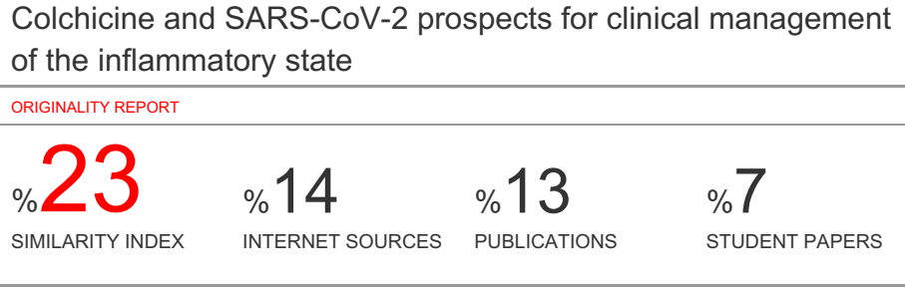

**Colchicine and SARS-CoV-2 prospects for clinical management of the inflammatory state**

**Abstract**

At date, research is moving for a direct SARS-CoV-2 antiviral, which will be, probably, the ideal solution to defeat the virus. In the meantime, evidences have shown that effective improvements for health status of infected patients can be found in the decrease or stop of the hyper inflammatory state. Experts have divided the SARS-CoV-2 infection in three phases. In the last one, phase 3, the most severe, the immune system goes an overdrive status and, as consequence, it launches a large-scale assault versus all the tissues. This phenomenon is known as “cytokine storm” and it can lead to a damage of organs and, in some cases to death. Several studies showed that blocking the cytokine storm or acting advance with a prevention of the phenomenon, can be effective; studies are ongoing to evaluate agents that can be able to reduce this hyperinflammatory state, as, for example, IL-6 or IL-1 inhibitors. However, other drugs that are able to block the cytokine cascade can also be considered. In this article is reported the scientific and molecular motivation related to the use of colchicine as monotherapy or in association in all three phases of infection by SARS-CoV-2 modulating the inflammatory state. Colchicine can be considered safe and effective for the treatment and prevention of Cytokine Storm in patients affected by SARS-CoV-2 infection, in particular as a remedy added to other therapeutical agents. In fact, colchicine, probably, provides a bigger benefit to all current agents and its safety profile is superior to the one provided by other drugs, such as corticosteroids and immunosuppressive drugs.

**Keywords**: colchicine, sars-cov-2, cytokine, interleukin, coronavirus, pneumonia

**Introduction**

In December 2019, an excessive number of cases of pneumonia caused by a new coronavirus identified as SARS-CoV-2 occurred in Wuhan, China. This coronavirus has shown a rapid spread in China and also in other countries. It was found that the genomic sequence of SARS-CoV-2 is 79.5% the same as SARS-CoV-2. Scientists have learned a lot about SARS-CoV-2 and its pathogenesis in recent months and it has been found that not all exposed people are infected and not all infected patients develop serious respiratory diseases.

Based on this, SARS-CoV-2 infection can be divided into three phases: phase 1, asymptomatic or mildly symptomatic incubation period that does not require hospitalization with or without detectable virus; phase 2, non-severely symptomatic period with the presence of the virus; phase 3, severe respiratory symptomatic phase with high viral load and generalized hyperinflammatory state. Phase 3 is the most severe and dangerous phase; the generalized hyperinflammatory state is caused by a sudden release of cytokines into the circulation defined as "cytokinic storm"(CS).

**Phases of SARS-CoV-2 infection**

As described above, the infection can be divided into three phases of increasing severity; for each one a specific therapeutic treatment could be indicated or avoided. It should be noted that the brief description below may vary from patient to patient, and therefore also the specific treatment.

*Phase 1 (or non-severe phase)*

In this phase, patient has contracted SARS-CoV-2, the infection starts and the immune system reacts against the virus. Initial symptoms can be cough, fatigue, fever, nausea and diarrhea.

The duration of this phase can be three-seven days. During this non-severe stage, a speciﬁc adaptive immune response is required to break down the virus and to avoid the disease progression in the severe stages. Therefore, strategies to increase the immune responses could be certainly important. At this stage it can be helpful an antiviral to inhibit the viral load and avoid complications with the prevention of virus replication. Probably, an antiviral could be effective to stimulate the immune system even more at this stage, avoiding the use of steroid or non-steroid anti-inflammatory drugs, and being able to take into consideration the administration of immunostimulants or plasma derived from cured patients.

Currently, there is evidence of efficacy as antivirals for the drugs remdesivir, lopinavir/ritonavir, chloroquine and hydroxychloroquine.

If the infection is contained in this stage and the virus defeated, this can be a very good chance of recovery without further complications.

*Phase 2 (moderate)*

The second phase of infection begins between the tenth and fourteenth day. A protective immune response is impaired, the immune system was not able to defeat the virus and this had a reproduction and an invasion of the deep respiratory tract, as the lungs.

The hypoxic phase starts; in this phase hospitalization and oxygen administration can be required.

Cardiac involvement and clotting problems could take place in this phase and patients with underlying heart disease could have a greater risk of entering the serious clinical picture. Laboratory tests show a decrease in lymphocytes, an increase in transaminases and a moderate increase in pro-inflammatory markers.

The treatment that could be indicated is a continuous use of anti-viral drugs and, when the respiratory situation worsens, need to be started the support of oxygen and/or use of anti-inflammatory drugs, antibiotics and the administration of LMWH-(Low-molecular-weight-heparin) to prevent thromboembolic events.

*Phase 3 (severe)*

The third stage is the most serious, which can lead to the death of the patient. In this phase there is a hyperactive and systemic (not only lung) inflammatory state which is called Cytokine Storm (CS) and that can appear in the patient and, briefly, lead to respiratory distress syndrome (ARDS). In this phase inflammation marker values (IL-2, IL-6, GCSF, TNF-alpha, D-dimer, ferritin, etc.) are very high.

The patient may have severe respiratory failure and cardiac shock.

All the organs may see a worsened condition. Immunological therapies (corticosteroids, anti-interleukin 6, such as tocilizumab and sarilumab, IL-1 receptor antagonists such as anakinra or canakinumab, JAK-inhibitors, convalescent plasma) are necessaries at this stage to attempt the reduction of an aberrant storm cytokinic response. The prognosis for patients at this stage of disease is very severe (1-13)

**Colchicine**

Colchicine was used for long time as a drug; today it is indicated (in some cases as off-label) in the treatment of gout, Behçet's disease and for the prevention of pericarditis, Family Mediterranean Fever (FMF), Sweet syndrome, scleroderma, amyloidosis due to FMF uncontrolled.

Probably in these years, the drug obtained the largest clinical success in the treatment of Family Mediterranean Fever (FMF) prophylaxis, on top of traditional use as anti-gout first line treatment. Recently, was also published a very important trial supporting the use of colchicine in secondary prevention post IMA (Acute Myocardial Infarction) and a lot of new papers are available exploring the potential role of colchicine as anti-atherothrombotic inflammatory drug.

The scientific hypothesis of the use of colchicine in SARS-CoV-2 infection is based on the anti-inflammatory properties of the drug.

Recent published data on colchicine seem to suggest a potential synergy in the treatment of cytokine cascade at different levels. In fact, colchicine acts by decreasing inflammation through multiple mechanisms. The principal action mechanism is to bind the tubulin molecule and then inhibit its polymerization as microtubules in neutrophils, with the subsequent inhibition of the migration. In addition, colchicine can alter the distribution of the adhesion molecules on the surface of neutrophils and endothelial cells, leading to a significant inhibition of the interaction between white blood cells and endothelial cells interfering with their transmigration. Considering the above-mentioned facts, there is an increasing evidence that the anti-inflammatory effect of colchicine is multiform. However, the main mechanism of action for CS reduction in patients with SARS-CoV-2 is, probably, the inhibition of IL-1, IL-6 and IL-18 due to the fact that it can interfere with the inflammatory protein complex NLRP3 which plays a central role in the CS.

Colchicine, in addition, inhibits the production of superoxide anion and inhibits the degranulation of mast cells. It is important to note that studies have shown that viroporin E, a component of the SARS associated coronavirus (SARS-CoV), creates Ca2C-permeable ion channels and activates inflammation of NLRP3. In addition, another viroporin 3a induces activation of NLRP3 inflammation. The mechanisms are unclear. Inflammasome NLRP3 can be activated through different mechanisms and it plays an important role in the development of cytokinin storm phase three from SARS-CoV-2. The upstream inhibition of inflammation NLRP3 can be considered as new approach for the prevention or treatment of SARS-CoV-2 infection. Several clinical trials are currently moving to study the efficacy of colchicine in patients with SARS-Cov-2 infection, as detailed in Table 1.

|  |  |  |
| --- | --- | --- |
| **Row** | **StudyTitle** | **Conditions** |
| **1** | Colchicine Coronavirus SARS-CoV2Trial(COLCORONA) | Corona Virus Infection |
| **2** | The GReekStudy in the Effects of Colchicine inCovid-19 | Corona Virus Disease 19 (SARS-Cov 2) |
| **3** | Colchicine Efficacy inCOVID-19Pneumonia | Corona VirusInfections Pneumonia Viral |
| **4** | The ECLA PHRICOLCOVIDTRIAL | SARS-Cov-2infection |
| **5** | Colchicine CounteractingInflammation in COVID-19 Pneumonia (ColCOVID-19) | SARS-Cov-2 |
| **6** | Treatment with colchicine of patientsaffected by Covid-19:a pilotStudy” | SARS-Cov-2 |

***Table 1****: Trials on going with colchicine in SARS-Cov-2 patients.(Clinicaltrials.gov)*

Since 1972 colchicine (at the dose of 0.5-2 mg/day) is the drug used in the prophylaxis of FMF attacks. The idea and hypothesis of extending the use of colchicine in SARS-Cov2 infection is closely related to its use in FMF, i.e. a hereditary autoinflammatory disease characterized by recurrent febrile episodes (attacks) and acute inflammation. For these considerations, the mechanism of action is similar; in fact, the use of colchicine up to a maximum dose of 3 mg/day is effective in preventing the onset of inflammatory attacks in 60-65% of FMF cases.  
Considering the pharmacodynamic properties of colchicine and based on knowledge of its tolerability profile (derived from the use of drugs for many years), the use of this drug could be considered in monotherapy or in combination in all three phases of coronavirus infection, in the first phase as prophylaxis, in the second and third phase as a CS blocker as shown in Table 2 and described below.

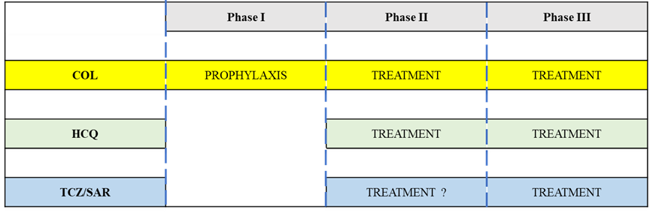

**Table 2**:*Hypothetical timing of clinical pharmacological management of the inflammatory state in the SARS-Cov-2 patient*

*Colchicine as monotherapy in phase 1 and for complications prevention in phase 2 or 3*

Based on the large number of data available on the efficacy of colchicine as monotherapy in the prevention of FMF and in the prevention of recurrent pericarditis, we believe that the drug can be used at common doses used for these diseases. In this phase 1, a practical approach could be to use low initial doses (0.5 mg/day) as a preventive method to avoid moving to phase two and/or three and at the same time give the possibility to use this therapy also in combination with antivirals to decrease the viral load and wait for the immune system reaction against the infection. Used at standard doses, colchicine shows a good tolerability profile and no immunosuppressive effect is expected. This is very important to fight the first phase. In addition, in this phase, the non-administration of immunosuppressants or glucocorticoids may be useful to avoid a decrease of the immune system.

*Colchicine as monotherapy or in combination for phase 2 treatment*

This phase is a crucial time for therapy. It may be important to continue treatment with antivirals even at this stage, monitoring the patient's condition and avoiding adverse reactions due to drug interactions. Based on clinical and laboratory parameters and inflammatory markers, a change in colchicine doses is considered.

During phase 2, a practical approach could be based on the use of colchicine increasing up to 0.5 mg twice daily if the patient is an adult with a body weight greater than 70 kg. Attention is needed to avoid the accumulation of toxic doses by monitoring liver and kidney health conditions and considering all possible interactions between colchicine and other agents in use.

Another therapeutic approach at this stage could be the use of a 0.5 mg dose of colchicine (as step 1) in combination with hydroxychloroquine. From a pharmacodynamic point of view, colchicine and hydroxychloroquine can act in sinergism modulating two fundamental objectives of inflammation. Hydroxychloroquine reduces the secretion of proinflammatory cytokines and in particular TNF by stimulated monocytes-macrophages and in addition to having antiviral effects, colchicine acts instead on inflammatory NLP3 as described above. (Figure 1)

The initiation of the use of anti IL6 or anti IL1 or glucocorticoids or other specific treatments able to interrupt the progression of the cytokine storm, including the right time to start LMWH or administer antibiotics, should be considered according to the patient's clinical condition.

**Figure 1***: Pharmacological synergism of the association colchicine-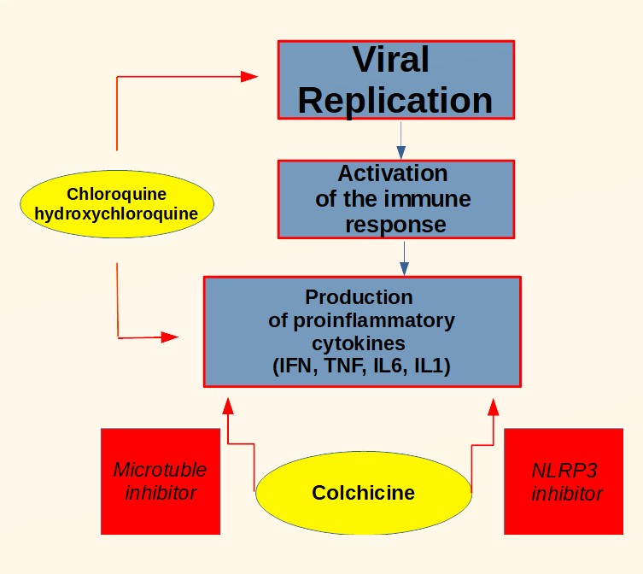chloroquine*

*Colchicine in association for phase 3 treatment*

The CS influences the patients state of health and it makes the clinical picture severe. At this stage it is evident that the most important therapeutic strategy to be implemented is to slow down or block the uncontrolled inflammatory response.

Antiviral treatments continue to be important even if we remember that now there is still a big confusion in terms of the greatest effects that this class of drugs can have. However, since CS has proved to be common in phase 3, anti-inflammatory therapy can help prevent further complications, multi-organ dysfunction and patient death.

As we know, there is a variety of anti-inflammatory drugs, including non-steroidal anti-inflammatory drugs, glucocorticoids, immunomodulators.

The use of glucocorticoids is still a matter of discussion, in particular the doses to be used and the time when can be used. In contrast, the use of cytokine inhibitors such as tocilizumab (IL-6 inhibitor) or anakinra (IL-1 receptor antagonist) has shown good efficacy, and several studies are underway to test them. However, as with glucocorticoids, there are still many open questions, when to use immunomodulators, what doses, to which patients? Only valid clinical trial protocols can answer these questions. All these questions are still the subject of intense debate and an uncommon answer in scientific opinion. The main concern, of course, is that immunomodulatory drugs can delay the elimination of the virus by the immune system and, worse still, increase the risk of secondary infections, especially of the respiratory tract. The biological agents that have shown good efficacy, and for which several trials are underway, are the inhibitors IL-6 tocilizumab and sarilumab, which are indicated for the treatment of rheumatoid arthritis. In addition, on August 30, 2017, Tocilizumab was approved in the United States for life-threatening cytokine release syndrome caused by chimeric T cell antigen receptor immunotherapy (CAR-T), and studies are now underway to evaluate its efficacy in the treatment of FMF and pericarditis, just like colchicine. At this stage 3, it may be useful to administer colchicine (0.5 mg once or twice daily), in monotherapy or in combination with IL6 inhibitors to control CS. The advantage of colchicine over IL-6 inhibitors is that it acts upstream of the cytokine cascade and not only on one cytokine in particular, it also appears to have a higher safety profile than immunomodulants and glucocorticoids. In addition, in the most critical phase a combination of colchicine and IL-6 inhibitors could be considered, which could show a pharmacological synergism, as shown in Figure 2. At this stage we could also consider a triple therapy hydroxychloroquine colchicine and IL-6 inhibitors to block the inflammatory cascade on multiple points.

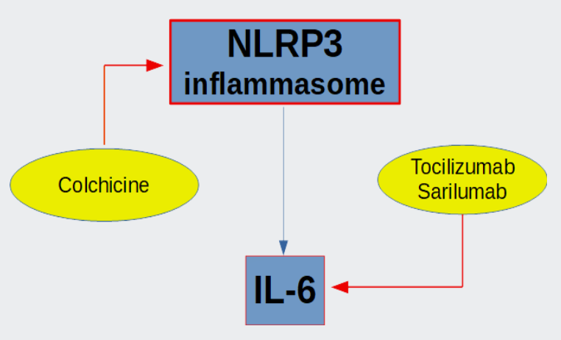**Figure 2:** *Pharmacological synergism of the association colchicine-inibhitors IL-6*

**Aspects of clinical pharmacology and safety considerations**

Although colchicine at low doses (0.5-1 mg per day) was found to be safe even if administered continuously for decades, there are possible side effects, more common, as the gastrointestinal ones found in 5-10% of cases, less common to consider as the bone marrow suppression, hepatotoxicity, myotoxicity. The dose in the three stages of SARS-CoV-2 infection in patients should however be modified depending on the clinical condition of the patient, especially renal and hepatic function. The simultaneous administration of colchicine and cytochrome P450 3A4 (CYP3A4) or glycoprotein P (P-gp) inhibitors increases the potential toxicity of colchicine. A patient with SARS-CoV-2 infection is a complex patient who may have various organ dysfunctions and take several medications. A patient with SARS-CoV-2 infection could be on therapy with cytochrome P450 3A4 (CYP3A4) inhibitors such as macrolides, this interaction may decrease the metabolization and excretion of colchicine, increasing the risk of severe adverse reactions, currently it seems reasonable to avoid co-administration of colchicine and macrolides. The macrolides as the clarithromycin are P-gp inhibitors, for this, concomitant administration with such as could increase the risk of toxicity. A SARS-CoV-2 patient may be in therapeutic treatment with antivirals such as Ritonavir lopinavirdarunavir and ribavirin. Due to inhibition of P-gp and/or CYP3A4 by ritonavir/lopinavir, a reduction in colchicine dose or discontinuation of treatment (in patients with regular renal or hepatic function) would be appropriate to avoid accumulation of toxic doses and serious adverse reactions such as rhabdomyolysis. Same interactions also for darunavir. Ribavirin does not inhibit cytochrome P450 enzymes. There is no evidence from toxicity studies that ribavirin induces liver enzymes or interferes with gl-P, so there is a minimal possibility of P450 and gl-P-based interactions with colchicine. The expression of CYP450 liver enzymes is suppressed by cytokines, such as IL-6, which stimulate chronic inflammation. Therefore, the expression of CYP450 can be reversed when used a powerful cytokine inhibition therapy with tocilizumab or sarilumab. In vitro studies with cultured human hepatocytes have shown that IL-6 causes a reduction in expression of the enzymes CYP1A2, CYP2C9, CYP2C19 and CYP3A4. In phase three, IL-6 is present at high levels. Tocilizumab or sarilumab can normalize the expression of these enzymes by inhibiting IL-6. Based on this, if colchicine is administered in phase three in combination with Tocilizumab or sarilumab, a decrease in colchicine concentrations may occur compared to when tocilizumab or sarilumab is not administered. No particular pharmacokinetic interaction seems instead to be found between colchicine and the following drugs, LWHM, immunostimulants, plasma derivatives or hydroxychloroquine. However, in any polytherapy it is always important to refer to the RCP of medicines to avoid unpleasant interactions. The most common adverse reactions with colchicine are related to the gastrointestinal tract, diarrhea is the most commonly reported symptom, followed by vomiting and nausea. Adverse events of the gastrointestinal tract can be a problem for the patient SARS-CoV-2 which can presents symptoms such as diarrhea, nausea and vomiting due to infection, in these patients a decrease in the dose of colchicine could be considered to avoid electrolyte imbalance. In addition, drugs such as hydroxychloroquine, ritonavir/lopinavir or macrolides can cause gastrointestinal symptoms such as diarrhea with common or very common frequency, this could be a problem with possible co-administration between these drugs and colchicine. In addition, concomitant therapy with colchicine hydroxychloroquine and darunavir or lopinavir / ritonavir could increase the risk of serious adverse reactions affecting the musculoskeletal system and connective tissue. Finally, in a polytherapy with colchicine, IL-6 inhibitors, hydroxychloroquine, and possibly glucocorticoids it should be monitored continuously the patient's inflammatory/immune status and to verify laboratory parameters. However, each patient should be carefully monitored for possible side effects, including blood tests (transaminases, serum creatinine, creatin kinase, creatin kinase and blood cell count), renal and liver function and possible drug interactions The SARS-CoV-2patient is to be considered a complex patient, the benefit-risk ratio in that specific patient with those specific clinical conditions should always be considered in any politherapy. Colchicine does not have a wide therapeutic window, treatment with this drug should be managed well, however, clinical studies and stronger evidence are needed to validate the use of colchicine in SARS-CoV-2 infection. (14-27)

* 1. **CONCLUSIONS**

SARS-CoV-2 infection can be divided into three phases: phase 1, an asymptomatic or slightly symptomatic incubation period with or without detectable virus; phase 2, slightly symptomatic period with presence of virus; phase 3, severely symptomatic respiratory phase with high viral load and generalized hyperinflammatory state. The third is the most severe and dangerous described by a generalized hyperinflammatory state, a sudden release of cytokines into the circulation defined as "cytokine storm" (CS). Waiting to find antivirals directed against SARS-CoV-2, evidence has shown that reducing or stopping the hyperinflammatory state that occurs in some infected patients is effective in improving health. We believe that it is of utmost importance to properly manage the inflammatory/immune status of the infected patient. The use of colchicine, as well as its proven efficacy in the prophylaxis and treatment of autoinflammatory diseases such as FMF or pericarditis, could be considered in all three stages of SARS-CoV-2 infection, especially in those patients at high risk of developing serious lung complications in a dramatically short time, in monotherapy or in combination, carefully monitoring possible drug interactions. Colchicine, if used in the recommended doses, could be in monotherapy or in combination a safe and effective treatment for the prevention or reduction of cytokine storm in patients with SARS-CoV-2. However, we believe that a combination of several drugs, each at a lower dosage than monotherapy, may be the most effective and tolerable solution to manage the patient's inflammatory state, particularly in phases two and three.

* 1. **MAIN STATEMENTS**

I, the undersigned, Francesco Ferrara and any other author, declare that:

* We have no conflict of interest;
* We have not received funding;
* There are no sensitive data and no patients were recruited for this study;
* The document does not conflict with ethical legislation.

Regards

The authors

**References**

1. Ware LB, Matthay MA. *The acute respiratory distress syndrome.*N Engl J Med 2000;342:1334–49.
2. Cell Death & Differentiation *COVID-19 infection: the perspectives on immune responses* Yufang Shi1, Ying Wang Changshun Shao, Jianan Huang, JianheGan, Xiaoping Huang, Enrico Bucci, Mauro Piacentini, Giuseppe Ippolito, Gerry Melino
3. Baggiolini M, Walz A, Kunkel SL. *Neutrophil-activating peptide-1/ interleukin-8: a novel cytokine that activates neutrophils.*J ClinInvest 1989;84:1045–9.
4. Standiford TJ, Rolfe MW, Kunkel SL, et al. *Macrophage inﬂammatory protein-1: expression in interstitial lung disease.* J Immunol 1993;151:2852–63.
5. Suter PM, Suter S, Girardin E, Roux-Lombard P, Grau GE, Dayer JM. *High bronchoalveolar levels of tumor necrosis factor and its inhibitors, interkeukin-1, interferon, and elastase, in patients with respiratory distress syndrome after trauma, shock, or sepsis*. Am Rev Respir Dis 1992;145:1016–22.
6. Siler TM, Swierkosz JE, Hyers TM, Fowler AA, Webster RO. *Immunoreactive interleukin-1 in bronchoalveolar lavage ﬂuid of high-risk patients and patients with the adult respiratory distress syndrome.* Exp Lung Res 1989;15:881–94.
7. Goodman RB, Strieter RM, Martin DP, et al. *Inﬂammatory cytokines in patients with persistence of the acute respiratory distress syndrome.* Am J RespirCrit Care Med 1996;154:602–11.
8. Park WY, Goodman RB, Steinberg KP, et al. *Cytokine balance in the lungs of patients with acute respiratory distress syndrome.* Am J RespirCrit Care Med 2001;164:1896–903.
9. Donnelly SC, Strieter RM, Reid PT, et al. *The association between mortality rates and decreased concentrations of interleukin-10 and interleukin-1 receptor antagonist in the lung ﬂuids of patients with the adult respiratory distress syndrome.*AnnInternMed 1996;125:191–6.
10. Arend WP, Joslin FG, Thompson RC, Hannum CH. *An IL-1 inhibitor from human monocytes: production and characterization of biologic properties.*J Immunol 1989;143:1851–8.
11. Arend WP. *Interleukin-1 receptor antagonist.*AdvImmunol 1993;54:167–227.
12. Burger D, Chicheportiche R, Giri JG, Dayer JM. *The inhibitory activity of human interleukin-1 receptor antagonist is enhanced by type II interleukin-1 soluble receptor and hindered by type I interleukin-1 soluble receptor.*J ClinInvest 1995;96:38–41.
13. [Conti P](https://www.ncbi.nlm.nih.gov/pubmed/?term=Conti%20P%5BAuthor%5D&cauthor=true&cauthor_uid=32171193)[Ronconi G](https://www.ncbi.nlm.nih.gov/pubmed/?term=Ronconi%20G%5BAuthor%5D&cauthor=true&cauthor_uid=32171193)[Caraffa A](https://www.ncbi.nlm.nih.gov/pubmed/?term=Caraffa%20A%5BAuthor%5D&cauthor=true&cauthor_uid=32171193)[Gallenga CE](https://www.ncbi.nlm.nih.gov/pubmed/?term=Gallenga%20CE%5BAuthor%5D&cauthor=true&cauthor_uid=32171193)[RossR](https://www.ncbi.nlm.nih.gov/pubmed/?term=Ross%20R%5BAuthor%5D&cauthor=true&cauthor_uid=32171193)[Frydas I](https://www.ncbi.nlm.nih.gov/pubmed/?term=Frydas%20I%5BAuthor%5D&cauthor=true&cauthor_uid=32171193)[Kritas SK](https://www.ncbi.nlm.nih.gov/pubmed/?term=Kritas%20SK%5BAuthor%5D&cauthor=true&cauthor_uid=32171193). *Induction of pro-inflammatory cytokines (IL-1 and IL-6) and lung inflammation by Coronavirus-19 (COVI-19 or SARS-CoV-2): anti-inflammatory strategies.* Masters PS, Perlman, S (2013) Coronaviridae. In: Knipe DM, Howley P (eds) Fields Virology. Lippincott Williams and Wilkins, Philadelphia, PA, pp 825–858.
14. THE LANCET Infectious Diseases Vol 3 November 2003 *Effects of chloroquine on viral infections: an old drug against today’s diseases?*Andrea Savarino, Johan R Boelaert, Antonio Cassone, Giancarlo Majori, and Roberto Cauda.
15. [J.Benhamou, Ori-Michael](https://www.ingentaconnect.com/search?option2=author&value2=J.+Benhamou,+Ori-Michael); [Geva, Shahar](https://www.ingentaconnect.com/search?option2=author&value2=Geva,+Shahar); [Jacobs, Miriam](https://www.ingentaconnect.com/search?option2=author&value2=Jacobs,+Miriam); [Drew, Jonathan](https://www.ingentaconnect.com/search?option2=author&value2=Drew,+Jonathan); [Waldman, Maor](https://www.ingentaconnect.com/search?option2=author&value2=Waldman,+Maor); [Kalchiem-Dekel,](https://www.ingentaconnect.com/search?option2=author&value2=Kalchiem-Dekel,+Or) *The Use of Colchicine in Respiratory Diseases* [Or](https://www.ingentaconnect.com/search?option2=author&value2=Kalchiem-Dekel,+Or)[Current Respiratory Medicine Reviews](https://www.ingentaconnect.com/content/ben/crmr), Volume 9, Number 5, 2013, pp. 300-304(5)
16. Front. Pharmacol., 16 August 2019The Association Between Usage of Colchicine and Pneumonia: A Nationwide, Population-Based Cohort Study
17. ["Colchicine Monograph for Professionals"](https://www.drugs.com/monograph/colchicine.html). Drugs.com. American Society of Health-System Pharmacists. Retrieved 27 March 2019.
18. Schachner, Lawrence A.; Hansen, Ronald C. (2011). [PediatricDermatology E-Book](https://books.google.de/books?id=tAlGLYplkacC&pg=PA177). ElsevierHealthSciences. p. 177. [ISBN](https://en.wikipedia.org/wiki/International_Standard_Book_Number) [9780723436652](https://en.wikipedia.org/wiki/Special:BookSources/9780723436652).
19. Hutchison, Stuart J. (2009). [Pericardial Diseases: Clinical Diagnostic Imaging Atlas with DVD](https://books.google.de/books?id=7mZS5PS97X4C&pg=PA58).Elsevier Health Sciences. p. 58. [ISBN](https://en.wikipedia.org/wiki/International_Standard_Book_Number) [9781416052746](https://en.wikipedia.org/wiki/Special:BookSources/9781416052746).
20. ["Colchicine for acute gout: updated information about dosing and drug interactions"](https://web.archive.org/web/20120630173701/http://www.nps.org.au/health_professionals/publications/nps_radar/2010/may_2010/brief_item_colchicine). National Prescribing Service, Australia. 14 May 2010. Archived from [the original](http://www.nps.org.au/health_professionals/publications/nps_radar/2010/may_2010/brief_item_colchicine) on 30 June 2012. Retrieved 14 May 2010.
21. Dalbeth N, Lauterio TJ, Wolfe HR (October 2014). ["Mechanism of action of colchicine in the treatment of gout"](https://www.clinicaltherapeutics.com/article/S0149-2918(14)00457-3/fulltext).ClinicalTherapeutics. **36** (10): 1465–79.
22. Chen LX, Schumacher HR (October 2008). "Gout: an evidence-based review". Journal of Clinical Rheumatology. **14** (5 Suppl): S55-62.
23. ["Colcrys (colchicine, USP) tablets 0.6 mg. Drug Approval Package"](https://www.accessdata.fda.gov/drugsatfda_docs/nda/2009/022352_colcrys_toc.cfm). US Food and Drug Administration. 17 February 2010. Retrieved 19 August 2018.
24. ["Information for Healthcare Professionals: New Safety Information for Colchicine (marketed as Colcrys)"](https://www.fda.gov/Drugs/DrugSafety/PostmarketDrugSafetyInformationforPatientsandProviders/DrugSafetyInformationforHeathcareProfessionals/ucm174315.htm). [U.S. Food and Drug Administration](https://en.wikipedia.org/wiki/U.S._Food_and_Drug_Administration).
25. Van Echteld I, Wechalekar MD, Schlesinger N, Buchbinder R, Aletaha D (August 2014). "Colchicine for acute gout". The Cochrane Database of Systematic Reviews. **8** (8): CD006190.
26. Alabed S, Cabello JB, Irving GJ, Qintar M, Burls A (August 2014). ["Colchicine for pericarditis"](http://openaccess.city.ac.uk/4043/5/Colchicine%20for%20pericarditis.pdf) . The Cochrane Database of Systematic Reviews. **8** (8): CD010652.
27. Portincasa P (2016). "Colchicine, Biologic Agents and More for the Treatment of Familial Mediterranean Fever. The Old, the New, and the Rare". Current Medicinal Chemistry. **23** (1): 60–86.