**Reviewer’s Comments**

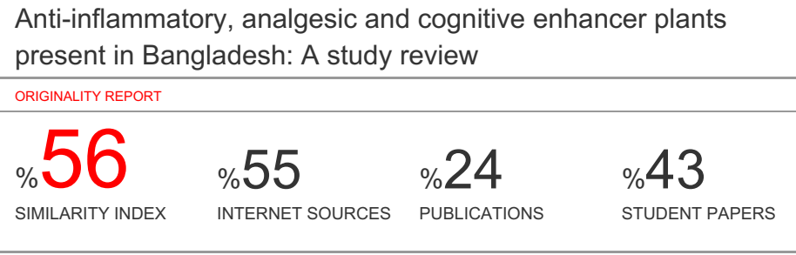

**Anti-inflammatory, analgesic and cognitive enhancer plants present in Bangladesh: A study review**

Abstract:

The use of traditional medicine is expanding to newer horizons and plants still remain as the novel source of structurally important compounds that lead to the development of innovative drugs. Bangladesh has about 45,000 plant species among which medicinal property has been attributed to several thousands. The traditional Bangladeshi system of medicine, the Ayurveda, mentions the use of plants in the treatment of various diseased conditions. Ethnobotanical research done in last few decades have revealed the anti-inflammatory, analgesic and cognitive properties of plants cited in the traditional literature. Many herbal preparations are being prescribed as anti-inflammatory, analgesic and cognitive in the traditional literature. The search for new anti-inflammatory, analgesic and cognitive agents from the huge array of medicinal plant resources is intensifying. This chapter reviews such plant species and their products that have shown experimental or clinical anti-inflammatory or analgesic or cognitive activities,the possible mechanism of action and their therapeutic value. Some of the important taxa which are found effective as anti-inflammatory, analgesic and cognitive agents are Ananas comosus (L.) Merr. Callophyllum inophyllum L., Calotropis gigantea (L.) R.Br., Calotropis procera (Ak.) R.Br., Camellia sinensis (L.) Kuntz., Cannabis sativa L., Curcuma longa L., Kalanchoe crenata Andr., Mangifera indica L., Ricinus communis Linn., Sida cordifolia L., Spillanthes acmella Murr , Zingiber officinale Roscoe,Ginkgo biloba ,Zizyphus jujube,Emblica Officinalis,Cocos nucifera,Celastrus paniculatus .These plants have shown varying degrees of anti-inflammatory, analgesic and cognitive activities.

**Keywords:** Medicinal Plant, Review, Anti-inflammatory, Analgesic and Cognitive activities.

**Introduction**

Plants are the backbone of all life in the earth and an essential resource for human well-being. The human race started using plants as a means of treatment of diseases and injuries from the early days of civilization on earth and in its long journey from ancient time to modern age the human has successfully used plants and plant products as effective therapeutic tools for fighting against diseases and various other health hazards (1).Plants are living organisms belonging to the kingdom plantae.They obtain most of their energy fro, sunlight via photosynthesis using cholorophyll contained choloroplasts, which gives them green color. Plants are important for human life in many ways. Without plants animal life on planet earth would be almost impossible. Plants have been used as a potent and powerful source of medication throughout the world since long (2). Plants are probably most important to people as food. Plants make up the largest proportion in our diet everything we eat comes directly or indirectly from plant. Throughout human history, approximately 7,000 different plant species have been used as food by people. Sometimes we eat plants themselves, as when we eat apples, peas or potatoes. But even when we eat meat or drink milk, we are using foods that come from an animal that eat plants. The seed of such plants as corn, rice and wheat are the chief source of food in most parts of the world (3). When we eat beets, carrots or sweet potatoes we are eating roots of plants. Coffee, tea and many soft drinks get their flavor from plants. Plants supply people with many important raw materials. Trees give us lumber for building homes and making furniture and other goods. Other important sources of fuel-coal, oil and natural gas also comes from plants. All living things plants, animals, fungi, protists and prokaryotes are linked by the cycle of nature. This natural process gives people oxygen to breathe, food to eat and heat to keep them warm (4). Medicinal plantsare rich sources of bioactive compounds and thus serve as important raw materials for drug production. They may constitute a valuable natural asset of a country and contribute a great deal to its health care systems. Medicinal plants and plant-derived drugs plays very important role in the economy of tropical countries. Bangladesh, being one of them and possessing such a rich flora of medicinal plant, should make serious efforts to derive maximum economic benefit from these plants by using them as raw materials for its indigenous drug manufacturing industries, if not by exporting to other countries. This will drastically reduce the volume of pharmaceutical raw materials and processed medicine of plant origin in the country and bring self-sufficiency in the indigenous drug industry, thus saving huge amount of foreign exchange (5). Although there are no apparent morphological characteristics in the medicinal plants that make them distinct from other plants growing with them, yet they possess some special qualities or virtues that make them medicinally important. It has now been established that the plant which naturally synthesis and accumulate some secondary metabolites, like alkaloids, glycoside, tannins, volatile oils and contain minerals and vitamins, possess medicinal properties (6).

**Materials and Methods:**

The aim of this review work is

* To create a list of traditionally used Analgesic, Anti-inflammatory and Cognitive enhancer plants in Bangladesh.
* To review scientific papers reposting Analgesic, Anti-inflammatory and Cognitive enhancer plants in Bangladesh.
* To identify the plants which used in both Analgesic and Cognitive enhancer in Bangladesh.

**Research Protocol:**

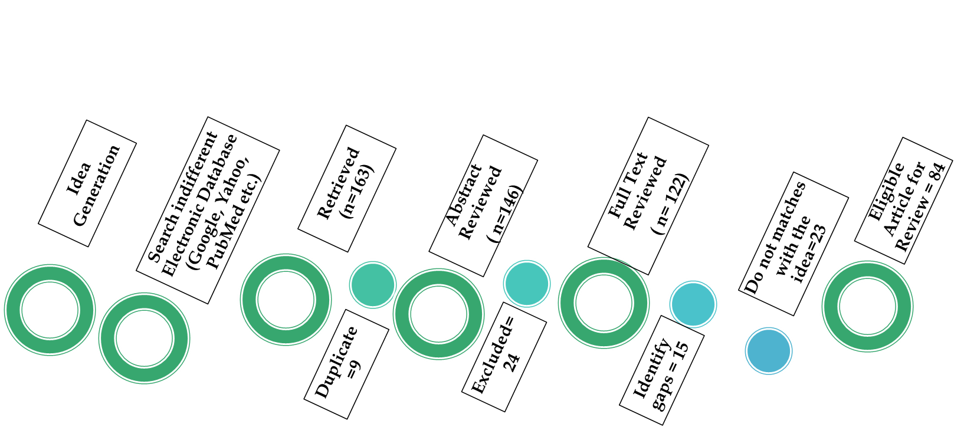

Results and Discussion:

Plants having Analgesic and Anti-Inflammatory activity available in Bangladesh:

|  |  |  |  |  |  |  |  |  |  |
| --- | --- | --- | --- | --- | --- | --- | --- | --- | --- |
| Sl no | | Plant name | Family | Used parts | Chemical Constituents | Area | Traditional use | Pharmacology use |  |
| 01 | | *Ananas comosus*  *( anarash)* | Bromeliaceae | Leaf extracts | high holocellulose,cellulose, hemi cellulose ,lignin | Tangail, Mymensingh, Gazipur, Sylhet, Moulvibazar, Chittagong | induce menstruation,  induce abortion | Anti -inflammatory and analgesic effect (7) |
| 02 | | *Clotropis Procera*  *( akanda)* | Asclepiadaceae | Latax | alkaloids, tannins | kurigram , Rajshahi, jessore | Diarrhoea,  Stomatic,  Skin disease | Analgesic effect.  (7) |
| 03 | | *Calotropis gigantea s*  *(* Akanda) | Leaves | Calotropnaphthalene,  terpenes | bogura, natore | Fevers,  Elephantiasis,  Nausea,  Vomiting,  Diarrhea | Anti-inflammatory (7). |
| 04 | | *Callophyllum inophyllum L*  *(*Sultan chapa) | Clusiaceae | Leaves extracts | alkaloid , triterpenoid, flavonoid, tannin, saponin | coastal areas and Sundarban | Wounds,  ulcers and to treat phthisis,  orchitis and lung affections | Anti -inflammatory and analgesic effect (8). |
| 05 | | *Camellia sinensis*  *( cha)* | Theaceae | extract of dried tea | epigallocatechin gallate ,  gallocatechin gallate ,  Gallocatechin,catechin, epicatechin ,gallate, epicatechin and  epigallocatechin | Chattogram,  Brahmanbaria. Habiganj, Moulvibazar, Sylhet | Stimulant,  Diuretic,  astringent | Anti -inflammatory and analgesic effect (8). |
| 06 | *Cannabis sativa L*  *( Ghaja)* | | Cannabinacea | leaves , flowers and fruits | α-Pinene ,Myrcene, Linalool, Limonene, α-Terpinolene,Trans-caryophyllene, α-Humulene,. | Naogaon, Rajshahi, Jamalpur and Netrokona, Cox’s Bazaar | Hallucinogenic  Hypnotic,   sedative,  analgesic,anti-inflammatory | Anti- inflammatory and analgesic effect (9). |
| 07 | *Kalanchoe crenata Andr.* | | Crassulaceae | bark extract | *alkaloids*, carbohydrate, phytosterols, resins, phenol, tannins, flavonoids and amino acid, triterpene | Rangamati and Khagrachari | otitis,  headache,  inflammations,convulsions | Anti- inflammatory and analgesic effect (9). |
| 08 | *Curcuma longa L*  *( Holud)* | | Zingiberaceae | Rhizom, leaves and flowers | Zingiberen, terpinolene ,  β-sesquiphellandrene | sherpur, shatkhikra | anticancer, antimicrobial  Anti-inflammatory | Anti- inflammatory and analgesic effect (9). |
| 09 | *Zingiber officinale Roscoe*  *( Ada)* | | whole plant, leaves | Flavonols, Terpenoids, Alkaloids, Sterols , Tanins | Dinajpur, Rangpur, Tangail, Chittagong and Rangamati | stomach upset,   nausea,  vomiting | Anti- inflammatory and analgesic effect (9). |
| 10 | *Mangifera Indica L*  *( Aam)* | | Anacardiaceae | leaf, root and seed oil | triterpenoids, quercetin and gallic acid, athujone, camphor and beta thujone | Rajshahi ,naogha ,chapainobabgonj | Dentifrices,  antiseptic | Anti- inflammatory and analgesic effect (10). |
| 11 | *Sida cordifolia L*  *(Bon methi)* | | Malvaceae | leaves and flowers | spilanthol, alkaloids ,carbohydrates, pungent amide tannins, steroids, carotenoids | - | Bronchial asthma  cold and flu  head ache  nasal congestion | Anti -inflammatory and analgesic effect (10). |
| 12 | *Hibiscus rosa sinensis*  *( Joba)* | | leaves | Flavons, alkaloids, beta-sitosterol,vitamin | Anywhere in BD | dysentery and diarrhea  analgesic | Analgesic effect (10). |
| 13 | *Spilanthes acmella Murr.*  *(Shormoni)* | | Asteraceae | whole plant, leaves | Flavonols, Terpenoids, Alkaloids, Sterols , Tanins | - | antiseptic  Antibacterial  antifungal  antimalarial | Anti -inflammatory and analgesic effect (10). |
| 14 | *Scoparia dulcis L*  *(Modhu maloti)* | | Scrophulariacae | whole herb | Alkaloids, carbohydrates, glycosides & tannins | Narshingdi, bogura,  kurigra,  tangail,  noakhali | fever,  hypertension  hemorrhoids  diarrhea | Analgesic effect (10) |
| 15 | *Manilkara zapota*  *( sofeda)* | | Sapotaceae | Leaves | Alkaloids, flavonoids, steroids, phenolic compounds | Chattograam,  Dhaka,tangail | coughs and colds  antidiarrheal | Analgesic effect (10). |

**Plants having cognitive enhancer activity available in Bangladesh:**

|  |  |  |  |  |  |  |  |
| --- | --- | --- | --- | --- | --- | --- | --- |
| Sl no | Plant name | Family | Used parts | Chemical constituents | Area | Traditional uses | Pharmacological uses |
| 01 | *Ginkgo biloba* | Ginkgoaceae | Plant seed, leaf | alkaloid, tannins, steroid, terpenoid, volatile oil, glycoside, fixed oil. |  | nerve tonic  Rejuvenant,  Sedative,  diuretic | Cognitive Enhancer (11). |
| 02 | *Cyperus rotundus*  *(Badhali))* | Cyperaceae | rhizome | Pinene,  Cineole, Terpenes, Isociprol | Noakhali | diarrhea  Diabetes  Pyresis  Inflammation  malaria | Cognitive Enhancer (11). |
| 03 | *Zizyphus jujube*  *(Kul)* | Rhamnaceae | fruit | Terpenoid, flavonoid and alkaloid,  phenyl glycosides | rajshahi, Khulna , anywhere in BD | gastrointestinal problems  stomach pain  constipation | Cognitive Enhancer, anti –inflammatory (12) |
| 04 | *Emblica Officinalis*  *(Amalaki)* | Phyllanthaceae | fruit | gallic acid, tannins, flavonoids, pectin, and quercetin | Rangamati | Antioxidant  immune modulatory  Antipyretic  analgesic | Cognitive Enhancer (12) |
| 05 | *Cocos nucifera*  *(Narikel)* | Arecaceae | fruit | catechins, epicatechins,tannins, and flavonoids | Jessore ,noakhali etc | diarrhea | Cognitive Enhancer (13) |
| 06 | *Celastrus paniculatus*  *(Jyotishmati)* | Celastraceae | Plant seed, leaf | alkaloid, tannins, steroid, terpenoid, volatile oil, glycoside, fixed oil. | - | nerve tonic,  Rejuvenant  Sedative  Diuretic | Cognitive Enhancer (13) |
| 07 | *Camellia sinensis*  *( Cha)* | Theaceae | leaves | epigallocatechin gallate ,  gallocatechin gallate ,  Gallocatechin, catechin, epicatechin ,gallate, epicatechin and  epigallocatechin | Chattogram,  Brahmanbari, Sylhet rangamati | Diuretic  astringent. | Cognitive Enhancer, Anti- inflammatory (14) |
| 08 | *bacopa monnieri*  *(Brahmi shakh)* | Plantaginaceae | leavesandflowers | alkaloids brahmine, herpestine, nicotine, saponin, monierin, hersaponin, triterpene, and bacosine | coastal areas | improve memory | Cognitive Enhancer (14) |
| 09 | *Rhodiola Rosea* | Crassulaceae | roots | flavonoids, proanthocyanidines, tyrosol, cinnamyl alcohol, glycosides, organic acids. | - | fatigue  Depression  anemia | Cognitive Enhancer, anti- inflammatory (15) |
| 10 | *Panax ginseng*  *( ginseng)* | Araliaceae | roots | ginseng saponins,phytosterol, carbohydrates and sugars. | - | diabetes | Cognitive Enhancer (15) |

**Conclusion:**

The current review highlighted the medicinal plants possessed analgesic and anti-inflammatory effects with special focus on their mode of action, as promising future drugs because of their safety and effectiveness. Many studies have been performed to identify Analgesic, Anti-inflammatory and Cognitive enhancer compounds with desired pharmacological activity and a limited toxicity. This review makes an attempt to give scientific account of use of valuable plant in Bangladesh as Analgesic, Anti-inflammatory and Cognitive enhancer source. Thefuture direction is to identify chemical constituents of the plants which is not has been discovered yet and evaluate its *in-vivo* data with animal models.

Reference:

1. Ottani, Alessandra; Leone, Sheila; Sandrini, Maurizio; Ferrari, Anna; Bertolini, Alfio (February 15, 2006). "The analgesic activity of paracetamol is prevented by the blockade of cannabinoid CB1 receptors". European Journal of Pharmacology.**531**(13):280281. [doi](https://en.wikipedia.org/wiki/Doi_(identifier)):[10.1016/j.ejphar.2005.12.015](https://doi.org/10.1016%2Fj.ejphar.2005.12.015). [hdl](https://en.wikipedia.org/wiki/Hdl_(identifier)):[11380/613413](https://hdl.handle.net/11380%2F613413). [PMID](https://en.wikipedia.org/wiki/PMID_(identifier)) [16438952](https://pubmed.ncbi.nlm.nih.gov/16438952).
2. Dani, Mélina; Guindon, Josée; Lambert, Chantal; Beaulieu, Pierre (November 14, 2007). "The local antinociceptive effects of paracetamol in neuropathic pain are mediated by cannabinoid receptors". European Journal of Pharmacology.**573**(1–3):214215. [doi](https://en.wikipedia.org/wiki/Doi_(identifier)):[10.1016/j.ejphar.2007.07.012](https://doi.org/10.1016%2Fj.ejphar.2007.07.012). [PMID](https://en.wikipedia.org/wiki/PMID_(identifier)) [17651722](https://pubmed.ncbi.nlm.nih.gov/17651722).
3. Merry AF, Gibbs RD, Edwards J, Ting GS, Frampton C, Davies E, Anderson BJ (January 2010). ["Combined acetaminophen and ibuprofen for pain relief after oral surgery in adults: a randomized controlled trial"](https://www.ncbi.nlm.nih.gov/pmc/articles/PMC2791549). British Journal of Anaesthesia. **104**(1): 80–8. [doi](https://en.wikipedia.org/wiki/Doi_(identifier)):[10.1093/bja/aep338](https://doi.org/10.1093%2Fbja%2Faep338). [PMC](https://en.wikipedia.org/wiki/PMC_(identifier)) [2791549](https://www.ncbi.nlm.nih.gov/pmc/articles/PMC2791549). [PMID](https://en.wikipedia.org/wiki/PMID_(identifier)) [20007794](https://pubmed.ncbi.nlm.nih.gov/20007794).
4. Trelle, Sven; Reichenbach, Stephan; Wandel, Simon; Hildebrand, Pius; Tschannen, Beatrice; Villiger, Peter M.; Egger, Matthias; Jüni, Peter (11 January 2011). ["Cardiovascular safety of non-steroidal anti-inflammatory drugs: network meta-analysis"](https://www.ncbi.nlm.nih.gov/pmc/articles/PMC3019238). British Medical Journal (Clinical Research Ed.). 342: c7086. [doi](https://en.wikipedia.org/wiki/Doi_(identifier)):[10.1136/bmj.c7086](https://doi.org/10.1136%2Fbmj.c7086). [PMC](https://en.wikipedia.org/wiki/PMC_(identifier)) [3019238](https://www.ncbi.nlm.nih.gov/pmc/articles/PMC3019238). [PMID](https://en.wikipedia.org/wiki/PMID_(identifier)) [21224324](https://pubmed.ncbi.nlm.nih.gov/21224324).
5. Dvorak J, Feddermann N, Grimm K (July 2006). "Glucocorticosteroids in football: use and misuse". British Journal of Sports Medicine. 40 Suppl 1: i48–54. doi:10.1136/bjsm.2006.027599. PMC 2657490. PMID16799104.
6. Scott JP, Peters-Golden M (September 2013). "Antileukotriene agents for the treatment of lung disease". Am. J. Respir. Crit. Care Med. **188** (5): 538–544. doi:10.1164/rccm.201301-0023PP. PMID 23822826.
7. Hamzelou, Jessica (23 October 2015). "Old rat brains rejuvenated and new neurons grown by asthma drug". New Scientist. Retrieved 28 October 2015.
8. Yirka, Bob. "Asthma drug found to rejuvenate older rat brains". medicalxpress.com. Retrieved 3 November 2015.
9. Bao, F.; John, S.M.; Chen, Y.; Mathison, R.D.; Weaver, L.C. (2006). "The tripeptide phenylalanine-(d) glutamate-(d) glycine modulates leukocyte infiltration and oxidative damage in rat injured spinal cord". Neuroscience. **140** (3): 1011–1022. doi:10.1016/j.neuroscience.2006.02.061. PMID 16581192.
10. Mathison, Ronald D.; Befus, A. Dean; Davison, Joseph S.; Woodman, Richard C. (2003). "Modulation of neutrophil function by the tripeptidefeG". BMC Immunology. **4** (3): 3. doi:10.1186/1471-2172-4-3. PMC 152650. PMID 12659660.
11. Mathison, R.; Davison, J.S.; Befus, A.D. (November 1994). "Neuroendocrine regulation of inflammation and tissue repair by submandibular gland factors". Immunology Today. **15** (11): 527–532. doi:10.1016/0167-5699(94)90209-7. PMID 7802923.
12. Mathison, Ronald D.; Malkinson, Terrance; Cooper, K.E.; Davison, J.S. (1997). "Submandibular glands: novel structures participating in thermoregulatory responses". Canadian Journal of Physiology and Pharmacology. **75** (5): 407–413. doi:10.1139/y97-077. PMID 9250374.
13. Dery, R.E.; Mathison, R.; Davison, J.; Befus; A.D. (2001). "Inhibition of allergic inflammation by C-terminal peptides of the prohormone submandibular rat 1 (SMR-1)". International Archives of Allergy and Immunology. **124** (1–3): 201–024. [doi](https://en.wikipedia.org/wiki/Doi_(identifier)):[10.1159/000053710](https://doi.org/10.1159%2F000053710). [PMID](https://en.wikipedia.org/wiki/PMID_(identifier)) [11306968](https://pubmed.ncbi.nlm.nih.gov/11306968).
14. Akhtar, N.; Haqqi, T. M. (2012). ["Current nutraceuticals in the management of osteoarthritis: A review"](https://www.ncbi.nlm.nih.gov/pmc/articles/PMC3400101). Therapeutic Advances in Musculoskeletal Disease. **4** (3): 181–207. [doi](https://en.wikipedia.org/wiki/Doi_(identifier)):[10.1177/1759720X11436238](https://doi.org/10.1177%2F1759720X11436238). [PMC](https://en.wikipedia.org/wiki/PMC_(identifier)) [3400101](https://www.ncbi.nlm.nih.gov/pmc/articles/PMC3400101). [PMID](https://en.wikipedia.org/wiki/PMID_(identifier)) [22850529](https://pubmed.ncbi.nlm.nih.gov/22850529).
15. Jagtap VA, Md Rageeb, Md Usman, Salunkhe PS, Gagrani MB, Anti-inflammatory Activity of Calotropisgigantea Linn. Leaves Extract on In-vitro Models, International Journal of Pharmaceutical review and Research, 1(2), August-october, 2010, 1-5.