**Reviewer’s Comments**

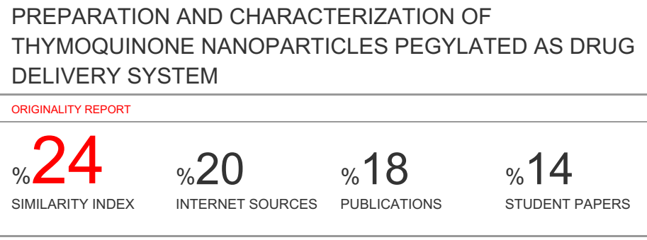

**PREPARATION AND CHARACTERIZATION OF THYMOQUINONE NANOPARTICLES PEGYLATED AS DRUG DELIVERY SYSTEM**

**ABSTRACT**

**Objective:**Thymoquinone is a main component of Black Cumin (Nigella Sativa Linn.) with various pharmacological activities, but has poor stability and bioavaibility. The purpose of this study was to carry out the preparation and characterization of ThymoquinonenanoparticlesPEGylation.

**Methodes:**The Thymoquinone nanoparticles were made with PEGylation using PEG 6000 with the concentrations on each preparation of 3 mM (A), 4 mM (B), and 5 mM (C) then were evaluated by the parameter of yield percentage Entrapment Efficiency (EE) , Drug Loading (DL), drug release, size and particledistribution, morphological analysis and Fourier Transform-Infrared spectrophotometer (FTIR).

**Results:**Preparation A has the highest entrapment efficiency of 99.9718 ± 0.029%, with the capacity of drug loading 0,66%, and the best drug release. The morphological observations with Scanning Electron Microscope (SEM) showed spherical nanoparticles morphology. The analysis of FT-IR showed that the Thymoquinone nanoparticles had similar characteristics with its coating polymer.

**Keywords** :Black Cumin, Nanoparticles, PEG 6000, Pegylation, Thymoquinone.

**INTRODUCTION**

Thymoquinone (TQ) is a bioactive compound derived from black seed oil (Nigella sativa Linn.) which grows in the Mediterranean region and in Western Asian countries. Black cumin oil has various therapeutic benefits such as dysentery, headaches, gastrointestinal problems, eczema, hypertension, and obesity, etc1,2,3.Thymoquinone can increase the immune system of patients with bronchial asthma due to allergies, in addition to its main properties as an allergy and anti-inflammatory2,3,4,5,6.

The chemical content of black cumin (*Nigella sativa* Linn.) is thymoquinone, thymohidroquinone, nigellienine, nigellamine-n-oxide, essential oils, fatty oils, alkaloid compounds, saponins, steroids, isoquinolin, oleic, and linolenic alkaloids. The main content of black cumin (Nigella sativa Linn.) Is Thymoquinone (TQ), Dithymoquinone (DTQ), and Thymol (THY) which acts as an antioxidant2,3.

Thymoquinone is an essential oil that has volatile properties, low melting point and is easily oxidized, so it will be difficult to formulate into a pharmaceutical dosage form7. In addition, thymoquinone is also difficult to dissolve in water, and has a poor bioavailability7,8. To overcome this problem a nanoparticle preparation was developed as a thymoquinone carrier9,

Nanoparticles are colloidal particles that range in size from 1-100 nm. The drug is dissolved, absorbed, encapsulated or attached to the nanoparticle matrix. The advantage of nanoparticles is that theyincrease the bioavailability of the drug, small doses of drug can be used, can reduce the possible drug side effects,can increase the surface area to enhance solubility of active ingredients in the fluid environment, such as in the digestive tract. Dissolution rates along with better absorption and bioavailability9,10,11. Within a few years, many methods have been designed in the development of formulations to improve the pharmaseuticproperties and pharmacokinetics of a drug compound to produce the maximum benefit of therapeutic action. One of them is pegylated nanoparticles. Pegylation is a modification of protein, peptide and non peptide molecules by forming bonds or links with one or more chains of polyethylene glycol (PEG). Polyethylene glycol (PEG) is a polymer that has been approved by the FDA in the application of nanomedicine and biomedicine. A good nanoparticle formulation should have a high drug loading capacity. The molecular weight of polyethylene glycol (PEG) can affect the loading capacity of the drug so that it is necessary to optimize the type and concentration of PEG used based on its molecular weight10,11,12,13,14. Based on this, it is necessary to do research on the preparation and characterization of thymoquinone nanoparticles so that they can be used for drug delivery.

**SUBJECTS AND METHODS**

Thymoquinone was obtained from Sigma Aldrich,USA.TheTQ was prepared into the form of d nanoparticles PeGylatedusingPEG. Inthis study, the TQ was quantified using UV-Visspechtrofotometer.

**Standard Solution preparation**

A stock solution of 100 ppm of Thymoquinone concentration was made by weighing 10 mg of Thymoquinone and dissolving it in 100 mL of phosphate buffer pH 7.4 in a 10 mL volumetric flask then shaken until homogeneous. The solution is used to determine the maximum wavelength of TQ. The λmax was observed with a spectrofotometer UV-VIS at 200 – 400 nm.

**Preparationof *Thymoquinone* Nanoparticle (TQ-NP)**

Nanoparticles are made by the pegylation method. A series of concentrations of PEG 400, PEG 4000 and PEG 6000 were made as polymers. Tween 80 was used as surfactant in the optimization of nanoparticles shown in table 1. Each formula was made as much as 5 mL with 1 mg of thymoquinone. One mg of thymoquinone is dissolved in 70% ethanol to form a solution of a concentration…... Tween 80 (0.03 mL) was added into the mixture until it was homogeneous, then the mixture was slowly dripped into polyethylene glycol (PEG) while being sterilized at a speed of 700 rpm for 6 hours. The TQ-PEG dispersion was then rotated to remove solvents and made into powder with freeze drying technique to obtain classiﬁed TQ-NP.

**Characterization of TQ-NP**

1. **TQ-NP Morphology**

Morphological observations of TQ-NP were carried out using Scanning Electron Microscope (SEM). The TQ-NP were dropped over cooper gird then coated with an auto carbon coated (JOEL JEM, Japan) tool for 5 seconds, dried at room temperature for 24 hours. TQ-NP was analyzed by accelerating the voltage at 120 kV and magnification of 60,000.

1. **Particle Size**

TQ-NP particle size was determined using a NicompTM 380 ZLS Submicron particlesize analyzer. A total of 2 drops of pH 4.0 TQ-NP added 5.0 mL aquadest, then mixed by flipping through a conical tube. After that, 3.0 mL was taken and put into cuvettes to analyze distribution and particle size.

1. **The Entrapment Efficiency (EE)and Drug Loading**

Fivemg of TQ-NP were centrifuged at 15,000 rpm, for 30 minutesand then absorbance was measured with UV-Vis spectrophotometry. Entrapment Efficiency of TQ-NPwas calculated by the equation:

%EE = $\frac{(drug Total-Free drug)}{Drug Total} x 100$

1. **Yield Value Percentation**

Weighed Thymoquinone nanoparticles and then determined the weight percentage of the material added, namely the weight of the drug and the polymer used.

$$PY\left(\%\right)= \frac{The weight of NP}{Total Solid Weight (PEG+ TQ)}x100\%$$

1. **In Vitro Study (Drug Release)**

The release of TQ-NP carried out in vitro using franz diffusion cells, the membrane used was removable python morolus skin. The medium fluid in the receptor compartment used was a phosphate buffer pH of 7.4 and maintained at a temperature of 35 ± 0.5°C as much as 50 mL. The snake skin is then placed between donor compartments with receptor compartments, samples weighed as much as 5 mg are applied to the surface of the skin. Medium liquid is flowed through the bottom of the skin membrane with the help of a magnetic stirrer at a speed of 100 rpm. Sampling was carried out at the 10, 20, 30, 40, 50, 60, 70, 80, 90, 110, and 120 minute where 5 mL samples were taken from the receptor compartment using a syringe and immediately replaced with a 5 mL medium solution. The samples were then measured for absorbance using UV-Vis spectrophotometry at a maximum wavelength of 260 nm.

1. **FT-IR Analysis**

Interactions with polymers were determined by IR spectroscopy. 1.0-2.0 grams of thymoquinone, PEG 6000 and TQ-NPwasmixed with potassium bromide. Small amounts of the powder are compressed into thin semitransparent granules using pressure. IR spectra are scanned from 750-4000 cm-1.

**RESULTS AND DISCUSSION**

The development of nanoparticles using thymoquinone as an active ingredient is based on volatility, low melting point and easily oxidized, thymoquinone is also difficult to dissolve in water, so it has a small bioavailability7,8,9Therefore, thymoquinone is made in the form of nanoparticles to improve the bioavailability of drugs, improve the physical properties of chemicals and protect medicinal ingredients so as to provide an effective therapeutic effect12,13,14.

Table1. Thymoquinone nanoparticles optimization

|  |  |  |  |  |  |
| --- | --- | --- | --- | --- | --- |
| No | Materials | Concentrations | | | Formed Solid Particles |
| P A | P B | P C |  |
| 1 | *Thymoquinone* | 1 mg | 1 mg | 1 mg | - |
| 2 | PEG 400 | 72 mg | - | - | No |
| 3 | PEG 4000 | - | 72 mg | - | No |
| 4 | PEG 6000 | - | - | 72 mg | Yes |
| 5 | Tween 80 | 0.03 mL | 0.03 mL | 0.03 mL | - |
| 6 | Etanol | Ad 5 mL | Ad 5 mL | Ad 5 mL | - |

In this study, the resulting nanoparticleTQ-NP was characterized by evaluating nanoparticle morphology, size and distribution of particles, measurement of entrapment efficiency (EE) and drug loading (DL), yield value percentage, nanoparticle release, and Fourier Transform-Infrared Spectroscopy analysis (FT- IR).

Table 2. Entrapment efficiency (EE) of TQ-NP

|  |  |  |
| --- | --- | --- |
| **No** | **Preparations (TQ:PEG 6000)** | **% EE** |
| 1  2  3 | A (1:3)  B (1:3)  C (1:3) | 99.9718 ± 0.029  99.9628 ± 0.026  99.9363 ± 0.049 |

In this study thymoquinone was prepared to form nanoparticles using the pegylated method using polyethylene glycol (PEG) as a polymer. The technique developed is expected to increase drug delivery and lack of drugs. PEG was chosen as a polymer used because it was 'safe' in the body and approved for use as excipients in many pharmaceutical formulations. PEG has been widely used in various nanoparticle systems to increase surface hydrophilicity and half-life by interacting with blood and mononuclear phagocyte cell systems. Pegylation is formed because physical adsorption or covalent grafting results in a layer of PEG on the surface of the particles so that it can increase the stability of the medicinal material16,17,18

One way to improve the properties of drugs that have poor bioavailability and solubility is formed thymoquinone nanoparticles. Several studies have shown that molecular weight and PEG configuration not only affect pharmacokinetic properties but also biological activity, so it is very important to choose PEG with different molecular weights. PEG is a constituent of nanoparticles so it is optimized between molecular weight (400, 4000, and 6000) and concentration of 3 mM.

Optimization was done by making preparations with a comparison of PEG polymers with different molecular weights, the type of PEG used (400, 4000, 6000) with a concentration of 3 mM. In making the pegylation method thymoquinone and PEG were dissolved in 70% ethanol, then tween 80 was added as a surfactant as much as 0.03 mL, the distrer was at 700 rpm, dropped thymoquinone and distrerer dispersion for 6 hours, using a rotary evaporator at 40 0C at a speed 50 rpm and mixed with freeze drying technique to form thymoquione nanoparticles. The optimization parameter is to see the formation of particles after being pollinated by the technique of freeze drying. The optimization results showed that only PEG 6000 produced powder (solid particles), can be seen in table 1.

**Yield Percentage**

Determination of the percentage of yield shows the efficiency of the method used in combining polymers, cross-linkers and medicinal ingredients by looking at the amount of nanoparticle powder produced. The yield percentage is obtained from the comparison between the nanoparticles produced with the amount of the material used in making these nanoparticles. The percentage yield depends on the concentration of the polymer used. High polymer concentrations cause the yield percentage22,23.

**Figure 1**. The percentage yields of TQ-NP

From the results of the study, shown in Figure 1, preparation A has a percentage yield value of 88.12%, preparation B has 92.43% and preparation C has the largest percentage yield of 93.11%.

***Entrapment Efficiency* (EE) dan*Drug Loading* (DL)**

Entrapment Efficiency (EE) shows the ability of polymers to absorb drugs, while DL shows the ability of drugs to be absorbed into the polymer matrix. EE can be influenced by the concentration of the polymer used in making nanoparticles. The EE test results show that all preparations have% EE, which are 99.9718 ± 0.029%, 99.9628 ± 0.026%, and 99.9363 ± 0.049%, respectively. From the results above it can be seen that the higher the polymer concentration will cause the EE value to be low. This can be caused by the high concentration of polymers that will produce a solution with high viscosity so that the drug ingredients will be difficult to diffuse into the polymer matrix23,24,25,26.

Figure 2. Drug Loading (DL) Histogram of Thymoquinone nanoparticles

The results of the DL test showed that the preparations A (3 mM), B (4 mM), and (5 mM) were 1.54%, 1.02%, and 0.66%, respectively. From these results it is known that preparation A has a high DL value compared to preparations B and C. An ideal nanoparticulate system has a high drug loading capacity thereby reducing the material used for drug delivery. Drug and drug loading is very dependent on drug solubility in materials or polymers, polymer composition, polymer molecular weight, and drug and polymer interactions18,22,23,24.

**Particles Size**

Particle size are very important characteristics in nanoparticle formulations. The particle size will determine the in vivodrug distribution, the fate of the drug in the biological system , its toxicity and the ability to target drugs in the nanoparticle system. The size and distribution of particle also affects drug absorption, drug release and stability of the nanoparticles15.The main application of nanoparticles is drug release and drug targeting. It has been found that particle size affects drug release. Small particles produce a larger surface area. As a result, most drugs that are inserted will spread to the surface of the particles to facilitate drug release faster. Instead, the drug will experience slower diffusion in larger 18,19,24,27.

Measurement of size and distribution of nanoparticles using preparations that have good percent EE and in vitro release values. The results obtained in preparation A showed a particle size distribution of 786.6 nm with an average size of nanoparticles produced 10.6 nm (see appendix 12), which is in the range of size of the nanoparticles (10-1000 nm).

The Polydispersity Index is a parameter to determine the particle size distribution of nanoparticles with a range that can be absorbed by the PEG 6000 polymer matrix. Preparations A (3 mM) have IP> 0.5 which is 0.350. According to Avadi in 2010, particles with IP> 0.7 have a very wide size distribution. The smaller IP, shows the particle size is uniform. So that it can be concluded that thymoquinone nanoparticles formed monodispersion or relatively homogeneous.

***TQ-NP* Morphology**

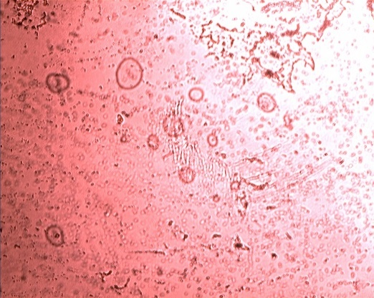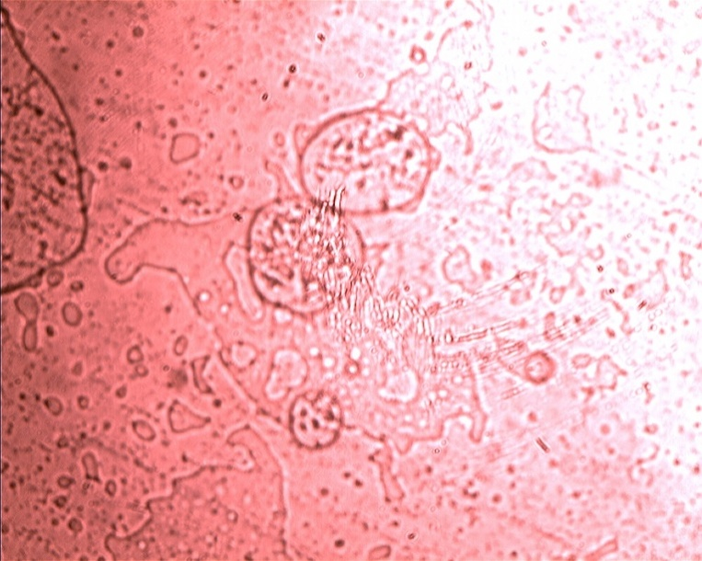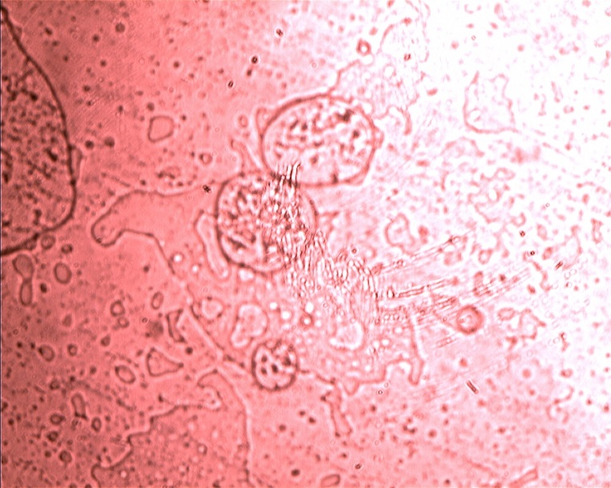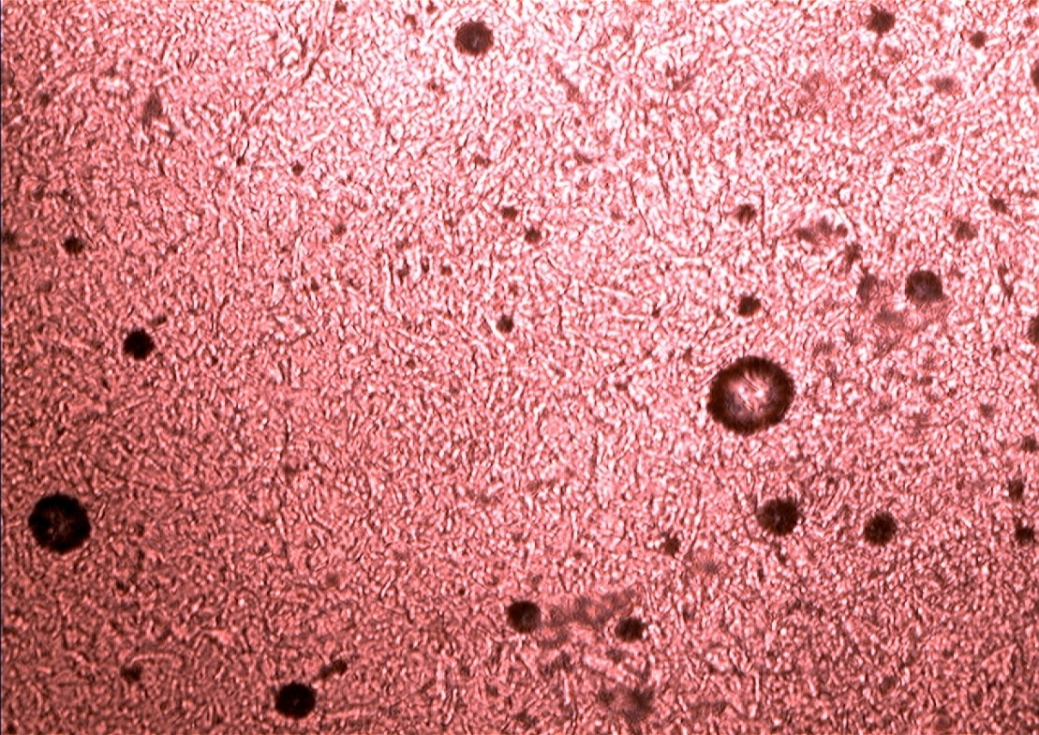

B

A

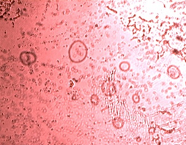

C

The morphology of Thymoquinone nanoparticles aims to see the shape and morphology of the nanoparticles formed using the irmeco® microscope and Scanning Electron Microscopy (SEM)

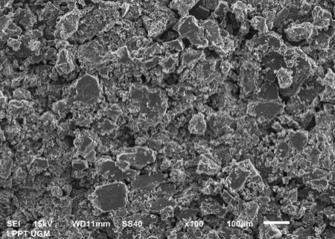

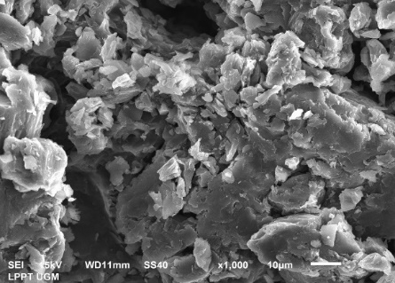

B

A

Figure 3. The micrograph of TQ-NP :A (3 mM), B (4 mM), C (5 mM) magnification 40 using an irmeco® microscope

B

A

Based on the results of observations using the irmeco® microscope shown in Figure 1, the thymoquinone nanoparticles formed have a round shape.Scanning Electron Microscope (SEM) is a type of electron microscope that provides a picture of the surface of a sample by scanning using a high-energy electron beam. Electrons interact with sample-forming atoms that produce signals containing information about the surface topography of the sample. Observations using SEMcan be seen in Figure 4. The results of observations on preparations A with a concentration of 3 mM showed a spherical shape on the surface of the particles.

A

B

Figure 4. Morphology of thymoquinone nanoparticles using Scanning Electron Microscopy (SEM) with A (1000x magnification)and B (100x magnification).

**TQ-NP *In VitroStudy***

To develop a nanoparticulate system, drug release and polymer biodegradation are important consideration factors. In general, the level of drug release depends on: (1) drug solubility; (2) surface desorption from adsorbed/ bound drugs; (3) drug diffusion through the nanoparticle matrix; (4) the erosion / degradation of the nanoparticle matrix and (5) the combination of the erosion / diffusion process.Solubility, diffusion and biodegradation of matrix materials regulate the release process15, 22,24,.

The nanoparticle diffusion release test was carried out using a franz diffusion cell withphosphate buffer pH 7.4 solution. The medium given describes the system of blood flow under the skin. From the results of Thymoquinone release from nanoparticles diffusion can be seen in the figure. The release of the drug can be caused by the presence of drugs that are on the surface of the nanoparticles.

Figure 3. In-vitro release graphics for preparation A with a concentration of 3 mM

The results of the studies in Figures 7, 8, and 9 showed that the highest drug release occurred after 50 minute and no release at 90 minutes, from the release of preparation A had a longer release time than preparations B and C (can be seen in figures 4 and 5).

Figure 4. In-vitro release graphs of the 4 mM B preparations

Figure 5. In-vitro release graphics for C preparations with a concentration of 5 mM

The results showed that in Figure 4 and 5 the highest drug release occurred in the 50th minute and no release occurred in the 70th minute.

**FT-IR Analysis**

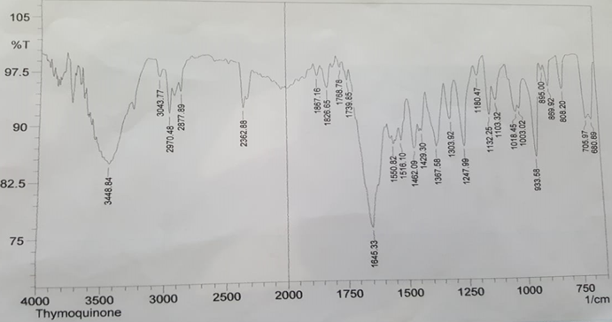

FT-IR or Fourier Transform-Infrared Spectroscopy measurements were used to determine the functional groups of nanoparticles and to determine the interactions that occurred between the drug ingredients, PEG 6000, with the wave number formed.

Figure 6. Results of FT-IR testing on thymoquinone

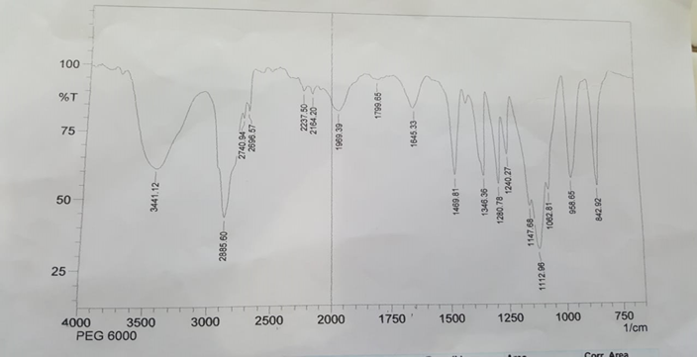

Figure 7. Results of FT-IR testing on PEG 6000

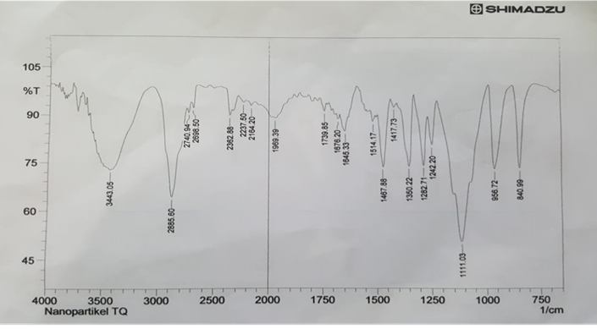

Figure 8. Results of FT-IR testing on thymoquinone nanoparticles

The FT-IR results shown in Figures 10, 11, 12 show similarities between thymoquinone nanoparticles and PEG 6000. This means that there is no chemical interaction between the polymer and the medicinal ingredients. After being characterized using FT-IR we found similar wave numbers from the drug coated with absorbing PEG.

**CONCLUSION**

From the results of this study Thymoquinone can be prepared into nanoparticles using Polyethylene Glycol 6000 with a concentration of 3 mM, 4 mM, and 5 mM. 99.9628 ± 0.026, and 99.9363 ± 0.049 respectively.

**Conflict of interest**

**ACKNOWLEDGMENTS**

The authors would like acknowledge Indonesian Ministry of education and Culutre, and faculty of Pharmacy, Universitas Muslim Indonesia.

**REFERENCES**

1. DehghaniH, HashemiM, EntezariM,MohsenifarA. The comparison of anticancer activity of thymoquinone and nanothymoquinone on human breast adenocarcinoma. Iranian journal of pharmaceutical research (IJPR) 2015; 14(2): 539.
2. MarlindaL.Effectivity Black Cumin Seeds Extract to Increase Phagocyrosis. Majority 2015; 4:(03).
3. El GazzarM, El MezayenR, Marecki JC, Nicolls MR, Canastar A, DreskinSC. Anti-inflammatory effect of thymoquinone in a mouse model of allergic lung inflammation. International immunopharmacology 2006; 6(7): 1135-1142
4. Bhattacharya S, Manisha A, PrasunP, et al. PEGylated-thymoquinone-nanoparticle mediated retardation of breast cancer cell migration by deregulation of cytoskeletal actin polymerization through miR-34a 2015; 51: 91-107

<https://doi.org/10.1016/j.biomaterials.2015.01.007>

1. Woo CC, SerYL,Veronica G, Chun WY, Gautam S, Alan PK, Kwong HBT. Anticancer activity of thymoquinone in breast cancer cells: Possible involvement of PPAR-γ pathway. Biochemical Pharmacology 2011; 82(5): 464-475

<https://doi.org/10.1016/j.bcp.2011.05.030>

1. OdehF, IsmailSI, Abu-DahabR, MahmoudIS, Al BawabA. Thymoquinone in liposomes: a study of loading efficiency and biological activity towards breast cancer. Drug Delivery2012; 19(8): 371-377
2. Salmani JMM, AsgharS, LvH, ZhouJ. Aqueous solubility and degradation kinetics of the phytochemical anticancer thymoquinone; probing the effects of solvents, pH and light. Molecules 2014;19(5): 5925-5939.
3. Vignesh KS, Renuka DP, Hemananthan E. In vitro studies to analyze the stability and bioavailability of thymoquinone encapsulated in the developed nanocarrier 2019, Journal of Dispersion Science and Technology: 41 (2)

<https://doi.org/10.1080/01932691.2018.1564672>

1. TubeshaZ, BakarZA,IsmailM*.* Characterization and stability evaluation of thymoquinonenanoemulsions prepared by high-pressure homogenization. Journal of Nanomaterials2013: 126.
2. SinghR, LillardJW. ‘Nanoparticle-based Target Drug Delivery’, Experimental and Molecular Pathology 2009; 86: 215-223
3. BalloutF, ZeinaH, Omar NR, Maamoun F, Hala GM. Thymoquinone-based nanotechnology for cancer therapy: promises and challenges. Drug Discovery Today 2018: 23 (5): 1089-1098

<https://doi.org/10.1016/j.drudis.2018.01.043>

1. AlamS.KhanZI,MustafaG, KumarM, IslamF, BhatnagarA, AhmadFJ. Development and evaluation of thymoquinone-encapsulated chitosan nanoparticles for nose-to-brain targeting: A pharmacoscintigraphic study. Int. J. Nanomed 2012; 7: 5705–5718.
2. BinarjoA, YuwonoT,PriyantiR. PengembanganPreparasiNanopartikel*Thymoquinone*-KitosanDenganMetodeKosolvenmenggunakanIsopropilAlkohol. Pharmaciana 2015; 5(2).
3. Pal SL, Jana U, MannaPK, MohantaGP, ManavalanR.Nanoparticle: An overview of preparation and characterization. Journal of Applied Pharmaceutical Science 2011; 01 (06): 228-234. ISSN: 2231-3354
4. HansenM, SmithMC, CristRM, ClogstonJD,McNeilSE. Analyzing the influence of PEG molecular weight on the separation of PEGylated gold nanoparticles by asymmetric-flow field-flow fractionation. Analytical and bioanalytical chemistry 2015; 407(29).
5. Priyanka UP, etal.Transferrin-decorated thymoquinone-loaded PEG-PLGA nanoparticles exhibit anticarcinogenic effect in non-small cell lung carcinoma via the modulation of miR-34a and miR-16. Biomaterial Sciencse *2019*, 10

<https://doi.org/10.1039/C9BM00912D>

1. HarrisJM, NancyEM, MarleneM.Pegylation : A Novel Process for Modifying Pharmacokinetics. Clinical Pharmacokinetics2001; 40(7):539-51

DOI: 10.2165/00003088-200140070-00005

1. Nanda RK, PatilSS, NavatharDA. Chitosan Nanoparticles Loaded with Thiocolchicoside.DerPharmaChemica 2012; 4 (4): 1619-1625
2. StoicaR, SomoghiR,IonRM.Preparation of Chitosan-Tripolyphosphate Nanoparticles for the Encapsulation of Polyphenols Extracted from Rose Hips, Digest Journal of Nanomaterials and Biostuctures 2013; 8 (3): 955-963
3. MohanrajVJ,ChenY. Nanoparticles-a review. Tropical Journal of Pharmaceutical Research 2006; *5*(1): 561-573.
4. Ranjit, K., &Baquee, A.A., 2013, Nanoparticle: An Overview of Preparation, Characterization, and Application, *International Research Journal Pharmacy*, vol. 4, no. 4, pp. 47-57
5. Suk JS, Qingguo X, Namho K, Justin H, Laura ME. PEGylation as a strategy for improving nanoparticle-based drug and gene delivery, 2016.
6. Kumar SKV, Ponnuswamy RD, Saru H, Eswaran H. Synthesis and characterisation of PEG modified chitosan nanocapsules loaded with thymoquinone. IET Biotechnologi 2017; 11 (1): 104-112
7. Hamidi M, Amir A, Pedram R. Pharmacokinetic Consequences of Pegylation 2008; 13: 399-409

<https://doi.org/10.1080/10717540600814402>

1. Agrawal P.Significance of Polymers in Drug Delivery System. Journal of Pharmacovigilance 2014; 3(1): 1-2

DOI: 10.4172/2329-6887.1000e127

1. Suka JS, Qingguo X, Namho K, Justin H, Laura ME. PEGylation as a strategy for improving nanoparticle-based drugand gene delivery. Adv Drug Deliv Rev2016;1: 28–51. doi:10.1016/j.addr.2015.09.012