Reviewer’s Comments
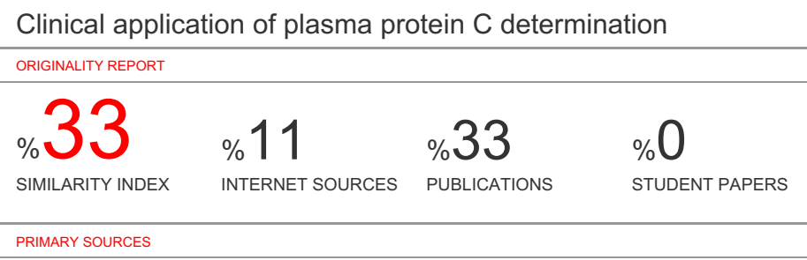

Clinical application of plasma protein C determination

Abstract
Objective: Protein C, a vitamin K-dependent coagulation factor, is involved in blood coagulation. Activated protein C inactivates the activated V and VIII and stimulates fibrinolysis by inducing a rise in plasma plasminogen activator activity. In this process,protein S serve as an important factor for activated protein C. Furthermore,excess protein S drives cancer cell proliferation and cell survival through oncogenic receptor Axl. We determined ranges of protein C both in healthy individuals and distinct hospitalized patients.
Methods: Plasma protein C antigen was measured using rocket immunoassay.
Results and conclusion: A rabbit antibody against human protein C was used for the quantitative estimation of plasma protein C. In healthy individuals protein C antigen(PC:Ag) ranges o.6439- 1.4752 u/ml. The mean coefficient of variation(CV) of length of rocket was calculated to be 12.45%. PC:Ag within laboratory variation was 11.47%. Plasma protein C antigen was destroyed at 56℃ for 30 minutes, whereas no significant decrease of protein C was found at 4℃ refrigerator for one week.
The results showed that plasma protein C antigen was considerably high in 22 diabetes mellitus. On the other hand,the PC:Ag was significantly decreased in 19 liver cirrhosis and was positively correlation with serum albumin levels. In 20 acute leukemias,on the average,there was slightly lower values in PC:Ag,and accompanied with significant decrease of PC:Ag in 5 M5 subtype and in 9 hyper-leukocytes acute leukemias. However,the 3 acute promyelocytic leukemia (APL) with overt laboratory picture of DIC had protein C concentration no lower than the remaining 2 patients wit infectious DIC, which suggested the coagulopathy in APL might be due to mechanisms different from other forms of DIC.

Keywords: plasma protein C antigen rocket immunoassay clinical determination
Introduction
Protein C is a vitamin K-dependent protein which was discovered by Stenflo in 1976(1).It was composed of a light and heavy chain linked by interchain sulfide bridges(figure 1)(2). In its activated form protein C inactivates the activated factor V and VIII and accelerates fibrinolysis(3). Activated protein C(APC) requires the presence of protein S(4).
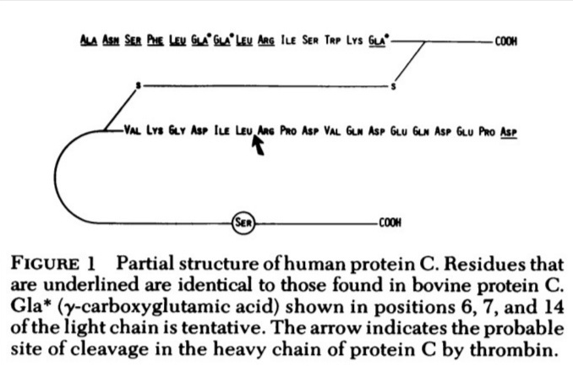

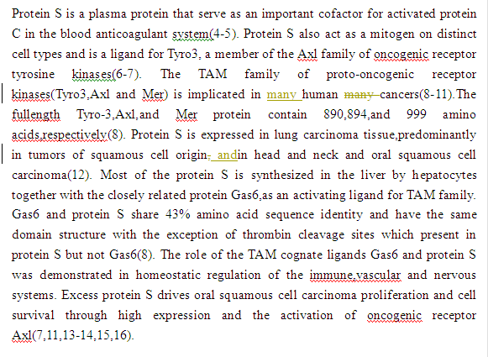
Based on literature review,Griffin etal (17) reported the first family with a congenital protein C deficiency. Bertina & Broekmans(4,18-19) reported the first Dutch family with a congenital protein C deficiency. Using an immunologic assay for protein C(20), we carried out the measurement of protein C in patients with clinical various diseases especially bleeding diathesis.

Materials and Methods
Venous blood was collected in 1/10 volume of 0.11 M sodium citrate.

Procedures:
(i).Preparation of antibody-containing agarose gels
A 12.5ml of 1% indubiose A37 or commeciable agarose solution is obtained by boiling in gel buffer(PH8.8 Tris-BB or Tris-BB-EDTA) during continuous stirring. The solution is allowed to cool to 55℃,and a 60ul amount of rabbit protein C antiserum and a 0.05ml of 0.11 mol/l sodium citrate solution was added during careful mixing. A 100 x 60 x 2 mm gel is prepared on small glass plate by pouring antibody-containing agarose(50～55℃) into a coated glass plate placed on a horizontal table. After 10 minutes the solidified gel is placed in a refrigerator(4℃) in a moist atmosphere. The gel should harden before wells can be punched.
(ii).Punching out the wells. Wells are punched out with a gel puncher,using a template.
(iii).Application of the samples. A row of wells(about 4 mm in diameter) with their centers at least 5 mm apart is punched in the gel. After appropriate dilution the samples(13 ul) are deposited in the wells. The ionic strength of the samples should preferably be approximately the same as that of the electrophoresis buffer. Subsequently,samples are applied after the glass plate has been placed on the electrophoresis apparatus and a low voltage has been applied(0.5 V/cm). Standards in suitable dilutions are deposited in the middle holes of the row.
(iv).Electrophoresis,staining and drying. Electrophoresis is performed at 120 voltes(4－6 mA/ plate ) at room temperature 12~30℃ for 20 hours overnight.
(v).Calculation of the test results. The length of rocket immunoprecipitate measured by using a ruler,which is linearly correlated to the amount of antigen. Results(including normal controls and patients) are plotted on log-log paper(length of rocket in mm versus percentage antigen),based on the construction of the standard curve.

Results
1).Protein C antigen in healthy individuals
Protein C antigen was measured in the plasma of 50 healthy individuals who contributed to our pooled normal plasma. A mean protein C antigen of 1.0578 u/ml was calculated with a SD of 0.1886 u/ml; individual protein C values ranged from 0.6439 u/ml to 1.4752 u/ml.
The distribution of age on the protein C antigen concentration was evaluated in 50 healthy individuals. The results were summarized in table 1,and which indicated that no statistical differences in protein C antigen were found for the different age groups(p>0.5). Also,no difference was observed between men(mean 1.0613 u/ml) and women(mean 1.0550 u/ml).

Table 1. The age distribution on plasma protein C antigen
Age No Protein C antigen(u/ml)
mean±SD range
18－25 9 1.0505±0.225 0.6439~1.3588
26－30 11 1.0623±0.2066 0.6870～1.4269
31－40 16 0.9767±0.1040 0.8047～1.1649
41－50 13 1.1268±0.1841 0.8785～1.4298
51 1 1.4752
Total 50 1.0578±0.1886 0.6439～1.4752

2).The qualitative evaluation of protein C antigen determination
a).For investigation,to perform the consective numerous assays on mixed pooled normal plasma as standard curve,the mean coefficient of variation(CV) of length of rocket was calculated to be 12.45%(table 2).

Table 2. Experimental results of PC peak height following a consective 18 assays from pooled normal plasma
Plasma dilution Repeat No. Rocket height(x±s)(cm) CV*(%) Mean CV*(%)
1:1 18 1.6217 ± 0.1463 9.02
1:2 18 1.1722 ± 0.1136 9.69
12.45%
1:4 18 0.8783 ± 0.1082 12.30
1:8 18 0.6256 ± 0.1181 18.8
*Mean CV=S/X x 100% S: total CV% X: 4 different dilution

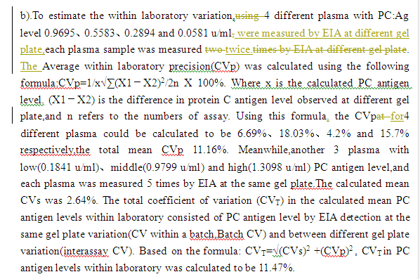
c).Influence of PC antigen level in electrophoresis buffer with or without EDTA
To determine whether electrophoresis buffer with or without EDTA could influence the peak height of PC antigen assay,pooled normal plasma was a dilution of 1:1、1:2、1:4 and 1:8, no significant difference in results obtained by EIA in the presence of EDTA-laurell method or without EDTA from the electrophoresis buffer(p>0.5).
When normal plasma was kept at 56℃ for 24、12、6、2.5、1 hour and 30 minutes respectively, no rocket-like immunoprecipitate was seen,which indicated that plasma protein C antigen could be destroyed at 56℃ for 30 minutes. After plasma frozen at 4℃ for 1、3、6、9、12 and 17 days,by using EIA assay,protein C antigen level could be measured at 1.0405、0.9779、1.0560、0.7008、0.8774 and 0.8950 u/ml. The results suggested no significant decrease of protein C antigen when stored at 4℃ refrigerator for one week.

d).Linear correlation and regression coefficient analysis
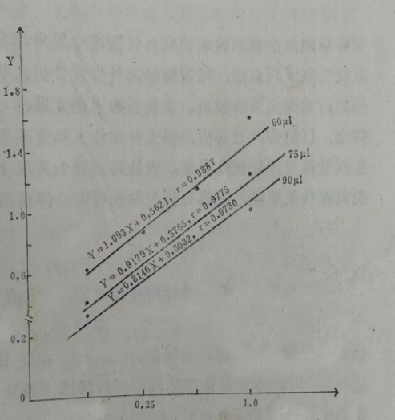
In this study,protein C antigen concentration was measured according to Laurell's rocket immunoelectrophoresis,and further Prof. Bertina's modification. Electroimmunoassay (EIA) or rocket immunoelectrophoresis is a rapid and producible method for identification and quantitation of even minor amounts of proteins. When electrophoresis of an antigen leave the wells and enter the agarose gel containing the corresponding antibody, and eventually the antigen-antibody complex precipates. In particular, a 'rocket-like' shape is seen. The majority of the antibody-antigen precipitate is indeed at the head of the rocket. More detail protocol,when 3 various concentration of PC:Ag antibodies (60ul,75ul,90ul) were mixed with 12.5 ml of 1% indubiose A-37 agarose solution in a gel plate,consequently,pooled diluted normal plasma was applied for EIA. Three linear regression equation regarding protein C antigen could be drawn (figure 2 ),and no statistical difference in results was obtained by comparative analysis of linear regression between each other, respectively(p>0.05). According to Prof. RM Bertina experience and our laboratory condition,an addition of 60ul amounts of rabbit protein C antiserum was better available in preparation of antibody-containing agarose gels. The head of the rocket is clear,higher peak,save the amounts of antibodies and easy to be measured by a ruler. It has been found that a good correlation between the peak height and protein C antigen level. After a consective 18 assays,the linear regression equation: Y=1.093X + 0.5621, r=0.9881 (see figure 2).
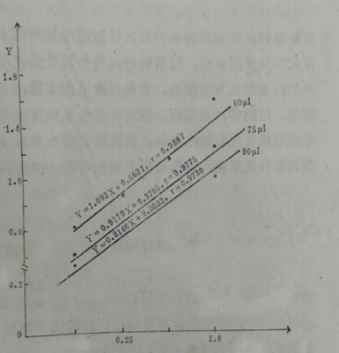

Peak height
(cm)

protein C concentration(u/ml)

Figure 2.The linear regression equation between the peak height and
protein C antigen concentration at various dilution of rabbit PC antiserum.

3).Protein C antigen in distinct diseases
Diabetes Mellitus(DM)
In a group of 22 patients with diabetes mellitus(DM) an average value of protein C antigen was 1.4238 u/ml,which is considerably higher than the average value in health individuals(1.0578 u/ml). Among them,8 DM the protein C antigen level was over 1.4752 u/ml. The increased plasma protein C antigen was in turn diabetic ketoacidosis(DKA)(n=4,1.5361 u/ml,range 1.3516～1.8434 u/ml)、diabetic angiopathy(n=5, 1.4551 u/ml,range 1.1888～2.0894 u/ml)、DM without vascular complication(n =9, 1.4403 u/ml,range 1.0834～1.8926 u/ml) and diabetic ketosis (n=4, 1.2352 u/ml,range 1.1955～1.2663 u/ml). Plasma PC:Ag level was positively correlation with urine glucose level(r=0.9581,p<0.001).

Pregnancy-Induced Hypertension Syndrome(PIHS)
In 15 pregnancy-induced hypertension syndrome(PIHS),10 severe preeclampsia the was significant increase of protein C antigen(PC:Ag) value(1.4673 u/ml,range 0.7781 ～2.2525 u/ml), 2 moderate PIHS the PC:Ag was normal limit range(0.7787,0.9481 u/ml respectively),whereas 3 mild patients with PIHS had decreased plasma PC:Ag level(0.5603 u/ml). Intriguing,repeat PC:Ag level was recovered to normal value (1.1455 u/ml) in one mild patient with PIHS after partum. Plasma protein C antigen was positively correlation with urine protein(r=0.9518,p<0.001).

Uremia
In a group of 10 uremia there were no significant changes of protein C antigen concentration when compared to normal controls(1.1387 vs 1.0578 u/ml,p>0.2)

Thrombotic diathesis
To screening congenital protein C deficiency, we detected 6 patients with cerebral haemorrhagic infarction and 3 deep venous thrombosis,no PC deficiency was found in this study.

Liver cirrhosis
19 patients with liver cirrhosis included viral liver cirrhosis 14 cases and other 1 primary biliary cirrhosis,1 scistosomal cirrhosis,1 alcoholic liver cirrhosis and 1 primary hepatocellular carcinoma, respectively. The average value of protein C antigen was 0.5501 u/ml(range:0.1436～0.9291u/ ml),which was significant lower than the average normal controls(1.0578 u/ml). Moreover, 13(68.4%) liver cirrhosis the protein C antigen was below the lower limit of normal control (range:0.1436～0.6188 u/ml). 14 patients with viral liver cirrhosis the protein C antigen was 0.5068 U/ml. Three severe liver cirrhosis had its the lowest value of protein C antigen 0.1436、0.1846 and 0.1919 u/ml respectively. The PC:Ag level was 1.0883 u/ml in one liver cirrhosis complicated with diabetes mellitus. Plasma PC:Ag level was positively serum albumin value(r= 0.9680, p<0.05).

Leukemias
In 20 acute leukemias,there was slightly decreased in protein C antigen level(0.9340 vs 1.0578 u/ml),but no statistical difference was found between acute leukemia and normal controls. When further analysis of acute leukemia with different cytological subtypes morphology according to FAB classification,it was shown that there was remarkably decrease of PC:Ag(0.8879 u/ml,p<0.05) in 5 M5 subtype. The decreased PC:Ag level(0.7833 u/ml) was also found in 9 hyper-leukocytes acute leukemias(WBC 23.6～280 x109/l). Intriguing, there were no significant difference in terms of protein C antigen between 3 acute promyelocytic leukemia(APL) with DIC,whereas 2 patients with infectious DIC(1 nodular panniculitis and 1 septic shock) the average value of protein C antigen was 0.2328 and 0.1646 u/ml respectively.

Protein C deficiency plasma
1 vial protein C deficient plasma which provided by RM. Bertina was measured the protein C antigen < 0.01%.
Table 3. Experimental data of plasma PC:Ag determination in patients and normal healthy subjects
Groups No Mean±SD (U/ml) Range(U/ml) P
DM 22 1.4238±0.2556 1.0834～1.8434 ＜0.001
PIHS 15 1.2054±0.4930 0.5163～2.2525 ＜0.05
Uremia 10 1.1387±0.2512 0.7787～1.5507 0.2＜P＜0.5
Thrombotic diathesis 9 1.1166±0.2699 0.7637～1.6893 0.2＜P＜0.5
Acute leukemias 20 0.9349±0.3388 0.3971～1.9220 ＞0.05
DIC: APL 3 0.8707,1.0019,1.2445
Infectious diseases* 2 0.2328,0.1646
Liver cirrhosis 19 0.5501±0.2536 0.1436～1.0883 ＜0.001
Viral liver cirrhosis 14 0.5068±0.2514 0.1436～0.9291
PC deficiency 1 <0.01
Healthy individuals 50 1.0578±0.1886 0.6439～1.4752
Note: DM:diabetes mellitus PIHS: Pregnancy-induced hypertension syndrome
*including 1 nodular panniculitis and 1 septic shock

Discussion
This underlines the need for each laboratory to construct its own reference values for PC antigen in the laboratory determination of different methods(5,21). We set up successfully the electroimmunoassay(EIA) of the protein C antigen with the laurell method. Based on our laboratory condition,the mean PC:Ag level in 50 healthy individuals was 1.0578±0.1886 u/ml, which was slightly higher PC antigen levels than that of Bertina's results.

To evaluate the performance and specificity of PC:Ag assays(5,21),the ICTH subcommittee on protein C organized an international collaborative study in which 13 lymphilized plasma samples were distributed among 17 different laboratories. Three main types of methods has been used: ELISA's using polyclonal anti-protein C IgG(n=9),electro- immunoassays(n=10) and other methods (three laboratories used monoclonal antibodies against protein C,one laboratory performed a RIA with affinity purified polyclonal antibodies against protein C and one laboratory used an immunoradio- metric assay of protein C antigen). No satistically significanct results were obtained with different methods. ELISA,RIA and IRMA methods were found to be more sensitive than the electro-immunoassay(EIA). The mean coefficient of variation(CV) for protein C antigen in various plasma was calculated to be 22%,with the contribution of within laboratory variation 11.7% and between laboratory variation 17.8%. In this study, the mean CV in the construction of standard curve for protein C antigen was 12.45%, with CV within laboratory 11.47%. The results indicated that the protein C antigen measurement was specific,practice and available in clinical useful.

The measurement of plasma PC:Ag has become relevant in clinical medicine since the demonstration that hereditary protein C deficiency is associated with a history of recurrent venous thrombosis(22). PC is also low in a number of acquired condition such as during the postoperative and neonatal periods(23),DIC(21,23,24),liver disease(21,23-25) and oral anticoagulant treatment(eg. warfarin)(4,17,26). Elevated PC levels,on the other hand,have been detected in a number of unrelated condition,such as ischemic heart disease(27),diabetes(27),late pregnancy(27) and in women taking oral contraceptive with a high estrogen content(28).

Type 2 Diabetes mellitus is characterized by vascular complication with accelerated micro and macro vascular thrombotic disease. A hypercoagulable state is appreciated in this disease. In this study,PC:Ag levels of patients especially in ketoaccidosis and diabetic angiopathy were significant higher than that of the control group(P<0.001). The results were consistent with the reports by Vigno(27) Takahashi(30),Saito(31),and Garcia(32). Moreover, evaluation of protein C and protein S levels in patients with DM receiving well- managed T2DM(type 2 DM) had significantly higher levels and activity of PC(5.78 vs 4.64 ug/ml),PS and ATIII compared to those that were poorly- managed (33). The decreased PC antigen was observed in type I diabetes mellitus(34,35). This may reflect the possibility that diabetic ketoacidosis (or angiopathy) and hypercoagulate may cause endothelial injury,which lead to elevated levels of thrombomodulin(TM) and compensatory increase the PC synthesis by hepatocytes.

Patients with the nephrotic syndrome and uremia are at increased risk of developing renal venous and arterial thromboembolism. In the measurement of PC:Ag levels in 10 uremia,there was no significant difference compared to normal controls. Cosio (36) measured the plasma concentration of protein C in 17 patients with severe proteinuria, the results was not significantly difference between the healthy subjects and 14 patients with chronic renal insufficiency(CRI). But protein C was elevated in 71% of patients with proteinura,and was inversely correlated with serum albumin concentrations. Demaschell(37) found that PC functional activity and the antigen level were normal in 30 uremic patients before dialysis.

Our data are consistent with the previous observation. In current study,PC:Ag levels in 19 various of liver cirrhosis were significant lower than those in healthy individuals (0.5501 vs 1.0578 u/ml,p< 0.001). 68.4% of liver cirrhosis had PC:Ag level below the lower limit of normal controls. Moreover,plasma PC:Ag level was positively correlation with serum albumin. In earlier studies, Griffin(24) reported the observation that eleven of 15 patients with clinically severe liver disease (9 with positive FDP,6 with negative FDP) has decreased plasma protein C levels. Mannucci(21,23) also found that in 58 chronic liver diseases protein C levels were lower than 60 healthy subjects, the decreased degrees roughly proportional to the severity of the disease. These findings indicated that protein C deficiencies occur the dysregulation of hepatic PC synthesis,and might play a role of predictor index in liver diseases(38).

Acute leukemias varied in PC antigen level. In current study,mean PC antigens in 20 acute leukemias were slightly lower than that of the normal individuals. Among FAB subtypes,the decreased PC:Ag concentration were found in those with M5 subtype and hyperleukocytic acute leukemias. Moreover,the PC:Ag had no lower in a limited 3 patients with APL complicated by DIC,which suggested the coagulopathy in APL might be due to mechanisms different from other forms of DIC such as infectious disease(eg.septic shock)(39,40). The results was similar to previous studies by Griffin etal(24) and Rodeghiero etal(25).

In clinics, two types of hereditary protein C deficiency can be recognized(4,22). In patients with type I protein C deficiency,the plasma concentration of protein C activity and/or protein C antigen will be below the lower limit of the normal range,while the ratio between protein C activity and protein C antigen is still within the normal range. A type I protein C deficiency inherits as an autosomal dominant trait. In type II protein C deficiency,the patients protein C antigen will be within the normal range,while the protein C activity and the ratio between protein C activity and protein C antigen are below the lower limit of the normal range. In both types of protein C deficiency the plasma concentration of the other vitamin K dependent coagulation factors should be within normal range. The presence of 1 vial PC deficiency plasma which was provided by RM Bertina was the lower than 0.01 u/ml,and which was consisted with the criteria of type I severe protein C deficincy(41-45). In Dutch family,more than 80 patients from 30 unrelated families have been identified with a type I protein C deficiency. Individual protein C values may vary between 0.30 and 0.76 u/ml(4,22). Up to now,only five patients with a type II protein C deficiency have been reported(22). It seems likely the main prevalence of clinical type I protein C deficiency. Like protein C deficiency,familial protein S deficiency is also reported(46-49). At present,some case reports and case series suggest that protein C concentrates may improve the outcome in patients with congenital or acquired protein C deficiency(45,50-52). The use of protein C concentrates in adult septic shock(53－55) is also testable.

Acknowlegements
This work was completed during the previous period of Master degree of medicine. The author greatly thanks for the kind assistance of my supervisor Prof. RM Bertina, University Hospital Leiden, The Netherlands.
Conclusion

References
1.Stenflo J. A new vitamin K-dependent protein. Purification from bovine plasma and preliminary characterization. J Biol Chem,1976,251:355－363
2.Kisiel W. Human plasma protein C. Isolation,characterization,and mechanism of activation by a-thrombin. J Clin Invest,1979,64:761－769
3.Broekmans AW and Bertina RM. Protein C. In: L. Poller,ed., Recent advances in blood coagulation,number four. Churchill Livingstone,Edinburgh,1985,pp.117－137
4.Bertina RM,Broekmans AW,van der Linden LK,etal. Protein C deficiency in a Dutch family with thrombotic disease. Thrombosis and Haemostasis,1982,48:1－5
5.Bertina RM. An international collaborative study on the performance of protein C antigen assays. Report of the ICTH subcommittee on protein C. Thromb Haemost,1987,57(1):112－117
6.O'Bryan JP,Frye RA,Cogswell PC,etal. axl,a transforming gene isolated from primary human myeloid leukemia cells,encodes a novel receptor tyrosine kinase. Molecular and Cellular Biology,1991,11(10):5016－31
7.Nuzzo S,Catuogno S,Capuozzo M,etal.Axl-targeted delivery of the oncosuppressor miR-137 in non-small-cell lung cancer. Molecular Therapy:Nucleic Acids,2019,17:
256－263
8.Lingev RMA,Keating AK,Earp HS,etal. TAM receptor tyrosine kinases:biologic functions,signaling,and potential therapeutic targeting in human cancer. Adv Cancer Res,2008,100:35－83
9.Burstyn-Cohen T,Heeb MJ and Lemke G. Lack of protein S in mice causes embryonic lethal coagulopathy and vascular dysgenesis. J Clin Invest,2009,119: 2942－
10.Wimmel A,Rohner I,Ramaswamy A,etal. Synthesis and secretion of the anti- coagulant protein S and coexpression of the Tyro3 receptor in human lung carcinoma cells. Cancer,1999,86:43－9
11.Abboud-Jarrous G,Priya S,Mairnon A,etal. Protein S drives oral squamous cell carcinoma tumorigenicity through regulation of Axl. Oncotarget,2017,8(8):13986－14002
12.Brand TM,Iida M,Stein AP,etal. Axl is a logical molecular target in head and neck squamous cell carcinoma. Clin Cancer Res,2015,21(11)2601－12
13.Lee N,Jang WJ,Seo JH,etal. 2－Deoxy-D-glucose-induced metabolic alteration in human oral sequamous SCC15 cells: involvement of N-glycosylation of Axl and Met. Metabolites,2019,9:188
14.Wilmes S,Hafer M,Vuorio J,etal. Mechanism of homodimeric cytokine receptor activation and dysregulation by oncogenic mutations. Science,2020,367:643－652
15.Zhu G,Saboor-Yaraghi AA,Yarden Y,Santos J,and Neil JC. Downregulating oncogenic receptor:from bench to clinic. Hematol Med Oncol,2016,1(1):30－40
16.Song XZ,Akasaka H,Wang HM,etal. Hematopoietic progenitor kinase 1 down- regulates the oncogenic receptor tyrosine kinase Axl in pancreatic cancer. Journal of Biological Chemistry(jbc),2020,29
17.Griffin JH,Evatt B,Zimmerman TS,etal. Deficiency of protein C in congenital thrombotic disease. J Clin Invest,1981,68:1370－1373
18.Broekmans AW,Veltkamp JJ and Bertina RM. Congenital protein C deficiency and venous thrombo-embolism A study in three Dutch families. N Eng J Med,1983,309: 340－344
19.Wintzen AR,Broekmans AW,Bertina RM,etal. Cerebral hemorrhagic infarction in young patients with hereditary protein C deficiency. British Medical Journal,1985, 290:350－352
20.Zhu YJ,Li JX. Plasma concentration of the natural anti-coagulants protein C and antithrombin III in leukemia(abstract). Thromb Haemost,1989,62(suppl, XII ISTH meeting,Tokyo,Japan):391
21.Mannucci PM,Boyer C,Tripodi A,etal. Multicenter comparison of five functional and two immunological assays for protein C. Thromb Haemost,1987,57(1):44－48
22.Broekmans AW. Hereditary protein C deficiency. Haemostasis,1985,15:233
23.Mannucci PM,etal. Deficiencies of protein C. an inhibitor of blood coagulation. Lancet,1982,2:463-7
24.Griffin JH,Mosher DF,Zimmerman TS,etal:Protein C,an antithrombotic protein,is reduced in hospitalized patients deficiencies of protein C,an inhibitor of blood coagulation. Blood,1982,60(1):261－264
25.Rodeghiero F,etal. Liver dysfunction rather than intravascular coagulation as the main cause of low protein C and antithrombin III in acute leukemia. Blood,1984, 63: 965
26.Vigano S,Mannucci PM,Solinas S,etal. Decrease in protein C antigen and formation of an abnormal protein soon after starting oral anticoagulant therapy. Br J Hematol,1984,57:213－20
27.Vigano S,Mannucci PM,D'Angelo A,etal. Protein C antigen is not an acute phase reactant and is often high in ischemic heart disease and diabetes. Thromb Haemost, 1984,52:263－6
28.Mannucci PM,Vigano S,Bottasso B,etal. Protein C antigen during pregnancy, delivery and puerperium. Thromb Hemost,1984,52:217
29.Meade TW,Stirling Y,Wilkes H,Mannucci PM. Effects of oral contraceptives and obesity on protein C antigen. Thromb Hemostas,1985,53:198－9
30.Takahashi H,Tatewaki W,Shibata A,etal. Plasma protein S in disseminated intravascular coagulation,liver disease,collagen disease,diabetes mellitus,and under oral anticoagulant therapy. Clinica Chimica Acta,1989,182(2):195－208.
31.Saito M,Kumabashivi l,Jokaji H,etal. The levels of protein C and protein S in plasma in patients with type II diabetes mellitus. Thromb Res,1988,52:479－486
32.Aslan B,Eren N,Cigerli S,etal. Evaluation of plasma protein C antigen,protein C activity and thrombomodulin levels in type 2 DM. Turkish Journal of Medical Sciences,
2005,15:305－310
33.Otchere Addai-Mensah,Max Eful Annani-akollor,Linda Ahenkorah Fondjo,etal. Effect of poor glycaemic control on plasma levels and activity of protein C,protein S,and antithrombin III in type 2 diabetes mellitus. Plos one,2019,14(9):e0223171
34.Ceriello A,Quatraro A,Dello Russo P,etal: Protein C deficiency in insulin dependent diabetes:A hyperglycemia-related phenomenon. Thromb Haemost,1990,64:104－7
35.Koert M,Nowak-Gottl U,Kreuz W,etal. 15 parameters of coagulation and fibrino- lysis in children with type I diabetes mellitus. Klin Padiatr,1991,203:429－32
36.Cosio FG,etal. Plasma concentrations of the natural anti-coagulants protein C and protein S in patients with proteinuria. J Lab Clin Invest,1985,106:218
37.Demichell M,Contino L,Aldo Ortensia,etal. Protein C and protein S levels in uremic patients before and after dialysis. Thromb Res,1993,68(6):451－7
38.Abo-Elenein AM,Mabrouk MM,Abou-Saif S,etal. Role of both protein C and antithrombin III as predictors of stage of liver disease in chronic viral hepatitis B or C infected patients. Endocrine,Metabolic & Immune Disorders- Drug Targets,2020, 20(1):112－117
39.Leclerc F,Hazelzet J,Jude B,etal. Protein C and S deficiency in severe infectious purpura of children: a collaborative study of 40 cases. Intensive Care Med,1992,18(4): 202－5
40.Fourrier F,Chopin C,Goudemand J,etal. Septic shock,multiple organ failure,and disseminated intravascular coagulation. Compared patterns of antithrombin III,protein C,and protein S deficiencies. Chest,1992,101(3):816－23
41.Seligsohn U,Berger A,Abend M,etal. Homozygous protein C deficiency manifested by massive venous thrombosis in the newborn. N Eng J Med,1984,310:559－562
42.Estelles A,Garcia-Plaza I,Dasi A,etal. Severe inherited "homozygous" protein C deficiency in a newborn infant. Throm Haemost,1984,52:53－56
43.Sills RH,Marlar RA,Montgomery RR,etal. Severe homozygous protein C deficiency. J Pediat,1984,105:409－413
44.Marciniak E,Wilson HD,Marlar RA. Neonatal purpura fulminans: a genetic disorder related to the absence of protein C in blood. Blood,1985,65:15－20
45.Dreyfus M,Magny JF,Bridey F,Schwarz HP. Treatment of homozygous protein C deficiency and neonatal purpura fulminans with a purified protein C concentrate. N Engl J Med,1991,325:1565－1568.
46.Comp PC,Nixon RR,Cooper MR,Esmon CT. Familial protein S deficiency is assiciated with recurrent thrombosis. J Clin Invest,1984,74:1082－88
47.Schwarz HP,Fischer M,Griffin JH,etal. Plasma protein S deficiency in familial thrombotic disease. Blood,1984,64:1297－1300
48.Broekmans AW,Bertina RM,Reinalda-Poot J,etal. Hereditary protein S deficiency and venous thromboembolism. A study in three Dutch families. Thromb Haemost, 1985,273－277
49.Shen MC,Lin JS,Tsay W. Protein C and protein S deficiencies are the most important risk factors associated with thrombosis in Chinese venous thrombophilic patients in Taiwan. Thromb Res,2000,99(5):447－52
50.Kroiss S,Albisetti M. Use of human protein C concentrates in the treatment of patients with severe congenital protein C deficiency. Biologic Targets & Therapy, 2010,4:51－60
51.Sanz-Rodriguez C,Gil-Fernandez JJ,Zapater P,etal. Long-term management of
homozygous protein C deficiency:replacement therapy with subcutaneous purified protein C concentrate. Thromb Haemost,1999,81(6):887－90
52.de Kort EHM,Vrancken SLAG,Van Heijst AFJ,etal. Long-term subcutaneous protein C replacement in neonatal severe protein C deficiency. Pediatrics,2011,127 (5):e1338－42
53.Crivellari M,Marino G,Belloni S,etal.Administration of human protein C concentrates in patients with double organ failure and severe sepsis after cardiac surgery. Minerva Anestesiologica,2008,74:48－49
54.Landoni G,Monti G,Facchini A,etal. Human protein C concentrate in pediatric septic patients. Signa Vitae,2010,5(1):13－19
55.Veldman A,Fischer D,Wang FY,etal. Human protein C concentrate in the treatment of purpura fulminans: a retrospective analysis of safety and outcome in 94 pediatric patients. Critical Care,2010,14:R156

