**Reviewer’s Comments**

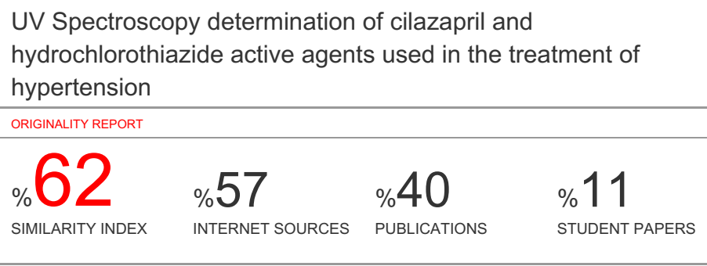

**UV Spectroscopy determination of cilazapril and hydrochlorothiazide active agents used in the treatment of hypertension**

**Abstract**

*In this study, various mixtures of silazapril?????? and hydrochlorothiazide were prepared, the matrix effect was formed in the drug and the determination of these active substances in the drug samples after optimum conditions were determined.In the spectrophotometric method, 100 mgL−1 solutions were prepared ofcilazapril and hydrochlorothiazide in methanol + 0.1 m HCL solvent and then mixtures of these solutions were prepared between specific ppm. The absorbance's of the solvent against the blind were read at 0,1 nm intervals. After the mixture, tablet (drug) sample was prepared and chemometrics methods were applied to the values obtained by saving the absorbance values.*

Key words:Principal component analysis, Cilazapril, Hydrochlorothiazide

**1. Introduction**

The systematic name of the silazapril (SİL) closed formula is C22H31N3O5 (1S, 9S) -9 - {[(2S) -1-ethoxy-1-oxo-4-phenylbutan-2-yl] amino} -10-oxo-octahydro 1 H-pyridazino [1,2-a] [1,2] diazepine-1-carboxylic acid is given in Figure 1 as the open formula, and is an angiotensin converting enzyme (ACE) inhibitor class (Thiol and sulfhydryl group) drug free. Silazapril is a drug used in the treatment of hypertension and heart failure1. Hydrochlorothiazide (HCT) is a white powder with a closed formula C7H8ClN3O4S2 and its systematic name is 6-chloro-3,4-dihydro-2H-1,2,4-benzothiadiazine-7-sulfonamide 1,1 dioxide, which leads to fluid retention in the body. It is a diuretic that helps to prevent the absorption of excess salt by the body. Hydrochlorothiazide is among the thiazide group diuretics. Figure 1 shows the open formula.

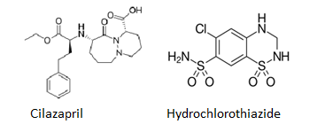

Figure 1. Structures of the studied compounds

Drug active substances tend to accumulate in human vital organs, which are generally toxic, non-spontaneous in nature, and which can move gradually throughout the food chain for a long period of time. Studies on the determination of active substances in drug samples are of increasing interest. In recent years, the scope of monitoring and determination of these active substances has been increasing.

In this study, various mixtures of cilazapril and hydrochlorothiazide were prepared and matrix effect was formed in the drug and optimum conditions were determined. These optimum conditions were then used in the determination of the drug samples of these active substances.

In pharmaceutical formulations, the combination of silazapril and hydrochlorothiazide is commonly given to patients as an antihypertensive and diuretic agent. On the other hand, these drugs are becoming important for quality control in commercial pharmaceutical tablets2. In recent years, chemometric calibration techniques, linear regression (MLR) (classical least squares, CLS and inverse least squares, ILS), main component regression (PCR), partial least regression (PLS) and neural network (Ann) have a wide range of applications of these techniques3,6. Several researchers have used these techniques simultaneously for binary analysis and a triple mix. Several analytical procedures have been described for concurrent determination of hydrochlorothiazide, benazepril hydrochloride, Triamterene and cilazapril in mixtures with other drugs, including spectrophotometry 7,9.

The multivariate calibration techniques use full spectrum, full automation, multivariate data analysis and the reduction of noise and the advantages of the selection calibration model. In addition, these multivariate calibrations do not need any separation procedure, they are very cheap, very easy to apply and very sensitive. For these reasons, these multivariatetechniques are popular today.

In this study powerful chemometricmethod was applied to analyses the synthetic mixtures and tablets consisting of SIL and HCT in the presence of interferences of the absorption spectra. The application of chemometrics allows the interpretation of multivariate data and is vital to the success of the simultaneous determination of the clinical drugs.

**2. Materials and Methods**

A Shimadzu UV-1700 UV-Visible spectrometer, connected to PS with UV Probe Software was used for all the measurements and data processing. A pair of 1.0 cm quartz cells was used for absorbance measurements. PCR method was implemented with the "Minitab 16" software package.

Stock solution 100 mg/100 mL hydrochlorothiazide and cilazapril in methanol were used to set up the calibration set samples. A concentration set of 15 mixture solutions consisting of cilazapril and hydrochlorothiazide in the concentration range of 0.2 - 1.0 and 2.0 – 10.0 μg/mL for hydrochlorothiazide and cilazaprilin the methanol solventwas symmetrically prepared from the prepared stock solutions respectively. The reason for symmetric set of calibration is to minimize errors in calibration that may occur during analysis. To test the application of the chemometric method, we used an independent verification set consisting of silazapril and hydrochlorothiazide synthetic blend solutions at the above working concentration intervals.

**3. Results and Discussions**

3.1. Chemometric method>>>>>move to method

PCR is a factor analysis multivariate statistical tools which have many of the full spectrum advantages and have been successfully applied to spectrophotometric analyses of multicomponent mixtures. PCR needs a calibration step where themodels for the spectra and the component concentrations of the unknown are estimated from the sample spectrum. Both of these methods involve spectral decomposition. The PCR decomposition is based entirely on spectral variations without regard for the component concentrations. The optimal of calibration method depend on the particular experimental conditions.

3.2. Method development>>>>move to Method

The overlapping spectra of cilazapril and hydrochlorothiazide at the range of 200-350 nm are shown in Fig. 1. Spectrum demonstrates that the classical approach will not allow compounds to be assigned simultaneously. For this reason, we are focusing on applying chemometric methods to binary mixtures of cilazapril and hydrochlorothiazide.

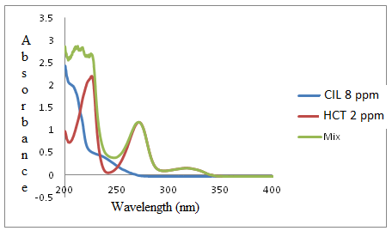

Figure 1. CIL, HCT and their mixtures in methanol.

3.3. Chemometric parameters>>>>move to Method

The application competence of a calibration model can be explained in several ways. These results can be examined numerically. One of the best ways to do this, by examining the predicted residual error sum of squares (PRESS). To calculate PRESS computed the errors between the expected and predicted values for all the samples, square them and sum them together.

PRESS = $\sum_{i=1}^{n}{(C_{i}^{added}-C_{i}^{found})^{2}}$

Strikingly speaking, this is not a correct way to normalize the PRESS values when not all of the data sets contain the same number of samples. If want correctly compare PRESS values for data sets that contain differing numbers of samples, should convert to standard error of prediction (SEP), which is given by following formula.

SEP = $\sqrt{\frac{\sum_{i}^{n}{(C_{i}^{added}-C_{i}^{found})^{2}}}{n-1}}$

where $C_{i}^{added}$ concentration of drug is, $C_{i}^{found}$ is thefound concentration of analyte and n is the total number of the synthetic mixtures. The SEP can provide a good measure of how well, on average, the calibration model performs. Often, however, the performance of the calibration model varies depending on the analyte level. All these values are calculated and shown in Table 1 for the study done. Again, in the same table, cilazapril and hydrochlorothiazide in the running mixtures are shown in the parameters between actual and estimated concentration values.

Table 1. Statistical parameters for PCR

|  |  |  |  |
| --- | --- | --- | --- |
| PCR | | | |
| Step | Parameter | CIL | HCT |
| Calibration | SEC | - | - |
|  | PRESS | 0.0658 | 0.0458 |
|  | Slope | 1.0000 | 0.9999 |
|  | Intercept | 0.0118 | 0.0220 |
|  | r | 0.9999 | 0.9999 |
| Prediction |  |  |  |
|  | Slope | 0.9952 | 0.9692 |
|  | Intercept | 0.0124 | 0.0382 |
|  | r | 0.9999 | 0.9999 |

3.4. Method validation

The accuracy of the applied chemometric method was determined by the performance of the reliable results obtained from the analyzes performed. For this reason, 15 synthetic mixtures containing cilazapril and hydrochlorothiazide were prepared at different concentrations. Recovery scales and relative standard deviations from this set are shown in Table 2. As can be seen from Table 2, the numerical values obtained for the applied chemometric methods are very suitable. Both compounds gave high accuracy and precise results. No interference or systematic faults were found during the analysis process.

Table 2. Recovery values for the applied chemometric method

|  |  |  |  |
| --- | --- | --- | --- |
| Mixtures added (μg/mL) Recovery (%) | | | |
| CIL | HCT | CIL | HCT |
| 2.0 | 0.2 | 99.98 | 99.86 |
| 4.0 | 0.4 | 99.86 | 100.04 |
| 6.0 | 0.6 | 100.02 | 100.00 |
| 8.0 | 0.8 | 100.08 | 100.14 |
| 10.0 | 1.0 | 100.00 | 100.08 |
| 5.0 | 0.2 | 100.04 | 100.04 |
| 5.0 | 0.4 | 99.68 | 99.96 |
| 5.0 | 0.6 | 100.12 | 100.02 |
| 5.0 | 0.8 | 100.10 | 99.88 |
| 5.0 | 1.0 | 99.98 | 100.06 |
| 2.0 | 0.5 | 100.02 | 100.04 |
| 4.0 | 0.5 | 100.00 | 100.02 |
| 6.0 | 0.5 | 100.04 | 100.00 |
| 8.0 | 0.5 | 99.98 | 99.98 |
| 10.0  Mean  RSDa | 0.5 | 100.02  99.99  0.1062 | 100.00  100.01  0.0708 |

RSDa : Relative Standard Deviation

**4. Conclusion**

A powerful chemometric technique in spectrometric analysis, PCR, was proposed for the simultaneous determination of CIL and HCT in their binarymixtures. These techniqueswere applied with great success to pharmaceutical product. The resolution of highly overlapping drug mixtures was achieved by the use of PCR techniques.A selection ofworkingwavelength having high correlation values with concentration due to interferencecomingfrommatrix sample or additional analytes outside theworkingrange.The proposed chemometric techniques can be applied for the routine analysis of pharmaceutical formulationwithoutanya priori chemical separation andwithout time consuming.

Conflict of interest

**References**

1. Hutchison, T. A., Shahan, D. R.(Ed.),"DRUGDEXW System", Edition Electronic Version. MICROMEDEX, Greenwood Village, CO.2003.

2. Dinc¸ E., Baleanu, D., "Spectrophotometric quantitative determination of cilazapril and hydrochlorothiazide in tablets by chemometric methods", Journal of Pharmaceutical and Biomedical Analysis, 30, 715–723, 2002.

3. Aktaş, A. H., "Chemometric assisted for the simultaneous spectrophotometric determination of calcium and magnesiumin natural water", ChemXpress 9(2), 099-108, 2016.

4. Kramer, R., " Chemometric Techniques in Quantitative Analysis", Marcel Dekker, New York, 51-97, 1998

5. Adams,M. J., "Chemometrics in Analytical Spectroscopy", The Royal Society of Chemistry, Thomas, Graham House, Science Park, Cambridge, p. 187, 1995.

6. Martens, H., Naes, T.,"Multivariate Calibration", J. Wiley and Sons, Chichester, UK. 1991.

7. Erk, N., "Comparative study of the UV spectra derivative spectrophotometry derivative spectrophotometry and vierordt's method applied to the analysis of lisonopril and hydrochlorothiazide in tablets", Spectroscopy Letters, 31(3), 633-645, 1998.

8. Salem, H., Pharmaceutical Chemistry Department, Faculty of Pharmacy , Zagazig University , Zagazig, Egypt El-Maamli, M., El-Sadek, M., Kheir, A. A., "UV and UV Derivative Spectrophotometric Determination of Two- Component Mixtures", Spectroscopy Letters, 24(3), 451-470, 1991.

9. Erk,N., Onur, F., "Simultaneous Determination of Analgine and Paracetamol in Tablets by Spectrophotometric Methods", Analytical Letters, 30(6), 1201-1210, 1997.