Reviewer’s Comments
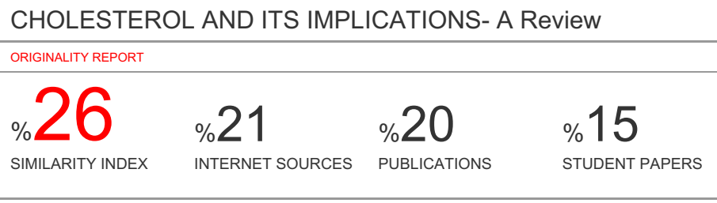
CHOLESTEROL AND ITS IMPLICATIONS- A Review
Abstract
Ambiguity associated with cholesterol portrays its significance and concern. Cholesterol is a steroid biomolecule of animal cells with a number of important functions in the body, including steroid hormone production, structural architecture of cell membranes, production of vitamin D, sources of bile salts and bile acids. Its sources include endogenous (de novo production by body’s tissues) and exogenous (dietary), contributing to cholesterol pool in the body. Cholesterol homeostasis is essentially regulated by the body. This chapter focuses on the following; basis of cholesterol, biological functions of cholesterol, structural description of cholesterol, Biosynthesis of cholesterol, cholesterol and its derivatives e.g bile acids, bile salts, steroid hormone, absorption and utilization of dietary cholesterol and current advancement in cholesterol management against risk factors. Hypercholesterolaemia is a major risk factor for cardiovascular diseases such as atherosclerosis, coronary heart diseases and stroke. Interventions for the management and prevention of Hypercholesterolaemia currently advocated include pharmaceuticals (drugs) and non pharmaceuticals, but more concern on non pharmacological therapeutic interventions such as the use of Medicinal Plants and herbs, Nutraceuticals, Diet and Exercises (lifestyle) and Functional and Mediterranean Foods. It is thus glaring that the disease linked implication of cholesterol can be prevented and managed using the appropriate interventions.

Keywords: Cholesterol, Animal fats, Life’s threat, Heart disease, Steroids, Diet, Cholesterol absorption, Nutraceuticals, Diet, Functional foods
1. Introduction: Basis of Cholesterol
Cholesterol is a sterol found only in animals. Its value is found to be 140g in an adult man of 70kg body weight (2g/kg body weight). Cholesterol constitutes a very small fraction of the total lipid and it is amphipathic because its structure has both hydrophilic and hydrophobic ends ¹. This structural endowment of cholesterol provides an enabling mechanism of transport along with proteins as lipoproteins or solubilized phospholipids and regulation after its biosynthesis. The cholesterol pool of the body arises from dietary sources, sources from extrahepatic tissues and from hepatic source. Cholesterol homeostasis in the body is critically maintained and regulated by the liver ². The liver removes cholesterol from the body by converting it into bile acids, bile salts and unesterified (free) form of cholesterol in bile into the intestine ³. Human tissues are laden with cholesterol deposition owing from imbalances of inflow and outflow of cholesterol, resulting in health challenges such as atheriosclerosis (plaque buildup from fat deposit in blood vessels, causing narrowing of blood vessels) and subsequent coronary artery diseases ⁴. Figure 1, shows various sources of cholesterol pool and tissues involved.
1.1 Biological Functions of Cholesterol
The essentiality of cholesterol to life is without alternative as it is known to perform some important functions summarized as follows ^{5, 6}.
- Cell membrane’s structural architecture: Cholesterol is a component of animal cell membrane structure. At physiological temperature ranges, cholesterol in animal cell membranes is actively involved cell membrane fluidity, build up and maintenance. It adjusts the fluidity of membranes by interacting with their complex lipid components of phosphatidylcholine and sphingomyelin.
- Precursor for Steroid Synthesis: Cholesterol serves as a major precursor for the biosynthesis of steroid hormones (aldosterone, adrenal gland, cortisol), vitamin D, bile salts and sex hormones (testosterone, progesterone, estrogen).
- Transport of Fatty Acids: Cholesterol aids the transport of fatty acids to the liver in the form of cholesteryl esters for fatty acids oxidation. After the ingestion of dietary cholesterol within seven hours, cholesterol enables the transport of absorbed fat round body’s tissues by lipoproteins’ extracellular medium ⁷.
- Transport of lipids: Essentially, cholesterol as a component of lipoprotein structure enables easy transport of lipids in the body.
- Signal Transduction: Cholesterol has been demonstrated and reported by several studies to be involved in cell signaling transduction and electrical insulators in complex with phospholipids as layers ⁸.

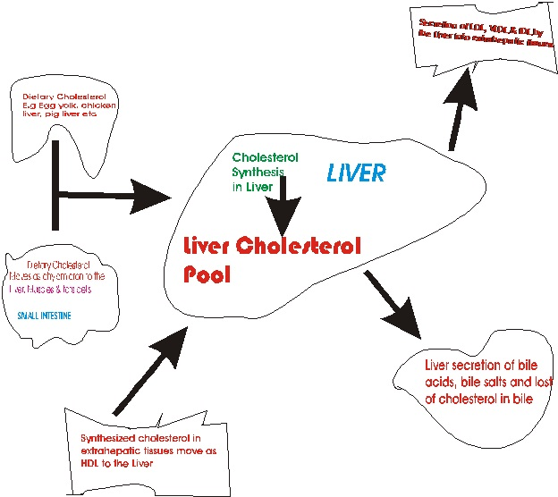
Figure 1: Outline of Sources of Cholesterol Pool in the body, routes of utilization and some tissues involved.

- Food Digestion and Absorption: Cholesterol is importantly involved in digestion of food. The excreted cholesterol by the liver as bile fluids (bile acids and bile salts) into the gall bladder breakdown fats by solubilizing them. This action allows molecules of fats and fats soluble vitamins (A, D, E and K) to be absorbed in the intestine ⁹.
1.2 Structural Description of Cholesterol
Cholesterol’s main structural frame work is a four fused hydrocarbon trans ring (A, B, C, D) skeleton of steroid nucleus as head and hydrocarbon branched tail. There are two methyl groups on carbons 18 and 19 of the fused ring, two methyl groups on the branched chain (on C-21 and C-27) and there is a double bond between carbons 5 and 6. It consists of a total of 27 carbon atoms, 46 hydrogen atoms and one oxygen atom. Its molecular formula is C₂₇H₄₅OH with a corresponding molar mass of 386g/mole. Thus, cholesterol has a tetracyclic cyclopenta [a] phenanthrene structure, giving an IUPAC-IUB nomenclature of cholest 18,19,21,27-tetra methyl-5-en-3-ol ¹⁰. It is an amphipathic compound with hydrophobic and hydrophilic portions [11]. Cholesterol as animal steroid is a very important sterol in animals because of the position (C-3) of the β-hydroxyl group. Thus, this structural arrangement of β-OH group on the steroid nucleus (hydrocarbon head) and the branched hydrocarbon tail in cholesterol makes animal sterols intestinal absorption faster than plant sterol ¹². Figure 4, shows structures of cholesterol and its derivatives.
2. Biosynthesis of cholesterol
Cholesterol is biologically synthesized by virtually all body tissues but the liver (about 50%), the intestine (about 15%), adrenal cortex, reproductive tissues and the skin contribute largely to the cholesterol pool of the body. In an adult human, cholesterol synthesis per day is close to 1g. The reaction is maintained by the supply of NADPH as the reducing equivalent and ATP as energy source. The carbon skeleton of cholesterol is supplied by acetate of acetyl CoA. Thus, the synthesis of I mole of cholesterol requires 16 moles of NADPH, 36 moles of ATP and 18 moles of acetyl CoA. The biosynthesis of cholesterol takes place mainly in the cytosol of the cell but makes use of enzymes both from the cytosol and the smooth endoplasmic reticulum ^{1, 12}.
2.1 Stages of Cholesterol Biosynthesis
The processes and enzymatic steps involved in the biosynthesis of cholesterol can be conveniently group into six stages for the purpose of comprehension. These are (1) Synthesis of 3-hydroxy-3-methylglutaryl (HMG) CoA also called β-hydroxy β-methylglutaryl CoA (HMG CoA) (2) Synthesis of Mevalonate (3) formation of Isoprenoid units (4) Production of Squalene (5) Synthesis of Lanosterol and (6) Conversion of Lanosterol to Cholesterol. Figure 2, present the enzyme pathway reaction involved in cholesterol synthesis.
- Synthesis of 3-hydroxy-3-methylglutaryl CoA (HMG CoA): The formation of this molecule requires the condensation of two moles of acetyl CoA to produce acetoacetyl CoA catalyzed by thiolase. Then another molecule of acetyl CoA is added for the formation of HMG CoA a six carbon compound, catalyzed by HMG CoA synthase. The pathway for the production of ketone bodies has similar reactions since they are both catalyzed by the isoenzyme HMG CoA synthase. However, since ketone bodies are synthesized in the mitochondria and cholesterol in the cytosol, the pathways are different, giving rise to two pools of HMG CoA in the living cell. Thus, for example, in the liver parenchymal cells, the HMG CoA synthase in the mitochondria participate in ketone bodies synthesis while the HMG CoA synthase in the cytosol participate in the synthesis of cholesterol ^{1, 12}.
- Production of Mevalonate: The formation mevalonate, a six carbon compound is from the reduction of HMG CoA by enzyme action of HMG CoA reductase, a rate limiting step in the synthesis of cholesterol. This reaction occurring in the cytosol is irreversible and is accomplished with the consumption of two NADPH molecules as reducing equivalent and a CoASH. HMG CoA reductase’ catalytic action is exercised in the cytosol but is an intrinsic membrane protein of the smooth endoplasmic reticulum ^{1, 12}.
- Formation of Isoprenoid compounds: All isoprenoid compounds are five carbon compounds. Mevalonate is converted to 3 – phospho – 5 – pyrophosphomevalonate by a three reaction steps catalyzed by kinases (mevalonate kinase, phosphomevalonate kinase and pyrophosphomevalonate kinase respectively). Unpon decarboxylation of 3 – phospho – 5 – pyrophosphomevalonate by pyrophosphomevalonate decarboxylase, an isoprenoid compound, isopentenyl pyrophosphate (IPP) is produced with a loss of CO₂. This later isomerizes by isopentenyl pyrophosphate isomerase to give another isoprenoid compound, dimethylallyl pyrophosphate (DPP) ^{1, 12}.
- Production of Squalene: The production of geranyl pyrophosphate (GPP), a 10 carbon atom is by the condensation of IPP and GPP and a fifteen carbon compound, farnesyl pyrophosphate (FPP) is synthesized when a molecule of IPP condenses with GPP both catalyzed by Cis prenyl transferase. Then squalene, a 30 - carbon compound is synthesized from the condensation of two molecules of FPP catalyzed by squalene synthase in the presence of Mg²⁺ and NADPH as reducing agent with a release of pyrophosphate (ppi). Farnesyl pyrophosphate is said to be involved in the synthesis of a number of isoprenoid compounds like dolichol, a glycoprotein component and ubiquinone, a coenzyme Q of electron transport chain ^{1, 12}.
- Synthesis of Lanosterol: Lanosterol is synthesized from squalene through hydroxylation by squalene monooxygenase, to produce oxidosqualene and ring cyclization by oxidosqualene cyclase in the presence of O₂ and NADPH as reducing equivalent ^{1, 12}.
- Conversion of Lanosterol to Cholesterol: The conversion of lanosterol to cholesterol involves a multistep enzymatic processes, which utilizes oxygen and NADPH to oxidize methyl groups which give rise to reduction of carbon atoms from 30 to 27 carbons and NADH for the reduction of ketone group, movement of double bond from carbon 8 to carbon 5 by mutases, removal of two methyl groups from carbon 4 and one methyl group from carbon 14 and double bond reduction between carbon 24 and carbon 25. The enzymes involved are connected with the smooth endoplasmic reticulum of the cell. From the conversion of lanosterol to cholesterol, some important intermediates are 14 – desmethyl lanosterol, zymosterol, desmosterol, cholestadienol and 7 – dehydrocholesterol, which finally produce cholesterol on reduction ^{1, 12}.
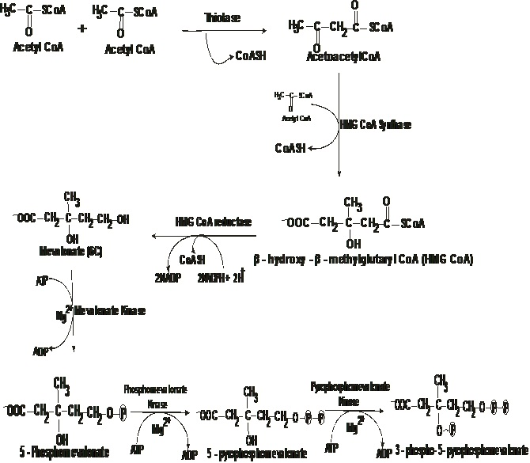

.

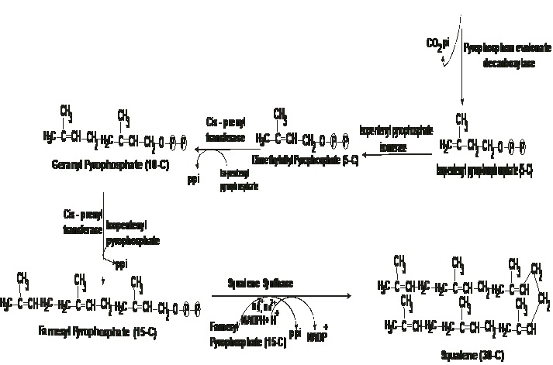
Figure 2: Pathway of Cholesterol Biosynthesis
2.2 Cholesterol and its Derivatives
Many other important steroid compounds are derived as degradation products of cholesterol such as Bile salts (e.g Taurochenodeoxycholic acid), bile acids (e.g Cholic acid), and steroid hormones, also it is a precursor for the following compounds; Cholesterol esters and vitamin D.
2.2.1 Cholesterol Ester
Cholesterol undergoes transformation in esterification process to produce esterified cholesterol known as cholesteryl ester, having fatty acid attached to C-3 and thereby increasing its hydrophobicity and insolubility in water in this form. Cholesterol ester bond is formed when the carboxylate group of fatty acid (acyl group), transferred from C-2 of lecithin (phosphatidyl choline) reacts with the hydroxyl group of cholesterol. This reaction is catalyzed by an esterase or transferase (E.g cholesterol esterase or Lecithin Cholesterol Acyltranferase –LCAT). Lecithin Cholesterol Acyltranferase is a plasma enzyme produced in the hepatic tissue. The end products are cholesterol ester and 1-acyl lysophosphatidyl choline. When the body needs cholesterol, cholesteryl esters are hydrolyzed and converted back to free cholesterol by the action of cholesterol esterase (figure 3), a pancreatic cholesteryl ester hydrolase, which in the presence of bile salts, hydrolysis the ester bond by addition of water and a subsequent release of free fatty acids ¹³.

Lecithin + Cholesterol Cholesteryl Ester + 1-acyl lysophosphatidyl Cholin
LCAT
LCAT
C₁₀H₁₈PO₈N⁺ + C₂₇H₄₅OH C₂₇H₄₄CO₂R + C₉H₁₉PO₈N⁺
Lecithin
Cholesterol
Cholesteryl Ester
1-acyl lysophosphatidyl Choline

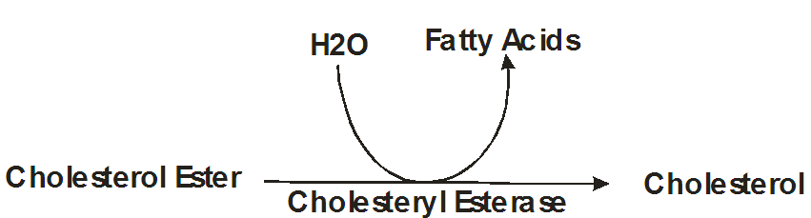
Figure 3: Production of free Cholesterol from Cholesteryl ester
Cholesteryl esters are reported to be found in a very small amount in most cells, possibly because the structural arrangement cannot easily transverse the cell membrane. They form a main part of the adrenal glands and are implicated in atherosclerotic plaques build up in the artery ¹⁴. The Lecithin Cholesterol Acyltranferase (LCAT) found in human is known to be a glycoprotein with a polypeptide of comparatively little mass of between 50 to 60kDa. This structural arrangement is as a result of a 4-N-glycosylation and 2-O-glycosylation building blocks. The liver is responsible for the major production of LCAT and it is reversibly bonded to high density lipoprotein via blood circulation. Activation of LCAT is possible by the major protein element of HDL called apolipoprotein A1, resulting in cholesterol esters build up in the nucleus of HDL for effective removal of cholesterol from the ester, cell membranes and into HDL. Due to the accumulation of cholesterol in HDL, the HDL molecule changes and turns to a sphere-shaped object ¹⁰.

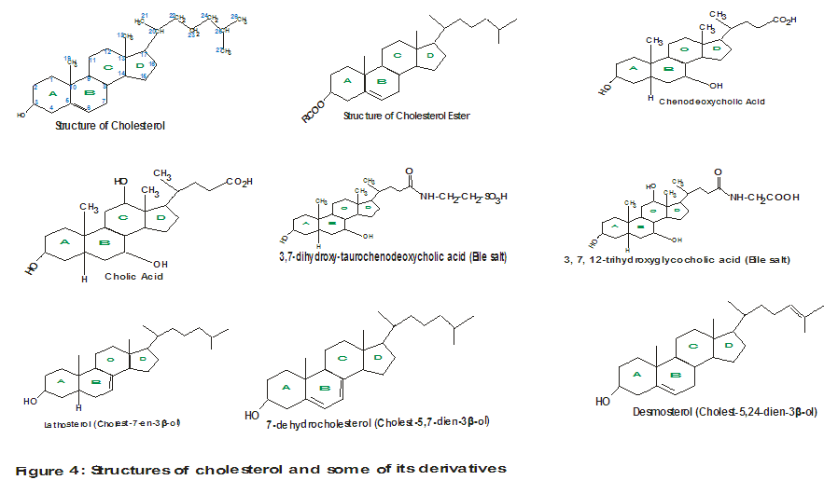
Cholesterol

The action of Lecithin Cholesterol Acyltranferase (LCAT) is paramount in maintaining proper cholesterol homeostasis and may be a recommended strategy for pharmacokinetic and pharmaco-therapeutic involvement in cardiovascular disease treatment and management. Another mechanism of removal of cholesterol from peripheral tissues to the liver is by Reverse Cholesterol Transport (RCT). This involves the transfer of cholesterol esters to low density lipoprotein (LDL) and very low density lipoprotein (VLDL), under the action of Cholesterol Ester Transfer Protein (CETP) ¹².
2.2.2 BILE: Bile Acids and Bile Salts
The bile is a liquid mixture of organic and inorganic molecules. The organic elements in a bile consist mainly of bile salts and lecithin. Bile is very essential in digestion, synthesized in the liver and transported to the duodenum of small intestine via the bile duct. However, when digestion stops, the excess bile is stored in gallbladder for future use ¹². The bile salts are conjugated forms of bile acids with either glycine or taurine (detail in synthesis of bile salts and bile acids). Bile acids are organic compounds consisting of 24 carbon atoms, 2 or 3 hydroxyl groups attached to the steroid nucleus on rings A, B and C and terminates with a side chain of a carboxyl group (COOH). Bile acids are emulsifiers in the intestine and are effectively involved in lipids digestion and absorption aided pancreatic digestive enzymes. They are able to serve these functions because of the amphipathic nature of their structure having both polar and non polar regions. The term “bile acids” is given to such compounds because at physiological pH, the carboxyl group is not completely ionized owing to its pKa value of approximately six (≈6) ¹².
2.2.2.1 Synthesis of Bile Acids
Bile acids are synthesized as degradation products of cholesterol. There are two classes of bile acids; the major bile acids and the minor bile acids. The synthesis of the major bile acids (figure 5) occur in the liver with a multi organo-reaction steps involving addition of hydroxyl groups at definite carbon atoms on the steroid nucleus of ring A, B and C, hydrogenation of the double bond in ring B to a single saturated bond (reduction reaction via hydrogenation or halogenations) and decarbonation and carboxylation (by loss of three carbon atoms) of the hydrocarbon chain resulting in a carboxyl group at the terminal end ¹³. The synthesis of the major bile acids such as Cholic acid and chenodeoxycholic acid involves a rate limiting step catalyzed by cholesterol-7-α-hydroxylase which transfer hydroxyl group to C-7 of the steroid nucleus and is inhibited by the presence of bile acids (figure 5). Cholic acid is more abundant in bile than chenodeoxycholic acid ¹.

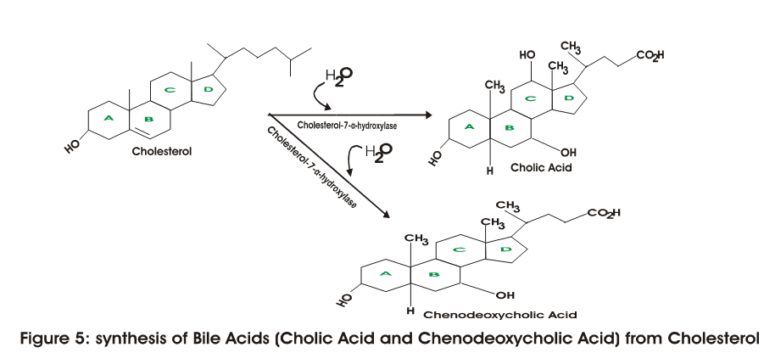
2.2.2.2 Synthesis of Bile Salts
The major bile acids undergo conjugation reaction in the liver with either glycine or taurine just before they enter into the intestine. Taurine is an end product of cystein metabolism. Glycine or Taurine conjugates with the major bile acids to yield glycocholic acid and taurocholic acid or glycochenodeoxycholic acid and taurochenodeoxycholic acid by forming an amide bond involving the amino group of either glycine or taurine and carboxyl group of the bile acid (figure 6). In the bile, these conjugated bile acids are found as alkaline earth metal salts (E.g potassium and sodium) and in this form, they are known as bile salts and are the only classes found in the bile ¹³. The minor bile acids are synthesized in the intestine, catalyzed by intestinal bacteria enzymes via dehydroxylation and deconjugation of the major bile acids to yield deoxycholic and lithocholic acids, minor bile acids. The amphipathic nature (polar and non polar ends) of bile salts makes them more surfactant in effect than bile acids. Thus, patients whose cells cannot degrade cholesterol to bile acids, owing to genetic defects are exogenously administered synthetic chenodeoxycholic ¹².
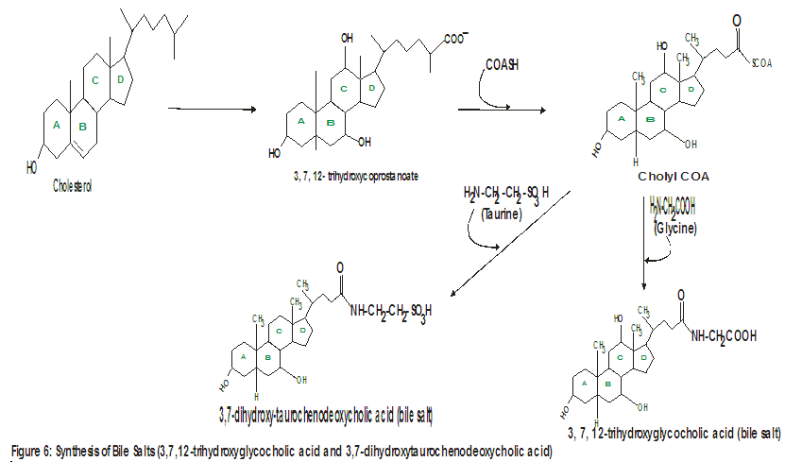
2.2.3 Steroid hormone
Cholesterol is the major precursor of all classes of steroid hormones including mineralocorticoids (e.g aldosterone), glucocorticoids (e.g cortisol), progestins (e.g progesterone), estrogens (e.g estradiol) and androgens (e.g testosterone). Steroid hormones are exclusively synthesized and secreted in the testes, ovaries, placenta and adrenal cortex. Synthesis and secretion of; testosterone occurs in the testes, aldosterone, cortisol and androgens in the adrenal cortex, progesterone and estrogens in the ovaries and placenta ¹⁰. Steroid hormones are synthesized (figures 7) from cholesterol by the shortening of its hydrocarbon chain and hydroxylation of the steroid nucleus. At first, cholesterol is converted to pregnenolone, a 21-C compound, catalyzed by desmolase which cleave cholesterol at its side chain and this is the rate limiting reaction step. The reactions in the synthesis of steroid hormones require NADPH and molecular oxygen (O₂). The term corticosteroid is used to mean mineralocorticoids and glucocorticoids. The complex formed by steroid hormones with plasma protein (plasma albumin) is due to their hydrophobic nature and enables them to be transported from the sites where they are synthesized via the blood to where they exert their effects. Steroid hormones generally perform biochemical and physiological functions which include; metabolic functions, immune system functions, menstrual cycle regulation, kidney related homeostasis functions linked to mineralocorticoids influenced reabsorption of sodium ion (Na⁺) and removal of potassium and hydrogen (K⁺ and H⁺) and reproductive functions ¹.
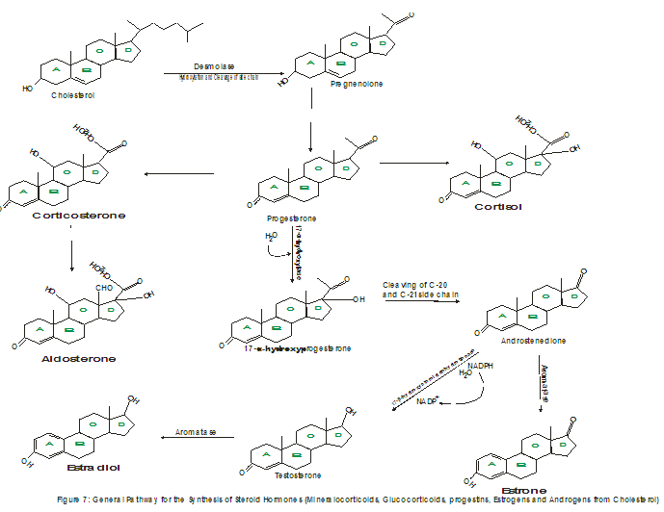
Synthesis of androgens and estrogens are either through the intermediate products; progesterone or pregnenolone. For the synthesis of androstenedione, an androgen, a steroid with 19-C atoms, progesterone undergoes hydrogenation at C-17 by the enzyme action of 17-α-hydroxylase and a subsequent cleaving of the side chain of C-20 and C-21. Similarly, androstenedione is reduced by 17-β-hydroxysteroid dehydrogenase (keto group reduction) in order to synthesis testosterone, another important androgen. The syntheses of estrogens are derived from androgens by de-methylation (removal of methyl group) at carbon 19 by the action of aromatase. Estradiol is derived from testosterone and estrone is synthesized from androstenedione. Steroid hormones perform essential function in the body. Progesterone is involved in enabled secretion by the mammary glands and uterus. It helps the fertilized egg to be implanted in the uterus until maturity. Testosterone is involved in the advancement and development of male secondary sex characteristics, promotes the production of sperm, encourages and involved in biosynthesis (anabolic steroid). Estrogens are involved in menstrual cycle control and in the advancement and development of female secondary sex characteristics ¹².

2.2.4 Vitamin D and its Synthesis
Vitamin D is a derived product of cholesterol due to ultraviolet light action on the rings (ring B) resulting in splitting of the ring. Cholesterol serves as a precursor of Vitamin D via its intermediate product of provitamin D₃ (7-Dehydrocholesterol) during cholesterol synthesis. The generation of 7-Dehydrocholesterol is due to electron movement by resonance in ring B. The provitamin D₃ is converted in the skin to Vitamin D₃ (cholecalciferol) by photolytic action of ultraviolet rays (figure 8). Subsequently, the active hormone, 5, 25 – dihydroxycholecalciferol (Calcitriol) is produced from cholecalciferol in the kidneys and liver via hydroxylation reaction ¹¹.
Vitamin D is very essential for both children and adults; recommended daily intake of vitamin D for both adults and children has been stated to be 400 IU/Q (International Units Per Quart) or 10 μg/q (Microgram Per Quart). Children with deficiency of vitamin D are likely to suffer rickets disease. Vitamin D deficiency in adults results in osteomalacia, a condition characterized by weakening and softening of the bones. Rickets result from insufficient bone and cartilage calcification. The sources of vitamin D include fortified foods, sunlight via skin conversion, and cod liver oil ¹⁰.

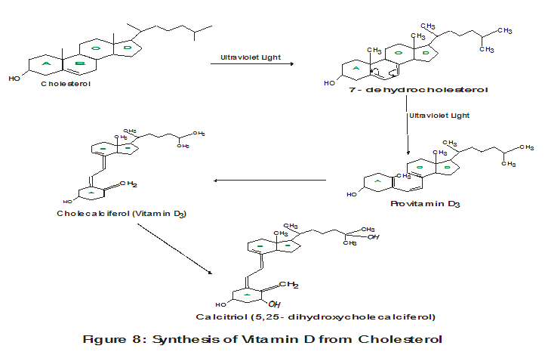

2.3 Digestion, Absorption and Utilization of Dietary Cholesterol
Dietary cholesterol is a complex compound ingested in food, digested via enzymatic mechanism to simpler products, absorbed by cells of the intestinal mucosal, incorporated and finally utilized by the cells of the body. In the complete catabolism of cholesterol in humans, the steroid ring structure is not catabolized to CO₂ and H₂O, thus only about 50% of cholesterol is converted ¹. Cholesterol can be secreted into bile and transported into the intestine for bacteria modification before excretion. In this way, cholestanol, coprostanol and vitamin D, reduced derivatives of cholesterol are produced as part of neutral fecal sterol. However, the integral ring nucleus of cholesterol is excreted from the body as bile salts and bile acids in the feces.
2.3.1 Digestion of Cholesterol
The digestion and absorption of cholesterol like other lipids would have been almost impossible since the digestive enzymes are found in aqueous environment and lipids are mostly hydrophobic. However, the body is able to overcome this problem by an intact mechanism in the gastrointestinal tract (GIT) which enhances the surface area of cholesterol for enabled digestion and splitting of the digested portions for enhanced absorption ¹.

2.3.2 Infinitesimal Digestion of Cholesterol in the Stomach
The digestion of cholesterol begins partially in the stomach and ends in the small intestine ¹. In the stomach, the enzyme acid stable lipase, also called lingual lipase since it is believed to have originated from the glands at the back of the tongue, generally catalyzes the starting of lipids digestion. Digestion of cholesterol and other lipids in the stomach of an adult is insignificant owing to the low pH (high acidity) content, which renders gastric lipase ineffective and un-emulsified cholesterol. However, in the stomach of infants, cholesterol in consumed milk is hydrolyzed since the pH of approximately 7 (≈7) is perfect for the action of gastric lipase ¹.
2.3.3 Cholesterol Digestion in the Small Intestine
Bile salts are very essential in cholesterol digestion and absorption in the small intestine. They form lipid emulsion globules or droplets, utilized for digestion and mixed micelles with cholesterol and other lipids (to be discussed later). The excretion of cholesterol as metabolic products and bile component is made possible by the mechanism of bile salts ¹². Emulsion formation enhances digestion of cholesterol and other lipids by breaking them into smaller droplets therefore amplifying the surface area of the droplets to volume ratio and a subsequent decrease in the surface tension of the droplets. This arrangement helps to expose both lipid and aqueous phases of the droplets for enzymes surface action and hence, an increased digestion. The mechanism through which emulsions are formed is thought to be based on the following three harmonizing mechanisms: (1) due to peristalsis churning mixing movement of intestinal muscles, which releases smaller droplets as suitable substrates for digestive enzyme (2) degraded cholesterol and other lipids (phospholipids, free fatty acids, mono acylglycerol) form surfactant whose actions improve lipase action on lipid droplets. They are immersed in the lipid – aqueous boundary therefore enhancing the surface area to volume ratio of the droplets and (3) bile salts action as biological detergents produced in the liver from cholesterol (reference should be made to Cholesterol and its derivatives above for more detail). Bile salts are secreted from the liver into the duodenum of the intestine ¹.
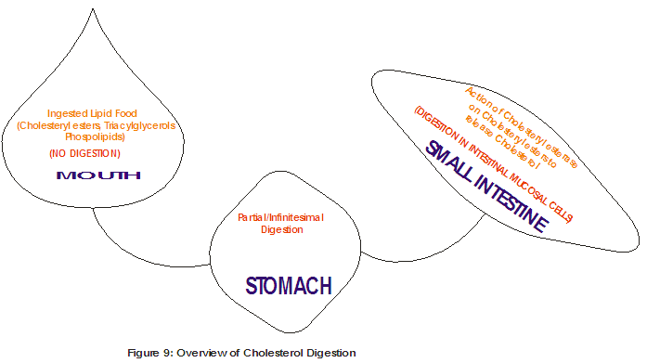
2.3.4 Absorption of Cholesterol and Other Lipids in Intestinal Mucosal Cells
The site of cholesterol and other lipids absorption is the membrane of intestinal mucosal cells. The major cholesterol pool of the body (figure 1) is dietary and liver sources, found in the small intestine. The absorption of cholesterol in the intestine is not complete because of it hydrophobicity (water insoluble). Less than 50% of the dietary cholesterol is absorbed while for the water soluble (hydrophilic) lipids such as free fatty acids and momoacylglycerol, absorption is nearly complete. The remaining unabsorbed part of cholesterol is excreted in the bile in feces. The absorption and circulation of cholesterol is of great clinical significance as its availability via liver production can enable low density lipoprotein aided cholesterol transport from the liver to hepatic tissues and a subsequent risk of development of coronary heart disease (CHD) and atherosclerosis ¹⁵.
2.3.5 Formation of Chylomicrons from Lipids
Just as cholesterol and other lipids are absorbed by the intestinal mucosal cells, they are also secreted from the same cells. Cholesterol is converted to cholesteryl ester and lysophospholipids are converted to phospholipids. The freshly produced lipids droplets in the intestinal mucosal, though varies from the dietary lipids are encapsulated by apolipoproteins A1 and B-48 along with phospholipids resulting in chylomicrons particles. The encapsulation of cholesterol as chylomicrons particles facilitates its solubility and move around the intestinal mucosal cells’ plasma membrane. Chylomicrons are present in the lymph soon after a lipid rich meal making the lymph milky in appearance. The entry of chylomicrons into the lymphatic vessels is exocytotically aided and through the thoracic ducts, they are carried in the blood into the large veins. The transport of cholesterol as chylomicrons particles in the blood of the large veins flows to the heart, peripheral tissues and liver ^{4, 1}.

2.3.6 Absorption Mechanism of Cholesterol and other Lipids
The function of bile salts in cholesterol and other lipids absorption is majorly important. Mixed micelles are formed by combination of bile salts with lipids (cholesterol, phospholipids, fat soluble vitamins E.g vitamins A & K and monoacylglycerol). Micelles are 200 times smaller in size and disk-like in shape compared to lipid emulsion employed for digestion of cholesterol. They are characterized to be amphipathic having two groups end (cores) with bile salts and lipids tails at the inside and the lipids heads at the outside ¹⁵. Thus, this makes the soluble part (hydrophilic end) of cholesterol and other lipids to tilt towards the inside of the micelles (bile salts end) and the insoluble part (hydrophobic end) of cholesterol and other lipids to tilt to the outside of the micelles (lipids’s hydrophobic end) as seen in figure 10. This arrangement enables the bile salt micelles to dissolve cholesterol and other lipids effectively than emulsion, breaking them continually to small enough sizes that can pass through the microvilli of the intestinal mucosal for absorption ¹.
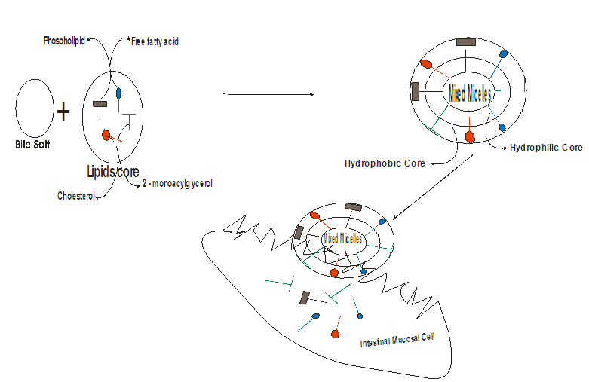
Figure 10: Absorption of Cholesterol and other lipids via mixed micelles in Intestinal Mucosal Cell
4.3.7 Theories of Cholesterol and other Lipids Absorption
The absorption of cholesterol as a lipid is explained by several theories as briefly discussed as follows.
Frazer Partition theory of Lipid Absorption: This theory explains that digestion of cholesterol and other lipids taken up by the intestinal mucosal cells are not complete owing to bile salts emulsion droplets formation ¹⁶.
Verzar Lipolytic theory of Lipid Absorption: This theory explains that fats undergoes complete hydrolyses to free fatty acids and glycerol and their absorption in the intestinal mucosal is as soap or in association with bile salts ¹⁷.
Bergstrom Theory of Lipid Absorption: This theory explains that free cholesterol, free fatty acids, 2-monoacylglycerol and phospholipids, the main products of lipid digestion amassed together with bile salts to form mixed micelles. This mixed micelles of lipids with bile salts aid faster absorption by the intestinal mucosal due to enhanced solubilization as a result of the amphipatic nature ¹⁵.
2.4 Current advancement in cholesterol management against risk factors
The plodding deposit of cholesterol in tissues especially in endothelial coatings of blood vessels, makes it a potential life threat to humans because the amount of cholesterol entering and leaving is not defined. This plodding deposit can form plaque, resulting in atherosclerosis (narrowing of the blood vessels) and increase the risk of peripheral vascular disease, cardiovascular disease and cerebro-vascular disease ¹². This singular metabolic anomaly poses a challenge to the circulation and absorption of cholesterol, giving rise to several associated pathological risk factors. Hypercholesterolaemia (abnormally high levels of cholesterol in the blood), also called hyperlipidaemia or dyslipidaemia in its general term (abnormally high levels of lipids, such as cholesterol, fatty acids, phospholipids, triacylglycerol, in the blood). Hypercholesterolaemia could be due to increased levels Oxygen linked β-N-acetylglucosamine transferase and insulin ¹⁸. Metabolic disorder in plasma lipids transport in the form of lipoproteins complexes, results in hyperlipoproteinaemia, characterized by increased levels of triacylglycerol¹⁹. Hypercholesterolaemia is also associated with other risk factors such as hyperglycaemia, obesity (uncontrollable weight gain due to excessive fat deposit) and ketonaemia. When there is relative or complete insulin deficiency in circulation or insulin resistance due to total or selective destruction of pancreatic β- islet cells of langerhans which subsequently results in diabetes ²⁰. Over production of acetyl CoA occurs that tend to bypass citric acid cycle resulting from high levels of triacylglycerol since fatty acids are mobilized from the adipose tissue to meet the need of energy. Thus, the metabolism of carbohydrates are impaired and increased rate of lipolysis is observed because of affected insulin production, which results in further accumulation of acetyl CoA and its conversion to ketone bodies, hence ketonaemia. Hyperlipidaemia is divided into primary hyperlipidaemia and secondary hyperlipidaemia ²¹. The primary hyperlipidemia could be due to a point mutation or single gene defect. While secondary hyperlipidaemia could result from (1) after effects of the use of some drugs like oral contraceptives and corticosteroidsis (2) dietary pattern (3) disease conditions including hyperglycaemia, diabetes, ketonaemia, chronic alcoholism or nephritic syndrome ^{22, 21}.
In 2012, an update of the Canadian Cardiovascular Society provided guidelines for the diagnosis and treatment of dyslipidemia for the prevention of cardiovascular disease in adults ²³ in addition to adjustment of lifestyle and the use drugs suggested by ²². Several efforts in exploiting plants and plants products and chemotherapeutics have been employed in the prevention and management of hypercholesterolaemia targeted at eliminating the onset of diseases linked with cholesterol risk factors. Some levels of success have been recorded. They are categorized into two major categories which are Pharmacological therapy (use of drugs) and Non Pharmacological therapy ²⁴. Pharmacotherapeutic agents in use in the management of hyperlipidaemia include niacin, statin, ezetimibe, fibrates and bile acid sequestrants. The use of these chemotherapeutics has been associated with adverse side effects. For instance, niacin may cause liver toxicity, gout and hyperglycaemia while it decreases the levels of Total Cholesterol (TC), Triacylglycerol (TAG), Low Density Lipoproteins (LDL) and increases High Density Lipoproteins (HDL) ²⁵. Statins drugs have been found to cause myopathy and hepatic malfunctions while they exert their effects by reducing the action of the enzyme, HMG CoA reductase and decrease the production of total cholesterol (TC) ²⁶. The use of ezetimibe has been associated with angioedema, liver toxicity and disorder in the gastrointestinal function while it reduces TC and increases HDL levels ²⁵. The use of fibrates drugs has been found to exacerbate the onset of bile stones, myopathy and pancreatitis while they reduce the levels of Very low Density Lipoprotein (VLDL), TAG and raises the activity of lipoprotein lipase ²⁷. The use of bile acid sequestrants can cause constipation, rise in TAG level while reducing the level of total cholesterol by converting cholesterol to bile ²⁷.
Some of the Non Pharmacological therapeutic interventions for the management of cholesterol against risk factors include the use of Medicinal Plants and herbs, Nutraceuticals, Diet and Exercises (lifestyle) and Functional and Mediterranean Foods.
2.4.1 Medicinal Plants and Herbs
Medicinal plants constitute a fundamental part of human daily dieting especially for the vegetarians and herbal medicine. They are classified as flowering and non flowering medicinal plants, cutting across all species herbs, woody plants, bushy plants, vines, trees, shrubs etc. ²⁸. Herbs are plants with the present or absence of lignin, otherwise found in other woody plants and they usually live shorter than other plants. Medicinal and other herbs are known for their smell, such as garlic, onion and have been associated with managing cholesterol and its abnormalities ²⁹. The exploitation of plants such as citrus fruits has been implicated to be effective in prevention and management of Hypercholesterolaemia ³⁰. Whole plant of Crataegus laevigata has been shown to have promising potential against hypercholesterolaemia in zebra fish larval model. Results from this study reveal that leaves and flowers of the plant had positive effects on cardiac and intravascular cholesterol levels and thus can serve as diet supplement ³¹. In a study carried out by ³², were rat model was fed with cholesterol enriched diet and treated with lime juice, honey and combination of honey and fresh lime juice, it was demonstrated that the use of combination therapy of lime juice and honey could be used to manage hypercholesterolaemia and prevention of obesity related heart diseases. The value and interest of medicinal plants over pharmaco-therapeutics is obviously associated to the presence of bioactive components in plants such as phenols, alkaloids, saponins, flavonoids, tannins and terpenoids ²⁴. The lipid lowering ability and hypoglycaemic potential of Chromolaena odorata in Albino wistar rats model showed that the plant posses ability to increase HDL, lower LDL, TAG and blood glucose ³³. A study on fresh leaf extract of flacourtia indica was reported to posses hypoglycemic as well as anti-anemic and hepatoprotective abilities administered against CCl₄ hepatotoxic challenged rats. The plant possesses anti-anemia, hypoglycemic and hepato-healing potentials as seen in the reduced levels of blood glucose, liver function assay, and in the raised levels of the hematological parameters ³⁴. Similarly, the hypoglycaemic, hypolipidaemic and non toxic effects of hydro-methanolic extracts of Ziziphus mauritiana, Ziziphus spina christi fruit were evaluated against alloxan induced diabetic rats. It was shown that these fruits are safe and effective in reducing both hyperlipidemia and hypoglycemia accompanying diabetes ³⁵. In a systematic review study, on the anti-lipid effects of herbs and their interactions with statins, anti-hypercholesterolaemia group of chemotherapy; it was revealed that independent use of several herbs with different pathways reduced serum lipid profile. But using drug-herbal combination therapy may result in reduced effects of pharmacological efficiency as anti-hypercholesterolaemia than when herbs are used ³⁶. In the review of ³⁷, on promising natural agent’s effectiveness on hyperlidaemia, it was shown that the hypolipidaemic effects of most plants and herbs are ascribed to their antioxidant properties. Ginger (Zingiber officinale) has been extensively used in folk medicine and as a spice. The presence of gingerols, zingerone and shogaols in it makes it distinctively known for its smell and tang ³⁸. When rats were fed high fat diet and treated with 400mg/kg of ginger, the lipid profile was seen to be cut down and also cholesterol absorption in the intestine was effectively reduced ³⁹. Fenugreek, a seed spice also called Trigonella foenum was shown to avert dyslipidaemia and stopped fat accumulation in high fat diet induced obese rats when treated with defatted and non defatted seeds extracts ⁴⁰. Its antioxidant and hypocholesterolemic abilities in cholesterolfed rats have been reported ⁴¹.

2.4.2 Nutraceuticals
The term nutraceutical was first used by Stephen Defelice in 1989 as a combination from the words ‘nutrient and pharmaceutical’. Nutrient depicts nourishing food or food constituent and pharmaceutical depict drugs. Thus, based on Stephen’s view, nutraceuticals are products that can be used as pharmaceuticals in pathological situations ¹⁸. Nutraceuticals are said to be food or part of food which enhances health either by preventing or/and treat disease. They can supplement diet and used as usual meal or as an item of diet ¹⁸. Nutraceutical as defined by Marrian – Webster online dictionary (MWOD) to be a food, mineral herbs, vitamins specifically or purposely treated that when eaten or drunk, enhance one’s health. Also, it is any fortified foodstuff or dietary supplement which profits the health and additional nutrient value ⁴². Nutraceutical is a diet supplement that delivers a concentrated form of a biologically active component of food in a nonfood matrix to improve health ⁴³. Recently, the food and drug administration (FDA) in US has accepted the Granny Smith apple polyphenolic extract as safe nutraceutical designed to reduce levels of total cholesterol (5%), low density lipoprotein (8%) and increase high density lipoprotein (5%) in blood and prevention of obesity ¹⁸. Another widely used nutraceutical which has entered pharmaceutical market is the Annurca apple nutraceuticals. Its extract can permit balance of healthy cholesterol by decreasing total cholesterol and enhancing HDL levels in the blood. The hypocholesterolaemic effect of Granny Smith- and Annurca apple-based nutraceuticals as applied combination therapy can be ascribed to the mixtures of the two polyphenolics present. Apple polyphenolic extract based nutraceuticals as inhibitors of hydroxymethyl-glutaryl-CoA (HMG CoA) have been seen to be without any adverse effects, common with chemotherapeutic ^{44, 18}

2.4.3 Functional and Mediterranean Foods
Functional foods have been described to be food or diet containing nutrient or active ingredients that when eaten improve health and provide physiological benefits ⁴³. Functional foods are composed of biologically active part essentially profiting the body with physiological health benefits, help to prevent and control onset of importunate diseases and risk factors, such as type 2 diabetes mellitus (T2DM), hypertension, hypercholesterolaemia and hyperglycaemia ⁴⁵. Frequent eating of functional foods is said to improve health and furnishing the body against oxidative stress, inflammatory responses, hypercholesterolaemia and insulin sensitivity⁴⁵. Functional foods consumed by high risk individuals to type 2 diabetes mellitus reduced complications as seen in the assayed parameters including regulation of blood pressure, glycaemic control, antioxidant enzymes activation and gut micrbiota maintenance ⁴⁶. Functional foods are said to include fortified grain products and probiotic yogurt ⁴⁷. Probiotics are described as living bacteria that can overwhelm the GIT and provide health benefits to the host organism when they are consumed. The strains of probiotics frequently used are the Lactobacillus acidophilus and Bifidobacterium lactis ⁴⁸. The presence of bile salt hydrolase in most bacteria probiotics enable them to partake in the degradation of bile acids and cholesterol and their subsequent excretion in the faeces. They can absorb cholesterol and are capable of converting cholesterol to coprostanol, thus preventing hypercholesterolaemia ⁴⁹. The lipid profile of pregnant women and young healthy women who daily consumed probiotic yogurt and conventional yogurt was found to be significantly reduced. In these studies, the effects of these functional foods significantly lower LDL and TC levels, while probiotic yogurt alone increases HDL levels ^{50, 51}. In a randomized control trial of a meta-analysis, the effect of probiotic bacteria was seen to reduce the body mass index and circumference of the waist while total cholesterol and LDL were significantly reduced ⁵².
Mediterranean diets (MD) are majorly plant based diets with vegetables and olive oil being the main part of the diet. Such diet is encouraged to be consumed with the availability of cheap vegetables, fruits and fish ⁵³. The complete Mediterranean food list was given by ⁵³ to include in part or complete in a meal the following vegetables such as tomato, cucumber, peppers, onions, carrot, mushroom, garlic etc; fish and seafood especially cured or canned small fatty fish such as anchovies, sardines, cod, shrimp, octopus etc; fruit such as oranges, tangerines, temons, apples, pears, cherries, watermelon etc; grains and breads such as bread from whole grains, paximadi of barley rusks, pita bread, rice, egg pasta, bulgur etc; herbs and spices such as oregano, parsley, dill, mint, cumin, various spice, cinnamon etc; greens such as chicory, punky, spinach, dandelion, beet greens etc; beans such as lentils, white beans, chickpeas etc; pantry items such as canned tomatoes, tomato paste, olives, honey, wine etc; dairy such as strained yogurt, sheep’s milk yogurt, feta cheese, fresh cheese (ricotta), parmesan etc; fats and nuts such as extra virgin olive oil, tahini, almonds, walnuts, pine nuts etc; and meat and poultry such as whole chicken, ground beef, veal, pork. The main sources of antioxidants in Mediterranean diet are citrus fruits and red meat and poultry in MD should be consumed in small amounts generally once a week ⁵³. The use of honey and lime juice was reported to significantly reduce TC, TAG and LDL while HDL was found to increase in a rat model experiment fed cholesterol enriched diet ³². Mediterranean food was demonstrated to effectively decrease the chances of metabolic syndrome and defend the body against Hypercholesterolaemia, waist circumference, blood pressure and hyperglycaemia in a meta-analysis of 50 studies involving 534,906 individuals ⁵⁴. Similarly, Mediterranean diet was shown to greatly reduce cardiovascular risk factors when compared to low fat diets in patients involved in the meta-analysis ⁵⁵. Mediterranean diets have been established to exert their hypolipidaemic, hypoglycaemic, anti-inflammatory and reduction of cardiovascular disease risk owing to their antioxidant properties ⁵⁶.
2.4.4 Diet and Exercises (lifestyle)
The management of cholesterol and prevention of Hypercholesterolaemia have been associated with lifestyle factors mainly dietary and exercise factors. The impact of dietary factors is highly appreciated. They can control hyperlipidaemia if there is amendment on dietary elements, exploit food supplements and food additives, minimize consumption of trans and saturated fats, increase consumption of foods fortified with plant sterols and frequent consumption of polyunsaturated and monounsaturated fats ⁵⁷. The avoidance of the following is significant; intake of bad fats such as red meat, whole milk, butter and cheese, tropical oils (coconut, palm and other tropical oils) and quit smoking; increase consumption of fiber rich diet such as fruits and vegetables; improve on daily exercise. Frequent exercise is said to increase the blood level of HDL to about 5% within two months, reduces LDL and triacylglycerol ⁵⁸. The ratios of LDL to HDL, TC to HDL, TAG to HDL and HDL to LDL have been used as a marker of hyperlipidaemia ³². In a rat model study where the rats were fed cholesterol enriched diet and then treated with honey, lime juice and combination of lime juice and honey, it was shown that ratios of LDL/HDL, TC/HDL and TAG/HDL were low while HDL/LDL ratio was high ³². Thus, for LDL/HDL ratio, a high value indicates high risk of heart attack. The moderate ratio value is between 2.5 to 3.3, > 3.3 is high and a low ratio of HDL/LDL implies higher value of LDL to HDL. The ideal value is 0.4 and moderate value is between 0.4 to 0.3 and the risk of heart disease increased when <0.3 ⁵⁹. Low glycemic index diets were compared with high glycemic index diets in meta-analyses to study their health effects in meal planning. It was revealed that low glycemic index diets possessed minimal effects on TC, TAG, LDL and HDL were not affected ⁶⁰.
Exercise has been widely studied and reported to have a tremendous reductive effects on the serum levels of LDL, TAG and TC and increment in the serum level of HDL. The needed amount of exercise required to increase the level of HDL is said to be 900kcal of energy exhausted in one week. That is, a usual aerobic exercise lasting for about 120 minutes ⁶¹. Exercise was shown to be better profits to patients with cardiovascular disease demonstrated in a meta-analysis of randomized controlled trials as engagement of aerobic exercise by patients resulted to increase in the level of serum HDL and reduction in the serum level of TAG ⁶². The logicality of combining exercise and diet is not farfetched from the fact that exercise alone increases serum HDL levels and lower LDL and TAG and diet on the other hand, reduces serum levels of TC, LDL and TAG. Thus combining the two advancements will be of greater benefits in the management of Hypercholesterolaemia ⁶³.

3. Conclusion
The implication of hypercholesterolaemia in cardiovascular disease is a serious concern to health. The total pool of body’s cholesterol is contributed by tissues producing cholesterol (endogenous) and from diet, hence the need for remedial homeostatic regulation. Several remedial interventions of non pharmaceutical therapies have been exploited since the use of chemotherapy comes with side effects. These include the use of plants, herbs, dietary, exercise, functional foods and mediterranean foods. Meanwhile, from available data on the use of non pharmaceutical therapeutics, the challenge is on the unclear mechanism of action of these herbal medicines. Most researchers attribute their potency as anti hypercholesterolaemia, anti-diabetic, anti-obesity, anti-inflammatory and anti-cancer to the antioxidant abilities of some phytochemicals such phenolic compounds. Since hypercholesterolaemia results from excess cholesterol in the blood, contributed both by de novo (endogenous tissue synthesis) and dietary sources, it is then worthwhile to minimize the intake of dietary sources of cholesterol possibly with augmentation diet.
Conflict of Interest
No conflicts of interest exist.

References
1. Satyanarayana U, Chakrapa U. Biochemistry, in Metabolism of Lipids. 3rd Ed., Kolkata 700009 (India), Arunabha Sen Books and Allied (P) Ltd: Chintamoni Das Lane; 2010; 285-326: 410 - 420.
2. Wolkoff AW, Cohen DE. Bile acid regulation of hepatic physiology: Hepatocyte transport of bile acids. Am. J. Physiol., Gastrointest., Liver Physiol. 2003; 284 (2): G175–179.
3. Lecerf JM, de Lorgeril M. Dietary cholesterol: from physiology to cardiovascular risk. Br. J. Nutr. 2011; 106 (1): 6–14. doi:10.1017/S0007114511000237.
4. Lewington S, Whitlock G, Clarke R, Sherliker P, Emberson J, Halsey J, Qizilbash N, Peto R, Collins R. Blood cholesterol and vascular mortality by age, sex, and blood pressure: a meta-analysis of individual data from 61 prospective studies with 55,000 vascular deaths. Lancet. 2007; 370 (9602): 1829–39. doi:10.1016/S0140-6736(07)61778-4.
5. Sadava D, Hillis DM, Heller HC, Berenbaum MR. Life: The Science of Biology. 9th Edition. San Francisco: Freeman; 2011;105–114. ISBN 978-1-4292-4646-0.
6. Payne AH, Hales DB. Overview of steroidogenic enzymes in the pathway from cholesterol to active steroid hormones. Endocrine Reviews. 2004; 25(6): 947–70. doi:10.1210/er.2003-0030.
7. Olson RE. Discovery of the lipoproteins, their role in fat transport and their significance as risk factors. J. Nutr. 1998; 128 (2 Suppl): 439S–443S. doi:10.1093/jn/128.2.439S
8. Incardona JP, Eaton S. Cholesterol in signal transduction. Curr. Opin. Cell Biol. 2000; 12 (2): 193–203. doi:10.1016/S0955-0674(99)00076-9.
9. Dubois C, Armand M, Mekki N, Portugal H, Pauli AM, Bernard PM, Lafont H, Lairon D. Effects of increasing amounts of dietary cholesterol on postprandial lipemia and lipoproteins in human subjects". Journal of Lipid Research. 1994; 35: 1993–2007.
10. Christie, WW. Sterols: 1. Cholesterol and Cholesterol Esters. In: Lipid Essential. The lipid Library Website. 2019 (Updated February 13th, 2019).
11. Afonso MS, Machado RM, Lavrador MS, Quintao ECR, Moore KJ, Lottenberg AM. Molecular pathways underlying cholesterol homeostasis. Nutrients. 2018; 10: 760.
12. Richard AH, Denise RF. Cholesterol and Steroid Metabolism. In: R. A. Harvey Robert Wood Johnson, editors. Biochemistry, Lippincott’s illustrated reviews. 5th Edition. Medical School Piscataway: New Jersey; 2011. 216 -243.
13. Ferrier RA, Harvey DR. Lippincott's illustrated reviews, biochemistry. 5th ed. Philadelphia: Wolters Kluwer Health; 2011. 175.
14. Ohvo-Rekilä H, Ramstedt B, Leppimaki P, Slotte JP. Cholesterol interactions with phospholipids in membranes. Prog. Lipid Res., 2002; 41: 66-97.
15. Bergstrom S, Danielsson H. Formation and metabolism of bile acids. In: C. F. Code, editors. Handbook of Physiology. 5th ed. Williams & Wilkins: Baltimore; 1968. Ch 6; 2391-2407.
16. Frazer AC. The System of Absorption of Fats. Bull Soc Chim Biol (Paris). 1951; 33(8):961-967.
17. Dawson M. Lipids: The Absorption of Fat. J. clin. Path. 1971; 24: Suppl. (Roy. Coll. Path.), 5, 77-84.
18. Antonello S, Ettore N. Nutraceuticals in hypercholesterolaemia: an Overview; British Journal of Pharmacology. 2017; 174: 1450–1463.
19. Virendra Y, Vishesh U, Dinesh DR. Importance of Herbs in the Treatment of Hyperlipidaemia. Sch. Acad. J. Pharm. 2014; 3(3): 306-312.
20. Abubakar SM, Umar SA, Alexander I, Abubakar N, Abdulazeez MA, Sule MS. Evaluation of hypoglycaemic, hypolipidaemic and non toxic effect of hydro-methanolic extracts of Ziziphus mauritiana, Ziziphus spina christi fruit and glibenclamide on alloxan induced diabetic rats, Journal of Drug Delivery and Therapeutics. 2018; 8(3): 82-92.
21. Vodnala M, Rubenfire RDB. Secondary causes of dyslipidaemia. American Journal of Cardiolology.2012; 110(6): 826-829, 2012.
22. Hendrani AD, Adesiyun T, Quispe R, Steven RJ, Neil JS, Roger SB, Seth SM. Dyslipidemia management in primary prevention of cardiovascular disease: Current guidelines and strategies. World Journal of Cardiology. 2016; 26(8): 201–210.
23. Anderson TJ, Grégoire J, Hegele RA, Couture P, Mancini GB, McPherson R, Francis GA, Poirier P, Lau DC, Grover S, Genest J Jr, Carpentier AC, Dufour R, Gupta M, Ward R, Leiter LA, Lonn E, Ng DS, Pearson GJ, Yates GM, Stone JA, Ur E. 2012 update of the Canadian Cardiovascular Society guidelines for the diagnosis and treatment of dyslipidemia for the prevention of cardiovascular disease in the adult. Canadian Journal of Cardiology. 2013; 29(2):151-167.
24. Dhaliya SA, Surya AS, Dawn VT, Betty C, Arun K, Sunil C. A review of hyperlipidemia and medicinal plants. Int.J.A.PS.BMS. 2013; 2(4): 219-23.
25. Hamilton SJ, Watts GF. Atherogenic dyslipidemia and combination pharmacotherapy in diabetes: recent clinical trials. The Review of Diabetic Studies. 2013;10: 191–203.
26. Aranda JF, Madrigal-Matute J, Rotllan N. MicroRNA modulation of lipid metabolism and oxidative stress in cardiometabolic diseases. Free Radical Biology and Medicine. 2013; 64:31-39.
27. Pajouhi M, Mohajeri-Tehrani MR, Fakhrzadeh H, Tabatabaei-Malazy O, Amini P. Lipid disorders. In: M. Arzaghi, O. Tabatabaei-Malazy, editors. Lipid Disorders in Persian language. Iran: Vista; 2011.1-217.
28. Shalinee N. Difference between plants and herbs. 2017: http://www.differencebetween.net/science/health/difference-between-plants-and-herbs.
29. Grant C. 10 Surprising uses for herbs. 2017. Alive. Available at: http://www.alive.com/lifestyle/10-surprising-uses-for-herbs/
30. Idoko A. Exploitative Beneficial Effects of Citrus. In: Mahammad Sajid and Amanullah, editors. Citrus – Health Benefits and Production Technology. IntechOpen: 41 – 45. DOI: 10.5772/intechopen. 79783.
31. Robert ML, Matthew M, Jay RH. Whole plant based treatment of hypercholesterolemia with Crataegus laevigata in a zebrafish model; BMC Complementary and Alternative Medicine. 2012; 12: 105.
32. Idoko A, Ikpe VPO, Nelson NO, Effiong JU, Alhassan AJ, Muhammad IU, Abubakar N, Abubakar SM. Effects of Lime Juice and Honey on Lipid Profile of Cholesterol Enriched Diet Fed Rat Model. Annual Research & Review in Biology. 2017; 20(3): 1-10.
33. Idoko A, Ikpe VPO, Rita ON, Nelson NO, Effiong JU, Alhassan AJ, Muhammed IU, Abubakar N, Abubakar SM, Ugwudike PO. Hypoglycermic and Lipid Profile Lowering Effect of Chromolaena Odorata (linn) in Albino Wistar Rats Fed Different Concentrations of Cholesterol Enriched Diet. Universal Journal of Pharmaceutical Research. 2018; 3(1): 37-42.
34. Idoko A, Ufedo-Enyo GE. Study on fresh leaf aqueous extract of flacourtia indica for hepatoprotective, anti-anemic and hypoglycemic abilities in CCl4 induced hepatotoxicity in albino wistar rats. Universal Journal of Pharmaceutical Research 2019; 4(1): 17-23.
35. Abubakar SM, Umar SA, Alexander I, Abubakar N, Abdulazeez MA, Sule MS, Evaluation of hypoglycaemic, hypolipidaemic and non toxic effect of hydro-methanolic extracts of Ziziphus mauritiana, Ziziphus spina christi fruit and glibenclamide on alloxan induced diabetic rats, Journal of Drug Delivery and Therapeutics. 2018; 8(3):82-92
36. Hojjat R, Hamid R, Esfandiar H, Fereshteh M, Mahmoud R. Herbs with anti-lipid effects and their interactions with statins as a chemical anti- hyperlipidemia group drugs: A systematic review. ARYA Atheroscler. 2015; 11(4).
37. Mahmoud B, Mahmoud M, Hedayatollah S, Mehrnoosh S, Nejmeh S, Mahmoud R. A Review on Promising Natural Agents Effective on Hyperlipidemia. Journal of Evidence-Based Complementary & Alternative Medicine. 2015; 20(3): 228-238.
38. Mohamad M. Medicinal Plants and Hyperlipidemia. Human & Health. 2016; 37:19 – 24.
39. Shalaby MA, Saifan HY. Some pharmacological effects of cinnamon and ginger herbs in obese diabetic rats. Journal of Intercultural Ethnopharmacology. 2014; 3(4): 144-149.
40. Parveen K, Uma B, Shrirang J. Fenugreek seed extract inhibit fat accumulation and ameliorates dyslipidemia in high fat diet-induced obese rats.BioMedResearchInternational.2014;11.
41. Belguith-Hadriche O, Bouaziz M, Jamoussi K, Simmonds MS, El Feki A, Makni-Ayedi F. Comparative study on hypocholesterolemic and antioxidant activities of various extracts of fenugreek seeds. Food Chem. 2013;138:1448–1453. doi: 10.1016/j.foodchem.2012.11.003.
42. Merriam-Webster Online Dictionary. Merriam-Webster Inc., P.O. Box 281, Springfield. 2014; MA 01102, United States.
43. Zeisel SH. Regulation of “nutraceuticals. Science. 1999; 285: 1853–1855.
44. Nagasako-Akazome Y, Kanda T, Ikeda M, Shimasaki H. Serum cholesterol-lowering effect of apple polyphenols in healthy subjects. J Oleo Sci. 2005; 54: 143–151.
45. Ahmad A, Catherine T, Ali T, Theeshan B, Hossein A, Roula B, Abdelkrim K, Jaakko T. Functional Foods and Lifestyle Approaches for Diabetes Prevention and Management. Nutrients. 2017; 9(12): 1310.
46. Mirmiran P, Bahadoran Z, Azizi F. Functional foods-based diet as a novel dietary approach for management of type 2 diabetes and its complications: A review. World J. Diabetes. 2014;5:267–281.
47. Department of Health & Human Services, US Food & Drug Administration. What is a dietary supplement? 2015. http://www.fda.gov/AboutFDA/Transparency/Basics/ ucm195635.htm
48. Paola MH, Robert AH. Functional foods and dietary supplements for the management of dyslipidaemia: Nature Review, Endocrinology. 2017; 1- 11.
49. Ishimwe N, Daliri EB, Lee BH, Fang F, Du G. The perspective on cholesterol-lowering mechanisms of probiotics. Mol. Nutr. Food Res. 2015; 59: 94–105.
50. Asemi Z, Samimi M, Tabasi Z, Talebian P, Azarbad Z, Hydarzadeh Z, Esmaillzadeh A. Effect of daily consumption of probiotic yoghurt on lipid profiles in pregnant women: a randomized controlled clinical trial. J. Matern. Fetal Neonatal Med. 2012; 25: 1552–1556.
51. Fabian E, Elmadfa I. Influence of daily consumption of probiotic and conventional yoghurt on the plasma lipid profile in young healthy women. Ann. Nutr. Metab. 2006; 50: 387–393.
52. Sun J, Buys N. Effects of probiotics consumption on lowering lipids and CVD risk factors: a systematic review and meta-analysis of randomized controlled trials. Ann. Med. 2015; 47:430–440.
53. Elena P. The Complete Mediterranean Diet Food and Shopping List. Olive Tomato. 2018. www.olivetomato.com
54. Kastorini C, Milionis HJ, Esposito K, Giugliano D, Goudevenos JA, Panagiotakos DB. The effect of Mediterranean diet on metabolic syndrome and its components: a meta-analysis of 50 studies and 534,906 individuals. J Am Coll Cardiol. 2011;57(11):1299–313.
55. Nordmann A, Suter-Zimmermann K, Bucher HC, Shai I, Tuttle KR, Estruch R, Briel M. Meta-analysis comparing mediterranean to low-fat diets for modification of cardiovascular risk factors. Am J Med. 2011;124(9):841–51.
56. Jay RW, Andreas JF, Lilach OL, Amir L. The Mediterranean Diet, its Components, and Cardiovascular Disease. Am J Med. 2015;128(3): 229–238.
57. Robert BK. Diet and Exercise in the Management of Hyperlipidaemia. Am Fam Physician. 2010; 81 (9):1097-1102, 1103-1104.
58. Andrew MF. High Cholesterol: Lifestyle Management; National Jewish Health. 2016. https://www.nationaljewish.org
59. Hanak V, Munoz J, Teaque J, Stanley AJr, Bittner V. Accuracy of the triglyceride to high-density lipoprotein cholesterol ratio for prediction of the low-density lipoprotein phenotype B. Am J Cardiol. 2004;94:219–22.
60. Opperman AM, Venter CS, Oosthuizen W, Thompson RL, Vorster HH. Meta-analysis of the health effects of using the glycaemic index in meal-planning. Br J Nutr. 2004;92(3):367-381.
61. Kodama S, Tanaka S, Saito K, Shu M, Sone Y, Onitake F, Suzuki E, Shimano H, Yamamoto S, Kondo K, Ohashi Y, Yamada N, Sone H. Effect of aerobic exercise training on serum levels of high-density lipoprotein cholesterol: a meta-analysis. Arch Intern Med. 2007; 167(10):999-1008.
62. Kelley GA, Kelley KS, Franklin B. Aerobic exercise and lipids and lipoproteins in patients with cardiovascular disease: a meta-analysis of randomized controlled trials. J Cardiopulm Rehabil. 2006; 26(3):131-139.
63. Varady KA, Jones PJ. Combination diet and exercise interventions for the treatment of dyslipidemia: an effective preliminary strategy to lower cholesterol levels? J Nutr. 2005; 135(8):1829-1835.

