**Reviewer’s Comments**

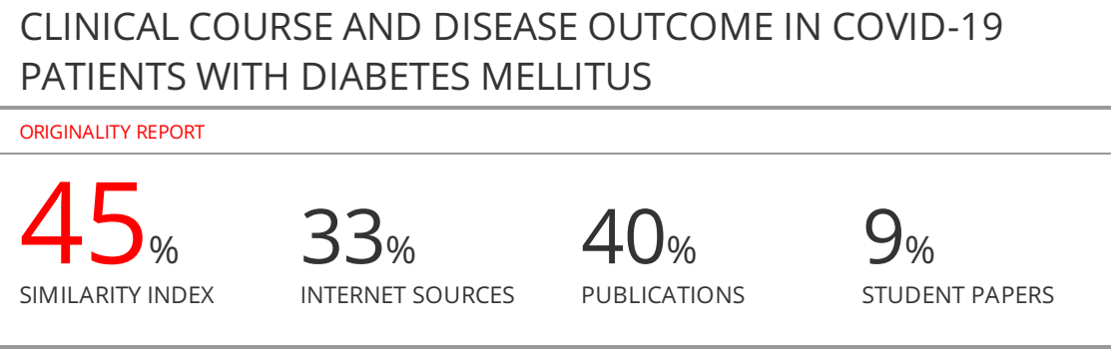

**CLINICAL COURSE AND DISEASE OUTCOME IN COVID-19 PATIENTS WITH DIABETES MELLITUS**

**Abstract:**

Severe acute respiratory syndrome coronavirus 2 (SARS-CoV-2) causes coronavirus disease 2019 (COVID-19) whose pandemic was declared on March 11 2021 (1). Spectrum of COVID-19 clinical manifestations is heterogeneous. Most patients present with mild symptoms, but some may rapidly develop acute respiratory distress syndrome (ARDS), respiratory failure, acute cardiac injury, multiple organ failure and death (2). Older age, diabetes and cardiovascular disease are reported as significant predictors of morbidity and mortality. We conducted retrospective analysis of 1513 patients with RT PCR confirmed COVID-19 hospitalized in Clinic for infectious disease, University Clinical Center, Sarajevo, Bosnia and Herzegovina, in a period of june 2020. to December 2020. Among them 417 had previously diagnose of diabetes mellitus. Results show that patients with diabetes mellitus are likely to require treatment in Intensive care unit, and oxygenic support with invasive ventilation. There was no statistically significant difference in outcome of the disease.

Keywords: Diabetes mellitus, COVID-19, outcome

**Introduction:**

Severe acute respiratory syndrome coronavirus 2 (SARS-CoV-2) causes coronavirus disease 2019 (COVID-19) whose pandemic was declared on March 11 2021 (1). Spectrum of COVID-19 clinical manifestations is heterogeneous. Most patients present with mild symptoms, but some may rapidly develop acute respiratory distress syndrome (ARDS), respiratory failure, acute cardiac injury, multiple organ failure and death (2). Older age, diabetes and cardiovascular disease are reported as significant predictors of morbidity and mortality.

Diabetes is one of the leading causes of morbidity and mortality throughout the world. The condition is associated with several macrovascular and microvascular complications, that ultimately impact the overall patient’s survival (3). A relationship between diabetes and infection has been clinically recognized with evidence suggesting greater susceptibility to infections and worse outcomes in diabetes patients (4). It is questionable whether diabetes itself increases susceptibility to infections and affects its outcomes or the renal and cardiovascular complications that are frequently associated with diabetes (5). Diabetes and uncontrolled glycaemia were reported as significant predictors of severity and mortality rate in patients infected with different viruses, including the pandemic influenza A (H1N1) (6) SARS-CoV (7)and MERS-CoV (8).  So far, there is no study that demonstrated independent predictive value of diabetes on mortality in COVID-19 patients, but there are many theories about the association between diabetes and susceptibility to SARS-CoV-2, as well as its impact on progression and prognosis of COVID-19 (9). Diabetes is hyper-inflammatory condition and seems that it may increase susceptibility for COVID-19 with potential mechanisms that include higher affinity cellular binding and efficient virus entry, decreased viral clearance, diminished T-cell function and increased susceptibility to hyperinflammation and cytokine storm syndrome (10). Coronavirus infections are proven to have a huge effect on the management of diabetes mellitus because they aggravate inflammation and alter immune system responses, leading to difficulties in glycaemic control (11). SARS-CoV-2 uses ACE2 as entry receptors, which are present on the islets of Langerhans. This can cause mild to fulminant damage to these cells, leading to different clinical states (12).

**Material and methods:**

This is an observational retrospective study of adult patients with COVID-19 and diabetes mellitus admitted to Clinic for infectious disease, University Clinical Center, Sarajevo, Bosnia and Herzegovina, in a period of june 2020. to December 2020. Patients with a laboratory-confirmed diagnosis of COVID-19 based on Real-Time PCR were included in study. Patients with unclear diagnosis, based only on rapid antigen test, were excluded as well as patients with newly discovered diabetes. Data were retrieved from the patient's history records: age, sex, duration of symptoms before hospitalisation, length of hospitalisation, requirement for oxygen support via facial mask, requirement to admission in Intensive Care Unit (ICU) with requirement for invasive ventilation, and the outcome of disease. Patient population was divided into two categories based on their history of diabetes: without diabetes and previously known cases of diabetes. We used descriptive and non-parametric statistical methods for the results interpretation.

**Results:**

In a period of june 2020. to December 2020. total of 1792 patients were hospitalised in Clinic for infectious diseases in Sarajevo. Out of that number, 1513 patients had COVID-19, confirmed with positive PCR test for SARS-CoV-2. For the statistical analysis we divided them into two groups: with or without diabetes mellitus (DM) as underlaying disease. In group with DM we had 417 (27.5%) patients and in the group without DM there were 1102 (72.5%) patients. Mean age in group with DM was 68 years (SD=11.17, range 22 – 96 years) and in a group without DM was 62 years (SD=14.86, range 19 – 95 years).

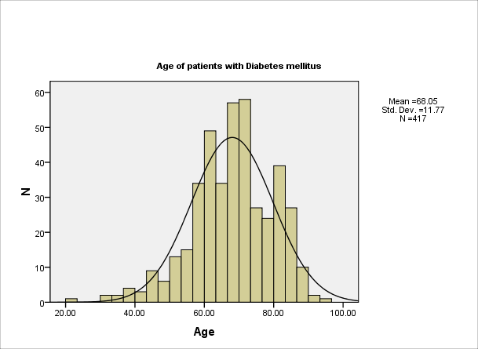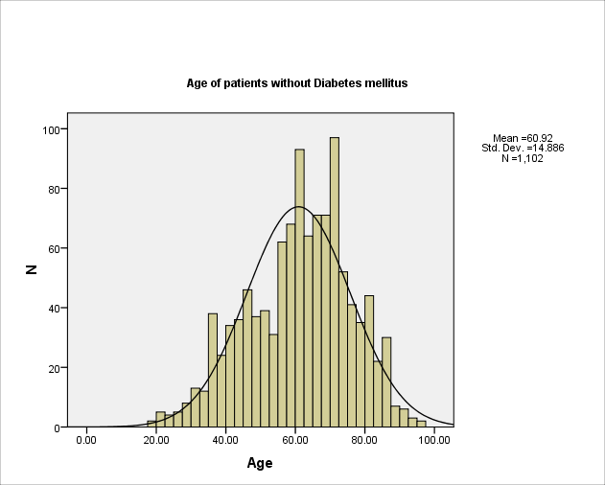

Graph 1. Age of patients admitted to the hospitalfor both groups

In both groups males were mostly presented – 61.4 vs 38.6% in group with DM, and 66.3 vs 32.7% in a group without DM. In a group with DM there was 61.4% of male and 38.6% of female patients.

Duration of presented symptoms before admission to hospital was in range 1 to 20 days (Me 7.96, SD=3.76) in a group with DM and in range 1-24 days (Me 7.86, SD=3.70) in a group without DM. Duration of hospital stay for a group with DM ranged 1 to 50 days (Me 10.02, SD=7.01), and in group without DM in range 1 to 90 days (Me 9.59, SD=6.89). There was no statistically significant difference between groups (Pearson's Chi square = 46.81, p = 0.15).

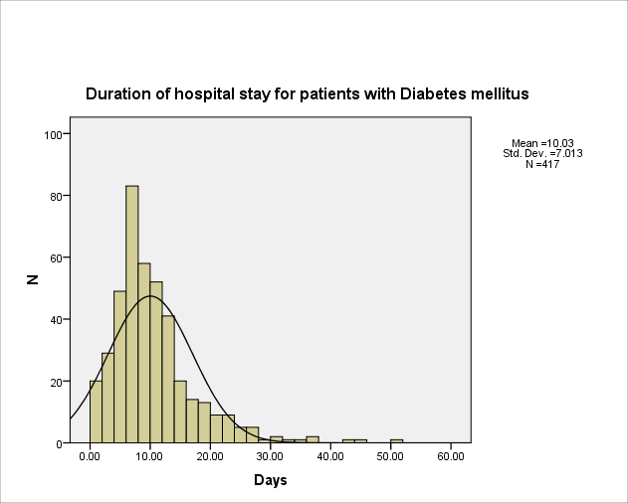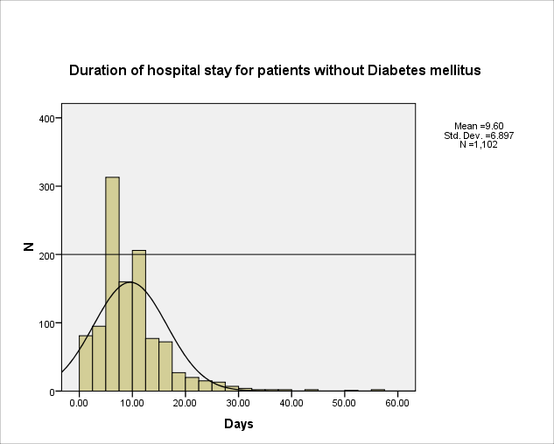

Graph 2. Duration of hospital stay for both group of patients

Total 85.1% patients in a group with DM required oxygenic support via facial mask while that number in a group without DM was 74.7%, with statistical difference between groups (Pearson's Chi square = 18.68, p < 0.001).

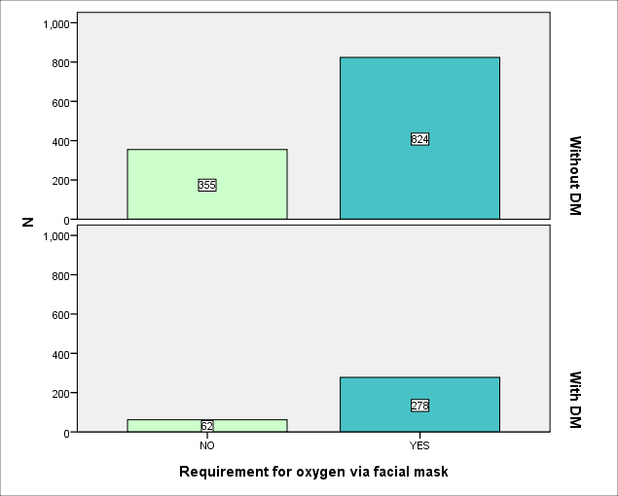

Graph 3. Patients who required oxygen via facial mask

Admission in intensive care unit (ICU) and oxygen support with respiratory machine (invasive ventilation), required 23.3% in a group with DM, while in group without DM that number was 13.1%, with significant difference between groups Pearson's Chi square = 18.68, p = 0.005).

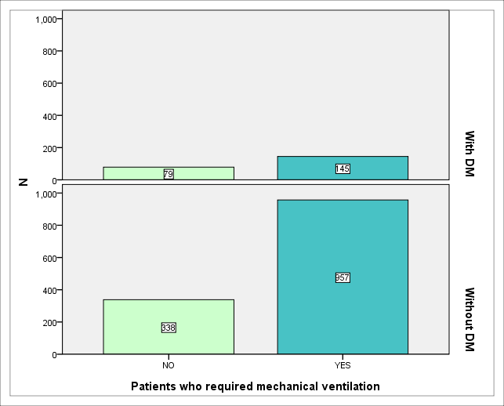

Graph 4. Patients who required mechanical ventilation

In a group with DM we had total of 107 (25.7%) lethal outcomes and in a group without DM we had total 289 (26.2%) lethal outcomes. Other patients were discharged from hospital as recovered.

There was no statistically significant difference between groups (Pearson's chi square=0.05, p=0.84).

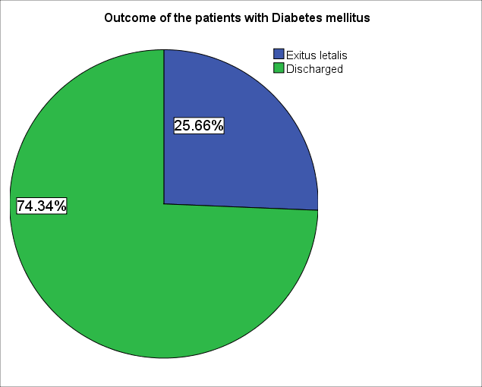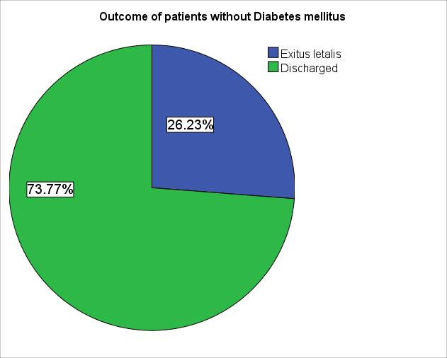

Graph 5. Outcome of disease for patients in both groups

**Statistical analysis**

**Discussion:**

Diabetes mellitus is recognised as one of possible risk factors for developing serious form of COVID-19. Since mortality from diabetes is in constant increase in Bosnia and Herzegovina in the last 10 years, this could be one of the reasons for very high morbidity and mortality for COVID-19 among citizens. (13)

In aperiod,July 2020. – December 2020. we admitted 1513 patients to Clinic for infectious diseases, Clinical center University of Sarajevo. Most of them were with moderate to severe clinical presentation, since mild and asymptomatic forms are treated through Primary care. We had very large proportion of patients with previously detected diabetes (27.5%), since diabetes was one of the comorbidities we used in prediction for severity of clinical picture and course of disease and indication for hospital admission.

In two largest meta-analyses that included 46 248 and 76 993 COVID-19 patients, respectively, diabetes was detected in 8.6% and 7.9%. (14,15)

The same group of authors in a larger group of COVID-19 patients (n = 1590) reported diabetes in 8.2%, and it was significantly more prevalent among COVID-19 patients with severe form than in patients with non-severe form of disease (34.6% vs 14.3%). (16)

Median age of our patients with diabetes was 68 years, and without diabetes 62 years.

Study conducted by Guo et al. also showed there was no significant difference in age between diabetics and non-diabetics. (17) But, we noticed significant difference between sex of admitted patients, since the ratio for total was around 2:1 for males vs. females. But, in similar study led by Hafidh and al. the percent of males with diabetes was 94%. (18)

Guo et al. proved that diabetes was significantly more prevalent in patients who experienced the primary composite end point (intensive care) admission, mechanical ventilation, and death, than in patients who did not have these complications (26.9% vs 6.1%). (19)

Wang et al. conducted a study including 1558 patients which proved diabetes is associated with severity of clinical symptoms, but not with admission in intensive care unit. (20)

Chen et al. by an outcome study about prevalence of diabetes in COVID-19 patients concluded that number of diabetics among non-survivors was 21% and among survivors 14%. In our study, 23.7% patients in a group with DM required oxygen support with respiratory machine (non-invasive or invasive ventilation), while in group without DM that number was 19.4%. (21)

A study from UAE reported 10% mortality among COVID-19 patients with diabetes. It also notified that the mortality and requirement for mechanical ventilation were higher for the cases with newly diagnosed diabetes when compared to those with pre-existing diabetes. (18)

Meta-analysis which included 6 studies suggested that the mortality of patients with COVID-19 was significantly related to diabetes with OR of 1.75 (95% CI 1.31–2.36; P = 0.0002). (22)

We didn't find statistically significant difference in outcome for patients with and without diabetes mellitus, (p=0.84).

**Conflict of interest**

**Author’s Contribution**

**Conclusion:**

Even we did not find increased mortality in patients with COVID-19 and diabetes mellitus, further studies should be done to determine risk for development of severe clinical forms and unfavourable outcome in COVID-19 in these patients.

**References:**

1. World Health Organization. Rolling updates on coronavirus disease (COVID-19). Available at: <https://www.who.int/emergencies/diseases/novel-coronavirus-2019/events-as-they-happen>.

Huang C. Wang Y. Li X. Ren L. Zhao J. Hu Y. et al. Clinical features of patients infected with 2019 novel coronavirus in Wuhan, China.Lancet. 020;395(10223):497-506.

Williams R. Karuranga S. Malanda B. Saeedi P. Basit A. Besançon S. et al. Global and regional estimates and projections of diabetes-related health expenditure: results from the International Diabetes Federation Diabetes Atlas, 9th edition. Diabetes Res Clin Pract. 2020 Apr;162:108072.

Pearson-Stuttard J. Blundell S. Harris T. Cook DG. Critchley J. Diabetes and infection: assessing the association with glycaemic control in population-based studies. Lancet Diabetes Endocrinol. 2016;4(2):148-58.

1. Allard R. Leclerc P. Tremblay C.Tannenbaum TN. Diabetes and the Severity of Pandemic Influenza A (H1N1) Infection. Diabetes Care. 2010; 33(7): 1491-1493.
2. Schoen K. Horvat N. Guerreiro NFC. De Castro I. De Giassi KS. Spectrum of clinical and radiographic findings in patients with diagnosis of H1N1 and correlation with clinical severity. BMC Infect Dis. 2019;19(1):964.
3. Yang J.K. Feng Y. Yuan M.Y. Yuan S.Y. Fu H.J. Wu B.Y. et al. Plasma glucose levels and diabetes are independent predictors for mortality and morbidity in patients with SARS. Diabet Med. 2006 Jun;23(6):623-8.
4. Alanazi KH. Abedi GR. Midgley CM. Alkhamis A. Alsaqer T. Almoaddi A. et al. Diabetes Mellitus, Hypertension, and Death among 32 Patients with MERS-CoV Infection, Saudi Arabia. Emerg Infect Dis. 2020;26(1):166-168.
5. Tadić M. Cuspidi C. Sala C. COVID-19 and diabetes: Is there enough evidence? J Clin Hypertens (Greenwich). 2020;22(6):943-948.
6. Muniyappa R. Gubbi S. COVID-19 pandemic, coronaviruses, and diabetes mellitus. Am J Physiol Endocrinol Metab. 2020;318(5):E736-E741.
7. Lim S. Bae JH. Kwon HS. Nauck MA. COVID-19 and diabetes mellitus: from pathophysiology to clinical management. Nat Rev Endocrinol. 2021;17(1):11-30.
8. Yang JK. Lin SS. Ji XJ. Guo LM. Ji X. Ji X. et al. Binding of SARS coronavirus to its receptor damages islets and causes acute diabetes. Acta Diabetol. 2010 Sep;47(3):193–9.
9. https://www.zzjzfbih.ba/svjetski-dan-dijabetesa-2017/

Li B, Yang J, Zhao F, Zhi L, et al. Prevalence and impact of cardiovascular metabolic diseases on COVID-19 in China. Clin Res Cardiol. 2020;109(5):531-538.

Yang J, Zheng Y, Gou X, et al. Prevalence of comorbidities in the novel Wuhan coronavirus (COVID-19) infection: a systematic review and meta-analysis. Int J Infect Dis. 2020;94:9

Guan WJ, Liang WH, Zhao Y, et al. China Medical Treatment Expert Group for Covid-19. Comorbidity and its impact on 1590 patients with Covid-19 in China: a nationwide analysis. Eur Respir J. 2020;55(5):2000547.

Guo W, Li M, Dong Y, et al. Diabetes is a risk factor for the progression and prognosis of COVID-19. Diabetes Metab Res Rev. 2020;e3319.

Hafidh K, Abbas S, Khan A, Kazmi T, Nazir Z, Aldaham T. The clinical characteristics and outcomes of COVID-19 infections in patients with diabetes at a tertiary care center in the UAE. Dubai Diabetes Endocrinol J. 2021;26:1–6.

Guo T, Fan Y, Chen M, Wu X, Zhang L, He T, Wang H, Wan J, Wang X, Lu Z. Cardiovascular implications of fatal outcomes of patients with coronavirus disease 2019 (COVID-19). JAMA Cardiol. 2020;e201017.

Wang B, Li R, Lu Z, Huang Y. Does comorbidity increase the risk of patients with COVID-19: evidence from meta-analysis. Aging (Albany NY). 2020;12(7):6049-6057.

Chen T, Wu D, Chen H, Yan W, Yang D, Chen G et al. Clinical characteristics of 113 deceased patients with coronavirus disease 2019: retrospective study. BMJ. 2020;26(368):m1091.

Wu ZH, Tang Y, Cheng Q. Diabetes increases the mortality of patients with COVID-19: a meta-analysis. *Acta Diabetol*. 2021;58(2):139-144.