**Reviewer’s Comments**

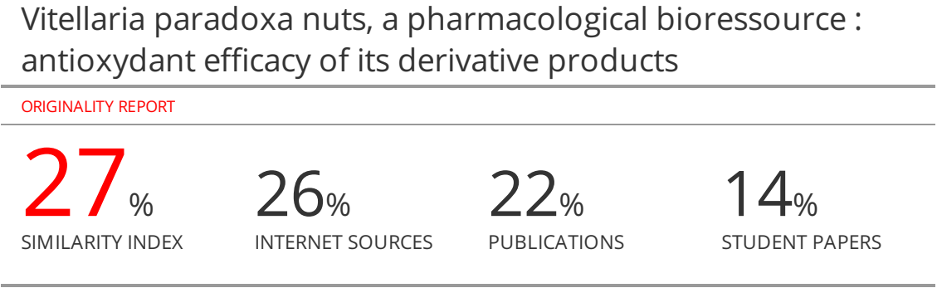

**Vitellaria paradoxa nuts, a pharmacological bioressource : antioxydant efficacy of its derivative products**

**Abstract**

Vitellaria paradoxa is an useful african tree…... ~~Its nuts~~ are mainly exploited for ~~their~~ fat or butter…... The present study was carried out in order to demonstrate the pharmacological virtues of shea nuts derivative products through their phytochemical components and their antioxydant efficacy. Therefore, their hydroalcoholic extracts were qualitatively screened in ordre to detect phytochemical components, and their antioxidant efficacy was tested through their ability to reducing DPPH. Results revealed that the whole shea nuts derivative products tested positive to phenolic compounds, flavonoids, tannins, terpenoids, triterpenic alcohols and to sterols ; most of these compounds are known as active principles. DDPH test also proved that the whole shea nuts derivative products have antioxidant power. This power varied creasingly (5.37%, 58.56% and 62.99%) from butter to hulls and press cake. Based on these results, shea nuts could constitute a value-added resource of bioactive principle, which might be taken into account in the prevention of ~~deseases~~ linked to oxidative stress, such as tumors, cancer and other degenerative deseases.

**Keywords** : Vitellaria paradoxa nuts, pharmaceutical virtues, phytochemical compounds, antioxidant efficacy, oxidative stress

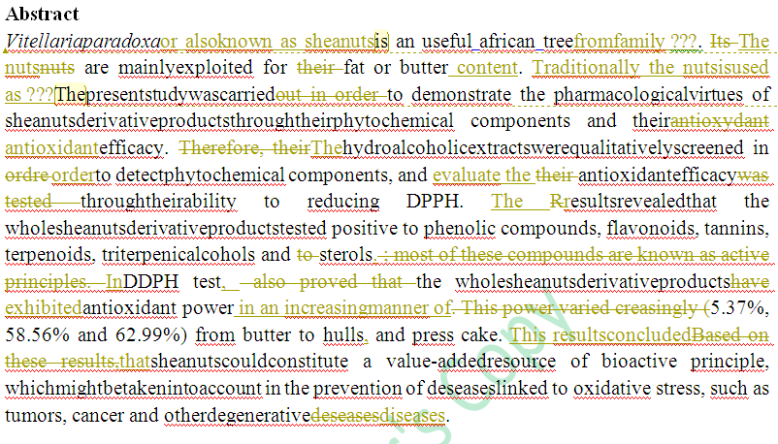

**Introduction**

Vitellaria paradoxa nut is an oleaginous seed which fat or butter is widely exploited for food and non-food purposes, mainly due to its physicochemical properties1-3. Its hulls and press cake are considered as waste and not efficiencely exploited as those of other oleaginous seeds do. Indeed, shea hulls are either burned or used as fuel and fertiliser. Press cakes as for them are given to cattle or used as salant in houses4,5. Parallely, hulls of many seeds serve in food industry as supplements and vitamins and amaminiacids providers6. They are also incorporated in cosmetics either entirely or their extract. These special uses are mostly linked to their contents in active compounds which would confer pharmacological virtues7. But, what about shea nuts hulls and press cakes ? Have-they any pharmacological interest ? Hence, this study was carry out in order to demonstrate the pharmacological virtues of shea nuts derivative products (butter, hull and pressvirtus) through their antioxydant efficacy. The study might be considered as a contribution to the prevention/fight against deseases due to oxidative stress like tumor and cancer, and also to the search for non-conventional source of bioactive compounds.

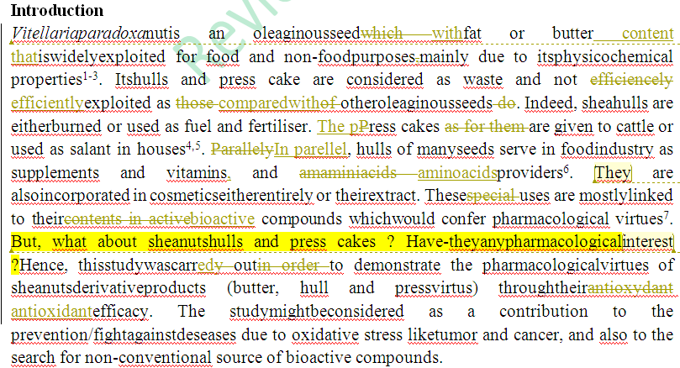

**Material and methods**

**~~Material~~**

For the study, dried shea nuts were kindly provided by the laboratory of the Pedagogy and Research United of Biotechnology located in University Felix Houphourt-Boigny (Côte d’ivoire). These nuts would be sun dried for five days, according to Megnanou et al.8 process.

**~~Methods~~**

**~~Phytochemical qualitative screening of shea nuts derivative products~~**

Qualitative screening methods described by Edeoga et al.9, Paris & Moyse10 and Evans11 were used to check the presence of phenolic compound, flavonoids, tannins, terpenoids, triterpenic alcohols and stérols, un shea nuts derivative products. Hence, hydromethanolic extracts of shea butter, hulls and press cakes were prepared folloing Singleton et al.12 method. A few amount of the resulting extracts was used for each qualitative test.

**~~DPPH assay for shea nuts derivative products antioxydant efficacy.~~**

The DPPH assay was conducted following Benhammou et al.13. The DPPH solution (6 mg in 100 mL methanol) was prepared by dissolving the DPPH radical in methanol at 70% (v/v). A 50 µL aliquot of methanol extract was pipetted in à tube à hemolyse and 1950 µl of DPPH solution then added. The mixture was incubated in darkness at room temperature for 30 min. The absorbance was read at 517 nm in a spectrophotometer (**Pioway, China**).

**Results and discussion**

**~~Phytochemical compounds of shea nuts derivative products~~**

Qualitative screening of phytochemical compounds revealed that the whole shea nuts derivative products tested positive to phenolic compounds, flavonoids, tannins, terpenoids, triterpenic alcohols and to sterols (**Table 1**).

**Table 1 : Phenolic compounds**

|  |  |  |  |  |  |  |
| --- | --- | --- | --- | --- | --- | --- |
|  | **Polyphenols** | **Flavonoids** | **Tannins** | **Saponin** | **Sterols** | **Triterpenic alcohols** |
| **SK** | **+** | **+** | **+** | **+** | **+** | **+** |
| **SB** | **+** | **+** | **+** | **+** | **+** | **+** |
| **SH** | **+** | **+** | **+** | **+** | **+** | **+** |
| **SPC** | **+** | **+** | **+** | **+** | **+** | **+** |

SK : Shea kernel ; SB : Shea butter ; SH : shea hull ; SPC : shea press-cake

(+) : Detected

These results mean that shea kernels, hulls, butter and press-cake contain valuable phytochemical compounds which are researched and widely exploited for pharmacological and cosmetical purposes. Indeed, terpenoids would be widely exploited in cosmetical industries under their identity of unsaponifiable fraction14 for their properties of antiaging, repairing, moisturing, etc.15. About unsaponifiable, anterior study has reported optimized shea butter important content Megnanou et al.8. As for phenolic compounds which are constituted by flavonoids and tannins chemical groups, they would confer antioxydant6,16, antidiabetic17,18, etc. virtues to their matrix ; they would be bioactive compounds like terpenoids. Matrix here, consisted in kernels, hulls, butter and press cakes ; the whole resulting from shea nuts. Hence shea nuts which is mostly exploited just for its fat, could now constitute a value-added resource of bioactive principle. A proof of this bioactivity was the antioxidant efficacy of its derivative products.

**~~Antioxidant efficacy of shea butter, hulls and press cakes~~**

Results of the antioxidant essay prooved that all the derivative products of shea nuts (butter, hulls and press cakes) reduced significantly DPPH which constituted in this study, the free-radicale to be scavenged. DPPH reducing powers varied (5.37 ± 0.89 %, 58.56 ± 0.24 % and 62.99 ± 0.56 %, for butter, hulls and press cakes, respectively) signficantly from a matrix to another (**Table 2**).

**Table 2 :** DPPH reducing power of shea nuts derivative products

|  |  |  |  |
| --- | --- | --- | --- |
|  | **Shea butter (0.2mg/mL)** | **Shea nuts hulls (10mg/mL)** | **Shea press cakes (10mg/mL)** |
| **DPPH reducing power (%)** | 5.37 ± 0.89 | 58.56 ± 0.24 | 62.99 ± 0.56 |

However, it is to retain that shea nut could constitute a powerful antioxidant matrix which can be either consumed directly like cola nut, cocoa, curcuma, etc., or be incorporated to food, drugs or cosmetics, as supplement. Indeed, with the present prevalence of metabolic diseases and those dues to oxidatif stress, shea nuts, with its derivative products, appears as a solution to the research for non-conventional source of antioxidants.

**Conclusion**

Shea nuts which are mainly trader and exploited for their fats, revealed through the present study, their ability as valuable sources of bioactive compounds such as phenolic compounds, flavonoids, tannins, terpenoids, triterpenic alcohols and to sterols. Moreover, all of the derivative products (butter, hulls and press cakes) proved antioxidant efficiency.

Shea nuts constitute a value-added resource of bioactive principle, and could be taken into account in the prevention of deseases linked to oxidative stress, such as tumors, cancer and other degenerative deseases.

**AcknowledgEments**

This work was supported by a PhD grant of the first author. The authors are grateful to UPR of Biotechnology of Félix Houphouët Boigny University (Côte d'Ivoire) for technical assistance.

**Conflict of interest**

No conflict of inerest associated with this work.

**Authors’ Contributions**

This work was carried out in collaboration among all authors. Authors RM and ABK designed the study, wrote the protocol. Authors ABK, and AESD anchored the field study, gathered the initial data and performed preliminary data analysis. While authors ABK, and RM managed the literature searches, interpreted the data and produced the initial draft. All authors read and approved the final manuscript.

**Human or Animal Context**

This article does not contain any studies with human or animal subjects.

**References**

**1. Amougou Marie GE.** Étude de l'effet hydratant du beurre de karité et de l'huile d'Ergan. Thèse de doctorat, Université de Rabat, Maroc ; 2009.p. 124.

**2. Dubut O**. Les beurres (karité (Butyrospermum parkii), cacao (Theobroma cacao), kokum (Garcinia indica) et illipé (Shorea stenoptera)). Thèse de doctorat d’état, Université de Nantes, France ; 2012. p. 128.

**3. Kouyate AM, Dembele U & Lykke AM**. Les espèces ligneuses locales à huile : une ressource utile pour les communautés locales au Sud du Mali. International Journal of Biological and Chemistry Science 2015 ; 9 (6): 2754-2763.

**4. Nkouam GB**. Conservation des fruits du karité (Vitellaria paradoxa Gaertn.) et de l’aiéle (Canarium schweinfurthii Engl.) : isothermes de sorption d’eau et extraction des matières grasses des fruits stockés. Thèse de doctorat, Université de Ngaoundere (Cameroun) et de l’institut national polytechnique de Lorraine (France), France ; 2007. p. 287.

**5. Tchakala I, Mande SA, Diyakadola DB, Tomkouani K, Moctar LB & Gbandi D**. Etude d'adsorption du phénol, du 4- chlorophénol et du 4-nitrophénol sur deux charbons actifs préparés à partir des tourteaux de karité (CA-K) et des graines de coton (CA- C) : étude cinétique. Journal de la Société Ouest-Africaine de Chimie 2019 ; 47: 40-51.

**6. Peng H, Deng Z, Chen X, Sun Y, Zhang B & Li H**. Major chemical constituents and antioxidant activities of different extractsn from the peduncles of Hovenia acerba Lindl. International Journal of Food Properties 2018 ; 21 (1): 2135-2155.

**7. Sereme A, Millogo-Rasolodimby J, Guinko S & Nacro M**. Proprietes therapeutiques des plantes a tanins du burkina faso. Pharmacopée et Médecine traditionnelle Africaines 2008 ; 15: 41-49.

**8. Megnanou R-M, Niamke S & Diopoh J**. Physicochemical and microbiological characteristics of optimized and traditional shea butters from Côte d’Ivoire. African Journal of Biochemistry Research 2007 : 1 (4): 41-47.

**9. Edeoga HO, Okwu DE & Mbaebie BO**. Phytochemical constituents of some Nigerian medicinal plants. African Journal of Biotechnology 2005 ; 4 (7): 685-688.

**10. Paris R & Moyse H**. Précis de matière médicinale. Paris: Masson ; 1969.

**11. Evans WC**. Trease and Evan's Pharmacognosy. London ; 2004. p. 302.

**12. Singleton VL, Orthofer R & Lamuela-Raventos RM**. Analysis of total phenols and other oxidation substrates and antioxidants by means of Folin-Ciocalteu reagent. Methods in Enzymology 1999 ; 299: 152-178.

**14. Masson P**. Intérêt de "l'insaponifiable de luzerne" dans une formulation cosmétique à usage solaire. Parfums, cosmétiques, arômes 1985 ; 62: 85-87.

**15. Yang W, Chen X, Li Y, Guo S, Wang Z & Yu X**. Advances in Pharmacological Activities of Terpenoids. Natural Product Communications2020 ; 15 (3): 1-13.

**16. Agrawal PK**. Carbon-13 NMR of flavonoids. New York: Elsevier ; 1989.

**17. Djoman AES, Kouakou AB, Mégnanou R-M & Doué GG**. Potential exploitation of Shea press cakes in glycaemia regulation: Inhibition of α-amylase and α-glucosidase by protein and methanolic extracts. GSC Biological and Pharmaceutical Sciences 2021 ; 15 (2): 83-91.

**18. Solayman M, Ali Y, Alam F, Asiful Islam M, Alam N, Ibrahim Khalil M & Hua Gan S**. Polyphenols: potential future arsenals in the treatment of diabetes. Current Pharmaceutical Design 2016 ; 22 (5): 549-565.