**Reviewer’s Comments**

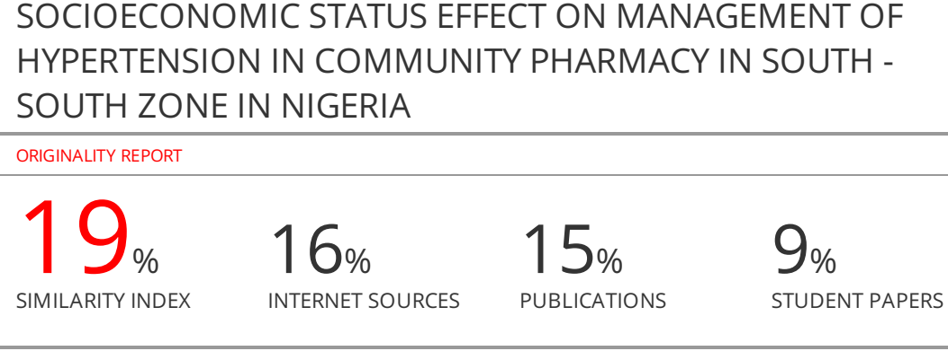

**SOCIOECONOMIC STATUS EFFECT ON MANAGEMENT OF HYPERTENSION IN COMMUNITY PHARMACY IN SOUTH - SOUTH ZONE IN NIGERIA**

**Abstract**

**Background to study:** Effective management of hypertension is influenced by several factors that center on social and economic status of the patient. Identification of these factors will enable informed intervention in the management of hypertensive patients. **Objective**: The study aimed to determine possible association between blood pressure control and socioeconomic status of patients who are managed in community pharmacies in Rivers State. **Method**: A descriptive cross-sectional survey of thirty-nine community pharmacies was conducted between July and December 2018. A total of 195 respondents participated in the study. Every patient’s consent was obtained. Further information on patients’ demographics were extracted from pharmacists’ documentation files. Such include age, medication patient is on, duration of hypertension, co-morbidity, income/ social status, lifestyle and habits like smoking, alcohol consumption, educational status, and mean blood pressure over the study period. The outcome measure taken as controlled blood pressure was mean BP ≤140/90 mm Hg for the general population and BP 130/80 mmHg for patients with diabetes as co-morbidity. BP >140/90 mm Hg was considered as uncontrolled blood pressure. **Result**: A total of 195 respondents participated in the study, of which 105(53.8%) were male and 90(46.2%) were female. Out of this number 75(38.5%) were below 40yrs of age, 105(53.8%) were between 41 – 50yrs of age and only 15(7.7%) were 60yrs and above. More female had BP control compared to the male (OR 1.89, 95%CI {1.16 - 3.07}, P=0.009. Patients within ages 41 - 59yrs had more controlled BP compared to older age, 60yrs and above, OR 1.48, 95% CI (0.84 - 2.42)p 0.18. Uncontrolled BP was found more among employed patients and patients with highest monthly income, OR 1.05 95% CI {0.58 - 2.00}; OR 1.16 95% CI {0.49 - 2.78} P, 0.36 respectively. Exercise activities have significant impact on BP control as alcohol consumption increased OR of BP control with no significant difference in OR on amount of monthly expenditure on medications. **Conclusion**: Male gender, employment, and high income earning have negative effect on BP control while exercise is associated with BP control

**Key Words: Socioeconomic factors, uncontrolled Blood Pressure, South - South Nigeria**

**Introduction**

Effective management of hypertension is being influenced by a number of factors that center on social and economic status of the patient. Identification of these factors will enable informed intervention in the management of hypertensive patients. Association between socioeconomic status and poor health, particularly cardiovascular condition, has been known for decades in high income countries (1- 4). Few studies have reported on hypertension in relation with individual patient-level socioeconomic status in sub–Saharan African. (5-7) Hypertension was defined as, in absence of anti-hypertensive drugs, blood pressure measured at least three times in different days, with a systolic blood pressure >140 mmHg and/ or diastolic blood pressure > 90mmHg. High blood pressure is a serious public health concern, with World Health Organization (WHO) reporting global hypertension mortality rate of 13%. (8) High blood pressure is a preventable disease and has been associated directly with lifestyle habits including tobacco smoking, educational status, lack of physical activity and alcohol consumption (9). In fact, the relationship between hypertension and socioeconomic status (SES) has been well established in advanced countries (4). Socioeconomic status (SES) is a complex term combining a number of variables including employment status, educational level, income, and wealth as well as place of residence. SES is a well-established cardiovascular risk factor and means for predicting behavior (10, 11). Educational status has been established as the best marker of SES since it offers the most stable measure at an individual level and does not have the problem of reverse causation such as income and wealth statue. (11) Studies of hospital populations have shown an association between low SES and higher prevalence of hypertension, poorer BP control and higher mortality rate (12-16). However, studies on the relationship between SES and hypertension in low- and middle-income countries are limited (17, 18). While the association between SES and BP control among patients who manage their BP condition in general practice has not been fully established. Thus this work aimed to evaluate influence of socioeconomic factors on management of hypertension among patients managed in community practice.

**Method**

**Study area**

Port Harcourt, one of the largest cities in the South -South geopolitical Zone of Nigeria, is the State capital of Rivers State. It has a total of 374 registered pharmacies spread across the State and grouped under 20 zones.

**Study Population**

This comprises of all patients 20yrs and above who visited community pharmacies for consultation and/or refill of their anti hypertensivemedication, and were willing to participate in the study.

**Sample size**

The sample size determined was calculated using the method by Araoye, 2004 (19). A total of 200 questionnaires were distributed across the 20 zones of the registered pharmacies, and a total of 195 were retrieved, with each patient giving consent to participate in the study.

**Study design**

A descriptive cross-sectional study was carried out among patients who attend community pharmacies for their anti-hypertensive medication needs, to assess the influence of socioeconomic status on the management of hypertension among these patients.

Structured pre-tested and validated questionnaires were used to collect the required data. The questionnaire designed consisted of 5 parts: A, B, C, D, and E. Part A consists of demographic information of the patients including age, gender and marital status. Part B consists of data on social information like life style habits, such as smoking, alcohol consumption and physical activities. Part C, consists of economic status such as monthly income, and average of cost of medication per month. Part D consists of management data such as medication used, frequency of blood pressure monitoring, current and average BP value for the period of study, and advice on life style modification by the health professional. Part E consist of other questions such as co-morbidity.

**Data analysis**

Data collected was analyzed using SPSS statistical package version 20 and significance difference was considered at p<0.05.

**Results**

The demographic and characteristic data of the respondents are shown in Table 1. Of the 195 respondents, 54%(105) were male and 46%(90) were female. The overall mean age was 56.8 $±$ 7.8yrs. Most, 53.8% (105) of the respondents were within the ages of 40yrs - 59yrs. Overall blood pressure ranged between 120mmHg systolic and 80mmHg diastolic to 160mmHg systolic and 100mmHg diastolic.

Table 1. Demographic and Characteristic data of Respondents

|  |  |  |
| --- | --- | --- |
| Demographic data | Proportion | Percentage |
| Gender  Male  Female | 105  90 | 53.8%  46.2% |
| Age  >40yrs  ≤40 - ≥59yrs  ≥60yrs | 75  105  15 | 38.5%  53.8%  7.7% |
| Marital status  Married  Single | 150  45 | 76.9%  23.1% |
| Educational status  Primary  Secondary  Tertiary | 30  100  65 | 15.4%  51.3%  33.3% |
| Employment status  Employed  Unemployed  Retired | 120  66  9 | 61.5%  34.0%  4.6% |
| Monthly income earning (Naira)  Lowest (>50,000.00)  Medium(≤50,000.00 - 100,000.00)  Highest (100,000.00) | 120  45  30 | 61.5%  23.1%  15.4% |
| Monthly expenditure on medication  Lowest (>5000.00)  Medium (≤5000.00 - 10,000.00)  Highest (10,000.00) | 120  40  35 | 61.5%  20.5%  18.0% |
| Exercise activity  Yes  No | 75  120 | 38.5%  61.5% |
| Alcohol intake  Yes  No | 95  100 | 48.7%  51.3% |
| Smoking  Yes  No | 30  165 | 15.4%  84.6% |

The results of various factors that affect blood pressure control is given in Table 2. Controlled blood pressure was considered as BP level ≤ 140 mmHg systolic and ≤ 90mmHg within the 6 months of study and BP level >140mmHg systolic and >90 mmHg diastolic was taken as uncontrolled blood pressure.

**Table 2: Factors that Influence Blood Pressure Control**

|  |  |  |  |  |  |
| --- | --- | --- | --- | --- | --- |
| Factor | Controlled BP≤140/90 mmHg | Uncontrolled BP>140/90mmHg | OR (odd ratio) | 95%CI (confidence interval) | p-value |
| Gender  Male  Female | 40(38.1%)  65(72.2%) | 65 (61.9%)  25(27.8%) | 1.89 | 1.168 -3.076 | 0.0096 |
| Age  >40yrs  41-59yrs  ≥60yrs | 30(40%)  45(42.9%)  11(73.3%) | 45(60%)  60(57.1%)  4(26.7%) | 1.43  1  0.67 | 0.842 -2.424  0.204 -2.172 | 0.186  0.501 |
| Marital status  Single  Married | 35(77.8%)  48(32%) | 10(22.2%)  102(68%) | 1  0.874 | 0.526 to 1.453 | 0.604 |
| Educational status  Primary  Secondary  Tertiary | 20(66.7%)  45(45%)  40(61.5%) | 10(33.3%)  55(55%)  25(38.5%) | 1  2.44  1.25 | 1.039 to 5.749  0.504 to 3.102 | 0.02  0.315 |
| Employment status  Employed  Unemployed  Retired | 75(62.5%)  40(60.6%)  8(88.9%) | 45(37.5%)  26(39.4%)  1(11.1%) | 1  1.083  0.208 | 0.585 to 2.007  0.025 to 1.721 | 0.399  0.072 |
| Monthly income (Naira)  >50,000.00  50,000.00 to 99,000.00  ≥100,000.00 | 40(33.3%)  32(71.1%)  9(30%) | 80(66.7%)  (13(28.9%)  21(70%) | 1  0.231  1.166 | 0.096 to 0.429  0.490 to 2.780 | 0.0015  0.363 |
| Monthly expenditure on medication  >5000.00  5000.00 to 10,000.00  <10,000.00 | 70(58.3%)  32(80%)  25(71.4%) | 50(41.7%)  8(20%)  10(28.6%) | 1  0.351  0.562 | 0.149 to 0.823  0.247 to 1.269 | 0.0080  0.0824 |
| Exercise Activities  Yes  No | 68(90.7%)  35(29.2%) | 7(9.3%)  85(70.8%) | 1  23.591 | 9.865 to 56.419 | 0.000 |
| Alcohol Consumption  Yes  No | 55(73.3%)  70(58.3%) | 20(26.7%)  50(41.7%) | 1  1.964 | 1.049 to 3.679 | 0.0174 |
| Smoking Habit  Yes  No | 8(26.7%)  45(27.3%) | 22(73.3%)  120(72.7% | 1  0.9696 | 0.403 to 2.335 | 0.4721 |

The various types of anti-hypertensive medication used by the patients and the frequency of their use is shown in Fig. 1. Amilodipine is the most frequently used of all the anti-hypertensive agents. Vasoprin which is an anti platelet or blood thinner is used as frequent but more than Clopidogrel which is also an anti-platelet, probably due to cost since Vasoprin is cheaper.

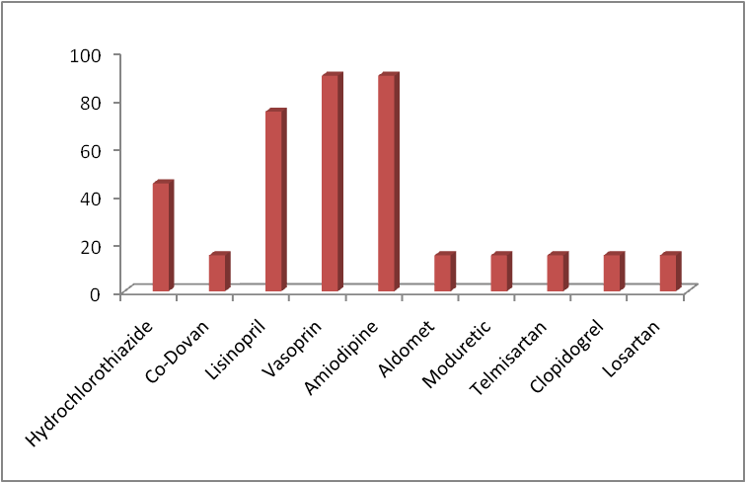

**Fig. 1. Various Anti-hypertensive agents used to control blood pressure**

**Discussion**

This study determined the influence of socioeconomic status on the management of hypertension among patients who manage their hypertensive condition in community Pharmacies in Port Harcourt, Rivers State. This study identified that socioeconomic status was associated with BP control among the patients who manage their blood pressure in the community pharmacies. The study found that more female achieve BP control than the male.Thismaybe related to female showing more concern to their health than their male counterparts. This finding is in line with two similar studies carried out in Western part of Nigeria (20) and South Eastern part (21) which opined that with respect to responsibilities of a traditional African man, such as family responsibility, as a factor predisposing more African males to increased blood pressure, hence hypertension with limited concern to its control.This result may be in line with a systematic review which indicated that prevalence of hypertension is higher among men than women (17, 22).

Studies have recommended that socioeconomic factors like education, occupation, and income should not be used interchangeably. (23 - 25 ) These factors were studied independently in this work and a significant difference in BP control was observed. Low educational level was found to be associated with BP control, which is similar to previous study (26) where effect of education level on BP control remained after adjustment for a number of factors. Probably, higher education may give advantage for better understanding of the risk of uncontrolled BP and importance of its treatment. It may also be possible that effect of education on BP control maybe related to employment status and monthly income earning or amount spent on medication. In Table 2 patient in employment have BP control of less than 140/90 mmHg than the unemployed. Again more patients on lowest income have uncontrolled BP. This maybe reflection of how much was spent on medication to control the BP as is shown that there is a significant difference (p<0.01) in BP control based on the amount spent on medication. Study by Antignac, et al., 2017(27) highlighted the relative association of individual wealth and country - level income with uncontrolled hypertension.

Another significant factor is marital status of the patients. Generally, it was observed that a larger number of the respondents were married (150(76.9%). Uncontrolled BP was identified more among the married compared to those single, p< 0.01. The reason for this observation is not clearly known but maybe attributed to the intricacies involved with marriage as a predisposing factor. The fact that more of the respondents are married (77%) maybe another reason, but considering and comparing the significance difference (p<0.05) between married with uncontrolled BP, and that of the single respondents’, points to other possible reason other than number.

In this study, social factors such as lack of exercise, smoking habit and alcohol consumption have been correlated to the management of hypertension. Respondents who do not exercise, and respondent who smoke as well as those who consume alcohol exhibited uncontrolled blood pressure, significantly different from that of those who do not indulge in these habits . This further supports these factors as risk factors to hypertension.

Again, the most frequently used anti-hypertensive agent was amilodipine, followed by lisinopril, the cost of which is less than ARB (angiotensin receptor blockers like losartan that are better kidney protector in the face of comorbidity like diabetes. This could also affect the level of BP control, further supporting cost effect on BP control.

**Conclusion**

Socioeconomic factors are found to associate with uncontrolled blood pressure. Male gender, employment, and lowest income earning as well as amount of monthly expenditure on medications have negative effect on BP control while exercise is associated with controlled blood pressure

**Disclosure**

The authors disclosed that the work was self sponsored and did not receive any fund. The protocol and data are therefore not influenced.

**Conflict of Interest**

The authors declare that they have no conflict of interest

**Author’s Contribution**

**References**

1. Hauser RM, Carr D, Hauser TS, et al., The class of1957 after 35 years; overview and preliminary findings. Center for Demography and Ecology Working Paper No 93 -17 Madison WI University of Wisconsin, Madison; 1994
2. Marmot MG, Shipley MJ, Rose G. (1984). Inequalities in death- specific explanations of of a general pattern? Lancet 1: 1003 - 1006
3. Marshall IJ, Wang Y, Crchton S, McKevitt C, Rudd AG, Wolfe CD. (2015). The effects of socioeconomic status on stroke risk and outcomes. Lacet Neurol. 14: 1206 - 1218. doi: 10.1016/S1474 -4422(15)00200-8.
4. Leng B, Jin Y, Li G, Chen L, Jin N. (2015). Socioeconomic status and hypertension: a meta-analysis. J Hypertens 33: 221 - 229. doi: 10.1097/HJH.0000000000000428.
5. Bunker CH, Okoro FI, Markovic N, Thai N, Pippin B, Ackrell M, Kuller LH. (1996). Relationship of hypertension to socioeconomic status in a West African population. Ethn Health. 1: 33 - 45. doi: 10.1080/13557858. 1996.9961768.
6. Bovet P, Ross AG, Gervasoni JP,Mkamba M, MtasiwaDM,Lengeler C, Whiting D, Paccaud F. (2002). Distribution of blood pressure, body mass index, and smoking habits in theurban population of Dar es Salaam, Tanzania, and associations with socioeconomic status. Int J Epidemiol. 31: 240 - 247.
7. Murphy GA, Asiki G, Ekoru K, Nsubuga RN, RN, Nakiyingi- Miiro J, Young EH, Seeley J, Sandhu MS, Kamali A. (2013). A Sociodemographic distribution of non - communicable disease risk factors in rural Uganda: a cross- sectional study. Int J Epidemiol. 42: 1740 - 1753, doi: 10: 10.1093/ije/dyt184.
8. WHO Global Health Risks: Mortality and Burden of Disease Attributable to Selected Major Risks, WHO Geneva, Switzerland, 2009.
9. WHO High Blood Pressure -- Country Experience and Effective Interventions Utilized across The European Region, WHO Copenhagen, Denmark, 2012.
10. Lam CSP. (2011). “The socioeconomic of hypertension: How $50,000 may buy a drop of blood pressure” Hypertension 58(2):140 - 141.
11. Minor D, Wofford, M, and Wyatt SB. (2008). “Does socioeconomic status affect blood pressure goal achievement?” Current hypertension reports 10(5): 390 - 397.
12. Mensah GA, Mokdad AH, Ford ES, Greenlund KJ, Croft JB. (2005). State of disparities in cardiovascular health in the United States. Circulation 111: 1233 - 1241
13. Avendano M, Glymour MM, Banks J, Mackenbach JP. (2009). Health disadvantage in US adults aged 50 to 74years: a comparison of the health of rich and poor Americans with that of Europeans. Am J Public Health 99: 540- 548
14. Avendano M, Kunst AE, Huisman M et al; (2006). Socioeconomic status and ischeamic heart disease mortality in 10 Western European populations during the 1990s. Heart 92: 461 - 467
15. Grotto I, Huerta M, Sharabi Y. (2008). Hypertension and Socioeconomic status. Current OpinCardiol 23: 335 - 339
16. Kaplan MS, Huguet N, Feeny DH, McFarland BH. (2010). Self- reported hypertension prevalence and income among older adults in Canada and United States. Soc Sci Med 70: 844- 849
17. Fang L, Song J, Ma Z, Zhang L, Jing C, and Chen D. (2014). “ Prevalence and Characteristics of hypertension in mainland Chinese adults over decades: a systematic review” Journal of Human Hypertension 28(11): 649 - 656
18. Liu J, Rozelle S, Xu Q, Xu , Yu N and Zhou T. (2019). Social engagement and elderly health in China: evidence from China health and retirement longitudinal survey (CHARLS)
19. Araoye MO. (2004). Sample size determination in Araoye, M.O. (Ed) Text book of Research Methodology with statistic for health and Social Scientists, Nathadex, Ilorin, Nigeria pp 117 -120
20. Akinlua JT, Meakin R, Umar AM, and Freemantle N. (2015). Current Prevalence of pattern of hypertension in Nigeria: A systematic review. PLoS one 10/10: e0140021 doi: 10.1371/journalpone.0140021
21. Oguoma VM, NwoseEU, Skinner TC, Digban KA, Onyia CI, Richards RS. (2015). Prevalence of cardiovascular disease risk factors among a Nigerian adult population: relationship with income level and accessibility to CVD risks screening. PMC Public Health 15:397doi: 10.1186/s 12889 -015 - 1709-2
22. Wu Y, Huxley R, Li L, et al.; (2008) “Prevalence, awareness, treatment, and control of hypertension in China: data from China National Nutrition and health survey 2002”. Circulation 118(25): 2679 - 2686
23. Chaix B, Bean K, Leal C, et al.; (2010). Individual/neighbourhood social factors and blood pressure in RECORD Cohort Study: which risk factor s explain the associations? Hypertension 55: 769 - 775
24. LahelmaE, Martikainen P, Laaksonen M, Aittomaki A. (2004). Pathways between socioeconomic determinants of health. J Epidemiol Community Health 58: 327 - 332
25. Geyer S, HemstromO, Peter R, Vagero D. (2006). Education, income, and occupational class cannot be used interchangeably in social epidemio;logy. Empirical evidence against a common practice. J Epidemiol Community Health 60: 804 - 810
26. Paulson MS, Andersen M, et al.; (2012). Socioeconomic status influences blood pressure despite equal access to care. Family practice 29(5): 503 - 510
27. Antignac M, Diop B, Do B, N’GuettaR, Toure IA, Zabsonre P, Jouven X. (2017).Quality assessment of 7 cardiovascular drugs in 10 sub- Saharan countries: the SEVEN study JAMA Cardiol. 2: 223 - 225. doi: 10.1001/jamacardio.2016.3851