**Reviewer’s Comments**

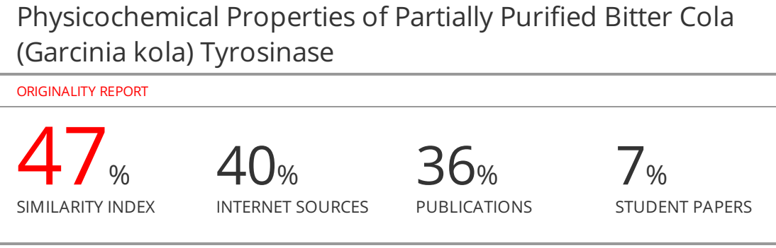

**Physicochemical Properties of Partially Purified Bitter Cola (*Garcinia kola*) Tyrosinase**

**Abstract**

Tyrosinase is a multifunctional, glycosylated and copper-containing oxidase, which catalyzes the first two steps in mammalianmelanogenesis and is responsible for enzymatic browning reactions in damaged fruits during post-harvest handling and processing. Neither hyperpigmentation in human skin nor enzymatic browning in fruits are desirable. In this study, the properties and inhibitory effect of some compounds on bitter cola tyrosinase were investigated. Bitter cola tyrosinase was isolated and characterized using standard protocols. Partial purification was carried out on Sephadex G-100 loaded column chromatography. Bitter cola tyrosinase had specific activity of 3.5 U/mg protein, purification fold of 2.4 and a yield of 34%. The optimum pH value was found to be 6.0 while the optimum temperature value for maximum enzyme activity was observed at 60°C. The enzyme was stable at 40oC for 20 minutes. Metals such as NaCl, KCl, MgCl2 and CaCl2 had inhibitory effect on the activity; though MgCl2 and CaCl2 had minimal effect. Also, EDTA, β-marcaptoethanol and glutathione greatly inhibited the enzyme activity at all the tested concentration. The properties of bitter cola tyrosinase compare very well with the tyrosinase from other sources. Also, the study was able to established the inhibitory effect of some compounds and this could be of used in food processing industries.

Keywords: Tyrosinase, inhibitors, bitter cola, specific activity, melanin

**Introduction**

Tyrosinase(also called monophenol monooxygenase, EC 1.14.18.1)is a binuclear copper containing enzyme that catalyzes the conversion of monophenols(tyrosine) into o-diphenols followed by the oxidation of o-diphenol to the corresponding o-quinone derivative (Figure 1) (Sánchez-Ferrer et al., ~~1995~~; Solomon et al., ~~1996~~). It is known to be the only copper-containing enzyme to perform these two subsequent reactions; the related catechol oxidases only catalyze the second reaction, using o-diphenols as substrates (Decker and Tuczek, ~~2000~~; Eicken et al., ~~1999~~). Tyrosinases recruit molecular oxygen as a co-substrate for the first reaction (Rolff et al., ~~2011~~). One of the oxygen atoms is incorporated in the phenolic ring while the other oxygen atom is reduced to a water molecule. This catalytic cycle requires a reducing agent to provide two electrons to carry out the first step. These two electrons originate from the second step of the reaction.

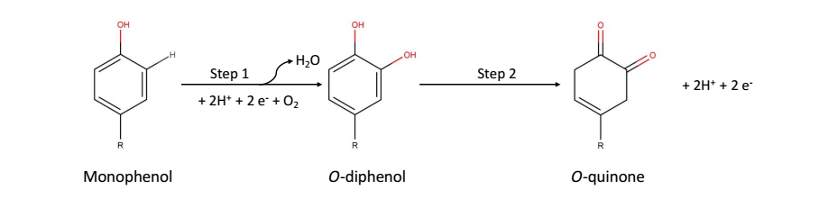Figure 1. Reaction catalyzed by tyrosinase (Sánchez-Ferrer et al., ~~1995~~; Solomon et al., ~~1996~~).

The final product of the tyrosinase-catalyzed reaction is DOPA-quinone, which is a precursor for the synthesis of melanin (Ito andWakamatsu, ~~2008~~). Melanins are pigments that play important roles in the survival of organisms ranging from bacteria, plants, to mammals (Riley, ~~1997~~; Butler and Day, ~~1998~~; Plonka and Grabacka, ~~2006~~). In mammals, including humans, melanin is mostly found in the skin, where it functions in photoprotection against UV radiation (Jablonski and Chaplin, ~~2010~~). Plants employ o-quinones to modify and harden the protective exterior layer and as an agent against invasive organisms.Function also occurs in fruits and potato, and in the fruit bodies of fungi. Although some tyrosinaseinhibitors have been discovered and reviewed (Rescigno et al., ~~2002~~; Parvez et al., ~~2007~~); the need for more inhibitors cannot be overemphasized. Tyrosinases have been isolated and characterized from different sources. However, some limited information has been provided on tyrosinase from bitter cola. This study therefore aims to investigate the properties of bitter cola tyrosinase and investigate the inhibitory effect of some selected compounds.

**Material and Methods**

**Materials**

Bitter cola used in this study was obtained at Akinola market in Ipetumodu, Ile Ife, Osun State Nigeria.

**Chemicals**

The chemicals used include; 3,4-dihydroxyphenyl-L-alanine (L-DOPA), sodium hydroxide pellet, trizma base, trizmaHCl, acetic acid, citric acid, sodium citrate, bovine serum albumin (BSA), sodium phosphate dibasic (Na2HPO4), anhydrous sodium phosphate monobasic (NaHPO4), phosphoric acid, Coomassie brilliant blue R-250 were obtained from Sigma Chemical Company, St Louis, USA.

**Methods**

**Preparation of bitter cola Homogenate**

The Bitter cola was peeled and 10 g of it was homogenized in 50 mM phosphate buffer at 4 oC. The 30% homogenate was centrifuged at 10,000×*g* for 30 min at 4 oC in order to obtain clear crude supernatants. The supernatant obtained was assayed for protein and tyrosinase activity.

**Standard tyrosinase activity assay**

Tyrosinase activities in crude and partially purified sample were determined using L-3,4-dihydroxyphenylalanine (L-DOPA) as substrate. Modified method of Lerch and Etlinger(1972) was adopted. This involved monitoring the change in absorbance of the assay mixture in a spectrophotometer. An assay mixture of 1 ml in a cuvette contained in final concentration, 50 mM sodium phosphate buffer pH 6.5, 1 mM L-DOPA and aliquot of enzyme concentration. A complete assay mixture in which enzyme was replaced with distilled water served as blank. Absorbance was read at intervals of 10 s at 475 nm for 3 min and the initial rate of the reaction was calculated as the change in absorbance per minute.

One unit of enzyme activity was defined as the amount of enzyme that catalysed the formation of 1 µmole of product (*o*-dopaquinone) per minute at 475 nm.

**Determination of Protein Concentration**

The protein concentrations in the crude homogenates, partially purified or purified tyrosinase were determined as described by Bradford (1976) using bovine serum albumin (BSA) as the standard protein.

**Effect of pH on Activity Tyrosinase**

Effect of pH on activities of tyrosinase from bitter cola was measured at different pH values ranging from 3 to 10. The following buffer systems at the indicated pH ranges were used: 50 mM citrate buffer, pH 3.0 - 6.0; 50 mM phosphate buffer, pH 7 – 8 and 50 M borate buffer, pH 9.0 - 10

**Effect of Temperature on Activity Tyrosinase**

The effect of temperature on activities of tyrosinase from bitter cola was carried out by incubating the reaction mixtures containing 50 mM phosphate buffer, pH 6.0 and 1.5 mM L-DOPA at temperatures ranging from 10 to 90 oC for 4 min. The residual tyrosinase activity was plotted against the different temperatures.

**RESULT AND DISCUSSION**

**Enzyme purification**

The partially purified enzyme had a specific activity of 3.50 micromole per mg of protein (U/mg), a purification fold of 2.4 and a percentage yield of 34.3%**.** Specific activity, purification fold and percentage yield of tyrosinase from different sources have been reported. The results obtained in this study is similar to the one reported by other researchers.The activity of bitter cola tyrosinase was found to be optimum at pH 6.0 while the optimum temperature for activity was 60oC (Figure 2 and 3). The result of heat stability study is shown in Figure 4. Research has shown tyrosinases with L-dopa as substrate to have maximum activity at different temperature. Balakrishnan and Kalirajan, (~~2015~~) reported an optimum temperature of 25oC for tubers of *Amorphophalluspaeoniifolius*tyrosinase. Also, Salah et al., ~~2021~~ reported an optimum temperature range of 37-40 oC for *Aspergillus terreus*tyrosinase. The result in this study corroborate the result obtained in literature. Most plant tyrosinases show maximum activity at or near neutral pH value. The optimum pH for maximum tyrosinase activity in plants varies and it depends on the extraction method, the substrates used for assay, and the localization of the enzyme in the plant cell. The optimum pH obtained in this study was 6.0. It has been reported that optimum pH for potato tyrosinase activity was 6.4 while it was 7.0 for the other fruits tyrosinase.



**Figure 2: pH effect on bitter cola tyrosinase activity**



**Figure 3: Effect of Temperature on bitter cola tyrosinase activity**

**Figure 4: Heat Stability Study;** Graph of % Residual activity against incubation time for the determination of heat stability of tyrosinase

##### Effect of Salts on bitter cola tyrosinase Activity.

The results of the effect of salts show that the activity of the enzyme was inhibited by NaCl, KCl, MgCl2 and CaCl2 at high concentration; though the divalent metals had little effect on the enzyme (Figure 5). Also, the result of inhibitory effect EDTA, Glutathione and β-mercaptoethanol is presented in Figure 6. A gradual loss of activity was noticed up to the highest concentration of EDTA (10 mM) that was used. At this highest concentration, about 50 % activity had been lost. β-Mercaptoethanol was found to be a potent inhibitor for the enzyme. At concentration of 8 mM, β-Mercaptoethanol abolish the activity of the enzyme. 10 mM concentrations of glutathione also hadgreat inhibitory effect on the enzyme. The result obtained in this study is in line with what was obtained in previous studies (Rescigno et al., ~~2002~~; Parvez et al., ~~2007~~)



**Figure 5: Effect of Some Selected Metal Ions on bitter cola tyrosinase Activity.**



**Figure 6: Inhibitory effect of some compounds on bitter cola tyrosinaseactivity**

**Conclusion**

The properties of bitter cola tyrosinase compare very well with the tyrosinase from other sources. Also, the study was able to established the inhibitory effect of some compounds and this could be of used in food processing industries.

**Conflict of interest**

**Author’s Contribution**

**References**

Balakrishnan, G. S. and Kalirajan, J. (2015). Characterization of tyrosinase enzyme from the tubers of Amorphophalluspaeoniifolius (Dennst.) Nicolson, (Araceae). Int. J. Pharmacognosy and Phytochem. Res.7:585-589

Bradford, M. M. (1976). A rapid and sensitive method for the quantification of microgram quantities of proteins utilising the principle of protein-dye binding. *Analytical Biochemistry*, 72: 248–254.

Butler, M.J., and Day, A.W. (1998). Fungal melanins: A review. *Canadian Journal of Microbiology*. *44*, 1115–1136

Decker, H., and Tuczek, F. (2000). Tyrosinase/catecholoxidase activity of hemocyanins: Structural basis and molecular mechanism. *Trends in Biochemical Sciences*. *25*, 392–397.

Eicken, C., Krebs, B., and Sacchettini, J.C. (1999). Catechol oxidase - Structure and activity. *Current Opinion in Structural Biology*. *9*, 677–683.

Ito, S. and Wakamatsu, K. (2008). Chemistry of mixed melanogenesis - Pivotal roles of dopaquinone. Photochem. Photobiol. *84*, 582–592.

Jablonski, N. G and Chaplin, G. (2010). Human skin pigmentation as an adaptation to UV radiation. PNAS, 107: 8962-68.

Lerch, K. and Etlinger, L. (1972). Purification and characterization of a tyrosinase from *Streptomyces glaucescens*. *European Journal of Biochemistry*, 31: 427– 437.

Parvez, S., Kang, M., Chung, H. S. and Bae, H. (2007). Naturally occurring tyrosinase inhibitors: mechanism and applications in skin health, cosmetics and agriculture industries, phytotherapy research. 21: 805-16.

Plonka, P.M., and Grabacka, M. (2006). Melanin synthesis in microorganisms - Biotechnological and medical aspects. ActaBiochim. Pol. *53*, 429–443.

Properties of Tyrosinase from Aspergillus terreus and Penicilliumcopticola; Undecanoic Acid from Aspergillus flavus, an Endophyte of Moringaoleifera, Is a Novel Potent Tyrosinase Inhibitor (2021). Molecules, 26, 1309.

Rescigno, A., Sollai, F., Pisu, B., Rinaldi, A. and Sanjust, E. (2002). Tyrosinase inhibition: general and applied aspects. Journal of enzyme inhibition and medicinal chemistry, 17: 207-18.

Riley, P.A. (1997). Melanin. Int. J. Biochem. Cell Biol. *29*, 1235–1239

Rolff, M., Schottenheim, J. and Decker, F. T. (2011). Cheminform abstract: Copper-O2 reactivity of tyrosinase models towards external monophenolic substrates: molecular mechanism and comparison with the enzyme. *Chemical society reviews* 40: 4077-98.

Salah Maamoun, H.; Rabie, G.H.; Shaker, I.; A. Alaidaroos, B.; El-Sayed, A.S.A. Biochemical

Sánchez-Ferrer, Á., Rodríguez-López, J. N., García-Cánovas, F. and García-Carmona, F. (1995). Tyrosinase: a comprehensive review of its mechanism. *Biochimica et BiophysicaActa*, 1247: 1–11.

Solomon, E.I., Sundaram, U.M., and Machonkin, T.E. (1996). Multicopper oxidases and oxygenases. Chem. Rev. *96*, 2563–2606