Reviewer’s Comments
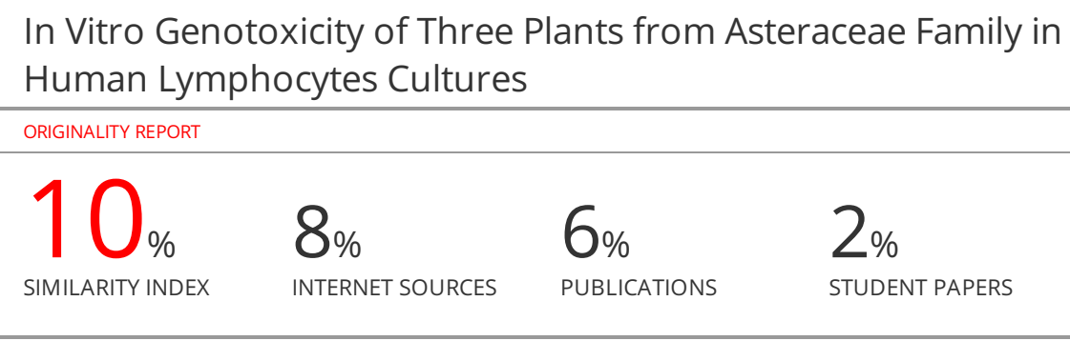
In Vitro Genotoxicity of Three Plants from Asteraceae Family in Human Lymphocytes Cultures
Abstract:
Onopordum carduiforme, Centaurea verutum, and Achillea santolina are medicinal plants grown in Syria and commonly used in traditional medicine. However, the genotoxic effects of these plants have not been studied. The aim of this study was to evaluate the genotoxic effects of hydroethanolic extracts of these plants on human lymphocyte cultures model by evaluating the cell proliferation, determination of mitotic index (MI), and their effects on chromosomes. The results showed that all three plants decreased non-significantly the mean of mitotic index at concentrations (1, 3, 5 mg/ml) and the range was between (2.25 ± 0.07 and 3.3 ± 0.28). However, C. verutum showed the lowest mitotic index (3 ± 0.14 at 1 mg/ml) and (2.25 ± 0.07 at 5 mg/ml), and did not induce chromatid or chromosome breaks or gaps. These preliminary results on cytotoxicity and mutagenicity of these plants provide valuable information about the safety of using them in alternative medicine.

Keywords: Achillea, Centaurea,, Onopordum, human lymphocytes cultures, karyotype, mitotic index (MI).

- Introduction
Medicinal plants have played a crucial role within the treatment of human sicknesses all over the world. The chemical components of medicinal plants are important for discovering new medicine such as chemotherapeutic¹. Onopordum carduiforme (O. carduiforme), Centaurea verutum (C. verutum), and Achillea santolina (A. santolina) are the plants used in this study. These plants belong to the Asteraceae family, which is one of the largest families in the plant kingdom, with an estimated number of 25,000 species spreading in wide areas. In addition, this family comes second in Syria in terms of species figures (322 species in Syria) belonging to 99 genera².

Onopordum carduiforme is a biennial or perennial herb, 30-100 cm height, sparsely cobwebbed, stem erect, much-branched; wings consisting of triangular long-spiny lobes connected by a narrow green margin, leaves are almost glabrous on the upper face, often cobwebbed and greyish on the lower, florets dark purple. The heads are numerous. Involucre 2-5 cm in diameter (not including spines). Florets time: March-August³. Onopordum genus has been commonly used in folkloric treatments, as an emetic expectorant, anti-asthmatic, and diuretic to treat nervousness, tetanus, and carcinomas. Various studies have demonstrated the efficiency of antihypertensive, antibacterial, cardio tonic, and hemostatic properties, increasing the tone of smooth muscles, and having protective activity against lipid peroxidation³⁻⁵.

Centaurea verutum is an annual plant, 50-130 cm height, stem rigid, simple, erect, or with erect branches; stem and leafy branches, lower leaves are mostly sinuate, other leaves are entire, oblong, the florets are yellow. Involucre broadly ovoid, truncate at base, 1.5-2 cm (not including spines). Flowering head 2-3 cm in diameter, Florets time: May-July³. This plant was used for the treatment of infectious diseases, stomach ache, edema, swellings, arthritis, and pain⁶. Several studies have confirmed that species of Centaurea have antibacterial and antioxidant properties ^{6,7}.

Achillea santolina is a perennial herb, 15-30 cm height, woolly, stems erect to ascending, simple or branched, leafy up to the inflorescence, leaves narrow, linear, green. Heads are radiate, in compound and corymbs. Involucre 4-5 mm. Florets time: March-April³. Pharmacological studies have shown that Achillea genus has different chemical and therapeutic properties as an anti-hyperlipidemia, Diuretic, hypotensive action, and antioxidant^{5,8}. However, extreme usage of medicinal plants can affect poisoning and death in humans and animals. Therefore, the genotoxicity and cytotoxicity of medicinal plants were used by the population are necessary to be aware of, along with the ones which pose mutagenic and carcinogenic risks^{1,5}. Cytogenetics is the area of genetics that studies chromosomes, consisting of numerical (46 chromosomes) changes, and their relationship to structural imbalances morphology, organization, and physiology. There is a bond between numerical and structural chromosomal and syndromic diseases, which include describing trisomy 21 in Down syndrome, describing monosomy X in Turner syndrome⁹.

Lymphocytes cultures is a blood cell karyotyping method which gives information about chromosomal abnormalities, such as, mitotic index (MI) as a measure of cytotoxicity: the MI assay is used to characterize proliferating cells and identify compounds that inhibit or induce mitotic progression¹⁰. The Mitotic index is described as the rate between the number of cells in mitosis and the total number of cells. MI can be worked out from a slide by using light microscopy. And to quantify cell division, colchicine, or other colchicine-derivative medications are used (i.e. colcemid). colchicine can arrest the cell cycle at this point leaving the chromosomes in their seen shape¹¹.

So far, no clinical evidence has been found in the literature regarding the genotoxic effects of these plants. This work evaluates the genotoxic effects of Onopordum carduiforme, Centaurea verutum, and Achillea santolina grown and used in Syria as folk medicine, by treating human lymphocyte cultures with their hydroethanolic extracts.

2. Materials and Methods
2.1. Plant Material
Fresh aerial parts (stems, flowers, leaves) of O. carduiforme, C. verutum, A. santolina were collected from different areas of Aleppo city in Syria. Plant specimens were identified by Dr. Ahmed Jadouh, Professor and expert at the Faculty of Agricultural Engineering, Aleppo University, Syria. The aerial parts were washed under running tap water, shade dried, then powdered using a mechanical grinder and kept in an airtight glass container until use.

2.2. Chemical reagents and Equipment
Ethanol GR (Eurolab, UK), KCl, chromosome medium P (EuroClone S.p.A, Italy), Colchicine 10 μg/ml, Glacial acetic acid, trypsin 1g/l, Giemsa stain.

2.3. Equipment
Sensitive balance (Sartorius TE214, Germany), rotary evaporator (Heidolph Instruments, Germany), UV-1800 spectrophotometer (Shimadzu, Japan), ultrapure TM water purification system (Lotun Co., Ltd., Taipei, Taiwan), centrifuge Germany, (HeraeusMegafuge), ultrasonic bath (POWERSONIC 405, Hwashin Technology Co., Korea), disposable syringes 5 ml (UK), disposable tub (China), heparin tub (China), autoclave, incubator, light microscopy.

2.4. METHODS
2.4.1 Preparation of extracts
The powdered plant samples (130 g of each plant) were extracted by ultrasonication assisted extraction, using ten folds of ethanol 70% at 40ºC for one hour. The extracts solutions were then filtered through Whatman No. 1 filter papers, and the residual material was re-extracted three times using the same procedure. The combined extracts were evaporated using the rotary evaporator at 40°C to remove the solvent. The crude extracts were kept separately in sterile sample tubes and stored at 4 °C for further usage. The yield percentage was then calculated using the following equation:

Yield (%) = W_{ex}/W_{p} * 100

Where W_{ex} is the weight of the dried extract and W_{p} is the weight of the dried plant material⁵.

2.4.2 Lymphocyte cultures and cell harvesting^{10,11,1}.
2.4.2.1Blood sample collection
Whole venous blood was collected from healthy volunteers (3) male, who were not taking any medications, and their ages ranged between 18-30 years old and placed into a heparinized tube.
2.4.2.2 Lymphocyte cultures and cell harvesting
Using an aseptic technique, 500 µl of blood was added to 10 ml of chromosome medium P in sterile culture tubes, then 200 µl of plants’ extracts were added to obtain the concentrations (1, 3, 5 mg/ml). And one of the tubes does not contain plants’ extracts as a negative control. Mixing the contents of each culture tube by shaking gently, then the culture tubes were incubated in a slanted position at 37°C for 71 h.
-2.4.2.3Harvesting of the lymphocyte cultures
After 71 h of incubation, 100 µl of colchicine (10 µg/ml) was added to each culture tube and mixed by shaking gently. This add is necessary for the spindle fibers to separate the chromosomes during anaphase. And to arrest the cell division at metaphase. Cells were harvested by centrifugation at 1200 r/min for 10 min. Then added hypotonic solution (0.75 M KCl) about 8 ml to the pellet pre-warmed. And Incubated for 25 min at 37 °C.
22.4.4Fixation of lymphocyte cultures
Approximately, 8 ml of fixative solution (3:1 ratio of methanol and acetic acid) was added and centrifuged four times of fixative washes were given. The fine pellet was dropped on microscopic sterile and chilled slides.
2.4.2.5-Spreading
Chromosome spreads were prepared by gently dropping the cell suspension from a height of 40-60 Cm onto a clean grease-free chilled slide and air-dried.
Staining
G-banding Technique: Slides were rinsed in distilled water and dried at room temperature. Then, soaked in trypsin (0.15 g/100 ml) for 7 Sec at 37°C, rinsed, and stained with 5% Giemsa solution for 10 min.
-Examination of Mitotic Index (MI)
MI was calculated as the proportion of metaphase for 1000 cells for each donor and concentration.

Mitotic Index (MI) = (Number of dividing cells/ Total number of cells) x 100

3. Statistical analysis
The effect of plants’ extracts on MI was performed in duplicate. The results were expressed as mean values ± standard deviation (SD). Statistical analysis was carried out using SPSS Version 25; where the data were subjected to ANOVA one-way test. Differences were considered significant at probability (p) value < 0.05.

4. RESULTS:
4.1 Extraction yield⁵
The crude dried extracts obtained were nicely aromatized, brown, and the yield percentage of the solid residue weight of C. verutum extract was higher than the other plants, followed by O. carduiforme extract and A. santolina extract came last in yield percentage, as shown in (Table 1).

Table 1: The yields percentage of solid residue of plants extracts.
Yield % | Plants
13.44% | Centaurea verutum( C. verutum)
15.92% | Onopordum carduiforme (O. carduiforme)
9.17% | Achillea santolina (A. santolina)

4.2 Determination of mitotic index (MI)
For the calculation of the mitotic index, the number of dividing cells has been counted for every 1000 cells counted, by using light microscopy. the microscopic Slides sights showed three types of cells: a-Dividing cells, b-Non-Dividing cells, c-Blast cells (Figure 1).
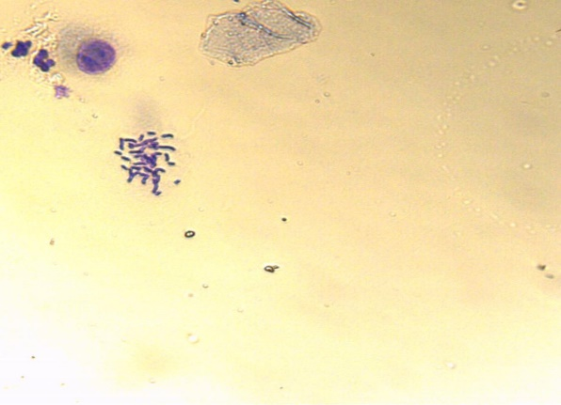  a) Dividing cells. | 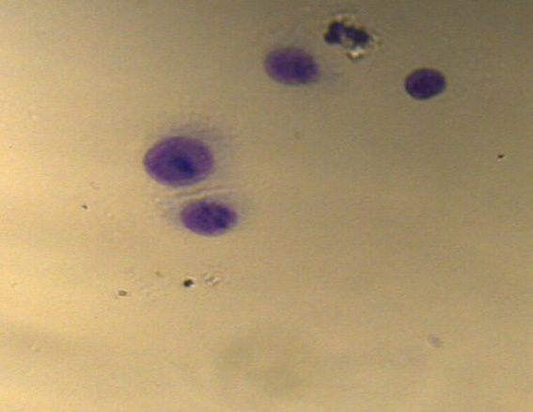  b) Non-Dividing cells | 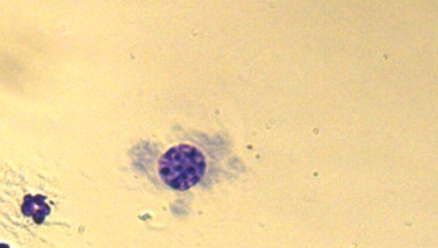  c) Blast cells

Figure 1. Images of the of human lymphocyte cells stained with 5% Giemsa solution observed under microscope (M.B. 100x).

The effects of plants’ extract on MI are shown in (Table 2, Figure 2). These results showed that there was a decrease in the mean of Mitotic Index values depending on the increasing plant concentrations, but not significantly in comparison with negative control (normal MI) (p>0.05). The mean value of MI of the control is 4.05 ± 0.21 The mitotic index range was between (2.25 ± 0.07 and 3.3 ± 0.28). C. verutum showed the lowest Mitotic Index (3 ± 0.14 at 1 mg/ml) and (2.25 ± 0.07 at 5 mg/ml). While A. santolina has the highest Mitotic Index (2.85 ± 0.07a t 5 mg/ml). Statistically, no significant effect was found between culture tubes that were treated with the extracts compared to the culture tubes without extracts (negative control) at probability (p) value >0.05. And did not have any mutagenic effects, such as inducing chromatid or chromosome breaks or gaps (Figure 3), deleted or duplicated chromosome. (Figure 4).

Table (2): The Mitotic Index (mean±SD) of human lymphocyte cultures (1000 cell counted) treated with O. carduiforme, C. verutum, A. santolina extracts and Negative control:
Plants’ extracts | Mitotic Index (Mean±SD)
Plants’ extracts | Concentration (mg\ml)
Plants’ extracts | 1 | 3 | 5
C. verutum | 3±0.14 | 2.8±0.14 | 2.25±0.07
O. carduiforme | 3.25±0.21 | 2.9±0.14 | 2.6±0.14
A. santolina | 3.3±0.28 | 3±0.14 | 2.85±0.07
Negative control  (Normal MI) | 4.05±0.21

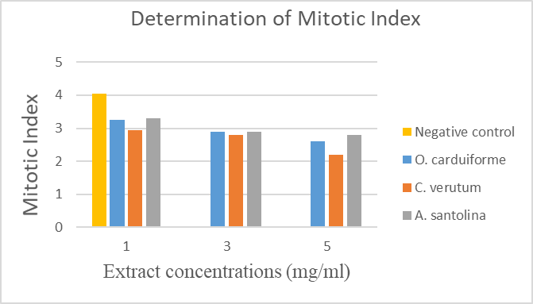
Figure 2. MI values of human lymphocyte cultures treated with different concentrations of plants’ extracts.
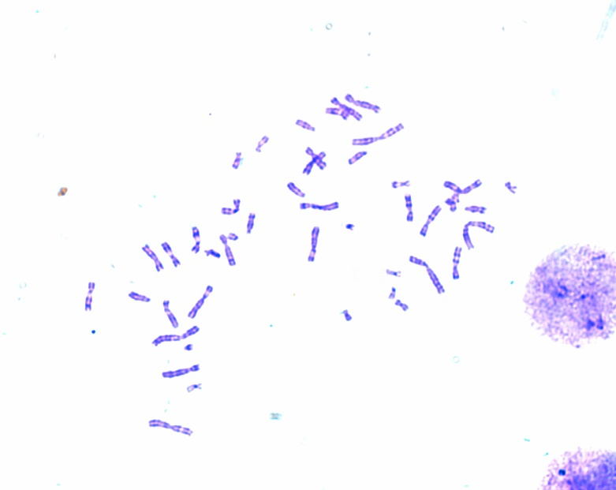  - Negative control-metaphase | 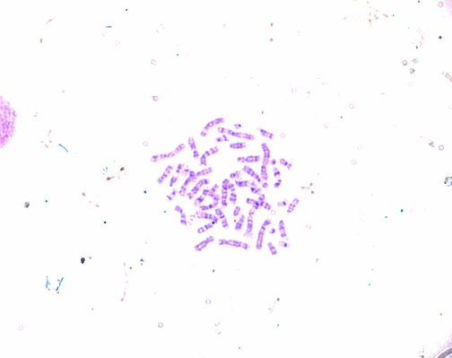  B) Metaphase for O. carduiforme extract at 5 mg/ml
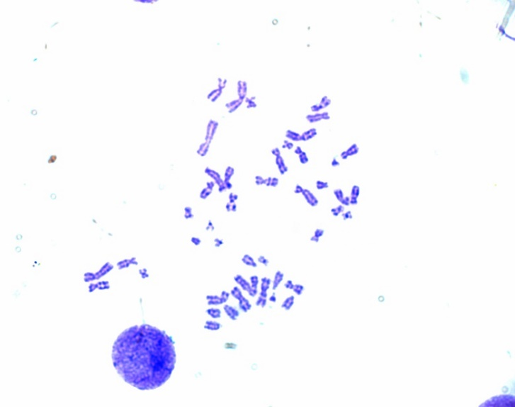  C) Metaphase for C. verutum extract at 5 mg/ml | 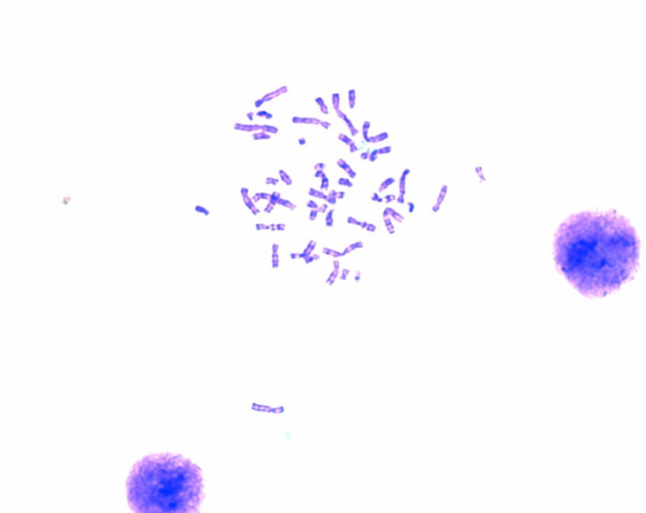  D) Metaphase for A. santolina extract at 5 mg/ml
Figure 3. Metaphase of human lymphocytes cultures stained with 5% Giemsa solution and treated with plants’ extracts at 5 mg/ml (M.B. 100x).
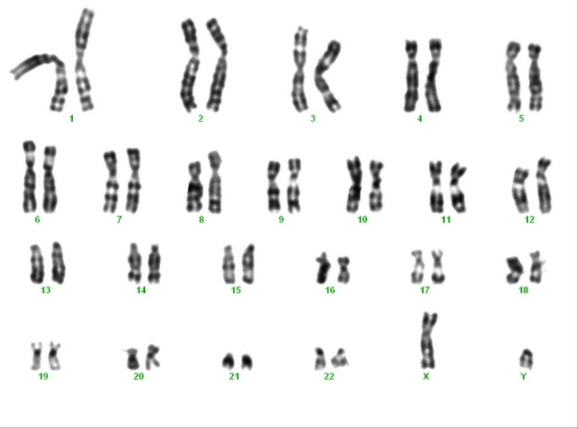  - Karyotyping for negative control | 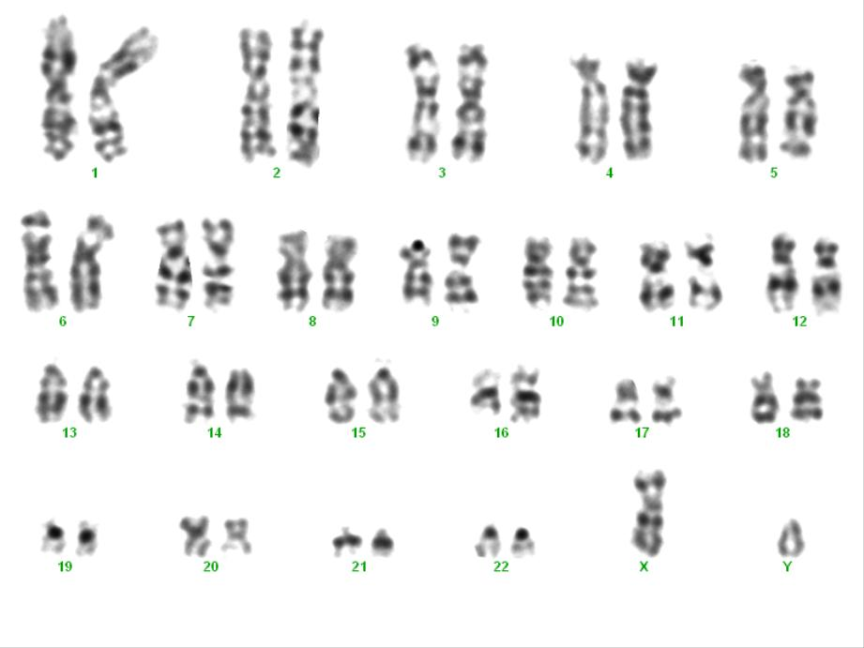  B) Karyotyping for O. carduiforme extract at 5 mg/ml
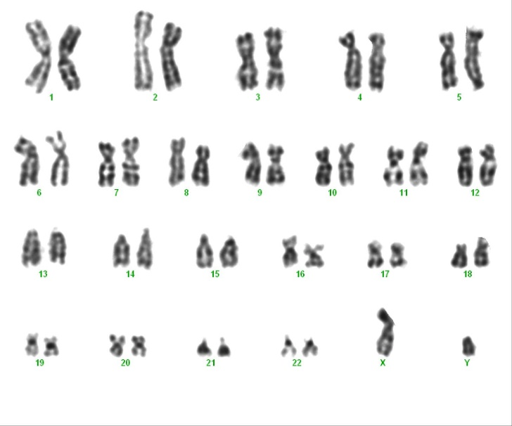  C) Karyotyping for C. verutum extract at 5 mg/ml | 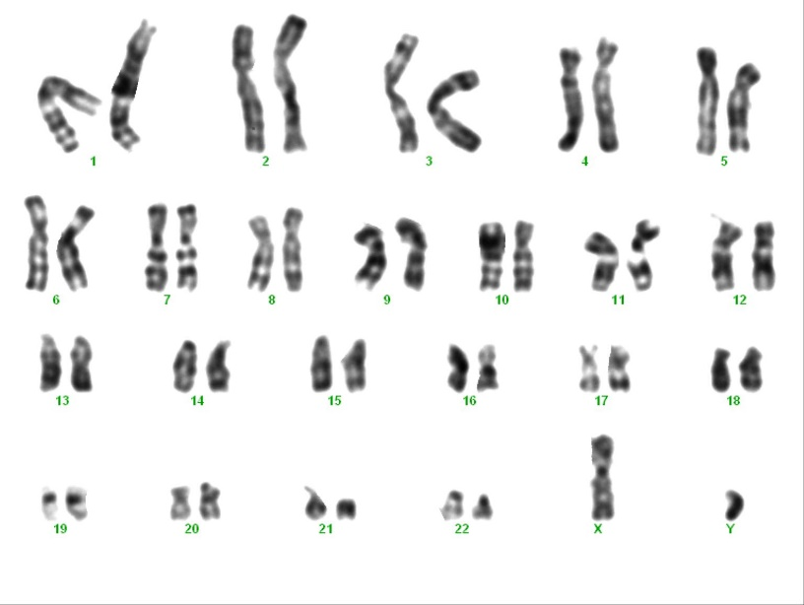  D) Karyotyping for A. santolina extract at 5 mg/ml

Figure 4. Karyotyping of human lymphocytes cultures treated with plants’ extracts at 5 mg/ml.
5. Discussion:
All Plants’ extract decreased the mean of mitotic index (MI) and the range was between (2.25 ± 0.07 and 3.3 ± 0.28). However, these values are all not significant compared to the negative control. Nevertheless, A. santolina was the best among the studied plants because it has the highest MI values at all concentrations used (3.3 ± 0.28 at 1 mg/ml, 3 ± 0.14 at 3 mg/ml 2.85 ± 0.07a t 5 mg/ml) close to the normal MI (4.05 ± 0.21).

The literature of plants from the same family Asteraceae showed a decrease in the mean of Mitotic Index approximately similar to the results of this study as shown in (Table 3).

(Table 3): Mean of mitotic index of human lymphocytes cultures treated with plants’ extracts from Asteraceae family
Plants name | mean of Mitotic Index MI | Concentration | Significant or not significant | References
Onopordum carduiforme | 2.6 ± 0.14 | 5 mg\ml | not significant | The current study
Centaurea verutum | 2.25 ± 0.07 | 5 mg\ml | not significant | The current study
Achillea santolina | 2.85 ± 0.07 | 5 mg\ml | not significant | The current study
Achillea millefolium | 2.43 | 3.5 mg/ml | not significant | ^{12.}
Silybum marianum | 2.63 ± 0.5 | 0.1 mg /ml | not significant | ^{13.}
Silybum marianum | 2.35 ± 0.4 | 0.5 mg /ml | not significant | ^{13.}
Silybum marianum | 1.58 ± 0.3 | 1 mg /ml | significant | ^{13.}
Sonchus oleraceus | 2.49 ± 0.5 | 0.1 mg /ml | not significant | ^{13.}
Sonchus oleraceus | 1.83 ± 0.6 | 0.5 mg /ml | significant | ^{13.}
Sonchus oleraceus | 1.12 ± 0.2 | 1 mg /ml | significant | ^{13.}
Matricaria chamomilla | 2.58 ± 0.4 | 0.1 mg /ml | not significant | ^{13.}
Matricaria chamomilla | 1.99 ± 0.5 | 0.5 mg /ml | significant | ^{13.}
Matricaria chamomilla | 1.49 ± 0.3 | 1 mg /ml | significant | ^{13.}
Helichrysum sanguineum, | 4.78 ± 1.26 | 0.01 mg /ml | not significant | ^{14.}
Helichrysum sanguineum | 3.01 ± 1.55 | 0.05 mg /ml | significant | ^{14.}
Helichrysum sanguineum | 1.10 ± 0.43 | 0.1 mg /ml | significant | ^{14.}
Helichrysum sanguineum | 0.30 ± 0.05 | 0.5 mg /ml | significant | ^{14.}
Helichrysum sanguineum | 0.21 ± 0.08 | 1 mg /ml | significant | ^{14.}

The decrease in the mean of mitotic index may be due to the phenolic compounds especially flavonoids and tannins derivatives and their concentrations since they induced DNA damage, and inhibit cell proliferation^{14,15,8,12}. Studies showed that the flavonoid and thymol decreased MI at a higher concentration, and also the pure resveratrol from grape skin antagonized the mitotic action of PHA and acted as an anti-mitotic agent ^{16,17}. The extracts from three plants which are investigated in the current study contain flavonoids and tannins, and the highest flavonoid content was observed in C. verutum⁵. This could explain why this plant showed the lowest Mitotic Index (3 ± 0.14 at 1 mg/ml and 2.25 ± 0.07 at 5 mg/ml). However, these values are not significant compared to the negative control which makes these plants nontoxic on lymphocytes within the studied concentration.

A study of Helichrysum species from Asteraceae family showed that three genera of Helichrysum decreased the MI and the values were significant compared to the negative control, in order that they were genotoxic and they should not be used although their antiproliferative activity may suggest antimitotic and anticarcinogenic properties¹⁴. Other studies showed that the same genus of plants studied in the current study had antitumor activity, such as Achillea millefolium which does not have a cytotoxic effect, and it has antiproliferative activity on different human liver tumors, whereas The average inhibition of proliferation was 55.3% for the HepG2/C3A, SK-HEP-1, and HA22T/VGH lines and 20.3% for the lines Hep3B and PLC/PRF/5 ¹⁸.

Accordingly, and since the decrease in cell proliferation is considered one of the mechanisms adopted as anti-tumor effects, plants in this study could be candidates as anti-tumor because they reduced the Mitotic Index of lymphocytes, yet not significantly. Therefore, we suggest conducting studies on the same plants but at higher concentrations to confirm the possible anti-tumor activity or not.

Conclusions
The primary results of this study of three plants of the Asteraceae family from Syrian flora conclude thatthe Onopordum carduiforme, Centaurea verutum, and Achillea santolina doesn’t showed toxicity effect on lymphocytes at the concentrations (1, 3, 5 mg/ml). In addition, these plants also did not induce chromatid or chromosome breaks or gaps. Thus, there is a need to investigate the anti-tumor activity by determining the reduction of MI at higher concentrations.

Acknowledgements
We greatly acknowledge the research laboratory, Department of Pharmacognosy- Aleppo University- Syria, for the technical and financial support of the research. And we acknowledge (Rihawi Medical Laboratoriy), Dr. Alaa Aldin Rihawi for the technical experience.

COMPETING INTERESTS:
Authors have declared that no competing interests exist.
Author’s Contribution

References
1- ÇELİK TA, ASLANTÜRK ÖS. Cytotoxic and genotoxic effects of aqueous extracts of Rosmarinus officinalis L., Lavandula stoechas L. and Tilia cordata Mill. on in vitro human peripheral blood lymphocytes. Cumhuriyet Science Journal;39(1):127-43.
2- Mouterd, P: Nouvlle flore du Liban et de La Syrie tome I, II et III. Beyrouth, Liban; 1960.
3- Dothan, F. N: Flora Palaestina, Part Three, Text Ericaceae to Compositae. Israel Academy of Science and Humanities, Jerusalem; 1978, 481.
- Mamedov N, Mehdiyeva NP, Craker LE. Medicinal plants used in traditional medicine of the Caucasus and North America. Journal of Medicinally Active Plants. 2015;4(3):42-66.
.
- Aljaja M, Lahdo R, Kitaz A. Phytochemical Study And Protective Effect Investigation Against Oxidative Damage In Human Erythrocytes Of Syrian Asteraceae Plants. Bulletin of Pharmaceutical Sciences. Assiut. 2021 May 6.
- Idris A, Aliyu AB, Oyewale AO. Phytochemical screening and antibacterial activity of Centaurea senegalensis growing in Nigeria. Journal of Applied Sciences and Environmental Management. 2019 19;23(6):1087-92.
- Albayrak S, Atasagun B, Aksoy A. Comparison of phenolic components and biological activities of two Centaurea sp. obtained by three extraction techniques. Asian Pacific journal of tropical medicine. 2017 1;10(6):599-606.
- Michel J, Abd Rani NZ, Husain K. A review on the potential use of medicinal plants from Asteraceae and Lamiaceae plant family in cardiovascular diseases. Frontiers in pharmacology. 2020 5;11:852.
- Bulla LM, Ambrosio EP, Martins AB, DellaRosa VA. Viability of lymphocyte culture, at different times after blood collection, for karyotype analysis. Jornal Brasileiro de Patologia e Medicina Laboratorial. 2014 50:124-30.
- Eroğlu HE, Aksoy A, Hamzaoğlu E, Budak Ü, Albayrak S. Cytogenetic effects of nine Helichrysum taxa in human lymphocytes culture. Cytotechnology. 2009 1;59(1):65-72.
- Chaitanya Chippada S, Vangalapati M. Cytotoxic and genotoxic effects of Centella asiatica extract in the cultured human peripheral blood lymphocytes. Research in Pharmacy. 2015 29;2(4).
- Teixeira RD, Camparoto ML, Mantovani MS, Vicentini VE. Assessment of two medicinal plants, Psidium guajava L. and Achillea millefolium L., in in vitro and in vivo assays. Genetics and Molecular Biology. 2003;26:551-5.
- D. Joujeh, R. Lahdo, J. Ghrewati, The Effect of Some Medicinal Plant Extracts on Lymphocytes Cultured In Vitro, Master Degree, Faculty of Pharmacy, Aleppo University; (2016).
- Erolu EH, Hamzaolu E, Aksoy A, Budak Ü, Özkul Y. In vitro genotoxic effects of four Helichrysum species in human lymphocytes cultures. Biological Research. 2010;43(2):177-82.
15- Cerqueira F, Cordeiro-da-Silva A, Araujo N, Cidade H, Kijjoa A, Nascimento MS. Inhibition of lymphocyte proliferation by prenylated flavones: artelastin as a potent inhibitor. Life Sciences. 2003 19;73(18):2321-34.
16- Abed RM. Cytotoxic, cytogenetics and immunomodulatory effects of thymol from Thymus vulgaris on cancer and normal cell lines in vitro and in vivo. Al-Mustansiriyah J Sci. 2011;22:41-53.
17- Mohammed ZY, Al-Jumaily EF, Yaseen NY. Cytogenetic study of the pure Resveratrol extracted from grape skin on normal peripheral human blood lymphocytes. Journal of Biotechnology Research Center. 2011 1;5(2):17-24.
18- Düsman E, Almeida IV, Coelho AC, Balbi TJ, Düsman Tonin LT, Vicentini VE. Antimutagenic effect of medicinal plants Achillea millefolium and Bauhinia forficata in vivo. Evidence-Based Complementary and Alternative Medicine. 2013 1;2013.

Author’s explanation
1- In Syria we don't have herbarium, so we don't have the plant's voucher numbers, but all plants were identified by Dr. Ahmed Jadouh, Professor and expert at the Faculty of Agricultural Engineering, Aleppo University, Syria.
2- I added the ethical clearance in section 2.4.2.1
3- To avoid the problem of moving the photos I attache (all photos and mention their name)
4- This reference (Aljaja M, Lahdo R, Kitaz A. Phytochemical Study And Protective Effect Investigation Against Oxidative Damage In Human Erythrocytes Of Syrian Asteraceae Plants. Bulletin of Pharmaceutical Sciences. Assiut. 2021 May 6. ) is correct, and this is the link https://bpsa.journals.ekb.eg/article_207152.html. In this study the Three plants were screened for their phytochemical components and they're contain phenols, flavonoids, tannins, coumarins, cardiac glycosides, terpenoids, steroids, and carbohydrates. Whereas no alkaloids or saponins were found. This is the answer for your question How do you confirm the presence of these compounds in the three plants?
5- How about any positive control? Any comparison? I didn't use a positive control, just compared with negative (normal) and the values are all not significant compared to the negative control. That means the plants' extracts don't have a toxic effect.
6- Purpose of this justification with your study?. According to the result and that study, which concluded that Achillea has antiproliferative activity. So we candidate that our plants may have an anti-tumor effect. So We suggest conducting studies on the same plants but at higher concentrations to confirm the possible anti-tumor activity or not.

