**Reviewer’s Comments**

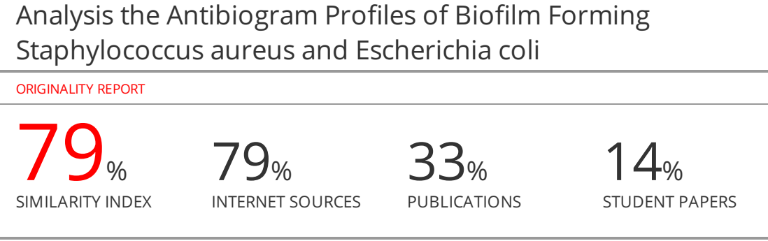

**Analysis the Antibiogram Profiles of Biofilm Forming *Staphylococcus aureus* and *Escherichia coli***

**ABSTRACT**

**Background and Objectives:**Bacteria attach to surfaces and produce polymeric matrix resulting in the formation of biofilms that are involved in a wide range of human infections. Biofilms forming that produced by *Staphylococcus aureus* and *Escherichia coli* are considered to be highly resistant to antibiotics.This study was aimed to analysis

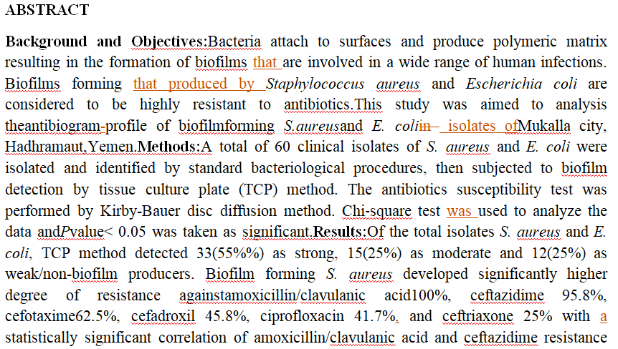

and bacterial biofilm production (*P-value*< 0.05). The rates of antibiotics resistance biofilm *E. coli* were 100%, 91.7%,75%, 70.8%, 66.7%, 62.5% and 33.3%for amoxicillin/clavulanic acid, cefadroxil, cefotaxime, ceftazidime, ceftriaxone, ciprofloxacin and co-trimoxazole respectively with statistically significant correlation of cefadroxil resistance (*P-value* < 0.05).**Conclusion:**TCP method showed that *S. aureus* and *E. coli* isolates have high degree of biofilm forming ability. A high antibiotics resistance was observed in biofilm producers than non-biofilm producers.

**Key words:**Biofilm formation, *Escherichia coli*,Multi-drug resistance, *Staphylococcus aureus*, Tissue culture plate

**INTRODUCTION**

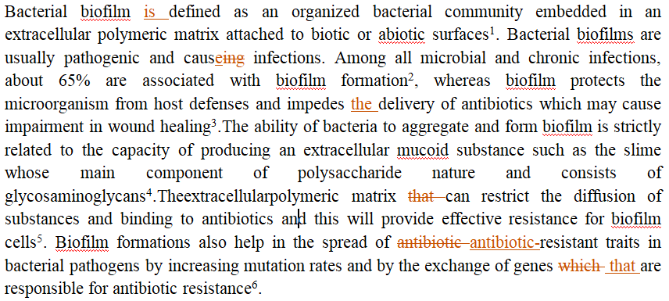 *Staphylococcus aureus* (*S. aureus*) and *Escherichia coli* (*E. coli*) are the most common etiologicalagent causing bothcommunity and hospital‑acquired infections7,8.*E. coli*infections leading to serioussecondary health issues worldwideand tends to form microcolonies in mucosalining of urinary bladder known as biofilm8. Thesebiofilms make the bacterium to resist the host immuneresponse, more virulent and lead to the evolution ofantibiotics resistance by enclosing them in anextracellular biochemical matrix9.The ability of *S. aureus* to form biofilm is considered to be a major virulence factor influencing its survival and persistence in both the environment and the host10.*S. aureus* biofilms have been associated with a variety of persistent infections which respond poorly to conventional antibiotic therapy 11.

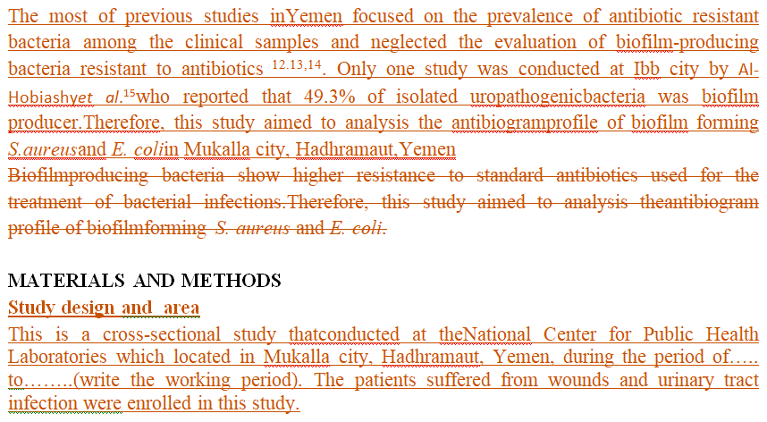

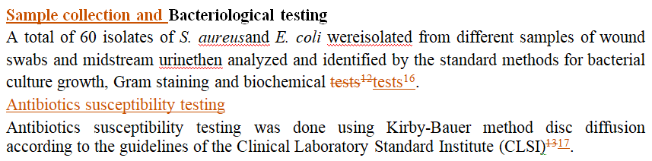

The antibiotics were used in this study included; Ciprofloxacin (….µg), Co-trimoxazole (….µg), Ceftriaxone (….µg), Cefotaxime (….µg), Amoxicillin/clavulanic acid (….µg), Amikacin (….µg), Cefadroxil (….µg), and Ceftazidime (….µg).

**Biofilm formation detection by tissue culture plate (TCP) method**

Quantitative TCP method was performed as described by Yadav et al.14. In briefly, subcultures of the isolates in nutrient agar were inoculated in

10mL of trypticase soy broth with 1% glucose and incubated for 24 hours at 37ºC, then the cultures were diluted 1:100 with fresh medium. The wells of sterile 96 polystyrene microtiter plates were filled with 0.2ml aliquots of the diluted cultures. Negative control wells were maintained by adding broth without culture. After incubation for 24 hours at 37ºC, the wells removed by gentle tapping and washed with 0.2mL phosphate buffer saline (pH 7.3) three times to remove free floating planktonic bacteria. Thewells then were dried for 1 hour and stained with crystal violet (0.1% w/v) and the excess stains removed using deionized water, then the plates were kept for drying. Quantitative analysis of biofilm production was performed by adding 150μl of 95% ethanol to destain each well. After 30 min, optical density (OD) of stained adherent biofilm was obtained by using microtiter plate ELISA reader at wave length 630 nm. The experiment was done in triplicate and repeated three times.Optical density cut-off value (ODc) calculated as average OD of negative control + 3x standard deviation (SD) of negative control.The bacterial species tested were classified into four categories as follows: OD ≤ ODc no biofilm producer; ODc< OD ≤ 2 x ODc weak biofilm producer; 2 x ODc< OD ≤ 4 x ODc moderate biofilm producer; 4 x ODc< OD strong biofilm producer.

**Statistical analysis**

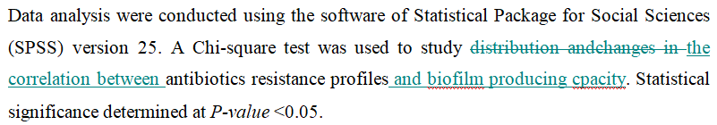

**RESULTS**

**Biofilm detection by tissue culture plate (TCP) method**

TCP method detected strong biofilm formation in 33(55%%) as ~~strong~~, 15(25%) as moderate and 12(25%) as weak/non-biofilm producers.Among *S. aureus* isolates, 18 were strong biofilm producers, 6isolates were moderate biofilm producers and 6 isolates were weak/non-biofilm producers. Of *E. coli* isolates showed 15were strong biofilm producers, 9isolates were moderate biofilm producers, and 6 isolates were weak/non-biofilm producers ~~andweak/non-biofilm producers isolates identified in 6 isolates~~. ~~There was no significant statistical analysis of TCP method for screening biofilm production (~~*~~P-value~~* ~~= 1.000) as shown in table (1~~).

**Table (1): Analysis of *S. aureus* and *E. coli* for biofilm formation by TCP method**

|  |  |  |  |
| --- | --- | --- | --- |
| Biofilm formation by TCP method | | χ² test value | *P-value* |
| Result | No. (%) |
| Strong | 33 (55) | 0.00 | 1.000 |
| Moderate | 15 (25) |
| Weak/None | 12 (20) |
| Total | 60 (20) |

**Relationship theantibiogram profiles with biofilm and non-biofilm producing *S. aureus* and *E. coli***

Among 60 *S. aureus* and *E. coli* isolates, biofilm producers isolates by TCP method showed high resistance rates to antibiotics used compared to non-biofilm producers isolates.*S. aureus* biofilm producing isolates found highly resistant to amoxicillin/clavulanic acid, ceftazidime, cefotaxime, cefadroxil, ciprofloxacin and ceftriaxone in a rate of 100%, 95.8%, 62.5%, 45.8%, 41.7% and 25% respectively. There was significant statistical correlation of antibiotic resistance of amoxicillin/clavulanic acidand ceftazidime and bacterial biofilm production (*P-value*< 0.05)as show in table (2).

**Table (2). Antibiogram profiles of biofilm and non-biofilm producing *S. aureus***

|  |  |  |  |  |  |  |  |  |
| --- | --- | --- | --- | --- | --- | --- | --- | --- |
| Antibiotic | Biofilm producer  24(80%) | | | Non-biofilm producer  6(20%) | | | χ² test value | P-value |
| S | I | R | S | I | R |
| Ciprofloxacin | 14 | 0 | 10 | 4 | 0 | 2 | 0.139 | 0.709 |
| Co-trimoxazole | 22 | 0 | 2 | 6 | 0 | 0 | 0.536 | 0.464 |
| Ceftriaxone | 8 | 10 | 6 | 3 | 2 | 1 | 0.590 | 0.745 |
| Cefotaxime | 2 | 7 | 15 | 2 | 3 | 1 | 4.766 | 0.092 |
| Amoxicillin/clavulanic acid | 0 | 0 | 24 | 1 | 0 | 5 | 4.138 | 0.042* |
| Amikacin | 19 | 2 | 3 | 6 | 0 | 0 | 1.500 | 0.472 |
| Cefadroxil | 5 | 8 | 11 | 3 | 1 | 2 | 2.149 | 0.342 |
| Ceftazidime | 0 | 1 | 23 | 2 | 0 | 4 | 8.704 | 0.013* |

\**P-value*< 0.05 is considered statistically significant

Biofilm producing *E. coli* isolates had increased resistance profiles of the antibiotics amoxicillin/clavulanic acid, cefadroxil, cefotaxime, ceftazidime, ceftriaxone, ciprofloxacinand co-trimoxazole, 100%, 91.7%, 75%, 70.8%, 66.7%, 62.5% and 33.3% respectively with significant statistical correlation of antibiotic resistance of cefadroxil (*P-value* < 0.05)as show in table (3).

**Table (3). Antibiogram profiles of biofilm and non-biofilm producing *E. coli***

|  |  |  |  |  |  |  |  |  |
| --- | --- | --- | --- | --- | --- | --- | --- | --- |
| Antibiotic | Biofilm producer  24(80%) | | | Non-biofilm producer  6(20%) | | | χ² test value | *P-value* |
| S | I | R | S | I | R |
| Ciprofloxacin | 8 | 1 | 15 | 4 | 0 | 2 | 2.304 | 0.316 |
| Co-trimoxazole | 16 | 0 | 8 | 4 | 0 | 2 | 0.00 | 0.694 |
| Ceftriaxone | 6 | 2 | 16 | 3 | 1 | 2 | 2.222 | 0.329 |
| Cefotaxime | 5 | 1 | 18 | 2 | 1 | 3 | 1.875 | 0.392 |
| Amoxicillin/clavulanic acid | 0 | 0 | 24 | 0 | 0 | 6 | - | - |
| Amikacin | 18 | 4 | 2 | 4 | 1 | 1 | 0.379 | 0.827 |
| Cefadroxil | 2 | 0 | 22 | 4 | 0 | 2 | 10.208 | 0.007* |
| Ceftazidime | 5 | 2 | 17 | 2 | 1 | 3 | 0.967 | 0.617 |

\**P-value*< 0.05 is considered statistically significant

**DISCUSSION**

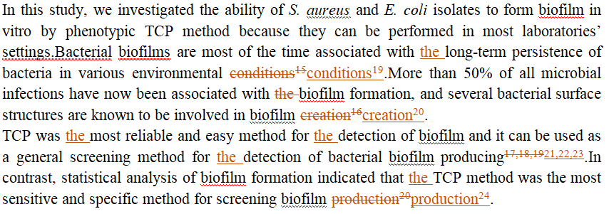

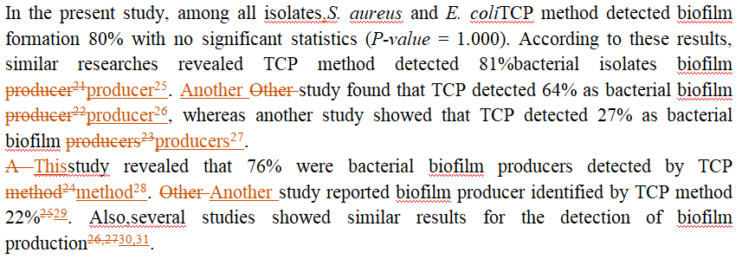

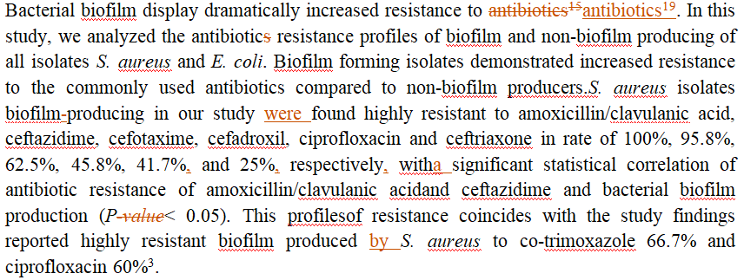

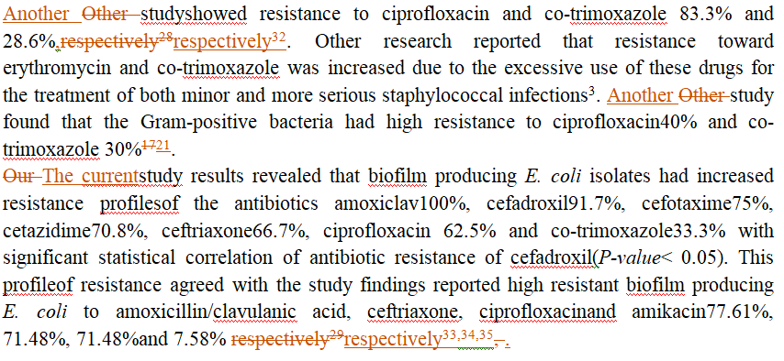

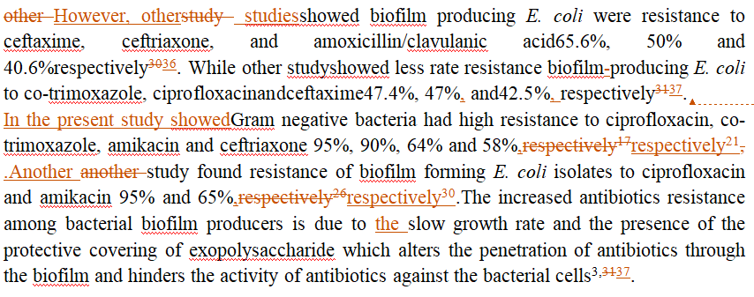

**CONCLUSION**

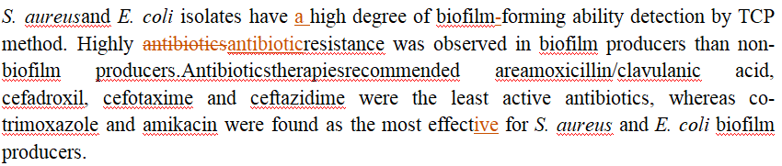

**ACKNOWLEDGMENTS**

Great thanks expressed to Biology Department, Faculty of Science, Hadhramout University andNational Center for Public Health Laboratories, Mukalla,Hadhramout, Yemen for their efforts of scientific research development.

**CONFLICT OF INTEREST**

No conflict of interest associated with this work.

**AUTHOR’S CONTRIBUTION**

The manuscript was prepared, written and approved in collaboration with all authors.

**REFERENCES**

1. Macià MD, Rojo-Molinero E,Oliver A.Antimicrobial susceptibility testing in biofilm-growing bacteria. Clinical Microbiology and Infection2014: 20(10):981-990.
2. Jamal M, Ahmad W, Andleeb S, Jalil F, Imran M, Nawaz MA, Hussain T, Ali M, Rafiq M,Kamil MA. Bacterial biofilm and associated infections. Journal of the Chinese Medical Association 2018: 81: 7-11.
3. Neopane P, Nepal HP, Shrestha R, Ueharas O,Abiko Y. In vitro biofilm formation by *Staphylococcusaureus* isolated from wounds of hospital-admittedpatients and their association with antimicrobialresistance. International Journal of General Medicine 2018: 11: 25–32.
4. Elkhashab THT, Adel LA, Nour MS, Mahran M,Elkaffas M. Association of intercellular adhesion gene A with biofilm formation in staphylococci isolates from patients with conjunctivitis. Journal of Laboratory Physicians 2018: 10(3): 309-315.
5. Murugan S, Devi PU, John PN. Antimicrobial susceptibility pattern of biofilm producing Escherichia coli of urinary tract infections. Current research in bacteriology 2011: 4(2): 73-80.
6. Eyoh AB, Toukam M, Atashili J, Fokunang C, Gonsu H, Lyonga EE, Mandi H, Ikomey G, Mukwele B, Mesembe M,Assoumou MCO.Relationship between multiple drug resistance and biofilm formation in *Staphylococcus aureus* isolated from medical and non-medical personnel in Yaounde, Cameroon. Pan African Medical Journal 2014: 17: 186.
7. Valaperta R, Tejada MR, Frigerio M, Moroni A, Ciulla E, Cioffi S, Capelli P, Costa E.*Staphylococcus aureus* nosocomial infections: the role of a rapid and low-cost characterizationfor the establishment of a surveillance system. New microbiologica 2010: 33: 223-232.
8. Tajbakhsh E, Ahmadi P, Abedpour-Dehkordi E, Arbab-Soleimani N,Khamesipou F. Biofilm formation, antimicrobial susceptibility, serogroups and virulence genes of uropathogenic E. coli isolated from clinical samples in Iran. Antimicrobial Resistance and Infection Control 2016: 5: 11. DOI 10.1186/s13756-016-0109-4.
9. Seema M, Madhu S,Uma C.Biofilm and multi-drug resistance in uropathogenic Escherichia coli. Pathog Glob Health 2015: 109(1): 26-9.
10. Torlaka E, Korkutb ET, Uncua A, Sener Y.Biofilm formation by *Staphylococcus aureus* isolates from a dentalclinic in Konya, Turkey. Journal of Infection and Public Health 2017: 10: 809-813.
11. Seema B,Atindra K.Biofilm. A challenge to Medical Science. Journal of Clinical and diagnostic research 2011: 5(1): 127- 130.
12. Tille PM.Bailey & Scott’s Diagnostic Microbiology, (13th edition). China: Mosby, Inc., an affiliate of Elsevier Inc. 2014: 202-927.
13. CLSI.Performance standards for antimicrobial susceptibility testing. 29th edition. CLSI supplement M100. Wayne, PA. CLSI 2019.
14. Yadav M, Khumanthem SD, Kshetrimayum MD,Damrolien S.Biofilm production and its correlation with antibiogram among clinical isolates of uropathogenic*Escherichia coli*. International Journal of Advances in Medicine 2018: 5(3): 638-643.
15. Tayal RA, Baveja SM,De AS.Analysis of biofilm formation and antibiotic susceptibility pattern of uropathogens in patients admitted in a tertiary care hospital in India. International Juornal of Health and Allied Sciences 2015: 4(4): 247-252.
16. Wojnicz D,Tichaczek-Goska D. Effect of sub-minimum inhibitory concentrations of ciprofloxacin, amikacin and colistin on biofilm formation and virulence factors of *Escherichia coli* planktonic and biofilm forms isolated from human urine. Brazilian Journal of Microbiology 2013: 44(1): 259-265.
17. Hassan A, Usman J, KaleemF, Omair M, Khalid A,Iqbal M.Evaluation of different detection methods of biofilm formation in the clinical isolates. Brazilian Journal of Infectious Diseases 2011: 15(4): 305-311.
18. Deka N.Comparison of Tissue Culture plate method, Tube Method and Congo Red Agar Method for the detection of biofilm formation by Coagulase Negative Staphylococcus isolated from Non-clinical Isolates. International journal of Current Microbiology and Applied Sciences 2014: 3(10): 810-815
19. Nosrati N, Jahromy SH, Karizi, SZ.Comparison of Tissue Culture Plate, Congo red Agar and Tube Methods for Evaluation of Biofilm Formation among Uropathogenic*E. coli* Isolates. Iranian Journal of Medical Microbiology 2017: 11(3): 49-58.
20. Triveni AG, Kumar MS, Manjunath C, Shivnnavar CT,Gaddad SM.Biofilm formation by clinically isolated *Staphylococcus aureus* from India. The journal of infection in developing countries 2018: 12(12):1062-1066.
21. Deotale VS, Attal R, Joshi S,Bankar N.Correlation between biofilm formation and highly drug resistant uropathogens (HDRU). Journal Impact Factor 2015: 7(2): 61-65.
22. Sheriff R,Sheena A.Assessment of Biofilm Production in Clinically Significant Isolates of *Staphylococcus epidermidis* and Comparison of Qualitative and Quantitative Methods of Biofilm Production in a Tertiary Care Hospital. International Journal of Scientific Study2016: 4(6): 41-46.
23. Ruchi T, Sujata B,Anuradha D. Comparison of Phenotypic Methods for the Detection of Biofilm Production in Uropathogens in a Tertiary Care Hospital in India. International journal of Current Microbiology and Applied Sciences2015: 4(9): 840-849.
24. Tiwari G, Arora DR, Mishra B,Dogra V.Comparative Evaluation of Methods Used For Detection of Biofilm Production. National Journal of Integrated Research in Medicine2017: 8(5): 1-8.
25. Osungunna MO, Onawunmi GO.Antibiotic resistance profiles of biofilm-forming bacteria associated with urine and urinary catheters in a tertiary hospital in Ile-Ife, Nigeria, Southern African Journal of Infectious Diseases2018: 33(3): 80–85.
26. Rewatkar AR, Wadher BJ.Staphylococcus aureus and Pseudomonas aeruginosa-Biofilm formation Methods. Journal of Pharmacy and Biological Sciences2013: 8(5): 36-40.
27. Bhardwaj A, Kharkwal AC,Singh VA. A Comparative Appraisal of Detection of Biofilm Production Caused by Uropathogenic*Escherichia coli* in Tropical Catheterized Patients by Three Different Methods. Asian Journal of Pharmaceutics2018: 12(4): 1445-1450.
28. Manandhar S, Singh V, Varma A, Pandey S,Shrivastava N.Biofilm Producing Clinical *Staphylococcus aureus* Isolates Augmented Prevalence of Antibiotic Resistant Cases in Tertiary Care Hospitals of Nepal, Frontiers in Microbiology2018: 9(2749): 1-9.
29. Sudheendra KR,Basavaraj PV. Analysis of antibiotic sensitivity profile of biofilm-forming uropathogenic*Escherichiacoli*. J Nat ScBiol Med2018: 9: 175-9.
30. Risal G, Shrestha A, Kunwar S, Paudel G, Dhital R, Budha MB,Nepal R. Detection of biofilm formation by *Escherichia coli* with its antibiogram profile. International Journal of Community Medicine and Public Health2018: 5(9): 3771-3775.
31. Shrestha B, Shrestha B, Poudel A, Lekhak B,Upreti MK.In-Vitro Biofilm Detection among Uropathogens and Their Antibiogram Profile. TUJM2018: 5(1): 57-62.

**Reviewer's comments and author response**

|  |  |
| --- | --- |
| **Reviewer's comments** | **Author response** |
| Similarity Index detected by [Turnitin](https://www.turnitin.com/)= 79%. Please revise your article according to the Turnitin report. | Similarity index was revised. |
| The article is good, the paragraphs that starts with number should be rewrite and use words for beginning. Also either use numbers or percent in describing the results | Paragraphs starts with number was rewrite and used words for beginning.  We used the percent in describing the results. |
| Just add a description for why just these bacteria and if there are any indicators that shows how these are considered as a problem | Description added. |
| * You should mention the number of isolates isolated from Wound swabs and number of isolates isolated from Midstream urine. * So, in results we can add if different sites of infection affects the existence of biofilm. * Although Biofilm formation detection by tissue culture plate (TCP) method was found to be superior to other phenotypic assays in terms of specificity and sensitivity, but the paper would be more enriched if you used genotypic assay along with the TCP method in routine diagnostics to detect biofilm producers in clinical samples. | * The number of isolates isolated from wound swabs and midstream urine was mentioned. * Regardingthe different sites of infection affects the existence of biofilmis not included and studied. * Genotypic assays in Yemen is difficult, because high cost of molecular biology techniques and their facilities. |
| * You did not mention any difference between biofilm production among wound swabs isolates and Midstream urine isolates. Does changing the bacterial isolate site of infection affects biofilm production? * You did not mention if the “non-biofilm producing strains” are from the same infection site, wound swab or midstream urine or not. If so, then the site of infection can affect the biofilm production and it should be mentioned in the paper. | * Regarding changing the bacterial isolate site of infection affects biofilm production is not included and studied. * Regarding the site of infection can affect the biofilm production or non-biofilm production is not included and studied. |
| Table 1 I think it is not necessary and if it should be kept the title of the table should be more specific. | Title of table 1 changed. |
| Add the percent of using these antibiotic in hospitals and if there any data about the resistance for the discussed antibiotic. | Some data available added. |
| Do not write “other study” or “Other research”, without referring to the author name. | Referring to the author name was added in the discussion. |
| Please follow the journal specifications for references.  Please add DOI to articles if available. | References revised.  DOI of articles available added. |