**Reviewer’s Comments**

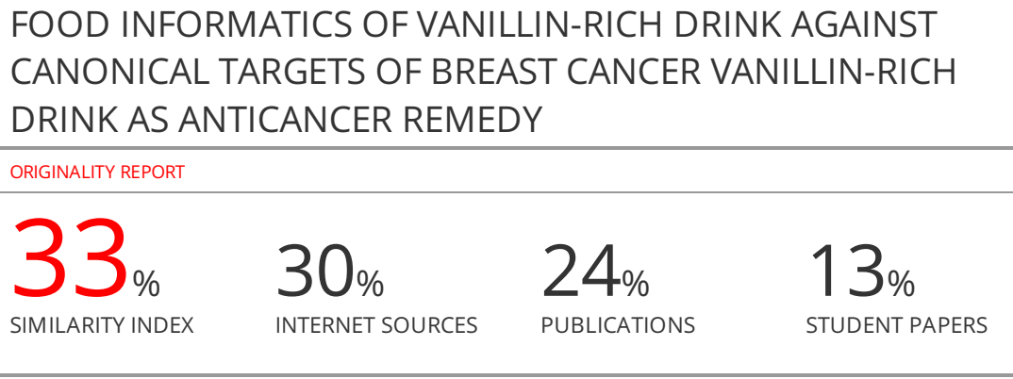**FOODINFORMATICS OF VANILLIN-RICH DRINK AGAINST CANONICAL TARGETS OF BREAST CANCERVANILLIN-RICH DRINK AS ANTICANCER REMEDY**

**ABSTRACT**

Vanillin-rich drink (Vimto®) is a popular drink among women. Here, chemical composition of Vimto®has been determined by gas chromatography and foodinformatics used to identify its putative binders to canonical targets of breast cancer. The binding affinity (kcal/mol) of the target proteins of breast cancerand the phytocompounds was computationally obtained. Major aliphatic hydrocarbons of Vimto®werehydroxymethylfurfurole, tetradecane, hexadecane, dodecane, octadecane and 9-octadecenamide while aromatic hydrocarbons were vanillin, benzoic acid, diisooctyl phthalate, butanoic acid, piperonal, bis (2-ethylhexyl) phthalate and germacrene D. 9-octadecenamidebound reliably to HER2 (human epidermal growth factor receptor 2) and warrant experimental studies. All aromatic hydrocarbons expect benzoic acid and vanillin showed reliableBA with HER2. Germacrene D showed acceptable binding affinity with estrogen receptor alpha (ERα) and reliable BA with sulfatase. Benzoic acid and diisooctyl phthalate showed reliable BA with phosphoinositide 3-kinases (PI3Ks) and AKT (protein kinase B), respectively.Bis (2-ethylhexyl) phthalate and diisooctyl phthalate have been docked with HER2. Butanoic acid and bis (2-ethylhexyl) phthalate showed reliablebinding affinity with aromatase. Benzoic acid and diisooctyl phthalate, and bis (2-ethylhexyl) are not safe compounds while bounded to target proteins of breast cancer. To sum up, Vimto®is amalgam of hazardous and safe compounds need further biosafety evaluation.

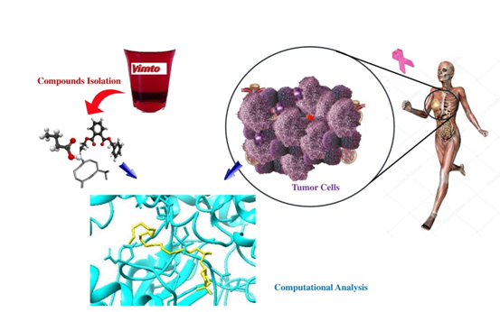

Graphic Abstract

**Keywords**: Breast cancer, Vimto®drink, molecular docking, vanillin, foodinformatics.

**INTRODUCTION**

Vimto(Vimto®) is a vanillin-rich soft drink produced mainly in the [United Kingdom](https://en.wikipedia.org/wiki/United_Kingdom) andthe Kingdom of Saudi Arabia, however distributed globally. The major formula of Vimto® is still ambiguous while it contains the juice of grapes, raspberries and blackcurrants flavored with herbs and spices. The original recipe of Vimto®was invented in 1908 by (John) Noel Nichols in the Lancashire town of Blackburn. It is available in cans and bottles and as a draught soft drink in pubs(1).

The major component of Vimto®, vanillin, is a plant secondary metabolite and the main constituent of vanilla which has a phenolic phenyl propane C6-C1 carbonic structure derivatives. Vanillin has been used as an important flavor and aromatic component worldwide and found in several plant essential oils, principally *Vanilla planifolia*, *Vanilla tahitensis*, and *Vanilla pompona*(2)and often found in processed foods, beverages, and pharmaceutical products, and perfumery (3, 4). Vanillin has antioxidative and antitumor potential and might be more beneficial for daily health care than had been previously thought (5-7). In addition, antimicrobial, hypotriglyceridemic, anti-inflammatory, and anti-mutagenic activities of vanillin have been demonstratedin rodents and humans (8-10). More specifically, vanillin has been shown to inhibit cancer invasion and migration through the reduction of matrix metalloprotease activity and downregulation of nuclear factor-kappa B (NF-kB) in hepatocellular carcinoma cells (11). Vanillin could also attenuate the formation of lamellipodia and angiogenesis in lung cancer via the suppression of PI3K activity and inducing the apoptosis of various cancer types such as human cervical cancer and breast cancer (BC; (12-14)). Moreover, vanillin in high concentrations (mM range) has been described as an *invitro* cytotoxic agent in many cell lines including mouse fibroblast 3T3 cells (15, 16), human ovarian carcinoma A2780-SC1 cells (17), human colorectal carcinoma HT-29 cells (16), HepG2 cells (18), human cervical carcinoma HeLa cells (14), and human colorectal carcinoma SW480 cells (19). However, studies focused on cytotoxicity of vanillin are scarce (20).

Breast cancer is one of the most common cancers among women globally (21). The majority of BCs are carcinoma-forming cells that make up milk constituents in the mammary gland. The molecular subtypes of breast cancer are classified based on the presence or absence of hormone receptors (estrogen and progesterone subtypes) and human epidermal growth factor receptor-2 (HER2), including hormone receptor positive and HER2 negative (luminal A subtype), hormone receptor positive and HER2 positive (luminal B subtype), hormone receptor negative and HER2 positive (HER2 positive), and hormone receptor negative and HER2 negative (basal-like or triple-negative breast cancers (TNBCs)). Hormone receptor positive breast cancers are largely driven by the estrogen signaling pathway (22). In HER2 positive breast tumors, HER2 activates the PI3K/AKT and the RAS/RAF/MAPK pathways and stimulate cell growth, survival and differentiation (23).

Many molecular modeling methods have been employed in pharmaceutical researches to discover new drugs and their biological and chemical systems. The conglomerate of computational and experimental strategies has a great value in the identification and development of new promising compounds. Molecular docking methods has been vastly used in novel drug designing, exploring the binding and ligand conformations accepted within the binding sites of macromolecular targets(24). This study introduced a package of foodinformatic tasks, in general, to investigate biosafety of food ingredients computationally. Furthermore, chemical composition and binding affinities of phytochemicals of Vimto®were reported here to make us more skeptic about the biosafety of Vimto®.

**MATERIALS AND METHODS**

**Chemical composition**

A commercial brand of soft drink Vimto® was a sweet glass bottle version made in Saudi Arabia (Fimto in Arabic) imported and distributed in Iranian markets. To prepare extracted oil of Vimto®, liquid-liquid extraction procedure has been employed. Briefly, solvent dichloromethane mixed with NaCl saturated Vimto® extracted in an ultrasonic batch. After that, the extracted oil was dried over anhydrous magnesium sulfate and kept at 4 °C before analysis (*vide infra*).The gas chromatography (GC) analysis was accomplished using a Hewlett-Packard chromatograph 5890 series equipped with flame ionization detector (FID) detector and a HP-1 fused silica column (30 m × 0.25 mm and film thickness 0.25 μm). Gas chromatography/mass spectrometry (GC/MS) analysis was performed on a Hewlett-Packard 5973 connected with a mass detector HP 6890 using a HP-1 column (30 m × 0.25 mm and film thickness 0.25 μm). Oven temperature was set on 40-250 °C with an escalation of 3 °C/min for both GC/FID and GC/MS while temperatures of injector and detector were 320 and 310 °C, respectively. Helium was carrier gas flew at a rate of 1 mL/min. The mass spectrometer was operated at 70 eV with the mass range of 40-350 amu and scan time 1 s. Exploration was based on model retention data and comparison with reliable standards like NIST MS library. The exploration was also certified by comparison of the retention indices with data in the literature (25, 26). The percentages of compounds were calculated by the area normalization method and the retention indices were calculated for all volatile constituents using a homologous series of *n*-alkanes (27).

***In silico* anti-breast cancer assay**

Molecular docking of target protein of BC (Table 1) and selected bioactive compounds of Vimto® was performed by VINA WIZARD docking program mounted on PyRx software (ver. 0.8; Table 2; (28)). First, crystal structures of BC target proteins were taken from the Protein Data Bank (PDB) (<http://www.RCSB.org>). The PDB format of target protein has been prepared for docking using Molegro Virtual Docker (29) and Chimera 1.12.1 (<http://www.rbvi.ucsf.edu/chimera>)softwares before submission to PyRx software. The structures of the major phytocompounds of Vimto® were retrieved from ZINC database ver. 12.0 (<http://zinc.docking.org/>) and/or PubChem (<https://pubchem.ncbi.nlm.nih.gov/>).

The docking results were presented as binding affinity (BA; kcal/mol) values. More negative the binding affinity declares superior docking of ligand to target proteins. The best pose of ligand in target protein in Molegro Virtual Docker or Chimera and its atomic interactions have been visualized by Lig+Plot software (30).

Table1. The list of canonical proteins involved in breast cancer, their PDB codes and inhibitors

|  |  |  |  |
| --- | --- | --- | --- |
| Target protein | PDBcode | Inhibitor | Reference |
| AKT serine/threonine-protein kinase | 3E88 | MK2206 | (31) |
| Receptor tyrosine-protein kinase  erbB-2 (HER2) | 3PP0 | Lapatinib | (32) |
| Mitogen-activated protein kinase 1  (ERK) | 5NGU | GSK2141795 | (33) |
| Aromatase | 3EQM | Exemestane | (34) |
| Estrogen receptor (ER)-alpha | 1X7E | Tamoxifen | (35) |
| Estrone sulfatase | 1P49 | STX-64 | (36) |
| Phosphatidylinositol 3-kinase (PI3K) | 5SW8 | Prifosine | (37) |

**RESULTS AND DISCUSSION**

Comprehensive GC/MS was used to analyze volatile components of Vimto®drink. Figure 1 showed GC of the Vimto®drink and the chemical constituents of Vimto®were displayed in Table 2. The main component that isolated from Vimto®in the presence of CH2Cl2 solvent was vanillin (Table 3, Figure 1). According to the results of chromatography (Table 3, Figure 1), the vanillin had the highest amount in this beverage (26.604%) as compared to benzoic acid (10.994%), hydroxymethylfurfurole (5.197%), and diisooctyl phthalate (2.353%). There were also minorcompounds with a low percentage (< 1%) in the Vimto®drink such as bis (2-ethylhexyl) phthalate (0.497%), butanoic acid (0.630%), germacrene D (0.142%) and 9-octadecenamide (0.408%).

Table2. The compounds from Vimto®beverage decomposition using GC-MS

|  |  |  |
| --- | --- | --- |
| Chemical structure | Zinc Database/PubChem code | Compound |
| Zinc Item 895132 | Z:895132 | Butanoic acid |
| Zinc Item 1648227 | Z:1648227 | Decane |
| Zinc Item 1531085 | Z:1531085 | Dodecane |
| Zinc Item 1698519 | Z:1698519 | Tetradecane |
| Zinc Item 1531089 | Z:1531089 | Pentadecane |
| Zinc Item 38141452 | Z:38141452 | Hexadecane |
|  | P:985 | N-Hexadecanoic acid |
| Zinc Item 8217397 | Z:8217397 | Heptadecane |
| Zinc Item 59592152 | Z:59592152 | Octadecane |
| Zinc Item 8036015 | Z:8036015 | 9-Octadecenamide |
|  | P:5364560 | z-5-Nanodecane |
| Zinc Item 15638542 | Z:15638542 | Eicosane |
| Zinc Item 1011 | Z:1011 | Benzoic acid |
| Zinc Item 30730221 | Z:30730221 | Germacrene D |
|  | P:237332 | Hydroxymethylfurfurole |
| Zinc Item 1953 | Z:1953 | Piperonal |
| Zinc Item 2567933 | Z:2567933 | Vanillin |
| Zinc Item 3860432 | Z:3860432 | Bis (2-ethylhexyl)phthalate |
| Zinc Item 4655188 | Z:4655188 | Diisooctyl phthalate |

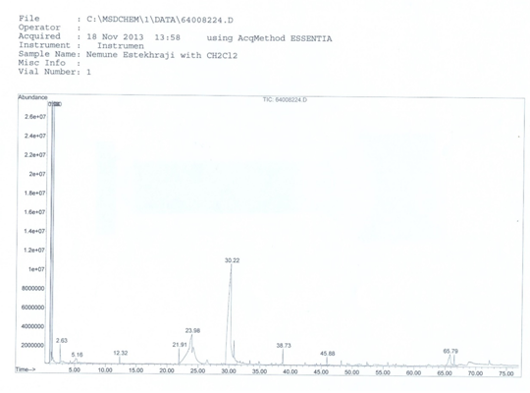

Figure 1. Gas chromatogram of the Vimto® through using dichloromethane as solvent. The main compounds represented from left to right on the chromatogram are benzoic acid,hydroxymethylfurfurole, vanillin and diisooctylphthalate

The best BA (lesser than -7.0) of compounds of Vimto®as presented in the Table 4, as well as, the interactions between the ligand and the proteins were depicted in the following figures.Based on docking results, all of aliphatic hydrocarbons except9-octadecenamide whichfound in the Vimto®drinkwere not reliably bound to selected target of BC. In addition, among aromatic hydrocarbons, piperonal and vanillin have been docked with selected target of BC with BA greater than -7 kcal/mol. While diisooctyl phthalate showed reliableBA with AKT protein at -7.1 kcal/mol (Table 4 and Figure 2), it has been docked to AKT protein with hydrogen bond (Lys214) and hydrophobic interactions (Val199, Asp326, Leu216, Phe196 and Leu329) which are common in MK-2206 with AKT (Figure 2A& 2B).

Table 3. Chemical composition (%) of the Vimto® in the presence of dichloromethane solvent.

|  |  |  |
| --- | --- | --- |
| Compounds | % | RI* |
| Butanoic acid  Decane  Dodecane  Benzoic acid  Hydroxymethylfurfurole  Piperonal  Vanillin  Tetradecane  Germacrene D  Pentadecane  Hexadecane  Heptadecane  Octadecane  Z-5-Nonadecene  *n*-Hexadecanoic acid  Eicosane  Diisooctyl phthalate  Bis(2-ethylhexyl) phthalate  9-Octadecenamide | 0.630  0.234  0.490  10.994  5.197  0.533  26.604  0.553  0.142  0.112  0.546  0.091  0.403  0.199  0.178  0.144  2.353  0.497  0.408 | 920  1110  1151  1155  120  1306  1316  1358  1382  1483  1560  1656  1728  1796  1825  2136  2153  2286 |

*RI: Retention indices in elution from HP-1 column

Table 4. *In silico* molecular docking of major compounds of Vimto drink against selected canonical targets in breast cancer expressed as binding affinity (kcal/mol)

|  |  |  |  |  |  |  |  |
| --- | --- | --- | --- | --- | --- | --- | --- |
| Phytocompound | AKT  3E88 | HER2  3PP0 | ERK  5NGU | Aromatase  3EQM | ER-Alpha  1X7E | Estrone Sulfatase  1P49 | PI3K  5SW8 |
| Butanoic_acid |  | -7.4 |  | -7.0 | -7.6 |  |  |
| 9-octadecenamide |  | -7.3 |  |  |  |  |  |
| Benzoic_acid |  |  |  |  |  |  | -7.5 |
| Germacrene_D |  | -7.0 | -7.0 |  | -8.4 | -7.0 |  |
| Vanillin |  |  |  |  |  |  |  |
| Bis(2-ethylhexyl)phthalate |  | -8.0 |  | -7.0 |  |  |  |
| Diisooctyl_phthalate | -7.1 | -7.7 |  |  |  | -7.5 |  |
| MK-2206 | -9.0 |  |  |  |  |  |  |
| Lapatinib |  | -10.3 |  |  |  |  |  |
| GSK-2141795 |  |  | -7.7 |  |  |  |  |
| Exemestane |  |  |  | -9.1 |  |  |  |
| Tamoxifen |  |  |  |  | -6.7 |  |  |
| STX-64 |  |  |  |  |  | -8.0 |  |
| Prifosine |  |  |  |  |  |  | -5.9 |

Note: Blank cell shows that binding affinity of ligand to target proteins was bigger than -7.0 kcal/mol and intentionally not reported.

Butanoic acid showedreliable BA with HER2 protein at BA of -7.4 kcal/mol(Table 4) and it has been docked to HER2 protein with hydrogen bond (Asp444) and hydrophobic interaction (Val315) which are common in lapatinib interaction with HER2 (Figure 3A & 3F).Butanoic acid has been also docked with hydrophobic interactions (Phe177 and Asp265) that are common in exemestane interaction with aromatase (Figure 5B& 5C) and they showed reliably BA with aromatase at identical -7.0 kcal/mol (Table4). Butanoic acid has been docked with a hydrogen bond with ER-alpha protein as common in tamoxifen (His213) binding to ER-alpha protein (Figure 6A& 6C).Butanoic acid has been docked with hydrophobic interactions (Arg129, Pro138, Glu94, Phe97, etc.) and hydrogen bonds (Glu95 and Arg107) with PI3K (Figure 8A).In Sum, butanoicacid showed trustful BA with BC classic targets and this short fatty acid can be considered as endogenous or exogenous compound for oncotherapy. One study showed that butanoic acid prodrugs that release formaldehyde, augment doxorubicin (Dox) anticancer activity and also protect against Dox cardiotoxicity (38). Based on these observations, clinical applications of these prodrugs for patients treated with Dox warrant further investigation(38).

9-Octadecenamid showedreliably BA with HER2 protein reliably BA at -7.3 (Table 4) and it has been docked to HER2 protein with hydrogen bond (Met96) and hydrophobic interactions (Leu147, Lys48, Leu91, Thr157, Asp158, etc.) (Figure 3B). This compound has antimicrobial and anti-inflammatory effects (39).

Germacrene D showed reliably BA with HER2 protein at -7.0 (Table 4) and it has been docked to HER2 protein with hydrophobic interactions (Val315, Asp444, Leu307, Phe577 and Leu433) that are common in lapatinib with HER2 (Figure 3C& 3F), bis (2-ethylhexyl) phthalate has been docked with acceptably BA at -8.0 (Table 4) and with hydrogen bonds (Thr157 and Asp158) and hydrophobic interactions (Leu147, Lys48, Val29, Thr93, Glu65, etc.) with HER2 protein (Figure 3D) and diisooctyl phthalate has been docked with reliably BA at -7.7 (Table 4) and docked with hydrogen bond (Asp444) and hydrophobic interactions (Val315, Leu307, Leu433, Phe577, and Cys386) to HER2 protein which lapatinib also employed these amino acids to dock with HER2 (Figure 3E& 3F). Germacrene D has been docked with hydrophobic interactions (Ala42, Leu146, Asp101, Ser143 and Met98), which GSK-2141795 also employed these amino acids to dock with ERK (Figure 4A& 4B) and showed reliablyBA with ERK protein at -7.0 kcal/mol (Table 4). Germacrene D has been docked with hydrophobic interactions (Met322, Leu318, Phe338, Thr281, etc.) with ER-alpha (Figure 6B) and showed reliably and acceptable BA with ER-alpha protein at -7.6 and -8.4 kcal/mol respectively (Table 4). Germacrene D has been docked with hydrophobic interactions (Trp528, Phe210, Leu206, Gly209, etc.) with estrone sulfatase (Figure 7A) and diisooctyl phthalate has been docked with hydrophobic interactions that are common in STX-64 (Gly158 and Phe155) with estrone sulfatase (Figure 7B& 7C) and showed reliably BA with estrone sulfatase protein at -7.0 and -7.5 kcal/mol, respectively (Table 4). Germacrene D has been docked with hydrophobic interactions (Arg93, Ile126, Arg129, Glu92, etc.) with PI3K (Figure 8B) and Bis (2-ethylhexyl) phthalate has been docked with hydrophobic interactions (Lys1064, Ile1075, Tyr1052, Val1047, Gln528, etc.) with PI3K (Figure 8C) and showed reliably BA with PI3K protein respectively at -7.0, -7.1 and -7.1 kcal/mol (Table 4).

Germacrene is a class of volatile organic hydrocarbons, specifically, sesquiterpenes. Germacrene is typically produced in a number of plant species for their antimicrobial and insecticidal properties, though they also play a role as insect pheromones. In a study, the antioxidant and cytotoxic capacity of the *KundmanniaSecula* plant, that a source of rich sesquiterpene hydrocarbon germacrene D, has been investigated and results of this study may support uses of this plant as a natural source of germacrene D to be exploited on an industrial level (40).

Bis (2-ethylhexyl) phthalate has been docked with hydrogen bond (Arg71) and hydrophobic interactions (Met330, Trp180, Leu328, Phe177, Thr266, Leu433, Val326 and Ile89) that are common in exemestane with aromatase (Figure 5A). Phthalates are chemical compounds that are commonly added to plastics to increase their flexibility, transparency, durability and longevity. Phthalates are used in a wide range of cosmetic and food products-plus, they’re released into the environment. Diet is believed to be the main source of phthalates because fatty foods such as milk, butter and meats are commonly packaged or stored in plastics containing this dangerous toxin (41). These compounds are known as toxic substances and have effects on liver, kidney, endocrine system and reproduction, it may also have a carcinogen in the long term (42). From these data, it can be concluded that phthalates present in the Vimto® may be transferred to manufacturing during production and packaging.

Since the *in silico*methods function on the basis of probabilities, compounds that have not been properly docked with proteins may affect the body. The most important of these compounds are benzoic acid and vanillin which have high percentages in Vimto®.

Benzoic acid is a white and crystalline powder with a faint and non-offensive odor. It is a compound naturally found in many plants and is an important precursor for the synthesis of many other organic substances. It is most commonly found in industrial settings to manufacture a wide variety of products such as perfumes, dyes, topical medications and insect repellents (43). Benzoic acid is one of these preservatives in processed foods like cheeses, varying sauces as well as meats. Miserably, it is also found in cosmetic products and many pharmaceutical products, so it can be hard to avoid (44). Immediatelyor shortly following being exposed to benzoic acid, the following can occur: eye damage, irritation of the skin (including rashes, redness, burning sensation, etc.). If benzoic acid is inhaled, it can cause irritation to the nose, lungs, and throat, which can lead to coughing, wheezing, and shortness of breath. Large amounts inhaled can also damage the nervous system (43).

Vanillin (4-hydroxy-3-methoxybenzaldehyde) a naturally occurring compound found in the pods of Vanilla spp, was found to significantly alter gene expression in the HepG2 human hepatocellular carcinoma cell line(18) and to suppress the invasion and migration of mammary adenocarcinoma cancer cells (12). Vanillin also has anti-mutagenic properties against spontaneous mutations in mammalian cells (9).

In one hand,Vimto® has anti-cancer effects due to its antitumor components and on the other hand, Vimto®may be putative cancer inducer due to the presence of phthalate. Therefore, studies are needed to know the whole composition of Vimto® and its pharmacological and toxicological effects.

**Figure 2.** Molecular docking of phytocompounds (in yellow color) of the Vimto® with AKT serine/threonine-protein kinase (PDB code 3E88; in cyan color). Hydrogen bonds are presented using dashed lines, while hydrophobic interactions showed with semicircles with spokes directed to ligand atoms they interact.

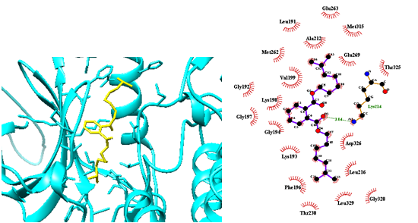

Figure 2A. AKT-3E88-diisooctyl-phthalate-4655188

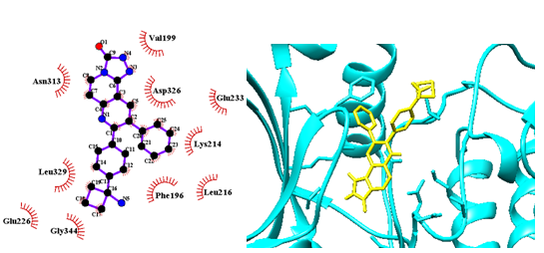

Figure 2B. AKT-3E88-MK-2206-24964624

**Figure 3.** Molecular docking of phytocompounds (in yellow color) of the Vimto® with HER2 (PDB code 3PP0; in cyan color). Hydrogen bonds are presented using dashed lines, while hydrophobic interactions showed with semicircles with spokes directed to ligand atoms they interact.

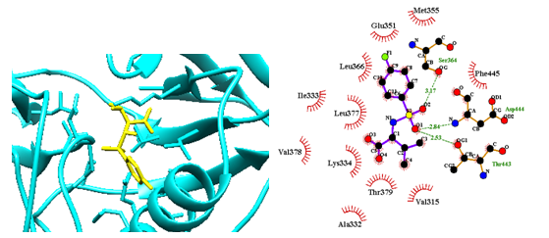

Figure 3A. HER2-3PP0-Butanoic-acid-166179

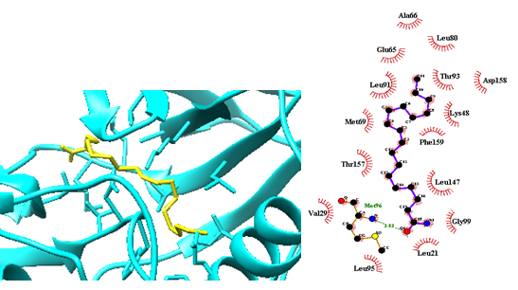

Figure 3B. HER2-3PP0-9-Octadecenamide-8036015

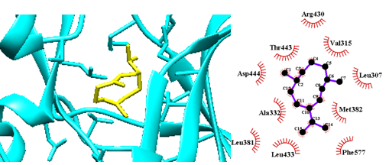

Figure 3C. HER2-3PP0-Germacrene-D-30730221

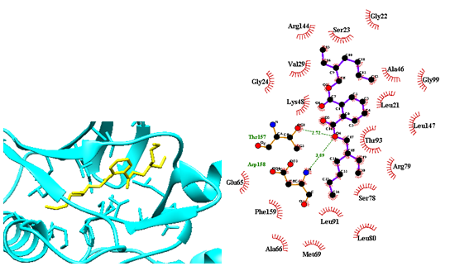

Figure 3D. HER2-3PP0-Bis (2-ethylhexyl) phthalate-3860432

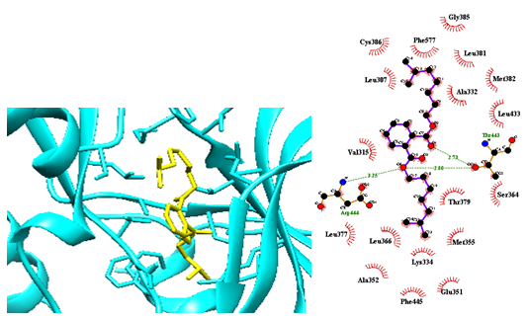

Figure 3E. HER2-3PP0-Diisooctyl-phthalate-4655188

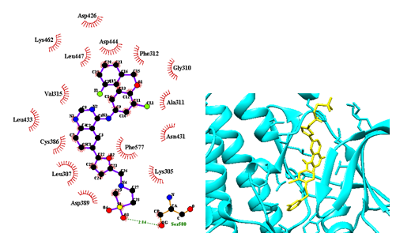

Figure 3F. HER2-3PP0-Lapatinib-208908

**Figure 4.** Molecular docking of phytocompounds (in yellow color) of the Vimto® with ERK (PDB code 5NGU; in cyan color). Hydrogen bonds are presented using dashed lines, while hydrophobic interactions showed with semicircles with spokes directed to ligand atoms they interact.

atoms they interact.

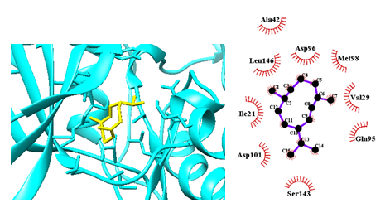

Figure 4A. ERK-5NGU-Germacrene-D-30730221

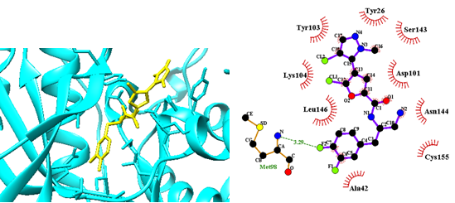

Figure 4B. ERK-5NGU-GSK-2141795-51042438

**Figure 5.** Molecular docking of phytocompounds (in yellow color) of the Vimto® with aromatase (PDB code 3EQM; in cyan color). Hydrogen bonds are presented using dashed lines, while hydrophobic interactions showed with semicircles with spokes directed to ligand atoms they interact.

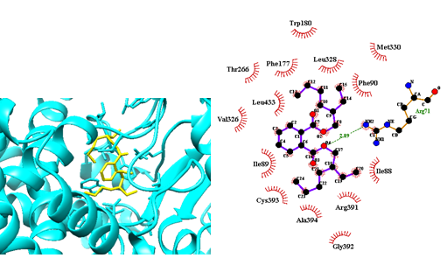

Figure 5a. Aromatase-3EQM-Bis (2-Ethylhexyl) Phthalate-3860432

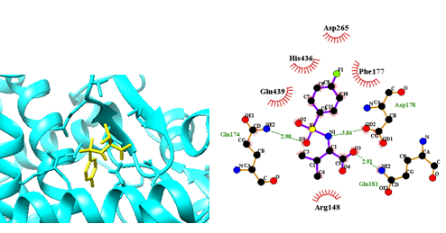

Figure 5B. Aromatase-3EQM-Butanoic-acid-166179

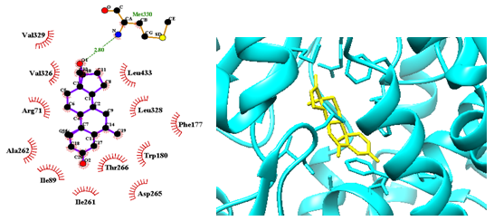

Figure 5C. Aromatase-3EQM-Exemestane-60198

**Figure 6.** Molecular docking of phytocompounds (in yellow color) of the Vimto® with ER-Alpha (PDB code 1X7E; in cyan color). Hydrogen bonds are presented using dashed lines, while hydrophobic interactions showed with semicircles with spokes directed to ligand atoms they interact.

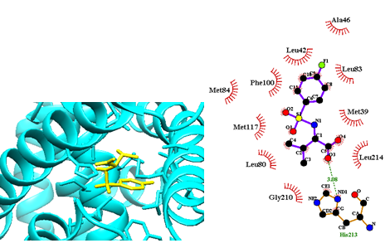

Figure 6A. ER-Alpha-1X7E-Butanoic-acid-166179

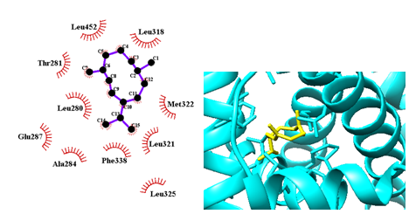

Figure 6B. ER-Alpha-1X7E-Germacrene-D-30730221

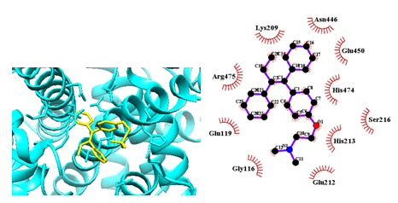

Figure 6C. ER-Alpha-1X7E-Tamoxifen-2733526

**Figure 7.** Molecular docking of phytocompounds (in yellow color) of the Vimto® with estrone sulfatase (PDB code 1P49; in cyan color). Hydrogen bonds are presented using dashed lines, while hydrophobic interactions showed with semicircles with spokes directed to ligand atoms they interact.

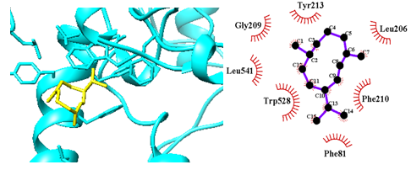

Figure 7A. Estrone-Sulfatase-1P49-Germacrene-D-30730221

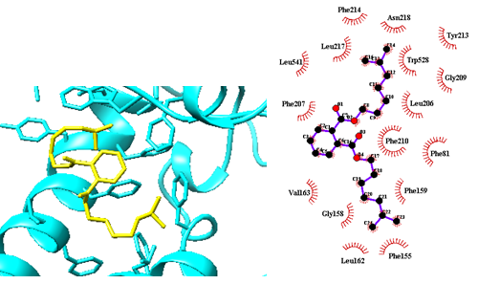

Figure 7B. Estrone-Sulfatase-1P49-Diisooctyl-Phthalate-4655188

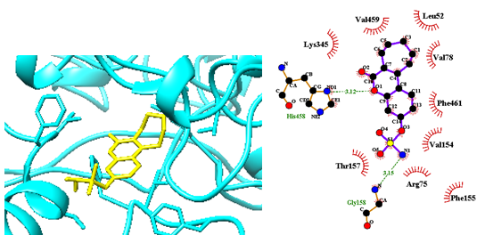

Figure 7C. Estrone-Sulfatase-1P49-STX-64-5287541

**Figure 8.** Molecular docking of phytocompounds (in yellow color) of the Vimto® with PI3K (PDB code 5SW8; in cyan color). Hydrogen bonds are presented using dashed lines, while hydrophobic interactions showed with semicircles with spokes directed to ligand

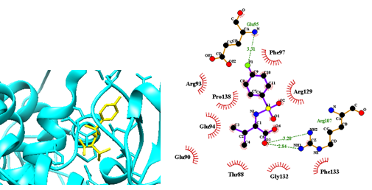

Figure 8A. PI3K-5SW8-Butanoic-acid-166179

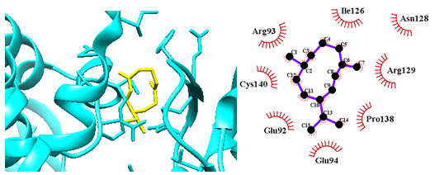

Figure 8B. PI3K-5SW8-Germacrene-D-30730221

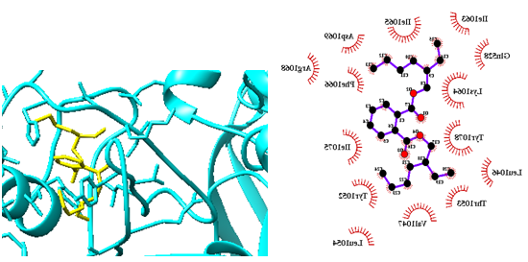

Figure 8C. PI3K-5SW8-Bis (2-Ethylhexyl) Phthalate-3860432

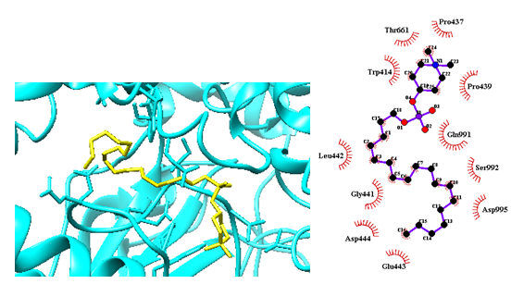

Figure 8D. PI3K-5SW8-Prifosine-8214653

**CONCLUSIONS**

The order of BA of Vimto®chemical compositions were as follows:diisooctyl phthalate>bis (2-ethylhaxyl) phthalate>germacrene D> 9-octadecenamide>butanoic acid with BA of -7.43, -7.36, -7.28, -7.30 and -7.27 respectively. In addition, the cardinal target proteins of BC include AKT, ERK, HER2 and aromatase showed better docking with compounds of Vimto®, because this compound has been docked with the proteins at their binding site with their inhibitors. Therefore, Vimto®drink showed the both anticancer and carcinogeniceffects due to the presence of diisooctyl phthalate and bis (2-ethylhaxyl) phthalate, a sterilizing agent.Here we were only focused on binding affinities less than -7.0 kcal/mol to consider a ligand as anti-cancer and/or inducer of cancer.

In essence, the compounds of Vimto®that dock to proteins of BC are not necessarily anticancer agents and may activate carcinogenic pathways since many of them are poisonous and harmful. Finally, according to the presence of anticancer and antibacterial compounds in Vimto®(9-octadecenamide, germacrene D and vanillin), and also due to the many enthusiasms to drinkVimto®, it is necessary to exclude its harmful and carcinogenic compounds (phthalates and benzoic acid), and a healthier drink offered to its customers.

**Acknowledgement**

Authors are thankful to the Razi University, for the motivation and support.

**Funding disclosure**

The work was entirely funded by RaziUniversity

**Declaration of competing interest**

The authors declare no conflicts of interest.

**Appendix A. Supplementary data**

Supplementary data to this article can be found online at researchgate page of corresponding author.

**Author’s Contribution**

**REFERENCES**

1. Keighren J. Famous Vimto monument gets a makeover The University of Manchester 2011 [Available from: https://www.manchester.ac.uk/discover/news/famous-vimto-monument-gets-a-makeover/.

2. Priefert H, Rabenhorst J, Steinbüchel A. Biotechnological production of vanillin. Applied Microbiology and Biotechnology. 2001;56(3):296-314.

3. Clark GS. Vanillin. Perfumer & flavorist. 1990;15(2):45-52.

4. Zamzuri NA, Abd‐Aziz S. Biovanillin from agro wastes as an alternative food flavour. Journal of the Science of Food and Agriculture. 2013;93(3):429-38.

5. Sawa T, Nakao M, Akaike T, Ono K, Maeda H. Alkylperoxyl radical-scavenging activity of various flavonoids and other phenolic compounds: implications for the anti-tumor-promoter effect of vegetables. Journal of Agricultural and Food Chemistry. 1999;47(2):397-402.

6. Tai A, Sawano T, Yazama F, Ito H. Evaluation of antioxidant activity of vanillin by using multiple antioxidant assays. Biochimica et Biophysica Acta (BBA)-General Subjects. 2011;1810(2):170-7.

7. Pedroso LS, Fávero GM, de Camargo LEA, Mainardes RM, Khalil NM. Effect of the o-methyl catechols apocynin, curcumin and vanillin on the cytotoxicity activity of tamoxifen. Journal of enzyme inhibition and medicinal chemistry. 2013;28(4):734-40.

8. Imanishi H, Sasaki Y, Matsumoto K, Watanabe M, Ohta T, Shirasu Y, et al. Suppression of 6-TG-resistant mutations in V79 cells and recessive spot formations in mice by vanillin. Mutation Research Letters. 1990;243(2):151-8.

9. King AA, Shaughnessy DT, Mure K, Leszczynska J, Ward WO, Umbach DM, et al. Antimutagenicity of cinnamaldehyde and vanillin in human cells: Global gene expression and possible role of DNA damage and repair. Mutation Research/Fundamental and Molecular Mechanisms of Mutagenesis. 2007;616(1-2):60-9.

10. Srinivasan K, Platel K, Rao M. Hypotriglyceridemic effect of dietary vanillin in experimental rats. European Food Research and Technology. 2008;228(1):103-8.

11. Liang J-A, Wu S-L, Lo H-Y, Hsiang C-Y, Ho T-Y. Vanillin inhibits matrix metalloproteinase-9 expression through down-regulation of nuclear factor-κB signaling pathway in human hepatocellular carcinoma cells. Molecular pharmacology. 2009;75(1):151-7.

12. Lirdprapamongkol K, Sakurai H, Kawasaki N, Choo M-K, Saitoh Y, Aozuka Y, et al. Vanillin suppresses in vitro invasion and in vivo metastasis of mouse breast cancer cells. European journal of pharmaceutical sciences. 2005;25(1):57-65.

13. Lirdprapamongkol K, Kramb J-P, Suthiphongchai T, Surarit R, Srisomsap C, Dannhardt G, et al. Vanillin suppresses metastatic potential of human cancer cells through PI3K inhibition and decreases angiogenesis in vivo. Journal of Agricultural and Food Chemistry. 2009;57(8):3055-63.

14. Lirdprapamongkol K, Sakurai H, Suzuki S, Koizumi K, Prangsaengtong O, Viriyaroj A, et al. Vanillin enhances TRAIL-induced apoptosis in cancer cells through inhibition of NF-κB activation. In vivo. 2010;24(4):501-6.

15. Babich H, Borenfreund E, Stern A. Comparative cytotoxicities of selected minor dietary non-nutrients with chemopreventive properties. Cancer letters. 1993;73(2-3):127-33.

16. Ho K, Yazan LS, Ismail N, Ismail M. Apoptosis and cell cycle arrest of human colorectal cancer cell line HT-29 induced by vanillin. Cancer epidemiology. 2009;33(2):155-60.

17. Durant S, Karran P. Vanillins—a novel family of DNA‐PK inhibitors. Nucleic Acids Research. 2003;31(19):5501-12.

18. Cheng W-Y, Hsiang C-Y, Bau D-T, Chen J-C, Shen W-S, Li C-C, et al. Microarray analysis of vanillin-regulated gene expression profile in human hepatocarcinoma cells. Pharmacological Research. 2007;56(6):474-82.

19. DeB J, Dibra H, Shan S, Rajan S, Manneh J, Kankipati CS, et al. Activity of aspirin analogues and vanillin in a human colorectal cancer cell line. Oncology reports. 2011;26(3):557-65.

20. Bezerra DP, Soares AKN, de Sousa DP. Overview of the role of vanillin on redox status and cancer development. Oxidative medicine and cellular longevity. 2016;2016.

21. George YM, Bagoury BM, Zayed HH, Roushdy MI. Automated cell nuclei segmentation for breast fine needle aspiration cytology. Signal Processing. 2013;93(10):2804-16.

22. Higgins MJ, Baselga J. Targeted therapies for breast cancer. The Journal of clinical investigation. 2011;121(10):3797-803.

23. Wang GM, Park BH. The role of PIK3CA mutations as a predictor of outcomes and a therapeutic target. Current Breast Cancer Reports. 2010;2(4):167-73.

24. Ferreira LG, Dos Santos RN, Oliva G, Andricopulo AD. Molecular docking and structure-based drug design strategies. Molecules. 2015;20(7):13384-421.

25. Shibamoto T. Retention indices in essential oil analysis: Huethig Verlag, New York; 1987.

26. Adams RP. Identification of essential oil components by gas chromatography/mass spectrometry: Allured publishing corporation Carol Stream, IL; 2007.

27. Karimi I, Hayatgheybi H, Kamalak A, Pooyanmehr M, Marandi Y. Chemical composition and effect of an essential oil of Salix aegyptiaca L., Salicaceae,(musk willow) in hypercholesterolemic rabbit model. Revista Brasileira de Farmacognosia. 2011;21:407-14.

28. Dallakyan S, Olson AJ. Small-molecule library screening by docking with PyRx. Chemical biology: Springer; 2015. p. 243-50.

29. Thomsen R, Christensen MH. MolDock: a new technique for high-accuracy molecular docking. Journal of medicinal chemistry. 2006;49(11):3315-21.

30. Laskowski RA, Swindells MB. LigPlot+: multiple ligand–protein interaction diagrams for drug discovery. ACS Publications; 2011.

31. Rouse MB, Seefeld MA, Leber JD, McNulty KC, Sun L, Miller WH, et al. Aminofurazans as potent inhibitors of AKT kinase. Bioorganic & medicinal chemistry letters. 2009;19(5):1508-11.

32. Aertgeerts K, Skene R, Yano J, Sang B-C, Zou H, Snell G, et al. Structural analysis of the mechanism of inhibition and allosteric activation of the kinase domain of HER2 protein. Journal of Biological Chemistry. 2011;286(21):18756-65.

33. Ward RA, Bethel P, Cook C, Davies E, Debreczeni JE, Fairley G, et al. Structure-guided discovery of potent and selective inhibitors of ERK1/2 from a modestly active and promiscuous chemical start point. Journal of medicinal chemistry. 2017;60(8):3438-50.

34. Ghosh D, Griswold J, Erman M, Pangborn W. Structural basis for androgen specificity and oestrogen synthesis in human aromatase. Nature. 2009;457(7226):219-23.

35. Manas ES, Unwalla RJ, Xu ZB, Malamas MS, Miller CP, Harris HA, et al. Structure-based design of estrogen receptor-β selective ligands. Journal of the American Chemical Society. 2004;126(46):15106-19.

36. Hernandez-Guzman FG, Higashiyama T, Pangborn W, Osawa Y, Ghosh D. Structure of human estrone sulfatase suggests functional roles of membrane association. Journal of Biological Chemistry. 2003;278(25):22989-97.

37. Miller MS, Maheshwari S, McRobb FM, Kinzler KW, Amzel LM, Vogelstein B, et al. Identification of allosteric binding sites for PI3Kα oncogenic mutant specific inhibitor design. Bioorganic & medicinal chemistry. 2017;25(4):1481-6.

38. Rephaeli A, Waks-Yona S, Nudelman A, Tarasenko I, Tarasenko N, Phillips D, et al. Anticancer prodrugs of butyric acid and formaldehyde protect against doxorubicin-induced cardiotoxicity. British journal of cancer. 2007;96(11):1667-74.

39. Hussein HM, Hameed IH, Ibraheem OA. Antimicrobial Activity and spectral chemical analysis of methanolic leaves extract of Adiantum Capillus-Veneris using GC-MS and FT-IR spectroscopy. International Journal of Pharmacognosy and Phytochemical Research. 2016;8(3):369-85.

40. Casiglia S, Bruno M, Bramucci M, Quassinti L, Lupidi G, Fiorini D, et al. Kundmannia sicula (L.) DC: a rich source of germacrene D. Journal of EssEntial oil rEsEarch. 2017;29(6):437-42.

41. De Toni L, Tisato F, Seraglia R, Roverso M, Gandin V, Marzano C, et al. Phthalates and heavy metals as endocrine disruptors in food: a study on pre-packed coffee products. Toxicology reports. 2017;4:234-9.

42. Iraba M. Phthalates....What were those again? Iraba Cosmetics2017 [Available from: https://irabacosmetics.com/blogs/news/phthalates-what-were-those-again.

43. Benzoic Acid – Uses and Safety VelocityEHS2015 [Available from: https://www.ehs.com/2015/02/benzoic-acid-uses-and-safety/.

44. Olson S. Benzoic Acid – A Harmful Preservative StopKillingMyKids2010 [Available from: https://www.stopkillingmykids.com/benzoic-acid-a-harmful-preservative/.