**Reviewer’s Comments**

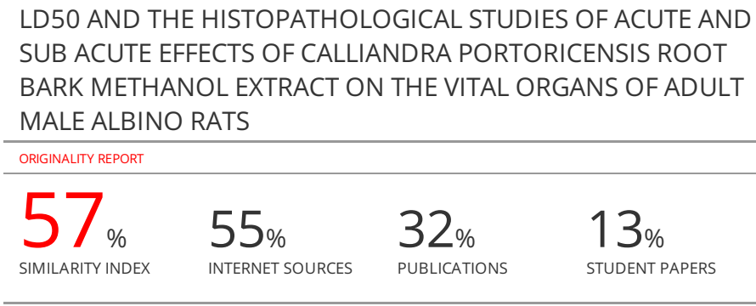

**LD50 AND THE HISTOPATHOLOGICAL STUDIES OF ACUTE AND SUB ACUTE EFFECTS OF *CALLIANDRA PORTORICENSIS* ROOT BARK METHANOL EXTRACT ON THE VITAL ORGANS OF ADULT MALE ALBINO RATS**

**Abstract**

**Introduction:***Calliandra portoricensis* (*C. portoricensis*) is also known as snowflake acacia or powder-puff and it is belongs to the family mimosaeae. Toxicology maybe defined as the study of harmful, poisonous and adverse effects of drugs and other chemicals constituents found in plants, which may increase the chances of mortality or weakness in the general health, physically as well as mentally. **Objective:** To evaluate the consequence of the administration of *Calliandra portoricensis* (C. portoricensis) *Calliandra portoricensis* root bark methanol extract on the vital organs of adult male albino rats. **Methods:** Acute oral toxicity studies where performed according to the organization for economic cooperation and development (OECD), 2002. Thirty-five Male albino rat (160-180g) where divided into seven groups with five rats per group. Group G were given a single oral limit dose of 5000 mg/kg b.wt of *C. portoricensis* root bark methanol extract while group A control animals received an equivalent volume of distilled water. Group B, C, D, E and F where administered 100, 200, 400, 800 and 1600 mg/kg b.wt of C. portoricensis root bark methanol extract respectively for 7 days. They were all observed daily for additional 7 days for signs and delayed toxicity.

The *C. portoricensis* root bark methanol extract was administered orally using a calibrated 1ml syringe with attached polythene cannula.At different stages in the study, the rats were sacrificed and the vital organs such as stomach, kidney, liver, small intestine and pancreas were excised and fixed in 10% formalin for Histological examination. **Result:** The rats administered CPRBME showed toxicity symptoms including writhing, dullness, decreased locomotion, fatigue etc after 2-4 hours of CPRBME administration in groups B – F as compared to group A. Also there were severe diffused vacuolar degeneration, necrosis of hepatocytes, necrotic-erosion of mucosa membrane and various degree of tubular degeneration in kidneys as compared to the control group A. The spleen of both control and treated groups had no visible lesion.

**Conclusion:** The current findings proposes that acute and sub acute administration (14 days as seen in this study) of *C. portoricensis* root bark methanol extract may impede the proper function of vital organs.

Key words: *Calliandra portoricensis*, vital organs, toxicity, necrotic-erosion, degeneration, animal

**Introduction**

Medicinal plants and herbs are invaluable resources that are considered as potentially safe medicines/drugs (Siemuri *et al.,* 2012). Natural products of plants origin have been and have remained the cornerstone of health care, playing an important role in alleviating human sufferings by contributing herbal medicines in the primary health care systems of rural and remote areas where more than 70% of population depends on folklore and traditional systems of medicines (Rice-Evans, 2004 ).

Sadly to say, most people who use these medicinal plants in our society have not undergone adequate training. Therefore, in order to have standard natural plant products, preliminary studies have to be done to evaluate possible risks such as, undesirable effects, overdose or poisoning associated with any plant.

Toxicology is an integral part of pharmacology which deals with the undesirable effect of phytocompounds on living organisms prior to their use as drugs clinically (Aneela *et al.,* 2011). Several studies are concentrated on toxicity analysis so as to determine the safeness of medicinal plants and their products. Toxicity analysis is essential, as some herbs consumed might have some toxic effects and many reports have been published for toxicity caused due to long term consumption of herbs (Dharmalingam and Natesan, 2017).

The occurrence of toxicity mechanism could differ depending on the cell membrane and chemical properties of the toxicants in human beings. It might happen within the cell membrane or on the cell surface or tissue underneath as well as at the extracellular matrix (Dharmalingam and Natesan, 2017). According to OECD guidelines, in order to ascertain the protection and effectiveness of a new drug, toxicological studies are extremely significant in animals like mice, rat, guinea pig, dog, rabbit, monkey etc. Toxicological studies help deciding whether a new drug must be adopted for clinical use or not. OECD guidelines such as 401, 423 and 425 do not permit the use of drug clinically without its clinical trial as well as toxicity studies (Ecobichon, 2007).

Depending on the duration of drug exposure to animals, toxicological testing could be classified into three types viz: acute, sub-acute and chronic toxicological studies. The acute toxicity test in which a single dose is used in each animal on one occasion (within 24 hours) only for the determination of gross behavior and also LD50 or median lethal dose. The chronic tests in which two species, one rodent and one non rodent are dosed daily for complete six months. The sub-acute tests wherein animals (typically rats and dogs) are dosed daily, beginning at around expected therapeutic level and increasing stepwise every two to three days until toxic symptoms are observed (Bhardwaj and Gupta, 2012).

*Calliandra portoricensis* (*C. portoricensis*) is also known as snowflake acacia or powder-puff. This shrub or little tree is native to Central America, and most precisely to Mexico, Panama, and to the West Indies.

*Calliandra portoricensis* (Jacq.) Benth is a straggling perennial shrub and belongsto the family mimosaeae (Hutchinson and Dalziel, 1937). *Calliandra portoricensis* belongs to a category ofmedicinal plants or herbs which has potency of curing ormanaging diseases. It is used in Nigeria folklore medicineas a laxative/worm expeller (Adesida, 1976) and an abortifacient in human beings (Ayensu, 1978). *It* has alsobeen reported to possess antimalarial, anticonvulsant,antidiarrheal, antisplasmodic, antipyretic, antirheumaticand analgesic activities in humans (Akah and Nwaiwu,1988; Aguwa and Lawal, 1988; Adesina, 1982). In addition, Ithas been reported to exhibit anticholigenic, antacid,antiulcer, molluscidal and ovucidal activities in laboratoryanimals (Aguwa and Lawal, 1988) as well as in the traditionalmanagement of sickle cell anaemia and prostate cancer inAfrica(Orishadipe *et al*., 2010). The plant extracts equallyhave antimicrobacterial activities against the followingorganisms: *Escherichia coli, Staphyloccocus aureus, Streptococcus faecium* and *Candida albicans* (Adesina,1982) and contains phytochemical constituents such as tannin saponins, flavonoids, cardiac glycosides (Aguwa and Lawal, 1998; Siemuri *et al.,* 2015).

In order to assess the toxic nature of a bioactive compounds present in the plant extract, acute oral toxicity is the first step to be carried out. Acute toxicity testing involves the estimation of lethal dose, the dose that kills 50% of the tested group of animals. In the present investigation, as a part of safety evaluation, acute and subacute toxic effects of *Calliandraportoricensis* methanol extract was studied in male albino wistar rats.

**Materials and Methods**

**Collection and identification of plant**

The root of *C. portoricensis*were collected from the medicinal plant garden of the Botany Department University of Ibadan, Ibadan and authenticatedLarge quantities of the root would also be collected from Ijebu-Ode, Ogun State Nigeria. The taxonomic identity of the plant was confirmed by a Botanist of the Botany Department University of Ibadan . Specimen copy was deposited at the herbarium and the plant was given voucher number UIH-22843.The root were freshly harvested, washed and the peeled barks air-dried and pulverized using local grinding machine into coarse/fine particles.

**Extraction of the Plant Materials**

Briefly 500g of the pulverized sample were cold macerated in 5.0 L methanol for 72 hours with occasional stirring. The extract was then filtered using Whatman No.1 filter paper. The filtrate were then dried in a rotary evaporator at 40°C until a semi-solid paste is obtained. This was then stored in airtight container in a refrigerator until needed for analysis. (Kumar *et al.,* 2010).

**Experimental animals**

Thirty-five healthy adult male Wistar rats weighing approximately 160 – 180 g obtained from the Department of Biochemistry, University of Ibadan, Nigeria were randomly assigned into seven groups of five animals per group. They were accommodated in polypropylene cages (55 x 32.7 x 19 cm) with sawdust litter and maintained the temperature of 30 ± 2ºC in a well-ventilated rat house The animals were fed with standard laboratory animal food pellets with water *ad libitum* and subjected to a natural photoperiod of 12-h light and 12-h dark cycle following the guidelines and with prior permission from the Institutional Animal Ethical Committee.

**Experimental Protocol for Acute and Sub-acute Toxicity Study**

Acute oral toxicity studies was performed according to the organization for economic cooperation and development (OECD), 2002. Male albino rat were divided into seven group with five rats per group. Group G were given a single oral limit dose of 5000 mg/kg b.wt of *C. portoricensis* root bark methanol extract while group A control animals received equivalent volume of distilled water.

The animals were fasted for 12 hours with free access to water only. Following the period of fasting, animals were weighed and test extract was administrated orally at a dose of 100, 200, 400, 800 and 1600 mg/kg. After the administration of test extract, food for the animals were withheld for 2 hours.

The treated rat were monitored for signs of toxicity and mortality at the first, second, fourth and sixth hour for immediate toxicity signs. Mortality observed in each group was recorded. thereafter, depending on the level of tolerance of the limit dose subsequent doses (less than the limit dose, if not well tolerated or greater than the limit dose if well tolerated. Group B, C, D, E and F where administered 100, 200, 400, 800 and 1600 mg/kg b.wt of *C. portoricensis* root bark methanol extract respectively. They were all observed daily for an additional seven days for signs and delayed toxicity. The *C. portoricensis* root bark methanol extract was administered orally using a calibrated 1ml syringe with attached polythene cannula.

The mortality and clinical signs which included changes in skin, fur, eyes and mucous membranes were noted for the first 4 hours subsequently for 72 hours and thereafter for 7 days of test drug administration. For complete 7 days, the gross behaviors like body positions, locomotion, rearing, tremors and gait were observed and also the effect of plant extract on grip strength, pain response and righting reflex were noted. In addition, the intake of food and water behavior was monitored.

**Histological Examination**

The histological study of the stomach, pancreas, liver, kidney, intestine, and heart adopted the method of Carlton (1967). Samples of the corpus from the stomach and tail of the pancreas were excised and fixed in 10% formol saline and later processed by routine techniques prior to embedding in paraffin. Sections (5 m thick) were mounted on glass slides and stained with haematoxylin and eosin. Permanent photomicrograph was obtained using Olympus Research Microscope (model BX51).

**Statistical Analysis:** All the experimental results were Mean ± SD of five parallel measurements. Linear regression analysis was used to calculate LD50 values. The statistical significance was evaluated by student’s t – test using Microsoft Excel. A value of P < 0.05 was accepted as significant difference between groups.

**Result**

**Table 1: Table 1:** Effect of *Calliandra portoricensis* root bark methanol extract (CPRBME) on acute and sub-acute oral toxicity test in Albino Wistar rats

|  |  |  |  |  |  |  |  |  |
| --- | --- | --- | --- | --- | --- | --- | --- | --- |
| S/No | Response |  | Tested Animals Group | | | | | |
| Group A control | Group B(100 mg/kg) | Group C(200 mg/kg) | Group D (400 mg/kg) | Group E (800 mg/kg) | Group F (1600 mg/kg) | Group G (5000 mg/kg) |
| 1 | Alertness | N | N | N | AN | AN | AN | AN |
| 2 | Grooming |  |  |  |  |  |  |  |
| 3 | Restlessness |  |  | + | + | + | + | + |
| 4 | Touch response | N | N | N | AN | AN | AN | AN |
| 5 | Pain response | N | N | N | AN | AN | AN | AN |
| 6 | Tremor |  |  | + | + | + | + | + |
| 7 | Convulsion |  |  | + | + | + | + | + |
| 8 | Rightning reflex | N | N | N | N | N | N | N |
| 9 | Gripping | N | N | N | AN | AN | AN | AN |
| 10 | Pinna reflex | + | + | + | + | + | + | + |
| 11 | Corneal reflex | + | + | + | + | + | + | + |
| 12 | Writhing |  |  | + | + | + | + | + |
| 13 | Pupil | N | N | N | N | N | N | N |
| 14 | Urination | N | N | AN | AN | AN | AN | AN |
| 15 | Salivation | N | N | AN | AN | AN | AN | AN |
| 16 | Lacrimation | N | N | AN | AN | AN | AN | AN |
| 17 | Food intake | N | N | AN | AN | AN | AN | AN |
| 18 | Water intake | N | N | AN | AN | AN | AN | AN |
| 19 | Mortality | Nil | Nil | Nil | + | + | + | + |

N = Normal ; AN = Abnormal ; - = Absent ; + = Present

Acute oral toxicity test was performed to determine the LD50 value of *C. portoricensis* root bark methanol extract. Experiments were carried out using healthy young adult male albino wistar rats weighing 160-180 g.

Acute toxicity determination is a method for assessing acute oral toxicity that involves the recognition of a dose level that causes mortality. The dose limits were selected on the basis of oral acute toxicity studies in rats according to OECD guidelines. The acute toxicity test was carried out in 24 rats by giving different doses of methanolic extract i.e. 100 (Group B), 200 (Group C), 400 (Group D), 800 (Group E) and 1600 (Group F) mg/kg body weight. Parameters such as alertness, loss of appetite, restlessness, touch response, constipation, pain response, tremors, convulsion, righting reflux, gripping, pinna reflex, corneal reflex, writhing, pupils, urination, salivation, locomotion, lacrimation, dullness, watery stool,decreased in sensitivity to touch**,** food intake, fatigue, paw licking, water intake and mortality were observed (Table 1).

The experimental rats treated with acute oral limit dose of 5000 mg/kg body weight of the methanol extract of *Calliandraportoricensis* root bark died, other signs of apparent toxicity symptoms were noticed 2 - 4 hours after extract administration (Table 1).

LD50 values were calculated by probit analysis within 95% confidence limits. The percentage mortality values are plotted against log-doses (Figure 1) and then the dose corresponding to probit 5, i.e., 50% was determined and the results are as shown in Table 2.

**Table 2: Results of LD50 Dose Determination Following the oral Administration of the methanol extract of *Calliandra portoricensis* root bark**

|  |  |  |  |  |
| --- | --- | --- | --- | --- |
| **Dose (mg/kg)** | **Log Dose** | **Motality Rate** | **Motality Ratio** | **% Motality** |
| **100** | 2.000 | 0 | 0:5 | 0 |
| **200** | 2.301 | 1 | 1:5 | 20 |
| **400** | 2.602 | 1 | 1:5 | 20 |
| **800** | 2.903 | 2 | 2:5 | 40 |
| **1600** | 3.204 | 4 | 4:5 | 80 |
| **5000** | 3.700 | 5 | 5:5 | 100 |

**Figure 1: Results of median lethal dose determination of the methanol extract of *Calliandraportoricensis* root bark**

The median lethal dose was calculated as follows y = 60.24x – 117.77

50 = 60.24x – 117.77

X = (50 + 117.77)/60.24

X = 2.79 Log dose

Take antilog

X = 102.79

X = 616.6mg/kg b.wt

* Log LD50 = 2.79 mg/kg b.wt
* LD50 = 616.6 mg/kg b.wt

The medium lethal dose value (LD50) was 616.6 mg/kg body weight for male albino rats. According to OECD, 2002 guide line, substances with LD50 values greater than 5000 mg/kg body weight are classified as substances with low toxicity. Thus, the methanol extract of *Calliandra portoricensis* can be considered as a substance with low toxicity. Furthermore, all the male rats died when treated with 5000 mg/kg body weight dose.

**Table 3: Weights of organ in subacute toxicity of *Wistar* albino rats given the methanol extract of *Calliandraportoricensis* root bark(g/kg of body weight)**

|  |  |  |  |  |  |  |  |
| --- | --- | --- | --- | --- | --- | --- | --- |
| Organs | Control | Group B | Group C | Group D | Group E | Group F | Group G |
| Liver | 4.464±0.03 | 4.06±0.07 | 3.824±0.12 | 3.86±0.09 | 4.002±0.2 | 4.104±0.01 | 4.391±0.03 |
| Small Intestine | 5.086±0.23 | 4.866±0.63 | 4.560±0.5 | 4.76±0.13 | 4.468±0.16 | 4.464±0.03 | 5.441±0.83 |
| Kidney | 0.625±0.1 | 0.613±0.07 | 0.705±0.13 | 0.675±0.3 | 0.711±0.09 | 0.633±0.16 | 0.701±0.02 |
| Spleen | 0.205±0.01 | 0.1820±0.008 | 0.171±0.05 | 0.1470±0.06 | 0.139±0.04 | 0.135±0.006 | 0.190±0.013 |
| Stomach | 0.25 ± 0.02 | 0.19 ± 0.007 | 0.2 ± 0.04 | 0.18 ± 0.01 | 0.21 ± 0.05 | 0.189 ± 0.03 | 0.24 ± 0.06 |

In sub-acute toxicity, the behavioural changes (aggressiveness) were same as observed in acute toxicity with rats during the experiment. As shown in Table 3, there were no significant difference in the weight of the organs of treated animals compared to the control. In the animals tested with the CPRBME extract there was a slight and time dependent decrease in body weight compared to the control group. This decrease in body weight could be due to reduced appetite or impairment of some nutrients as a result of the extract.

The results of the histological examination as depicted in Figure 4 B,C showed mild vacuolar, portal congestion and cell infiltration by mononuclear of the hepatic tissues while control rats revealed mild diffuse vacuolar degeneration as shown in Figure 4 A.

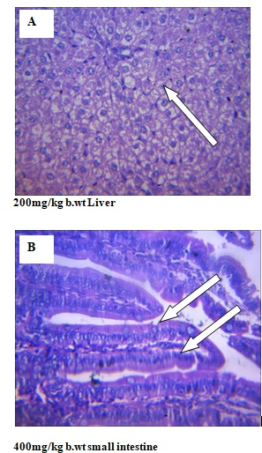

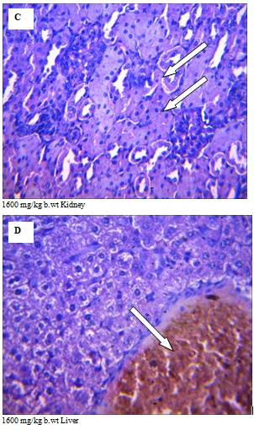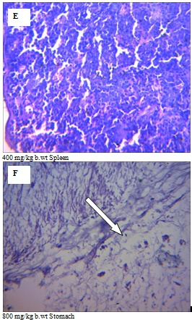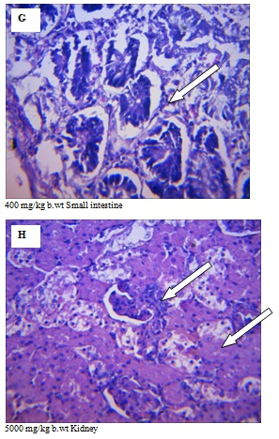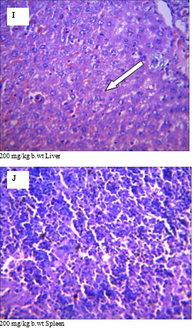

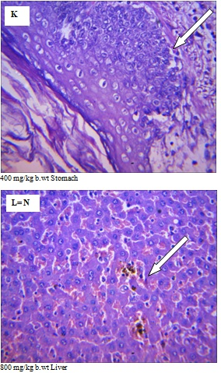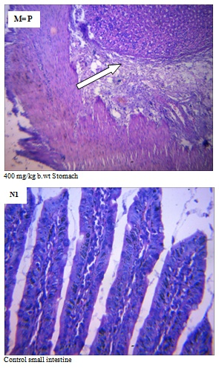

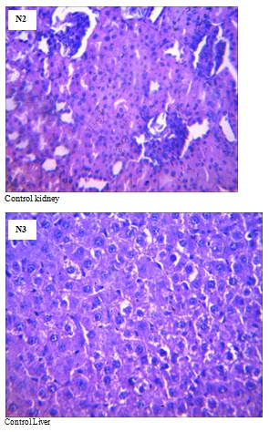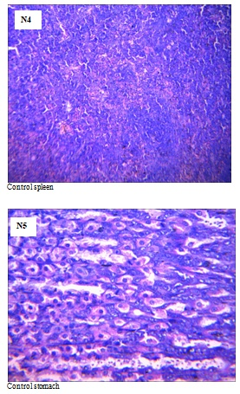

**Figure 2:** Photomicrographs (X400) of vital organs in male albino rat showing histopathological scoring of acute and subacute oral dose levels of 100 - 5000 mg/kg body weight from CPRBME extract.

(A) 200mg/kg b.wt Liver: Severe diffuse vacuolar degeneration of hepatocytes. (B) 400mg/kg b.wt Small intestine: No visible lesions seen. There is a parasite stage within the lumen of the intestine. (C) 1600 mg/kg b.wt Kidney: No visible lesions seen. (D) 1600 mg/kg b.wt Liver: mild portal congestion, with a severe diffuse vacuolar degeneration and necrosis of hepatocytes.(E) 400 mg/kg b.wt Spleen: No visible lesions seen. (F) 800 mg/kg b.wt Stomach: severe erosion and necrosis of the mucous membrane. (G) 400 mg/kg b.wt Small intestine: severe villi necrosis/sloughing, the crypts however are intact and prominent. (H) 5000 mg/kg b.wt Kidney: multiple foci of tubular degeneration and necrosis at the renal cortex. (I) 200 mg/kg b.wt Liver: slightly congested sinusoids, mild diffuse vacuolar degeneration of the hepatocytes. (J) 200 mg/kg b.wt Spleen: No visible lesions seen. (K) 400 mg/kg b.wt Stomach: submucosa appeared infiltrated. (L) 800 mg/kg b.wt Liver: mild diffuse congestion of the portal area and sinusoids. (M) 400 mg/kg b.wt Stomach: sub mucosa is infiltrated and expanded. No lesions on the mucous membrane. (N1-N5) Control for small intestine, kidney, liver, spleen and stomach: No visible lesions seen.

**Discussion**

Medicinal plants are precursors for the synthesis of useful drugs(Ronald *et al.,* 2008). Over 5000 plants are known to be used for medicinal purposes in Africa, but only a few have been studied(Taylor *et al.,* 2001). Thus, knowledge of uses and side effects of medicinal plants provide a vital contribution to human health care.

Toxicological tests are used to ascertain the safe limit products such as individual compounds, mixture of compounds, crude extract, pesticides, medications, food additives, packing materials or their chemical ingredients on animals, humans and the ecosystems. World health organization (WHO) recommends that medicinal herbs would be the dominant source to obtain a range of drugs. Therefore, such medicinal plants must be investigated for better understanding of their medicinal properties, safety and effectiveness (Nascimento and Braunwald, 2008).

Safety of plant extract is evaluated mostly by acute oral toxicity analysis. In the present study, the plant extract showed an LD50 of 616 mg/kg body weight (Fig 1). Thus, the plant extract even at 616 mg/kg may be considered as safe.This observation is agreed with Pooja*et al*. (2016) who assessed acute and sub-acute toxicity of aqueous and ethanol extracts of *Tanacetum parthenium*using two concentrations i.e 1000 mg/kg and 2000 mg/kg and they reported no behavioural changes and no mortality was observed in animals when used both the concentrations. In addition, the present study corroborate the work of Siemuri *et al.* 2012 who studied lethal concentration of *Calliandraportoricensis* root bark methanol extract using brine shrimps and found an LC50 of 0.88%.

*C. portoricensis*root bark methanol was investigated on male albino rats to see the effects on visceral organs. Our observation from the photomicrograph showed that when *C. portoricensis* is consumed repeatedly for prolong time may indeed elicit toxicity in vital organs such as liver, stomach, intestine etc as seen in animals from group B- F (Fig 2). This observation corroborate the study of Ofusori and Adejuwon, 2011 and Ojiako and Nwanjo, 2006 who reported distorted arrangement in gastric gland and pancreatic degeneration.

**CONCLUSION**

**ACKNOWLEDGMENTS**

**CONFLICT OF INTEREST**

No conflict of interest associated with this work.

**AUTHOR’S CONTRIBUTIONS**

**References**

Adesida, G. A. 1976. Personal Communication. Chemistry Department, University of Ibadan, Ibadan Nigeria.

Adesina, S. K. 1982. Studies on some plants used as anticonvulsant in Amerindian and African traditional plant medicines. *Fitoterapia* 53: 147-162.

Aguwa, C.N. and Lawal, A.M. (1988): Pharmacological studies on the active principle of *Calliandra portoricensis* leaf extracts. *Journal* of *Ethnopharmacology* 22: 63-71.

Akah, P.A. and Nwaiwu, J.I. (1988). Anticonvulsant activity of root and stem extracts of *Calliandraportoricensis*. J Ethnopharm 1988; 22(2): 205-210.

Aneela, S., De S., Kanthal, L. K., Choudhury, N. S., Das, B. L. and Sagar, K. V. (2011). Acute oral toxicity studies of *Pongamia pinnata* and *Annonas quamosa* on albino wistar rats. *International Journalof Research in Pharmacy and Chemistry*. 1(4):820-4.

Bhardwaj, S. and Gupta, D. (2012). Study of acute, subacute and chronic toxicity test*. Int J Adv Pharm Biol Sci*. 2:103-29.

Dharmalingam, S. and Natesan, G. (2017). Evaluation of acute toxicity of the methanolic extract of *Tanacetum parthenium* L. in albino wistar rats.*JSIR*6(3): 113-115.

Ecobichon, A. S. H.(2007). *Essential of pharmacognosy*. 1st edition, New Delhi: Birla Publications Pvt. Ltd.,2007.

Hutchinson, J.M. and Dalziel (1937). Flora of tropical West Africa. Crown overseas Agents for the colonies, London 2nd ed. 504.

Kumar, A. K., Ramachandra, S. S. and Narsu, L. (2010). Pharmacognostic and phytochemical investigations of roots of Hibiscus micranthus Linn. *Research Journal of pharmaceutical, Biological and Chemical Sciences (RJPBCS)*. 1(4): 324 – 337.

Nascimento Antman EM. and Braunwald E. 2008. ST-elevation myocardial infarction: pathology, pathophysiology, and clinical features. In: Libby P, Bonow RO, Mann DL, *et al*., eds. *Braunwald’s heart disease: a textbook of cardiovascular medicine*. Philadelphia, PA: Saunders Elsevier. 1207-1232.

Ofusori, D. A . and Adejuwon, A. 2011. Histopathological studies of acute and chronic effects of Calliandra portoricensis leaf extract on the stomach and pancreas of adult Swissalbino mice.*Asian Pac J Trop Biomed*. 1(3): 182-185.

Ojiako, O. A. and Nwanjo, H. U. 2006. Is Vernonia amygdalina hepatotoxic or hepatoprotective? Response from biochemical and toxicity studies in rats. *Afr J Biotechnol*5(18): 1648-1651.

Rice-Evans, C. (2004) Flavonoids and isoflavones: absorption, metabolism and bioactivity. *Free Rad. Biol.Med.* 36: 827-828.

Ronald, K., Pierre, D., Martin, J., Ralph, C. and Lucien, R. 2008. A new class of anthelmintics effective against drug- resistant nematodes. *Nature*. 452:176-180.

Siemuri, E. O., Akintunde, J. K., Bello, I. J. and Dairo, K. P. (2012): Assessment of cytotoxic effects of methanol extract of *Calliandra portoricensis* using brine shrimp (*Artemia salina*) lethality bioassay. *G.J.B.B*., VOL.1 (2) 257-260.

Siemuri,E. O., Akintunde, J. K. and Anuoluwapo, J. S. (2015).Effects of sub-acute methanol extract treatment of *Calliandra portoricensis* root bark on antioxidant defence capacity in an experimental rat model. *J. Basic Clin. Physiol. Pharmacol.* pp 1-8.

Taylor, J. L., Rabe, T., McGraw, L. J., Jäger, A. K. and Staden, J. 2001. Towards the scientific validation of traditional medicinal plants. *Journal Plant Growth Regulation. 34:23-37.*