Original Research Article

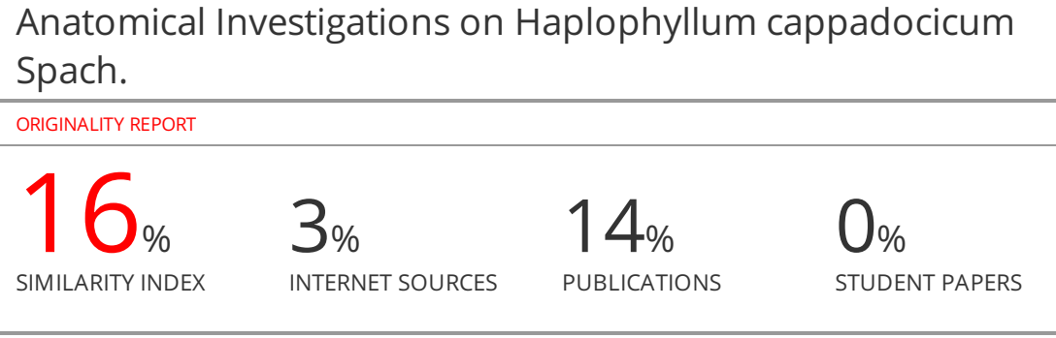
Anatomical Investigations on Haplophyllum cappadocicum Spach.
ABSTRACT
Aim and objective: Haplophyllum cappadocicum is a Rutaceae plant which is endemic for Turkey. It is aimed to determine the anatomical characteristics of this plant.
Methods: Plant materials were fixed in 70 % ethyl alcohol. The anatomical studies include transverse sections of roots, stems, leaves, fruits and seeds with illustrations. The investigations were made under microscope and photographs were taken by microphotography apparatus.
Conclusion: Haplophyllum genus with potential pharmaceutical interest are worthy of investigation not only for chemical content but also anatomically. This is the first report on anatomical features of Haplophyllum cappadocicum collected from Malatya, Türkiye.
Key words: anatomy, Haplophyllum cappadocicum, Rutaceae
INTRODUCTION
The genus Haplophyllum (Rutaceae) is represented by about seventy species distributed in an area stretching from the Mediterranean to Eastern Siberia¹. Members of the genus Haplophyllum are known for their use in traditional medicine²⁻⁴, as well as for containing a variety of chemical constituents of diverse structures such as lignans, quinoline alkaloids, coumarins, flavonoids and volatile compounds ⁵⁻¹⁵.
In previous studies, phytochemical investigations have been carried out on Haplophyllum cappadocicum. Lignans and quinoline alkaloids isolated from this plant exhibit its potential activity¹⁶⁻²¹.
The aim of this work is to put forward the anatomical features of Haplophyllum cappadocicum which is endemic to Turkey.
MATERIALS AND METHODS
Material for Haplophyllum cappadocicum was collected from Boranköy, Malatya. Voucher specimens are deposited in the Herbarium of the Ege University, Faculty of Pharmacy, Department of Pharmacognosy (1178).
A part of the plant material was fixed in 70 % alcohol for anatomical studies of root, stem, leaf, fruit and seed. The investigations were made under microscope and photographs taken by microphotography apparatus (Carl Zeiss Jena).
Haplophyllum cappadocicum Spach.
Stems moderately to densely crisped-pubescent, 25-50 cm. Leaves usually entire, oblanceolate to linear, rarely lanceolate-obovate, occasionally trisect or incised, long-attenuate and pseudopetiolate below. Infloresence broad and lax, the lower branches much exceeding the terminal cyme, at least the upper branches crisped-pubescent. Sepals broadly to narrowly deltoid, persistent. Petals bright yellow, oblong-elliptic, 5-6 mm. Filaments abruptly expanded and ± parallel-sided in the lower half. Young ovary segments biovulate, each with a pronounced terminal apical corniculus, densely pilose on the upper inner surface, more sparingly so below. Capsule with divergent unbonate appendages on the upper dorsal surface, remaining glands convex, the raised margins not confluent into transverse ridges. Fl. 6-7. Grassy and stony steppe, 700-1500 m²².
RESULTS AND DISCUSSION
Anatomy of Root
On the outermost side there is a single layer of exodermis made up of suberised cells. The vascular bundles constitute a collateral arrangement. The endodermis is not detected in the transverse sections (Fig. 1).
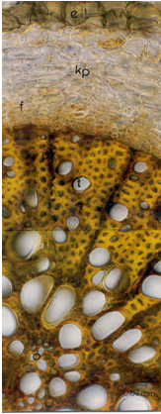

Figure 1. Cross section of the root of Haplophyllum cappadocicum
e: exodermis, f: phloem, kp: cortex parenchyma, t: trachea, ök: medullary rays, ö: pit

Anatomy of Stem
Stem cortex, with a thin cuticle on the outer side, has xerophytic stomata. On the epidermis, thick walled unicellular hairs with dots on cuticle (Fig. 2), assume straight or hook-like shapes. In the cortex parenchyma, schizolysigenous oil cavities are just in touch with the epidermal cells (Fig. 3). The cortex parenchyma consists of starch sheath cells, schlerenchyma fibers, xylem, phloem and the pith. The pith is composed of parenchymatous cells (Fig. 4).
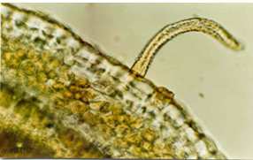
Figure 2. Unicellular hair on the epidermis of the stem
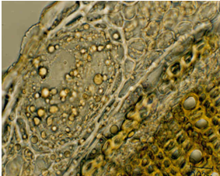
Figure 3. Oil Cavity In the Cross Section of the Stem

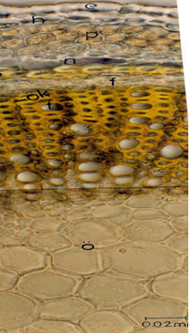
Figure 4. Cross section ofthe stem of Haplophyllum cappadocicum
e: epidermis, h: hypodermis, p: parenchymatous cells, n: starch sheath cells, s: schlerenchyma fibers, f: phloem, t: trachea, ök: medullary rays, ö: pith

Anatomy of Leaf
The leaf is monofacial. As seen in the cross sections of leaf laminae, the outer layers of lower and upper epidermis with thickened walls, have xerophytic stomata (Fig. 5). Within the mesophyll tissue, palisade parenchyma is composed of two or three rows whereas the spongy parenchyma takes a little place on the center of the mesophyll tissue. Oil cavities are just in touch with upper epidermis (Fig. 6). In the cross sections of the mid-rib region, thin-walled parenchymatous cells surround the collateral vascular bundles. Schlerenchyma fibers are detected between starch sheath cells and the phloem (Fig. 7).
In the surface view of the leaf, on the basis of the arrangement of four to six subsidiary cells relative to stoma, the stomata is found to be as anomocytic type. In the surface wiew of the epidermis, the epidermal walls seem to be thick and unicellular hairs assume straight or hook-like shapes (Fig. 8).

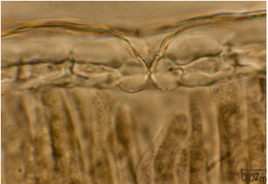
Figure 5. Xerophytic stomata in the cross section of the leaf

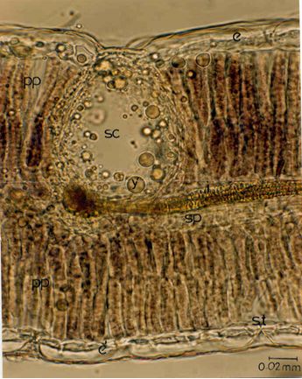
Figure 6. Cross section of the leaf of Haplophyllum cappadocicum
e: upper epidermis, sc: oil cavity, y: oil droplets, pp: palisade parenchyma, sp: spongy parenchyma, i: vascular bundles, st: stoma, é: lower epidermis

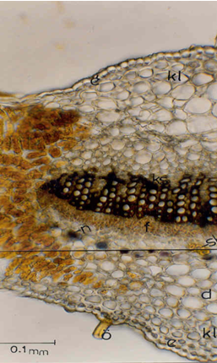
Figure 7. The cross section of the mid-rib region
e: upper epidermis, é́: lower epidermis, kl: collenchyma, ks: xylem, f: phloem, sk: schlerenchyma fibers, n: starch sheath cells, d: parenchyma, ö: unicellular hair

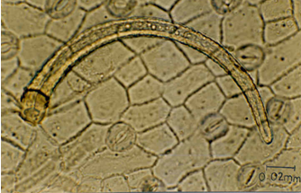
Figure 8. The surface view of the leaf

Anatomy of Fruit and Seed
The exocarp with thick outer cell walls, has thin cuticle. In the tissue of the mesocarp, essential oil cavities are orientated where the neigbouring cells to these cavities are thin-walled. The tissue of the endocarp is entirely sclerenchymatous (Fig. 9).
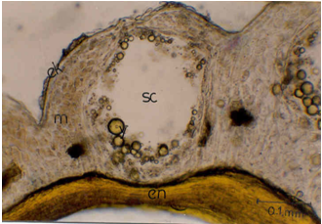
Figure 9. Fruit section of Haplophyllum cappadocicum
ek: exocarp, m:mesocarp, sc: oil cavity, y: oil droplets, en: endocarp
Testa, the destroyed cells of nucellus, endosperm and embryo constitutes the seed. In the cross section of the seed, the epidermal cells of the testa, assuming papillae’s shape with thick outer cell walls, have hair-like elongations and crystal-like grains which are destroyed by acidic reagents with gases coming out. The lateral and inner walls are thinner than the outer walls of the epidermal cells of the testa. The cell walls of the testa parenchyma are thick and seemed to be partially pressed in the mature seeds. The endosperma lying under the destroyed nucellus cells, is composed of thin walled parenchymatous cells and oil droplets as reserve substances are located within the cells (Fig. 10 A and B).

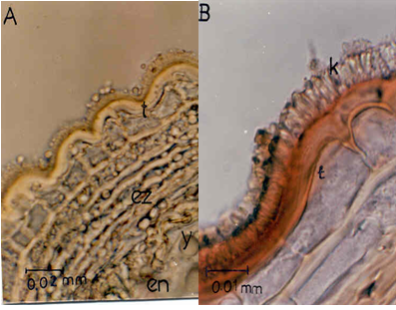

Figure 10. The cross section of the seed of Haplopyllum cappadocicum
A. In Sartur Reagent B: In Chloralhydrat Reagent
t: testa, ez: destroyed cells of nucellus, en: endosperma, y: oil droplets, k:crystal-like grains

CONCLUSION
Haplophyllum genus possessing biologically active natural substances of potential pharmaceutical interest, are worthy of investigation not only for chemical content but also anatomically. To the best of our knowledge, comprehensive anatomical studies have been carried out on Haplophyllum cappadocicum, an endemic plant to Iran-Turan phytogeographical region, from Boranköy-Malatya, Turkey, for the first time in this report.
CONFLICT OF INTEREST
Authors declare that there is no conflict of interest with the present work.

Acknowledgements

Author’s Contribution

REFERENCES
1. Willis, JC. A Dictioanary of Plants and Ferns, 8 th ed., revised by Airy H. K. Shaw, Cambridge University Press, Cambridge, 1980, p.532.
2. Bessonova IA, Batsuren D, Yunusov S. Yu. Alkaloids of Haplophyllum dauricum. Chem Nat Comp 1984; 20: 68-70.
3. Bessonova IA, Kurbanov D, Yunusov S.Yu. Components of Haplophyllum ramosissimum, Chem Nat Comp 1989; 25 (1): 39-40.
4. Ali MB, Mohamed AH, Bashir AK, Salih AM. Pharmacological investigation of Haplophyllum tuberculatum: Int J Pharmacognosy 1992; 30(1): 39-45.
5. Kostova I, Ivanova A, Bozhanka M, Vitkova A. Lignans and Alkaloids from Haplophyllum suaveolens. Monatsh Chem 2000; 131:191-194.
6. Gözler B, Rentsch D, Gözler T, Ünver N, Hesse M. Lignans, Alkoloids and coumarins from Haplophyllum vulcanicum. Phytochemistry 1996;42(3): 695-699.
7. Gözler T, Gözler, B, Linden A, Hesse M. Vulcanine, a beta-carboline alkaloid from Haplophyllum vulcanicum. Phytochemistry 1996; 43(6):1425-1426.
8. Prieto JM, Recio MC, Giner RM, et al. Topical Anti-Inflammatory Lignans from Haplophyllum hispanicum. Z. Naturforschung [C] 1996; 51(9-10):618-622.
- Bessonova IA Componenets of Haplophyllum bucharicum. Chem Nat Comp 2000; 36(3): 323-324.
- Al-Rehaily AJ, Al-Howiriny TA, Ahmad MS, Al-Yahya MA, El-Feraly FS, Hufford CD, McPhail AT. Alkaloids from Haplophyllum tuberculatum Phytochemistry 2001; 57(9):597-602.
- Evcim Ü, Gözler B, Freyer AJ, Shamma M. Haplomyrtin and (-)-haplomyrfolin: two lignans from Haplophyllum myrtifolium. Phytochemistry 1986; 25(8): 1949-1951.
- Ulubelen A, Gil, RR, Cordell GA, Meriçli AH, Meriçli F. Prenylated lignans from Haplophyllum ptiliostlum. Phytochemistry 1995; 39(2): 417-422
- Saglam H, Gozler T, Gozler B, Kıvçak B. A new prenylatedarylnaphthalene lignan from Haplophyllum myrtifolium. Fitoterapia 2003; 74(6): 564-569.
- Saglam H, Gozler T, Kıvçak B, Demirci B, Başer KHC. Volatile compounds from Haplophyllum myrtifolium. Chem Nat Comp 2001; 37(5): 442-444.
- Arar G, Gözler, T. Malatyamine, a 4-quinolone alkaloid from Haplophyllum cappadocicum. J Nat Prod 1985; 48(4): 642-643.
- Ostan I, Saglam H, Limoncu ME, Ertabaklar H, Ozensoy Toz S, Ozbel Y, Ozbilgin A. In vitro and in vivo activities of Haplophyllum myrtifolium against Leishmani tropica. New Microbiol 2007; 30(4):439-45.
- Gözler B, Arar G, Gözler T, Hesse M. Isodaurinol, an arylnaphtalene lignan from Haplophyllum capadocium. Phytochemistry 1992; 31(7) 2473-2475.
- Gözler B, Gözler T, Sağlam H, Hesse M. Minor lignans from Haplophyllum cappadocicum. Phytochemistry 1996; 42(3): 689-693.
- Gözler, B., Güneş, S. and Hesse, M. Further Lignans From Haplophyllum cappadocium. J Fac Pharm Gazi 1995; 12(1): 9-15.
- Gözler B, Kıvçak B, Arar G, Gözler T, Hesse M. (-)-Padocin: A Novel Epoxylignan from Haplophyllum cappadocicum. Heterocycles 1994; 39(1): 243-249.
- Gözler B, Önür MA, Gözler T, Kadan G., Hesse M. Lignans and lignan glycosides from Haplophyllum capadocium. Phytochemistry 1994; 37(6) 1693-1698.
- Townsend, CC. Haplophyllum (In) Davis, P. H. (Ed.) Flora of Turkey and The East Aegean Islands, University Press, Edinburgh.1967, p. 496, 504-505.

